**Build a Model :**

1. **Task Description**

This project involves creating a Django application that retrieves a list of all cities in India using an external API. The cities' data is then processed and saved into a CSV file for easy access and future use. The project highlights the integration of APIs and data handling in Django.

1. **Task Output Screenshot**

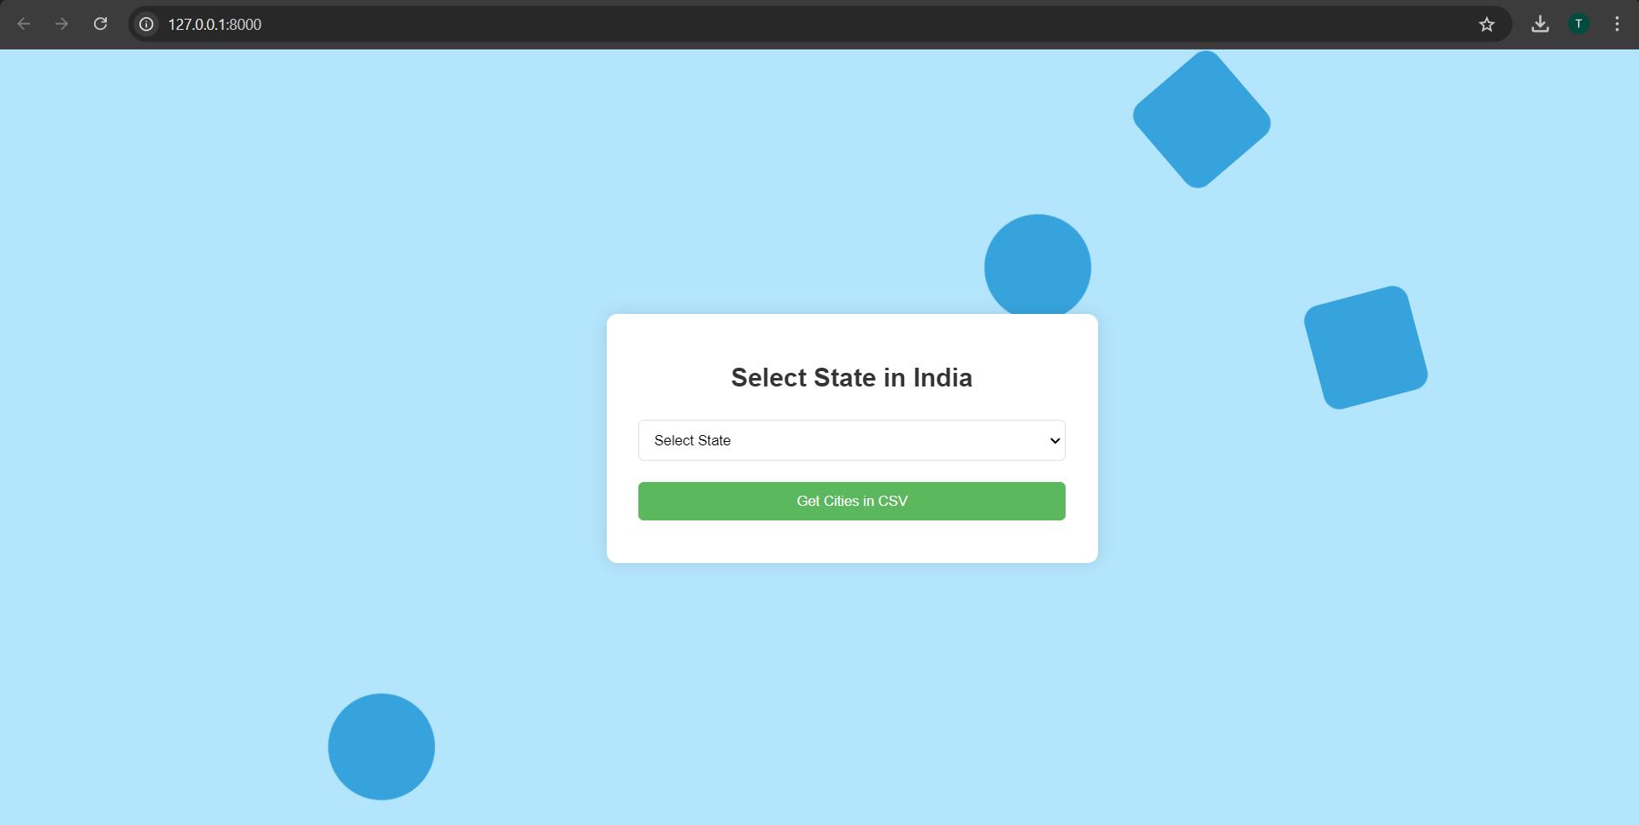

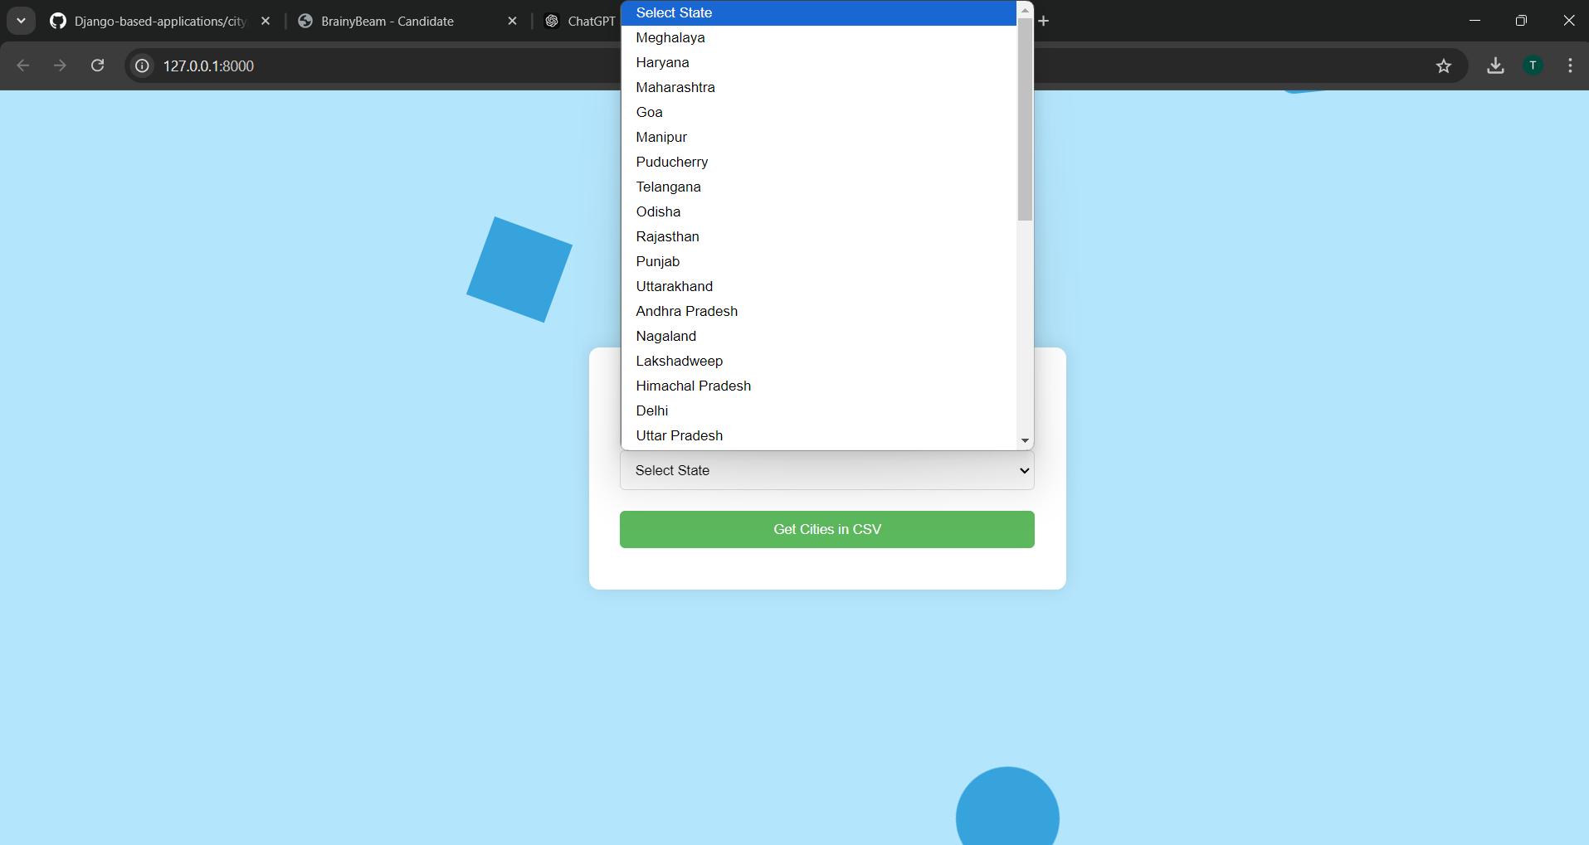

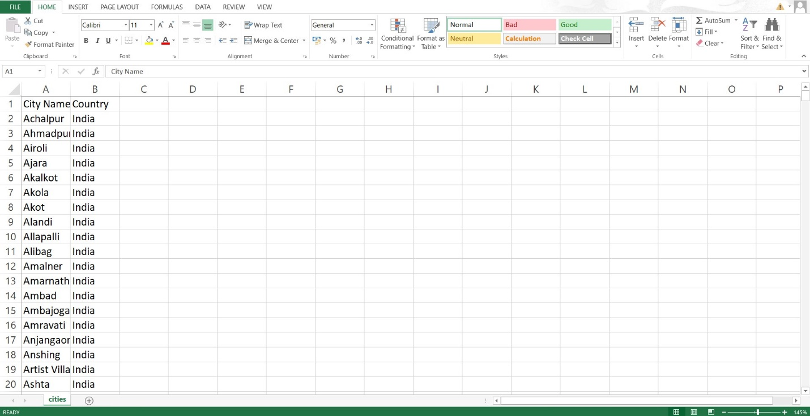

## Project Setup

### Starting the Project-

* **Create a Django Project:**

Initialize a new Django project and navigate to the project directory.

* **Create an App:**

Create a new app dedicated to handling city data.

### Creating the Model-

## Although a model isn't strictly necessary for this project, it can be created in the future if data storage in a database is needed.

## User Interface Development

### Data Insertion Form-

### Develop a simple form on the homepage that allows users to trigger the fetching of city data from the API.

### Displaying Inserted Data-

## After the data is fetched and saved, display a confirmation message on the webpage to inform users of the successful operation.

## Functionality Improvements

### Categorizing Inserted Data-

### To enhance the usability of the application, cities can be categorized based on various attributes such as state. This categorization allows users to easily filter and search for cities of interest. For example, implementing dropdowns or checkboxes in the user interface can enable users to select specific categories, making the data more organized and accessible.

## Conclusion

This project effectively demonstrates the process of integrating an external API within a Django application to fetch and save data. By compiling a comprehensive list of Indian cities and exporting it to a CSV file, the application provides a practical tool for accessing city information. This approach not only emphasizes the ease of data retrieval in Django but also sets the foundation for future enhancements.