CodeTruth Agent V2 | Full Project Overview | June 2026
CodeTruth Agent V2
Deterministic Pre-Modification Governance Layer for Python Code Changes
Version 2 | Python | Open Source | June 2026

CodeTruth Agent V2 is an open-source deterministic governance layer that analyzes candidate function pairs using semantic similarity and behavioral analysis, and produces SAFE, REVIEW, or BLOCK governance decisions before repository modification is attempted.

8-Repository Evaluation | 7,862 Files | 1,241 Pair Analyses | 0 Pipeline Errors | V2 Release

1. Project Snapshot
Project Name | CodeTruth Agent
Version | V2 (Governance Release)
Builds On | V1 — Rule-Based Safe-Merge Reasoning System
Language | Python 3.11+
Type | Developer Tool / Pre-Modification Governance Gate
Category | Code Governance | AI Safety Tooling | Code Change Verification
Status | Evaluated and Released — 8-Repository Evaluation Complete
Evaluation | 7,862 files | 1,241 pair analyses | 0 pipeline errors
Target Users | Software Developers, Tech Leads, Platform Engineers, DevOps Teams, AI Agent Builders
Author | Zeeshan Saud
Release Date | June 2026
License | GPLv3 (Commercial license available)
Repository | github.com/ZeeshanSaud/CodeTruthAgent

2. Project Objective
Core Goal: Build a deterministic governance gate that verifies candidate code changes across semantic, behavioral, and risk dimensions — before any modification reaches the repository.

CodeTruth Agent V2 extends V1's safe-merge reasoning with three additional analysis stages and wires them into a single pre-modification governance pipeline:

- Decide whether a candidate code change is SAFE, requires REVIEW, or must be BLOCKED — before it is applied.
- Combine semantic similarity, behavioral signature detection, and multi-signal fusion into one deterministic decision.
- Detect opposing-behavior function pairs (e.g., a function that backs up data vs a function that deletes it) that name-similarity alone cannot catch.
- Produce explainable, reproducible governance decisions — every decision traceable to specific engine signals.
- Evaluate at real-world scale — from 9-file tutorial repos to 4,426-file production codebases — with zero pipeline errors.
- Preserve V1's governance capabilities as the integrated ground truth layer via V1 Adapter.

3. Core Problem Being Solved

3.1 The AI Agent Code Modification Problem
AI coding agents can now generate and apply code changes autonomously. The missing piece is a verification layer that runs before those changes reach the repository.

Function Pair | Semantic Score | Why It Matters
commit vs savepoint_commit | 0.63 — similar names | Different SQL operations — merging causes data corruption
rollback vs get_rollback | 0.95 — very similar | One carries RECOVERY_OPERATION; other is a pure getter
update_version_in_file vs update_version_in_examples | 0.70 — similar names | One rewrites files; other deletes — opposing behaviors

In each case, semantic score alone would not block the pair. V2's behavioral fusion layer does.

4. How CodeTruth Agent V2 Works
V2 Pipeline: Repository Scan → Governance Layer → V1 Adapter → Decision Pipeline (Semantic → Behavioral → Fusion → Risk) → Governance Action → Memory → Report

4.1 V2 Pipeline Diagram
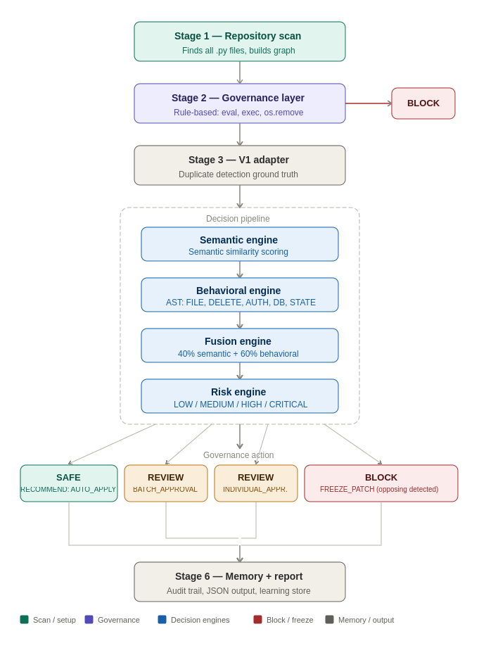

4.2 The 5-Layer Architecture
Layer 1 — Scanner | repository_graph_engine.py — scans all Python files, builds repository graph
Layer 2 — Governance | governance_wiring.py — rule-based: flags global mutation and dangerous API calls (eval, exec, os.remove, subprocess)
Layer 3 — Orchestration | decision_orchestrator.py + v2_orchestrator.py — wires semantic, behavioral, fusion, and risk engines into the decision pipeline
Layer 4 — Patch Workflow | patch_generation, patch_validation, risk_classification, test_execution, incremental_change engines — 4 deterministic patch templates
Layer 5 — AI Gateway | ai_interface.py + llm_adapter.py — V3 scaffolding, DISABLED in V2. LLM integration is V3 scope.

4.3 The Decision Pipeline — 4 Engines
Semantic Engine | Converts function names and bodies to embedding vectors using all-MiniLM-L6-v2 (local, offline, no API). Computes cosine similarity score 0.0–1.0. Pure mathematics — deterministic.
Behavioral Engine | Reads function AST. Classifies detected operations: FILE_READ, FILE_WRITE, DELETE_OPERATION, STATE_MUTATION, DATABASE_OPERATION, AUTH_OPERATION, NETWORK_CALL, PROCESS_OPERATION, OBJECT_CREATION, BACKUP_OPERATION. Rule-based pattern matching — no AI.
Fusion Engine | Combines semantic score (40% weight) + behavioral risk (60% weight). Detects opposing behavioral signatures. Conservative default: BLOCK when signals conflict.
Risk Engine | Classifies outcome: LOW / MEDIUM / HIGH / CRITICAL. Routes to governance action: AUTO_APPLY / BATCH_APPROVAL / INDIVIDUAL_APPROVAL / FREEZE_PATCH. Note: V2 recommends governance action — it does not autonomously modify code.

4.4 Governance Actions
Decision | Action | Triggered When
SAFE | RECOMMEND: AUTO_APPLY | Low risk — similar functions, matching behavioral profiles
REVIEW | BATCH_APPROVAL | Medium risk — semantic similarity with minor behavioral difference
REVIEW | INDIVIDUAL_APPROVAL | High risk — significant behavioral asymmetry
BLOCK | FREEZE_PATCH | Critical — opposing behavioral signatures detected

5. What V2 Catches That V1 Alone Does Not
Function Pair | Repo | V2 Finding
commit vs savepoint_commit | Django | BLOCK — different SQL transaction operations
atomic vs _non_atomic_requests | Django | BLOCK — decorator vs its inverse
_get_new_csrf_string vs _add_new_csrf_cookie | Django | BLOCK — generator vs side-effecting writer
update_version_in_file vs update_version_in_examples | transformers | FREEZE_PATCH — opposing behaviors (score 0.70)
get_all_tests vs infer_tests_to_run | transformers | FREEZE_PATCH — DELETE vs READ+WRITE+MUTATE
shell_command (eval) + Config.from_pyfile (exec) | Flask | Governance BLOCK — dynamic execution detected

6. Technology — What V2 Uses and Does Not Use
V2 uses a local embedding model for semantic similarity and does not use an LLM in the governance decision path. All governance decisions are deterministic, explainable, and reproducible.

Component | Used in V2 | What It Is
Rule Engine (governance_wiring.py) | Yes | Deterministic AST rules — no AI
AST Analysis (behavioral engine) | Yes | Python ast module — no AI
Fusion Logic (fusion_engine.py) | Yes | Weighted arithmetic — no AI
Local Embedding Model (all-MiniLM-L6-v2) | Yes | Local ML model, offline, deterministic
LLM / Generative AI | No | V3 scope only
OpenAI / Anthropic / Google API | No | No external API dependencies

7. Technical Architecture — 14 Components

7.1 Core Files
ai/decision_orchestrator.py | DecisionOrchestrator class — wires semantic, behavioral, fusion, risk engines into one decision
ai/v2_orchestrator.py | Master controller — runs all pipeline stages end-to-end
ai/semantic_decision_engine.py | Semantic similarity scoring using embedding vectors
ai/behavioral_signature_engine.py | AST-based behavioral tag classification
ai/fusion_engine.py | 40/60 weighted fusion with opposing-behavior detection
ai/governance_wiring.py | Rule-based governance scan — global mutation + dangerous API
ai/repository_graph_engine.py | Repository scanner — builds file and function graph
ai/v1_adapter.py | Integrates V1 duplicate detection as ground truth
ai/risk_classification_engine.py | LOW / MEDIUM / HIGH / CRITICAL risk classification
ai/embedding_similarity.py | Vector embedding computation and cosine similarity
ai/fallback_orchestrator.py | V1 fallback protection when V2 signals are insufficient
validation/approval_engine.py | Programmatic HITL API — no UI (V3 scope)
memory/governance_memory_engine.py | Persistent governance decision store
reporting/report_generator.py | JSON report generation with full audit trail

8. 8-Repository Evaluation Results
V2 was evaluated on 8 open-source Python repositories totalling 7,862 files, spanning small tutorials to one of the largest Python ML codebases in existence.

Repository | Files | Gov Findings | Gov BLOCKs | Pipeline Pairs | Pipeline BLOCKs | Opposing | Errors | Status
Flask tutorial | 9 | 2 | 0 | 4 | 0 | 0 | 0 | PASSED
click | 60 | 3 | 1 | 25 | 3 | 0 | 0 | PASSED
httpx | 60 | 0 | 0 | 25 | 3 | 0 | 0 | PASSED
Flask full | 83 | 4 | 2 | 25 | 8 | 0 | 0 | PASSED
DRF | 154 | 2 | 1 | 50 | 24 | 0 | 0 | PASSED
Rich | 213 | 14 | 4 | 37 | 9 | 0 | 0 | PASSED
Django | 2,917 | 68 | 16 | 100 | 55 | 0 | 0 | PASSED
transformers | 4,426 | 296 | 76 | 1,000 | 464 | 4 | 0 | PASSED
Total | 7,862 | 386 | 99 | 1,241 | 563 | 4 | 0 | 8/8 PASSED

9. BLOCK Precision Audit — 14 Pairs
Group | Sample | Purpose
Group A | 5 pairs — diversity sample | click, DRF, Django — spans decorator families, transaction code, security code
Group B | 5 pairs — random (seed 20260603) | transformers — randomly sampled from 464 BLOCK decisions
Group C | 4 pairs — exhaustive | All opposing-behavior detections across full 8-repo evaluation

9.1 Groups A+B Results
Classification | Count | What This Means
Governance-significant (GENUINE) | 6 / 60% | Real semantic or behavioral differences worth surfacing for review
Family-pattern (NOISE_FAMILY) | 3 / 30% | Decorator/factory family members — BLOCK technically correct but no merge intent
Embedding limitation (NOISE_EMBEDDING) | 1 / 10% | Functions closely related but embedding under-scores similarity

9.2 Group C — Opposing Detections (All 4 GENUINE)
Pair | Semantic Score | Action | Why GENUINE
update_version_in_file vs update_version_in_examples | 0.70 | FREEZE_PATCH | Names similar — but one writes files, other deletes. Strongest opposing example.
get_all_tests vs infer_tests_to_run | 0.56 | FREEZE_PATCH | DELETE vs READ+WRITE+MUTATE — test pipeline inversion
get_all_tests vs filter_tests | 0.61 | FREEZE_PATCH | Same get_all_tests — opposing profile confirmed
check_dependencies_and_create_import_node vs create_modules | 0.36 | FREEZE_PATCH | DELETE+FILE_WRITE vs FILE_WRITE only — deletion asymmetry

10. Key Features
Multi-Signal Fusion | Semantic (40%) + Behavioral (60%) + Risk Classification into one SAFE/REVIEW/BLOCK decision
Opposing-Behavior Detection | FREEZE_PATCH on behavioral inversion — catches what name-similarity misses
Governance Layer | Rule-based scan for global mutation and dangerous API calls — independent of decision pipeline
Behavioral Signatures | 10 operation categories: FILE_READ, FILE_WRITE, DELETE_OPERATION, STATE_MUTATION, DATABASE_OPERATION, AUTH_OPERATION, NETWORK_CALL, PROCESS_OPERATION, OBJECT_CREATION, BACKUP_OPERATION
Deterministic Decisions | Same input = same output, every run. No LLM non-determinism in the governance path.
V1 Integration | V1 duplicate detection preserved as ground truth via v1_adapter.py — V2 extends, never replaces
Scale Proven | Tested from 9 files (Flask tutorial) to 4,426 files (transformers) — zero pipeline errors
Zero External Dependencies | No OpenAI, Anthropic, or Google API. Runs fully locally and offline.

11. Impact and Value
Global Contribution: Semantic Similarity + Behavioral Signatures + Multi-Signal Fusion + Opposing-Behavior Detection + Deterministic Governance Gate = One Pre-Modification Verification Pipeline
V2 contributes an open-source implementation of a deterministic pre-modification governance gate — combining semantic similarity, behavioral analysis, and multi-signal fusion — for Python code changes.

12. Known Limitations (V2)
Python Only | Current version supports Python projects only. Multi-language support is V3 scope.
No Patch Generation | V2 decides SAFE/REVIEW/BLOCK but does not generate patches. LLM-driven patch generation is V3 scope.
No HITL UI | Human-in-the-loop approval is a programmatic API only — no interactive UI. V3 scope.
NOISE_FAMILY Pattern | Token-overlap fallback generates naming-family pairs on codebases with large naming families. Documented in V2_BLOCK_PRECISION_AUDIT.md. Planned for future calibration work as part of the V3 roadmap.
V1 25-File Sampling Cap | V1 adapter samples 25 files on large repos. V1-driven extraction did not activate in any of the 8 evaluated repos. Documented honestly.
Single-Reviewer Audit | 14-pair BLOCK precision audit is single-reviewer. Inter-rater agreement not measured.

13. Version Roadmap
Version | Direction | Status
V1 | Rule-based safe-merge reasoning system | COMPLETE — published GPLv3
V2 | Deterministic pre-modification governance gate | COMPLETE — this release
V3 | LLM patch generation gated by V2 governance layer | Future scope
V3+ | Interactive HITL UI, CI/CD packaging, multi-language support | Future scope

14. Final Position
8-Repository Evaluation: 7,862 files | 1,241 pair analyses | 0 pipeline errors | 4 opposing detections confirmed GENUINE | 8/8 PASSED
CodeTruth Agent V2 — Cleared for GitHub Release

CodeTruth Agent V2 is an open-source deterministic governance layer that analyzes candidate function pairs using semantic similarity and behavioral analysis, and produces SAFE, REVIEW, or BLOCK governance decisions before repository modification is attempted.
Zeeshan Saud | CodeTruth Agent V2 | Deterministic Pre-Modification Governance Layer | June 2026
CodeTruth Agent V2 | Open Source — GPLv3 | github.com/ZeeshanSaud/CodeTruthAgent

