CodeTruth Agent V1
Intelligent Safe-Merge Reasoning System
Version 1 | Python | Open Source | May 2026
"CodeTruth Agent is a system designed to safely transform code by combining detection, decision-making, risk awareness, and learning into one controlled pipeline."

UAT/SIT: 22 / 22 Test Cases Passed | 100% Pass Rate | Prototype release

1. Project Snapshot

Project Name | CodeTruth Agent.
Version | V1 (Learning System).
Language | Python 3.x
Type | Developer Tool / Intelligent Static Analysis Agent.
Category | Code Quality | Refactoring | AI-Assisted Development.
Status | Test Cases Complete — Prototype release.
Test Coverage | 22 Test Cases — 100% Pass Rate.
Target Users | Software Developers, Tech Leads, Code Reviewers, DevOps Teams.
Author | Zeeshan Saud.
Release Date | May 2026

2. Project Objective

Core Goal
Build an intelligent system that can: Understand code → Detect duplication → Decide best version → Analyze risk → Safely refactor → Learn from decisions. Goal: Reduce manual effort, minimize risk, and improve code quality at scale.

CodeTruth Agent was built to achieve six specific objectives:

- Detect duplicate functions accurately — identical copies, logically equivalent functions with different names, and compact vs verbose style variants.
- Prevent dangerous merges — by detecting business logic conflicts, semantic domain conflicts, type conflicts, constant value differences, recursive functions, and nested vs flat structures.
- Protect the codebase — automatic backups before any modification, full dependency tracking, and explicit human approval for every change.
- Learn from developer decisions — remembering approved and rejected pairs across runs, never suggesting the same rejected fix twice.
- Work on real production codebases — zero observed false positives in the validated test scope, including selected production-library testing.
- Scale across multiple files — detecting duplicates spread across any number of project files simultaneously.

3. Core Problem Being Solved

3.1 Duplicate Code Problem
In real-world systems, the same logic is written multiple times, functions are duplicated across files, and slight variations create hidden duplicates that are nearly impossible to find manually.
- Hard to maintain — changes must be made in multiple places
- Increased bugs — different versions diverge silently over time
- Inconsistent logic — same business rule applied differently across the codebase

3.2 Refactoring is Risky
Developers know duplication exists but avoid fixing it because: "What if removing this breaks something?"
- Teams avoid refactoring out of fear
- Technical debt grows with every sprint
- Many tools provide partial guidance, but end-to-end safe-merge governance remains limited.

3.3 Lack of Intelligent Tools
Current tools in the market can detect duplicates and suggest improvements — but they do not decide, analyse risk, or apply changes safely. The end-to-end decision system is missing.

3.4 No Learning System
Existing tools analyse once and forget everything. They do not learn team preferences, remember past decisions, or improve over time — causing the same suggestions to repeat every run.
Area | Industry Today | CodeTruth Agent
Detection | Strong | Enhanced Structural + Semantic
Decision | Partial | Governance Decision Engine
Safe Execution | Partial | Backup + Approval
Learning | Rare | Persistent Decision Memory
Risk Analysis | Partial / Limited | Merge-Blocking Governance
Dependency Map | Usage Tracking / View-Oriented | Pre-Merge Safety Gate

Disclaimer/Note:
The comparative capability analysis presented in this document is based on the best of the author’s knowledge, publicly available information, practical experimentation, and observed tooling behaviours at the time of publication.

4. How CodeTruth Agent Works

The Pipeline
Scan → Parse → Detect → Risk Analysis → Dependency Map → Human Approval → Safe Modify → Memory Learning

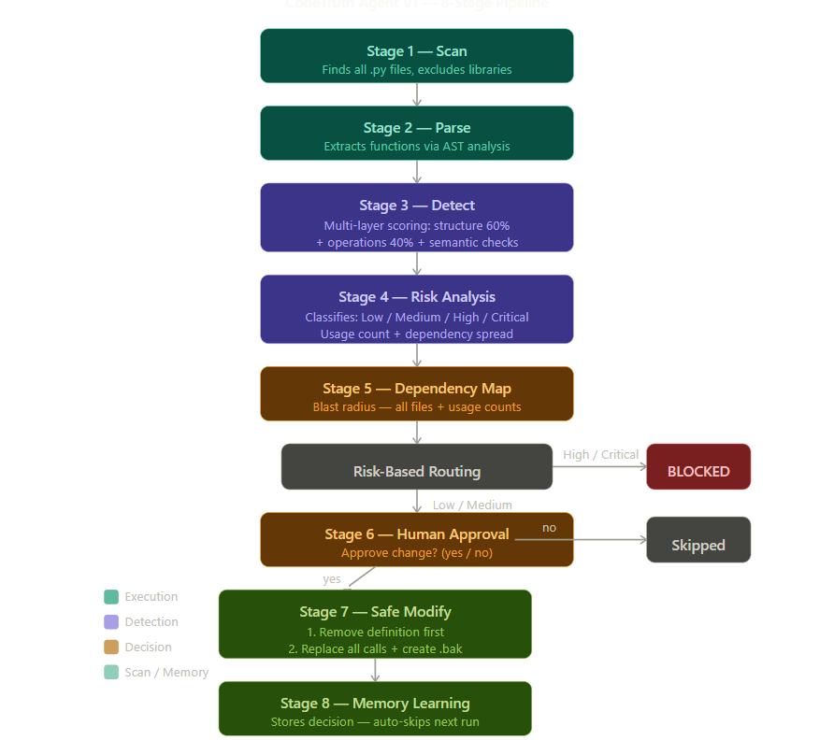

4.1 The 8-Stage Pipeline

Stage 1 — Scan | Reads entire codebase. Finds all functions across all project files. Excludes libraries and engine files.
Stage 2 — Detect | Compares every function pair using multi-layer scoring: structure, operations, constants, types, semantics, recursion, and name similarity.
Stage 3 — Decide | Chooses the best function to keep based on simplicity, structure, naming quality, and implementation length.
Stage 4 — Risk Analysis | Determines impact level (Low / Medium / High / Critical) based on usage count, dependency spread, and conflict type.
Stage 5 — Dependency | Tracks every file and line where each function is called across the entire project. Shows full map before any change.
Stage 6 — Safe Modify | On approval creates .bak backup, replaces all function calls across dependent files, removes duplicate safely.
Stage 7 — Human Approval | Every change requires explicit developer confirmation. Engine never modifies files autonomously.
Stage 8 — Memory | Stores all approved and rejected decisions persistently. Auto-skips previously rejected pairs on future runs.

4.2 Risk-Based Execution Workflow

Low Risk | Approval prompt shown directly — safe to proceed
Medium Risk | Warning shown first — cross-file dependency detected — then approval prompt
High Risk | BLOCKED automatically — recommendation report shown — no approval prompt
Critical Risk | BLOCKED automatically — blast radius shown — manual phased refactor required

4.3 Detection Capabilities
- Identical function copies with different names
- Same logic with different variable or parameter names
- Compact one-line vs verbose multi-line style variants
- Nested function vs flat function with equivalent logic
- Recursive duplicate functions
- Cross-file duplicate detection across project files within practical runtime and hardware limits.
- Large complex real-world functions with stable execution in validated test scenarios.

4.4 Safety Capabilities
- Business logic conflict — catches different constant values (tax rates, port numbers, multipliers)
- Semantic domain conflict — catches functions from different domains (email vs username, payment vs auth)
- Type annotation conflict — catches functions handling different data types
- High usage risk blocking — automatically blocks merges when dependency count is critical
- Recursive function safety — flags self-calling functions as unsafe to auto-merge
- Automatic backup creation before every approved file modification.

5. What Makes CodeTruth Agent Different

Most duplicate detection tools primarily focus on text similarity, clone detection, or basic AST comparison. CodeTruth Agent extends beyond duplicate detection into intelligent safe-merge reasoning and risk-aware execution.

Core Philosophy
same structure ≠ safe merge

The engine never assumes that structurally similar code is automatically safe to merge. Every merge candidate is verified through conflict checks, dependency analysis, and risk routing.

Capability | Traditional Tools | CodeTruth Agent
Text Matching | Yes | Yes
AST Comparison | Basic to Advanced | Advanced Multi-Layer
Semantic Conflict Detection | Rare / Limited | Yes
Business Logic Conflict | Rare | Yes
Dependency-Aware Risk | Limited | Yes
Risk-Based Execution Routing | Rare | Yes
Human Approval Workflow | Rare | Yes
Persistent Learning Memory | Rare | Yes
Automatic Backup & Rollback | Limited | Yes
Cross-File Duplicate Detection | Limited to Moderate | Yes

Disclaimer/Note:
The comparative capability analysis presented in this document is based on the best of the author’s knowledge, publicly available information, practical experimentation, and observed tooling behaviours at the time of publication.

6. Current AI Architecture

Important Clarification
CodeTruth Agent V1 is primarily a rule-based intelligent reasoning system. The current version does not rely on machine learning or deep learning models. All intelligence is derived from structured rules, AST analysis, and weighted scoring logic.

The intelligence in V1 comes from:

AST Analysis | Abstract Syntax Tree parsing — understands code structure beyond text matching
Weighted Similarity Scoring | Multi-factor scoring combining structure (60%), operations (40%), constants, types, and semantics
Semantic Keyword Filtering | Rule-based domain classifier using curated keyword dictionaries
Dependency Reasoning | Cross-file usage tracking — calculates blast radius before any merge
Risk Escalation Logic | Automated risk routing: Low / Medium / High / Critical based on usage count and conflict type
Persistent Learning Memory | JSON-based decision store — remembers approved and rejected pairs across all runs

V2 Direction
V2 is expected to extend the current rule-based detection engine with embedding-based AI reasoning and NLP-assisted semantic analysis to improve meaning-based duplicate detection beyond traditional structural comparison.

7. Technical Architecture

7.1 Core Components

main.py | Entry point — orchestrates the full 8-stage pipeline.
core/duplicate_detector.py | Main engine — multi-layer similarity scoring and conflict detection.
core/parser.py | AST parser — extracts and normalizes all functions from Python files.
core/dependency_tracker.py | Tracks every file and line where each function is called across the project.
core/risk_analyzer.py | Risk governance — business semantic safety and core file protection (V2 primary engine).
core/code_modifier.py | Safely applies approved merges — removes definition first, then replaces all calls.
core/memory_store.py | Persistent learning system — stores all decisions across runs.
core/merge_advisor.py | Selects the best function to keep based on quality and structure.
core/quality_checker.py | Validates modified file is syntactically correct before saving.
core/project_scanner.py | File discovery — finds all Python files, excludes libraries and engine files.

7.2 Similarity Scoring System

Structure Score | AST structural comparison — evaluates shape, depth, branching patterns, and control-flow similarity (weight: 60%).
Operations Score | Mathematical and logical operations comparison (weight: 40%)
Final Score | Combined weighted score evaluated against adaptive threshold (0.6 to 0.85).
Adjustment | Score adjusted based on semantic conflict filters, recursion handling, type mismatch, name similarity.
Threshold | Nested functions: 0.85 threshold.  Standard functions: adaptive threshold (~0.6–0.8) depending on context and complexity.

8. Repository Structure

CodeTruthAgent/
│
├── main.py ← Entry point
├── sample_code.py ← Primary test functions
├── uat_test_cases.py ← All 22 TC test functions
├── billing.py / orders.py ← Multi-file TC tests
├── helpers.py / utils.py ← Multi-file TC tests
├── inventory.py / reports.py ← Multi-file TC tests
├── db_prod.py / db_test.py ← TC16/TC21 DB conflict tests
│
├── core/
│ ├── duplicate_detector.py ← Main engine
│ ├── parser.py ← AST parser
│ ├── dependency_tracker.py ← Cross-file dependency tracking
│ ├── risk_analyzer.py ← Risk governance engine
│ ├── merge_advisor.py ← Best choice selector
│ ├── code_modifier.py ← Safe file modifier
│ ├── memory_store.py ← Learning memory system
│ ├── quality_checker.py ← Syntax validator
│ └── project_scanner.py ← File discovery
│
├── real_world/
│ └── utils.py ← TC19 real-world library scan
│
├── tests/
│ ├── run_uat.py ← Automated UAT runner (full report)
│ ├── run_uat_per_case.py ← Per-TC individual output runner
│ ├── uat_test_cases.py ← All 22 TC test functions
│ └── output/ ← Individual TC output files (TC01–TC22)
│ └── output/ ← Test_Cases_Full_Report.txt
│
│
├── docs/
│ ├── CodeTruth_Final_Project_Overview.docx
│
│
├── memory_template.json ← Learning memory template
├── .gitignore
└── README.md

9. Key Features

Feature | Description
Multi-Layer Detection | 6 independent conflict and similarity checks per function pair — structure, operations, constants, types, semantics, and recursion handling
Risk-Based Routing | Low: approve | Medium: warn + approve | High/Critical: blocked with recommendation report
Semantic Domain Detection | Rule-based domain classifier prevents merging functions from different business domains
Learning Memory System | Persistent JSON memory stores developer decisions — auto-skips previously rejected pairs on future runs
Dependency Mapping | Cross-file dependency tracking shows file usage and dependency spread before merge execution
Automatic Backup | Creates .bak file before every approved modification — supports rollback recovery
Adaptive Thresholds | Similarity thresholds adjust dynamically based on function complexity and nesting patterns
Real-World Safe | Tested against requests/utils.py with zero observed false positives in the validated test scope
Safe Modification Order | Removes duplicate definition first, then replaces dependent calls — helping prevent silent rename inconsistencies
Human-in-the-Loop | Every modification requires explicit developer approval — no autonomous file modification

10. Impact & Value

10.1 Developer Impact

Time Saved | Reduces hours of manual duplicate review into seconds or minutes of automated scanning depending on project size
Error Prevention | Helps prevent silent business logic errors caused by unsafe merges
Confidence | Provides visibility into file dependencies and usage counts before removing a function
Trust | Low false-positive behaviour in validated test scenarios increases developer trust in recommendations
Learning | Persistent memory reduces repeated rejected suggestions across future runs

10.2 Business Impact

Code Quality | Helps reduce technical debt caused by duplicate and redundant logic across the codebase
Risk Reduction | Helps reduce production risks caused by unsafe or inconsistent duplicate logic
Maintainability | Smaller and cleaner codebases are generally easier and cheaper to maintain long-term
Onboarding | Reduced duplicate logic can help new developers understand the codebase more efficiently
Audit Trail | Decision logging provides traceability of merge recommendations, approvals, and modifications

Global Contribution
Detection + Decision + Risk Analysis + Safe Execution + Learning
= One Controlled Pipeline
CodeTruth Agent V1 combines duplicate detection, dependency-aware risk analysis, safe execution workflows, and persistent learning into a unified controlled pipeline — an integration not commonly emphasized in traditional duplicate-detection tools.

11. Test Cases Results

TC ID | Test Case | Critical Area | Result
TC01 | Basic identical duplicate detection | AST similarity | PASS
TC02 | Different names same logic | Semantic duplicate detection | PASS
TC03 | False positive rejection | Precision filtering | PASS
TC04 | Business logic conflict detection | Safe merge reasoning | PASS
TC05 | Semantic domain conflict | Semantic safety | PASS
TC06 | High usage CRITICAL block | Dependency protection | PASS
TC07 | Nested function duplicate | Structure reasoning | PASS
TC08 | Type conflict detection | Type safety | PASS
TC09 | Clean codebase no false positives | Production precision | PASS
TC10 | Approval YES workflow | Safe merge execution | PASS
TC11 | Rejection workflow | File protection | PASS
TC12 | Recursive function handling | Recursion safety | PASS
TC13 | Empty function handling | Parser stability | PASS
TC14 | Single line vs multi line duplicate | Style variant detection | PASS
TC15 | Cross-file duplicate detection | Multi-file intelligence | PASS
TC16 | Default argument conflict detection | Argument safety | PASS
TC17 | Large function comparison | Performance stability | PASS
TC18 | Learning memory persistence | Adaptive memory | PASS
TC19 | Real-world validation (requests/utils.py) | Production stability | PASS
TC20 | Full end-to-end pipeline | Full workflow integration | PASS
TC21 | Cross-file dependency tracking | Blast-radius reasoning | PASS
TC22 | Learning system auto-skip memory | Persistent decision learning | PASS

Metric | Result
Total Test Cases | 22
Passed | 22
Failed | 0
Crashes | 0
Real-World False Positives | 0
Overall Pass Rate | 100%
GitHub Release Status | CLEARED

12. Known Limitations (V1)

Honest Reality
CodeTruth Agent V1 does not fully solve the broader duplicate-refactoring problem space yet — but it establishes the core safe-merge reasoning foundation. It helps bridge the gap between duplicate detection and controlled safe execution, which remains a relatively under-emphasized area in traditional tooling workflows.

Semantic Domain Detection | Rule-based keyword dictionary only. Functions using domain words outside the dictionary may not trigger semantic conflict detection. V2 plans to introduce AI/NLP-based semantic reasoning.
Python Only | Current version supports Python projects only. Planned V2/V3 expansion includes JavaScript, TypeScript, Java, and additional languages.
V1 Validation Scope | Current validation focused on engine stability, reasoning correctness, and observed false-positive behaviour against selected production-library testing (requests/utils.py). Broader multi-library benchmarking planned for V2.
No GUI | Current version is command-line based. Planned V2 includes a visual dashboard for duplicate management and dependency analysis.
Single-Threaded | Large projects with high function counts may experience slower scan times. Future versions may introduce parallel processing optimizations.

13. Roadmap — V2

V2 Main Objective
Upgrade CodeTruth Agent from a rule-based safe refactoring system (V1) into an AI-powered code intelligence and safe reasoning system that understands code meaning, not just code structure.

V2 Pipeline

Scan → Parse → V1 Detection → AI Purpose Analysis
→ AI Semantic Similarity → AI Decision Engine
→ AI Risk Analysis → Test Validation
→ Human Approval → Safe Modification
→ Memory Learning → Report Generation

V2 Planned Enhancements

AI Semantic Understanding | Enhance rule-based detection with AI/NLP-assisted semantic analysis  to improve contextual code understanding.
Meaning-Based Detection | Detect duplicates by meaning, not only structure, to identify hidden logical duplication.
AI Decision & Risk Reasoning | AI evaluates and recommends the best candidate function  based on readability, maintainability, performance,  context, and purpose.
Test Validation Before Change | Validate modifications against automated tests  to reduce the risk of system breakage before applying changes.
Multi-Library Benchmarks | Validate against 5-10 real production libraries — not just requests/utils.py

Version | Direction
V1 | Rule-based structured safe refactoring system — COMPLETE
V2 | AI-powered intelligent safe-merge reasoning system
V3 | Multi-language support — Python, JavaScript, TypeScript, Java, C#

14. Final Position

What CodeTruth Agent V1 Represents
A system designed to help bridge the gap between duplicate detection and controlled safe execution — combining structural reasoning, risk awareness, and learning workflows into one controlled pipeline developers can trust.

CodeTruth Agent V1 is a tested and validated prototype demonstrated across 22 UAT/SIT scenarios covering duplicate detection, conflict filtering, dependency-aware analysis, and real-world library scanning. The current V1 engine is stable and prepared for open-source release.

UAT/SIT Final Result
22 of 22 Test Cases Passed | 0 Failures | 0 Crashes | 0 observed False Positives in Validated Scope
CodeTruth Agent V1 — Cleared for GitHub Release

"CodeTruth Agent is a system designed to safely transform code by combining detection, decision-making, risk awareness, and learning into one controlled pipeline."

Zeeshan Saud | CodeTruth Agent V1 | Intelligent Safe-Merge Reasoning System | May 2026

