**Practical No. 4**

**Create and simulate a simple ad hoc network**

Step 1: Start the Omnetpp simulator through the following procedure

Click on the file mingwenv

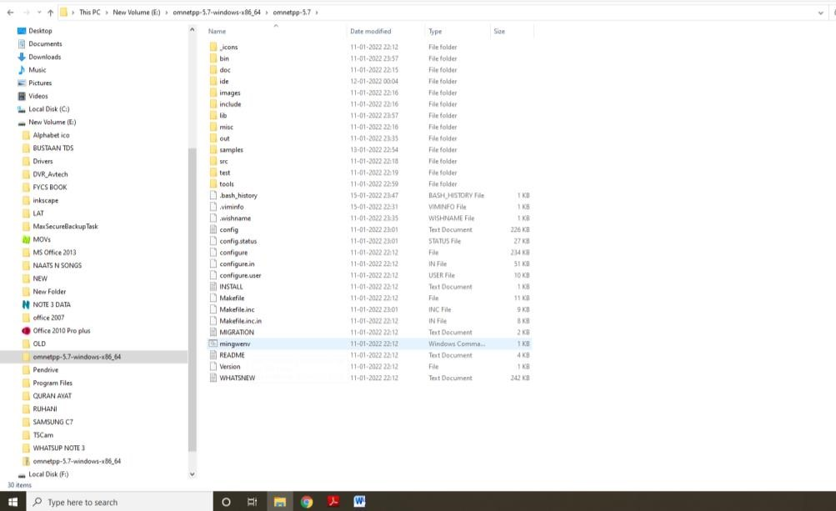

We will get the following $ prompt, type omnetpp and enter

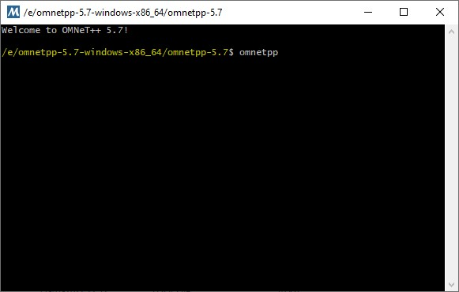

Step 2: The omnetpp simulator in now ready with the following user interface

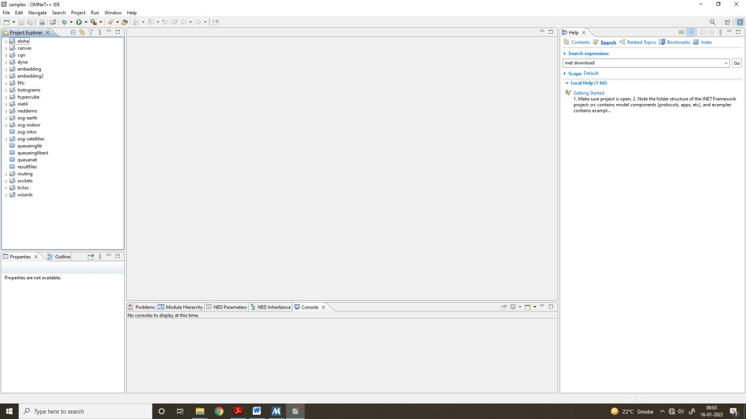

Click on inet folder, then in it click on examples, then on adhoc and then on idealwireless as given

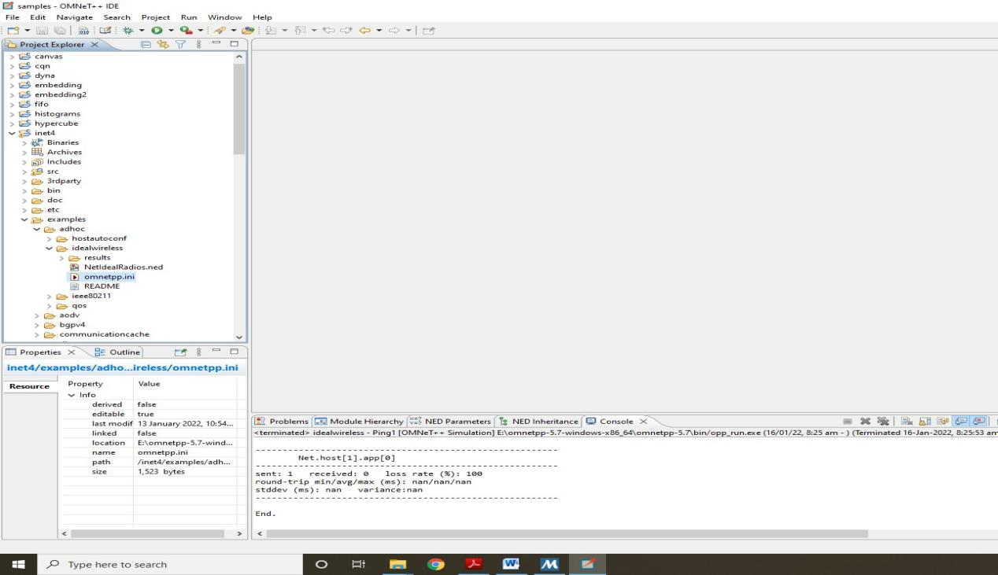

Step 3: In order to load the simulation, double click on two files NetIdealRadios.ned and omnetpp.ini

Step 4: Now we run the simulation

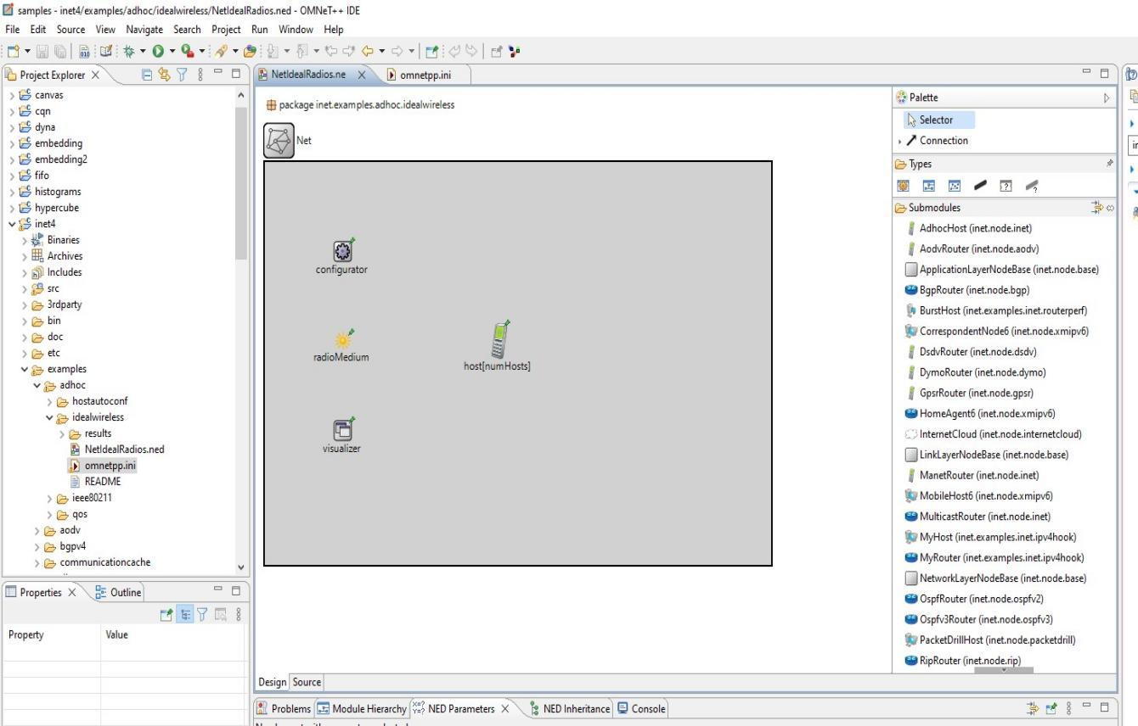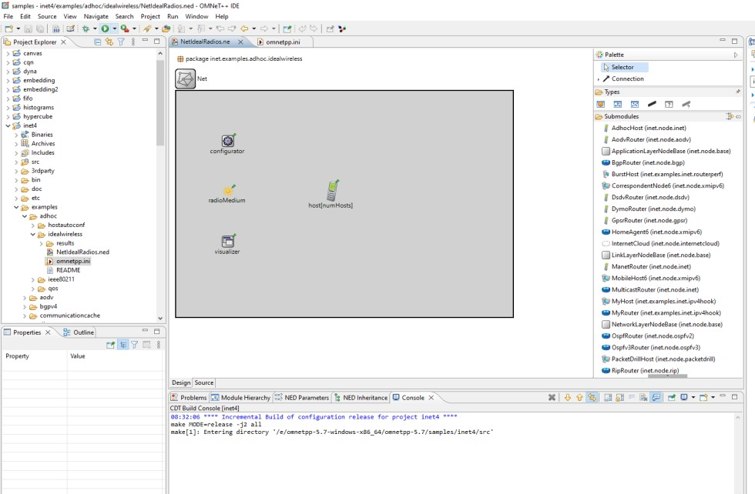

Step 5: After running the simulation we get the following

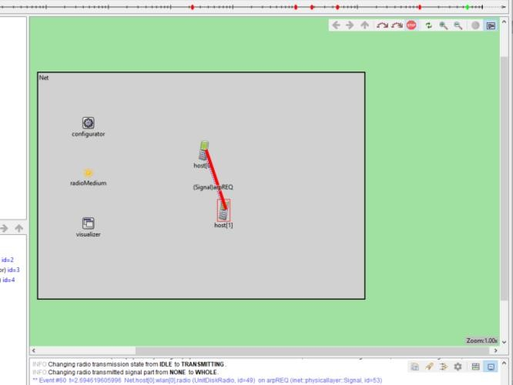

The number of hosts can be increased by the following

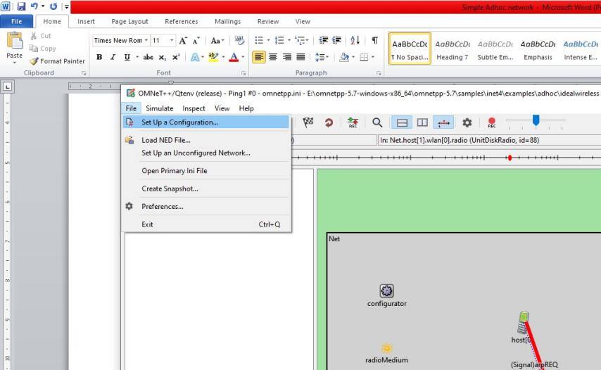

In this we get a dropdown menu, select n host option and enter the required hosts

**Conclusion :-**

**Practical No. 5**

**Reading and Analyzing Routing Table of a network**

Step 1

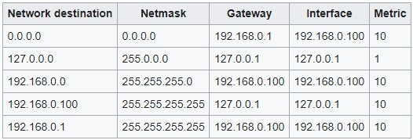

Consider the following topology

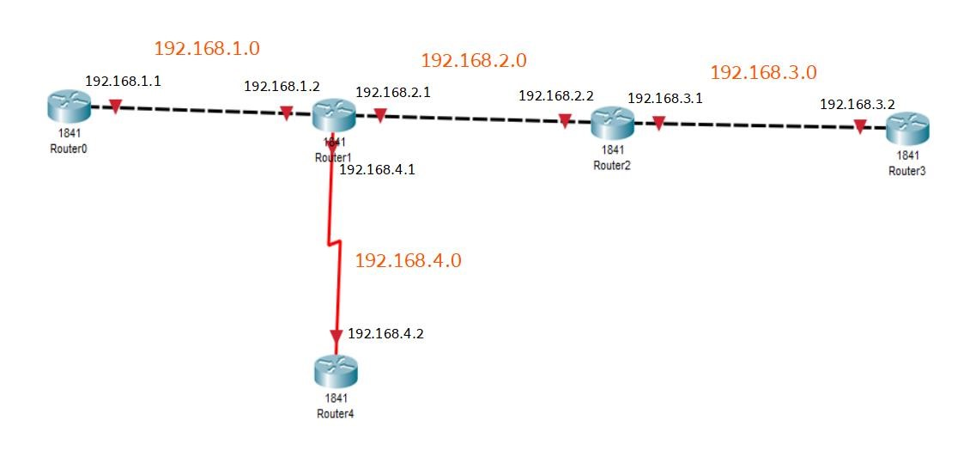

The ip addresses are configured on the given interfaces of the Routers.

The Routing path is also set using RIP.

We get the following Routing information from Router1

C 192.168.1.0/24 is directly connected, FastEthernet0/0

C 192.168.2.0/24 is directly connected, FastEthernet0/1

R 192.168.3.0/24 [120/1] via 192.168.2.2, 00:00:18, FastEthernet0/1

C 192.168.4.0/24 is directly connected, Serial0/1/0

**Conclusion :-**

**Practical No. 6**

**MANET implementation simulation**

Step 1: Open the Omnet++ software and click on inet4 folder

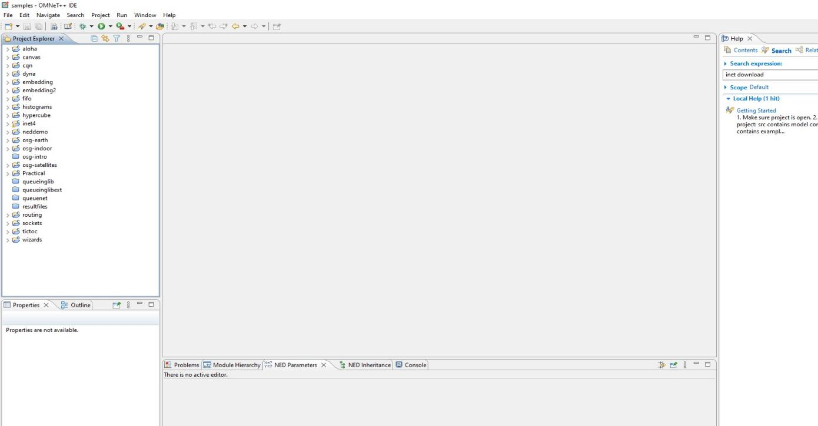

Step 2: Now select the examples folder and then in that folder select manetrouting folder

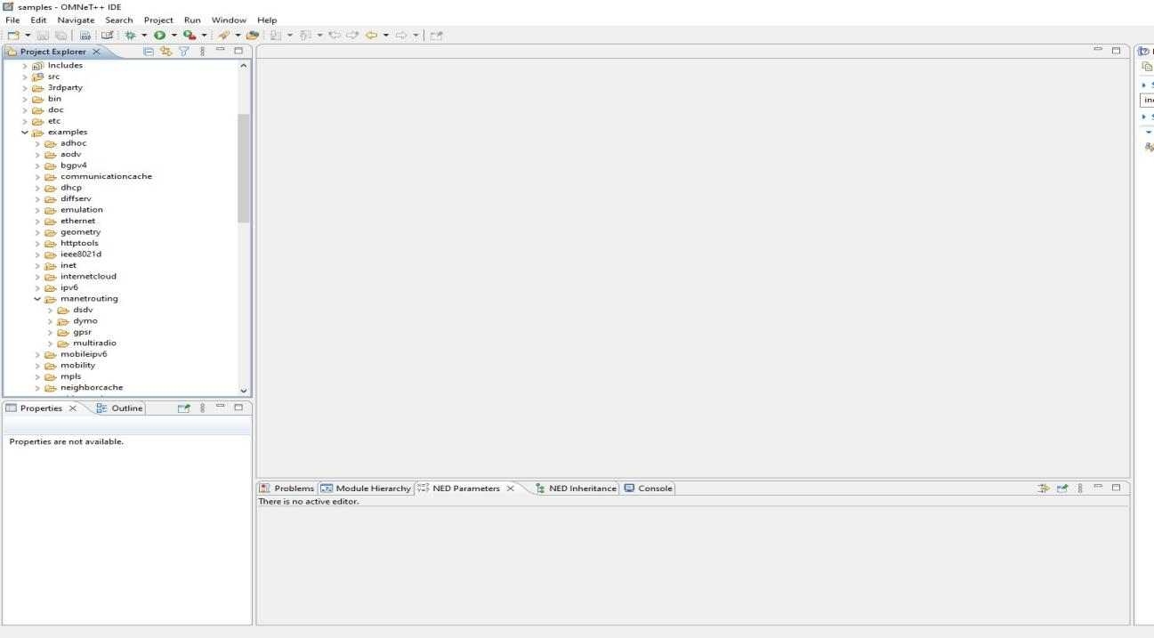

Step 3 : In manetrouting folder click dymo folder and then load the DYMONetwork.ned and omnetpp.ini files by double clicking

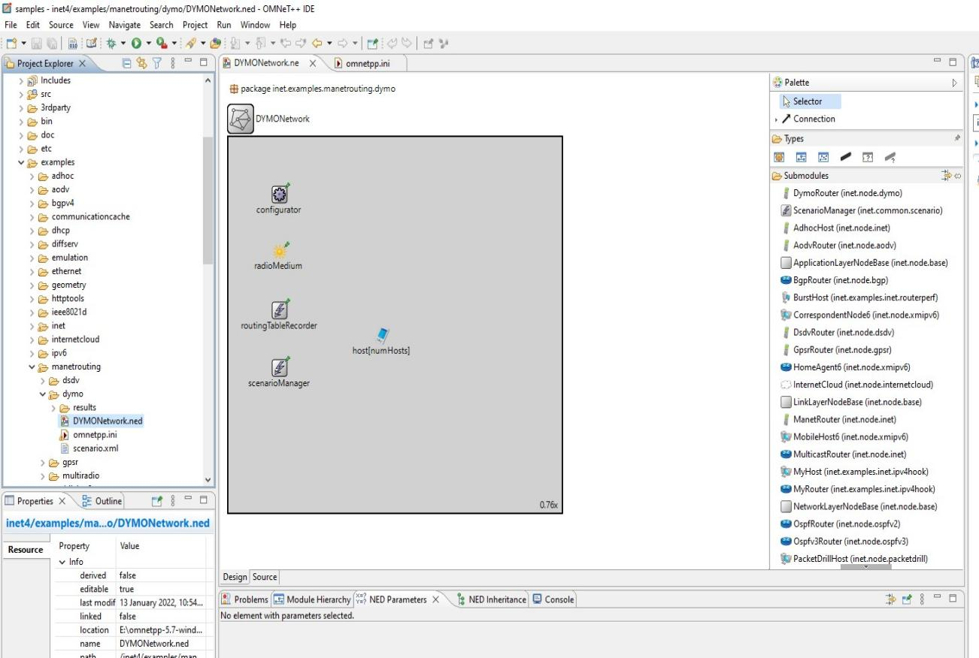

Step 4: Select omnetpp.ini file and click on parameters, we need to add mobility to the nodes

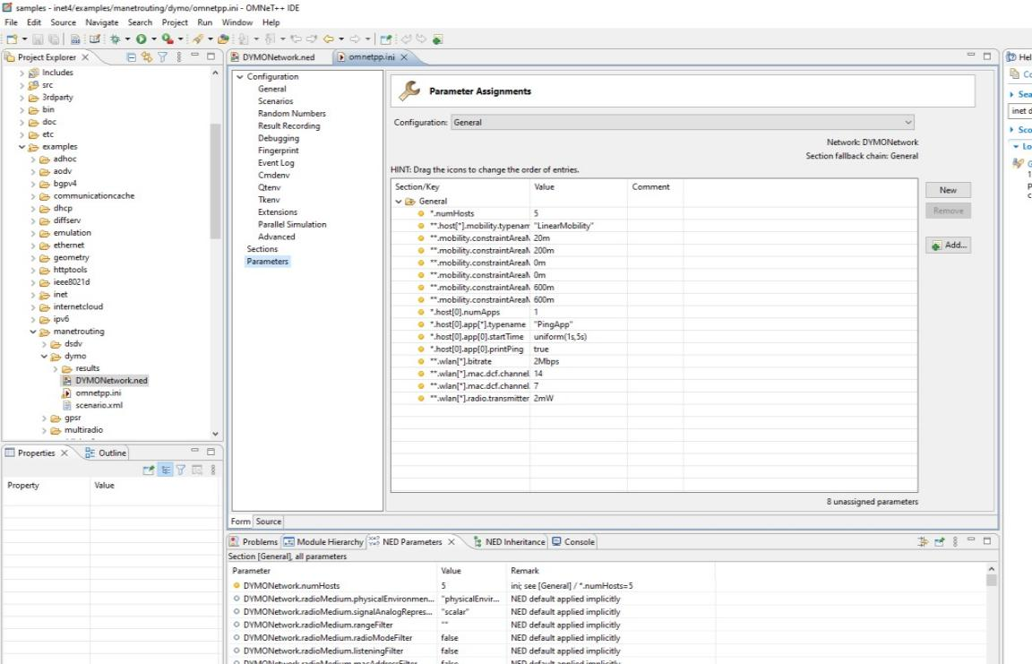

Step 5: For adding a new parameter click on add button and add the parameter **.mobility.speed

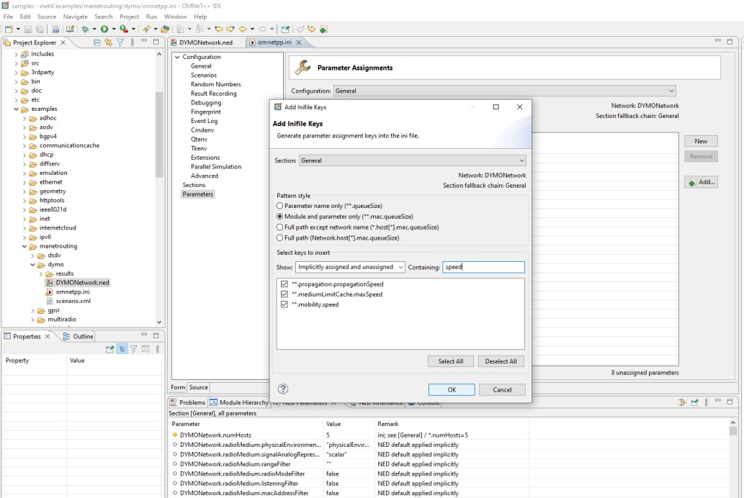

Step 6: Set the value for **.mobility.speed = 400mps

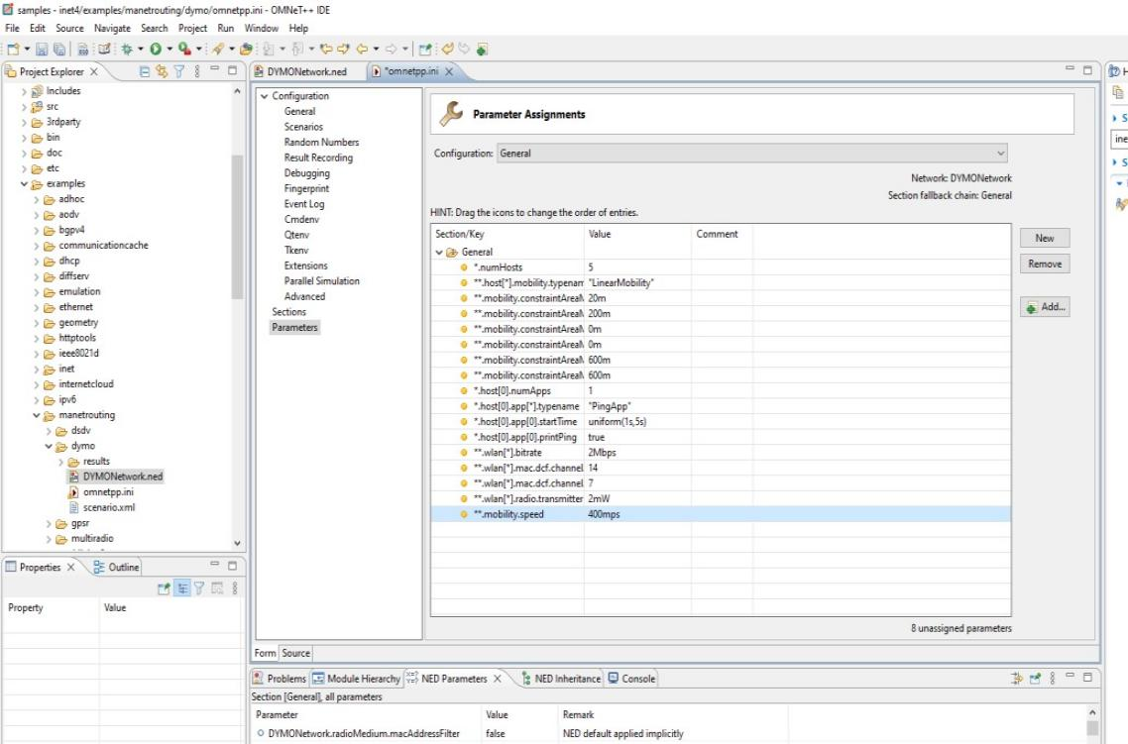

Step 7: Now we run the simulation with 5 mobile hosts forming MANET and get the following output

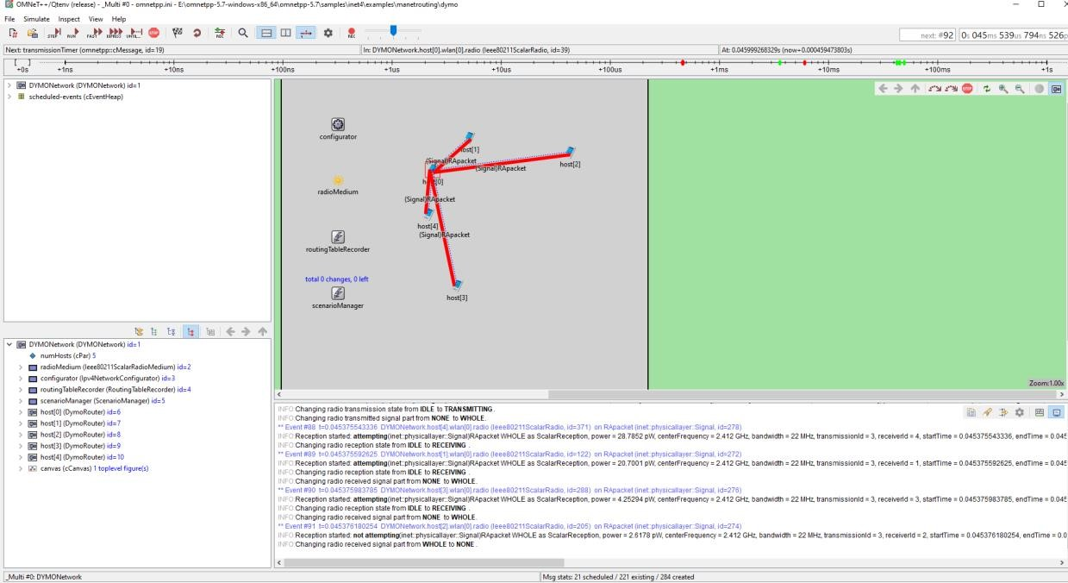

**Conclusion :-**

**Practical No. 7**

**Create MAC protocol simulation implementation for wireless sensor Network.**

Step 1

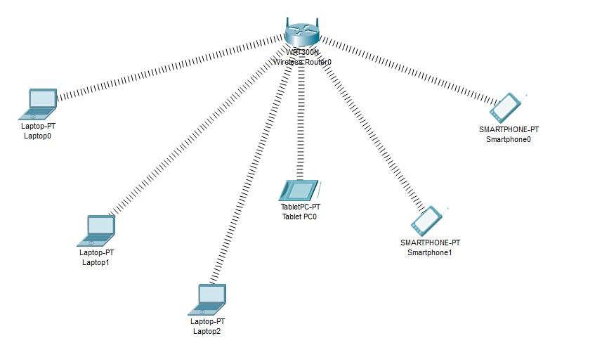

**Smart phones and Tablet have a wireless interface by default, while the laptop does not has a wireless interface, we need to add the interface in all the laptops**

# Adding the wireless interface to each Laptops as follows

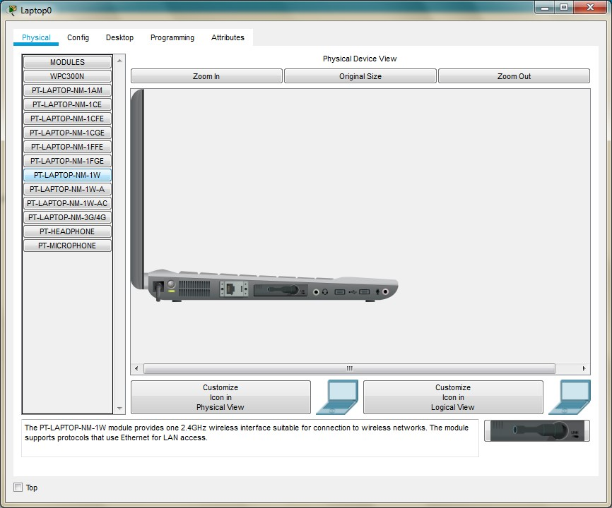

Copy the MAC address of each component as follows

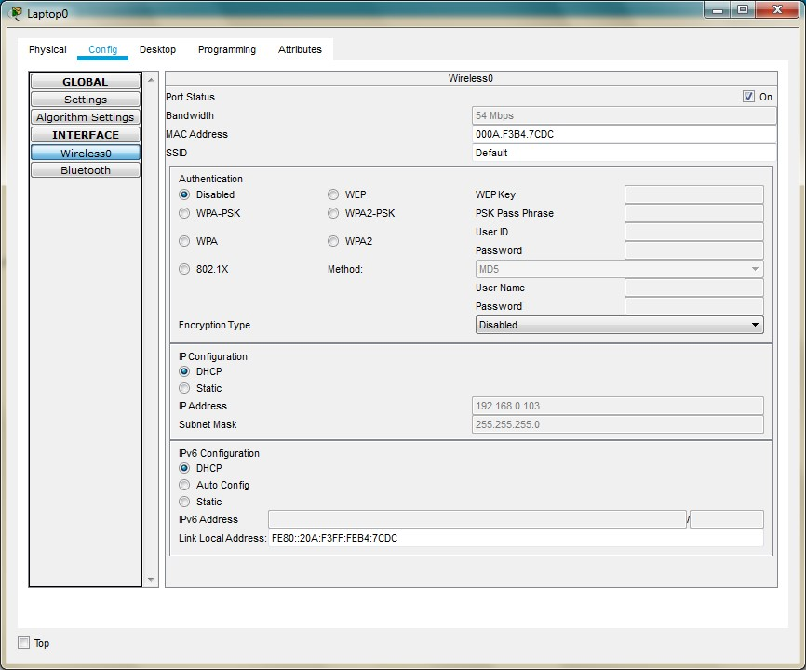

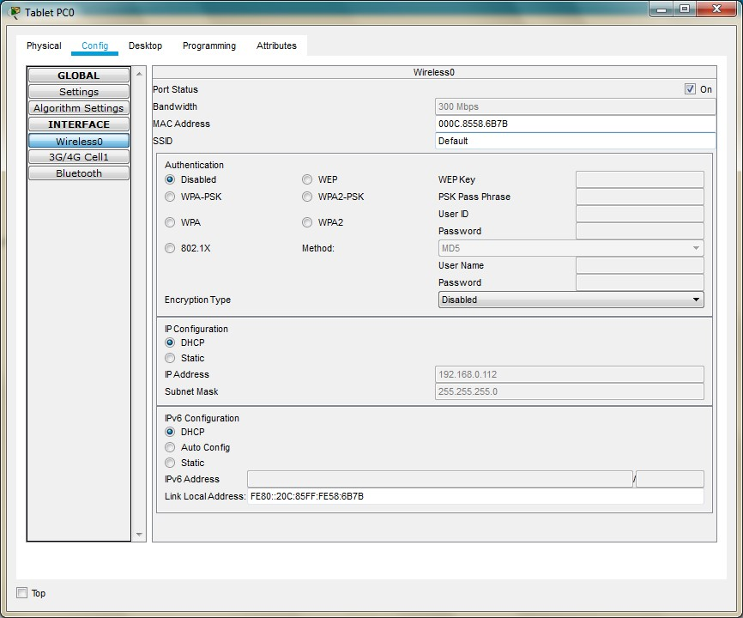

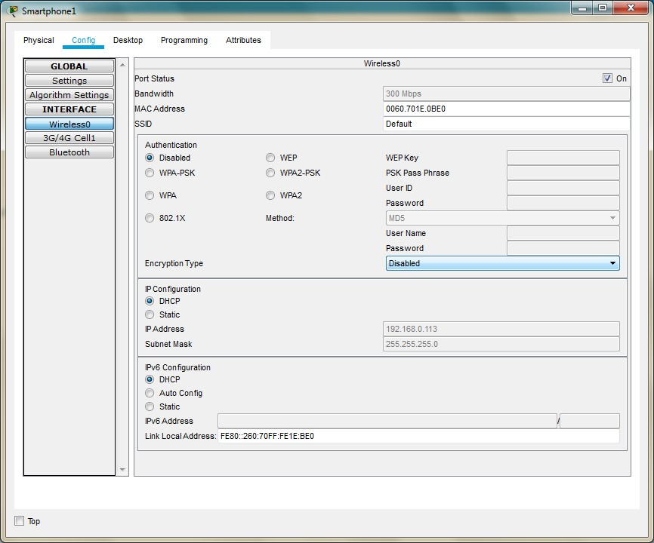

**We note the following MAC addresses and convert them to the following form**

|  |  |  |
| --- | --- | --- |
| **Component** | **MAC Address** | **Converted MAC address** |
| **Laptop0** | **000A.F3B4.7CDC** | **00:0A:F3:B4:7C:DC** |
| **Laptop1** | **0001.4269.6539** | **00:01:42:69:65:39** |
| **Laptop2** | **0060.5CB8.B919** | **00:60:5C:B8:B9:19** |
| **TabletPC** | **000C.8558.6B7B** | **00:0C:85:58:6B:7B** |
| **SmartPhone0** | **00D0.9774.32BD** | **00:D0:97:74:32:BD** |
| **SmartPhone1** | **0060.701E.0BE0** | **00:60:70:1E:0B:E0** |

Now we add few addresses in the wireless MAC filter of the Wireless Router and then use the given options for either allow or deny the Wireless access

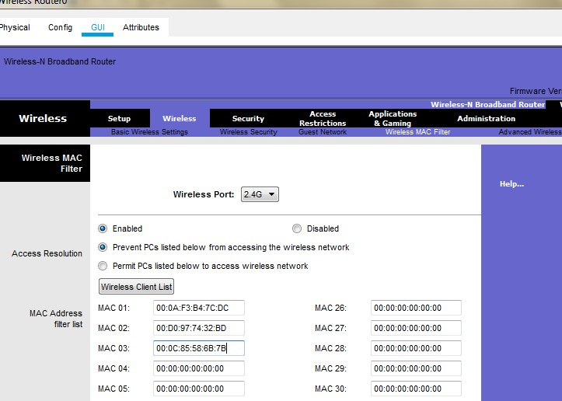

As seen in above screen shot we add the MAC address of Laptop0, TabletPC SmartPhone0 in the list so as to deny them accessing the Wireless network and then save the settings Similarly we can change the setting so that the above devices get wireless connectivity and the remaining devices do not get the wireless connectivity

**Conclusion :-**

**Practical No. 8**

**Simulate Mobile Adhoc Network with Directional**

**Antenna**

We use the following network

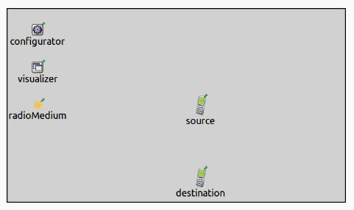

This simulation can be run by using the following steps

1. Start the Omnetpp IDE: (**Open** INET/showcases/directionalantenna)

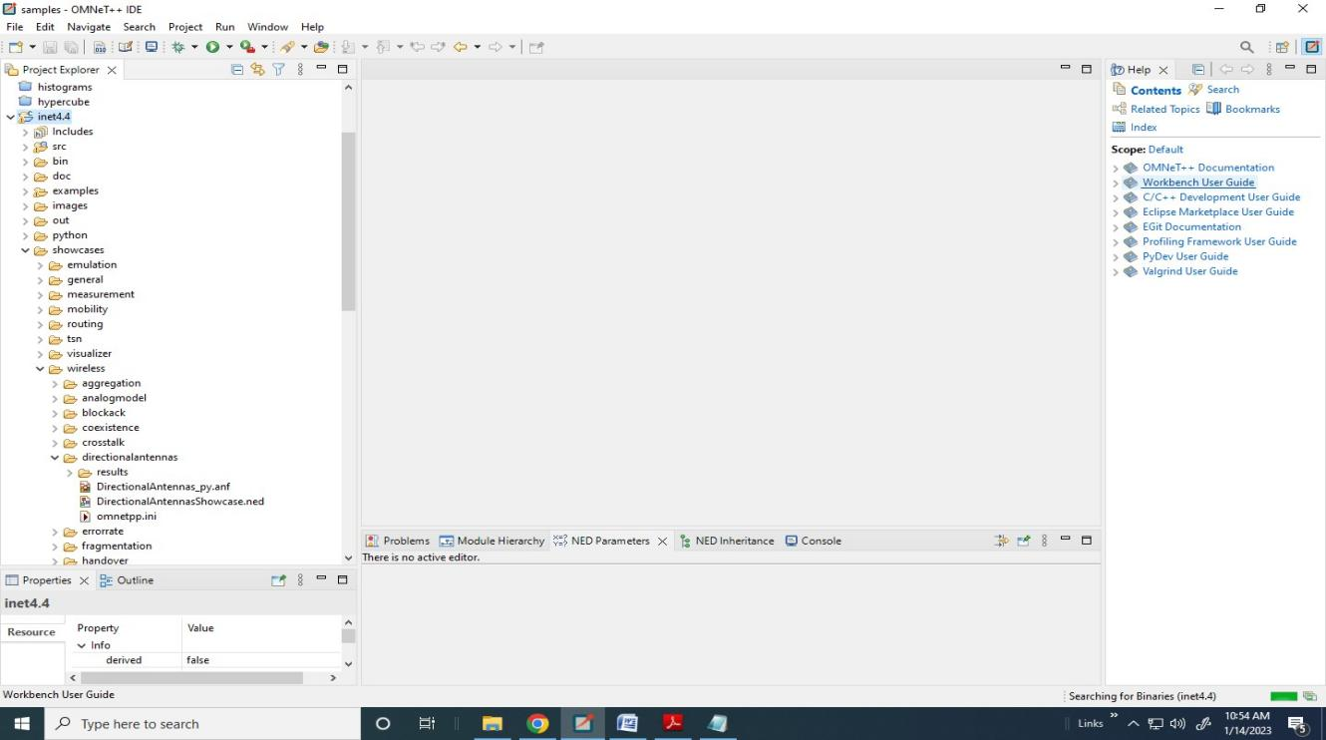

1. Load the files DirectionalAntennaShowcases.ned and omnett.ini

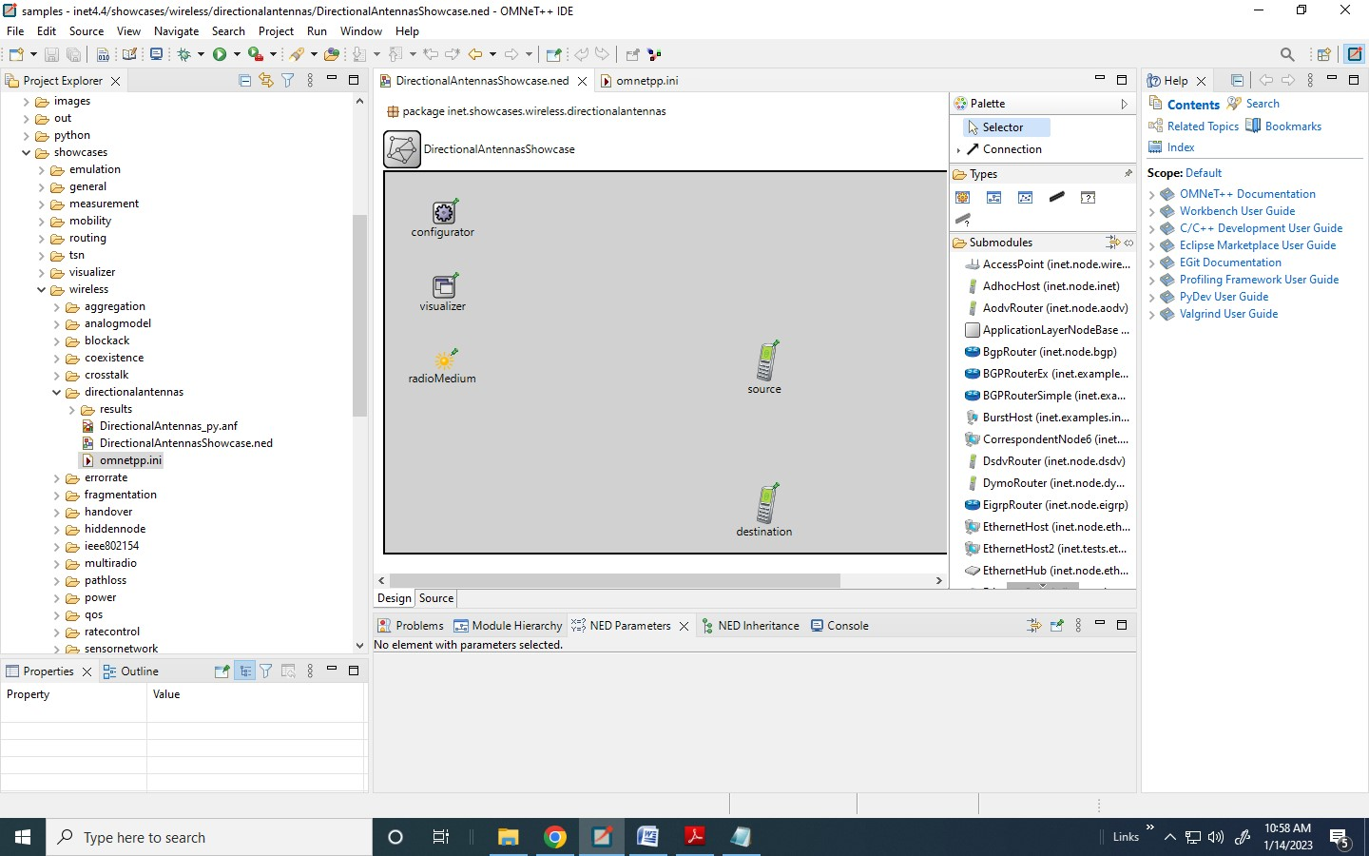

1. **Start the simulation:**

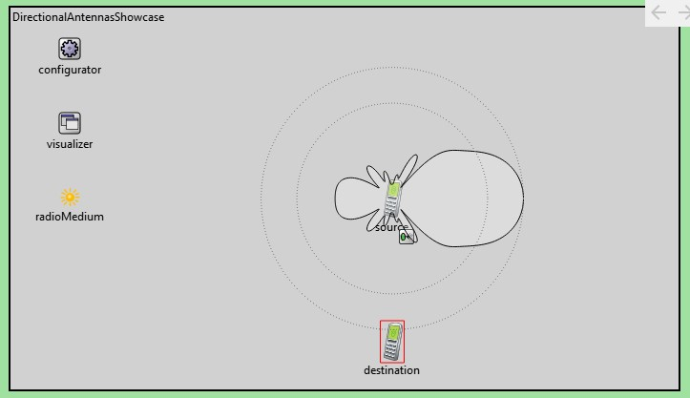

1. **Run the Simulation:**

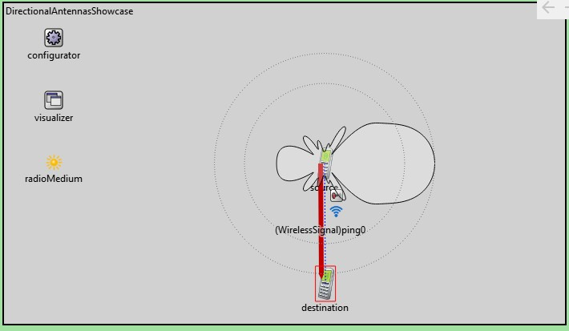

**Conclusion :-**

**Practical No. 9**

**Create a mobile network using Cell Tower, Central Office Server, Web browser and Web Server. Simulate connection between them.**

Consider the following topology

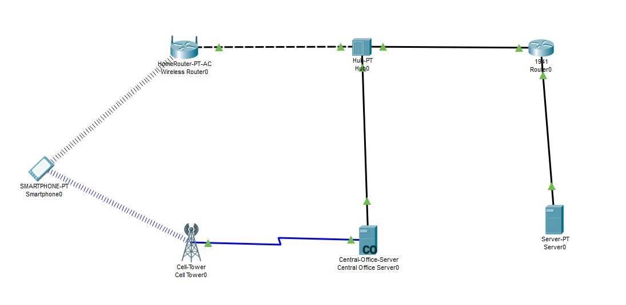

We create the above topology using the Cisco packet tracer

IP address configuration is done for the following devices

1. Router 0:

* 1. Interface: FastEthernet0/0:

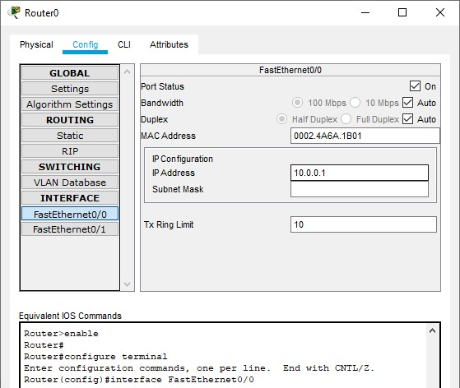

* 1. Interface: FastEthernet0/1:

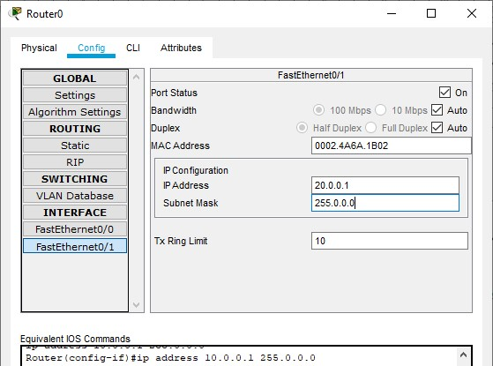

1. Wireless Router:

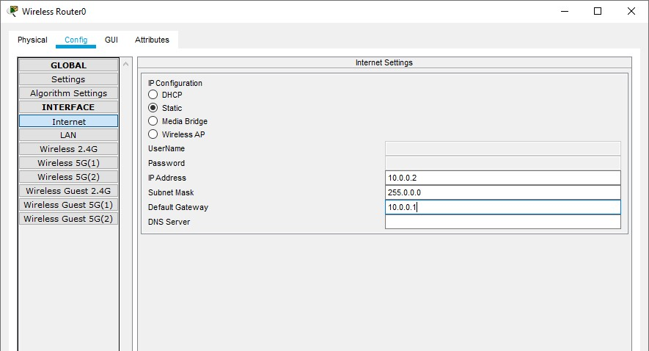

1. Smartphone:

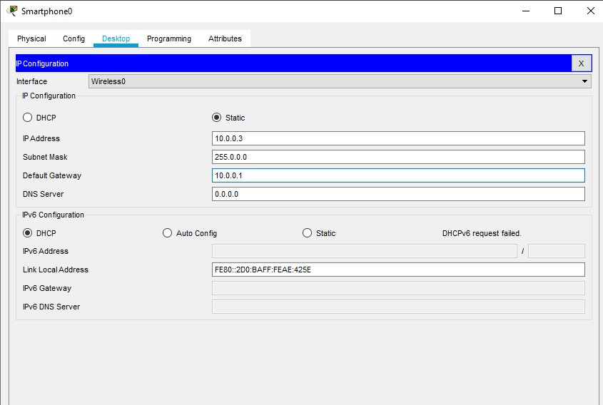

1. Server:

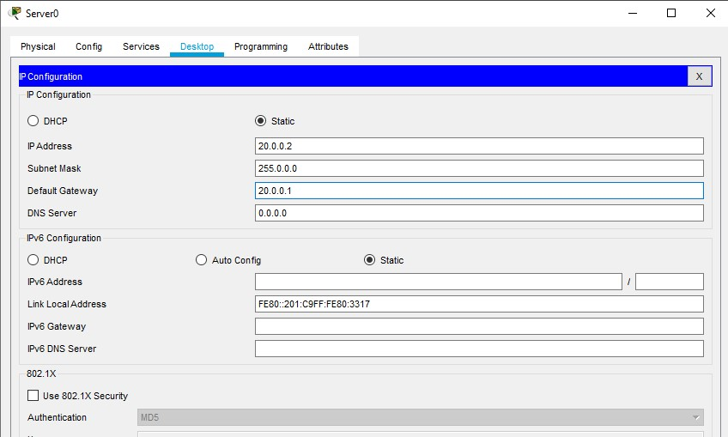

**Conclusion :-**