 | DAWOOD UNIVERSITY OF  ENGINEERING AND TECHNOLOGY
FACULTY OF INFORMATION AND COMPUTING
SCIENCES
DEPARTMENT OF COMPUTER SCIENCE
Instructor Manual
Lab Name: Computer Architecture and Assembly Language (COAL)
Batch: 24F and Onwards
Prepared By: M. Imran Khan
Batch | 24F and Onwards
Date | 14-09-2026
Version | 1.2
Prepared By | M. Imran Khan
Reviewed By

Learning Outcomes and Graduate Attributes
Laboratory Learning Outcomes (LLOs)
- LLO-1: Practice using Assembly language simulator to write and execute programs involving data transfer instructions, arithmetic and logical operations, addressing modes, control flow (branching and loops), stack operations, subroutines, array handling, and basic input/output operations. (Mapped GA: GA-2; Bloom Level: P-3)
- LLO-2: Demonstrate the ability to implement core system components, including an 8-bit ALU, register organization, and data path, hard-wired control logic, memory hierarchy, pipeline execution, and assembly-to-machine code translation using simulation tools. (Mapped GA: GA-4; Bloom Level: P-4)
- LLO-3: Cooperate with peers to develop assembly programs and solve computational problems as part of a team-based project. (Mapped GA: GA-6; Bloom Level: A-2)
Graduate Attributes (Seoul Accord)
The following GA definitions are based on the supplied Graduate Attributes document.
GA-1 - Academic Education: Prepare graduates as computing professionals.
GA-2 - Knowledge for Solving Computing Problems: Apply computing fundamentals, specialization knowledge, mathematics, science, and domain knowledge to abstract and conceptualize computing models from defined problems and requirements.
GA-3 - Problem Analysis: Identify, formulate, research literature, and solve complex computing problems using fundamental principles and reach substantiated conclusions.
GA-4 - Design/Development of Solutions: Design and evaluate solutions for complex computing problems and systems, components, or processes that meet specified needs.
GA-5 - Modern Tool Usage: Create, select, adapt, and apply appropriate techniques, resources, and modern computing tools while understanding their limitations.
GA-6 - Individual and Team Work: Function effectively as an individual and as a member or leader in diverse and multidisciplinary teams.
GA-7 - Communication: Communicate effectively through reports, design documentation, presentations, and clear instructions.
GA-8 - Computing Professionalism and Society: Understand and assess societal, health, safety, legal, and cultural issues and the responsibilities of professional computing practice.
GA-9 - Ethics: Understand and commit to professional ethics, responsibilities, and norms of professional computing practice.
GA-10 - Life-long Learning: Recognize the need and ability to engage in independent learning for continual professional development.
Practical Assessment Distribution
The practical component of this course carries a total of 50 marks, distributed across the semester as follows.
Assessment Component | Weightage | Marks
Sessional | 40% | 20
Practical Test | 30% | 15
Viva | 30% | 15
Total (Practical) | 100% | 50

COMPUTER ARCHITECTURE AND ASSEMBLY LANGUAGE (COAL)
Index / Tentative Plan for Lab Experiments
Lab | Objective (Lab Experiment) | LLO | Mapped GA(s) | Hours | Bloom Level
Lab-1 | Practice installing and configuring TASM for assembly language programming. | LLO-1 | GA-2 | 3 | P-3
Lab-2 | Practice number systems in assembly language. | LLO-1 | GA-2 | 3 | P-3
Lab-3 | Perform binary arithmetic in assembly language. | LLO-1 | GA-2 | 3 | P-3
Lab-4 | Practice control commands using the DEBUG programming utility. | LLO-1 | GA-2 | 3 | P-3
Lab-5 | Assemble, link, and execute an assembly language program using TASM tools. | LLO-1 | GA-2 | 3 | P-3
Lab-6 | Practice and understand how instructions affect flag registers in assembly language. | LLO-1 | GA-2 | 3 | P-3
Lab-7 | Open-Ended Lab-1: count 1s and display Flags register values. | LLO-1 | GA-2 | 3 | P-3
Lab-8 | Execute iterative and conditional statements in assembly language. | LLO-1 | GA-2 | 3 | P-3
Lab-9 | Use integer arithmetic and bit-manipulation instructions. | LLO-1 | GA-2 | 3 | P-3
Lab-10 | Demonstrate arrays, constants, and string handling. | LLO-1 | GA-2 | 3 | P-3
Lab-11 | Execute basic instructions and practice addressing modes. | LLO-1 | GA-2 | 3 | P-3
Lab-12 | Study logic design and HCL in Y86 architecture. | LLO-2 | GA-4 | 3 | P-4
Lab-13 | Practice pipelining and pipelined Y86 implementations. | LLO-2 | GA-4 | 3 | P-4
Lab-14 | Open-Ended Lab-2: logical tests and array reversal. | LLO-1 | GA-2 | 3 | P-3
Lab-15 | Semester Project: apply assembly instructions to solve a computational problem. | LLO-3 | GA-6 | — | A-2
 | Total Contact Hours |  |  | 42

Lab-1: TASM Installation, Configuration, and First Program
Lab | Lab-1 | Mapped LLO(s) | LLO-1
Mapped GA(s) | GA-2 | Contact Hours | 3
Aim
Install or access the TASM toolchain, configure a DOS-compatible working environment, and assemble, link, and execute a first 16-bit assembly language program.
Learning Outcomes
- Identify the roles of an assembler, object-file linker, executable file, and emulator or DOS-compatible environment.
- Create a valid TASM source file and use TASM and TLINK from the command line.
- Run a program and record the generated source, object, and executable files.
Required Tools and Resources
- TASM and TLINK
- DOSBox, FreeDOS, or an equivalent DOS-compatible environment
- Text editor and a folder for laboratory work
Background / Theory
TASM translates symbolic mnemonics into machine-readable object code. TLINK combines the object code with required libraries or startup information to create an executable program. A repeatable folder structure and command-line workflow make errors easier to locate and ensure that the source program can be reproduced.
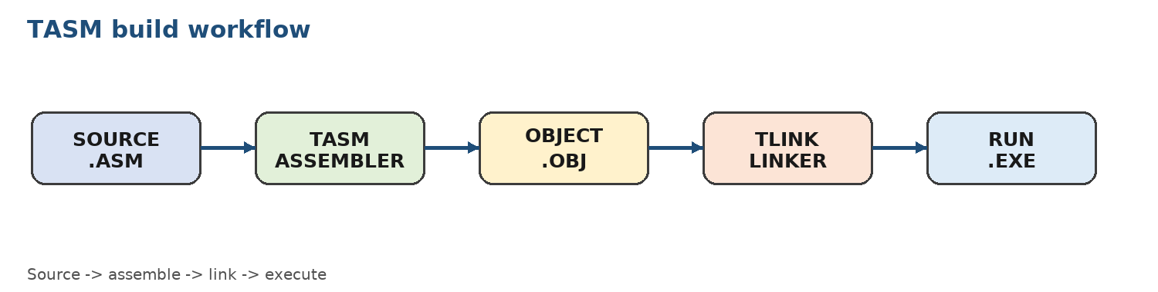

Procedure
- Create a working folder such as COAL\LAB01 and copy the TASM tools or add their location to the DOS-compatible environment path.
- Create FIRST.ASM using the sample program below. Save the file using plain text.
- Assemble with TASM FIRST.ASM. Correct syntax errors before continuing.
- Link the object file with TLINK FIRST. Execute the generated program and record the output.
- Capture the commands used and list the files generated at each stage.
Illustrative Code / Control Logic
.MODEL small
.STACK 100h
.DATA
msg DB 'COAL Lab: TASM is ready.$'
.CODE
main PROC
MOV AX, @DATA
MOV DS, AX
LEA DX, msg
MOV AH, 09h
INT 21h
MOV AX, 4C00h
INT 21h
main ENDP
END main
Expected Observation
The program should display the message and return to the command prompt without an unhandled error. The student record should include the TASM and TLINK command output.
Execution Notes
Record the input, key register or memory values, output, and any error correction made during execution.

Tasks for Submission
Complete all three tasks. Each task is tagged with the LLO it assesses.
1. (LLO-1) Configure a fresh laboratory folder and submit a screenshot or transcript showing the TASM and TLINK commands used.
2. (LLO-1) Modify the program to display the student name and registration number on separate lines.
3. (LLO-1) Introduce one deliberate syntax error, document the assembler message, correct it, and explain the correction.
LLO-Based Assessment Rubric
Assess the mapped LLO for every laboratory. Suggested total: ___ marks.
Criterion | 4 - Excellent | 3 - Good | 2 - Developing | 1 - Beginning
LLO-1: Concepts and tool usage | Explains the concept accurately, selects valid instructions, uses the required tools correctly, and interprets results precisely. | Minor conceptual or tool-use errors; results are mostly accurate and corrected with limited guidance. | Partial understanding with repeated tool or instruction errors; interpretation is incomplete. | Cannot explain the concept or use the required tool without substantial assistance.
LLO-1: Design, implementation, and testing | Design is clear; implementation is correct, well-tested, and documented with meaningful edge cases. | Solution works for normal cases with reasonable structure and some testing evidence. | Solution is incomplete or works only for limited cases; testing and documentation are weak. | No workable solution or evidence of systematic testing.
Laboratory Record
Record the evidence used to award each LLO level.
Evidence / Test Case | Result / Observation | Instructor Initials
1.
2.
3.
Instructor Notes
Apply the LLO-based rubric consistently. Students should submit source code, execution evidence, and a short explanation of the result.

Lab-2: Number Systems in Assembly Language
Lab | Lab-2 | Mapped LLO(s) | LLO-1
Mapped GA(s) | GA-2, GA-3 | Contact Hours | 3
Aim
Convert values among binary, decimal, and hexadecimal representations and relate those representations to registers, memory, and instruction operands.
Learning Outcomes
- Convert unsigned values among binary, decimal, and hexadecimal forms.
- Determine the range and storage requirement of common 8-bit and 16-bit values.
- Use hexadecimal notation to interpret registers and memory dumps.
Required Tools and Resources
- TASM environment
- A calculator or hand-conversion worksheet
- DEBUG utility for viewing memory values
Background / Theory
Assembly language commonly uses hexadecimal because four binary bits map directly to one hexadecimal digit. An 8-bit unsigned value ranges from 00h to FFh, while a 16-bit unsigned value ranges from 0000h to FFFFh. The same bit pattern can represent different signed or unsigned values, so the intended interpretation must be stated.
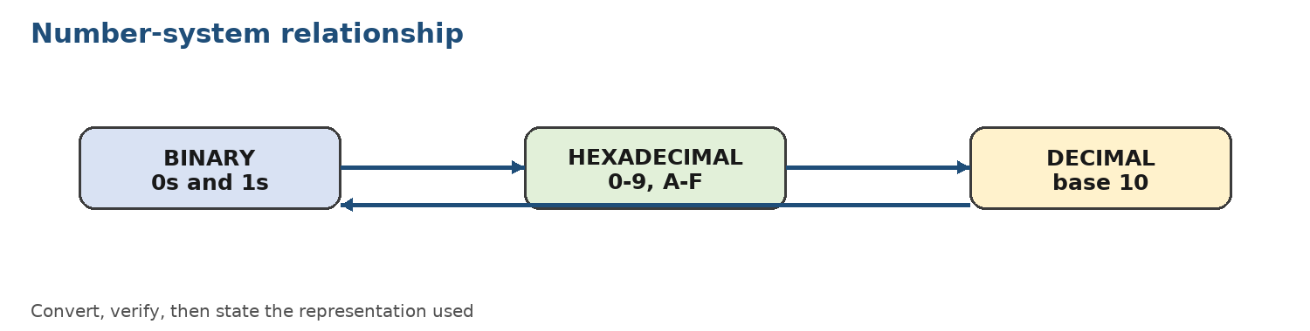

Procedure
- Prepare a conversion table for the values 0, 1, 15, 16, 31, 64, 127, 128, 200, and 255.
- For each value, write its binary and hexadecimal forms, including leading zeroes for an 8-bit representation.
- Use DEBUG or a short TASM program to place selected hexadecimal values in registers or memory.
- Inspect the values and compare the display format with the original worksheet.
- Record any difference between signed and unsigned interpretations.
Illustrative Code / Control Logic
MOV AL, 0FFh ; unsigned 255
MOV BL, 080h ; unsigned 128, signed -128
MOV CX, 1234h ; 16-bit hexadecimal value
MOV DX, 00A5h ; 16-bit value with leading zeroes
Expected Observation
The register values should match the hexadecimal operands. Explain why 80h is 128 when unsigned but -128 when interpreted as an 8-bit signed two's-complement value.
Execution Notes
Record the input, key register or memory values, output, and any error correction made during execution.

Tasks for Submission
Complete all three tasks. Each task is tagged with the LLO it assesses.
1. (LLO-1) Convert 3A7h, 10110101b, and 725d into the other two number systems, showing all working.
2. (LLO-1) Create a TASM program that stores five hexadecimal constants and displays their decimal equivalents.
3. (LLO-1) Explain the signed and unsigned interpretations of F0h, 80h, and 7Fh in an 8-bit register.
LLO-Based Assessment Rubric
Assess the mapped LLO for every laboratory. Suggested total: ___ marks.
Criterion | 4 - Excellent | 3 - Good | 2 - Developing | 1 - Beginning
LLO-1: Concepts and tool usage | Explains the concept accurately, selects valid instructions, uses the required tools correctly, and interprets results precisely. | Minor conceptual or tool-use errors; results are mostly accurate and corrected with limited guidance. | Partial understanding with repeated tool or instruction errors; interpretation is incomplete. | Cannot explain the concept or use the required tool without substantial assistance.
LLO-1: Design, implementation, and testing | Design is clear; implementation is correct, well-tested, and documented with meaningful edge cases. | Solution works for normal cases with reasonable structure and some testing evidence. | Solution is incomplete or works only for limited cases; testing and documentation are weak. | No workable solution or evidence of systematic testing.
Laboratory Record
Record the evidence used to award each LLO level.
Evidence / Test Case | Result / Observation | Instructor Initials
1.
2.
3.
Instructor Notes
Apply the LLO-based rubric consistently. Students should submit source code, execution evidence, and a short explanation of the result.

Lab-3: Binary Arithmetic in Assembly Language
Lab | Lab-3 | Mapped LLO(s) | LLO-1
Mapped GA(s) | GA-2 | Contact Hours | 3
Aim
Implement binary addition and subtraction and observe carry, borrow, and result behavior in 8-bit and 16-bit registers.
Learning Outcomes
- Use ADD, ADC, SUB, and SBB for multi-byte arithmetic.
- Differentiate carry and borrow from signed overflow.
- Verify arithmetic results using binary and hexadecimal representations.
Required Tools and Resources
- TASM and TLINK
- DEBUG or register inspection
- Worksheet for expected results and flags
Background / Theory
The processor performs arithmetic on bit patterns. ADD adds two operands and updates status flags; ADC adds an additional carry bit, making it useful for multi-byte values. SUB and SBB perform subtraction with borrow. Carry Flag is primarily relevant to unsigned arithmetic, while Overflow Flag indicates a signed-result range problem.
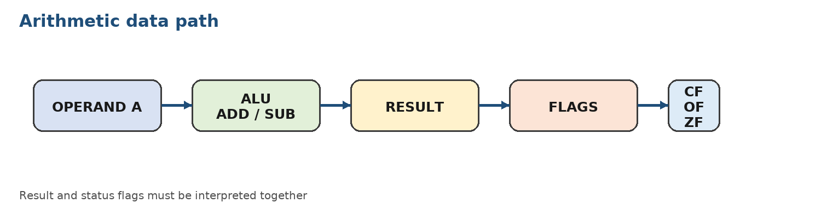

Procedure
- Calculate expected results by hand before writing the program.
- Use AL for 8-bit addition and AX for 16-bit addition.
- For a multi-byte addition, add the low bytes first and use ADC for the high bytes.
- Repeat with subtraction using SUB and SBB.
- Inspect the result and relevant flags after each operation.
Illustrative Code / Control Logic
MOV AL, 0F0h
ADD AL, 025h ; result wraps in 8 bits

MOV AX, 1234h
ADD AX, 0102h

MOV AL, 05h
SUB AL, 09h ; unsigned borrow example
Expected Observation
Record the final register values and the state of CF, OF, SF, ZF, and AF where applicable. State whether each result is valid as unsigned, signed, or both.
Execution Notes
Record the input, key register or memory values, output, and any error correction made during execution.

Tasks for Submission
Complete all three tasks. Each task is tagged with the LLO it assesses.
1. (LLO-1) Write a program that adds two 16-bit values represented as high and low bytes using ADD and ADC.
2. (LLO-1) Write a program that subtracts a 16-bit subtrahend from a 16-bit minuend using SUB and SBB.
3. (LLO-1) Test four operand pairs and classify each result as a carry, borrow, signed overflow, or no exceptional condition.
LLO-Based Assessment Rubric
Assess the mapped LLO for every laboratory. Suggested total: ___ marks.
Criterion | 4 - Excellent | 3 - Good | 2 - Developing | 1 - Beginning
LLO-1: Concepts and tool usage | Explains the concept accurately, selects valid instructions, uses the required tools correctly, and interprets results precisely. | Minor conceptual or tool-use errors; results are mostly accurate and corrected with limited guidance. | Partial understanding with repeated tool or instruction errors; interpretation is incomplete. | Cannot explain the concept or use the required tool without substantial assistance.
LLO-1: Design, implementation, and testing | Design is clear; implementation is correct, well-tested, and documented with meaningful edge cases. | Solution works for normal cases with reasonable structure and some testing evidence. | Solution is incomplete or works only for limited cases; testing and documentation are weak. | No workable solution or evidence of systematic testing.
Laboratory Record
Record the evidence used to award each LLO level.
Evidence / Test Case | Result / Observation | Instructor Initials
1.
2.
3.
Instructor Notes
Apply the LLO-based rubric consistently. Students should submit source code, execution evidence, and a short explanation of the result.

Lab-4: DEBUG Programming Utility and Control Commands
Lab | Lab-4 | Mapped LLO(s) | LLO-1
Mapped GA(s) | GA-2 | Contact Hours | 3
Aim
Use the DEBUG utility to enter, inspect, trace, and execute small machine-code sequences while observing registers and memory.
Learning Outcomes
- Use DEBUG commands for assembling, displaying, tracing, dumping, and executing code.
- Inspect register and flag changes after individual instructions.
- Relate machine-code bytes and disassembled instructions to assembly mnemonics.
Required Tools and Resources
- DEBUG in a DOS-compatible environment
- TASM for comparison
- A command log sheet
Background / Theory
DEBUG is a low-level utility that exposes registers, memory, and instruction execution. Common commands include A (assemble), R (registers), D (dump), U (unassemble), T (trace), G (go), and Q (quit). Single-step tracing is valuable for checking the effect of one instruction at a time.
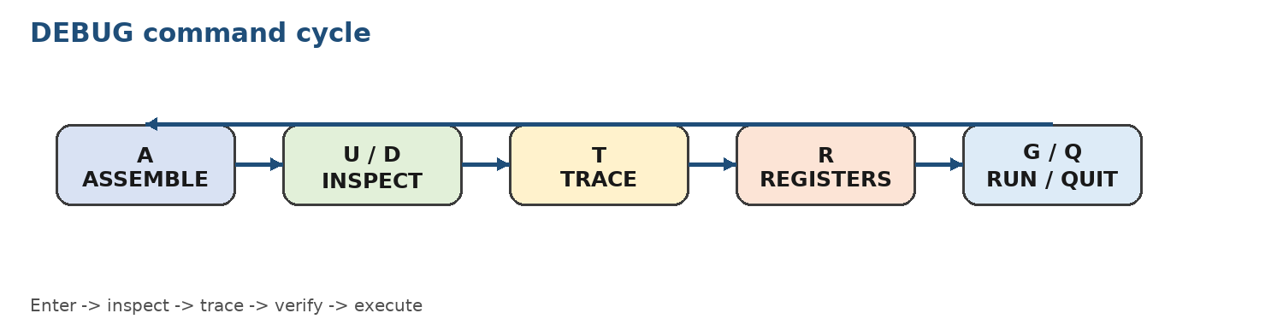

Procedure
- Start DEBUG and use R to display the initial register values.
- Use A to enter a short sequence that loads values into registers and adds them.
- Use U to inspect the entered bytes as instructions.
- Use T after each instruction and record the changed registers and flags.
- Use D to inspect a selected memory range, then exit with Q.
- Repeat the same logic in TASM and compare the results.
Illustrative Code / Control Logic
-a 100
xxxx:0100 mov ax,1234
xxxx:0103 mov bx,0002
xxxx:0106 add ax,bx
xxxx:0108
-t
-r
-u 100
-q
Expected Observation
The register trace should show AX changing from 1234h to 1236h. The exact segment values may differ between environments; record the values observed in your session.
Execution Notes
Record the input, key register or memory values, output, and any error correction made during execution.

Tasks for Submission
Complete all three tasks. Each task is tagged with the LLO it assesses.
1. (LLO-1) Use DEBUG to enter and trace a program that subtracts two values and record every register change.
2. (LLO-1) Use DEBUG D and U commands to show a memory dump and disassembly, then annotate both outputs.
3. (LLO-1) Compare the DEBUG trace with the TASM execution of the same algorithm and report two similarities and two differences.
LLO-Based Assessment Rubric
Assess the mapped LLO for every laboratory. Suggested total: ___marks.
Criterion | 4 - Excellent | 3 - Good | 2 - Developing | 1 - Beginning
LLO-1: Concepts and tool usage | Explains the concept accurately, selects valid instructions, uses the required tools correctly, and interprets results precisely. | Minor conceptual or tool-use errors; results are mostly accurate and corrected with limited guidance. | Partial understanding with repeated tool or instruction errors; interpretation is incomplete. | Cannot explain the concept or use the required tool without substantial assistance.
LLO-1: Design, implementation, and testing | Design is clear; implementation is correct, well-tested, and documented with meaningful edge cases. | Solution works for normal cases with reasonable structure and some testing evidence. | Solution is incomplete or works only for limited cases; testing and documentation are weak. | No workable solution or evidence of systematic testing.
Laboratory Record
Record the evidence used to award each LLO level.
Evidence / Test Case | Result / Observation | Instructor Initials
1.
2.
3.
Instructor Notes
Apply the LLO-based rubric consistently. Students should submit source code, execution evidence, and a short explanation of the result.

Lab-5: Assembling, Linking, and Executing a TASM Program
Lab | Lab-5 | Mapped LLO(s) | LLO-1
Mapped GA(s) | GA-2 | Contact Hours | 3
Aim
Develop a complete TASM source program, generate an object file, link it, execute it, and troubleshoot common build errors.
Learning Outcomes
- Organize a source file into data, stack, and code segments.
- Use the TASM and TLINK stages in the correct order.
- Diagnose errors caused by labels, operands, segment setup, and missing entry points.
Required Tools and Resources
- TASM and TLINK
- DOS-compatible command environment
- Text editor
Background / Theory
A source file contains declarations, labels, instructions, and directives. The assembler validates syntax and produces an object file. The linker resolves references and creates an executable. Segment initialization is essential before accessing variables in the data segment.
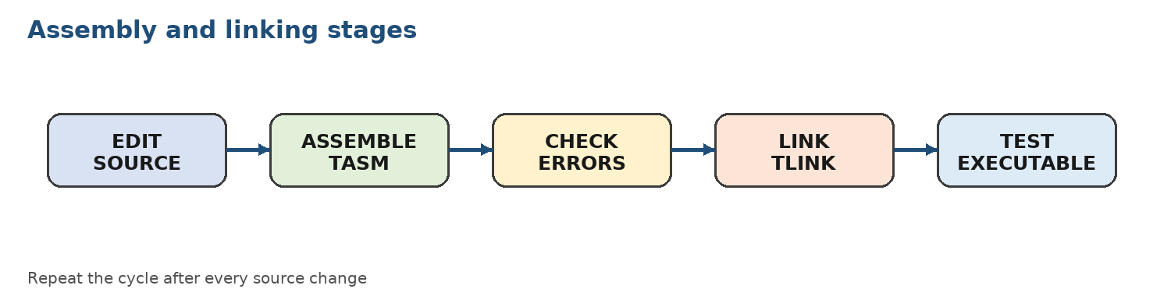

Procedure
- Create SUM.ASM with two byte variables and a result variable.
- Initialize DS from the address of the data segment.
- Load the operands, add them, and store the result.
- Assemble, link, and run the program.
- Use a debugger or an output routine to verify the result.
- Change one operand and rebuild to confirm that the executable reflects the new source.
Illustrative Code / Control Logic
.MODEL small
.STACK 100h
.DATA
first DB 27
second DB 15
result DB ?
.CODE
main PROC
MOV AX, @DATA
MOV DS, AX
MOV AL, first
ADD AL, second
MOV result, AL
MOV AX, 4C00h
INT 21h
main ENDP
END main
Expected Observation
The object and executable files should be regenerated after every source change. The result variable should contain 42 decimal for the given operands.
Execution Notes
Record the input, key register or memory values, output, and any error correction made during execution.

Tasks for Submission
Complete all three tasks. Each task is tagged with the LLO it assesses.
1. (LLO-1) Create a program that subtracts two byte variables and stores the absolute difference.
2. (LLO-1) Add a third operand and use a 16-bit result so that values greater than 255 can be represented.
3. (LLO-1) Submit a build log containing one successful build and one corrected build error, with the cause and fix.
LLO-Based Assessment Rubric
Assess the mapped LLO for every laboratory. Suggested total: ___ marks.
Criterion | 4 - Excellent | 3 - Good | 2 - Developing | 1 - Beginning
LLO-1: Concepts and tool usage | Explains the concept accurately, selects valid instructions, uses the required tools correctly, and interprets results precisely. | Minor conceptual or tool-use errors; results are mostly accurate and corrected with limited guidance. | Partial understanding with repeated tool or instruction errors; interpretation is incomplete. | Cannot explain the concept or use the required tool without substantial assistance.
LLO-1: Design, implementation, and testing | Design is clear; implementation is correct, well-tested, and documented with meaningful edge cases. | Solution works for normal cases with reasonable structure and some testing evidence. | Solution is incomplete or works only for limited cases; testing and documentation are weak. | No workable solution or evidence of systematic testing.
Laboratory Record
Record the evidence used to award each LLO level.
Evidence / Test Case | Result / Observation | Instructor Initials
1.
2.
3.
Instructor Notes
Apply the LLO-based rubric consistently. Students should submit source code, execution evidence, and a short explanation of the result.

Lab-6: Instruction Effects on Flag Registers
Lab | Lab-6 | Mapped LLO(s) | LLO-1
Mapped GA(s) | GA-2 | Contact Hours | 3
Aim
Analyze how arithmetic, logical, shift, and compare instructions affect the processor status flags.
Learning Outcomes
- Explain the purpose of CF, PF, AF, ZF, SF, and OF.
- Predict flag values before executing selected instructions.
- Use PUSHF and POP to capture the Flags register for analysis.
Required Tools and Resources
- TASM and TLINK
- A flag worksheet
- Optional DEBUG tracing
Background / Theory
Flags summarize properties of an operation. ZF indicates a zero result, SF copies the most significant result bit, CF records an unsigned carry or borrow, and OF identifies signed overflow. Logical instructions generally clear CF and OF, while shifts move bits through CF.
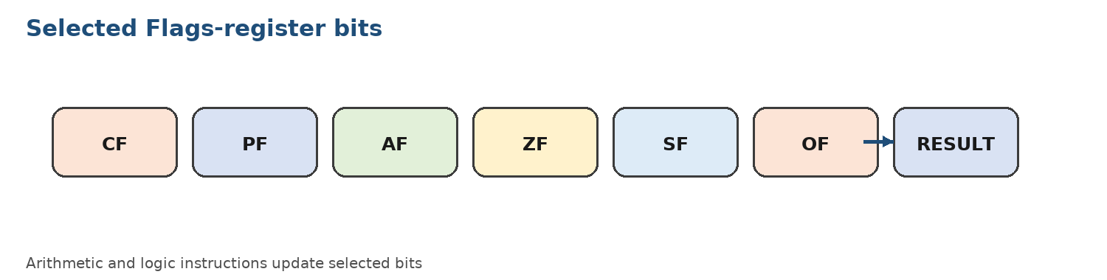

Procedure
- Predict the flags for ADD, SUB, INC, DEC, AND, OR, XOR, CMP, and shifts.
- Execute each operation in a separate test section so that the result can be isolated.
- Use PUSHF followed by POP AX to copy the flags word into AX.
- Record the result and decode the relevant flag bits.
- Compare predicted and observed values and explain every mismatch.
Illustrative Code / Control Logic
MOV AL, 7Fh
ADD AL, 01h
PUSHF
POP BX ; BX contains the Flags word

MOV AL, 00h
SUB AL, 01h
PUSHF
POP CX
Expected Observation
For 7Fh + 1, the 8-bit result is 80h and signed overflow is expected. For 00h - 1, the result is FFh and unsigned borrow is expected.
Execution Notes
Record the input, key register or memory values, output, and any error correction made during execution.

Tasks for Submission
Complete all three tasks. Each task is tagged with the LLO it assesses.
1. (LLO-1) Build a flag-testing program for ADD, SUB, AND, OR, and XOR and present the result in a table.
2. (LLO-1) Find two operand pairs where CF is set but OF is clear, and two where OF is set but CF is clear.
3. (LLO-1) Use CMP to compare three pairs of values and explain the flags without changing the operands.
LLO-Based Assessment Rubric
Assess the mapped LLO for every laboratory. Suggested total: ___ marks.
Criterion | 4 - Excellent | 3 - Good | 2 - Developing | 1 - Beginning
LLO-1: Concepts and tool usage | Explains the concept accurately, selects valid instructions, uses the required tools correctly, and interprets results precisely. | Minor conceptual or tool-use errors; results are mostly accurate and corrected with limited guidance. | Partial understanding with repeated tool or instruction errors; interpretation is incomplete. | Cannot explain the concept or use the required tool without substantial assistance.
LLO-1: Design, implementation, and testing | Design is clear; implementation is correct, well-tested, and documented with meaningful edge cases. | Solution works for normal cases with reasonable structure and some testing evidence. | Solution is incomplete or works only for limited cases; testing and documentation are weak. | No workable solution or evidence of systematic testing.
Laboratory Record
Record the evidence used to award each LLO level.
Evidence / Test Case | Result / Observation | Instructor Initials
1.
2.
3.
Instructor Notes
Apply the LLO-based rubric consistently. Students should submit source code, execution evidence, and a short explanation of the result.

Lab-7: Open-Ended Lab-1: Bit Counting and Flags Display
Lab | Lab-7 | Mapped LLO(s) | LLO-1
Mapped GA(s) | GA-2 | Contact Hours | 3
Aim
Design and implement small assembly programs that use bit-level reasoning, loops, and flag inspection to solve open-ended problems.
Learning Outcomes
- Decompose an open-ended problem into initialization, iteration, test, and output stages.
- Use shifts or masking to inspect individual bits.
- Present test cases, evidence, and a short explanation of the chosen algorithm.
Required Tools and Resources
- TASM and TLINK
- DOS-compatible environment
- A flowchart or pseudocode editor
Background / Theory
An 8-bit population count can be implemented by repeatedly shifting the input and testing the bit shifted into CF, or by masking one bit at a time. Flag display requires saving the Flags register and converting selected bits into readable characters. Both problems emphasize algorithm design rather than a single prescribed code sequence.
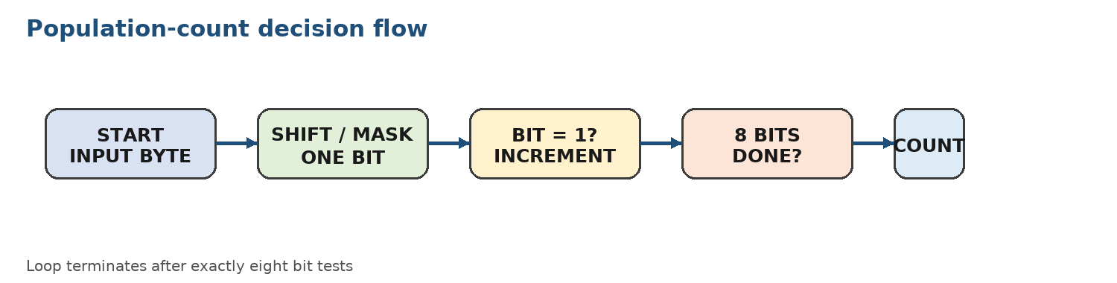

Procedure
- Write pseudocode and a flowchart before coding.
- Choose a test input and show the expected count or flag pattern.
- Implement the program in TASM using a loop and a clearly named counter.
- Test normal, boundary, and repeated-bit inputs.
- Submit source code, output evidence, and a brief complexity explanation.
Illustrative Code / Control Logic
MOV AL, 0B5h ; sample input
MOV CX, 8
XOR BL, BL
COUNT_BIT:
SHR AL, 1
ADC BL, 0 ; add CF to BL
LOOP COUNT_BIT
; BL contains the number of 1 bits
Expected Observation
For the sample input B5h (10110101b), the population count is five. If an alternative algorithm is used, the output must still match the test cases.
Execution Notes
Record the input, key register or memory values, output, and any error correction made during execution.

Tasks for Submission
Complete all three tasks. Each task is tagged with the LLO it assesses.
1. (LLO-1) Write and test an assembly program to count the number of 1s in an 8-bit input.
2. (LLO-1) Write a program that displays the values of CF, ZF, SF, and OF after a user-selected instruction.
3. (LLO-1) Propose one additional bit-manipulation problem, implement it, and justify the selected algorithm with three test cases.
LLO-Based Assessment Rubric
Assess the mapped LLO for every laboratory. Suggested total:___marks.
Criterion | 4 - Excellent | 3 - Good | 2 - Developing | 1 - Beginning
LLO-1: Concepts and tool usage | Explains the concept accurately, selects valid instructions, uses the required tools correctly, and interprets results precisely. | Minor conceptual or tool-use errors; results are mostly accurate and corrected with limited guidance. | Partial understanding with repeated tool or instruction errors; interpretation is incomplete. | Cannot explain the concept or use the required tool without substantial assistance.
LLO-1: Design, implementation, and testing | Design is clear; implementation is correct, well-tested, and documented with meaningful edge cases. | Solution works for normal cases with reasonable structure and some testing evidence. | Solution is incomplete or works only for limited cases; testing and documentation are weak. | No workable solution or evidence of systematic testing.
Laboratory Record
Record the evidence used to award each LLO level.
Evidence / Test Case | Result / Observation | Instructor Initials
1.
2.
3.
Instructor Notes
Apply the LLO-based rubric consistently. Students should submit source code, execution evidence, and a short explanation of the result.

Lab-8: Iterative and Conditional Statements
Lab | Lab-8 | Mapped LLO(s) | LLO-1
Mapped GA(s) | GA-2 | Contact Hours | 3
Aim
Use comparisons, conditional jumps, and loops to implement structured decision-making and iteration in assembly language.
Learning Outcomes
- Translate if/else logic into CMP and conditional jump instructions.
- Use LOOP or a counter-controlled jump safely.
- Test branches using values that exercise every path.
Required Tools and Resources
- TASM and TLINK
- Flowchart or pseudocode
- Test-case worksheet
Background / Theory
Assembly has no built-in if, while, or for statement. CMP updates flags as if a subtraction had occurred, and conditional jumps inspect those flags. A loop needs a clear initialization, termination condition, and progress update to avoid infinite execution.
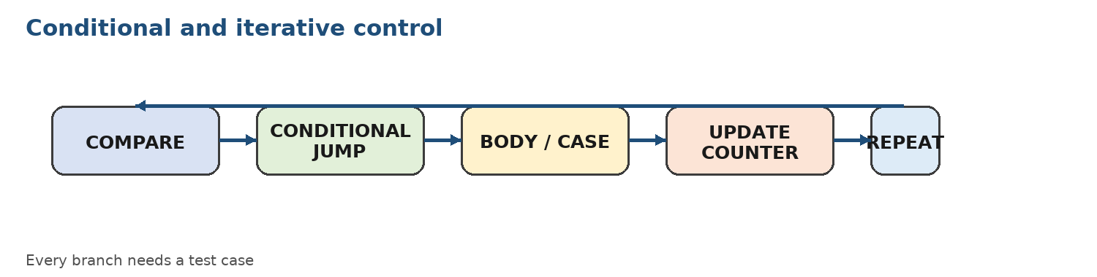

Procedure
- Write pseudocode for a number classification problem.
- Translate each comparison into CMP followed by the appropriate conditional jump.
- Implement a counted loop to process a fixed set of values.
- Include a default branch and verify that it is reachable.
- Test values below, equal to, and above each comparison threshold.
Illustrative Code / Control Logic
MOV AL, 7
CMP AL, 10
JB BELOW_TEN
JE EQUAL_TEN
JA ABOVE_TEN
BELOW_TEN:
; branch for AL < 10
JMP DONE
EQUAL_TEN:
; branch for AL = 10
JMP DONE
ABOVE_TEN:
; branch for AL > 10
DONE:
Expected Observation
Each test input should reach exactly one classification branch. Record the input, branch label, and output for every test case.
Execution Notes
Record the input, key register or memory values, output, and any error correction made during execution.

Tasks for Submission
Complete all three tasks. Each task is tagged with the LLO it assesses.
1. (LLO-1) Write a program that finds the largest of three unsigned byte values.
2. (LLO-1) Write a loop that calculates the sum of the first N positive integers.
3. (LLO-1) Write and test a menu-driven classification program with at least four mutually exclusive cases.
LLO-Based Assessment Rubric
Assess the mapped LLO for every laboratory. Suggested total: __ marks.
Criterion | 4 - Excellent | 3 - Good | 2 - Developing | 1 - Beginning
LLO-1: Concepts and tool usage | Explains the concept accurately, selects valid instructions, uses the required tools correctly, and interprets results precisely. | Minor conceptual or tool-use errors; results are mostly accurate and corrected with limited guidance. | Partial understanding with repeated tool or instruction errors; interpretation is incomplete. | Cannot explain the concept or use the required tool without substantial assistance.
LLO-1: Design, implementation, and testing | Design is clear; implementation is correct, well-tested, and documented with meaningful edge cases. | Solution works for normal cases with reasonable structure and some testing evidence. | Solution is incomplete or works only for limited cases; testing and documentation are weak. | No workable solution or evidence of systematic testing.
Laboratory Record
Record the evidence used to award each LLO level.
Evidence / Test Case | Result / Observation | Instructor Initials
1.
2.
3.
Instructor Notes
Apply the LLO-based rubric consistently. Students should submit source code, execution evidence, and a short explanation of the result.

Lab-9: Integer Arithmetic and Bit Manipulation
Lab | Lab-9 | Mapped LLO(s) | LLO-1
Mapped GA(s) | GA-2 | Contact Hours | 3
Aim
Apply integer arithmetic and bit-manipulation instructions to implement efficient low-level algorithms.
Learning Outcomes
- Use MUL, IMUL, DIV, and IDIV with appropriate operand sizes.
- Use AND, OR, XOR, NOT, SHL, SHR, ROL, and ROR for bit operations.
- Explain how instruction choice changes the resulting bit pattern.
Required Tools and Resources
- TASM and TLINK
- Bit-pattern worksheet
- Test values covering zero and boundary cases
Background / Theory
Arithmetic instructions have implicit operands and produce results in specific registers. Bitwise instructions are useful for masks, permissions, parity, packing, and fast powers of two. A correct solution must account for operand size, sign, and possible overflow or division remainder.
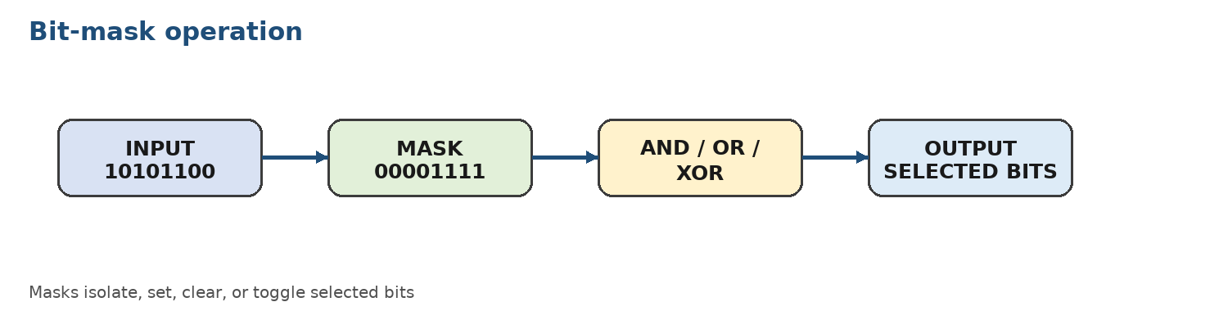

Procedure
- Write the expected decimal and binary result for each test.
- Implement one arithmetic operation and one bit-manipulation operation.
- Inspect the destination registers and remainder where relevant.
- Repeat with zero, maximum, and negative values when the instruction is signed.
- Explain which flags or registers carry additional information.
Illustrative Code / Control Logic
MOV AL, 6
MOV BL, 7
MUL BL ; AX = AL * BL

MOV AL, 10101100b
AND AL, 00001111b ; keep low nibble
OR AL, 10000000b ; set high bit
XOR AL, 00000001b ; toggle low bit
Expected Observation
Record the binary value before and after each logical instruction. For multiplication and division, record both the main result and any remainder or high-order result.
Execution Notes
Record the input, key register or memory values, output, and any error correction made during execution.

Tasks for Submission
Complete all three tasks. Each task is tagged with the LLO it assesses.
1. (LLO-1) Implement multiplication and division of two unsigned 16-bit values and display the quotient and remainder.
2. (LLO-1) Use a mask to set, clear, and toggle selected bits in an 8-bit value.
3. (LLO-1) Implement a rotate-based or shift-based method to reverse the bit order of an 8-bit value and verify it with three inputs.
LLO-Based Assessment Rubric
Assess the mapped LLO for every laboratory. Suggested total:___ marks.
Criterion | 4 - Excellent | 3 - Good | 2 - Developing | 1 - Beginning
LLO-1: Concepts and tool usage | Explains the concept accurately, selects valid instructions, uses the required tools correctly, and interprets results precisely. | Minor conceptual or tool-use errors; results are mostly accurate and corrected with limited guidance. | Partial understanding with repeated tool or instruction errors; interpretation is incomplete. | Cannot explain the concept or use the required tool without substantial assistance.
LLO-1: Design, implementation, and testing | Design is clear; implementation is correct, well-tested, and documented with meaningful edge cases. | Solution works for normal cases with reasonable structure and some testing evidence. | Solution is incomplete or works only for limited cases; testing and documentation are weak. | No workable solution or evidence of systematic testing.
Laboratory Record
Record the evidence used to award each LLO level.
Evidence / Test Case | Result / Observation | Instructor Initials
1.
2.
3.
Instructor Notes
Apply the LLO-based rubric consistently. Students should submit source code, execution evidence, and a short explanation of the result.

Lab-10: Arrays, Constants, and String Handling
Lab | Lab-10 | Mapped LLO(s) | LLO-1
Mapped GA(s) | GA-2 | Contact Hours | 3
Aim
Store and process collections of values and character strings using indexed addressing and string instructions.
Learning Outcomes
- Declare byte and word arrays with constants.
- Traverse arrays using index registers and a counter.
- Use string instructions or explicit loops for comparison, copying, and searching.
Required Tools and Resources
- TASM and TLINK
- Sample arrays and strings
- A trace table for index and accumulator values
Background / Theory
An array is a contiguous sequence of elements. The element address is calculated from a base address plus an offset. String instructions such as MOVSB, CMPSB, and SCASB use SI, DI, and direction control, while explicit loops make the address calculation visible to beginners.
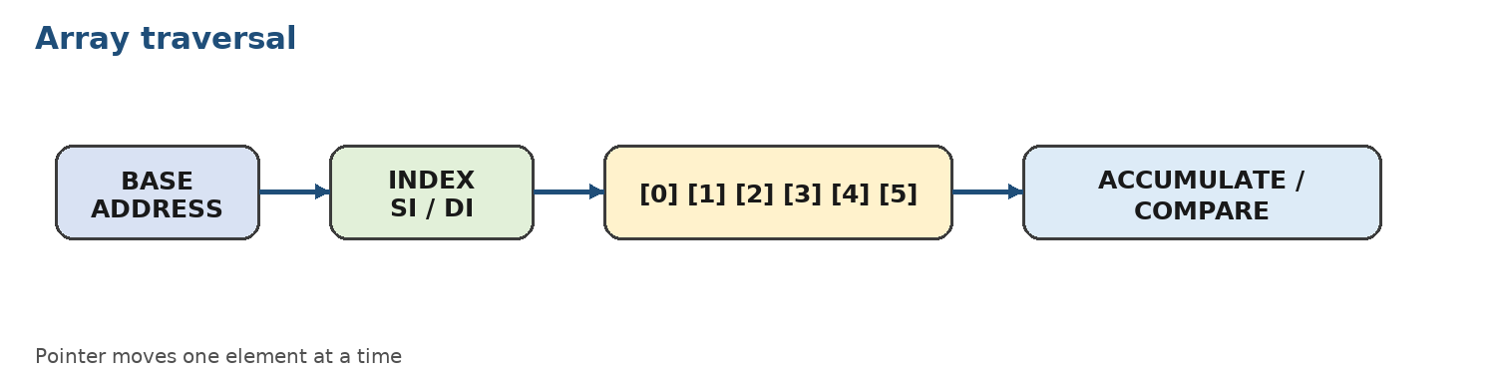

Procedure
- Declare an array of at least eight bytes and a null-terminated string.
- Use an index register to scan the array and compute a sum or maximum.
- Use a counter to prevent reads beyond the array boundary.
- Implement a string operation and test equal, unequal, empty, and longer inputs.
- Record the index, current element, and accumulator after each iteration.
Illustrative Code / Control Logic
numbers DB 4, 9, 2, 7, 5, 1
count EQU ($ - numbers)

LEA SI, numbers
MOV CX, count
XOR AX, AX
NEXT:
XOR BH, BH
MOV BL, [SI]
ADD AX, BX
INC SI
LOOP NEXT
Expected Observation
The accumulator should contain the sum of all array elements. The trace should show the pointer moving one element at a time and the counter reaching zero.
Execution Notes
Record the input, key register or memory values, output, and any error correction made during execution.

Tasks for Submission
Complete all three tasks. Each task is tagged with the LLO it assesses.
1. (LLO-1) Find the minimum and maximum values in an array of ten unsigned bytes.
2. (LLO-1) Count vowels and consonants in a null-terminated string.
3. (LLO-1) Compare two strings and report whether they are equal, including the first mismatch position when they differ.
LLO-Based Assessment Rubric
Assess the mapped LLO for every laboratory. Suggested total: ___marks.
Criterion | 4 - Excellent | 3 - Good | 2 - Developing | 1 - Beginning
LLO-1: Concepts and tool usage | Explains the concept accurately, selects valid instructions, uses the required tools correctly, and interprets results precisely. | Minor conceptual or tool-use errors; results are mostly accurate and corrected with limited guidance. | Partial understanding with repeated tool or instruction errors; interpretation is incomplete. | Cannot explain the concept or use the required tool without substantial assistance.
LLO-1: Design, implementation, and testing | Design is clear; implementation is correct, well-tested, and documented with meaningful edge cases. | Solution works for normal cases with reasonable structure and some testing evidence. | Solution is incomplete or works only for limited cases; testing and documentation are weak. | No workable solution or evidence of systematic testing.
Laboratory Record
Record the evidence used to award each LLO level.
Evidence / Test Case | Result / Observation | Instructor Initials
1.
2.
3.
Instructor Notes
Apply the LLO-based rubric consistently. Students should submit source code, execution evidence, and a short explanation of the result.

Lab-11: Basic Instructions and Addressing Modes
Lab | Lab-11 | Mapped LLO(s) | LLO-1
Mapped GA(s) | GA-2 | Contact Hours | 3
Aim
Identify and apply common addressing modes while tracing how operands are fetched and stored.
Learning Outcomes
- Distinguish immediate, register, direct, register-indirect, based, indexed, and based-indexed addressing.
- Calculate effective addresses for memory operands.
- Select an addressing mode that matches the data structure and algorithm.
Required Tools and Resources
- TASM and TLINK
- Memory diagram
- DEBUG for optional address inspection
Background / Theory
An addressing mode describes how an instruction locates its operand. Immediate data is part of the instruction; register operands are inside the CPU; memory operands use an effective address calculated from a displacement, base register, index register, or combination. Correct address calculation is essential for arrays and records.
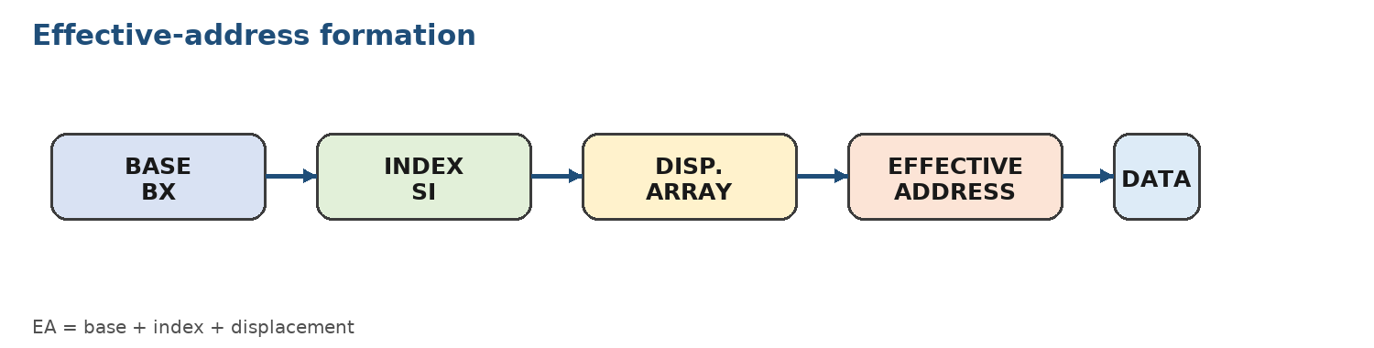

Procedure
- Create a data segment containing scalar variables, an array, and a small record-like block.
- Write one instruction using each addressing mode available in the selected 8086 subset.
- Calculate the effective address by hand before execution.
- Trace the program and verify the accessed value.
- Annotate the source with the addressing mode used by each instruction.
Illustrative Code / Control Logic
MOV AX, 1234h ; immediate
MOV BX, AX ; register
MOV AL, value ; direct memory
MOV SI, OFFSET array
MOV AL, [SI] ; register indirect
MOV AL, array[SI] ; indexed with displacement
MOV AL, [BX+SI] ; based-indexed
Expected Observation
For every memory access, record the effective address and the value read or written. State which registers contribute to the address.
Execution Notes
Record the input, key register or memory values, output, and any error correction made during execution.

Tasks for Submission
Complete all three tasks. Each task is tagged with the LLO it assesses.
1. (LLO-1) Create a labeled example of at least six valid addressing modes and explain each effective address.
2. (LLO-1) Process a two-dimensional 3x3 byte matrix using based-indexed addressing.
3. (LLO-1) Compare two implementations of the same array operation using direct indexing and register-indirect addressing.
LLO-Based Assessment Rubric
Assess the mapped LLO for every laboratory. Suggested total: __marks.
Criterion | 4 - Excellent | 3 - Good | 2 - Developing | 1 - Beginning
LLO-1: Concepts and tool usage | Explains the concept accurately, selects valid instructions, uses the required tools correctly, and interprets results precisely. | Minor conceptual or tool-use errors; results are mostly accurate and corrected with limited guidance. | Partial understanding with repeated tool or instruction errors; interpretation is incomplete. | Cannot explain the concept or use the required tool without substantial assistance.
LLO-1: Design, implementation, and testing | Design is clear; implementation is correct, well-tested, and documented with meaningful edge cases. | Solution works for normal cases with reasonable structure and some testing evidence. | Solution is incomplete or works only for limited cases; testing and documentation are weak. | No workable solution or evidence of systematic testing.
Laboratory Record
Record the evidence used to award each LLO level.
Evidence / Test Case | Result / Observation | Instructor Initials
1.
2.
3.
Instructor Notes
Apply the LLO-based rubric consistently. Students should submit source code, execution evidence, and a short explanation of the result.

Lab-12: Logic Design and HCL in Y86 Architecture
Lab | Lab-12 | Mapped LLO(s) | LLO-2
Mapped GA(s) | GA-4 | Contact Hours | 3
Aim
Model instruction behavior and control logic using the Y86 instruction set and Hardware Control Language (HCL).
Learning Outcomes
- Identify Y86 registers, instruction bytes, status codes, and sequential stages.
- Read HCL expressions for register and control-signal selection.
- Modify a simple control expression and test its effect in a Y86 simulator.
Required Tools and Resources
- Y86 simulator or course-provided Y86 tool
- HCL reference sheet
- Instruction trace table
Background / Theory
Y86 is an educational instruction set based on the ideas of x86 but simplified for studying datapaths and control. HCL expresses combinational control logic such as selecting a destination register or determining whether a condition is true. The design must account for instruction type, function code, register identifiers, and status.
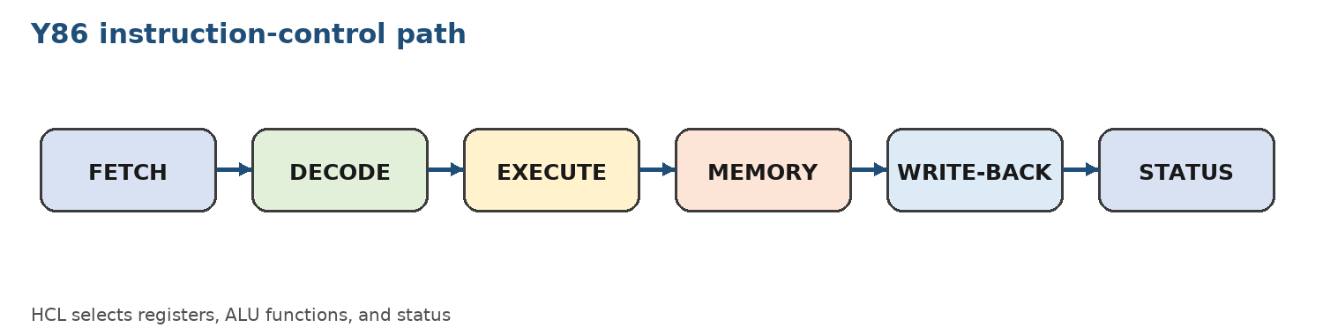

Procedure
- Load a small Y86 program into the simulator.
- Trace fetch, decode, execute, memory, and write-back behavior for representative instructions.
- Identify the HCL expression that selects a destination or ALU function.
- Change one input condition in a controlled copy of the HCL file.
- Run the simulator and compare the original and modified traces.
Illustrative Code / Control Logic
# Illustrative HCL-style selection
word dstE = [
icode in { IIRMOVQ, IALU } : rB;
icode == IPOPQ : rA;
1 : RNONE;
];
Expected Observation
The trace should identify the instruction code, source and destination registers, ALU operation, and resulting status. Note any instruction that becomes invalid after the control change.
Execution Notes
Record the input, key register or memory values, output, and any error correction made during execution.

Tasks for Submission
Complete all three tasks. Each task is tagged with the LLO it assesses.
1. (LLO-2) Trace a Y86 sequence containing irmovq, rrmovq, OPq, and halt through all stages.
2. (LLO-2) Modify an HCL selection rule for dstE or ALU input and document the changed behavior.
3. (LLO-2) Design a small control table that maps three Y86 instruction classes to their register and ALU controls.
LLO-Based Assessment Rubric
Assess the mapped LLO for every laboratory. Suggested total: ___marks.
Criterion | 4 - Excellent | 3 - Good | 2 - Developing | 1 - Beginning
LLO-2: Concepts and tool usage | Explains the concept accurately, selects valid instructions, uses the required tools correctly, and interprets results precisely. | Minor conceptual or tool-use errors; results are mostly accurate and corrected with limited guidance. | Partial understanding with repeated tool or instruction errors; interpretation is incomplete. | Cannot explain the concept or use the required tool without substantial assistance.
LLO-2: Design, implementation, and testing | Design is clear; implementation is correct, well-tested, and documented with meaningful edge cases. | Solution works for normal cases with reasonable structure and some testing evidence. | Solution is incomplete or works only for limited cases; testing and documentation are weak. | No workable solution or evidence of systematic testing.
Laboratory Record
Record the evidence used to award each LLO level.
Evidence / Test Case | Result / Observation | Instructor Initials
1.
2.
3.
Instructor Notes
Apply the LLO-based rubric consistently. Students should submit source code, execution evidence, and a short explanation of the result.

Lab-13: Pipelining and Pipelined Y86 Implementations
Lab | Lab-13 | Mapped LLO(s) | LLO-2
Mapped GA(s) | GA-4 | Contact Hours | 3
Aim
Analyze the stages, hazards, and performance of a pipelined Y86 implementation.
Learning Outcomes
- Describe the role of pipeline registers between fetch, decode, execute, memory, and write-back.
- Identify data, control, and structural hazards in an instruction sequence.
- Use stalls, bubbles, or forwarding concepts to preserve correctness.
Required Tools and Resources
- Y86 pipeline simulator or course-provided diagrams
- Cycle-by-cycle trace sheet
- Calculator or spreadsheet
Background / Theory
Pipelining overlaps independent instructions so that several instructions are in progress at once. Dependencies can cause hazards. A pipeline may resolve them by forwarding a result, stalling a stage, inserting a bubble, or predicting and recovering from a control transfer. Performance is measured using cycles per instruction and total completion time.
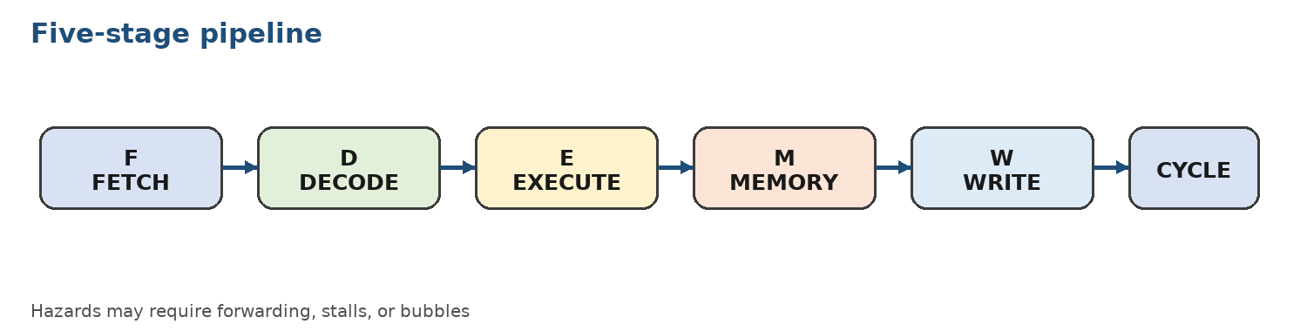

Procedure
- Draw the five-stage pipeline for a short independent instruction sequence.
- Add a data dependency and mark the cycle in which the consumer needs the producer result.
- Compare the schedule with and without forwarding or a stall.
- Introduce a conditional branch and discuss the control hazard.
- Calculate total cycles and effective CPI for each schedule.
Illustrative Code / Control Logic
# Conceptual sequence for a pipeline trace
irmovq $10, %rax
irmovq $3, %rbx
addq %rbx, %rax
rrmovq %rax, %rcx
halt
Expected Observation
The pipelined trace should show overlapping stages and any inserted stall or bubble. Explain why the dependent instructions cannot always advance together.
Execution Notes
Record the input, key register or memory values, output, and any error correction made during execution.

Tasks for Submission
Complete all three tasks. Each task is tagged with the LLO it assesses.
1. (LLO-2) Create a cycle-by-cycle pipeline diagram for five independent Y86 instructions.
2. (LLO-2) Analyze a dependent sequence and compare cycles with forwarding versus a one-cycle stall.
3. (LLO-2) Calculate CPI for a 20-instruction sequence with four stalls and one control bubble, stating assumptions.
LLO-Based Assessment Rubric
Assess the mapped LLO for every laboratory. Suggested total: __marks.
Criterion | 4 - Excellent | 3 - Good | 2 - Developing | 1 - Beginning
LLO-2: Concepts and tool usage | Explains the concept accurately, selects valid instructions, uses the required tools correctly, and interprets results precisely. | Minor conceptual or tool-use errors; results are mostly accurate and corrected with limited guidance. | Partial understanding with repeated tool or instruction errors; interpretation is incomplete. | Cannot explain the concept or use the required tool without substantial assistance.
LLO-2: Design, implementation, and testing | Design is clear; implementation is correct, well-tested, and documented with meaningful edge cases. | Solution works for normal cases with reasonable structure and some testing evidence. | Solution is incomplete or works only for limited cases; testing and documentation are weak. | No workable solution or evidence of systematic testing.
Laboratory Record
Record the evidence used to award each LLO level.
Evidence / Test Case | Result / Observation | Instructor Initials
1.
2.
3.
Instructor Notes
Apply the LLO-based rubric consistently. Students should submit source code, execution evidence, and a short explanation of the result.

Lab-14: Open-Ended Lab-2: Logical Tests and Array Reversal
Lab | Lab-14 | Mapped LLO(s) | LLO-1
Mapped GA(s) | GA-2 | Contact Hours | 3
Aim
Design complete assembly solutions for logical classification and in-place array manipulation.
Learning Outcomes
- Select an appropriate logical operation for a decision problem.
- Use two-pointer or indexed access to reverse an array in place.
- Validate a solution with boundary and negative tests.
Required Tools and Resources
- TASM and TLINK
- Flowchart or pseudocode
- Test-case table
Background / Theory
Even/odd classification can be performed by testing the least significant bit. Array reversal can be performed by swapping the first and last elements, then moving inward until the indexes meet. Both exercises require explicit attention to boundaries and data representation.
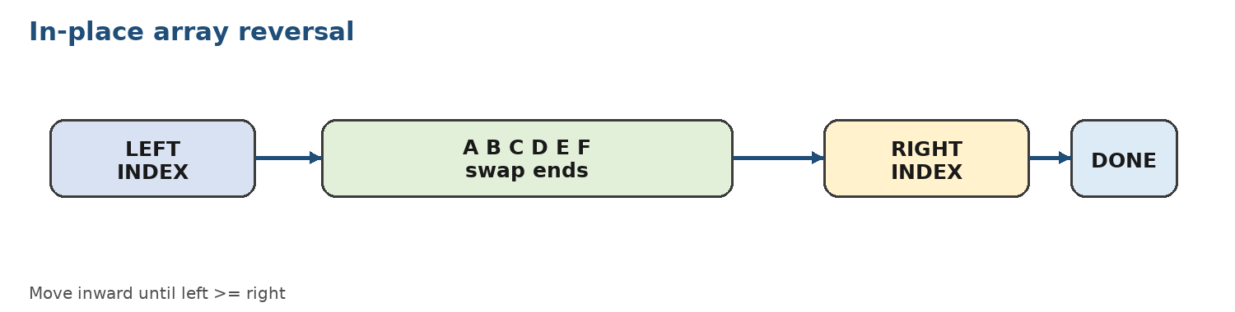

Procedure
- Write the algorithm in pseudocode and identify all boundary cases.
- Implement the logical test using TEST or AND.
- Implement array reversal using two indexes or a left/right pointer pair.
- Test empty, one-element, two-element, repeated-value, and mixed-value inputs where applicable.
- Document the number of comparisons and swaps.
Illustrative Code / Control Logic
MOV AL, 37
TEST AL, 1
JZ EVEN_NUMBER
; odd branch
JMP DONE
EVEN_NUMBER:
; even branch
DONE:
Expected Observation
The least significant bit is zero for even unsigned integers and one for odd unsigned integers. The reversed array should contain the original elements in the opposite order without losing any element.
Execution Notes
Record the input, key register or memory values, output, and any error correction made during execution.

Tasks for Submission
Complete all three tasks. Each task is tagged with the LLO it assesses.
1. (LLO-1) Write an assembly program that checks whether an input number is even or odd using a logical operation.
2. (LLO-1) Write an in-place program to reverse an array of eight bytes.
3. (LLO-1) Extend one solution with input validation and submit a trace for at least five test cases.
LLO-Based Assessment Rubric
Assess the mapped LLO for every laboratory. Suggested total:__ marks.
Criterion | 4 - Excellent | 3 - Good | 2 - Developing | 1 - Beginning
LLO-1: Concepts and tool usage | Explains the concept accurately, selects valid instructions, uses the required tools correctly, and interprets results precisely. | Minor conceptual or tool-use errors; results are mostly accurate and corrected with limited guidance. | Partial understanding with repeated tool or instruction errors; interpretation is incomplete. | Cannot explain the concept or use the required tool without substantial assistance.
LLO-1: Design, implementation, and testing | Design is clear; implementation is correct, well-tested, and documented with meaningful edge cases. | Solution works for normal cases with reasonable structure and some testing evidence. | Solution is incomplete or works only for limited cases; testing and documentation are weak. | No workable solution or evidence of systematic testing.
Laboratory Record
Record the evidence used to award each LLO level.
Evidence / Test Case | Result / Observation | Instructor Initials
1.
2.
3.
Instructor Notes
Apply the LLO-based rubric consistently. Students should submit source code, execution evidence, and a short explanation of the result.

Lab-15: Semester Project: Integrated Assembly Solution
Lab | Lab-15 | Mapped LLO(s) | LLO-3
Mapped GA(s) | GA-6 | Contact Hours | Project
Aim
Integrate assembly language concepts, TASM tool usage, data structures, control flow, and low-level debugging in a small working project.
Learning Outcomes
- Translate a computational problem into an assembly-oriented design.
- Use TASM to build, test, debug, and document a multi-part program.
- Evaluate correctness using test cases and explain design decisions.
Required Tools and Resources
- TASM and TLINK
- DOS-compatible environment
- Project report template
- Optional DEBUG and Y86 simulator where relevant
Background / Theory
A semester project combines the complete laboratory workflow: problem definition, data representation, algorithm design, instruction selection, implementation, testing, and documentation. The project should be small enough to demonstrate clearly but rich enough to use arrays or strings, arithmetic or bit operations, and conditional or iterative control.
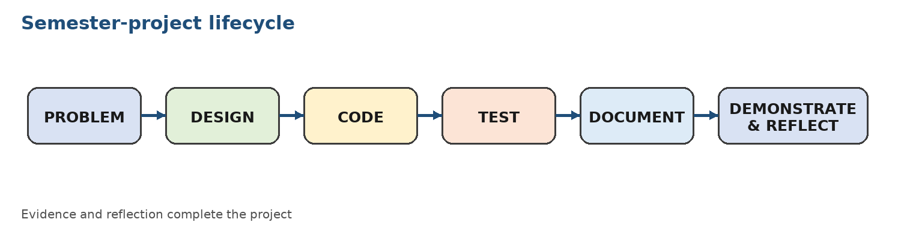

Procedure
- Submit a one-page proposal stating the problem, inputs, outputs, constraints, and expected LLO/GA mapping.
- Create a flowchart, data layout, and module plan before implementation.
- Develop the program incrementally and maintain a build log.
- Test normal, boundary, invalid, and repeated-input cases.
- Demonstrate the executable and submit source code, report, test evidence, and a short reflection.
Illustrative Code / Control Logic
; Suggested project structure
.MODEL small
.STACK 100h
.DATA
; constants, arrays, strings, and result storage
.CODE
main PROC
; initialize data segment
; input / processing / output modules
; terminate through DOS service
main ENDP
END main
Expected Observation
The final demonstration must show a working executable and explain how the project satisfies LLO-3, including evidence of effective collaboration with peers. Include evidence that the program was assembled and linked with TASM tools.
Execution Notes
Record the input, key register or memory values, output, and any error correction made during execution.

Tasks for Submission
Complete all three tasks. Each task is tagged with the LLO it assesses.
1. (LLO-3) Submit a build-and-debug portfolio: source, TASM/TLINK commands, one corrected error, and an annotated trace of a critical routine.
2. (LLO-3) Implement the approved project with at least three meaningful test cases and a result table.
3. (LLO-3) Present the design, explain two instruction-level decisions, map each major feature to an LLO, and identify one possible improvement.
LLO-Based Assessment Rubric
Assess the mapped LLO for every laboratory. Suggested total:___ marks.
Criterion | 4 - Excellent | 3 - Good | 2 - Developing | 1 - Beginning
LLO-3: Concepts and tool usage | Explains the concept accurately, selects valid instructions, uses the required tools correctly, and interprets results precisely. | Minor conceptual or tool-use errors; results are mostly accurate and corrected with limited guidance. | Partial understanding with repeated tool or instruction errors; interpretation is incomplete. | Cannot explain the concept or use the required tool without substantial assistance.
LLO-3: Design, implementation, and testing | Design is clear; implementation is correct, well-tested, and documented with meaningful edge cases. | Solution works for normal cases with reasonable structure and some testing evidence. | Solution is incomplete or works only for limited cases; testing and documentation are weak. | No workable solution or evidence of systematic testing.
Laboratory Record
Record the evidence used to award each LLO level.
Evidence / Test Case | Result / Observation | Instructor Initials
1.
2.
3.
Instructor Notes
Apply the LLO-based rubric consistently. Students should submit source code, execution evidence, and a short explanation of the result.

DAWOOD UNIVERSITY OF ENGINEERING AND TECHNOLOGY
FACULTY OF INFORMATION AND COMPUTING SCIENCES
DEPARTMENT OF COMPUTER SCIENCE
COMPUTER ARCHITECTURE AND ASSEMBLY LANGUAGE (COAL)
Intel 8086 / TASM Instruction Set Summary
Prepared By: M. Imran Khan | Batch: 24F and Onwards
This reference groups the instructions used in the COAL labs by category: data transfer, arithmetic, logical and bit operations, addressing modes, conditional branches, loops, strings, procedures, and Y86/HCL. Syntax follows Intel-style 8086/TASM notation unless a Y86 instruction is explicitly identified.
1. Data Transfer Instructions
Instruction / Form | Intel Syntax | Operation / Use | Flags Affected | Related Labs
MOV | MOV dest, source | Copies a byte or word from register, memory, or immediate source to destination. Source and destination cannot both be memory operands. | None | L1, L2, L3, L5, L8-L11
LEA | LEA reg, memory | Loads the effective address of a memory operand into a register; it does not load the data stored at that address. | None | L1, L10, L11
XCHG | XCHG op1, op2 | Exchanges the contents of two registers or a register and a memory operand. | None | L14, L15
PUSH | PUSH source | Decrements SP by two and stores a word on the stack. | None | L6, L15
POP | POP destination | Loads a word from the stack and increments SP by two. | None | L6, L15
PUSHF | PUSHF | Pushes the 8086 Flags register onto the stack for later inspection. | Flags are saved | L6, L7
POPF | POPF | Restores the Flags register from the word at the top of the stack. | Flags are restored | L6, L7
2. Arithmetic Instructions
Instruction / Form | Intel Syntax | Operation / Use | Flags Affected | Related Labs
ADD | ADD dest, source | Adds source to destination and stores the sum in destination. | CF OF SF ZF AF PF | L3, L5, L6, L9
ADC | ADC dest, source | Adds source plus the current Carry Flag to destination; useful for multi-byte addition. | CF OF SF ZF AF PF | L3, L7
INC | INC operand | Increments an operand by one. It is useful for counters and indexes. | OF SF ZF AF PF; CF unchanged | L6, L8, L10, L14
SUB | SUB dest, source | Subtracts source from destination and stores the difference. | CF OF SF ZF AF PF | L3, L5, L6
SBB | SBB dest, source | Subtracts source plus the current Carry Flag; useful for multi-byte subtraction. | CF OF SF ZF AF PF | L3
DEC | DEC operand | Decrements an operand by one, commonly used with reverse indexes and counters. | OF SF ZF AF PF; CF unchanged | L6, L8, L14
CMP | CMP op1, op2 | Performs op1 - op2 only to set flags; neither operand is changed. | CF OF SF ZF AF PF | L6, L8, L10, L11, L14
NEG | NEG operand | Replaces an operand with its two's-complement negation, equivalent to 0 - operand. | CF OF SF ZF AF PF | L3, L9
MUL | MUL source | Unsigned multiply. AL/AX is implicitly multiplied; the double-width result is placed in AX or DX:AX. | CF and OF indicate high half; others undefined | L9, L15
IMUL | IMUL source | Signed multiplication using the implicit accumulator or the supported explicit-operand form. | CF and OF indicate signed overflow; others undefined | L9, L15
DIV | DIV source | Unsigned division. AX or DX:AX is divided; quotient and remainder use fixed registers. | Undefined; divide error possible | L9, L15
IDIV | IDIV source | Signed division using the sign-extended dividend. | Undefined; divide error possible | L9, L15
3. Logical and Bit-Test Instructions
Instruction / Form | Intel Syntax | Operation / Use | Flags Affected | Related Labs
AND | AND dest, source | Performs a bitwise AND; useful for clearing bits and applying masks. | CF=0, OF=0; SF ZF PF set; AF undefined | L6, L7, L9, L14
OR | OR dest, source | Performs a bitwise OR; useful for setting selected bits. | CF=0, OF=0; SF ZF PF set; AF undefined | L6, L9
XOR | XOR dest, source | Performs a bitwise exclusive OR; useful for toggling bits or clearing a register with XOR reg, reg. | CF=0, OF=0; SF ZF PF set; AF undefined | L6, L9
NOT | NOT operand | Complements every bit of the operand. | No flags affected | L9
TEST | TEST op1, op2 | Performs AND only for flag setting; the result is not stored. | CF=0, OF=0; SF ZF PF set; AF undefined | L9, L14
4. Shift and Rotate Instructions
Instruction / Form | Intel Syntax | Operation / Use | Flags Affected | Related Labs
SHL / SAL | SHL dest, count | Shifts bits left; zeros enter from the right. Each shift by one is equivalent to an unsigned multiply by two when no overflow occurs. | CF = last bit out; OF defined for count 1; SF ZF PF affected | L6, L7, L9
SHR | SHR dest, count | Logical right shift; zeros enter from the left and the least significant bit moves into CF. | CF = last bit out; OF defined for count 1; SF ZF PF affected | L6, L7, L9
SAR | SAR dest, count | Arithmetic right shift; copies the sign bit and is suitable for signed division by powers of two. | CF = last bit out; OF cleared for count 1; SF ZF PF affected | L9, L15
ROL | ROL dest, count | Rotates bits left; the bit shifted out of the most significant position enters the least significant position. | CF = last bit rotated; OF defined for count 1 | L9
ROR | ROR dest, count | Rotates bits right; the bit shifted out of the least significant position enters the most significant position. | CF = last bit rotated; OF defined for count 1 | L9
RCL | RCL dest, count | Rotates left through Carry Flag, treating CF as an additional bit. | CF updated; OF defined for count 1 | L7, L9
RCR | RCR dest, count | Rotates right through Carry Flag, treating CF as an additional bit. | CF updated; OF defined for count 1 | L7, L9
5. Addressing Modes
Instruction / Form | Intel Syntax | Operation / Use | Flags Affected | Related Labs
Immediate | MOV AL, 25h | The constant is encoded inside the instruction. It is useful for initialization and masks. | Depends on instruction | L2, L3, L9
Register | MOV AX, BX | The operand is in a CPU register; this is usually faster than a memory access. | Depends on instruction | L2, L3, L5
Direct memory | MOV AL, value | The instruction contains the displacement or named memory address of the operand. | Depends on instruction | L5, L10
Register indirect | MOV AL, [SI] | A register contains the effective address of the memory operand. | Depends on instruction | L10, L11
Based | MOV AL, [BX+disp] | A base register plus an optional displacement addresses a variable or record field. | Depends on instruction | L11
Indexed | MOV AL, [SI+disp] | An index register plus displacement accesses array elements or fields. | Depends on instruction | L10, L11
Based-indexed | MOV AL, [BX+SI] | Base and index registers are added to form an effective address; useful for tables and matrices. | Depends on instruction | L11
Relative control | JNZ label | The target is reached using a signed displacement relative to the next instruction. | No flags changed by jump | L8, L14
6. Conditional and Unconditional Control Transfer
Instruction / Form | Intel Syntax | Operation / Use | Flags Affected | Related Labs
JMP | JMP label | Unconditionally transfers control to a label. | No flags changed | L4, L8, L14
JE / JZ | JE label | Jumps when the previous result was equal or zero. | Tests ZF=1 | L8, L14
JNE / JNZ | JNE label | Jumps when the previous result was not equal or not zero. | Tests ZF=0 | L8, L14
JB / JC / JNAE | JB label | Unsigned lower-than branch after a compare or subtraction. | Tests CF=1 | L8, L14
JAE / JNB / JNC | JAE label | Unsigned greater-than-or-equal branch. | Tests CF=0 | L8, L14
JA / JNBE | JA label | Unsigned greater-than branch. | Tests CF=0 and ZF=0 | L8
JBE / JNA | JBE label | Unsigned less-than-or-equal branch. | Tests CF=1 or ZF=1 | L8
JG / JNLE | JG label | Signed greater-than branch. | Tests ZF=0 and SF=OF | L8
JL / JNGE | JL label | Signed less-than branch. | Tests SF<>OF | L8
JGE / JNL | JGE label | Signed greater-than-or-equal branch. | Tests SF=OF | L8
JLE / JNG | JLE label | Signed less-than-or-equal branch. | Tests ZF=1 or SF<>OF | L8
JS / JNS | JS / JNS label | Branches according to the sign of the previous result. | Tests SF=1 or SF=0 | L6, L8
JO / JNO | JO / JNO label | Branches according to signed overflow. | Tests OF=1 or OF=0 | L6, L8
JP / JPE | JP label | Branches when the parity flag is set. | Tests PF=1 | L6, L8
JNP / JPO | JNP label | Branches when the parity flag is clear. | Tests PF=0 | L6, L8
7. Loop and Counter-Control Instructions
Instruction / Form | Intel Syntax | Operation / Use | Flags Affected | Related Labs
LOOP | LOOP label | Decrements CX and jumps when CX is not zero. It does not change arithmetic flags. | Flags unchanged | L7, L8, L10
LOOPE / LOOPZ | LOOPE label | Decrements CX and jumps when CX is not zero and ZF is one. | Flags unchanged by LOOP | L8, L10
LOOPNE / LOOPNZ | LOOPNE label | Decrements CX and jumps when CX is not zero and ZF is zero. | Flags unchanged by LOOP | L8, L10
JCXZ | JCXZ label | Jumps when CX is zero; useful for an empty-count test before entering a loop. | Flags unchanged | L8, L10
CALL | CALL procedure | Pushes the return address and transfers control to a procedure. | No arithmetic flags changed | L5, L15
RET | RET | Pops the return address and transfers control back to the caller. | No arithmetic flags changed | L5, L15
8. String and Block-Processing Instructions
Instruction / Form | Intel Syntax | Operation / Use | Flags Affected | Related Labs
MOVSB / MOVSW | MOVSB / MOVSW | Copies a byte or word from DS:SI to ES:DI and updates SI and DI according to DF. | Flags unchanged | L10, L15
CMPSB / CMPSW | CMPSB / CMPSW | Compares DS:SI with ES:DI and updates flags as a subtraction. | CF OF SF ZF AF PF | L10
SCASB / SCASW | SCASB / SCASW | Compares AL/AX with ES:DI and updates flags; useful for searching. | CF OF SF ZF AF PF | L10
LODSB / LODSW | LODSB / LODSW | Loads a byte or word from DS:SI into AL/AX and updates SI. | Flags unchanged | L10
STOSB / STOSW | STOSB / STOSW | Stores AL/AX to ES:DI and updates DI. | Flags unchanged | L10
REP | REP instruction | Repeats a string instruction CX times. | Depends on repeated instruction | L10
CLD / STD | CLD / STD | Clears or sets Direction Flag to control whether SI and DI increment or decrement. | DF changed | L10
9. Procedures, Interrupts, and Program Control
Instruction / Form | Intel Syntax | Operation / Use | Flags Affected | Related Labs
INT | INT n | Software interrupt; INT 21h provides common DOS services such as display and termination. | Flags are pushed; service may change registers | L1, L5, L15
IRET | IRET | Returns from an interrupt by restoring IP, CS, and Flags. | Flags restored | L15
NOP | NOP | Performs no operation; useful for timing or instruction-space placeholders. | No flags changed | L4, L13
HLT | HLT | Stops processor execution until an interrupt or reset; normally used in controlled low-level contexts. | No ordinary arithmetic flags | L12, L13
CLC / STC | CLC / STC | Clears or sets Carry Flag explicitly before multi-byte arithmetic. | CF changed | L3, L6
CLD / STD | CLD / STD | Controls the Direction Flag for string operations. | DF changed | L10
10. Y86 Instructions and HCL Elements
Instruction / Form | Intel Syntax | Operation / Use | Flags Affected | Related Labs
halt / nop | halt / nop | Stops a Y86 program or performs no operation. | Y86 status/control | L12, L13
irmovq | irmovq $Imm, rB | Loads an immediate constant into a register. | Condition codes unchanged | L12, L13
rrmovq / cmovXX | rrmovq rA, rB | Copies a register; conditional move forms copy only when a condition code is true. | Condition codes unchanged | L12, L13
OPq | addq/subq/andq/xorq rA, rB | Performs a Y86 integer operation on registers. | ZF SF OF updated | L12, L13
mrmovq | mrmovq D(rB), rA | Reads a quadword from memory into a register. | Condition codes unchanged | L12, L13
rmmovq | rmmovq rA, D(rB) | Writes a quadword from a register to memory. | Condition codes unchanged | L12, L13
jXX | jXX Dest | Conditional or unconditional Y86 control transfer based on condition codes. | Tests condition codes | L12, L13
call / ret | call Dest / ret | Y86 procedure call and return using the stack pointer. | Condition codes unchanged | L12, L13
pushq / popq | pushq rA / popq rA | Stores or retrieves a quadword using the stack. | Condition codes unchanged | L12, L13
HCL selectors | word dstE = [ ... ]; | Selects register IDs, ALU inputs, memory controls, and status signals in a Y86 control design. | Control logic, not an instruction | L12, L13
Flag abbreviations: CF = Carry, OF = Overflow, SF = Sign, ZF = Zero, AF = Auxiliary Carry, PF = Parity, DF = Direction. For instructions marked undefined, do not use the flag value for program logic.

