
PUCIT
Punjab University College of Information Technology

LIFE CARE

Deliverable 1
Planning and Requirement

Anum Tariq
Advisor’s Signature: _____________

Table of Contents

First Deliverable Guide 3
1 Introduction 3
1.1 Project/Product Feasibility Report 3
1.1.1 Technical Feasibility 4
1.1.2 Operational Feasibility 4
1.1.3 Economic Feasibility 4
1.1.4 Schedule Feasibility 4
1.1.5 Specification Feasibility 5
1.1.6 Information Feasibility 5
1.1.7 Motivational Feasibility 5
1.1.8 Legal & Ethical Feasibility 5
1.2 Project/Product Scope 5
1.3 Project/Product Costing 5
1.3.1 Project Cost Estimation By Function Point Analysis 6
1.3.2 Project Cost Estimation by using COCOMO’81 (Constructive Cost Model) 8
1.4 CPM - Critical Path Method 9
1.5 Gantt chart 12
1.6 Introduction to Team member and their skill set 13
1.7 Tools and Technology with reasoning 13
1.8 Vision Document 13
1.9 Risk List 14
1 Introduction 15
1.1 Systems Specifications 16
1.2 Identifying External Entities 17
1.3 Context Level Data Flow Diagram 17
1.4 Capture "shall" Statements 17
1.5 Allocate Requirements 18
1.6 Prioritize Requirements 18
1.7 Requirements Trace-ability Matrix 18
1.8 Example 18
1.8.1 Introduction 18
1.8.2 Existing System Business Organization 18
1.8.4Scope of the System 19
1.8.5 Summary of Requirements:(Initial Requirements) 20
1.8.6 Identifying External Entities 22
1.8.9 Capture "shall" Statements and External Entities 23
1.8.10 Allocate Requirements 23
1.8.11 Priorities Requirements 25
1.8.12 Requirements Traceability Matrix 28
1.9 High Level Usecase Diagram 30

LIFE CARE

1 Introduction
Life Care will be helpful for those people who are in emergency and they have android phone that has life care already installed .They just logged in and can locate a specific ambulance and guide the ambulance about the path, track them. User will also inform his/her family member about emergency and will also arrange the blood through this app.
So, our basic purpose of making this app is to facilitate the user by providing almost all the feature relevant to emergency at one place.

Project/Product Feasibility Report
The Feasibility of a project or a product means the extent to which the appropriate data and information is readily available and can be obtained with resources such as Staff, expertise, time and equipment. Our Project is feasible because it will be implemented using the available technology and within given cost and schedule constraints.

Technical Feasibility
Technical feasibility means the system can be developed or not. Technically the Project Life Care is Feasible. The tools, technologies and expertise that are required to develop this project is readily available. We are not using such tools and technologies that are obsolete or rare. We will be using embedded java and android for programming.

Operational Feasibility
As far as technical expertise required to operate this device is concerned, a simple user who knows how to use an android phone will be able to use it. This System will help in
Arranging the ambulance in emergency ,tracking the ambulance and informing the relatives about emergency . The one feature that enhance our app is blood arrangement through this app. So all these features solve our problem of facilitating the user in the end.

1.1.3 Economic Feasibility
Cost estimation is done later in the section 3, so only benefits are stated here. There is no financial benefits involved in this project we are doing this project for the sake of knowledge. We will get to know how things work practically, and how to interact with the bigger systems and real time applications.

1.1.4 Schedule Feasibility
Time is an important factor for the completion and evaluation of the project. We are able to develop this project within time. Work is assigned equally to the team members and all members are present in the working hours, full description of activities and resources allocated to them are presented later in the section 4 of this document.

1.1.5 Specification Feasibility
We have complete specification of the system, and we have enough information about the project to work further.

1.1.6 Information Feasibility
The project is feasible in terms of the information, as the information is enough, reliable and meaningful. We have well defined information about this project. We will ensure reliability and better flow of information.

1.1.7 Motivational Feasibility
Anyone can be in emergency situation at any time. So we want to make this app to facilitate the patient in emergency situation. So, we can provide emergency services as early as possible. This is our motivation to serve the people by taking care of their precious life.

1.1.8 Legal & Ethical Feasibility
The project is legal and we will not be using such materials and procedures which are restricted or will violate someone’s privacy.

Project/Product Scope
The primary goal of our project is to authenticate the user ,request ambulance and let them track the ambulance ,inform relatives about emergency ,arrange blood and it will help the Administration to take a record of all the users, and this information will be very helpful in the future.

Users
- Can view direction and location of the ambulance
- Can view the estimated time of the ambulance
- Can send message to relatives
- Check blood arrangement details
- Can track the ambulance
- Can contact ambulance driver

//Admin
- Can register any user
- Can view the record of any user
- Can change or delete the user
- Can manage ambulance and their route data
- Can remain updated about the security issues

It will be done by getting the coordinates (longitude, latitude) of the ambulance, we will do it by enabling ambulance with the android devices. This android device will be a way of communication between ambulances, users and administration. The data will be saved in a common database, and our goal will be to make database so flexible that can be change in the future easily.

1.2.1 Objectives

- Helps in authenticating the users
- Helps user in locating the ambulance
- It will help in storing the records of the users
- Location of the ambulance will be shown on the map
- Users can see all the routes
- Users can see blood record
- Users can send message to relatives

1.2.2 Functional Requirements

- Register new user
- Request Ambulance
- Guide ambulance to location
- Track ambulance
- Contact ambulance driver
- Inform family member
- Arrange blood

1.2.3 Non-Functional Requirements

- Performance
- Usability
- Reliability

1.2.4 Context
The project will not include the following:
- Application will not save the data of some specific areas of Lahore
- Get patient report from doctor
- Previous record of patient
- Inform hospital about coming ambulance/patient
- Specialized Doctor search

1.2.5 Time
We have approximately 7 months that is enough for this project

1.3 Project/Product Costing
A metric is some measurement we can make of a product or process in the overall development process. Metrics are split into two broad categories:
- Knowledge oriented metrics: these are oriented to tracking the process to evaluate, predict or monitor some part of the process.
- Achievement oriented metrics: these are often oriented to measuring some product aspect, often related to some overall measure of quality of the product.
Most of the work in the cost estimation field has focused on algorithmic cost modeling. In this process costs are analyzed using mathematical formulas linking costs or inputs with metrics to produce an estimated output. The formulae used in a formal model arise from the analysis of historical data. The accuracy of the model can be improved by calibrating the model to your specific development environment, which basically involves adjusting the weightings of the metrics.
Cost estimation can be done by just one methodology.

1.3.1 Project Cost Estimation By Function Point Analysis
Function-oriented software metrics use a measure of the functionality delivered by the application as a normalization value. Since ‘functionality’ cannot be measured directly, it must be derived indirectly using other direct measures. Function-oriented metrics were first proposed by Albrecht, who suggested a measure called the function point. Function points are derived using an empirical relationship based on countable (direct) measures of software’s information domain and assessments of software complexity.
Function Point Analysis can provide a mechanism to track and monitor scope creep. Function Point counts at the end of requirements; analysis, design, code, testing and implementation can be compared. The function point count at the end of requirements and/or designs can be compared to function points actually delivered. If the project has grown, there has been scope creep. The amount of growth is an indication of how well requirements were gathered by and/or communicated to the project team. If the amount of growth of projects declines over time it is a natural assumption that communication with the user has improved.
Function points are computed by completing the table shown in the figure below. Five information domain characteristics are determined and counts are provided in the appropriate table location.
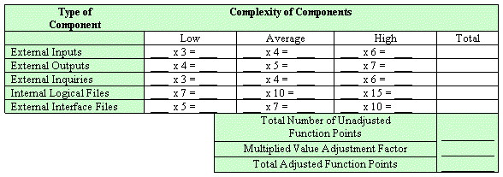

Information domain values are defined in the following manner:

Number of user inputs: Each user input that provides distinct application-oriented data to the software is counted. Inputs should be distinguished from inquiries, which are counted separately.

Number of user outputs: Each user output that provides application-oriented information to the user is counted. In this context output refers to reports, screens, error messages, etc. Individual data items within a report are not counted separately.

Number of user inquiries: An inquiry is defined ass an on-line input that results in the generation of some immediate software response in the form of an on-line output. Each distinct inquiry is counted.

Number of files: Each logical master file (i.e. a logical grouping of data that may be one part of a large database or a separate file) is counted.

Number of external interfaces: All the machine-readable interfaces (e.g., data files on storage media) that are used to transmit information to another system are counted.

Once these data have been collected, a complexity value is associated with each count. Organizations that use function point methods develop criteria for determining whether a particular entry is simple, average, or complex. Nonetheless, the determination of complexity is somewhat subjective.

To compute function points (FP), the following relationship is used:

FP est. = Count Total * [ 0.65 + 0.01 * (Fi)]

Where count total is the sum of all FP entries obtained from above figure and (Fi) is value adjustment factor (VAF) is based on 14 general system characteristics (GSC's) that rate the general functionality of the application being counted. Each characteristic has associated descriptions that help determine the degrees of influence of the characteristics. The degrees of influence range on a scale of zero to five, from no influence to strong influence.

1. Data communications
2. Distributed data processing
3. Performance
4. Heavily used configuration
5. Transaction rate
6. On-Line data entry
7. End-user efficiency
8. On-Line update
9. Complex processing
10. Reusability
11. Installation ease
12. Operational ease
13. Multiple sites
14. Facilitate change

Finally, Total Project Cost and Total Project Effort are calculated given the average productivity parameter for the system.

The formulae are given as follows:

Cost / FP = labor rate / productivity parameter

Total Project Cost = FP est. * (cost / FP)

Total Estimated Effort = FP est. / productivity parameter

1.3.2 Project Cost Estimation by using COCOMO’81 (Constructive Cost Model)
Boehm's COCOMO model is one of the mostly used models commercially. The first version of the model delivered in 1981 and COCOMO II is available now. COCOMO 81 is a model that allows one to estimate the cost, effort, and schedule when planning a new software development activity, according to software development practices that were commonly used in the 1970s through the 1980s. It exists in three forms, each one offering greater detail and accuracy the further along one is in the project planning and design process. Listed by increasing fidelity, these forms are called Basic, Intermediate, and Detailed COCOMO. However, only the Intermediate form has been implemented by USC in a calibrated software tool.
Three levels:

Basic: Is used mostly for rough, early estimates.
Intermediate: Is the most commonly used version, includes 15 different factors to account for the influence of various project attributes such as personnel capability, use of modern tools, hardware constraints, and so forth.
Detailed: Accounts for the influence of the different factors on individual project phases: design, coding/testing, and integration/testing. Detailed COCOMO is not used very often.

Each level includes three software development types:
- Organic: Relatively small software teams develop familiar types of software in an in-house environment. Most of the personnel have experience working with related systems.
- Embedded: The project may require new technology, unfamiliar algorithms, or an innovative new method
- Semi-detached: Is an intermediate stage between organic and embedded types.

Basic COCOMO
Type Effort Schedule
Organic PM= 2.4 (KLOC)1.05 TD= 2.5(PM)0.38
Semi-Detached PM= 3.0 (KLOC)1.12 TD= 2.5(PM)0.35
Embedded PM= 2.4 (KLOC)1.20 TD= 2.5(PM)0.32

PM= person-month (effort)
KLOC= lines of code, in thousands
TD= number of months estimated for software development (duration)

Intermediate COCOMO
Type Effort
Organic PM= 2.4 (KLOC)1.05 x M
Semi-Detached PM= 3.0 (KLOC)1.12 x M
Embedded PM= 2.4 (KLOC)1.20 x M

PM= person-month
KLOC= lines of code, in thousands
M.- reflects 15 predictor variables, called cost drivers

The schedule is determined using the Basic COCOMO schedule equations.

People Required = Effort / Duration

1.4 CPM - Critical Path Method
In 1957, DuPont developed a project management method designed to address the challenge of shutting down chemical plants for maintenance and then restarting the plants once the maintenance had been completed. Given the complexity of the process, they developed the Critical Path Method (CPM) for managing such projects.
CPM provides the following benefits:

- Provides a graphical view of the project.
- Predicts the time required to complete the project.
- Shows which activities are critical to maintaining the schedule and which are not.

CPM models the activities and events of a project as a network. Activities are depicted as nodes on the network and events that signify the beginning or ending of activities are depicted as arcs or lines between the nodes. The following is an example of a CPM network diagram:
Steps in CPM Project Planning

1. Specify the individual activities.
2. Determine the sequence of those activities.
3. Draw a network diagram.
4. Estimate the completion time for each activity.
5. Identify the critical path (longest path through the network)
6. Update the CPM diagram as the project progresses.
1. Specify the Individual Activities
From the work breakdown structure, a listing can be made of all the activities in the project. This listing can be used as the basis for adding sequence and duration information in later steps.

2. Determine the Sequence of the Activities
Some activities are dependent on the completion of others. A listing of the immediate predecessors of each activity is useful for constructing the CPM network diagram.

3. Draw the Network Diagram
Once the activities and their sequencing have been defined, the CPM diagram can be drawn. CPM originally was developed as an activity on node (AON) network, but some project planners prefer to specify the activities on the arcs.

4. Estimate Activity Completion Time
The time required to complete each activity can be estimated using past experience or the estimates of knowledgeable persons. CPM is a deterministic model that does not take into account variation in the completion time, so only one number is used for an activity's time estimate.

5. Identify the Critical Path
The critical path is the longest-duration path through the network. The significance of the critical path is that the activities that lie on it cannot be delayed without delaying the project. Because of its impact on the entire project, critical path analysis is an important aspect of project planning.

Determining the following six parameters for each activity which can identify the critical path:

ES: earliest start time: the earliest time at which the activity can start given that its precedent activities must be completed first.
ES (K)= max [EF(J) : J is an immediate predecessor of K]

EF: earliest finish time: equal to the earliest start time for the activity plus the time required to complete the activity.
EF (K)= ES (K) + Dur (K)

LF: latest finish time: the latest time at which the activity can be completed without delaying the project.
LF (K)= min [LS(J) : J is a successor of K]

LS: latest start time: equal to the latest finish time minus the time required to complete the activity.
LS (K)= LF(K) – Dur (K)

TS: Total Slack: the time that the completion of an activity can be delayed without delaying the end of the project
TS (K)= LS(K) – ES(K)

FS: Free Slack: the time that an activity can be delayed without delaying both the start of any succeeding activity and the end of the project.
FS (K)= min [ES(J) : J is successor of K] – EF(K)

The slack time for an activity is the time between its earliest and latest start time, or between its earliest and latest finish time. Slack is the amount of time that an activity can be delayed past its earliest start or earliest finish without delaying the project.
The critical path is the path through the project network in which none of the activities have slack, that is, the path for which ES=LS and EF=LF for all activities in the path. A delay in the critical path delays the project. Similarly, to accelerate the project it is necessary to reduce the total time required for the activities in the critical path.

6. Update CPM Diagram
As the project progresses, the actual task completion times will be known and the network diagram can be updated to include this information. A new critical path may emerge, and structural changes may be made in the network if project requirements change.

Example:

Activity | Immediate Predecessor | Duration (Weeks)
A | None | 5
B | None | 3
C | A | 8
D | A, B | 7
E | None | 7
F | C, D, E | 4
G | F | 5

D
E
B
A
C
F
G
End
Start

Network Diagram for the above-mentioned activities

Activity | Duration | ES | EF | LS | LF | TS | FS
A | 5 | 0 | 5 | 0 | 5 | 0 | 0
B | 3 | 0 | 3 | 3 | 6 | 3 | 2
C | 8 | 5 | 13 | 5 | 13 | 0 | 0
D | 7 | 5 | 12 | 6 | 13 | 1 | 1
E | 7 | 0 | 7 | 6 | 13 | 6 | 6
F | 4 | 13 | 17 | 13 | 17 | 0 | 0
G | 5 | 17 | 22 | 17 | 13 | 0 | 0

The parameters and slacks are calculated as follows:

The critical path is:
A-> C-> F-> G

1.5 Gantt chart

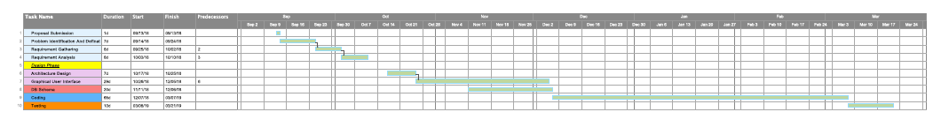
1.6 Introduction to Team member and their skill set

Umair Zahid
C/C++, android developer, good software engineering , web developer and good testing skills. Have good communication and project management skills.

Muhammad Anees
Android developer , good software engineering . Very good communication skills and aiming to become good Software Analyst in the future.

Zeeshan Ahmad Sarwar
C/C++, android developer, web developer and designer ,good testing skills. Aiming to become highly skilled Software Engineer with good communication and leadership skills.

Ali Raza
Android developer, java programmer ,highly skilled software engineering and aiming to become good Software Architecture. Very good presentation and management skills.

Muhammad Saad Mirza
Android developer, java programmer , Back end developer, much interest in embedded programming good testing skills. Aiming to work on real time applications and want to make it carrier further.

1.7 Tools and Technology with reasoning

The application tools which are to be used on back and front end of the system to be developed are listed here with reasoning:
- Software Development Life Cycle
It will be implemented during documentation phase

- Android Studio
To develop android application android studio is required
- Java
Java will be used in developing android application
- GPS
Android mobile phone’s built in GPS will be used to locate
- Ionic framework / React Native
Ionic framework is also used for UI .
- Database
SQLite and firebase
- //Microsoft Project 2013
It will be used for project management
- Google API’S

1.8 Vision Document
Our problem is that whenever we are in case of emergency , we lost so much time in arranging the ambulance and blood for patient . So , we are designing a GPS based location system and blood arrangement system that will facilitates the users using android application. Anyone can be in emergency situation at any time. So we want to make this app to facilitate the patient in emergency situation. So, we can provide emergency services as early as possible to safe the precious life and time .
Users must register on this app by signing up .At this time the system takes all the details of users. We will call the ambulance by enabling ambulance with android devices which will constantly sends the location of the ambulances and with single click of button user request will be sent to the nearest ambulance and user will track the ambulance , guide the ambulance driver through this app. User will also contact the ambulance driver as well as sent alert to the family members about the emergency situation .Users will also arrange blood through this app in case of emergency.
All of the records of users can be accessed through admin portal and the location of the ambulance and all the routes can be accessed through Android mobile application as well as blood record. Our goal is to make database so flexible, so any stakeholder can customize it into his desired needs.
And if possible we are also going to make the medical record of patient , going to inform the hospital about upcoming patient through this app but depends on time .
This system is very much feasible both economically and operationally.
Our purpose of making this app "LIFE CARE” is to facilitate the customers by providing almost all features in one app relevant to emergency. So, in case of emergency instead of getting worried, our customers will easily arrange the ambulance , track ambulance,guide ambulance driver , arrange blood, sent alerts to relative .
"Life is 10 % what happens to you and 90% how we react to it”.

1.9 Risk List
Risks are those factors which may lead to the failure of project. Risks involves different uncertain situation. Due to importance of risks they should be completely and comprehensively listed. Following are the risks that can occur in our project:
- Failure to meet the requirements till deadline
- Unavailability of hardware components
- Major change in requirements
- Lack of tools and technologies used
- Compatibility of components
- Performance issues
- Unable to get enough Data
- Security Alerts

*********************REQUIREMENTS ENGINEERING*********************

1 Introduction
Requirements engineering process provides the appropriate mechanism for understanding what the customer wants, analyzing need, assessing feasibility, negotiating a reasonable solution, specifying the solution unambiguously, validating the specification and managing the requirements as they are transformed into an operational system. The task of capturing, structuring, and accurately representing the user's requirements so that they can be correctly embodied in systems which meet those requirements (i.e. are of good quality).

- Requirements elicitation
- Requirements analysis and negotiation
- Requirements specification
- System modeling
- Requirements validation
- Requirements management

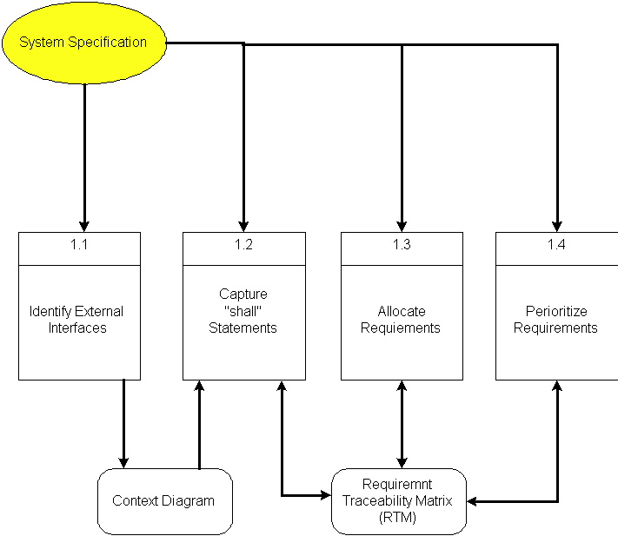

Here, requirements specification is to be discussed. Requirements specification would lead to the following four steps:
- Identify external interfaces
- Development of context diagram
- Capture “shall statements
- Allocate requirements
- Prioritize requirements
- Development of requirements traceability matrix

1.1 Systems Specifications
The following are the clauses that must be included while describing the system specifications.
Introduction
This clause should contain brief “Introduction” of the system under discussion domain knowledge. It can also contain company, its location, its historical background and its current status in the market. The most important part of this clause is to give an overview of the major business areas of the company. This overview must be very brief so that one can get a bird’s eye view of the organization under study.
Existing System
This clause must be focusing on providing a comprehensive detail of main business areas of the organizations that we have just mentioned in the previous clause. But here the discussion should be more elaborative.
Organizational Chart
Organizational chart will be very much supportive to get a better overview of the organization’s business areas and their decomposition into different departments.
Scope of the System
The Scope may include the boundaries of the system under study. To what domain you want to restrict your project must be clearly mentioned in this clause.
Summary of Requirements (Initial Requirements)
An abstract is necessary at this stage to give an understanding of the initial requirements of the system. This will show what high level requirements the proposed system must address. This abstract will act as a foundation for the future analysis of the system.

1.2 Identifying External Entities
The identification of the external entities will be based on the information contained in your Abstract. This identification is done after two phases. We will map the “Green wood” case study to make things more comprehensible.

The Identification of External Entities is done in two phases.

a. Over Specify Entities from Abstract
On the basis of the Abstract, one might identify the entities from the problem.

b. Perform Refinement
After over specifying the entities, you have to refine them on the basis of your business logic. For example, in this example we found the following entities more related to our business logic;

1.3 Context Level Data Flow Diagram
Context level data flow diagram contains only one process, representing the entire system. The process is given the number zero and all external entities are shown on the context diagram as well as major data flow to and from them. The diagram does not contain any data stores.

1.4 Capture "shall" Statements
Identify “shall” statements, as they would be all functional requirements.

1.5 Allocate Requirements
Allocate the requirements in the use cases.

1.6 Prioritize Requirements
Requirements must be prioritized as this will help achieve tasks easily. Rank them as “highest, medium, and lowest”.

1.7 Requirements Trace-ability Matrix
The requirements trace-ability matrix is a table used to trace project life cycle activities and work products to the project requirements. The matrix establishes a thread that traces requirements from identification through implementation.

1.8 Example
Here is an example to explain all the above. We are taking the system of Green Wood Company.

1.8.1 Introduction
Green Wood (GW) is a multinational company, which deals in manufacturing, delivery and selling of sports goods and sports ware throughput the world. GW deals in almost all types of support goods and has its manufacturing set-up in Sialkot, Pakistan. They have their own products selling outlets and showrooms throughout the world. They also supply their goods to other dealers on wholesale ordering basis. Currently GW is managing their operations manually. GW management has decided to completely automate the whole business processes of the company. Also in order to increase their sales, GW wants to have fully automated system, which can support online 24x7 electronic buying and selling.

1.8.2 Existing System Business Organization
GW deals in following three main business areas:

- Sport goods manufacturing
- Sport goods ordering and supply
- Consumer Outlets & Showrooms

Following departments/offices facilitates above mentioned business services:

1.8.2.1Sport Goods Manufacturing Department
Deals in manufacturing of sport goods.

1.8.2.2 GW Supplier Office
It deals in supply of sport goods to their own selling outlets or to other dealers. It also processes orders from the dealers. Following are some business processes, which are handled in this department.

- Order Management
- Customer Account Maintenance
- Order Processing
- Shipping Department
- Product Inventory
- Accounts & Administration
- CRM
- MIS
- HRM & Pay Roll
- Sales & Marketing

1.8.2.3 GW Consumer Outlets & Showrooms
They directly deals with buying and selling of goods to customers
- Shopping Centre
- Stock Maintenance
1.8.3 Business Organization Chart

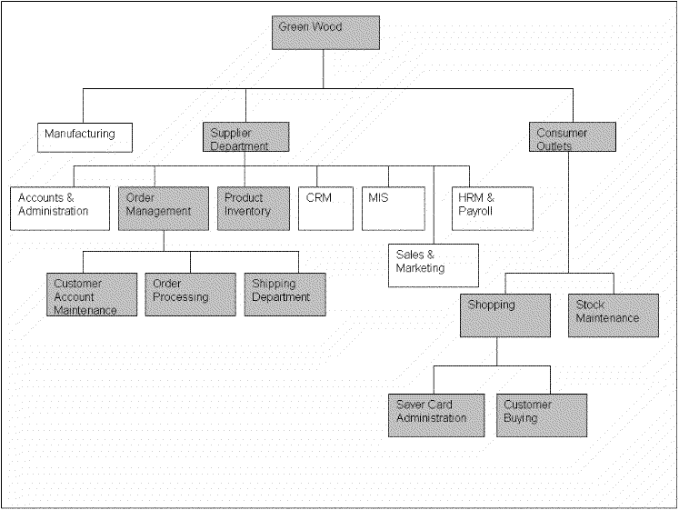

1.8.4Scope of the System
The GW System is divided in to three phases.

1.8.4.1 Phase I
Phase I includes following business areas:
- Customer Account Maintenance
- Order Processing
- Product Inventory

1.8.4.2 Phase II
Phase II involves complete automation of the Supplier Department. Phase II includes following business areas:
- Accounts and Administration
- CRM
- MIS
- HRM and Payroll
- Sales and Marketing

1.8.4.3 Phase III
Phase III covers a complete solution for Green Wood. Phase III includes remaining business areas which are not developed in previous phases.
This document scope is limited to Phase I only.

1.8.5 Summary of Requirements:(Initial Requirements)
The purposed system must fulfill following requirements as follow:

1.8.5.1 Order Management

1. Only registered customer could place order for goods. So a customer must be able to register himself to the system by requesting for registration. There should have to be two types of registration process, normal and privileged. Customer should provide his personal, organizational, authorizer and payment details in the registration request process. All the requests are to be viewed by the customer account administrator (CA). CA could accept, reject and temporarily waive the requests on the basis of credentials provided. If admin accept the registration request, a login information (Password, Id & role) should be assigned and mailed to the corresponding customer. Similarly customer could also request for the updating of his record. He could request for different types of updating e.g. updating of his personal/shipping details, or upgrading of his status from registered to privileged customer, or updating of his payment methodology. Customer could also view his details for verification purposes and similarly CA could search any customer detail and could also view the whole list of currently registered customers.

2. Both registered and privileged customers could order for goods. Customer places an order by providing his ID and other order related details A complete order must contain personal details of the customer, shipping information, product list along with product quantity and payment details. Customer could make payment either through cash or through a credit card. Accordingly invoice should be generated, and user should be given the option to finally place the order and in the end confirmation receipt must be given to the customer. Invoice contains the list of complete product along with their pricing details. It also contains discounts, sales tax and total pricing details. User could also view the status of their orders by providing the Order Number. Privileged customers could also place the request for the updating of their orders if the orders are not shipped. They could place request for the updating of shipping address and product quantity only. Similarly the privileged customer could also place the request for the cancellation of the order. But all these updating and cancellation requests are to be viewed by the Order Administrator in order to accept, reject, or waive them.

3.Action List mechanism should be adopted for better notification/messaging services, business interaction and control. An action event should be generated for a corresponding administrator when a request is placed for updating of orders or customer details etc. These actions could be generated by the Order Operator or through the updating process. Similarly on the other hand corresponding administrator could view his Action List containing different actions, and correspondingly process these pending actions. Similarly when the action processing is completed or if the action is just a notification message then administrator could delete these actions from the action list. Actions List configuration should be done by System Admin, who could add new action events and delete any current event from the system.

4. Shipping Department ships the corresponding orders.

1.8.5.2 Product Inventory

Deals with addition, searching, updating of products and their stocks. Whenever a product stock arrives, the Inventory Administrator updates the stocks of the products. He could add new product in the inventory. He could also view, search and modify the product details. The Admin could view the whole product list and their product summaries.

1.8.5.3 Consumer Dealing Department Requirements
Deals with front office customer dealing related to goods sales and marketing.

1.8.5.4 Shopping Centre
- Deals with customer registration and saver card administration
- Also deals with customer buying and returning of goods

1.8.5.5 Product Stock Maintenance
Deals with addition, searching, updating of products and their stocks.

1.8.6 Identifying External Entities or Actors
The identification of the external entities will be based on the information contained in your Abstract. This identification is done after two phases. We will map the “Green wood” case study to make things more comprehensible.
- An external entity (person or machine) that interacts with or uses the system
- Things that the project cannot control
- An actor is external to a system, interacts with the system, may be a human user or another system, and has goals and responsibilities to satisfy in interacting with the system. Actors address the question of who and what interacts with a system. In the UML, an actor is shown as a "stick figure" icon.

The Identification of External Entities or Actors is done in two phases.

1.8.7Over Specify Entities from Abstract
On the basis of the Abstract, one might identify the following entities from the Green Wood case study.

- Customer
- Order
- Order Product
- Shipment
- Invoice
- Product
- Payment
- Account
- Credit Card
- Cheque
- Request

1.8.8 Perform Refinement
After over specifying the entities, you have to refine them on the basis of your Business Logic. For example, in this example we found the following entities more related to our Business Logic;

- Customer
- Inventory
- Shipment
- Account

1.8.9 Capture "shall" Statements and the external entities (Actors)

Para # | External Entity | Initial Requirements
1.0 | customer | A customer “shall” place order for goods
1.0 | customer | A customer “shall” register himself to the system
1.0 | System | The system “shall” provide two types of registration process, normal and privileged
1.0 | CA | CA “shall” accept, reject and temporarily waive the requests on the basis of credentials provided.
1.0 | customer | A customer “shall” login to the system and can change his password
1.0 |  | System “shall” update the customers Request
1.0 |  | System “shall” process different types of updating e.g. updating of his personal/shipping details, or upgrading of his status from registered to privileged customer, or updating of his payment methodology
1.0 | customer | A customer “shall” view his details for verification purposes
1.0 |  | CA “shall”accept, reject and temporarily waive the requests on the basis of credentials provided.
1.0 |  | System “shall” search any customer details
2.0 |  | Both registered and privileged customers “will”order for goods.
2.0 | customer | Customer “shall” make payment; either through cash or through a credit card
2.0 |  | System “shall” generate invoice, confirmation receipt and finally will place order
2.0 |  | User “shall” view the status of their orders by providing the Order Number
2.0 |  | Privileged customers “shall”place the request for the updating of their orders if the orders are not shipped.
2.0 | Privileged customer | Privileged customer “shall” place the request for the cancellation of the order. But all these updating and cancellation requests are to be viewed by the Order Administrator in order to accept, reject, or waive them.
3.0 | administrator | An action event "shall" be generated for a corresponding administrator when a request is placed for updating of orders or customer details etc
3.0 | administrator | Corresponding administrator "shall" view his Action List containing different actions, and correspondingly process these pending actions
3.0 |  | When the action processing is completed or if the action is just a notification message then administrator "shall" delete these actions from the action list

1.8.10 Allocate Requirements

Para # | Initial Requirements | Use Case Name
1.0 | A customer “will” place order for goods | UC_Place_Order
1.0 | A customer “shall” register himself to the system | UC_Registration_Request
1.0 | The system “shall” provide two types of registration process, normal and privileged | UC_Place_Order_Request
1.0 | CA “shall”accept, reject and temporarily waive the requests on the basis of credentials provided. | UC_Process_Customer_Request
1.0 | A customer “shall” login to the system and can change his password | UC_Login
1.0 | System “shall” update the customers Request | UC_Update_Request
1.0 | System “shall” process different types of updating e.g. updating of his personal/shipping details, or upgrading of his status from registered to privileged customer, or updating of his payment methodology | UC_Change_Status
1.0 | A customer “shall” view his details for verification purposes | UC_View_Customer_Details
1.0 | System “shall” search any customer details | UC_Search_Customer
1.0 | CA “shall”accept, reject and temporarily waive the requests on the basis of credentials provided. | UC_Accept_Customer_Request  UC_Reject_Customer_Request  UC_View_Customer_Request
2.0 | Both registered and privileged customers “will”order for goods. | UC_Place_Order_Privleged
2.0 | Customer “will” make payment; either through cash or through a credit card | UC_Pay_For_Order
2.0 | System “will” generate invoice, confirmation receipt and finally will place order | UC_Invoice_Generation,
2.0 | User “shall” view the status of their orders by providing the Order Number | UC_Serach_Orders
2.0 | Privileged customers “shall”place the request for the updating of their orders if the orders are not shipped. | UC_Update_Request
2.0 | Privileged customer “shall” place the request for the cancellation of the order. But all these updating and cancellation requests are to be viewed by the Order Administrator in order to accept, reject, or waive them. | UC_Change_Payment_Details,  UC_Change_Status,  UC_Change_Personal_Details
3.0 | The System “shall” generate an action event for a corresponding administrator when a request is placed for updating of orders or customer details etc | UC_Create_Action,
3.0 | Corresponding administrator “shall ” view his Action List containing different actions, and correspondingly process these pending actions | UC_View_Action,

1.8.11 Priorities Requirements

Para # | Rank | Initial Requirements | Use Case ID | Use Case Name
1.0 | Highest | A customer “will” place order for goods | UC_1 | UC_PlaceOrder
1.0 | Highest | A customer “shall” register himself to the system | UC_2 | UC_Registration_Request
2.0 | Highest | Customer “will” make payment either through cash or through a credit card | UC_3 | UC_Pay_For_Order
2.0 | Highest | System “will” generate invoice, confirmation receipt and finally will place order | UC_4 | UC_Invoice_Generation,
2.0 | Medium | Both registered and privileged customers “will”order for goods. | UC_5 | UC_Place_Order_Privleged
1.0 | Medium | The system “shall” provide two types of registration process, normal and privileged | UC_6 | UC_Place_Order_Request
3.0 | Medium | The System “shall” generate an action event for a corresponding administrator when a request is placed for updating of orders or customer details etc | UC_7 | UC_Create_Action
1.0 | Medium | CA “shall”accept, reject and temporarily waive the requests on the basis of credentials provided. | UC_8  UC_9  UC_10 | UC_Accept_Customer_Request  UC_Reject_Customer_Request  UC_View_Customer_Request
1.0 | Medium | System “shall” update the customers Request | UC_11 | UC_Update_Request
1.0 | Medium | System “shall” process different types of updating e.g. updating of his personal/shipping details, or upgrading of his status from registered to privileged customer, or updating of his payment methodology | UC_12  UC_13  UC_14 | UC_Change_Payment_Details,  UC_Change_Status,  UC_Change_Personal_Details
1.0 | Medium | A customer “shall” view his details for verification purposes | UC_15 | UC_View_Customer_Details
1.0 | Medium | System “shall” search any customer details | UC_16 | UC_Search_Customer
2.0 | Medium | User “shall” view the status of their orders by providing the Order Number | UC_17 | UC_Serach_Orders
2.0 | Medium | Privileged customers “shall”place the request for the updating of their orders if the orders are not shipped. | UC_18 | UC_Update_Request
2.0 | Medium | Privileged customer “shall” place the request for the cancellation of the order. But all these updating and cancellation requests are to be viewed by the Order Administrator in order to accept, reject, or waive them. | UC_19  UC_20  UC_21 | UC_View_All_Orders  UC_Manage_Order
1.0 | Lowest | A customer “shall” login to the system and can change his password | UC_22  UC_23 | UC_Login,
3.0 | Lowest | Corresponding administrator “shall ” view his Action List containing different actions, and correspondingly process these pending actions | UC_24 | UC_View_Action,
3.0 | Lowest | When the action processing is completed or if the action is just a notification message then administrator “shall” delete these actions from the action list | UC_25 | UC_Delete_Action

1.8.12 Requirements Traceability Matrix

Sr# | Para # | System Specification Text | Build | Use Case Name | Category
1 | 1.0 | A customer “will” place order for goods | B1 | UC_Place_Order | Business
2 | 1.0 | A customer “shall” register himself to the system | B1 | UC_Registration_Request | Business
3 | 1.0 | The system “shall” provide two types of registration process, normal and privileged | B1 | UC_PlaceOrderRequest,  UC_PlaceCustomerRequest | Business
4 | 1.0 | CA “shall”accept, reject and temporarily waive the requests on the basis of credentials provided. | B1 | UC_Accept_Customer_Request  UC_Reject_Customer_Request  UC_View_Customer_Request | Business
5 | 1.0 | A customer “shall” login to the system and can change his password | B1 | UC_Login, | Business
6 | 1.0 | System “shall” update the customers Request | B1 | UC_Update_Request | Business
7 | 1.0 | System “shall” process different types of updating e.g. updating of his personal/shipping details, or upgrading of his status from registered to privileged customer, or updating of his payment methodology | B1 | UC_Change_Payment_Details,  UC_Change_Status,  UC_Change_Personal_Details | Business
8 | 1.0 | A customer “shall” view his details for verification purposes | B1 | UC_View_Customer_Details | Business
9 | 1.0 | System “shall” search any customer details | B1 | UC_SearchCustomer | Business
10 | 2.0 | Both registered and privileged customers “will”order for goods. | B1 | UC_Place_Order_Privellged | Business
11 | 2.0 | Customer “will” make payment; either through cash or through a credit card | B1 | UC_Pay_For_Order | Business
12 | 2.0 | System “will” generate invoice, confirmation receipt and finally will place order | B1 | UC_Invoice_Generation | Business

1.9 High Level Usecase Diagram
A use case scenario is a visual description, typically written in structured English or point form, of a potential business situation that a system may or may not be able to handle.
A use case defines a goal-oriented set of interactions between external actors and the system under consideration.
A use case is initiated by a user with a particular goal in mind, and completes successfully when that goal is satisfied. It describes the sequence of interactions between actors and the system necessary to deliver the service that satisfies the goal. It also includes possible variants of this sequence, e.g., alternative sequences that may also satisfy the goal, as well as sequences that may lead to failure to complete the service because of exceptional behavior, error handling, etc. The system is treated as a “black box”, and the interactions with system, including system responses, are as perceived from outside the system.
Thus, use cases capture who (actor) does what (interaction) with the system, for what purpose (goal), without dealing with system internals. A complete set of use cases specifies all the different ways to use the system, and therefore defines all behavior required of the system, bounding the scope of the system.
Generally, use case steps are written in an easy-to-understand structured narrative using the vocabulary of the domain. This is engaging for users who can easily follow and validate the use cases, and the accessibility encourages users to be actively involved in defining the requirements.

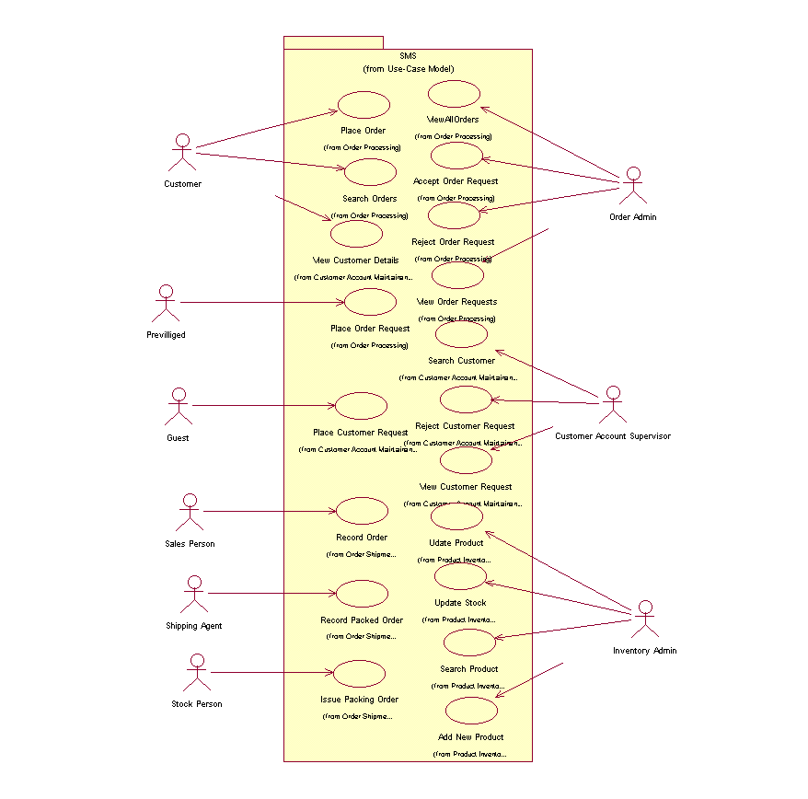
Example

