Mcsf19a029

**Lecture1-3:**

***Install git.***

1. First task is to create an account on github and create a repository.

Here is the link to my repository below.

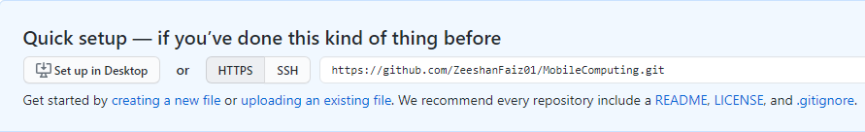

https://github.com/ZeeshanFaiz01/MobileComputing.git

1. Second task is to create a folder and then create a clone of our repository in that folder and I’m doing that using Git Bash.

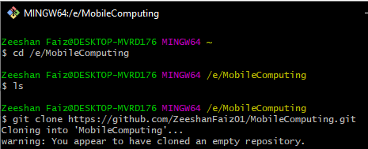

A cloned repository has been created in my local directory

E:\MCPics\3.PNG

1. Third task is to save any file in the cloned or we can say local repository.

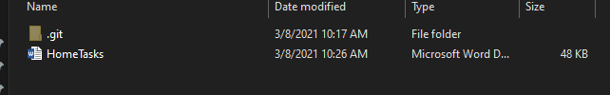

1. Fourth task is to add this file in the central repository using Git Bash.

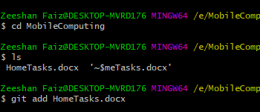

1. Fifth task is to commit.

While Committing, Git Bash Requires my username and email address

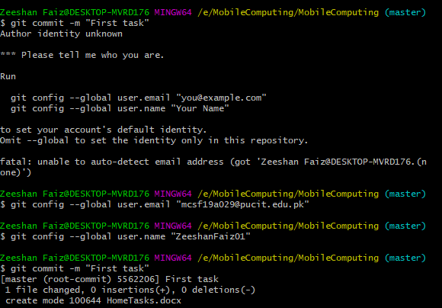

1. We can also check our status of repository using a command (git status).

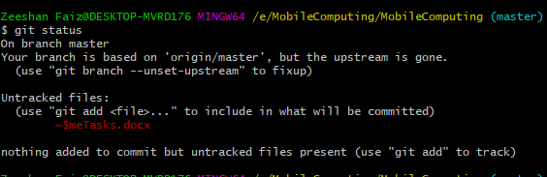

1. Sixth task is to push the file from local repository to the central repository.

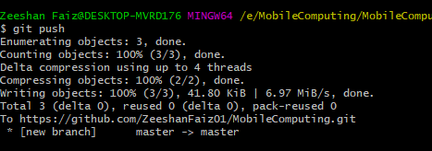

1. Now, the file has been uploaded to the central repository.

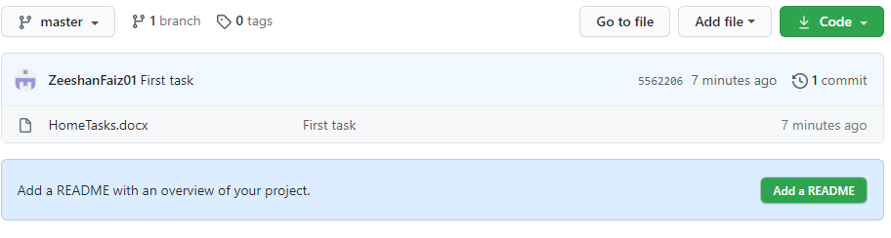

1. Now, if we want to edit our file in the local repository, we’ll change according to our need and then apply the same procedure on Git Bash from git add command to git push command.

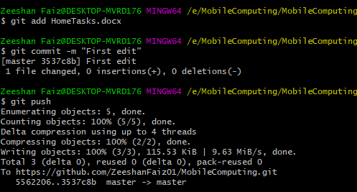

1. Changes have been done as you can see below.

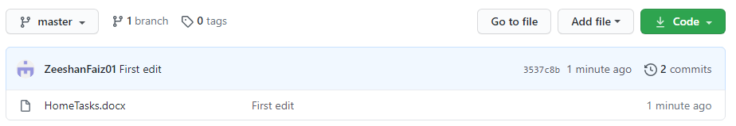

1. We can apply different commands just like to delete file, for branching but will do when needed. We can also remove the merging conflicts. I’ll apply all the commands by the time when needed.
2. We can also make changes in the file from the central repository. But when we make changes in the central repository we need to apply “**git pull”** command to pull the changings form the central repository to the local repository.