**Evaluation Only. Created with Aspose.Words. Copyright 2003-2016 Aspose Pty Ltd.**

Licensing .NET Applications

Introduction to Licensing

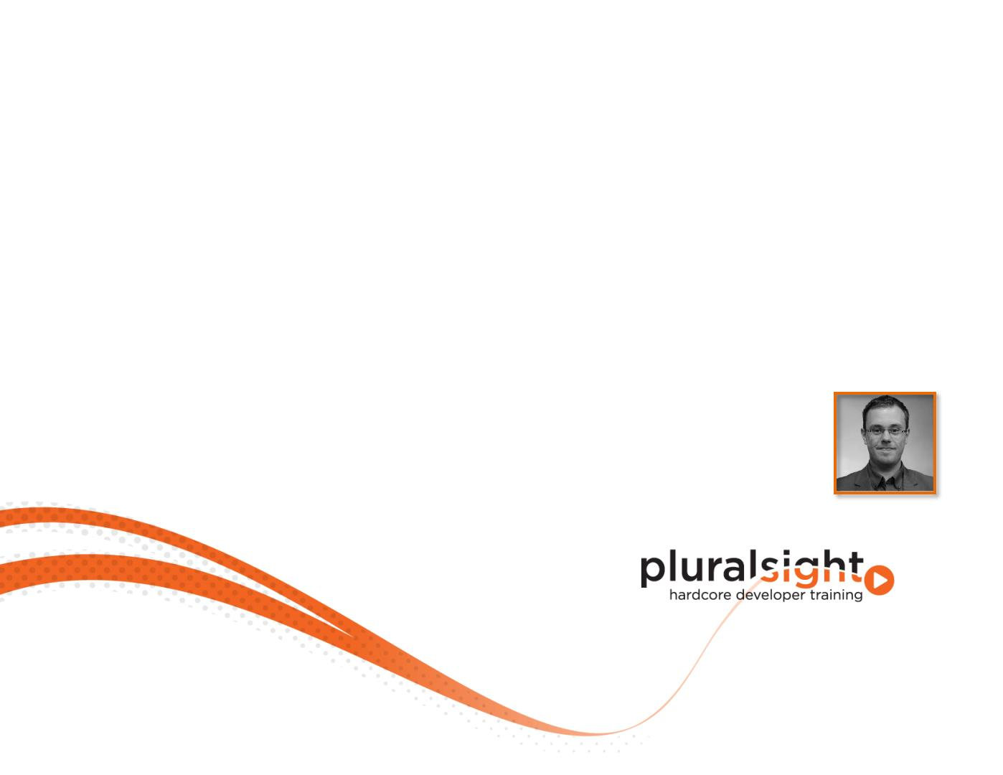

Evaluation Only. Created with Aspose.Pdf. Copyright 2002-2016 Aspose Pty Ltd.

What is a License?

. Refers to a given permission

The permission itself

To the document recording the permission

Legal instrument governing specific rights

. What about a software license?

The same as a “normal“ license

Use or redistribute an application or code

End User License Agreement (EULA)

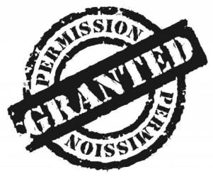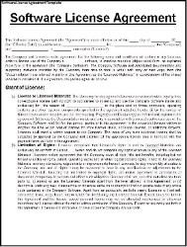

Evaluation Only. Created with Aspose.Pdf. Copyright 2002-2016 Aspose Pty Ltd.

What is a License?

Organizational point of view

Legal instrument refers to permissions

Technical point of view

Grants a right to use software code to someone else

