SECTION A: CONTAINERIZATION:
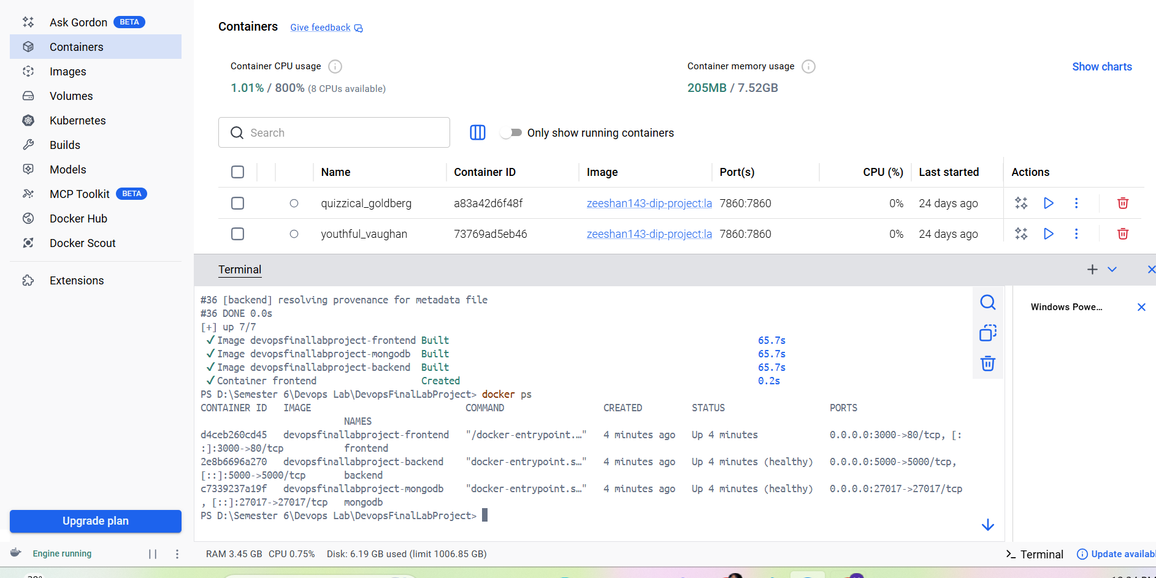

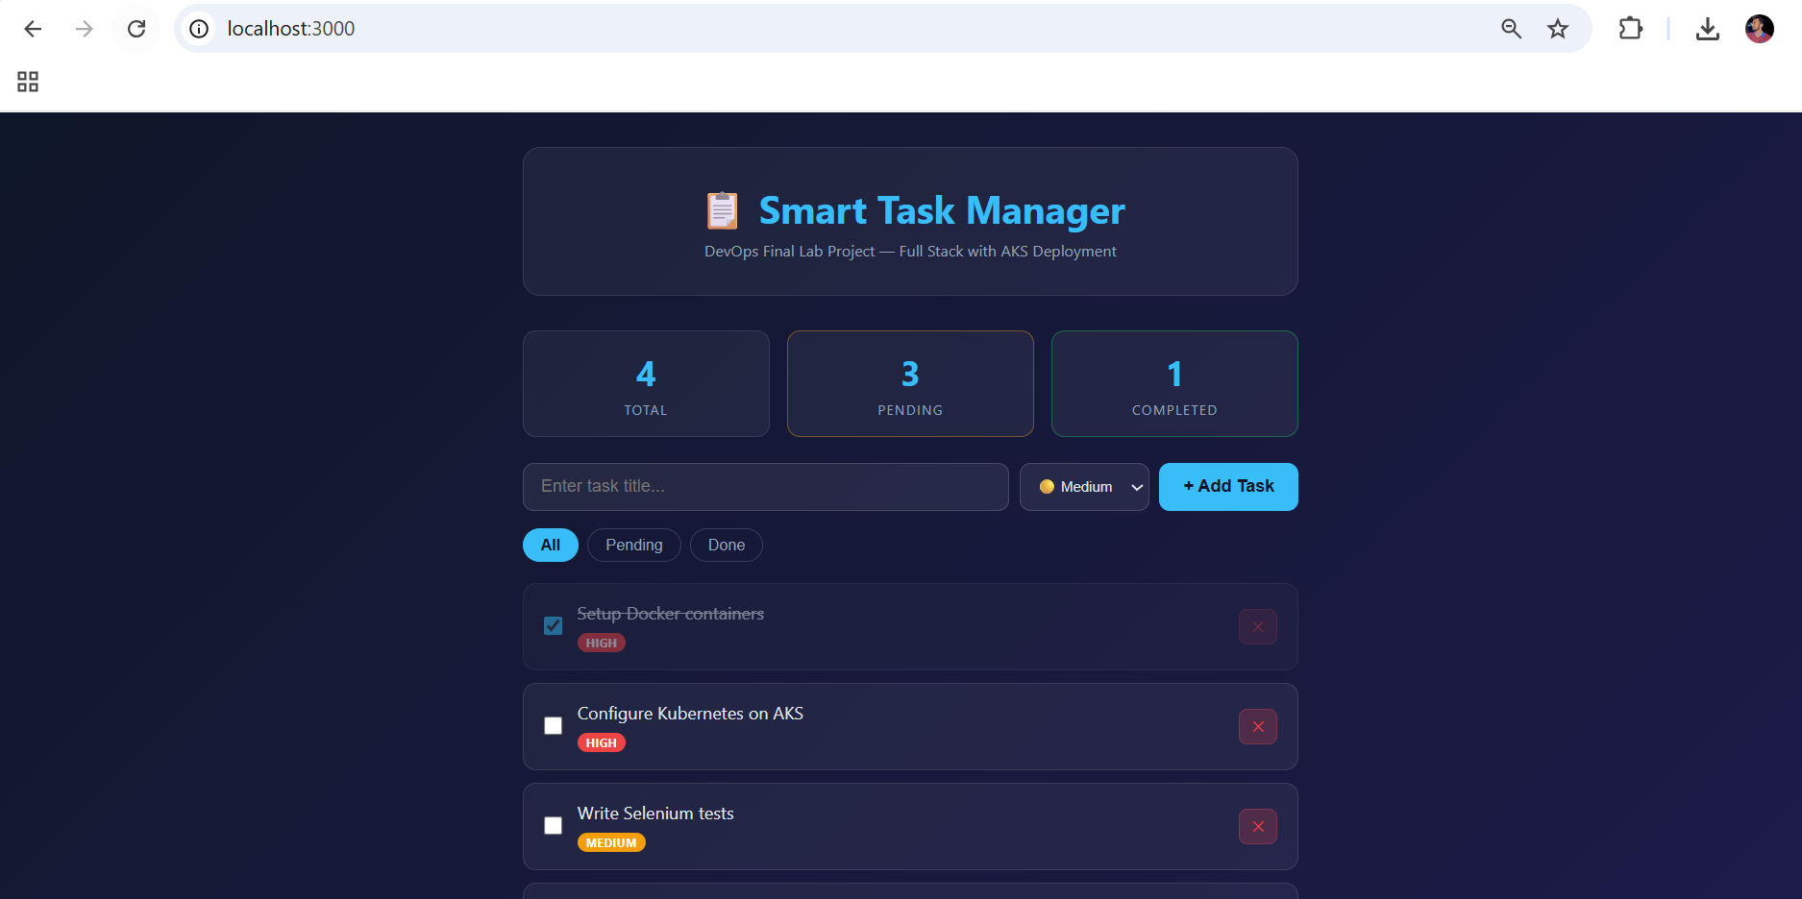

SECTION B: CI/CD AUTOMATION:
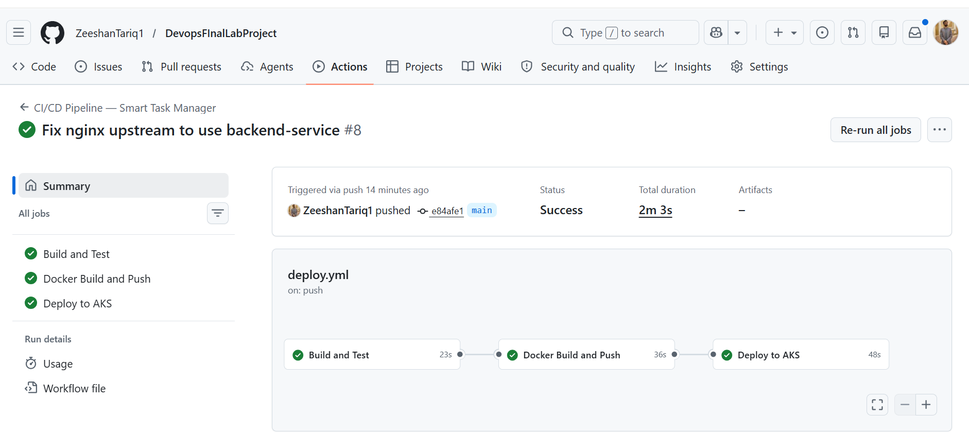

Deploy.yml:
name: CI/CD Pipeline — Smart Task Manager

on:
push:
branches: [ main ]
pull_request:
branches: [ main ]

env:
DOCKER_USERNAME: ${{ secrets.DOCKER_USERNAME }}
IMAGE_BACKEND: ${{ secrets.DOCKER_USERNAME }}/taskmanager-backend
IMAGE_FRONTEND: ${{ secrets.DOCKER_USERNAME }}/taskmanager-frontend

jobs:

# ─── STAGE 1: Build & Test ───────────────────────────────────────
build-and-test:
name: Build and Test
runs-on: ubuntu-latest

steps:
- name: Checkout code
uses: actions/checkout@v3

- name: Setup Node.js
uses: actions/setup-node@v3
with:
node-version: '18'

- name: Install backend dependencies
run: |
cd backend
npm install

- name: Run backend tests
run: |
cd backend
npm test

- name: Install frontend dependencies
run: |
cd frontend
npm install

- name: Build frontend
run: |
cd frontend
npx vite build

# ─── STAGE 2: Docker Build & Push ────────────────────────────────
docker-build-push:
name: Docker Build and Push
runs-on: ubuntu-latest
needs: build-and-test

steps:
- name: Checkout code
uses: actions/checkout@v3

- name: Login to Docker Hub
uses: docker/login-action@v2
with:
username: ${{ secrets.DOCKER_USERNAME }}
password: ${{ secrets.DOCKER_PASSWORD }}

- name: Build and push backend image
uses: docker/build-push-action@v4
with:
context: ./backend
push: true
tags: |
${{ env.IMAGE_BACKEND }}:latest
${{ env.IMAGE_BACKEND }}:${{ github.sha }}

- name: Build and push frontend image
uses: docker/build-push-action@v4
with:
context: ./frontend
push: true
tags: |
${{ env.IMAGE_FRONTEND }}:latest
${{ env.IMAGE_FRONTEND }}:${{ github.sha }}

# ─── STAGE 3: Deploy to AKS ──────────────────────────────────────
deploy-to-aks:
name: Deploy to AKS
runs-on: ubuntu-latest
needs: docker-build-push
if: github.ref == 'refs/heads/main'

steps:
- name: Checkout code
uses: actions/checkout@v3

- name: Login to Azure
uses: azure/login@v1
with:
creds: ${{ secrets.AZURE_CREDENTIALS }}

- name: Get AKS credentials
run: |
az aks get-credentials \
--resource-group ${{ secrets.AKS_RESOURCE_GROUP }} \
--name taskmanager-aks \
--overwrite-existing

- name: Deploy to AKS
run: |
kubectl apply -f k8s/mongo-deployment.yaml
kubectl apply -f k8s/backend-deployment.yaml
kubectl apply -f k8s/frontend-deployment.yaml
kubectl rollout restart deployment/backend
kubectl rollout restart deployment/frontend

- name: Wait for deployments
run: |
kubectl rollout status deployment/backend --timeout=120s
kubectl rollout status deployment/frontend --timeout=120s

- name: Show running pods
run: kubectl get pods

SECTION C: KUBERNETES ON AZURE (AKS):
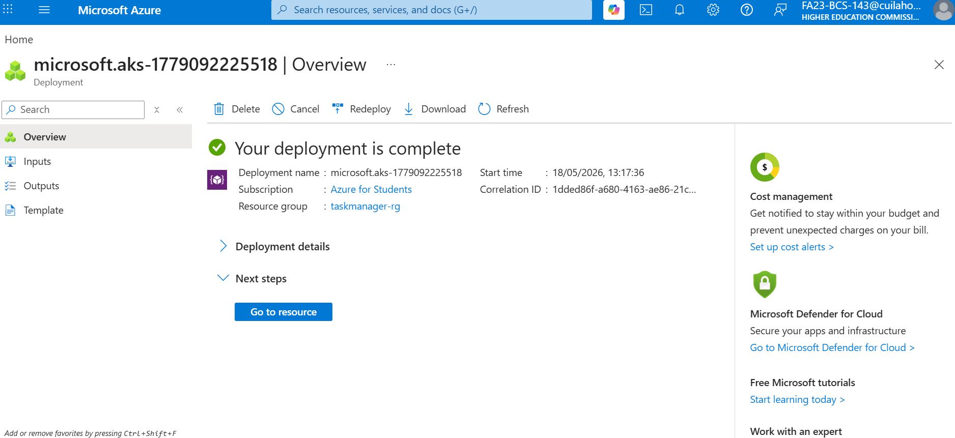

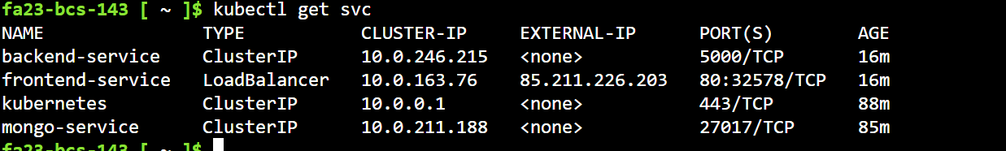

External IP Deployment of Website:
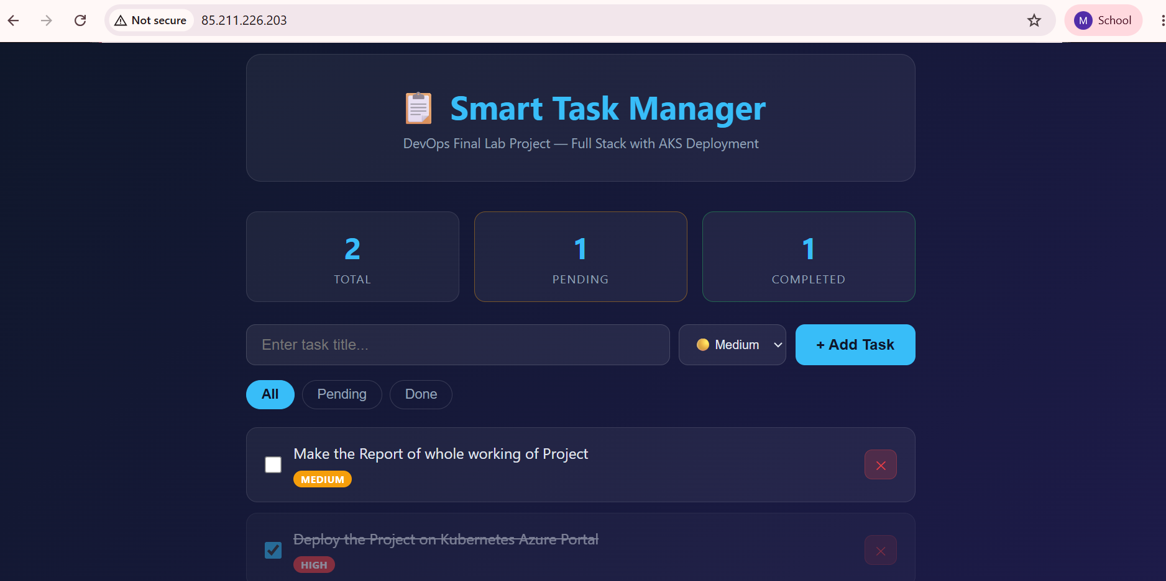

SECTION D: SELENIUM AUTOMATED TESTING

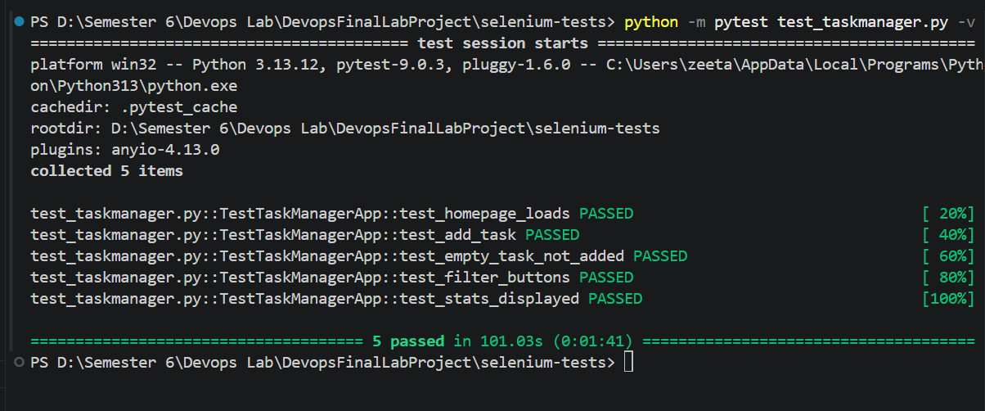

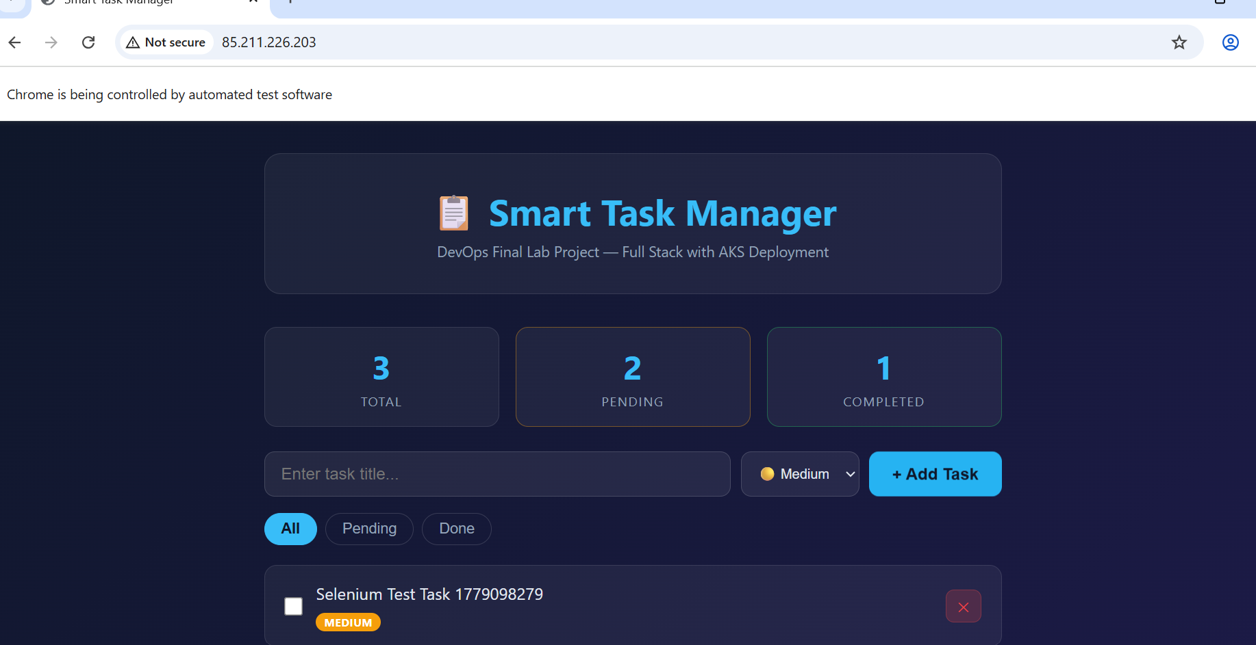

Python Script:

import pytest
import time
from selenium import webdriver
from selenium.webdriver.common.by import By
from selenium.webdriver.common.keys import Keys
from selenium.webdriver.chrome.service import Service
from selenium.webdriver.chrome.options import Options
from selenium.webdriver.support.ui import WebDriverWait
from selenium.webdriver.support import expected_conditions as EC
from webdriver_manager.chrome import ChromeDriverManager

# Change this to your actual URL when testing against AKS
# For local testing use: http://localhost:3000
APP_URL = "http://85.211.226.203/"

@pytest.fixture
def driver():
"""Setup Chrome browser for each test"""
options = Options()

options.add_argument("--no-sandbox")
options.add_argument("--disable-dev-shm-usage")
options.add_argument("--window-size=1280,800")

service = Service(ChromeDriverManager().install())
driver = webdriver.Chrome(service=service, options=options)
driver.implicitly_wait(10)

yield driver # Give driver to each test

driver.quit() # Close browser after each test

class TestTaskManagerApp:

# ── Test 1: Homepage loads correctly ─────────────────────────────
def test_homepage_loads(self, driver):
"""Verify the homepage loads with correct title and heading"""
driver.get(APP_URL)
time.sleep(2)

# Check page title
assert "Task Manager" in driver.title or driver.title != "", \
f"Page title is empty, got: {driver.title}"

# Check main heading exists
heading = driver.find_element(By.TAG_NAME, "h1")
assert "Task Manager" in heading.text, \
f"Heading not found, got: {heading.text}"

# Check form is visible
task_input = driver.find_element(By.ID, "task-input")
assert task_input.is_displayed(), "Task input field is not visible"

print(" Test 1 PASSED: Homepage loaded correctly")

# ── Test 2: Add a new task ────────────────────────────────────────
def test_add_task(self, driver):
"""Verify that adding a task works and appears in the list"""
driver.get(APP_URL)
time.sleep(2)

# Find input field and type a task
task_input = driver.find_element(By.ID, "task-input")
task_title = "Selenium Test Task " + str(int(time.time()))
task_input.clear()
task_input.send_keys(task_title)

# Select priority
priority_select = driver.find_element(By.ID, "priority-select")
priority_select.send_keys("High")

# Click Add Task button
add_btn = driver.find_element(By.ID, "add-btn")
add_btn.click()

# Wait for task to appear in list
time.sleep(2)

# Verify task appears in the page
page_source = driver.page_source
assert task_title in page_source, \
f"Task '{task_title}' was not found in the page after adding"

print(f" Test 2 PASSED: Task '{task_title}' added successfully")

# ── Test 3: Form validation — empty task ─────────────────────────
def test_empty_task_not_added(self, driver):
"""Verify that submitting empty task does not add anything"""
driver.get(APP_URL)
time.sleep(2)

# Get current number of tasks
task_items_before = driver.find_elements(By.CSS_SELECTOR, "[data-testid='task-item']")
count_before = len(task_items_before)

# Try to add empty task
task_input = driver.find_element(By.ID, "task-input")
task_input.clear() # Make sure it's empty

add_btn = driver.find_element(By.ID, "add-btn")
add_btn.click()
time.sleep(1)

# Count tasks after — should be same
task_items_after = driver.find_elements(By.CSS_SELECTOR, "[data-testid='task-item']")
count_after = len(task_items_after)

assert count_after == count_before, \
f"Empty task was added! Before: {count_before}, After: {count_after}"

print(" Test 3 PASSED: Empty task correctly rejected")

# ── Test 4: Filter buttons work ───────────────────────────────────
def test_filter_buttons(self, driver):
"""Verify All, Pending, Done filter buttons are present and clickable"""
driver.get(APP_URL)
time.sleep(2)

# Find all filter buttons
filter_buttons = driver.find_elements(By.CSS_SELECTOR, ".filter-btn")
assert len(filter_buttons) >= 3, \
f"Expected at least 3 filter buttons, found {len(filter_buttons)}"

# Click each filter button
for btn in filter_buttons:
btn.click()
time.sleep(0.5)
assert "active" in btn.get_attribute("class"), \
f"Filter button '{btn.text}' did not become active after click"

print(" Test 4 PASSED: All filter buttons work correctly")

# ── Test 5: Stats section shows numbers ──────────────────────────
def test_stats_displayed(self, driver):
"""Verify stats cards (Total, Pending, Completed) are displayed"""
driver.get(APP_URL)
time.sleep(2)

stat_cards = driver.find_elements(By.CSS_SELECTOR, ".stat-card")
assert len(stat_cards) == 3, \
f"Expected 3 stat cards, found {len(stat_cards)}"

# Each stat card should have a number
for card in stat_cards:
num = card.find_element(By.CSS_SELECTOR, ".stat-num")
assert num.text.isdigit(), \
f"Stat number is not a digit: {num.text}"

print(" Test 5 PASSED: Stats section displays correctly")

if __name__ == "__main__":
pytest.main([__file__, "-v", "--tb=short"])

