**VIRTUAL DESKTOP ASSISTANT USING PYTHON**

1**Zeeshan Raza, 2Aftab Amin Sheikh, 3Ankush Shahu, 4Abhijeet Thakur, 5Ruhina Quazi**

1234Student,Department of Electronic and Telecommunication Engineering, Anjuman College of Engineering and Technology, Nagpur, Maharashtra, India

5Assistant Professor, Department of Electronic and Telecommunication Engineering, Anjuman College of Engineering and Technology, Nagpur, Maharashtra, India

1[zeeshanzx26@gmail.com](mailto:zeeshanzx26@gmail.com), 2[aftabsheikh449@gmail.com](mailto:aftabsheikh449@gmail.com), 3[ankushshahu1998@gmail.com](mailto:ankushshahu1998@gmail.com), [4abhijeett64@gmail.com](mailto:4abhijeett64@gmail.com), 5rquazi@anjumanengg.edu.in

**ABSTRACT**

This project thesis looks at how new technologies can be used to develop an intelligent Virtual Desktop Assistant that focuses on user-based data. It will analyze the possible utility of one single piece of software as a Virtual Desktop Assistant by looking at examples of intelligent programs with natural language processing that are now available, with various categories of support. Natural Language Processing is used to activate the ability to communicate socially, storing (and evaluating) information in the context of the user. New technology, it is suggested, may soon make the concept of virtual assistants a reality. Experiments conducted on this system, combined with user testing, have provided evidence that a basic program with natural language processing algorithms in the form of a Virtual Desktop Assistant, with basic natural language processing and the ability to function without the need for other type of human input (or programming) may already be viable.

***Keywords*:** Voice Assistant, Desktop Voice Assistant, Python Project, Assistant using Python and Virtual Assistant.

1. **INTRODUCTION**

Human interaction is rapidly being supplanted by. Performance is one of the key reasons behind this shift. Rather than progress, technology has undergone a significant transformation. In today's world, we use technologies like Machine Learning and Neural Networks to teach our machines to do their jobs on their own or to think like people. With the help of virtual assistants, we may now communicate with our machines in the modern world. Companies such as Google, Apple, Microsoft, and others have virtual assistants such as Google Now, Siri, and Alexa that allow users to operate their machines just by speaking to them. These types of virtual assistants are beneficial to the elderly, the visually and physically challenged, children, and others by ensuring that interacting with machines is no longer a challenge. Even blind persons who are unable to see the computer can communicate with it just through their voice. The following are some of the basic tasks that most virtual assistants can help with:

* Previous year question papers (RTMNU)
* Aggregate Percentage Calculator
* Search on Wikipedia
* Stream Binaural Beats
* Open Any Websites
* Random Password Generator etc.

Our voice assistant is a desktop-based application created with Python modules and libraries. This assistant is only a basic version that can do all of the duties listed above, but current technology, while impressive, still has to be combined with Machine Learning and the Internet of Things (IoT) for greater results. The understanding and executing commands are still to reach a new level like the virtual assistant of the iron man named Jarvis.

Although this is a work of fiction, it is possible to achieve with virtual assistants. All you have to do is give the assistant a command, and the assistant will take care of the rest. There will be no need to write extensive codes to execute a task with the help of voice-activated virtual assistants; the system will do it for us. Depending on the application, the machine will operate in one of three modes: supervised, unsupervised, or reinforcement learning. All of this is feasible because to machine learning.

1. **METHODOLOGY**
   1. **PROPOSED SYSTEM: -**

* The system to be developed here is a Virtual Desktop Assistant.
* This system is based on Functional Programming.
* The main structure is linked with small modules containing specific task which is to be performed.
* The keyword “import” is used to link all the small modules with main structure.
* This Virtual Assistant can be used to perform multiple tasks such as getting Aggregate Percentage (RTMNU), Random Password Generator, etc.
* Basically, it provides helping hand to all the students.
  1. **BLOCK DIAGRAM**

USER INPUT (VOICE CMD)

PERFORM THE TASK

DISPLAY OUTPUT

CMD

ASSISTANT

TAKING USER INPUT AGAIN

CONVERT THE VOICE INPUT INTO TEXT

Fig. 1 Block diagram of Electro

1. **User Input (Voice Command):** Initially, the assistant electro will greet the user with respect to time and then ask the user for task and then listen to it.
2. **Assistant:** Here the assistant consists of three sub blocks i.e.
   * + Convert The Voice Input into Text:
     + Perform The Task:
     + Display Output:
3. **Convert The Voice Input into Text:**

Here with the help of speech recognition module the electro will convert the input command into text.

1. **Perform The Task:**

Now according to the user input the electro will perform the task.

1. **Display Output:**

The result of the given task is shown here.

1. **Feedback:** The assistant will run in a loop i.e., keep asking for the input and the performing the tasks until “turn off” command is given. The turn off command will break the loop.
   1. **FLOW DIAGRAM**

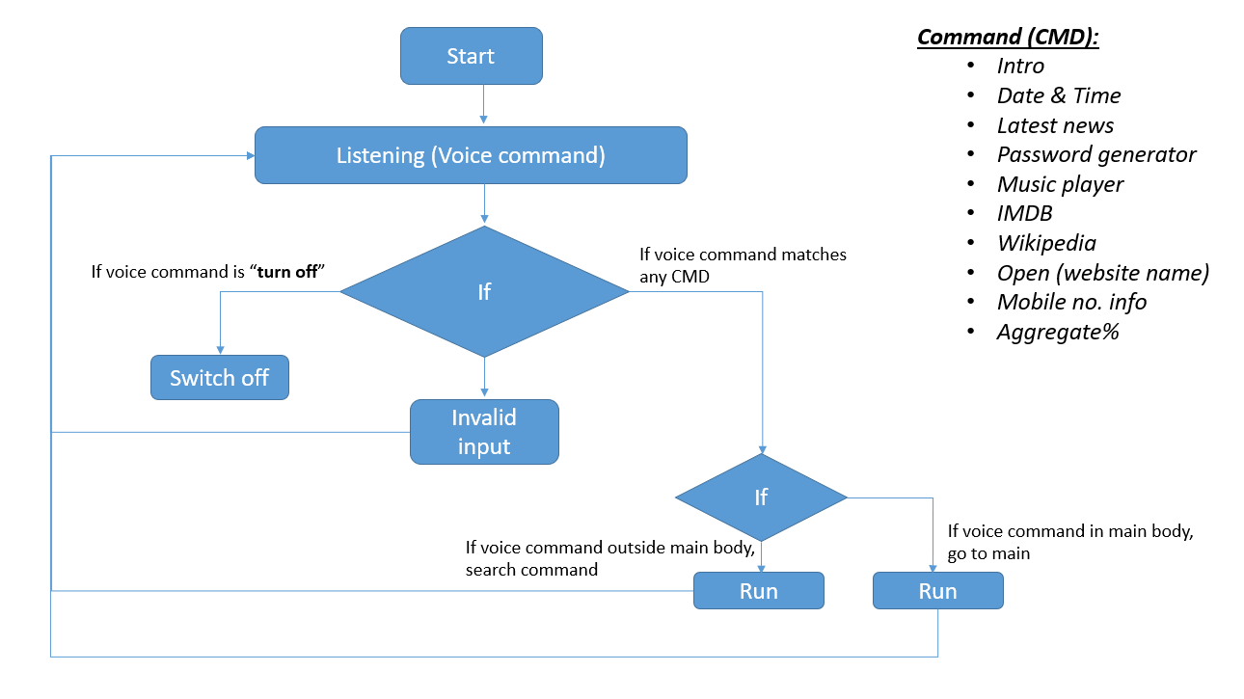

Figure 1 Flowchart of Virtual Desktop Assistant (Electro)

* This is the flowchart of our virtual desktop assistant.
* When we run the program, it starts with greeting the user according to time, like good morning, good afternoon.
* After this, it will start listening to the user’s voice command, and recognizes the command.
* If the given command matches any of the following command then it will search for the particular function whether it is present in the main body or not.
* Wherever it is present it will execute the command and after successful execution it will go back to the listening mode.
* If it does not match or recognize the user’s voice command then it says “Invalid input” and again go back to listening mode.
* To finish the software, the user must say turn off, and the loop will be broken.

1. **RESULT ANALYSIS**

We've created a voice assistant that can perform any task in exchange for commands from users without making any mistakes. We've added more functionality, such as listening to the user's speech solely and not being activated by background noise. This project's modular structure makes it simple to comprehend and more adaptable. More features can be added without affecting the program's overall functionality. The essential Python packages have been installed, and the code was written using the Visual Studio Code Integrated Development Environment (IDE).

1. **CONCLUSION**

How quickly did the time pass? When we go back twenty years, Voice Recognition was still in its infancy. When the computer system first appeared, it was a pipe dream to have full-fledged interaction with the machine. Now we can chat, question, and even give orders to complete the task.

This technological innovation is propelling the planet forward. When we consider the future capabilities of voice recognition and facial detection, we can see how they can assist security services in verifying criminal details and so on. If we look back two decades, our remarks might not have carried as far as we could have expected.

Desktop Assistant performs many of the same functions as a smartphone, such as managing several applications via voice commands. It allows you to access the system without having to type anything. An individual can access the system using facial recognition, and face detection helps to secure the data by ensuring that no other person can access the system. It employs machine learning algorithms and assists users in gaining secure access.

1. **REFERENCES**
2. Zwass V. Speech Recognition [Internet]. Encyclopedia Britannica Online: 2016; [cited 2019 April 7].
3. Markowitz J. Toys That Have a Voice. Speech Technology Magazine [Internet]. 2003 March [cited 2019 April 7].
4. Pinola M. Speech Recognition Through the Decades: How We Ended Up with Siri. PC World [Internet]. 2011 November 2 [Cited 2019 April 7].
5. Swapnil Saurav, Python Programing-learn and practice (2nd Edition). Ingram short title; 2018 January 1
6. Grant Smith, Everything You Need To Ace Computer Science in One Big Fat Notebook, Workman Publishing Co. Inc., 2020 March.