import random

def uniform_sample(a, b):

return a + (b - a) * random.random()

# function ke bahar print karna hai print(uniform_sample(1,2))

print(uniform_sample(3,6)) print(uniform_sample(5,9))

1.8539430777857777

4.335120946780651

5.691480126887752

import random

def create_samples_list(a,b,n):

return [ round(a+ (b - a) * random.random(),2) for _ in range(n)] print(create_samples_list(4, 8, 5))

[7.6, 6.82, 5.8, 6.12, 7.78]

 Exercise 1

Write a function that samples a uniform random number from a to b. Use function random.random from package random

Double-click (or enter) to edit

 Exercise 2

Write a function that creates a list of length n of samples like in Excercise 1.

Double-click (or enter) to edit

 Exercise 3

Write a function that computes an average of a list of numbers.

# Function to compute average of a list of numbers

def average(numbers):

if len(numbers) == 0: return None

total = sum(numbers) count = len(numbers) return total / count

# Example runs

print(average([2, 4, 6, 8]))

print(average([10, 20, 30]))

#print(average([]))

5.0

20.0

import random

def uniform_sample(a, b):

return a + (b - a) * random.random()

def create_samples_list(n, a, b):

return [uniform_sample(a, b) for _ in range(n)]

def average(numbers):

if len(numbers) == 0: return None

return sum(numbers) / len(numbers)

def create_m_lists_and_averages(m, n, a, b):

lists = [create_samples_list(n, a, b) for _ in range(m)] averages = [average(lst) for lst in lists]

return lists, averages

lists, averages = create_m_lists_and_averages(3, 5, 1, 10)

print("Lists:")

for i, lst in enumerate(lists, start=1): print(f"List {i}: {lst}")

print("\nAverages:")

for i, avg in enumerate(averages, start=1): print(f"Average of list {i}: {avg}")

Lists:

List 1: [2.950421135269705, 4.800990696600179, 9.290161588734842, 5.407052885969666, 3.2599671817784244]

List 2: [3.5816151126403972, 1.7829453041341452, 6.172638635918153, 9.360629740992055, 6.4776590960404645]

List 3: [2.9378220519172022, 8.04812858598691, 3.7678743891092044, 2.9503757551095315, 6.821713812844199]

Averages:

Average of list 1: 5.141718697670563

Average of list 2: 5.475097577945043

Average of list 3: 4.905182918993409

 Exercise 4

Write a function that creates m lists like in Exercise 2 and computes average of each list

Create a list of averages of numbers between 1.0 and 2.0. Make each list of size 10. Vary number of averages from 100 to 10000. Adjust number of bins in the histogram for the best visualization.

Use matplotlib library as follows: from matplotlib import pyplot as plt

plt.figure() plt.hist(array, bins=50) plt.show()

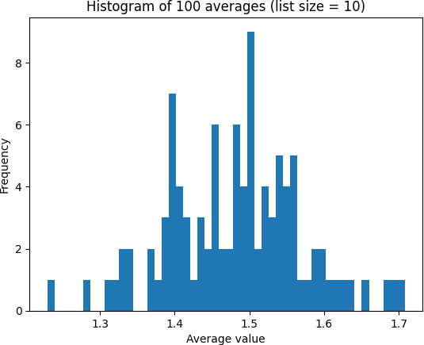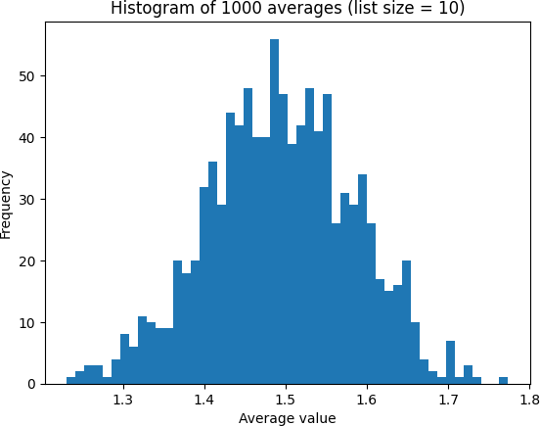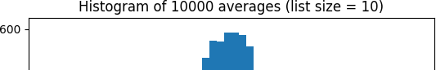

import random

from matplotlib import pyplot as plt

def create_averages(num_averages, list_size=10, a=1.0, b=2.0): averages = []

for _ in range(num_averages):

numbers = [a + (b - a) * random.random() for _ in range(list_size)] avg = sum(numbers) / len(numbers)

averages.append(avg) return averages

for num_averages in [100, 1000, 10000]:

avg_list = create_averages(num_averages)

plt.figure()

plt.hist(avg_list, bins=50)

plt.title(f"Histogram of {num_averages} averages (list size = 10)") plt.xlabel("Average value")

plt.ylabel("Frequency") plt.show()

