Can we trust the objective ~ subjective model in Experiment 4?
Ensemble Phenomenology of Colour — analysis note
Question. Experiment 4 (stimulus variance, SD 3/5/7; 52 average and 51 experience participants, ~210 trials each) was analysed in both directions. The two models disagree sharply in effect size. Before we use the reverse model to test the exaggeration hypothesis, we need to know whether that disagreement reflects something about perception or something about the measure.
Short answer. The data are sound and both models are correctly fitted, but the reverse slope cannot carry the exaggeration claim: its near-null result is an arithmetic cancellation, not a finding. The claim is testable — and significant — in a different form, on the same data. No new data collection is needed for this question.

1. What the two models say
Both are linear mixed models with the predictor centred within participant and random intercepts and slopes by participant.
Forward, report ~ objective mean. The slope is the transfer function: 1 means the report tracks the stimulus one-to-one, below 1 means compression toward the participant’s own mean.
 | SD 3 | SD 5 | SD 7
experience | 1.095 | 0.966 | 0.859
average | 1.073 | 0.916 | 0.777

Objective mean × variance: F(2, 10584) = 68.22, p < .001 (experience); F(2, 10668) = 115.57, p < .001 (average); F(2, 21254) = 180.37, p < .001 combined. Every pairwise step is significant at p < .001 in both conditions.
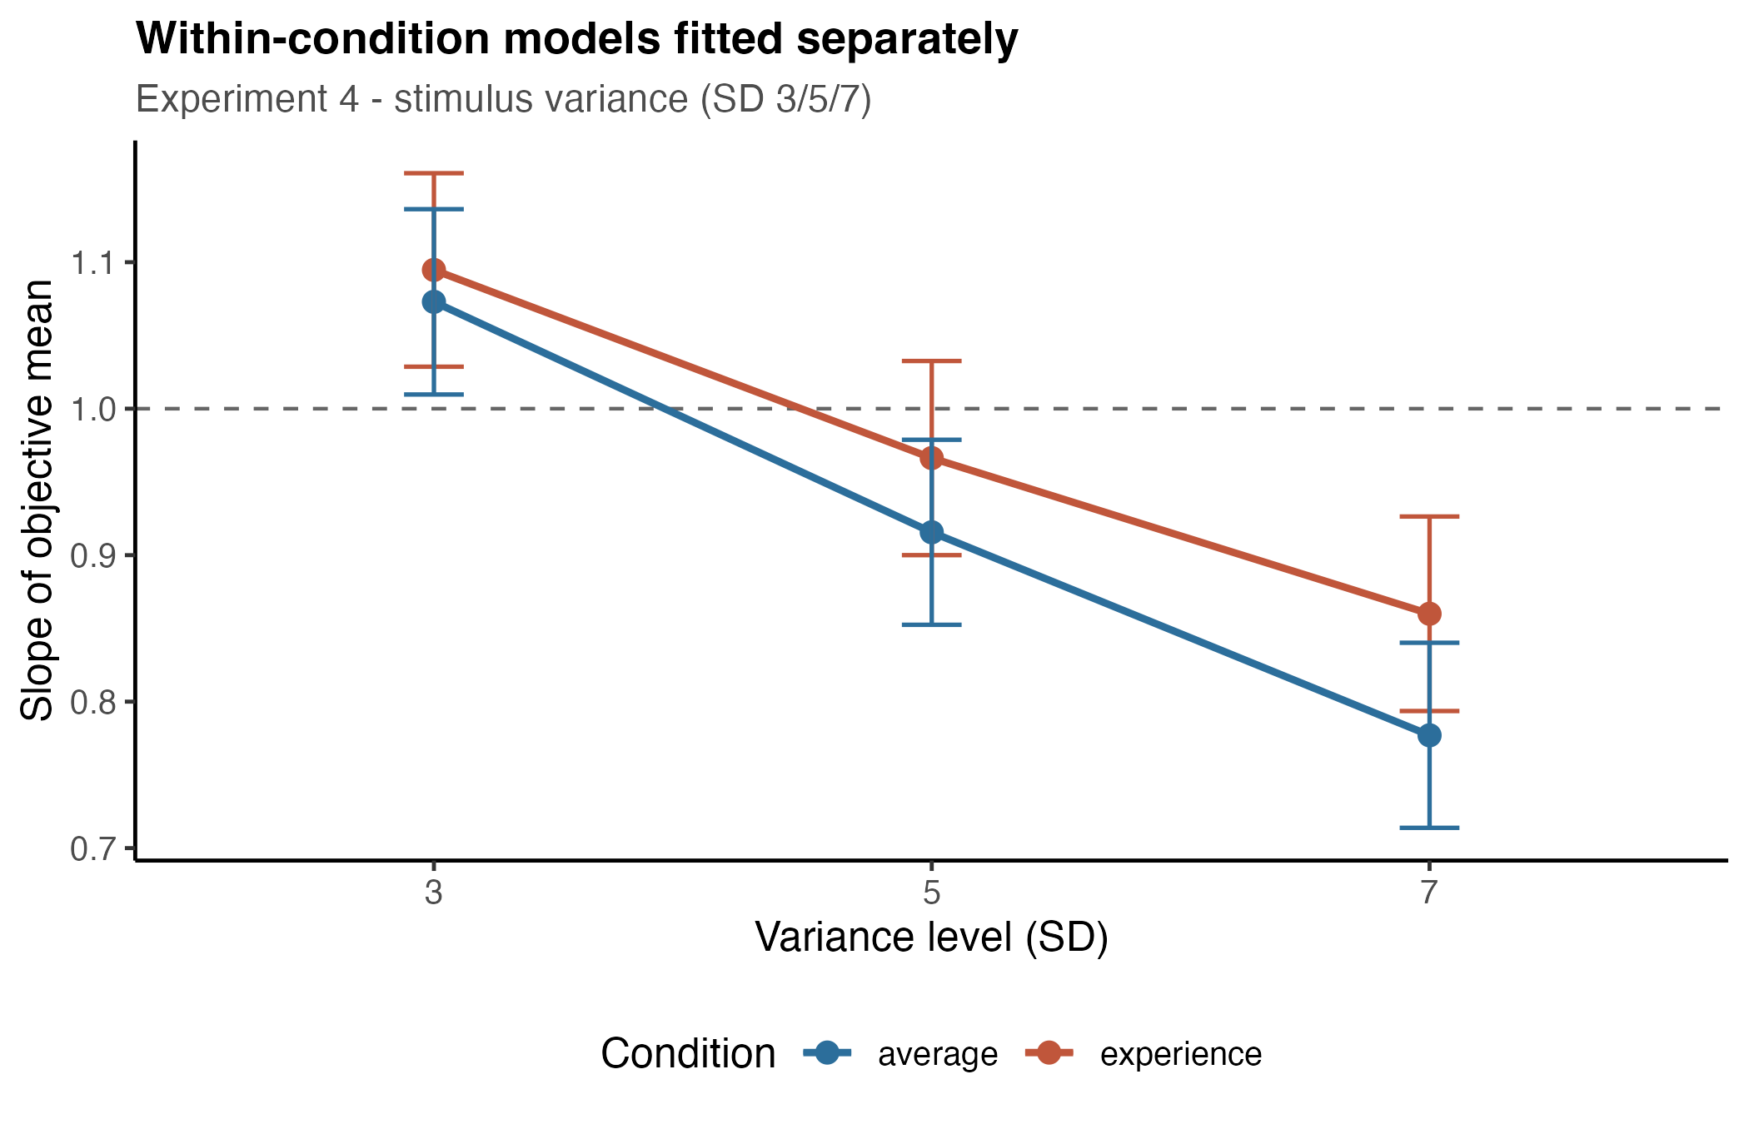
Figure 1. Forward slopes from the within-condition models. Bars are 95% CIs; the dashed line marks one-to-one tracking.
Reverse, objective mean ~ report. The slope answers the inverse question: given a report, how extreme was the stimulus behind it.
 | SD 3 | SD 5 | SD 7
experience | 0.616 | 0.612 | 0.589
average | 0.618 | 0.650 | 0.614

Report × variance: F(2, 10608) = 3.13, p = .044 (experience, only SD 3 vs SD 7 significant); F(2, 10716) = 4.91, p = .007 (average, but non-monotonic — the slope rises from SD 3 to SD 5, p = .023, then falls, p = .014).
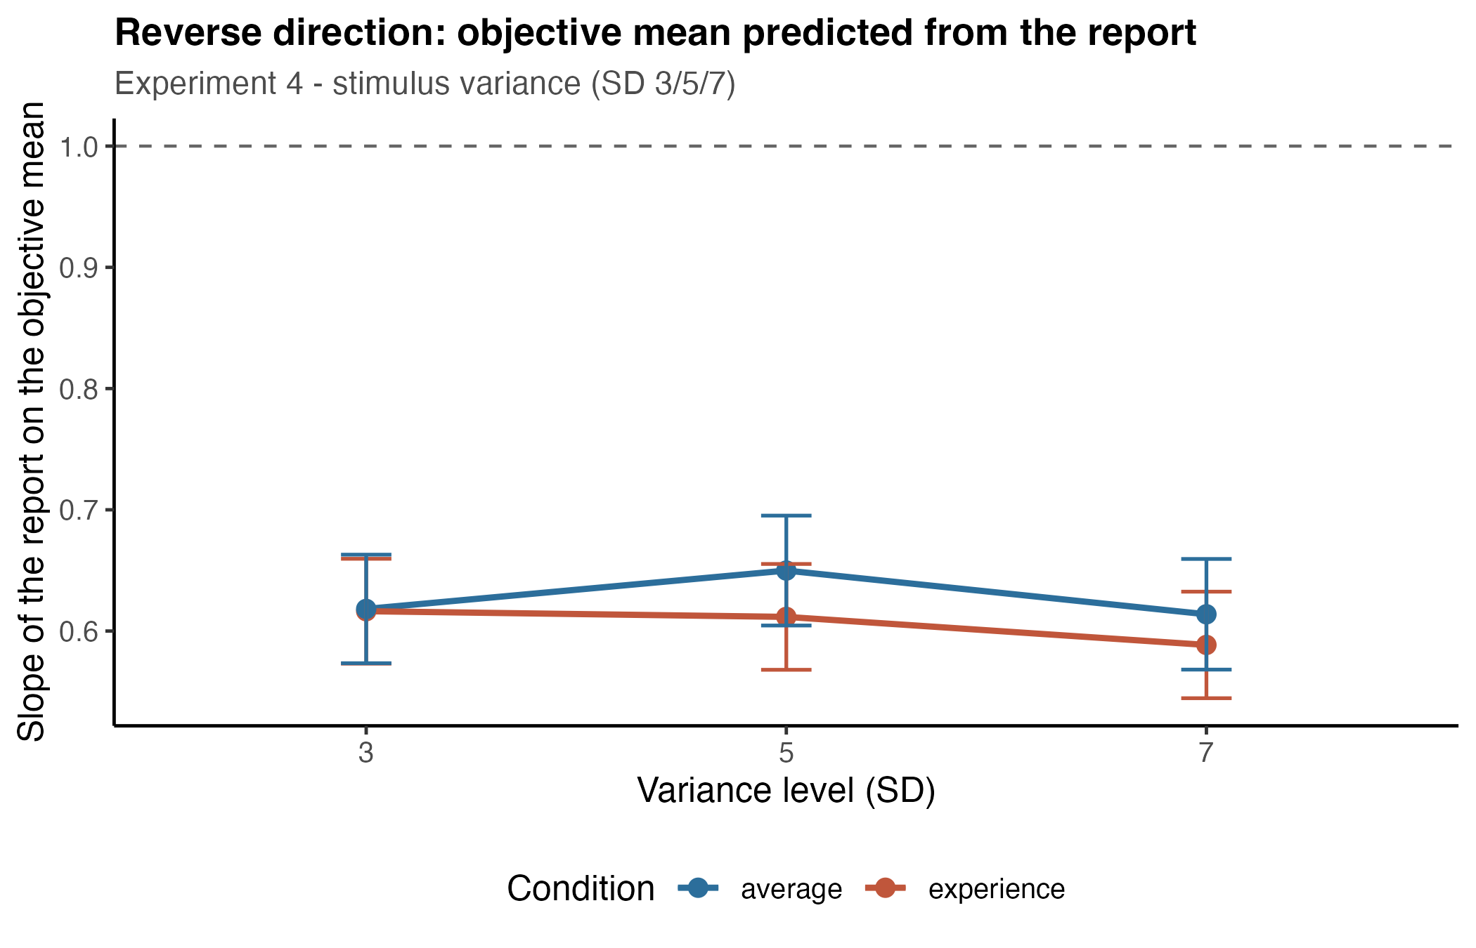
Figure 2. Reverse slopes, same data and same random-effects structure. Note the compressed vertical range compared with Figure 1.

2. The problem
Same trials, same participants, same random-effects structure. The forward slope moves 22% (experience) and 28% (average) across the variance manipulation. The reverse slope moves 4% and 1%, and in the average condition it does not even move monotonically.
That is not a small difference in sensitivity, it is a difference in kind. Taken at face value the reverse model says the inverse mapping is essentially unaffected by stimulus variance — which, if true, would undercut the exaggeration hypothesis, since that hypothesis is naturally phrased in the reverse direction (“when someone reports 40, is there less behind it under noise?”).
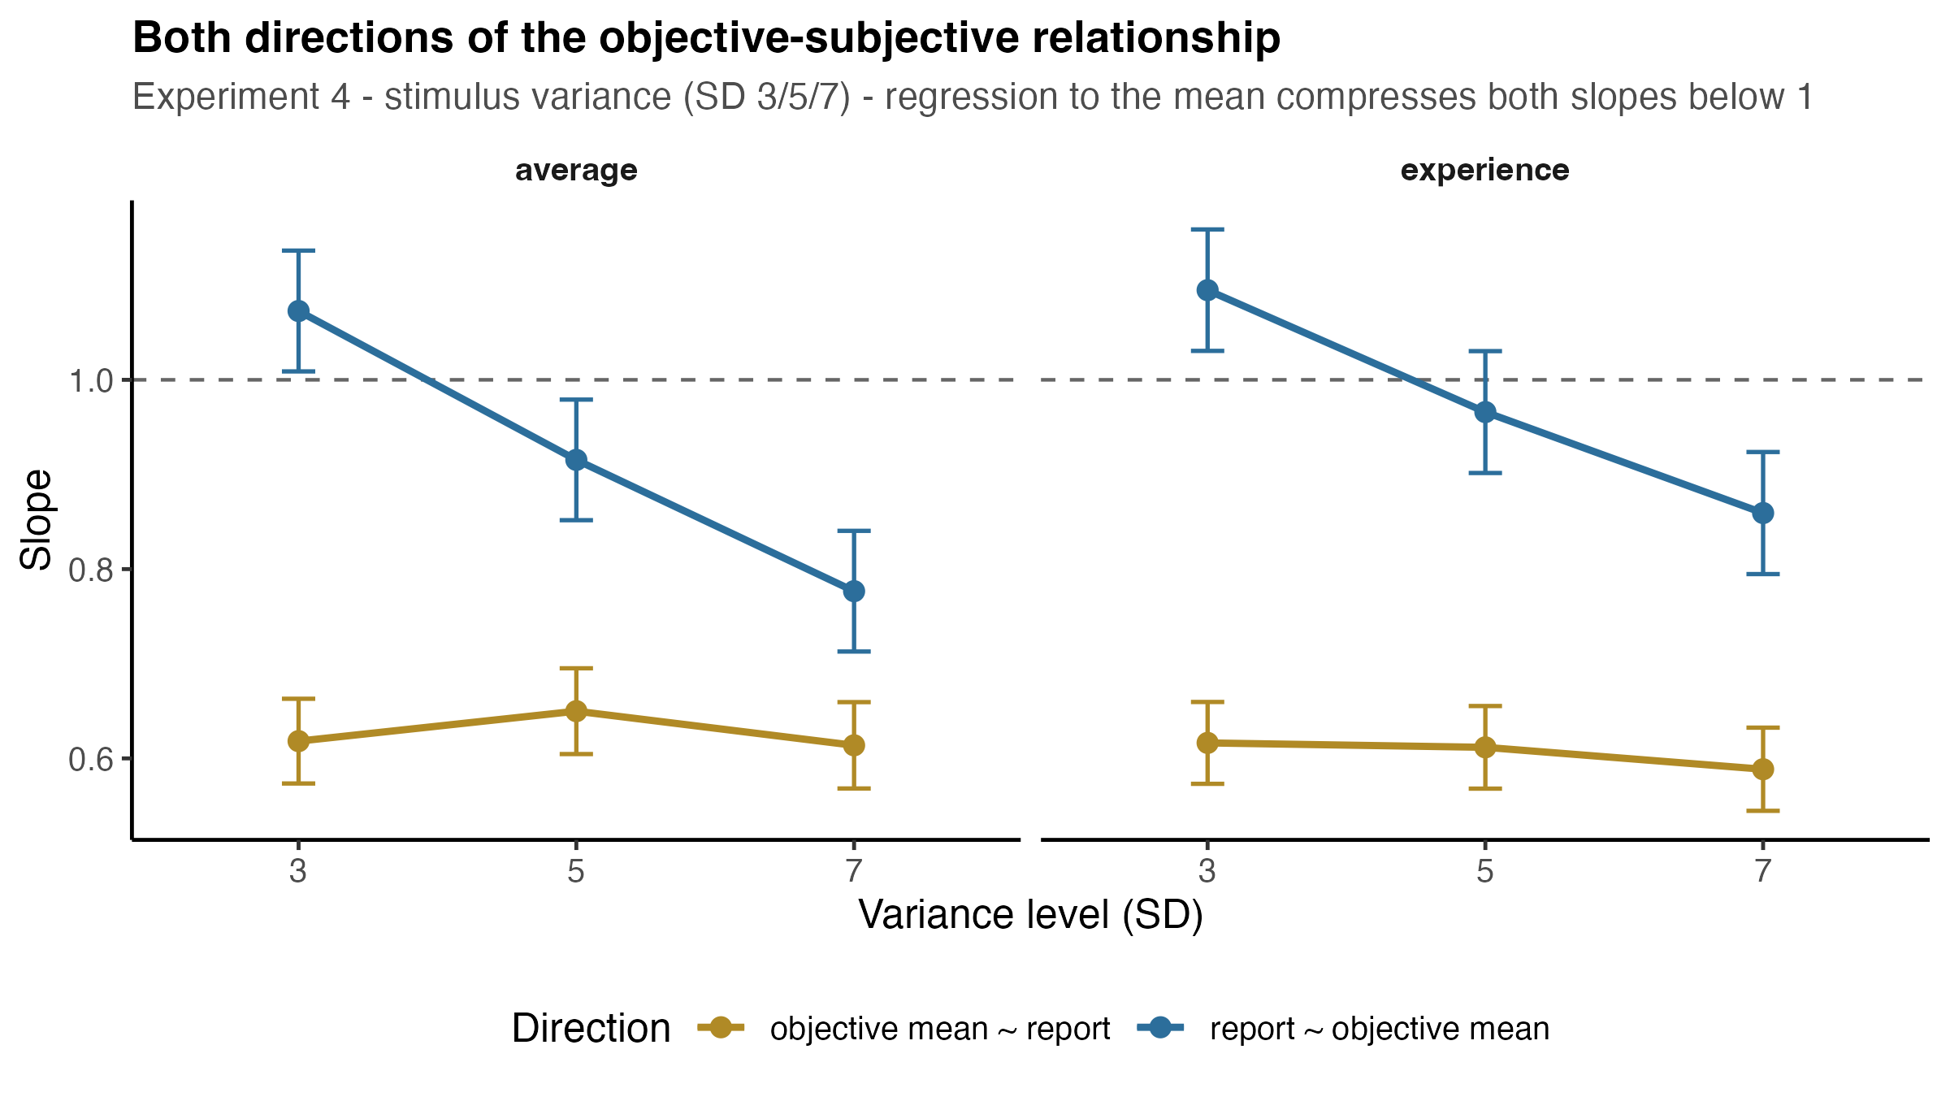
Figure 3. The two directions on one axis. The forward slope tracks the variance manipulation; the reverse slope is nearly flat.

3. Why the two directions diverge
The two OLS slopes are not free to disagree. With x the objective mean, y the report, r their correlation and G = SD_y / SD_x:
b_forward = r · G b_reverse = r / G
b_forward · b_reverse = r² b_forward / b_reverse = G²
There are only two independent quantities here, r and G; the two slopes are the same information in different coordinates. Rearranging gives the key relation:
Δlog b_reverse = Δlog b_forward − 2 · Δlog G
The reverse slope changes only to the extent that a change in the forward slope is not accompanied by a proportional change in the spread of the responses. Noise lowers both r and G, so the two effects compound in the forward slope and cancel in the reverse one.
Checked against the fitted models, lowest versus highest stimulus dispersion:
 | Δlog r | Δlog G | pred. Δlog b_fwd | observed | pred. Δlog b_rev | observed
Exp 4, average | −0.163 | −0.147 | −0.310 | −0.323 | −0.016 | −0.007
Exp 4, experience | −0.159 | −0.084 | −0.243 | −0.242 | −0.075 | −0.046
Exp 2, average | −0.093 | −0.090 | −0.182 | −0.180 | −0.003 | −0.007
Exp 2, experience | −0.048 | −0.048 | −0.096 | −0.104 | +0.000 | −0.006
Exp 3, average | −0.120 | −0.068 | −0.188 | −0.169 | −0.052 | −0.033
Exp 3, experience | −0.025 | −0.082 | −0.106 | −0.101 | +0.057 | +0.080

In the Experiment 4 average condition r and G fall almost exactly in step (−0.163 against −0.147), so the reverse slope is frozen while the forward slope drops 28%. In Experiment 3’s experience condition G falls more than r, and the reverse slope correspondingly goes up. The reverse column is predicted, in sign and rough magnitude, in every cell.
Two further properties of the reverse slope are worth recording.
It is a function of quantities we already have. Because the stimulus is set by us and carries no measurement error, regressing it on the report gives b_rev = b · SD_x² / (b² · SD_x² + σ_e²), where σ_e is the residual SD of the reports. Computing that from the forward fit alone predicts the fitted reverse slopes to within 0.009 in every Experiment 4 cell. The reverse model estimates no new parameter.
Its conditional means are reconstructable. Rebuilding E[objective | report] from each participant’s forward line, their own residual SD and their own set of presented stimuli reproduces the observed binned means to a weighted mean absolute error of 0.098 scale units on a 50-point scale, across ~21,000 trials. The pronounced curvature of the reverse function — reports spanning 2.5 to 47.5 map onto objective means spanning only 16.8 to 32.3 — is fully accounted for by the bounded stimulus list plus response noise, not by anything perceptual.
One caveat that does not apply here. Because b_rev depends on SD_x, it changes when the stimulus range changes, so it is a property of observer and design rather than of the observer alone. Within Experiment 4 the stimulus distribution is matched across variance levels — the SD of the objective means presented is 6.18 / 6.22 / 6.19, F(1.98, 199.7) = 1.41, p = .248 — so comparisons across variance levels are clean. The dependence would only bite if we compared across experiments with different stimulus ranges.

4. The alternative: test the claim where it lives
The exaggeration hypothesis, stated plainly, is about the tails: when someone reports an extreme value, is there less behind it under noise? The global reverse slope is a poor instrument for that, because it averages a large inward pull at the edges together with nothing in the middle, on top of the cancellation above.
Mean objective value behind each report bin, Experiment 4:
report | n at SD 3 | objective, SD 3 | objective, SD 7 | change
≤ 12 | 784 | 17.33 | 17.92 | +0.59
13–17 | 1334 | 18.82 | 19.27 | +0.46
18–22 | 1397 | 21.67 | 21.70 | +0.03
23–27 | 1308 | 25.52 | 25.40 | −0.12
28–32 | 1197 | 28.83 | 27.96 | −0.87
33–37 | 747 | 30.94 | 30.07 | −0.86
≥ 38 | 390 | 32.17 | 30.93 | −1.24

All of the movement is in the tails, in both directions, and it is flat through the middle where most trials sit.
Recommended test — symmetric report windows. Take trials where the report fell within ±2 of 10, and within ±2 of 40, and ask what was behind them:
 | SD 3 | SD 5 | SD 7
reported ~10 | 17.06 | 16.96 | 17.64
reported ~40 | 31.97 | 31.46 | 31.03
reality bracketed by a 30-unit report span | 14.90 | 14.50 | 13.39

Low window: F(2, 1389) = 4.74, p = .009 (SD 3 vs 7, p = .026; SD 5 vs 7, p = .013). High window: F(2, 798) = 4.73, p = .009 (SD 3 vs 7, p = .006). SEs on the widths are ~0.33, so the 1.5-unit narrowing is roughly 4–5 standard errors.
A report of 40 is backed by ~1 scale unit less extreme a stimulus at SD 7 than at SD 3, and a report of 10 by ~0.6 units. A given extreme report carries about 10% less reality when the array is noisy. That is the exaggeration claim, tested directly, on the same data, significant on both tails.
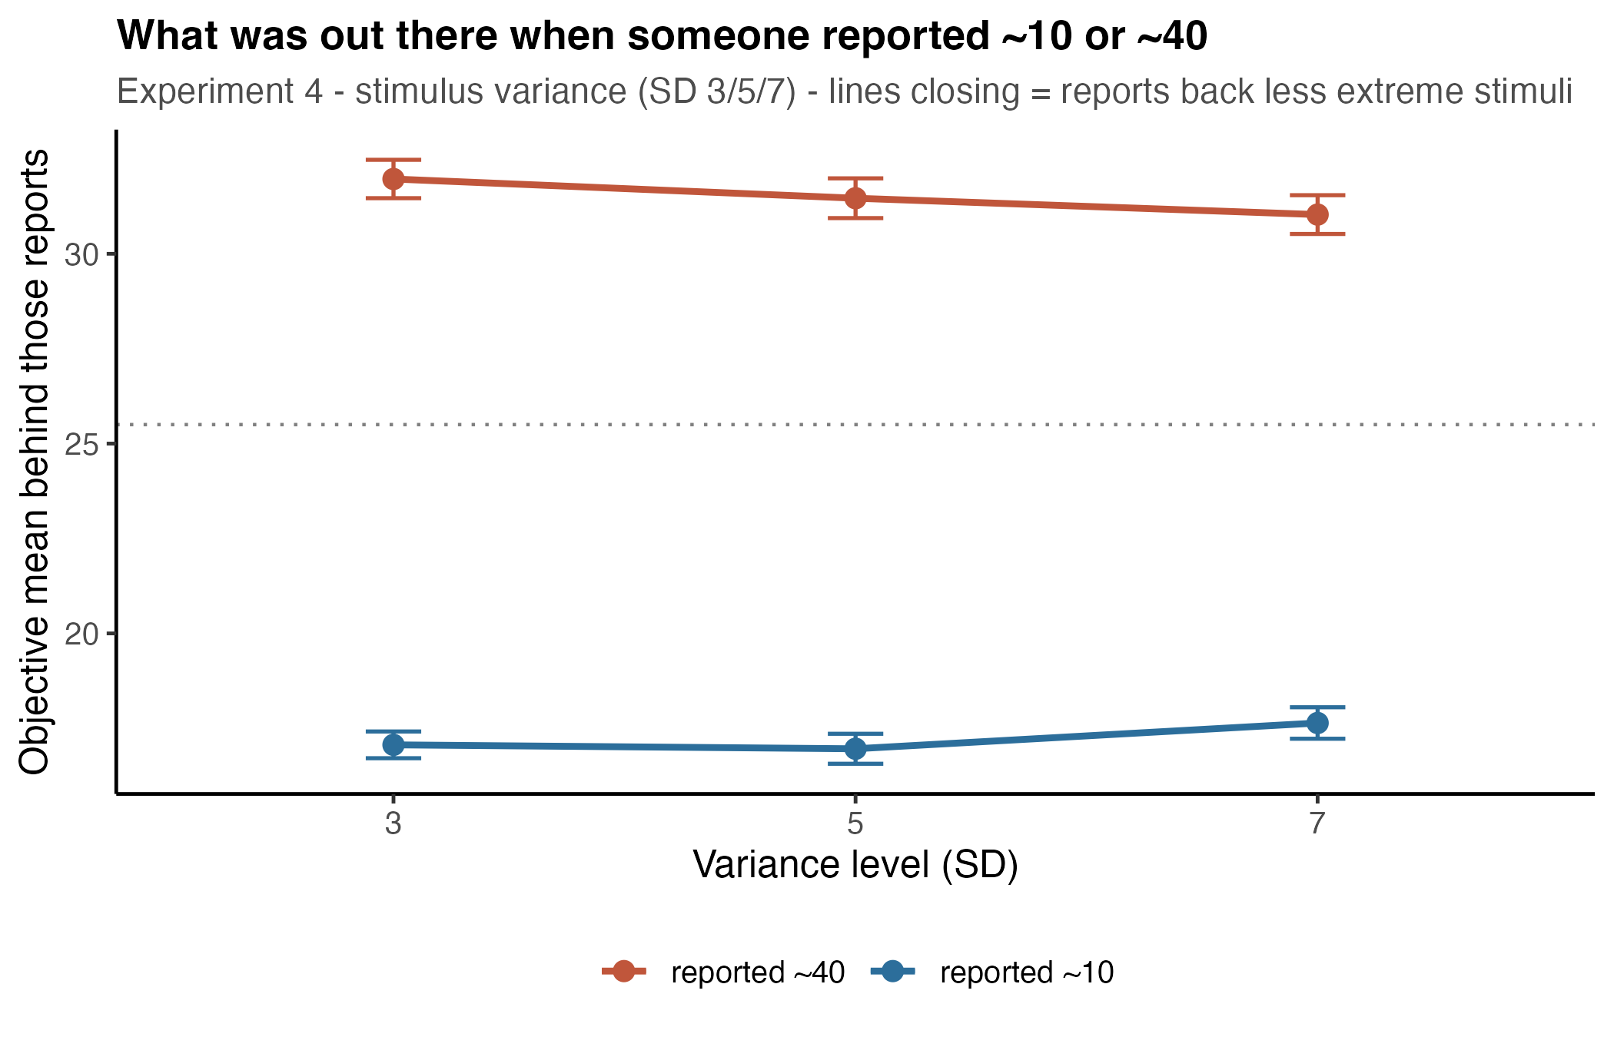
Figure 4. What was out there when someone reported ~10 or ~40. The two lines close in on the centre as variance rises.
The independent robustness check already run — the fixed cutoffs used for the exaggeration measure (< 14, > 36) — gives the same answer: the bracketed window narrows 14.97 → 14.54 → 13.54.
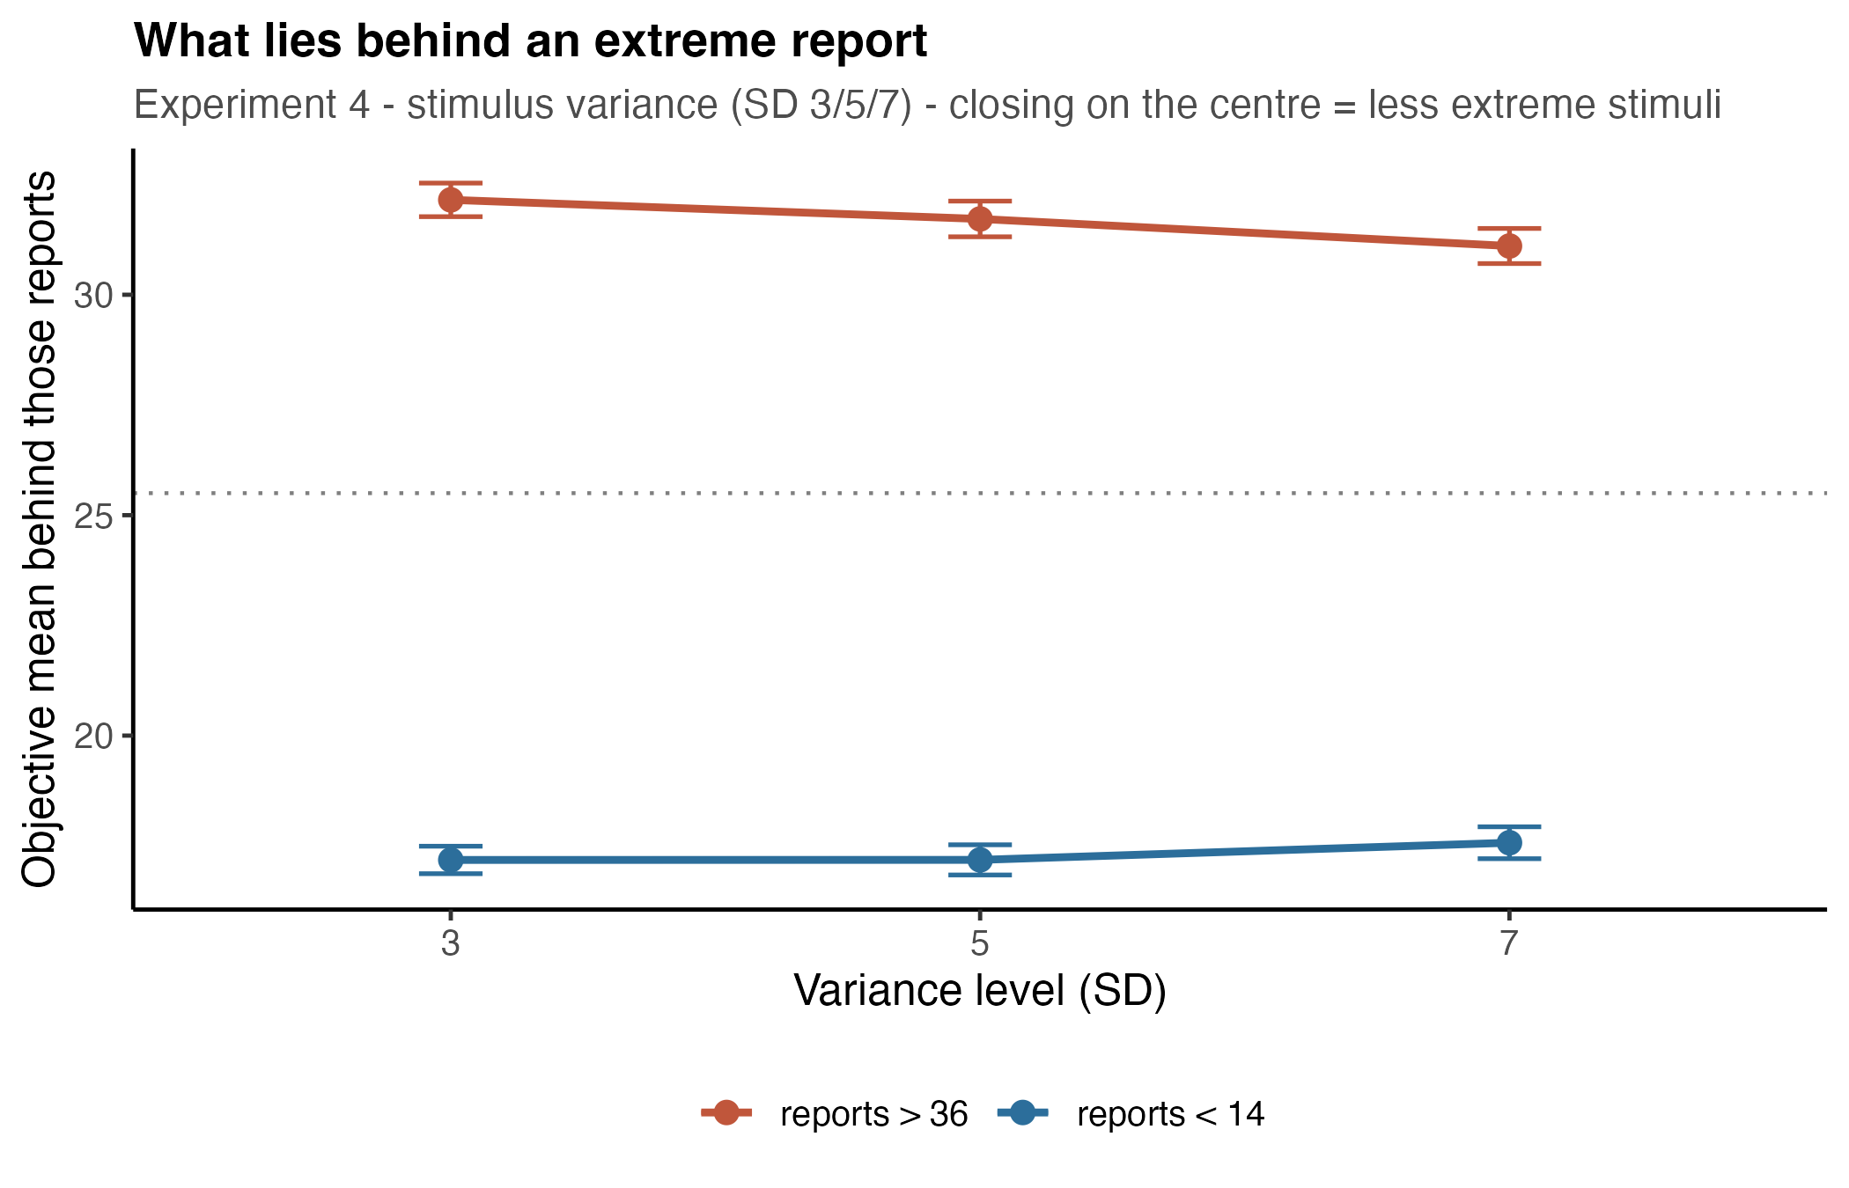
Figure 5. Robustness check with the fixed exaggeration cutoffs, same inward movement.
Two constructs, currently both called “exaggeration”. They move in opposite directions, and separating them resolves most of the apparent tension in the results:
• Systematic overshoot — the transfer function amplifies, forward slope > 1. In Experiment 4 this holds only at SD 3 (average 1.073, 95% CI [1.009, 1.137]; experience 1.095, [1.031, 1.159]) and it decreases with variance.
• Diagnosticity loss — an extreme report backs less extreme reality, the windows result above. This increases with variance.
The rate of extreme responding, measured as the proportion of trials past the fixed cutoffs, also falls with variance (0.169 → 0.121 → 0.108 in experience; F(1.80, 181.5) = 46.06, p < .001), consistent with the first construct rather than the second.
Worth noting for interpretation: the response-to-stimulus SD ratio G, the natural “were responses more spread out than the stimuli” measure, does not isolate systematic amplification either, since G² = b² + (σ_e / SD_x)². A ratio above 1 can be produced by response noise alone with a compressive transfer function. The clean pair to report is the gain b and the response noise σ_e.

5. Verdict
The data are trustworthy. Both models fit correctly, the reverse model reproduces the observed conditional means to a tenth of a scale unit, and the stimulus distribution is matched across the variance levels, so the comparison of interest is not confounded by design.
The reverse slope is not trustworthy as evidence about the effect of variance. Its small, partly non-monotonic effect is what the algebra predicts when r and G shrink together; reporting it as “variance does not affect the inverse mapping” would be reporting a cancellation.
What to do:
1. Report the forward model as the estimate of the perceptual mapping. It is the direction in which the stimulus is error-free, so its slope is the unbiased transfer function.
2. Test the exaggeration hypothesis with the symmetric report windows, citing the fixed-cutoff version as a robustness check.
3. Keep the reverse model and the reverse Galton diagram as description — they communicate the double squeeze well — but state that the flat slope reflects r and G moving together rather than stability of the inverse mapping.
4. Separate the two exaggeration constructs by name in the write-up.
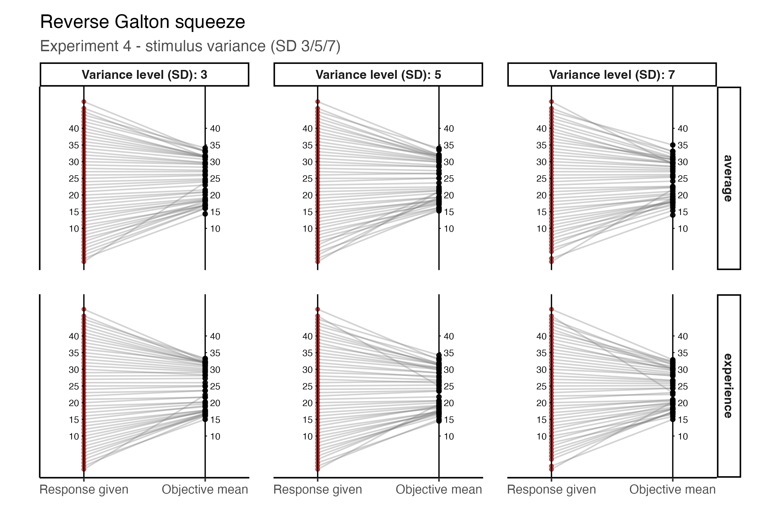
Figure 6. The reverse Galton squeeze, worth keeping as description. Its curvature is produced by the bounded stimulus list plus response noise, so it should not be read as a perceptual effect on its own.

All figures generated by analysis/run_all.R. Experiment 4 outputs in analysis/output/exp4/ (lmm_bycondition_*, revlmm_*, tails_windows_*, anova_*); cross-experiment tables in analysis/output/.

