Regression to the mean in subjective experience — results
Round 4. All analyses regenerated from the raw session logs by analysis/run_all.R; every number below is traceable to a file in analysis/output/.

Exploratory analysis of existing data (Goldenberg et al., 2021)

Method
To examine our hypothesis we looked for an existing paradigm that would let us observe the effect of added variance on participants' experience. We used the open data of Goldenberg et al. (2021), Experiment 1, which used the ensemble perception paradigm to study how people estimate the average emotion of crowds.

Materials
Fifty participants completed 150 trials each. On every trial participants saw an array of up to 12 faces expressing different intensities of emotion, either neutral to angry or neutral to happy. The average valence of the faces and the set size were randomised. After each trial participants reported the average valence using a scale that morphed a face on screen to match their answer. Faces and responses were scored on a 100–150 valence scale. After removing trials with missing values, 7,304 trials from 50 participants entered the analysis.

Results
A linear mixed model predicted the group mean valence from the participant's rating, the number of faces and their interaction, with random intercepts for participants, fitted separately for positive and negative arrays.
For positive arrays there were significant main effects of rating, b = 0.71, SE = 0.02, t(3783.87) = 35.64, p < .001, and of number of faces, b = 4.49, SE = 0.41, t(3763.10) = 10.91, p < .001, and a significant rating × number of faces interaction, b = −0.036, SE = 0.003, t(3762.25) = −11.14, p < .001: the association between rating and group valence weakened as the number of faces increased.
For negative arrays the pattern replicated: rating, b = 0.69, SE = 0.02, t(3493.62) = 30.27, p < .001; number of faces, b = 3.74, SE = 0.44, t(3481.55) = 8.53, p < .001; interaction, b = −0.030, SE = 0.003, t(3481.70) = −8.66, p < .001.
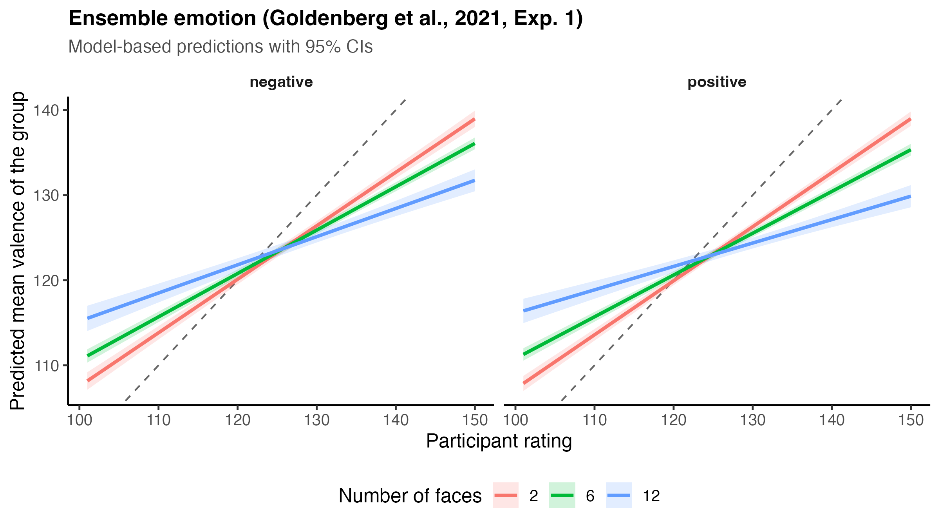
Figure 1. Ensemble emotion (Goldenberg et al., 2021, Experiment 1). Model-based predictions of group mean valence as a function of rating and number of faces, with 95% CIs.
To place this on the same footing as the colour experiments that follow, we refitted the same data in the opposite direction — rating predicted from the objective group mean, centred within participant, with random slopes. The slope of the objective mean declined with set size in both valences: positive, b = 0.70 at 2 faces, 0.64 at 6, 0.54 at 12; negative, 0.70, 0.64, 0.55. Slopes below 1 mean the ratings are compressed toward the participant's own mean, and the compression grows with set size.

The paradigm
To extend the exploratory analysis we looked for further evidence of regression to the mean in low-level visual perception, for two reasons. A low-level paradigm lets us control the amount and source of variance precisely, and it lets us ask whether noise-driven distortions appear even in perceptual functions that are normally robust.
In the Ensemble Phenomenology of Colour (EPoC) paradigm each stimulus is a set of coloured squares, all red or all blue in primary hue but varying in shade. The colour scales were built by segmenting a continuous gradient into 50 distinct shades coded 1–50 (red #FFC0CB → #FF0000; blue #ADD8E6 → #0000FF). After the array disappeared, participants used a continuous response scale to match a single square to the perceived average hue of the set; moving the cursor left to right shifted the square from pale to bright. The analysis compares the objective colour mean of each array with the participant's report.
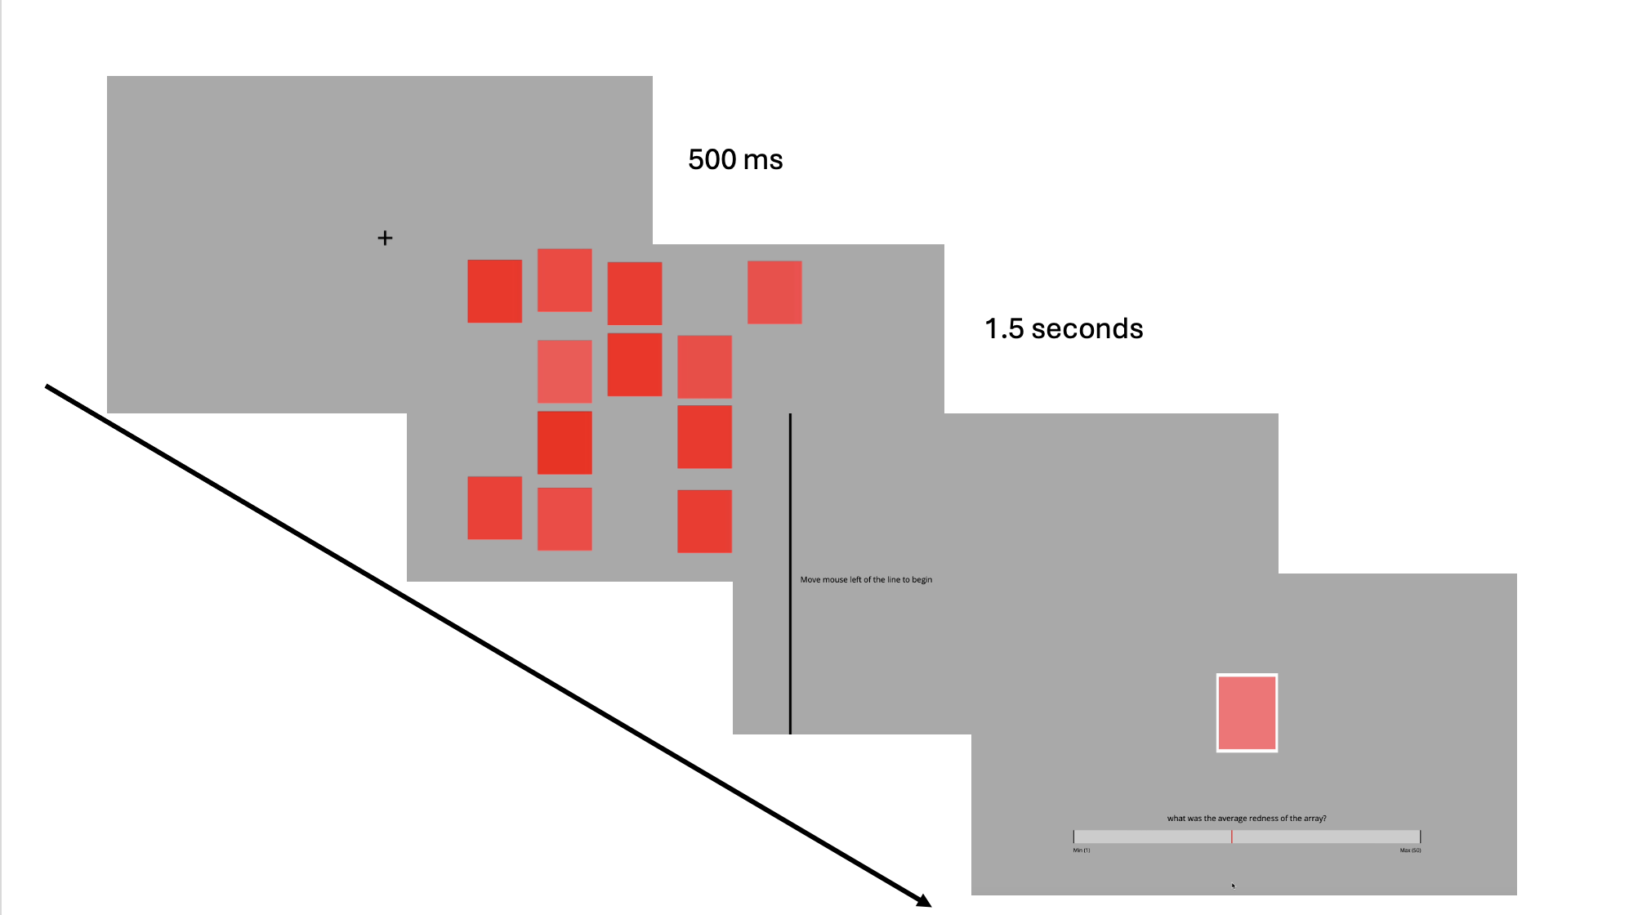
Figure 2. A trial in the EPoC paradigm. A fixation cross is followed by the array of coloured squares; after it disappears participants move the cursor to initialise the response scale and then match a central square to their estimate of the average colour.
Across experiments we manipulated perceptual noise by increasing either the number of items in the array or the variance of item values. The prediction was that greater variability makes extraction of the ensemble mean less precise, producing more regression to the mean — a shallower relationship between objective mean and reported value.

Analysis strategy, common to all experiments
Data were cleaned identically throughout. Training trials were removed; trials with RT < 200 ms or > 8,000 ms were excluded; a within-participant ±2.5 SD trim was applied to RT; trials whose absolute deviation from the objective mean exceeded 30 scale units were removed. Participants retaining fewer than 85% of their trials, and participants whose Spearman correlation between objective mean and report was ≤ .30, were excluded.
Three analyses are reported for every experiment.
- Tracking accuracy. The within-participant correlation between objective mean and
report at each noise level, Fisher-z transformed, in a mixed ANOVA with noise within and condition between. Greenhouse–Geisser corrected throughout, so degrees of freedom are fractional.
- Regression to the mean. A linear mixed model of the report on the objective mean
(centred within participant), noise level and their interaction, with random intercepts and slopes. The slope of the objective mean is the measure: 1 is one-to-one tracking, below 1 is compression toward the participant's own mean. Each condition is modelled on its own first — this is the primary model — followed by a combined model that adds condition and tests whether the two differ.
- Exaggeration. The proportion of responses more extreme than the stimulus
(< 14 when the objective mean is < 20, > 36 when it is > 30), per participant and noise level, in the same mixed ANOVA. This is supplemented by a tail analysis asking what objective value lies behind an extreme report (Supplement C).
None of the experiments was preregistered.

Experiment 1 — array size 2 / 6 / 8 / 12

Participants
Participants were recruited on Prolific; inclusion required US nationality and residence, fluent English, and no colour blindness. Thirty-three participants (16 female, M age = 43) were assigned to the average-assessment condition and thirty-six (18 female, M age = 41) to the experience-assessment condition. Usable session files were returned by 32 and 30 participants respectively.

Method
Participants completed an EPoC task with four array sizes — 2, 6, 8 or 12 squares. After each array they gave one of two ratings. In the average condition they adjusted the response square to match the average colour of the array; in the experience condition they adjusted it to match how red or blue the stimulus felt to them. The main task was 12 trials per array size within each colour block, 96 trials in total, with block order randomised. Twenty learning trials preceded the main task.

Results
Preprocessing. In the average condition 8 participants were excluded for low trial retention and 1 for not tracking the stimulus, leaving N = 23. In the experience condition 6 and 3 were excluded, leaving N = 21. Mean 92 trials retained per participant; mean absolute error 5.08 (average) and 5.01 (experience) scale units.
Tracking accuracy. Correlations were positive throughout. Mean r fell from .78 to .72 across array size in the average condition and from .82 to .72 in the experience condition, with a recovery at size 12 in the experience condition (.79). Main effect of array size, F(2.91, 122.25) = 5.73, p = .001; no effect of condition, F(1, 42) = 0.67, p = .416; no interaction, F(2.91, 122.25) = 0.99, p = .399. Only the size 2 versus size 8 contrast in the experience condition survived correction, p = .006.
Regression to the mean. In the experience condition responses tracked the objective mean overall, b = 0.85, 95% CI [0.73, 0.97], and the slope varied with array size, F(3, 1881) = 3.94, p = .008. Slopes were 0.89, 0.83, 0.76 and 0.93 at sizes 2, 6, 8 and 12 — compression up to size 8 and then a return, with only the 8 versus 12 contrast significant, p = .009.
In the average condition the decline was orderly: 0.90, 0.80, 0.77, 0.72, F(3, 2070) = 4.65, p = .003, with size 2 differing from both 8 (p = .043) and 12 (p = .002).
The combined model found no effect of condition, F(1, 42) = 0.06, p = .810, and no objective mean × condition interaction, F(1, 41.99) = 0.48, p = .491, but a significant three-way interaction, F(3, 3950) = 4.10, p = .006, driven entirely by size 12, where the conditions differed by 0.21, p = .022.
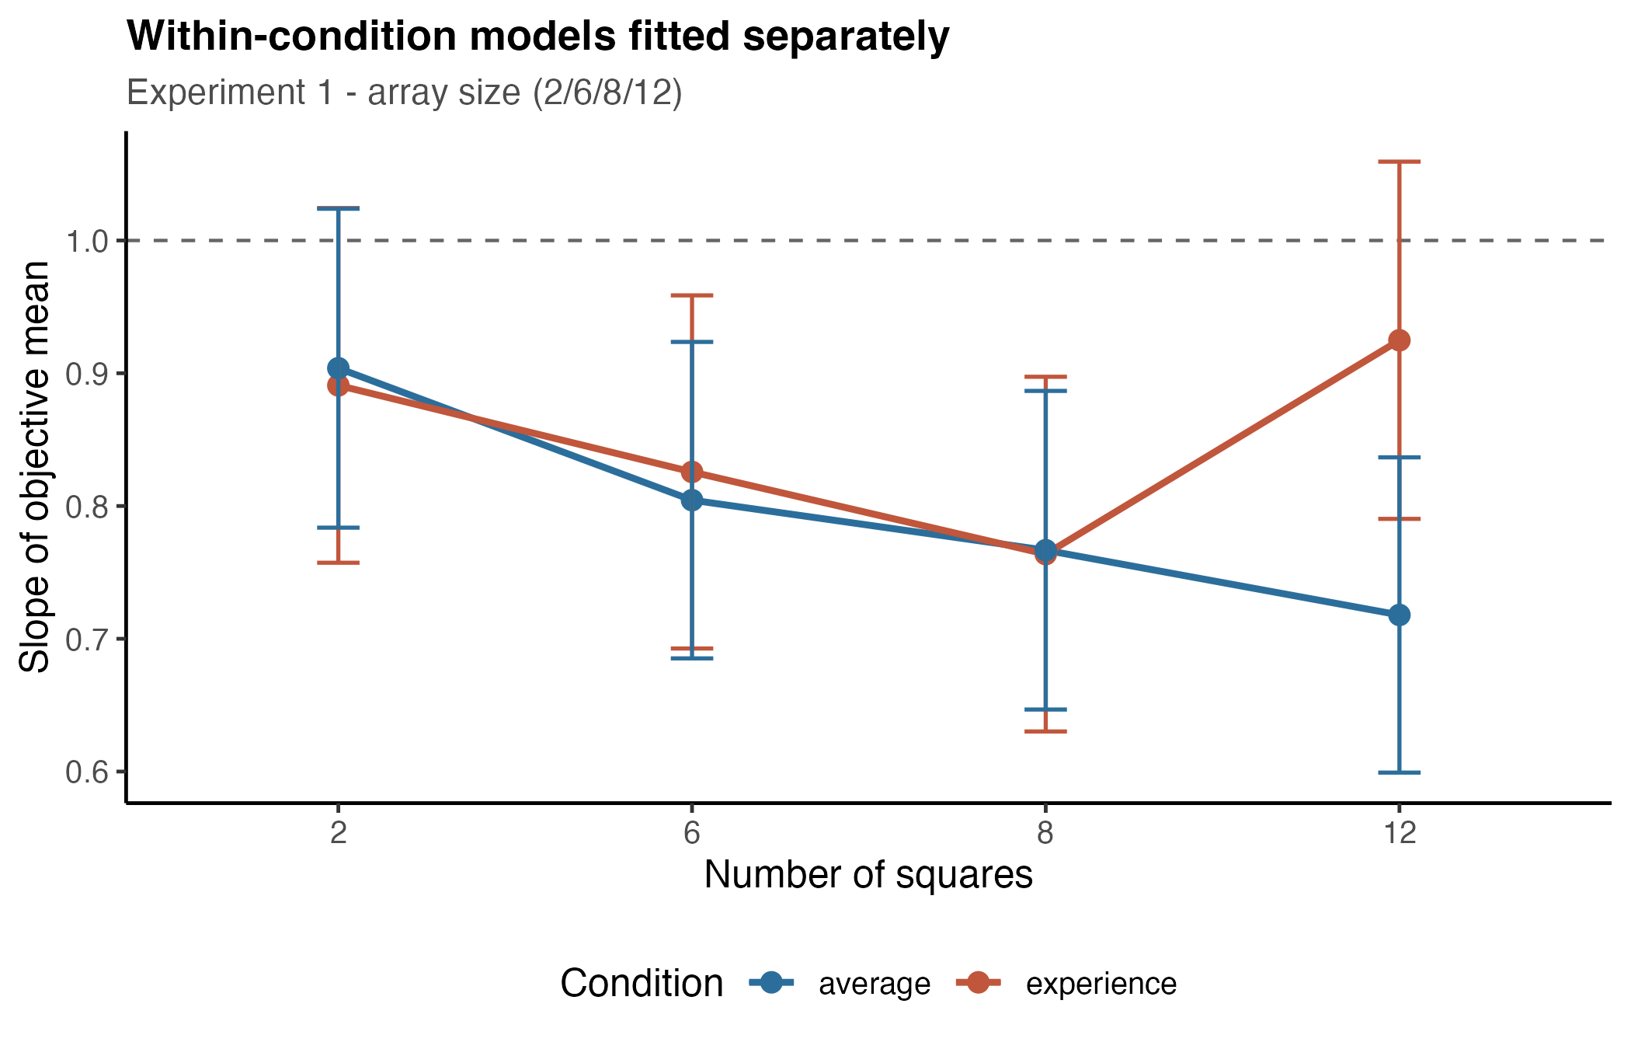
Figure 3. Experiment 1. Slope of the objective mean by array size, from models fitted separately within each condition. The dashed line marks one-to-one tracking.
Exaggeration. No effects: array size, F(2.50, 105.16) = 1.41, p = .248; condition, F(1, 42) = 0.88, p = .353; interaction, F(2.50, 105.16) = 1.62, p = .196.
Experiment 1 is the smallest sample in the set and its experience-condition pattern should be read with that in mind. As Section 7 shows, the apparent recovery at size 12 occurs at a stimulus dispersion identical to size 8, so it cannot be a variance effect in either direction.

Experiment 2 — array size 2 / 10 / 20
Because Experiment 1 produced only a narrow range of noise, Experiment 2 widened the array sizes to create more distinct levels of visual load.

Participants
One hundred participants (50 female, M age = 42) were assigned to the average condition and one hundred (50 female, M age = 40.5) to the experience condition. Usable session files were returned by 92 and 91 participants.

Method
As Experiment 1, with array sizes of 2, 10 or 20 squares, 16 trials per array size within each colour block, 96 trials in total.

Results
Preprocessing. Five average and eight experience participants were excluded for low retention, one and three for not tracking the stimulus, leaving N = 86 and N = 80. Mean 92 trials per participant.
Tracking accuracy. Mean r = .81 / .74 / .77 (average) and .81 / .77 / .78 (experience). Main effect of array size, F(1.91, 313.24) = 16.77, p < .001; no effect of condition, F(1, 164) = 0.66, p = .417; no interaction, F(1.91, 313.24) = 1.57, p = .211. Note that accuracy is lowest at size 10, not at size 20.
Regression to the mean. Experience: overall b = 0.87, 95% CI [0.86, 0.89], with slopes 0.92, 0.83, 0.87 at sizes 2, 10, 20, F(2, 7210) = 8.03, p < .001; only the 2 versus 10 contrast was significant, p < .001. Average: overall b = 0.75, slopes 0.81, 0.68, 0.74, F(2, 7751) = 25.38, p < .001, with all three contrasts significant.
The combined model found a main effect of condition, F(1, 164.02) = 11.07, p = .001, and an objective mean × condition interaction, F(1, 15029) = 115.14, p < .001 — slopes were higher in the experience condition at every array size (all p < .001) — but no three-way interaction, F(2, 14956) = 1.16, p = .315.
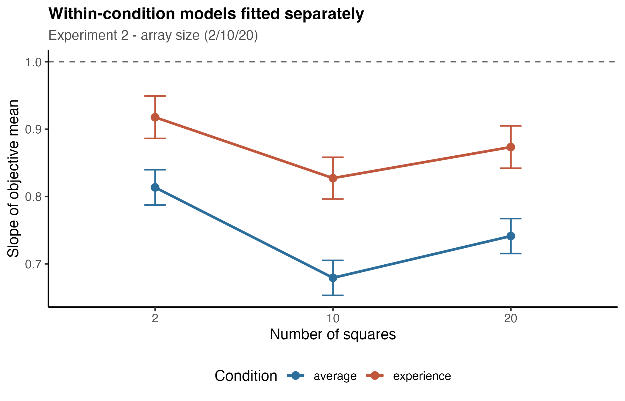
Figure 4. Experiment 2. Slope of the objective mean by array size. Note that compression is greatest at array size 10, not at 20.
Exaggeration. Main effect of array size, F(1.92, 314.93) = 10.73, p < .001, and of condition, F(1, 164) = 4.63, p = .033, with no interaction, p = .073. The array size effect is again non-monotonic and driven by the average condition, where exaggeration dipped at size 10 (.079) relative to sizes 2 (.129) and 20 (.122), both p < .001.
Both the tracking and the slope results are V-shaped in array size, with the strongest compression at 10 rather than at 20. Section 7 shows why.

Experiment 3 — array size 2 / 10 / 20 with a Mondrian frame
Given the robustness of the paradigm, Experiment 3 introduced a second source of visual noise.

Participants
Fifty participants (30 female, M age = 42.8) were assigned to the average condition and fifty-two (27 female, M age = 43) to the experience condition. Usable session files were returned by 50 and 51.

Method
As Experiment 2, with a frame of randomly generated coloured squares surrounding the array on every trial. The frame never contained the target colour, and participants were instructed to ignore it.
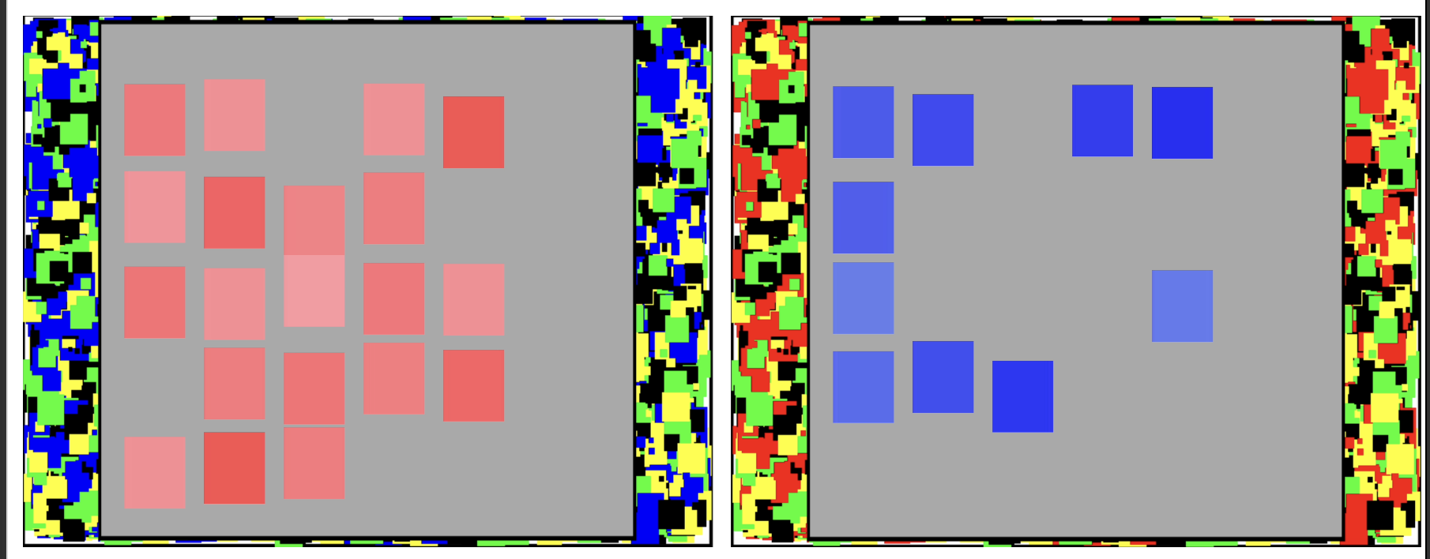
Figure 5. Experiment 3 stimuli. The array is surrounded by a frame of randomly generated coloured squares; the target colour never appears in the frame, and participants were told to ignore it.

Results
Preprocessing. After exclusions, N = 46 (average) and N = 39 (experience).
Tracking accuracy. Mean r = .81 / .73 / .75 (average) and .80 / .79 / .80 (experience). Main effect of array size, F(1.99, 165.40) = 5.70, p = .004; no effect of condition, F(1, 83) = 1.66, p = .201; but a significant array size × condition interaction, F(1.99, 165.40) = 5.34, p = .006. Array size reduced tracking in the average condition (2 vs 10, p < .001) and not at all in the experience condition (all p > .95).
Regression to the mean. Experience: slopes 0.87, 0.79, 0.87, F(2, 3526) = 5.82, p = .003, with 10 differing from both 2 (p = .012) and 20 (p = .007) — the same V-shape as Experiment 2. Average: 0.83, 0.70, 0.74, F(2, 4123) = 13.34, p < .001. The combined model gave no objective mean × condition interaction, F(1, 82.74) = 2.68, p = .105, and a marginal three-way interaction, F(2, 7648) = 2.83, p = .059.
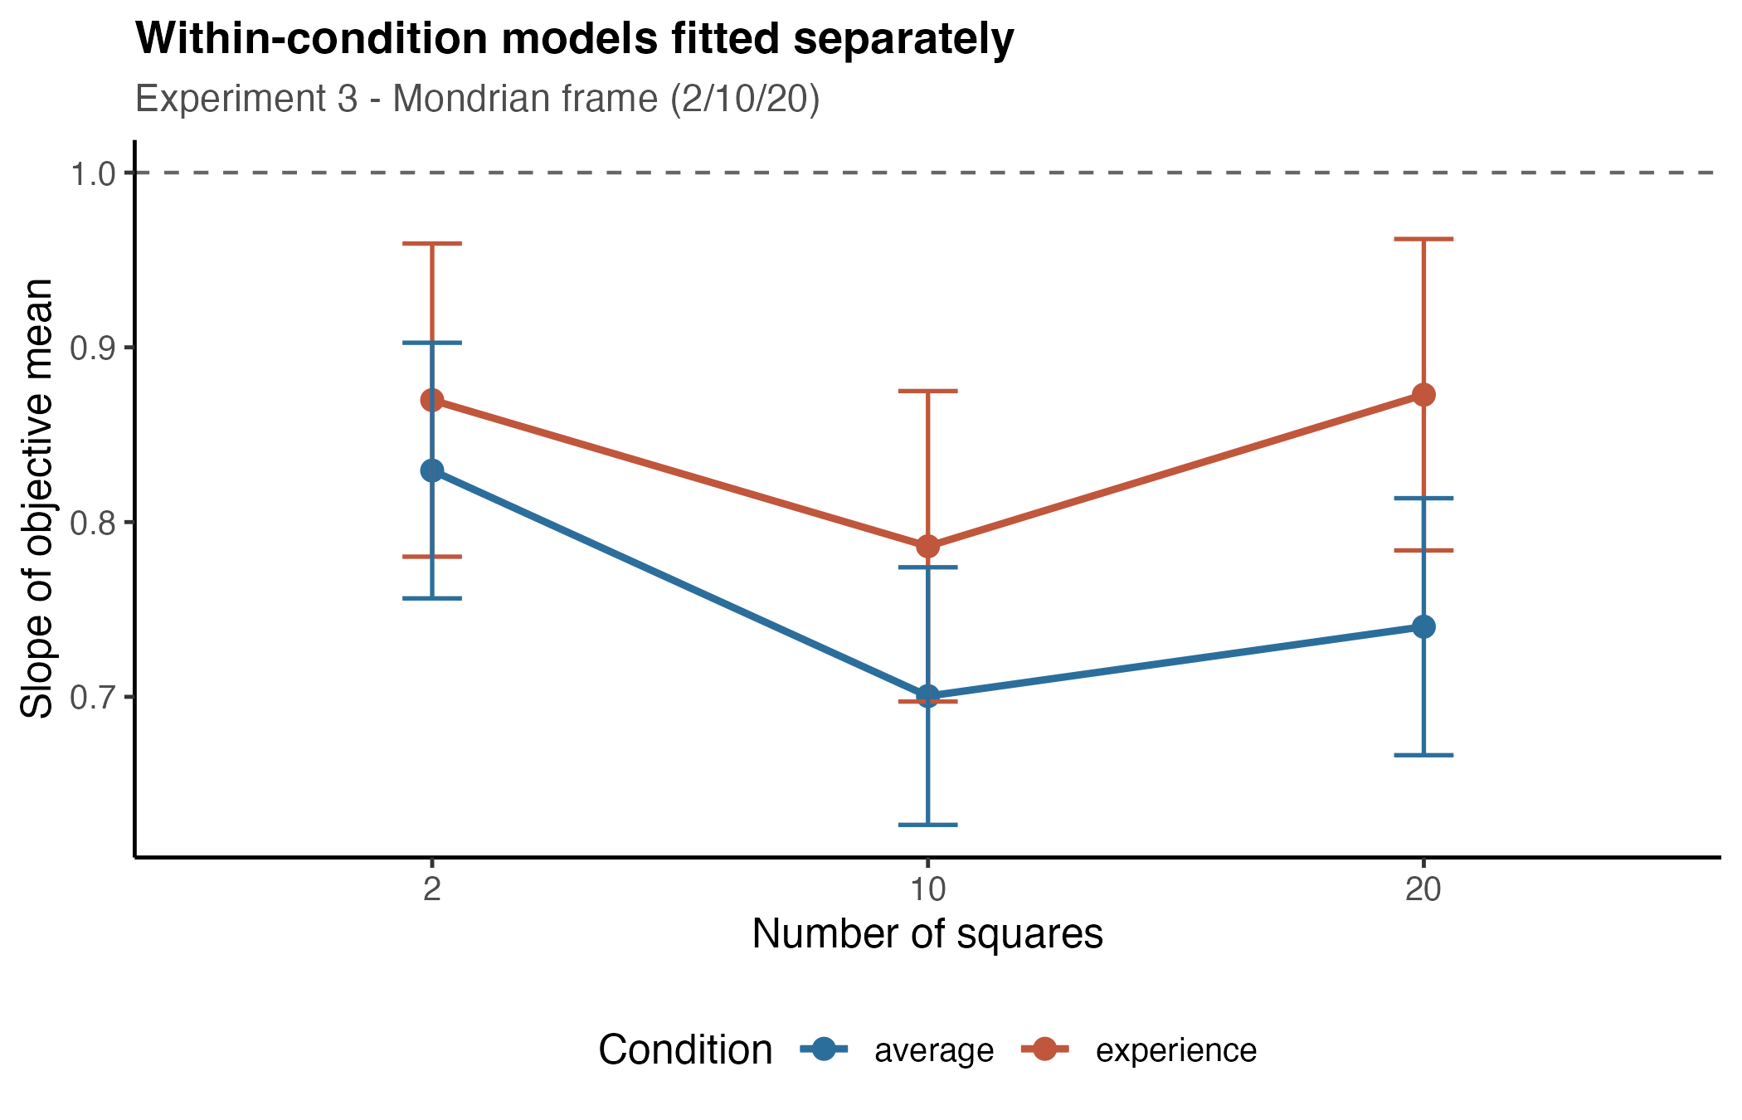
Figure 6. Experiment 3. Slope of the objective mean by array size, with the Mondrian frame present on every trial.
Exaggeration. Main effect of array size, F(1.95, 161.83) = 9.07, p < .001; no condition effect, p = .161; no interaction, p = .325. Again driven by the average condition and again non-monotonic.

Does the Mondrian frame add regression to the mean?
Because Experiments 2 and 3 used identical array sizes, we pooled them with frame as a factor. The frame had no general effect: objective mean × frame, F(1, 22687) = 1.20, p = .273; objective mean × array size × frame, F(2, 22572) = 0.33, p = .721. Nor did it affect tracking accuracy — main effect of frame F(1, 247) = 0.01, p = .906, with every frame comparison p > .74.
There was a three-way objective mean × frame × condition interaction, F(1, 22687) = 4.46, p = .035: averaged over array sizes the frame lowered the slope by 0.033 in the experience condition (p = .028) and by nothing in the average condition (p = .457). No individual array size reached significance (p = .070, .061, .957), and the effect vanished at size 20.
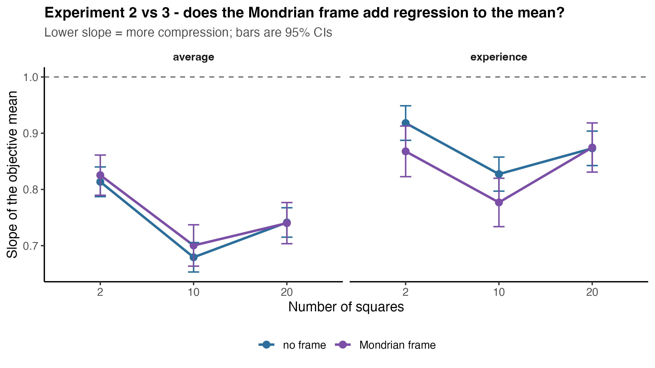
Figure 7. Experiments 2 and 3 pooled, with frame as a factor. The frame produced no general change in the objective-subjective slope.
We do not think this supports a frame effect. It is small, absent at the highest array size, unaccompanied by any change in tracking accuracy, and — importantly — the frame is between-subjects and between-batches, since the two experiments ran on different samples several months apart. Irrelevant colour noise placed around the array did not measurably increase regression to the mean.

Experiment 4 — stimulus variance SD 3 / 5 / 7
Experiments 1–3 manipulated the number of items. Experiment 4 manipulated the dispersion of the items directly, holding the number constant.

Participants
Sixty participants (30 female) were assigned to the average condition and seventy-one (35 female) to the experience condition. Usable session files were returned by 53 and 58.

Method
Every array contained 10 squares generated around a mean drawn pseudorandomly from a predefined list spanning 14–36 on the colour scale, with each participant seeing all means. Deviations of individual squares from that mean were drawn with a standard deviation of 3, 5 or 7, constrained so that values stayed within 1–50. Exposure was shortened to 500 ms, allowing 216 trials: a 20-trial learning phase followed by two blocks of 108 trials, each block in a single colour, variance level randomised within block and block order counterbalanced.

Results
Preprocessing. One average participant was excluded for low retention; two experience participants for low retention and five for not tracking the stimulus. N = 52 (average) and N = 51 (experience), with a mean of 208 and 210 trials retained.
Tracking accuracy. Mean r fell monotonically: .82 / .78 / .71 (average) and .83 / .78 / .71 (experience). Main effect of variance, F(1.91, 193.04) = 131.21, p < .001, with every pairwise step significant at p < .001 in both conditions. No effect of condition, F(1, 101) = 0.04, p = .845, and no interaction, p = .520.
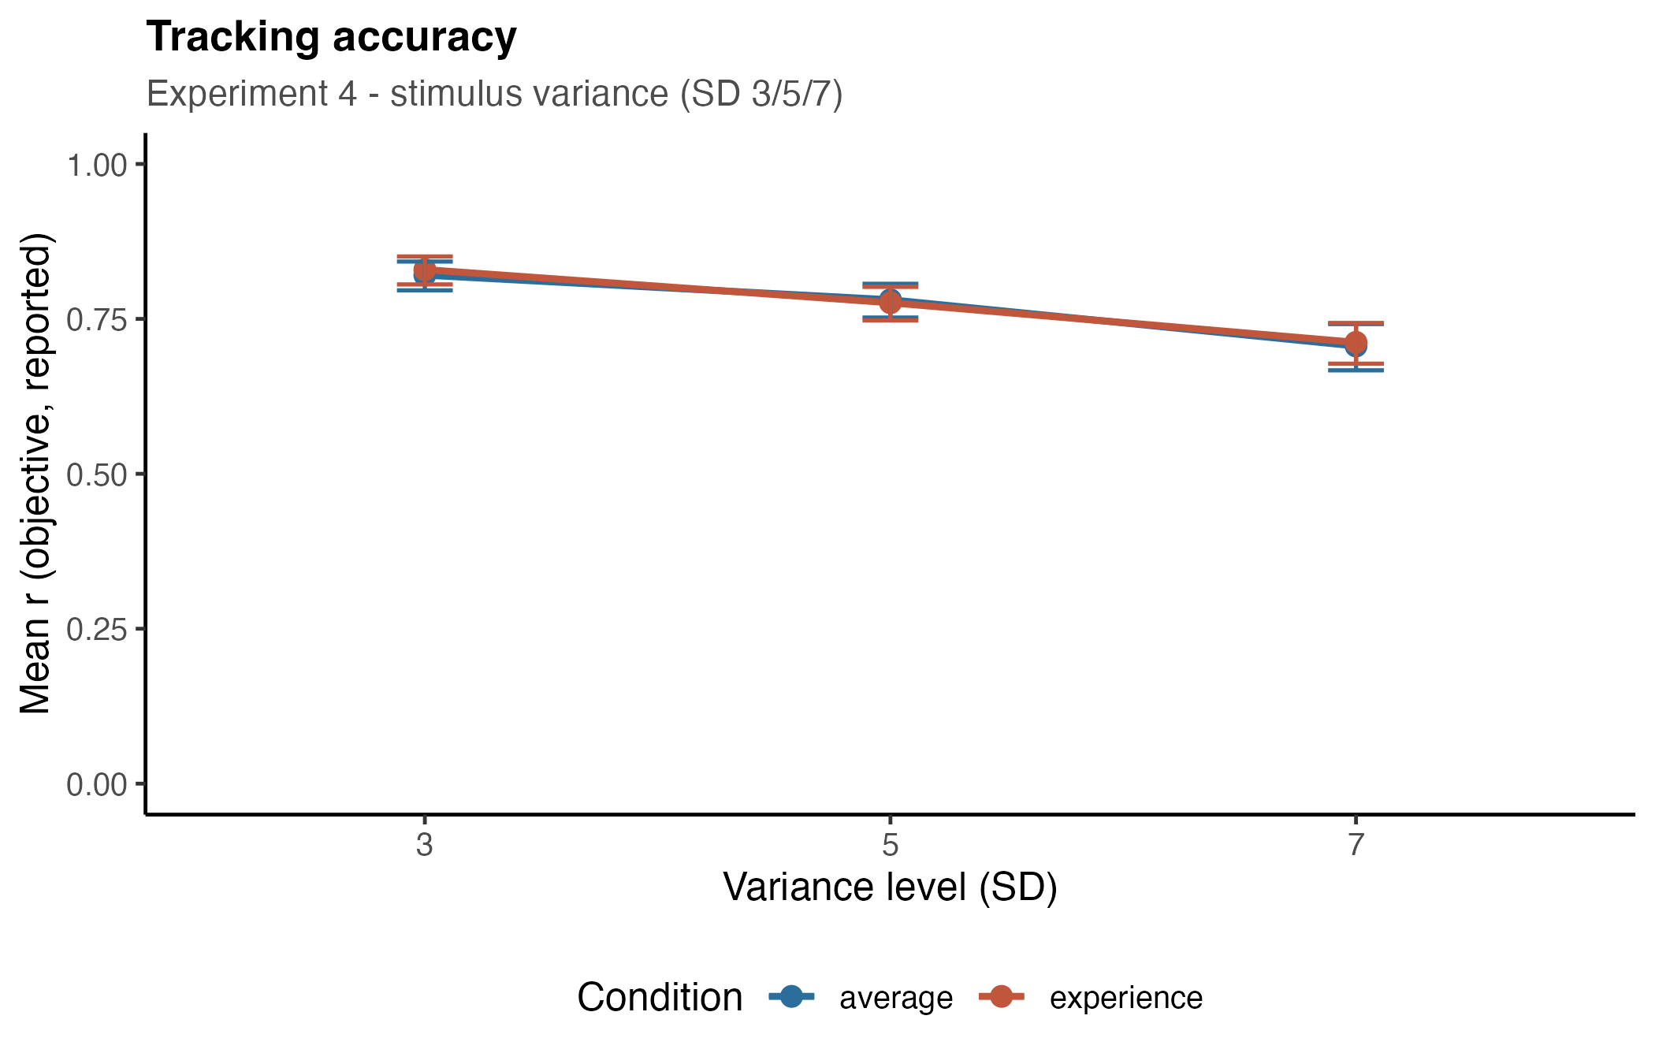
Figure 8. Experiment 4. Mean within-participant correlation between objective mean and report, by variance level.
Regression to the mean. The slope declined step by step in both conditions:
 | SD 3 | SD 5 | SD 7
experience | 1.095 [1.029, 1.161] | 0.966 [0.900, 1.033] | 0.860 [0.794, 0.926]
average | 1.073 [1.010, 1.136] | 0.916 [0.852, 0.979] | 0.777 [0.714, 0.840]

Objective mean × variance: F(2, 10584) = 68.22, p < .001 (experience) and F(2, 10668) = 115.57, p < .001 (average); every pairwise step p < .001 in both. At the lowest variance the slope is significantly above 1 in both conditions — mild systematic overshoot — crossing below 1 by SD 5.
The combined model found no effect of condition, F(1, 100.93) = 1.39, p = .241, no objective mean × condition interaction, F(1, 100.92) = 1.46, p = .230, and no three-way interaction, F(2, 21254) = 2.33, p = .097. The variance effect is large, graded and identical in the two conditions.
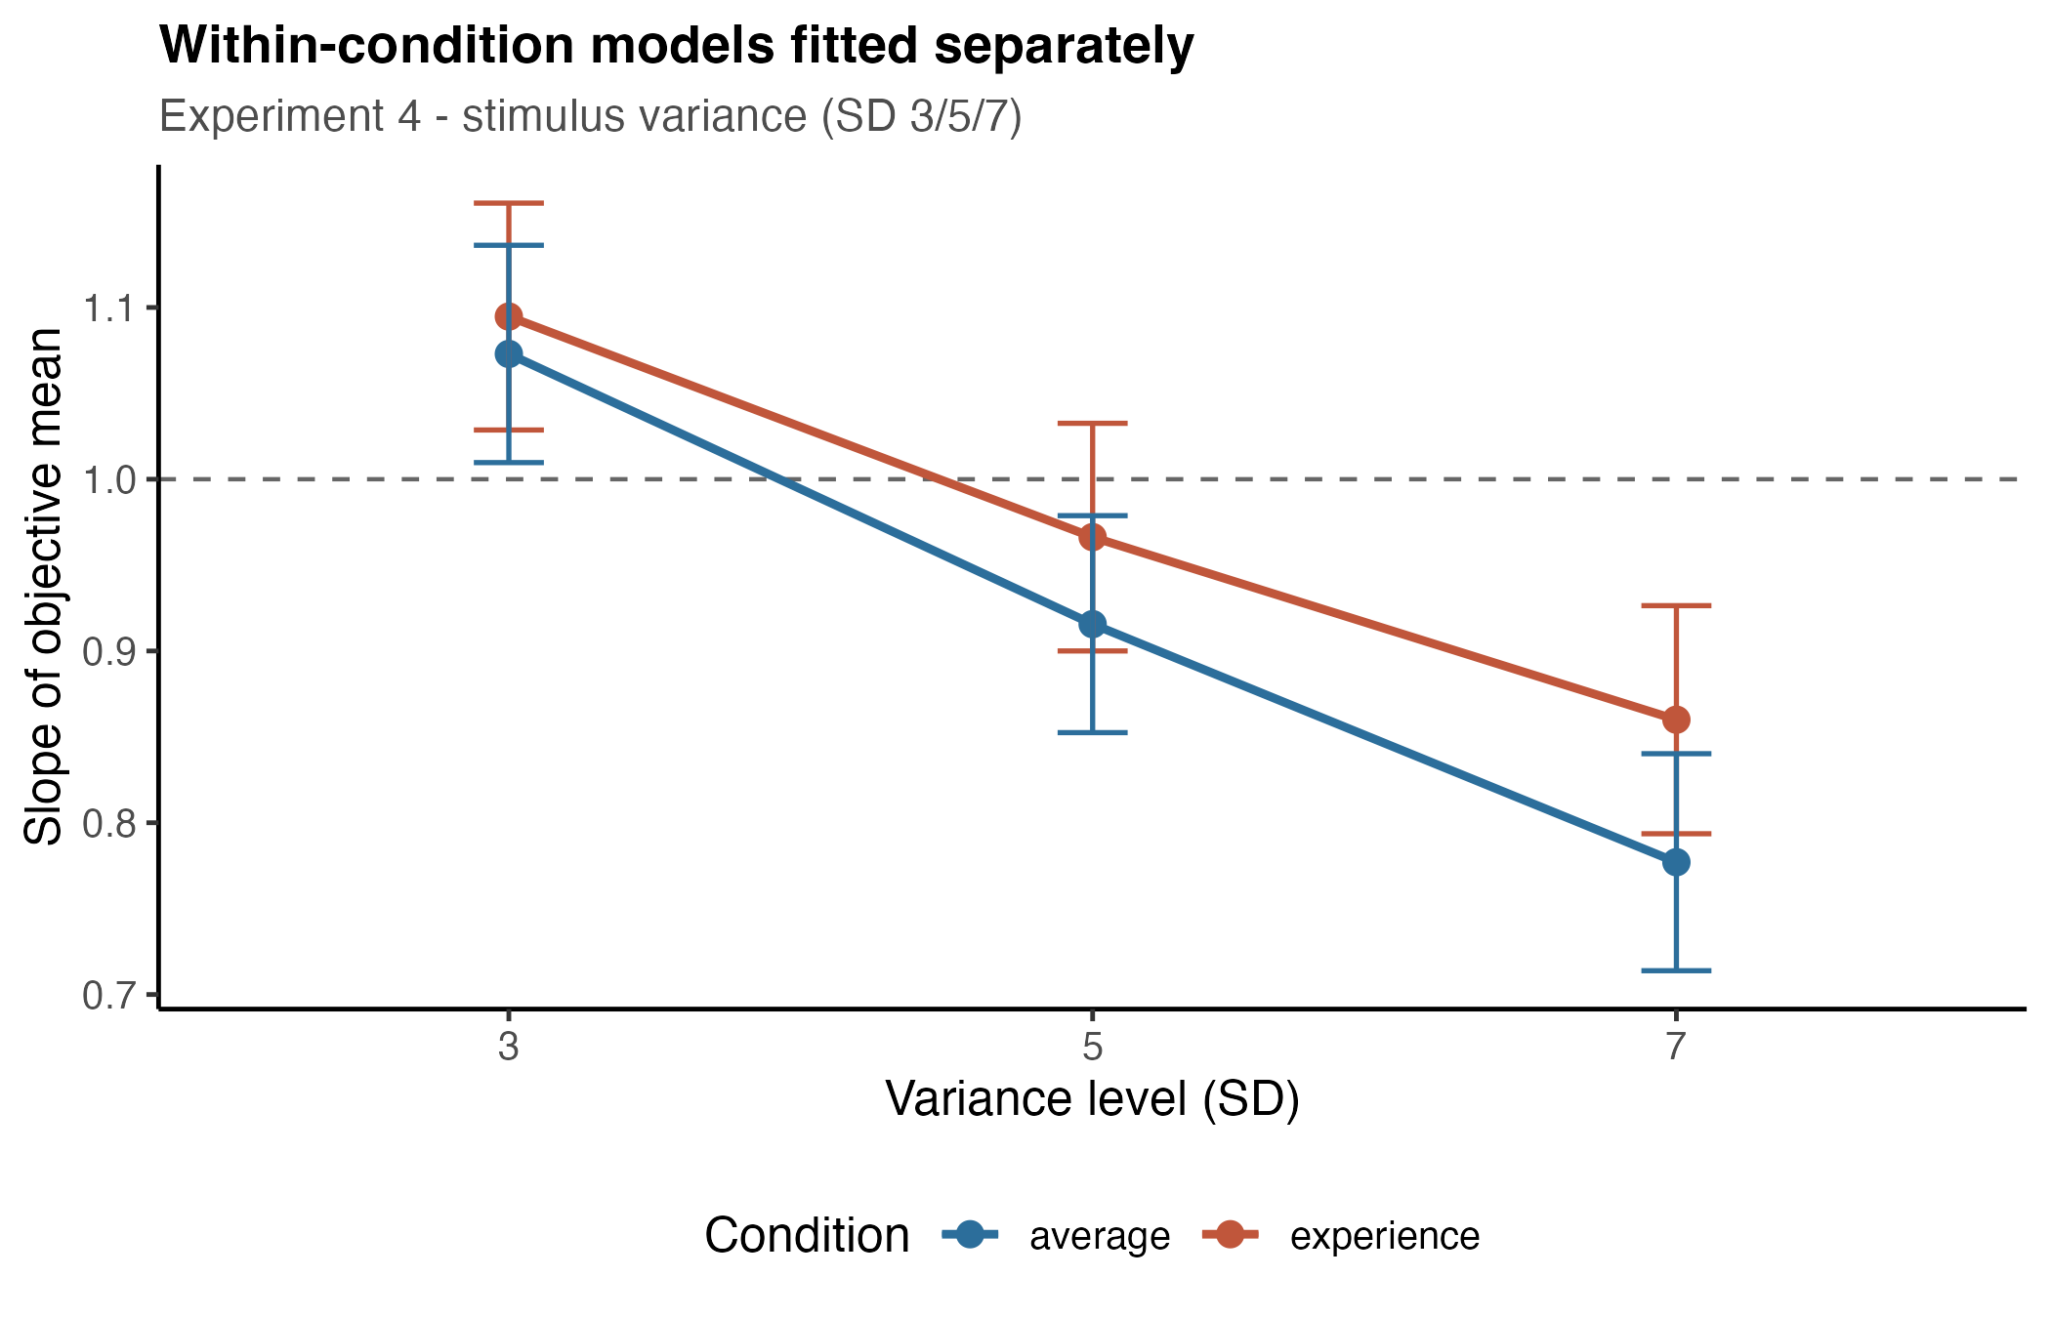
Figure 9. Experiment 4. Slope of the objective mean by variance level. The graded decline is the clearest effect in the set and is statistically identical in the two conditions.
Exaggeration. extreme responding decreased with variance: .159 / .109 / .103 (average) and .169 / .121 / .108 (experience). Main effect of variance, F(1.80, 181.54) = 46.06, p < .001, with SD 3 differing from both SD 5 and SD 7 (p < .001) and no difference between 5 and 7. No condition effect (p = .494) and no interaction (p = .829). The number of eligible trials was essentially constant across levels, so this is not a base-rate artefact. Fewer extreme responses under higher variance is what compression predicts.
What lies behind an extreme report. Extreme responses also became less diagnostic. Taking trials where the report fell within ±2 of 10 or of 40, the objective mean behind them moved toward the centre — 17.06 / 16.96 / 17.64 for reports near 10 and 31.97 / 31.46 / 31.03 for reports near 40. Low window, F(2, 1389) = 4.74, p = .009 (SD 3 vs 7, p = .026); high window, F(2, 798) = 4.73, p = .009 (SD 3 vs 7, p = .006). The reality bracketed by a 30-unit span of reports narrowed from 14.90 to 13.39 scale units, roughly 4–5 standard errors. The fixed exaggeration cutoffs give the same answer (14.97 → 13.54).
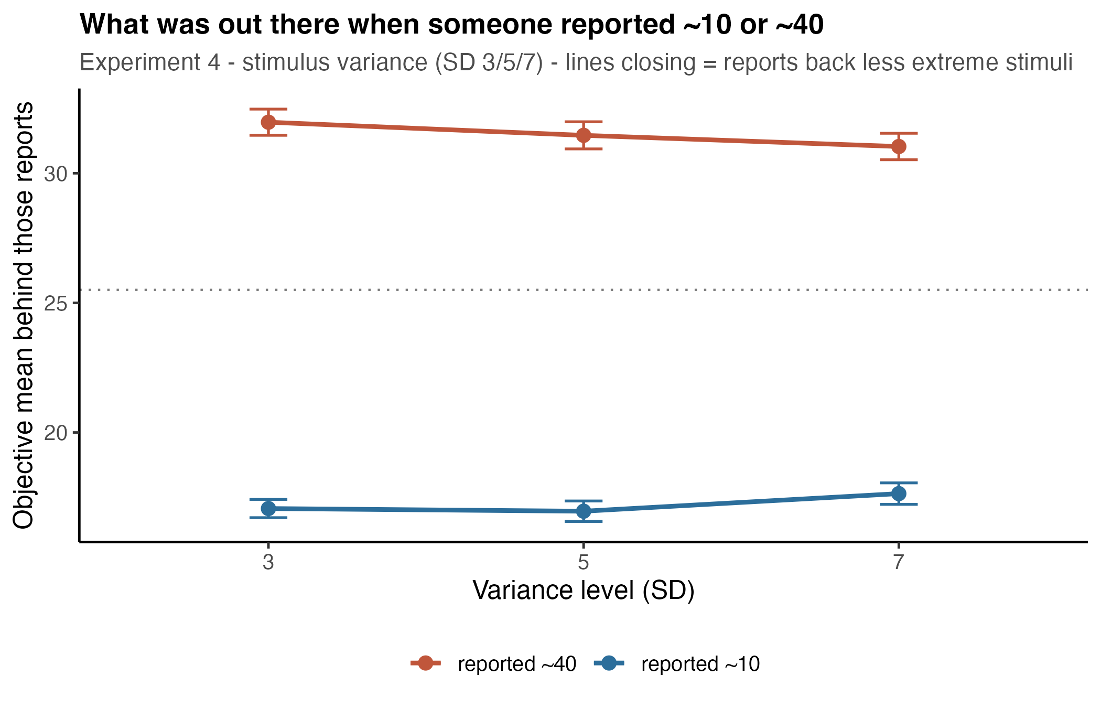
Figure 10. Experiment 4. Objective mean behind reports falling within +/-2 of 10 and of 40. The two lines close on the scale centre as variance rises.
Note that these two results are not in conflict: extreme responses became rarer, and the ones that occurred were backed by less extreme stimuli. Both follow from compression of the response distribution. See Supplement B for why these are two distinct constructs and why they should be named apart.

Reanalysis across experiments: what the arrays actually looked like
The cleaned data record array size and objective mean, but not the individual square values. Recovering those from the raw session logs shows that dispersion was not a by-product of array size. The stimulus generator used a fixed deviation template per level, so the displayed dispersion was:
Experiment | levels | measured item SD
Experiment 1 | 2 / 6 / 8 / 12 | 3.98 / 4.39 / 5.47 / 5.47
Experiments 2 and 3 | 2 / 10 / 20 | 3.97 / 5.93 / 5.50
Experiment 4 | SD 3 / 5 / 7 | 2.86 / 4.75 / 6.65

The 10-square arrays were more dispersed than the 20-square arrays, and in Experiment 1 sizes 8 and 12 were identical. Array size and stimulus variance were therefore perfectly confounded in Experiments 1–3, and confounded non-monotonically. At array size 20 the item SD was identical on every single trial.
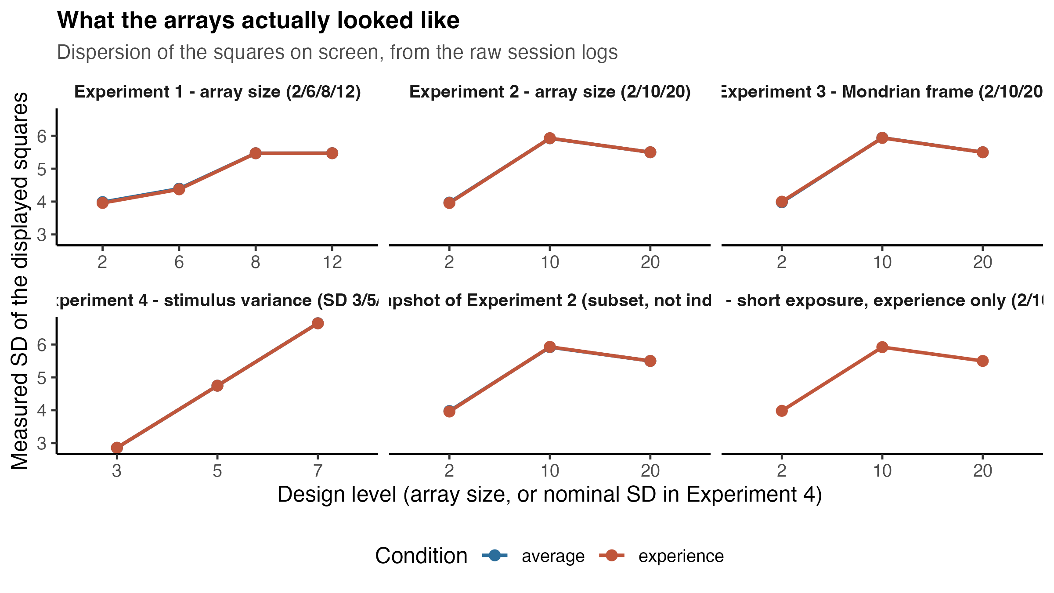
Figure 11. Measured dispersion of the squares actually displayed, recovered from the raw session logs. Array size and stimulus variance are confounded, and non-monotonically so.
Re-ordering each experiment's levels by measured dispersion rather than by array size makes the slopes monotonic in 7 of 9 independent experiment × condition datasets (Spearman = −1.00 in each). The two exceptions are Experiment 3's experience condition, where the inversion is 0.003, and Experiment 1's experience condition, where the inversion falls between two levels of identical dispersion.
The decisive comparison is array size 10 against 20 in Experiments 2 and 3: the set size doubles while dispersion falls, and the slope rises — 0.68 → 0.74, 0.70 → 0.74 in the average conditions. A processing-load account predicts the opposite; a dispersion account predicts exactly this.
Regressing cell slopes on measured item SD, weighted by precision, with an intercept per experiment: b = −0.058, SE = 0.013, t = −4.54, p < .001. Each additional unit of dispersion costs about 0.06 of slope, and the per-experiment intercepts do not differ reliably.
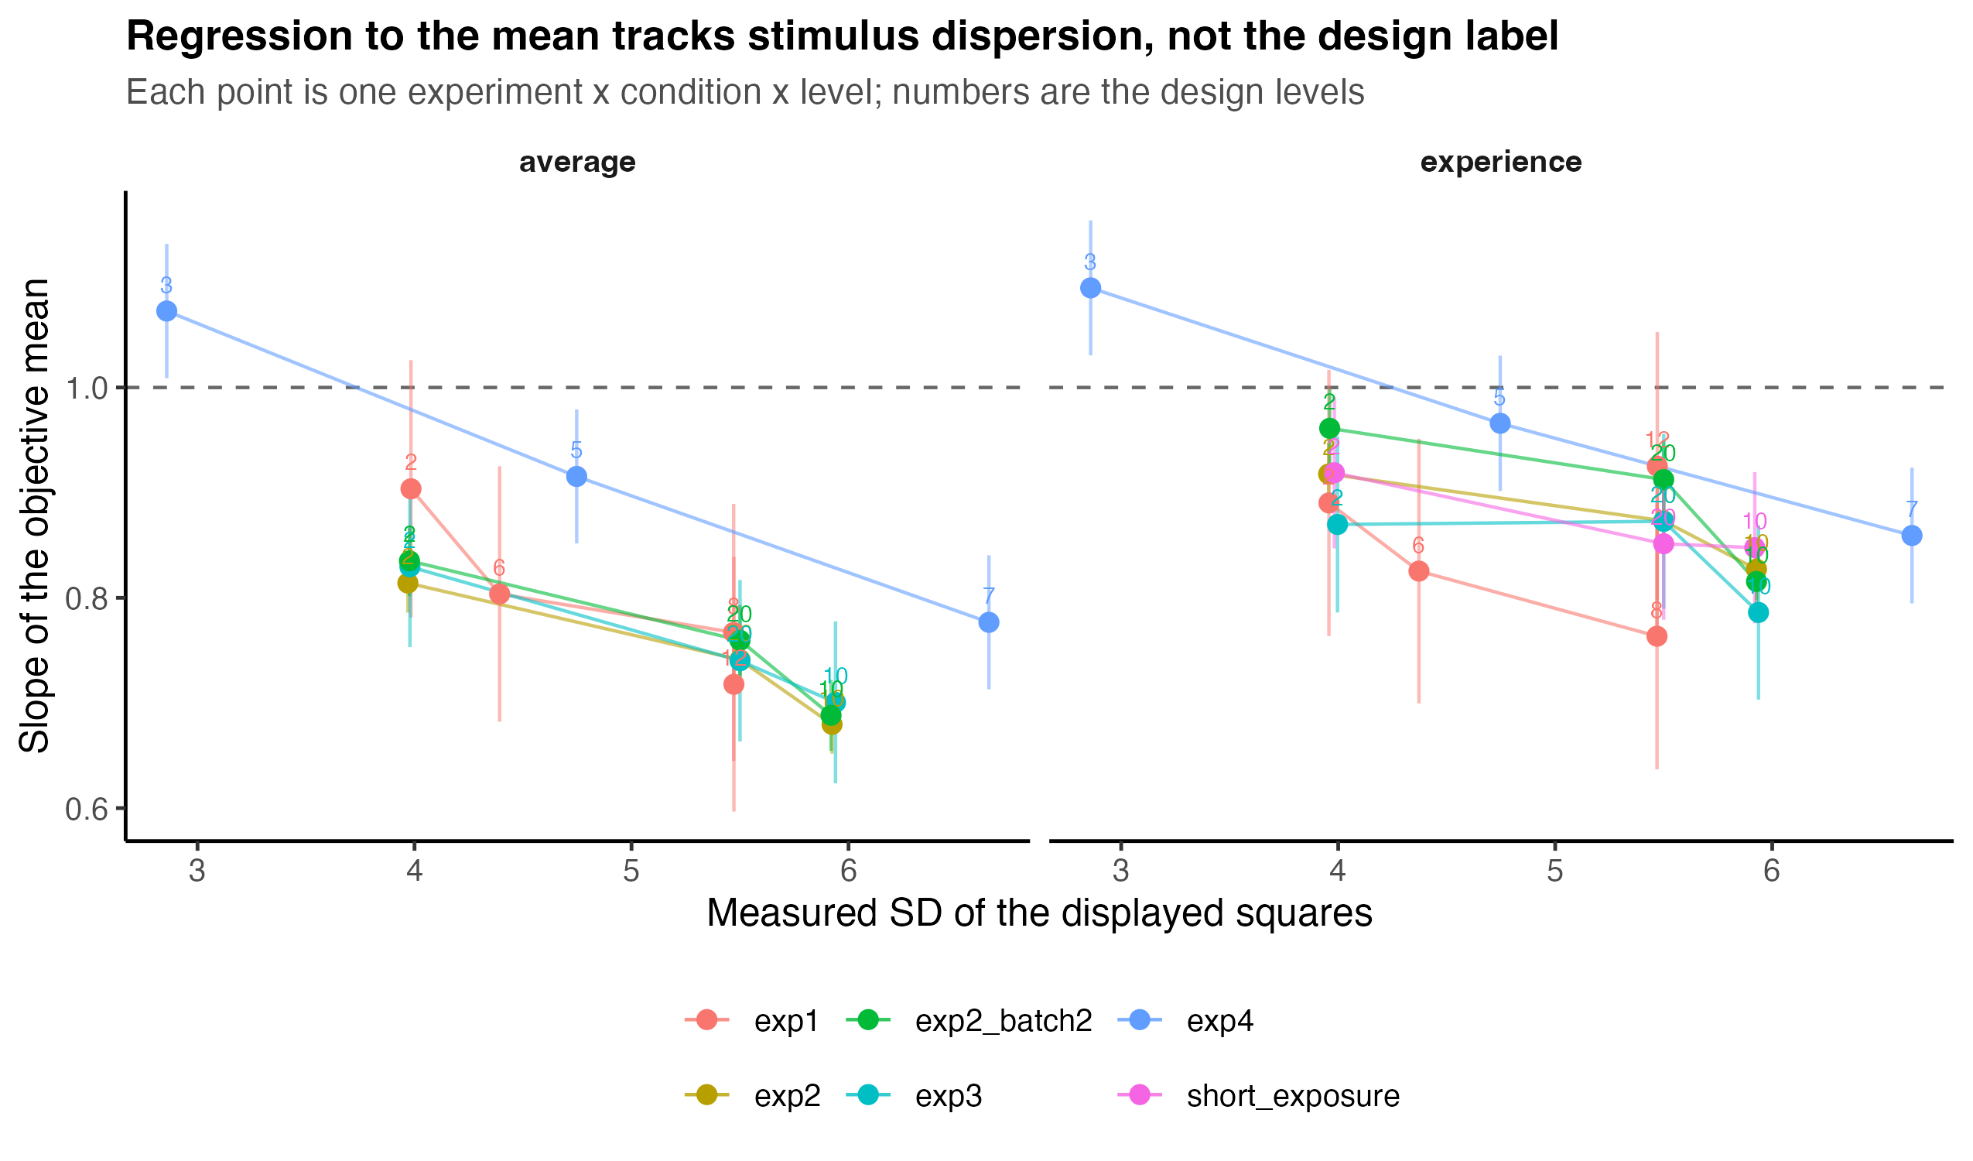
Figure 12. Slope of the objective mean plotted against measured stimulus dispersion. Each point is one experiment x condition x level; numbers are the design levels.

Overview
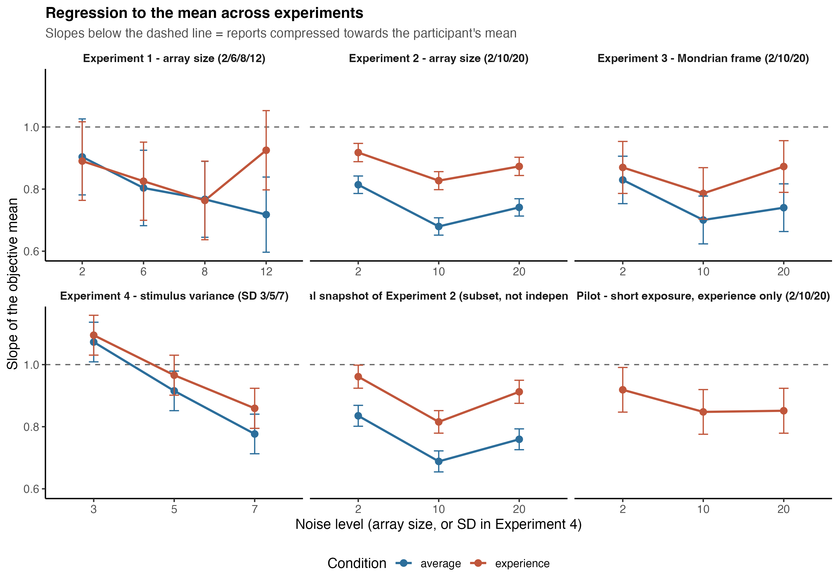
Figure 13. Regression to the mean across all four experiments. Slopes below the dashed line indicate reports compressed toward the participant's own mean.
Across four experiments and roughly 400 participants, reports of colour ensembles are systematically compressed toward the participant's own mean, and the degree of compression is governed by the dispersion of the items in the array.
The experiments do not divide into three failures and one success. Experiments 1–3 manipulated dispersion incidentally, over a narrow range and in a scrambled order, which is why their slope patterns looked non-monotonic in array size; Experiment 4 manipulated the same variable deliberately, over roughly twice the range and in the right order, and produced a graded effect roughly three to six times larger (generalised η² = .177 against .027–.036). Ordered by what was actually on screen, the four experiments tell one story.
Three further conclusions follow.
Number of items is not what matters. Where set size and dispersion move in opposite directions — array 10 versus 20 — regression to the mean follows dispersion. Adding irrelevant colour noise around the array (Experiment 3's Mondrian frame) did nothing either. What degrades the ensemble estimate is variability within the set being averaged, not processing load or external clutter.
Experience and estimation behave alike. We found no consistent difference between the two conditions. Tracking accuracy never differed (Exp 1 p = .416, Exp 2 p = .417, Exp 3 p = .201, Exp 4 p = .845), and in Experiment 4 — the only experiment with a clean, graded manipulation — the variance effect on the slope was statistically identical in the two conditions (p = .097 for the three-way interaction). Experiment 2 showed consistently higher slopes in the experience condition, but this did not replicate in Experiments 1, 3 or 4. The original prediction that noise distorts experience more than estimation is not supported.
Exaggeration and compression coexist. They are not competing predictions. Under higher variance, extreme responses became rarer and less diagnostic, while at the lowest variance level of Experiment 4 the transfer function genuinely overshot (slope > 1). Naming these separately — systematic overshoot versus diagnosticity loss — removes most of the apparent tension in the earlier draft.

Supplementary material

Supplement A — Analysis pipeline and reproducibility
All results were produced by a single pipeline (analysis/run_all.R) that reads the raw Pavlovia session logs, applies identical cleaning to every experiment, and writes every table and figure reported here. A complete rebuild from raw data takes under three minutes and reproduces the output exactly. Per-experiment output includes the participant flow through each exclusion stage, per-participant retention and tracking coefficients, all model tables, and the random-effects structure each model settled on.
Random effects follow a Barr-style ladder: the maximal structure named for each experiment is fitted first and simplified only until the model converges without a singular fit. Slopes and contrasts are obtained with emmeans::emtrends, so they do not depend on the contrast coding. Mixed ANOVAs use afex::aov_ez with Greenhouse–Geisser correction, which scales both degrees of freedom; fractional df throughout are a consequence of that correction.
Two datasets in the archive are not independent experiments and are excluded from all pooled analyses: the greaternoise2 folders are a partial mid-collection snapshot of Experiment 2 (identical session files and participants), and a short-exposure pilot (N = 38, experience only) that was never reported. The four reported experiments and the pilot share no participants.

Supplement B — Two constructs called "exaggeration"
The write-up has used one word for two measures that move in opposite directions.
Systematic overshoot is a property of the transfer function: the slope of the report on the objective mean exceeds 1, so a stimulus one unit above the mean produces a report more than one unit above it. In this dataset it occurs only in Experiment 4 at SD 3 (average 1.073, 95% CI [1.010, 1.136]; experience 1.095, [1.029, 1.161]) and it decreases with variance.
Diagnosticity loss is a property of the inverse mapping: a given extreme report is backed by a less extreme stimulus. It increases with variance (Experiment 4 windows, above).
A third measure sometimes used for the same idea — whether responses are more spread out than the stimuli, SD(report) / SD(objective) — does not isolate either, because
SD(report)² = b² · SD(objective)² + σ²
so the ratio exceeds 1 whenever response noise is large enough, even when the transfer function is compressive. In Experiments 2 and 3 the experience condition has a ratio above 1 with a slope below 1: the wider response distribution there is noise, not amplification. The clean pair to report is the slope and the residual SD.

Supplement C — What the reverse-direction model can and cannot show
Because the exaggeration hypothesis is naturally phrased in the inverse direction, we also fitted the objective mean on the report. That model is a poor instrument for testing the hypothesis, for a reason that is arithmetic rather than empirical.
Writing r for the correlation and G = SD(report)/SD(objective):
b(forward) = r · G b(reverse) = r / G
so b(forward) · b(reverse) = r², and the two slopes contain only two independent quantities. In logs,
Δlog b(reverse) = Δlog b(forward) − 2 · Δlog G
Noise lowers both r and G, so the two effects compound in the forward slope and cancel in the reverse one. In Experiment 4's average condition Δlog r = −0.163 and Δlog G = −0.147 — almost exactly equal — so the forward slope falls 28% while the reverse slope moves under 1%. The near-null reverse result is that cancellation, not evidence that variance leaves the inverse mapping intact.
Two further checks confirm the reverse model adds no independent information here. Predicting the reverse slope from the forward fit alone — b · SD²(objective) / (b² · SD²(objective) + σ²) — reproduces the fitted values to within 0.009 in every Experiment 4 cell. Reconstructing the whole reverse conditional-mean function from each participant's forward line, residual SD and own stimulus set reproduces the observed binned means to a weighted mean absolute error of 0.098 scale units across ~21,000 trials, including its pronounced curvature — which is therefore a consequence of the bounded stimulus list, not of perception.
The inverse question is still worth asking; it is simply better asked at the tails, where the effect is concentrated, using the report-window analysis reported for Experiment 4. The reverse Galton diagrams are retained as description.
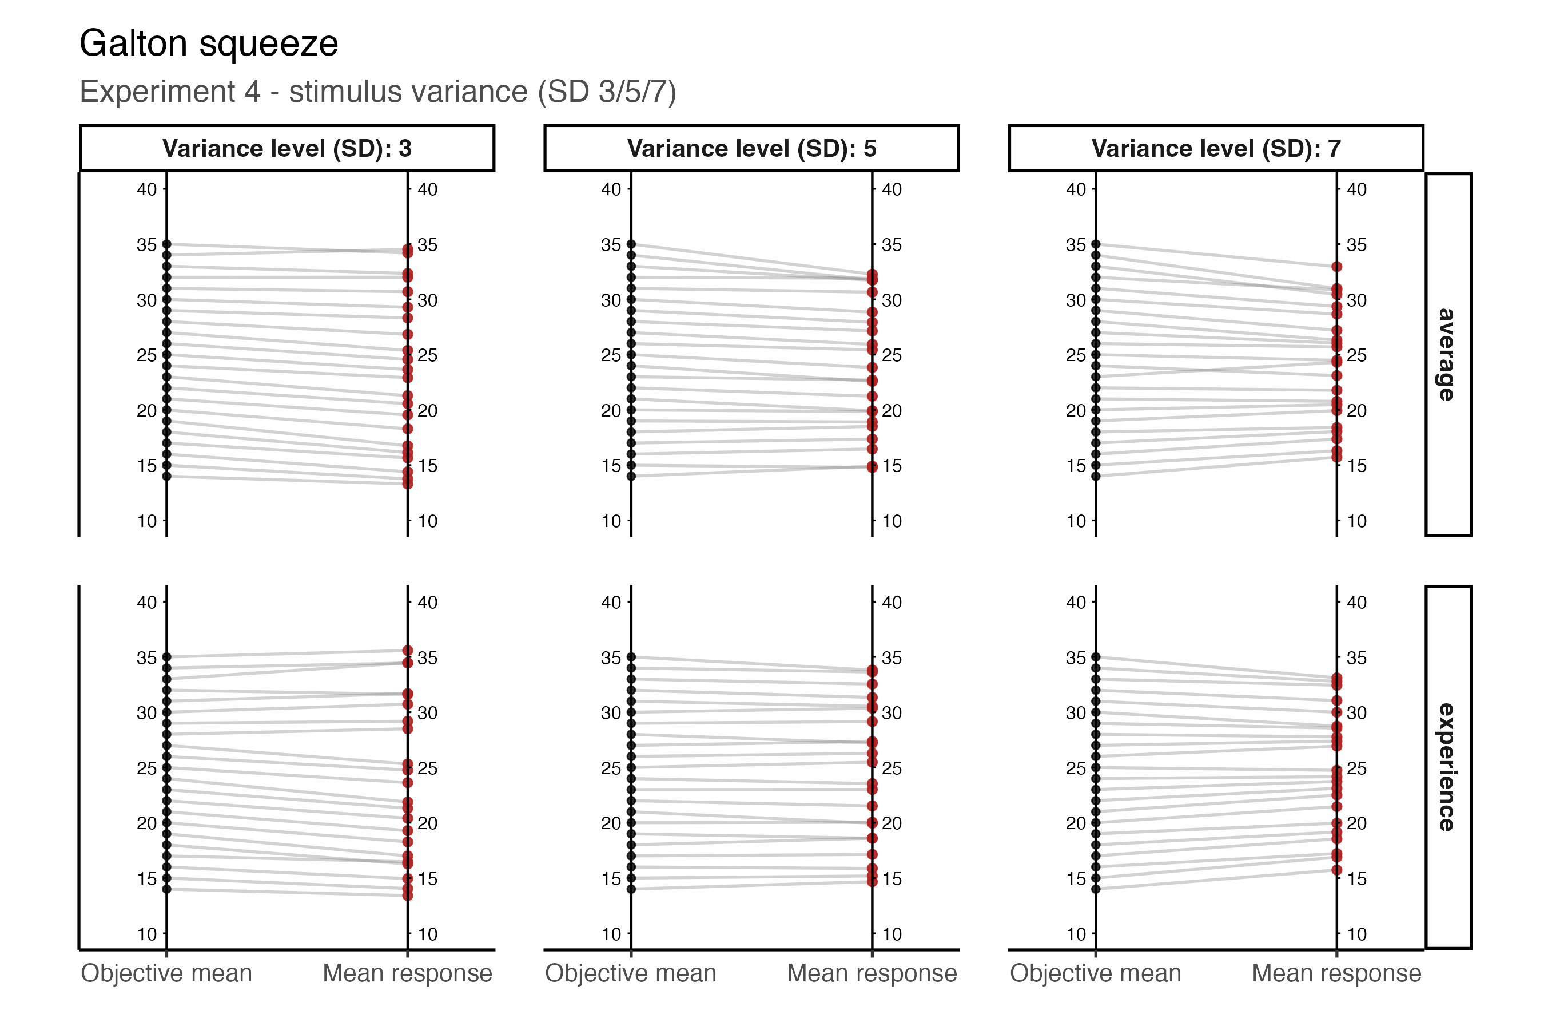
Figure S1. Experiment 4. Galton squeeze: objective mean on the left axis, mean response on the right. Lines converging toward the centre on the right are regression to the mean.
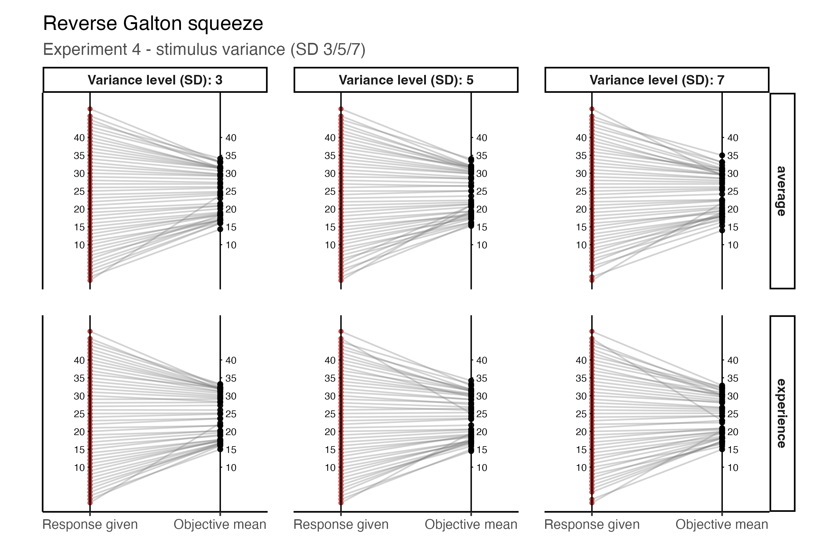
Figure S2. Experiment 4. Reverse squeeze: the report on the left axis and the mean objective value behind it on the right. The curvature is produced by the bounded stimulus list plus response noise (Supplement C).
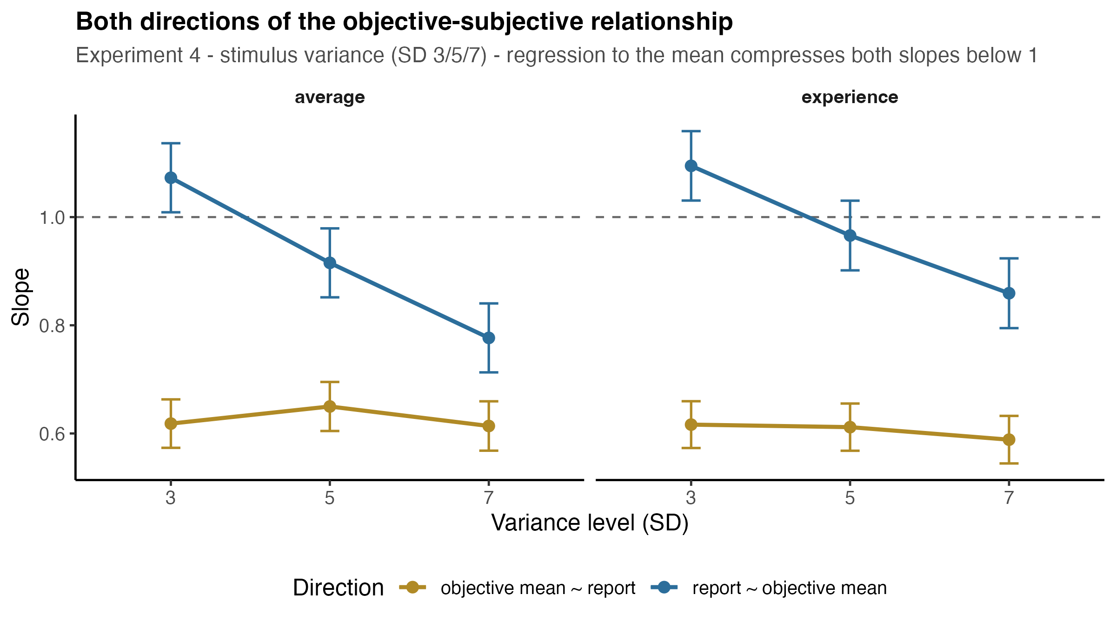
Figure S3. Experiment 4. Forward and reverse slopes on one axis. The forward slope tracks the variance manipulation; the reverse slope is nearly flat.

Supplement D — Model-free confirmation
Because the main tests are mixed-model F-tests, whose values depend on the random-effects structure, every experiment was also analysed in two stages: each participant × noise-level cell was reduced to a single number computed directly from the trials, and those numbers were entered into a mixed ANOVA with no model involved.
The two approaches agree. Per-participant OLS slopes match the mixed-model estimates to within 0.005 in Experiment 4 and within 0.019 anywhere in the set. Experiment 4 by ANOVA: F(1.79, 181.22) = 126.76, p < .001, generalised η² = .177, with all six pairwise steps p < .001.
Two measures from this analysis are informative in their own right. SD of reports is a model-free index of compression, and it falls monotonically with variance in Experiment 4 (8.25 → 7.16 average, 8.50 → 7.50 experience; F(1.60, 162.03) = 50.11, p < .001). SD of the objective means presented is a control: it is set by the stimulus generator and should not vary. It does not, in Experiment 4 (p = .248) or in Experiments 2 and 3 (p = .600 and p = .876), which rules out the possibility that the noise manipulations also shifted the distribution of stimuli that participants saw.
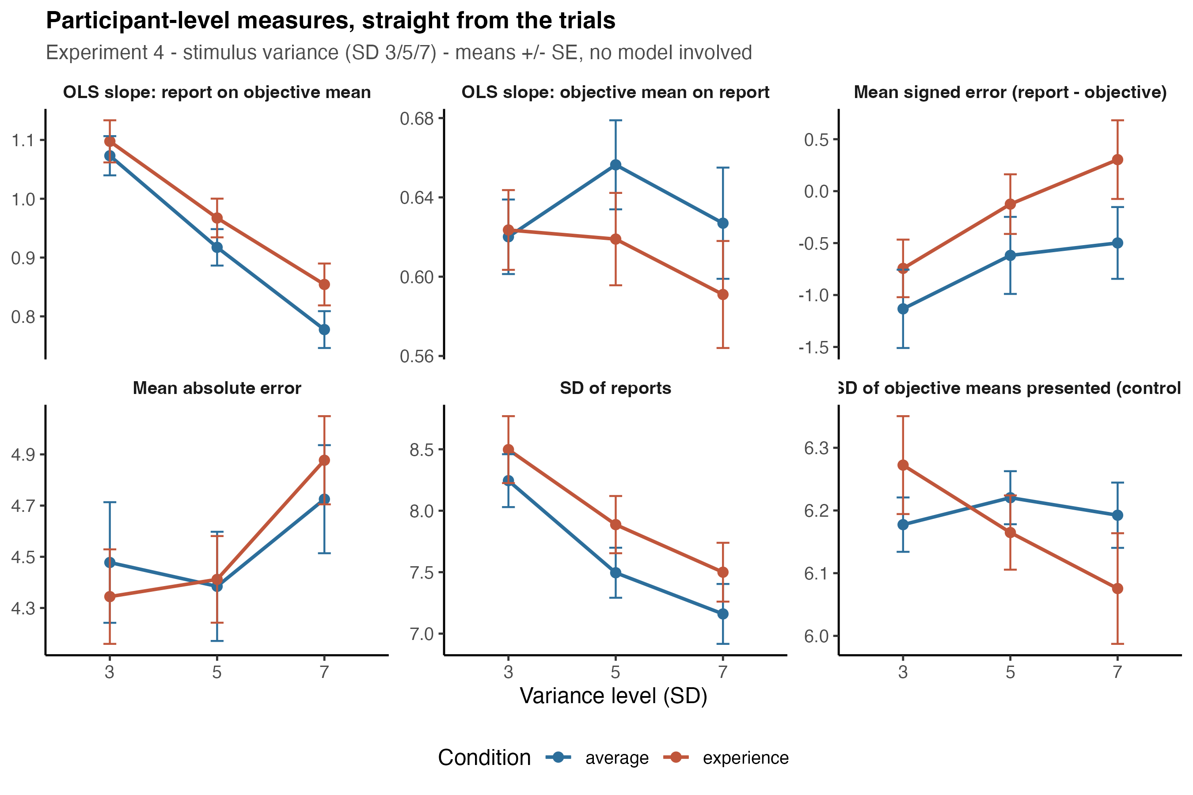
Figure S4. Experiment 4. Participant-level measures computed directly from the trials, with no model involved. Note the falling SD of reports and the flat SD of objective means presented.
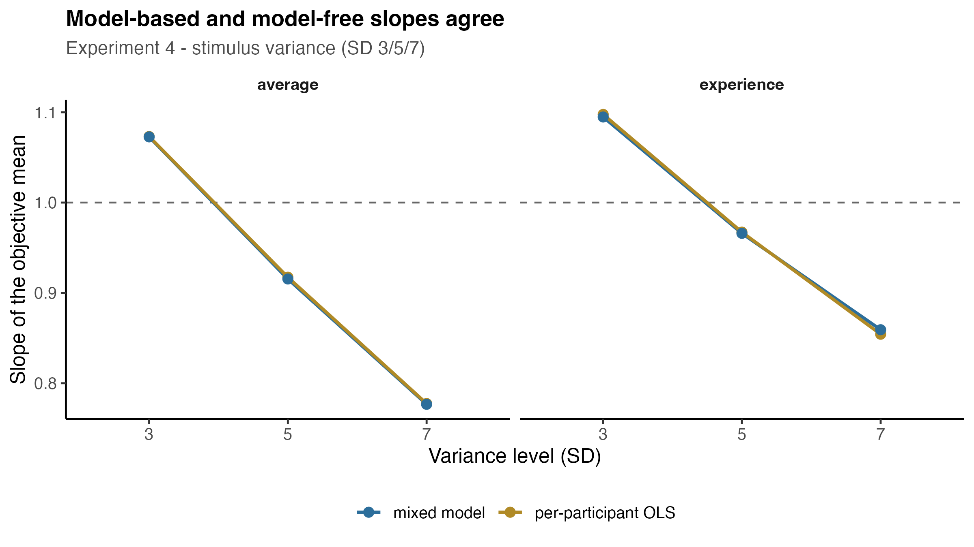
Figure S5. Experiment 4. Per-participant OLS slopes against the mixed-model estimates.

Supplement E — Stimulus audit
Full per-level dispersion measurements, the slope ordering by dispersion, and the meta-regression are in analysis/output/stimulus_audit/. Trial-level item SDs recovered from the raw logs are cached there as well, so the audit can be re-run or extended without re-parsing the session files.

