Experiment 1 (array size 2/6/8/12): a walkthrough of the results
  - Regression to the mean in perceptual experience — exploratory, not the main write-up
19 September 2026
Table of Contents

About this document
Experiment 1 - array size (2/6/8/12). Arrays of 2, 6, 8 or 12 coloured squares (24 trials per array size, 96 per session). Noise was manipulated through the number of squares; each array size always used the same fixed offsets around the mean. Participants reported the colour on a 50-step scale, either the average colour or how red/blue the array felt (experience condition).
This document walks through every result of this experiment: first whether the data and the manipulation are sound, then what they show about regression to the mean (RttM) in perceptual experience. Every number and figure is recomputed from the analysis pipeline when the file is knitted; it is exploratory and not part of the main write-up. True values are the mean of the squares actually shown (EPOC_TRUE_VALUE = "shown").
Two directions of RttM. Forward: given a stimulus, is the report less extreme? (slope of report on true value). Reverse: given a report, was the stimulus less extreme? (the exaggeration claim: extreme experiences overstate the world). Pure noise produces reverse RttM but leaves the forward slope at 1, so a forward slope below 1 needs more than noise.

Bottom line
Regression to the mean, but no reliable effect of array size on it. Reports tracked the stimulus less tightly at some array sizes (correlation .80 / .76 / .72 / .76, p = .001), but not in design order: tracking was worst at 8 squares, and 8- and 12-square arrays are equally dispersed. The forward slope (.89 / .82 / .76 / .81) changes in the participant-level test (p = .013) but not in the strict mixed model (p = .15), and reports do not narrow reliably (p = .27). Extreme reports come from less extreme stimuli at every array size (reverse slope about .6). At the extremes, the differences between 2 and 12 squares point in opposite directions at the two ends (+1.3 units for high reports, −1.7 for low reports, as given): that is the overall shift of 2-square reports (about 2.4 units low), not a change in exaggeration, and nothing remains once each participant’s shift is removed.
Key results at a glance (levels in design order; array size is not the order of colour dispersion, see section 2)
Question | Result
Do reports track the stimulus less tightly at higher noise? (correlation) | r 0.80 / 0.76 / 0.72 / 0.76; p = .001
Does the forward slope change with noise? (strict model) | slopes 0.89 / 0.82 / 0.76 / 0.81; p = .154
Same, participant-level ANOVA | p = .013
Do reports narrow at higher noise (SD ratio, lowest vs highest level)? | ratio 1.19 / 1.17 / 1.14 / 1.16; p = .274
Same extreme high report: stimulus less extreme at 12 squares than 2 squares? (as given) | +1.33 units, p = .007
Same extreme low report: stimulus less extreme at 12 squares than 2 squares? (shift removed) | -0.35 units, p = .569

1. Sample and data quality
Participant flow
Stage | Average | Experience
Started | 32 | 30
Second session (already did the other condition) | 0 | 0
Incomplete session | 0 | 0
Kept < 85% of trials | 8 | 6
Did not track the stimulus (Spearman r ≤ .30) | 1 | 3
Analysed | 23 | 21
- Trials analysed: average 2,111 (about 92 per participant, mean absolute error 5.05 units); experience 1,923 (about 92 per participant, mean absolute error 4.99 units).
- Cleaning, identical for all experiments: second sessions dropped; reports of 0 treated as missing (the response scale’s starting value, saved when someone clicks without crossing the scale); RT < 200 ms or > 8 s; ±2.5 SD RT trimming per participant; errors ≥ 30 units; participants keeping < 85% of trials or with Spearman r ≤ .30.

2. Does the manipulation work?
Stimulus checks (true value = mean of the squares shown)
Level | Spread within arrays (SD) | Spread of true means (SD) | Mean true value
2 squares | 4.00 | 6.60 | 25.29
6 squares | 4.32 | 6.69 | 25.37
8 squares | 5.48 | 6.62 | 25.19
12 squares | 5.45 | 6.64 | 25.55
The spread of true means across trials is the same at every level, so only the arrays themselves differ between levels. Each level always used the same template of offsets, so the array make-up does not vary within a level and cannot be tested against the report.
Problems found.
- Array size does not track colour dispersion. The fixed templates give within-array spreads of about 4.0 / 4.3 / 5.5 / 5.5, so 8- and 12-square arrays are equally dispersed. Array size is therefore not a clean noise manipulation.
- The 12-square template does not average to zero (the squares shown average 0.33 above the logged mean). This document uses the mean of the squares actually shown as the true value, which removes the problem.
- 2-square arrays read low (about 2.4 units below the mean shown). This is not explained by the colour scale, and only slightly (if at all) by weighting the lighter square; nearly identical practice pairs read low too.
- Trial order: 2-square trials come slightly earlier in each colour block (the same biased-shuffle signature as Experiment 4; the Experiment 1 task code actually run has not been checked).
- One-step colour offset between stimulus squares and response images (same images as Experiment 4): a perfect observer would report about 1 unit low; this does not affect slopes or comparisons between levels.
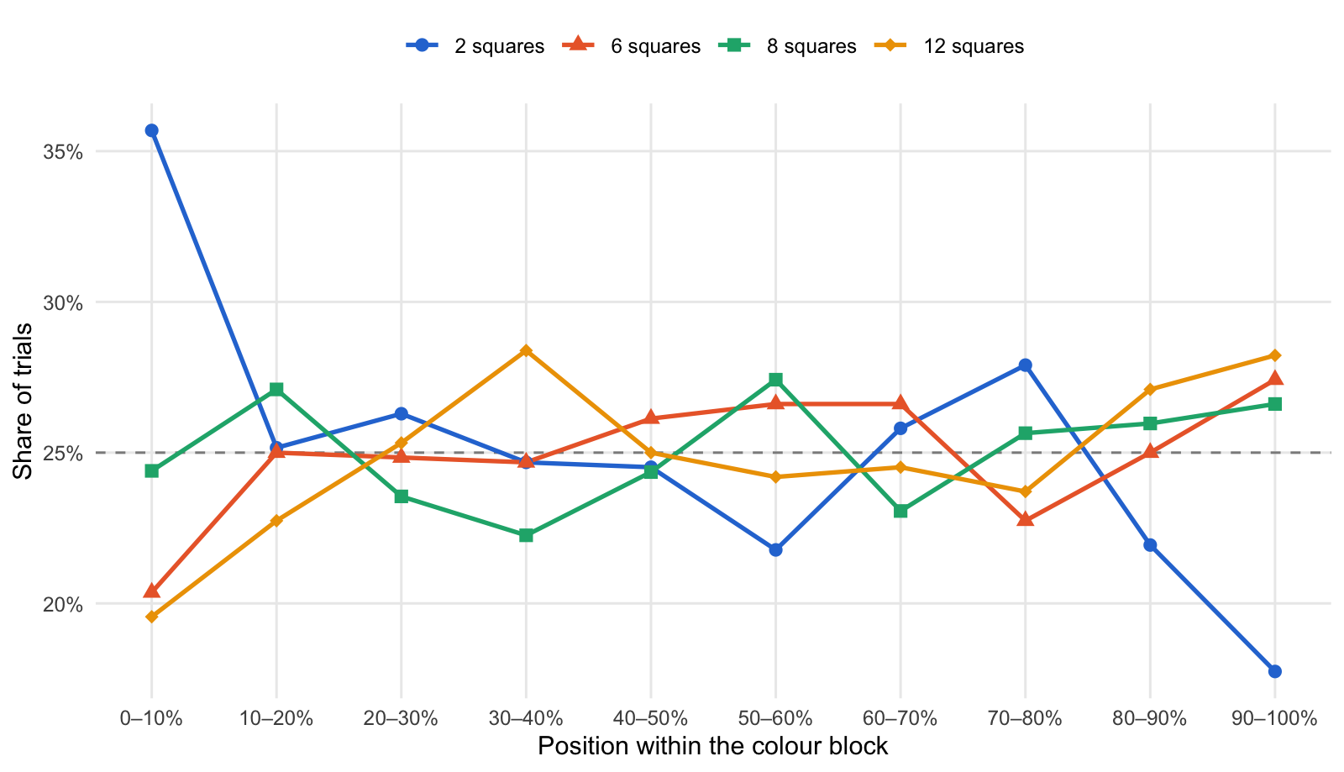
Where in each colour block the levels were shown (dashed = equal share)

3. Tracking: how closely reports follow the stimulus
Mean within-participant correlation between true mean and report
Condition | 2 squares | 6 squares | 8 squares | 12 squares
average | 0.78 | 0.75 | 0.71 | 0.72
experience | 0.82 | 0.77 | 0.72 | 0.79
Effect of array size on the correlation: F(2.90, 121.7) = 5.71, p = .001; condition p = .371; interaction p = .419.
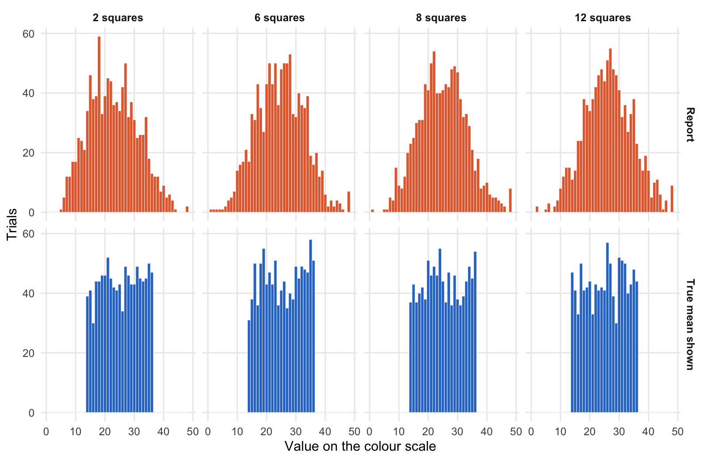
Stimuli shown (blue) vs reports given (orange) at each level
Per-participant accuracy, overall shift and spread (averaged over participants)
Level | Mean absolute error | Shift (report − true) | SD of reports | SD of true values
2 squares | 5.09 | -2.40 | 7.59 | 6.55
6 squares | 4.86 | -0.70 | 7.54 | 6.65
8 squares | 5.12 | -0.20 | 7.24 | 6.60
12 squares | 5.08 | 0.86 | 7.45 | 6.61

4. Forward regression
Forward slopes (report on true mean), strict model: each participant has their own slope at each level
Condition | Level | Slope | 95% CI
average | 2 squares | 0.90 | [0.79, 1.01]
average | 6 squares | 0.81 | [0.68, 0.95]
average | 8 squares | 0.75 | [0.63, 0.88]
average | 12 squares | 0.71 | [0.57, 0.84]
experience | 2 squares | 0.88 | [0.77, 1.00]
experience | 6 squares | 0.83 | [0.69, 0.97]
experience | 8 squares | 0.76 | [0.63, 0.89]
experience | 12 squares | 0.92 | [0.78, 1.06]

Does the slope change with array size? Robustness checks
Check | Result
Strict mixed model | F(3, 83) = 1.79, p = .154
Participant-level ANOVA of each person’s slopes | F(2.63, 110.6) = 3.95, p = .013
Strict model + trial position | F(3, 83) = 1.87, p = .141
Slope × array size × condition | p = .256

Mean participant slopes within each third of the colour block
Part of block | 2 squares | 6 squares | 8 squares | 12 squares
early | 0.80 | 0.89 | 0.75 | 0.76
middle | 0.99 | 0.82 | 0.79 | 0.74
late | 0.99 | 0.81 | 0.72 | 0.94
A slope of 1 keeps the stimulus differences in full; below 1 means extreme stimuli are reported as less extreme.
The same question value by value: the average report for each true value. Each cell shows the mean report (SD of the reports, trials); the SD includes differences between participants.
Average report for each true value (true values rounded)
True value | 2 squares | 6 squares | 8 squares | 12 squares
14 | 14.1 (5.2, 39) | 17.1 (5.1, 31) | 15.6 (7.4, 37) | 17.1 (6.2, 47)
15 | 13.6 (5.6, 41) | 15.7 (5.6, 38) | 17.4 (5.4, 43) | 17.9 (5.4, 41)
16 | 13.9 (4.0, 30) | 16.0 (6.0, 50) | 15.4 (5.9, 37) | 18.7 (7.0, 33)
17 | 16.5 (5.3, 44) | 18.8 (6.9, 36) | 18.8 (5.8, 40) | 19.7 (6.4, 50)
18 | 15.7 (4.7, 44) | 19.7 (6.5, 50) | 20.4 (4.6, 42) | 23.3 (5.6, 41)
19 | 17.0 (5.3, 46) | 18.9 (6.4, 55) | 21.0 (5.9, 38) | 22.2 (5.9, 42)
20 | 17.6 (5.2, 46) | 21.1 (5.6, 43) | 21.0 (5.8, 51) | 23.0 (6.7, 44)
21 | 18.7 (5.7, 52) | 20.1 (5.0, 47) | 22.6 (5.3, 46) | 22.4 (5.9, 33)
22 | 19.3 (4.5, 45) | 21.3 (5.9, 43) | 23.4 (6.3, 49) | 23.1 (5.7, 43)
23 | 20.1 (6.2, 42) | 22.1 (6.8, 51) | 22.8 (6.1, 46) | 23.0 (7.3, 41)
24 | 22.1 (5.8, 41) | 23.0 (5.8, 36) | 23.2 (6.6, 55) | 26.5 (6.1, 42)
25 | 22.0 (6.4, 43) | 24.4 (5.2, 41) | 24.1 (7.7, 44) | 25.6 (6.2, 41)
26 | 22.2 (7.5, 34) | 25.8 (5.0, 44) | 26.6 (6.7, 37) | 26.6 (5.7, 57)
27 | 24.6 (6.7, 49) | 26.9 (6.6, 35) | 25.9 (6.3, 47) | 28.8 (6.7, 50)
28 | 25.8 (6.6, 46) | 27.4 (9.1, 40) | 27.5 (6.2, 36) | 27.7 (7.5, 39)
29 | 28.4 (5.8, 43) | 28.2 (4.5, 38) | 28.0 (5.5, 46) | 28.2 (6.5, 30)
30 | 27.3 (5.3, 43) | 28.7 (6.3, 49) | 28.6 (6.3, 38) | 30.7 (5.9, 52)
31 | 28.8 (6.2, 49) | 29.4 (4.6, 45) | 30.0 (5.8, 36) | 29.7 (5.0, 51)
32 | 29.3 (6.4, 45) | 30.0 (5.3, 49) | 31.7 (7.2, 39) | 31.4 (7.3, 50)
33 | 28.5 (6.1, 44) | 29.7 (7.0, 48) | 31.6 (6.2, 44) | 32.6 (6.4, 40)
34 | 30.9 (7.4, 45) | 31.1 (5.9, 47) | 32.1 (6.7, 49) | 33.8 (6.5, 43)
35 | 31.0 (6.5, 50) | 32.5 (6.2, 58) | 32.3 (7.7, 45) | 35.0 (6.7, 48)
36 | 32.3 (6.1, 47) | 34.0 (7.3, 51) | 31.8 (6.6, 54) | 35.8 (5.5, 44)

Summary by zone (bias = report − true value)
True values | SD of reports, 2 squares | SD of reports, 6 squares | SD of reports, 8 squares | SD of reports, 12 squares | Bias, 2 squares | Bias, 6 squares | Bias, 8 squares | Bias, 12 squares
high (>= 32) | 6.49 | 6.33 | 6.87 | 6.48 | -3.61 | -2.53 | -2.25 | -0.27
low (<= 17) | 5.09 | 5.91 | 6.10 | 6.22 | -0.90 | 1.20 | 1.37 | 2.87
middle | 5.83 | 5.96 | 6.09 | 6.15 | -2.36 | -0.41 | 0.16 | 1.26

Same extreme true value: was the report pulled further toward the middle at the higher level? (participant-level, paired)
Extreme true values | Comparison | People | Pulled further toward the middle
low | 12 squares vs 2 squares | 43 | +4.21, p < .001
high | 12 squares vs 2 squares | 44 | -3.22, p < .001
Compression shows up as positive values at both ends (reports move toward the middle from both sides); opposite signs at the two ends mean an overall shift of the reports at one level rather than compression.

5. Why the forward slope changes: noise and narrowing
Slope = correlation × (SD of reports / SD of true values); values centred within participant
Level | Within-array SD | r | SD true | SD reports | SD ratio | Slope | Calibrated slope (r²) | Reverse slope
2 squares | 4.00 | 0.744 | 6.56 | 7.81 | 1.19 | 0.89 | 0.55 | 0.63
6 squares | 4.32 | 0.703 | 6.64 | 7.75 | 1.17 | 0.82 | 0.49 | 0.60
8 squares | 5.48 | 0.665 | 6.58 | 7.48 | 1.14 | 0.75 | 0.44 | 0.59
12 squares | 5.45 | 0.700 | 6.61 | 7.69 | 1.16 | 0.82 | 0.49 | 0.60
From 2 squares to 12 squares: log change in slope -0.084, of which 73% from the correlation and 27% from the SD ratio (within participants: correlation p = .034, ratio p = .274). Pure noise would raise the ratio as the correlation falls; a falling ratio is a genuine narrowing of the reports. A calibrated observer’s forward slope would equal r²; slopes above that mean people correct less than their noise warrants, which leaves extreme reports exaggerated (reverse slope = r² / forward slope).
SD ratio within each third of the block (trial order held constant)
Part of block | 2 squares | 6 squares | 8 squares | 12 squares
early | 1.12 | 1.19 | 1.08 | 1.12
middle | 1.23 | 1.14 | 1.20 | 1.06
late | 1.23 | 1.18 | 1.14 | 1.28
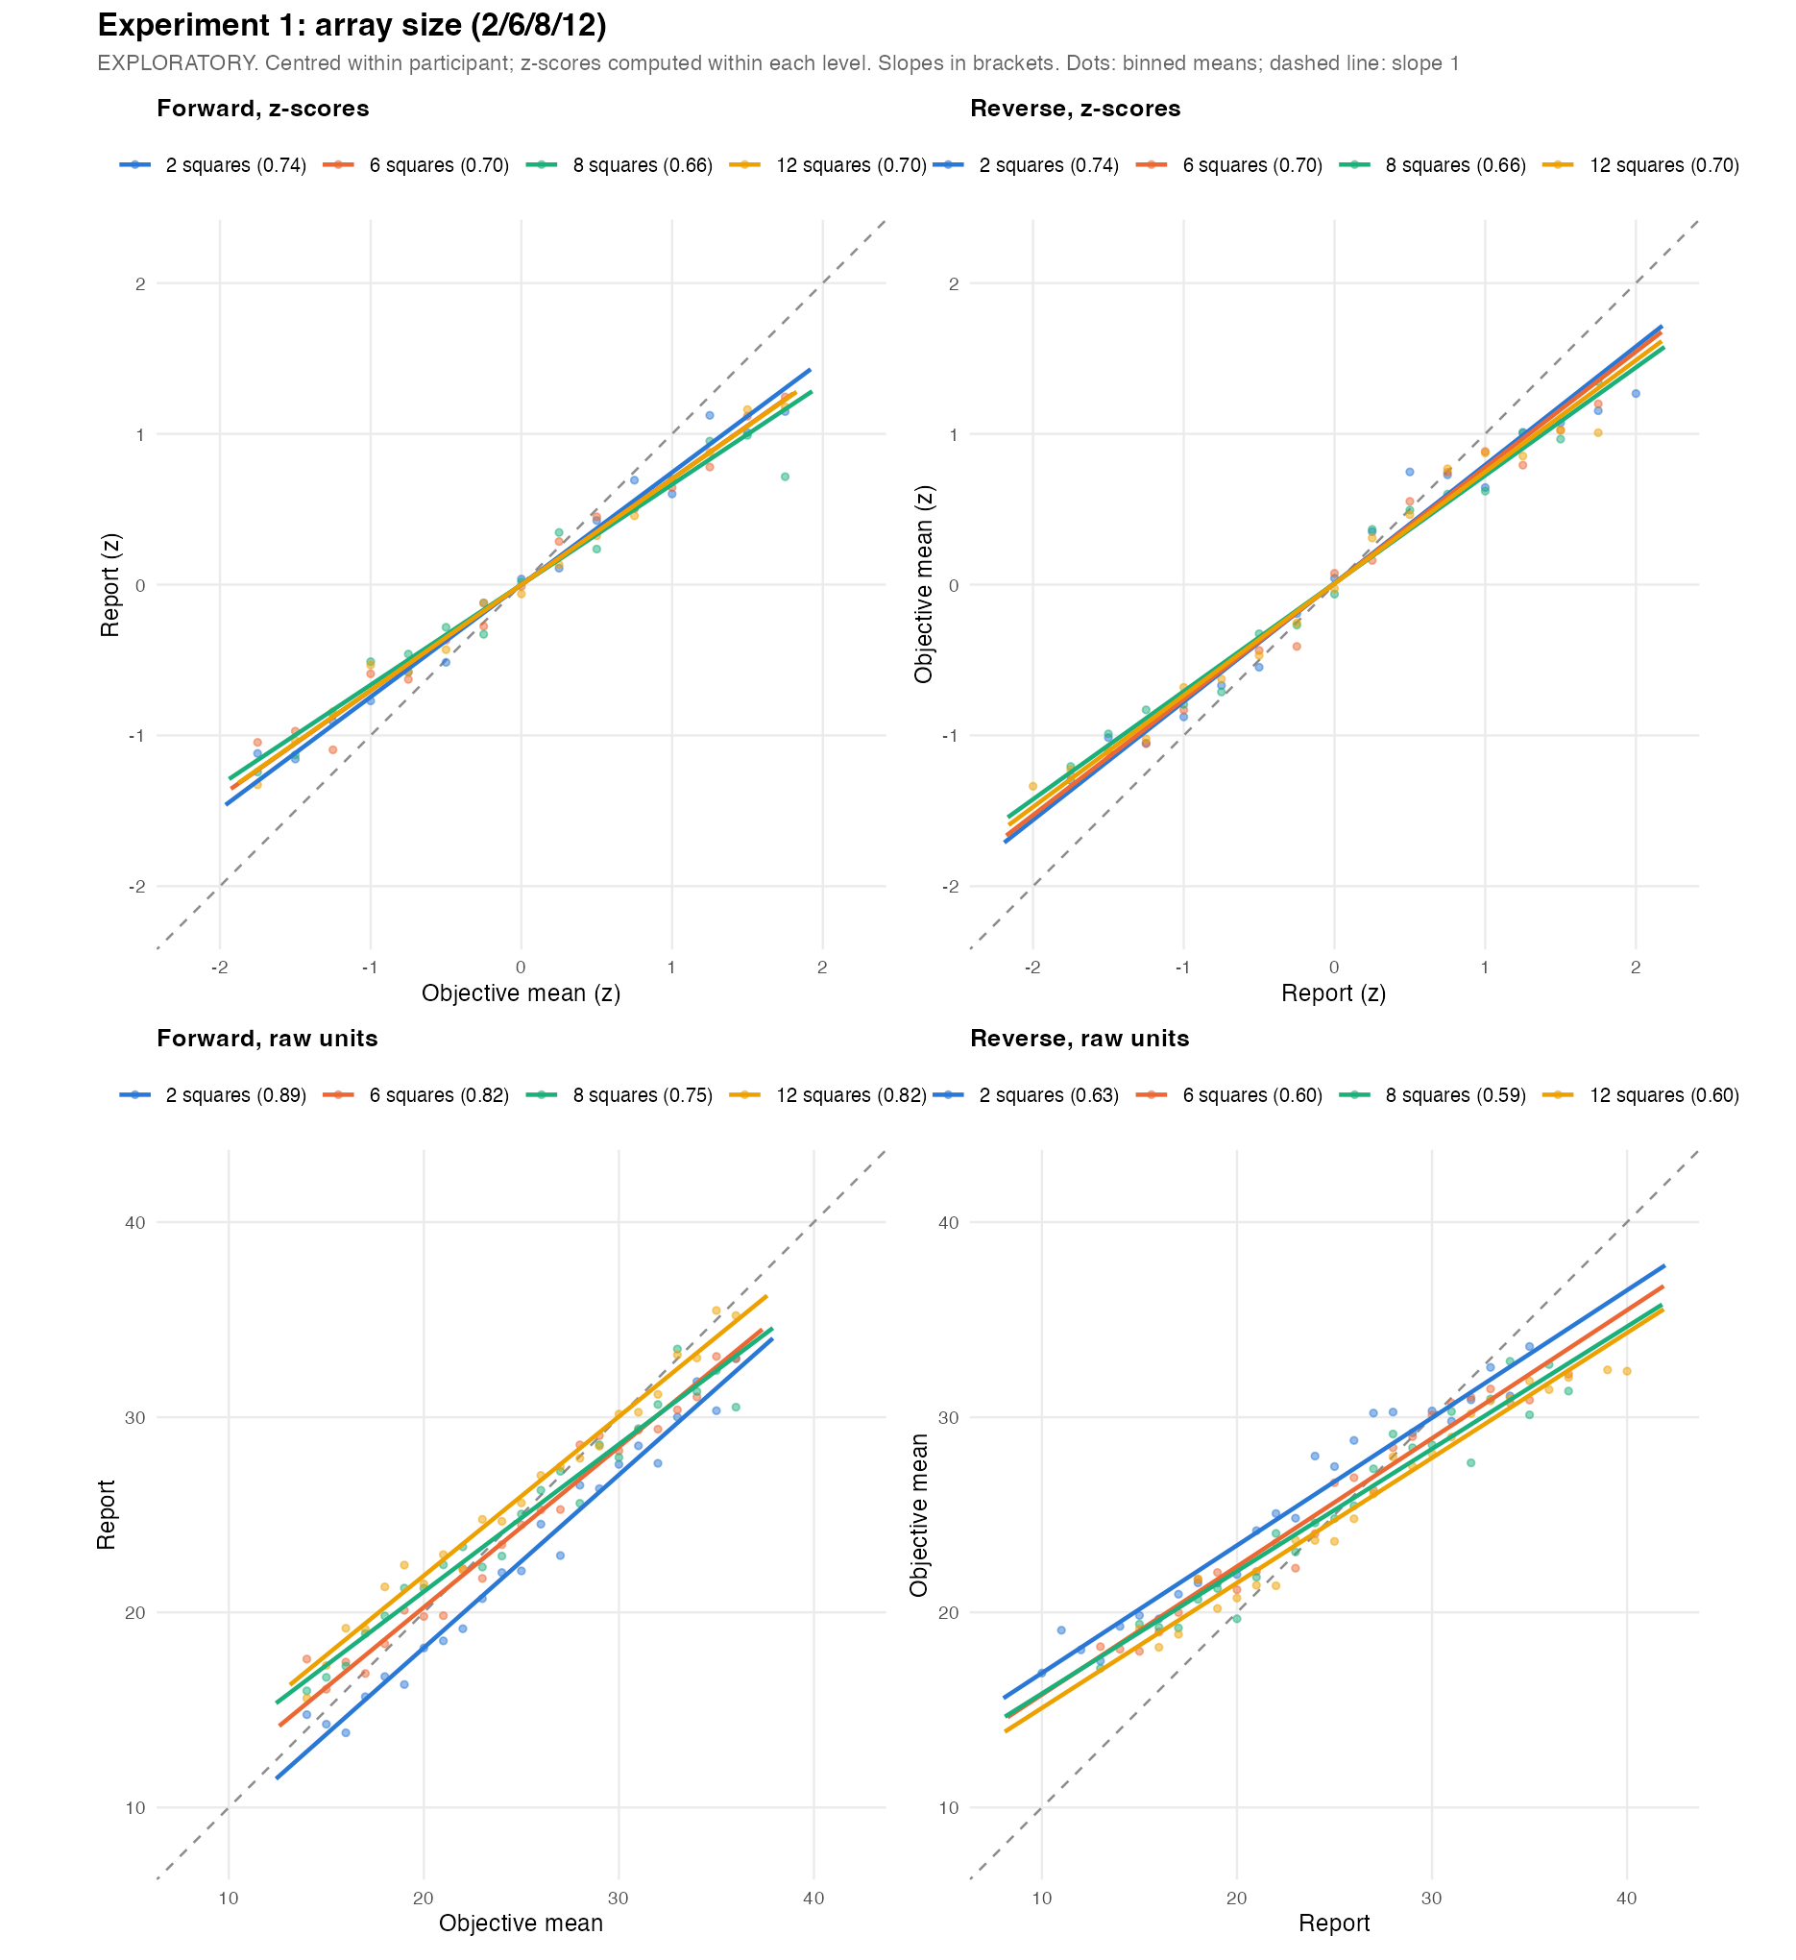
Regression lines per level: forward and reverse, in z-scores (both slopes equal r) and raw units

6. Reverse regression
One straight reverse line (true value on report); each participant’s own slope per level, no participant intercept (zero by design)
Level | Reverse slope | 95% CI
2 squares | 0.66 | [0.60, 0.72]
6 squares | 0.64 | [0.58, 0.70]
8 squares | 0.63 | [0.56, 0.69]
12 squares | 0.63 | [0.57, 0.69]
Change in the straight-line reverse slope with array size: mixed model p = .855, participant level p = .208. A straight line mixes the middle of the range with the nearly flat ends (true means only span about 14–36), so the piecewise model below separates them.
Piecewise reverse slopes (reports as given)
Segment | 2 squares | 6 squares | 8 squares | 12 squares
low | 0.454 | 0.178 | 0.308 | 0.297
mid | 0.626 | 0.649 | 0.593 | 0.612
high | 0.096 | 0.114 | 0.186 | 0.218

Do the piecewise slopes differ between levels? (low and high segments use trial-level df; rely on the participant-level column there)
Version | Segment | Level effect | Lowest − highest level | Participant-level
As given | low | F = 0.94, p = .418 | +0.157, p = .420 | -0.195, p = .764
As given | mid | F = 0.47, p = .701 | +0.013, p = .803 | +0.033, p = .379
As given | high | F = 0.26, p = .854 | -0.122, p = .487 | -0.340, p = .024
Shift removed | low | F = 0.97, p = .404 | -0.360, p = .110 | -0.320, p = .802
Shift removed | mid | F = 0.58, p = .628 | +0.047, p = .302 | +0.052, p = .148
Shift removed | high | F = 0.14, p = .933 | -0.039, p = .798 | -0.777, p = .362
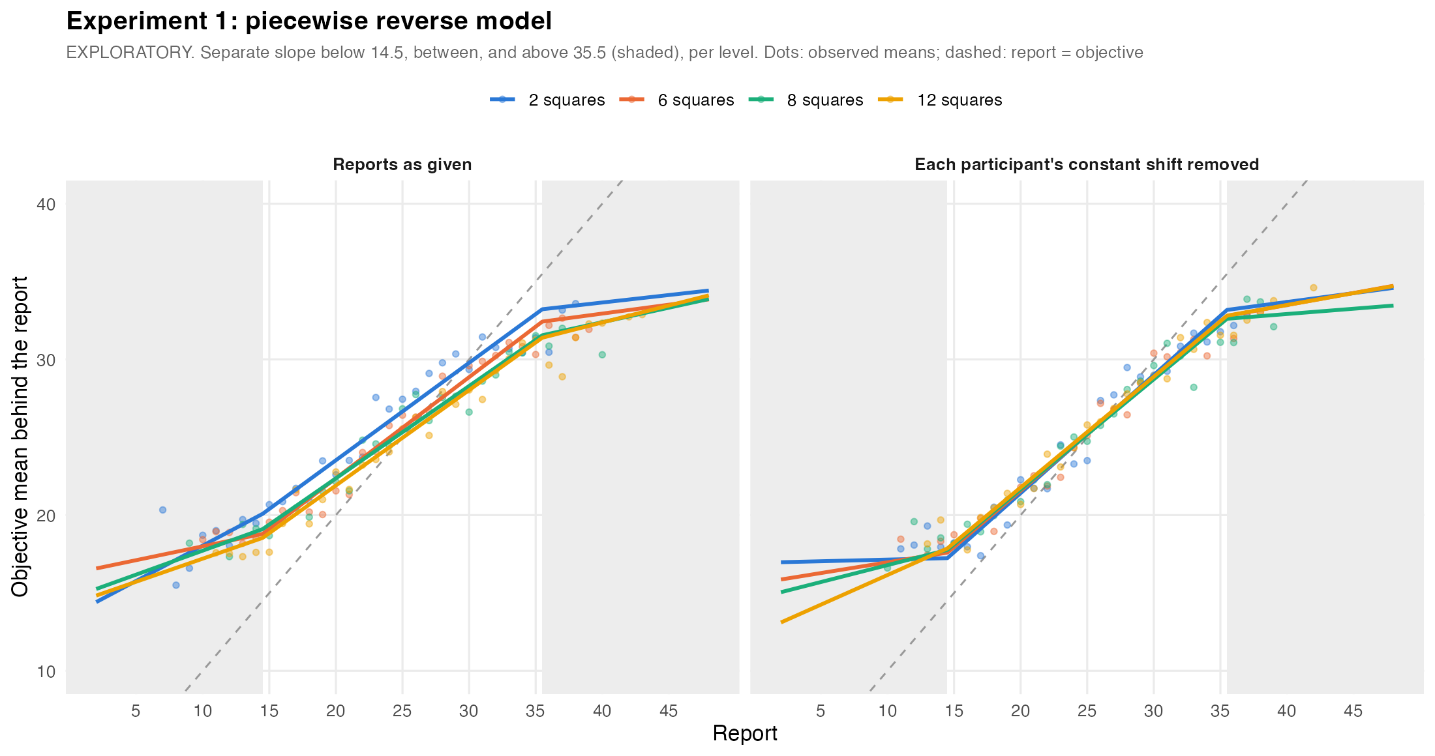
Piecewise reverse model per level (shaded: low and high report segments)

7. Exaggeration at the extremes
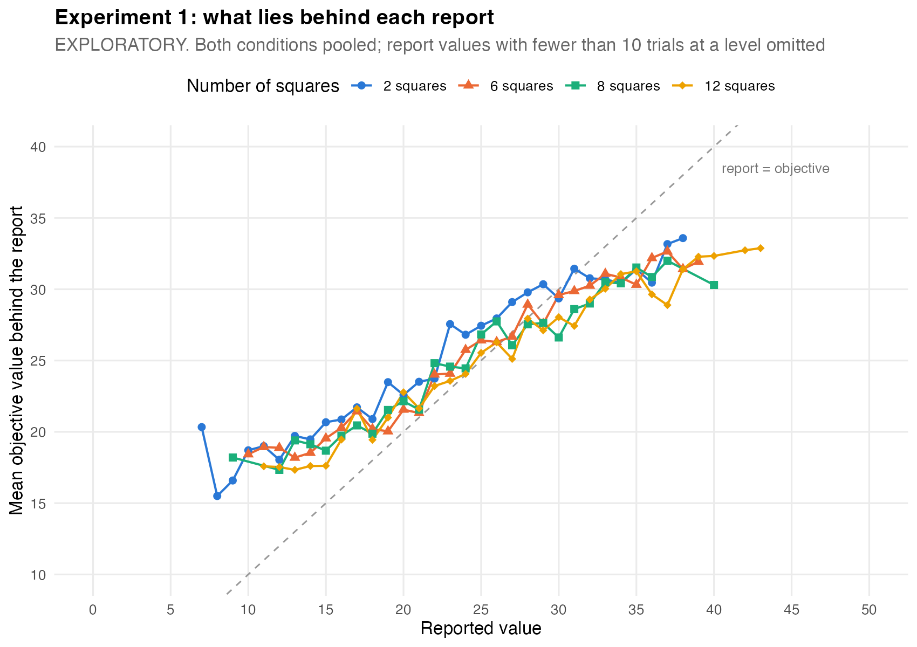
Average true value behind each report value, all levels (reports as given)
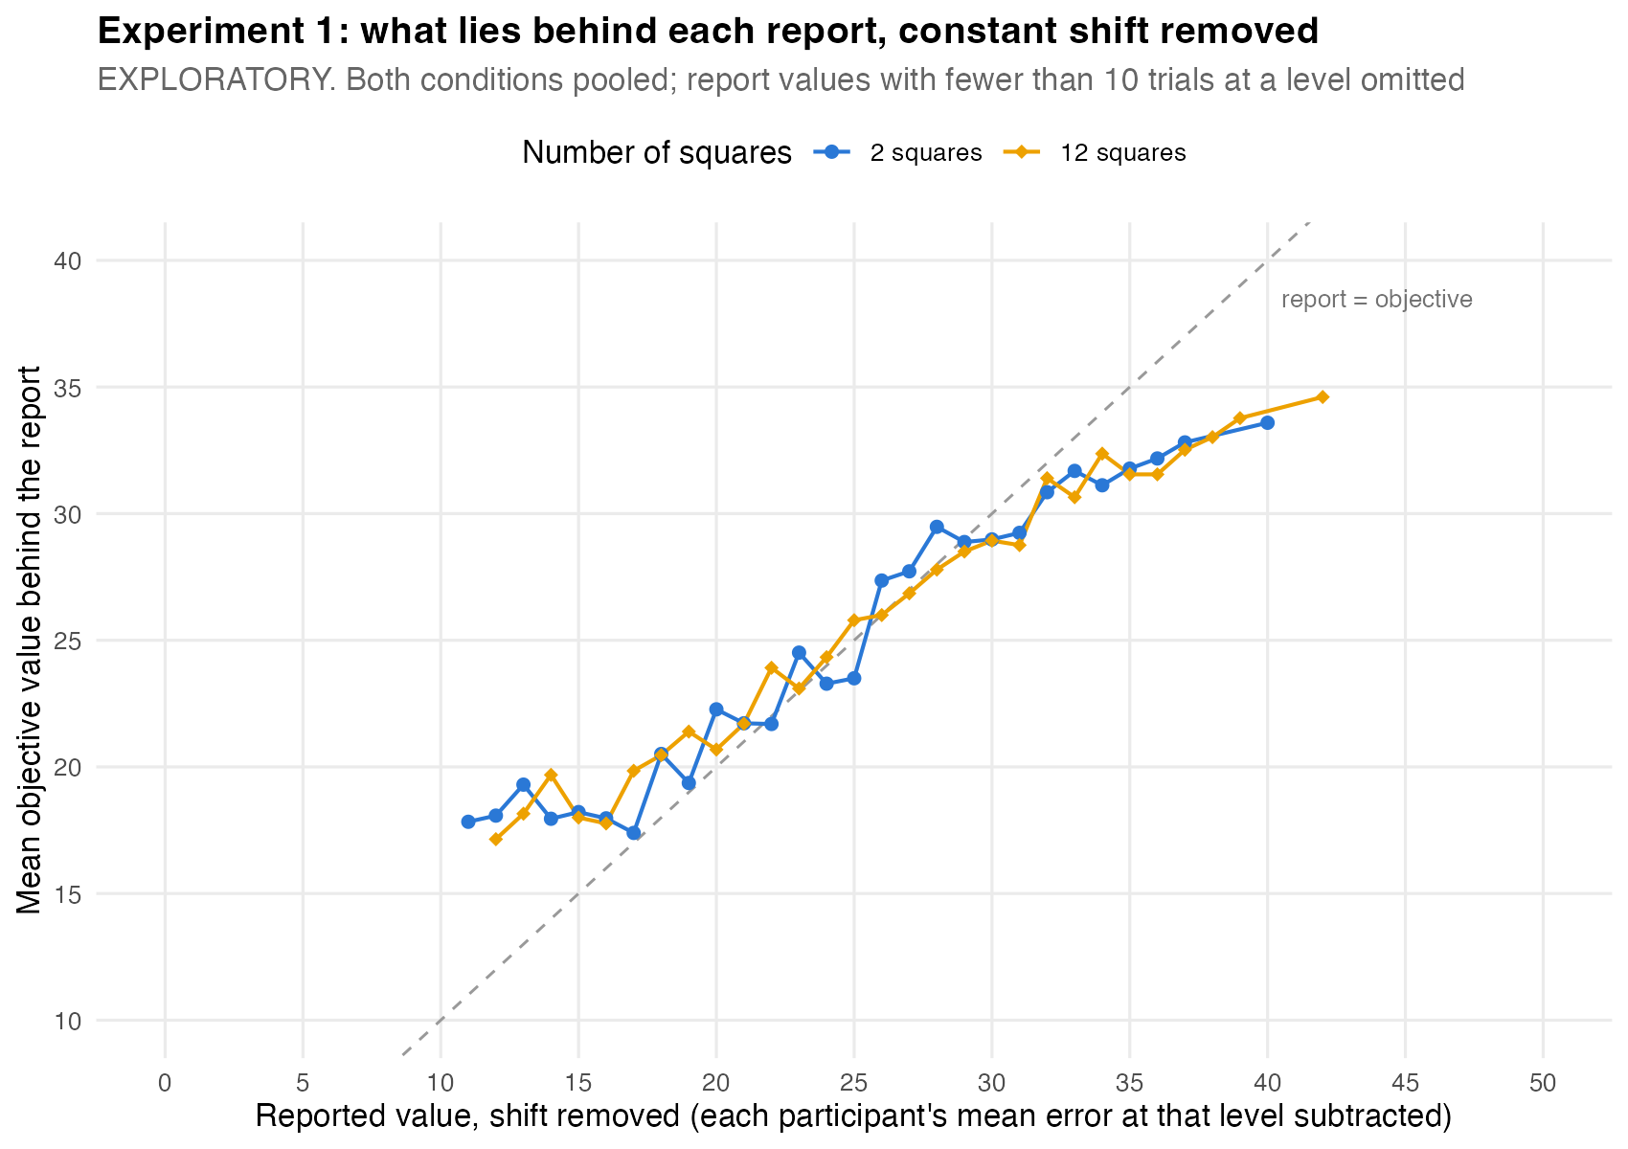
Lowest vs highest level, each participant’s constant shift removed
How much more the same extreme report exaggerated its stimulus at 12 squares than at 2 squares (positive = more exaggeration at the higher level)
Extreme reports | Participant-level | + trial position | + position, reweighted
High (≥ 36) as given | +1.33, p = .007 | +1.39, p = .005 | +1.29, p = .011
Low (≤ 14) as given | -1.67, p = .009 | -1.65, p = .009 | -1.54, p = .015
High (≥ 36) shift removed | +0.09, p = .837 | +0.06, p = .897 | +0.05, p = .904
Low (≤ 14) shift removed | -0.35, p = .569 | -0.26, p = .663 | -0.17, p = .782
Only trials with the same report value are compared. “Shift removed” subtracts each participant’s average reporting error at each level first, so a general tendency to answer high or low at one level cannot look like exaggeration at one end; it removes only a constant, not the regression itself. “Reweighted” gives every level the same distribution of true values.
Extreme reports in four bands (as given); gap = how much less extreme the stimulus was than the report
Band | Level | Trials | People | Report mean (SD) | True mean (SD) | Gap
extreme low (1-9) | 2 squares | 47 | 22 | 7.83 (1.11) | 17.51 (4.37) | 9.68
extreme low (1-9) | 6 squares | 23 | 11 | 6.87 (2.38) | 18.00 (3.49) | 11.13
extreme low (1-9) | 8 squares | 27 | 15 | 7.93 (1.77) | 17.37 (5.02) | 9.44
extreme low (1-9) | 12 squares | 12 | 8 | 6.58 (2.57) | 19.00 (4.77) | 12.42
low (10-14) | 2 squares | 121 | 37 | 12.25 (1.42) | 19.02 (3.88) | 6.78
low (10-14) | 6 squares | 85 | 35 | 12.13 (1.38) | 18.58 (4.34) | 6.45
low (10-14) | 8 squares | 72 | 30 | 12.56 (1.37) | 18.82 (3.99) | 6.26
low (10-14) | 12 squares | 61 | 27 | 12.15 (1.30) | 17.33 (3.21) | 5.19
high (36-40) | 2 squares | 53 | 25 | 37.75 (1.41) | 32.68 (3.36) | 5.08
high (36-40) | 6 squares | 68 | 29 | 37.62 (1.29) | 32.35 (3.90) | 5.26
high (36-40) | 8 squares | 59 | 32 | 37.71 (1.43) | 31.66 (4.24) | 6.05
high (36-40) | 12 squares | 88 | 33 | 37.81 (1.45) | 30.77 (5.18) | 7.04
extreme high (41-50) | 2 squares | 18 | 11 | 42.72 (2.11) | 33.50 (2.96) | 9.22
extreme high (41-50) | 6 squares | 23 | 14 | 44.74 (2.54) | 32.91 (3.76) | 11.83
extreme high (41-50) | 8 squares | 33 | 14 | 44.18 (2.60) | 32.58 (3.53) | 11.61
extreme high (41-50) | 12 squares | 46 | 18 | 43.98 (2.39) | 33.20 (2.75) | 10.78

12 squares vs 2 squares within each band (participant-level, paired)
Version | Band | People | Gap difference | Same-report difference
As given | extreme low (1-9) | 7 | +1.30, p = .329 | +0.93, p = .624
As given | low (10-14) | 27 | -1.88, p = .028 | -2.14, p = .006
As given | high (36-40) | 21 | +1.20, p = .083 | +1.23, p = .031
As given | extreme high (41-50) | 8 | +1.36, p = .208 | +0.71, p = .242
Shift removed | extreme low (1-9) | 2 | n/a | n/a
Shift removed | low (10-14) | 25 | +0.30, p = .709 | +0.35, p = .646
Shift removed | high (36-40) | 29 | -0.36, p = .514 | -0.26, p = .581
Shift removed | extreme high (41-50) | 10 | +0.31, p = .797 | +0.96, p = .080

SD of the true values behind a report (averaged over report values, weighted by trials)
zone | 2 squares | 6 squares | 8 squares | 12 squares
High (≥ 36) | 2.78 | 3.57 | 3.70 | 4.33
Low (≤ 14) | 3.76 | 4.18 | 4.16 | 3.50
Middle | 4.75 | 5.06 | 5.19 | 5.19
The absolute size of the gap depends on the range of stimuli presented (true values here span about 14–36), so it describes observer and stimulus set together; the differences between levels, which share the same stimulus distribution, carry the claim.

8. Average vs experience condition
The two conditions side by side
Result | Average | Experience
Correlation by level | 0.78 / 0.75 / 0.71 / 0.72 | 0.82 / 0.77 / 0.72 / 0.79
Forward slope by level (strict model) | 0.90 / 0.81 / 0.75 / 0.71 | 0.88 / 0.83 / 0.76 / 0.92
Same-report exaggeration, high reports as given | +1.95, p = .016 | +0.72, p = .243
Same-report exaggeration, low reports shift removed | -0.60, p = .509 | -0.08, p = .922
Condition differences: correlation p = .371; slope change × condition p = .256; participant-level slopes × condition p = .016.

