Experiment 4 (stimulus variance SD 3/5/7): a walkthrough of the results
  - Regression to the mean in perceptual experience — exploratory, not the main write-up
19 September 2026
Table of Contents

About this document
Experiment 4 - stimulus variance (SD 3/5/7). Arrays of 10 coloured squares whose colours were spread around the mean with SD 3, 5 or 7 (72 trials per level, 216 per session). Only the within-array spread changes; this is the clean noise manipulation. Participants reported the colour on a 50-step scale, either the average colour or how red/blue the array felt (experience condition).
This document walks through every result of this experiment: first whether the data and the manipulation are sound, then what they show about regression to the mean (RttM) in perceptual experience. Every number and figure is recomputed from the analysis pipeline when the file is knitted; it is exploratory and not part of the main write-up. True values are the mean of the squares actually shown (EPOC_TRUE_VALUE = "shown").
Two directions of RttM. Forward: given a stimulus, is the report less extreme? (slope of report on true value). Reverse: given a report, was the stimulus less extreme? (the exaggeration claim: extreme experiences overstate the world). Pure noise produces reverse RttM but leaves the forward slope at 1, so a forward slope below 1 needs more than noise.

Bottom line
The clean test, and it supports both directions of the account. Tracking falls (r .83 / .78 / .71) and the forward slope drops from 1.08 to 0.94 to 0.82 (strict model p < .001; survives trial order, value reweighting and participant-level testing). About 58% of the drop is noise (the weaker correlation) and 42% a genuine narrowing of the reports (p < .001), which noise alone cannot produce. Extreme reports come from less extreme stimuli at every level (reverse slope about .6), and more so at higher noise: reports of the same extreme stimulus were pulled 1.8–2.4 units further toward the middle at SD 7 than at SD 3; and for the same extreme report the stimulus was 0.6–1.0 unit less extreme at SD 7 than at SD 3 (high reports as given; both tails once each participant’s shift is removed), in the same direction at both ends, which is the signature of more exaggeration rather than a shift. Average and experience conditions do not differ.
Key results at a glance (levels in order of increasing noise)
Question | Result
Do reports track the stimulus less tightly at higher noise? (correlation) | r 0.83 / 0.78 / 0.71; p < .001
Does the forward slope change with noise? (strict model) | slopes 1.08 / 0.94 / 0.82; p < .001
Same, participant-level ANOVA | p < .001
Do reports narrow at higher noise (SD ratio, lowest vs highest level)? | ratio 1.36 / 1.25 / 1.21; p < .001
Same extreme high report: stimulus less extreme at SD 7 than SD 3? (as given) | +0.88 units, p < .001
Same extreme low report: stimulus less extreme at SD 7 than SD 3? (shift removed) | +0.67 units, p = .003

1. Sample and data quality
Participant flow
Stage | Average | Experience
Started | 53 | 58
Second session (already did the other condition) | 0 | 1
Incomplete session | 0 | 0
Kept < 85% of trials | 2 | 2
Did not track the stimulus (Spearman r ≤ .30) | 0 | 5
Analysed | 51 | 50
- Trials analysed: average 10,603 (about 208 per participant, mean absolute error 4.42 units); experience 10,475 (about 210 per participant, mean absolute error 4.51 units).
- Cleaning, identical for all experiments: second sessions dropped; reports of 0 treated as missing (the response scale’s starting value, saved when someone clicks without crossing the scale); RT < 200 ms or > 8 s; ±2.5 SD RT trimming per participant; errors ≥ 30 units; participants keeping < 85% of trials or with Spearman r ≤ .30.

2. Does the manipulation work?
Stimulus checks (true value = mean of the squares shown)
Level | Spread within arrays (SD) | Spread of true means (SD) | Mean true value
SD 3 | 2.86 | 6.28 | 24.14
SD 5 | 4.75 | 6.20 | 24.19
SD 7 | 6.65 | 6.23 | 24.69
The spread of true means across trials is the same at every level, so only the arrays themselves differ between levels. At a fixed true mean, the make-up of an array does not predict the report; adding it changes the slopes by at most 0.002.
Problems found.
- The trial list is not properly shuffled (confirmed in colorvariance/index.html): both the SD-level list and the true-value list were built in order and ‘shuffled’ with .sort(() => Math.random() - 0.5), which leaves items near their starting place. SD 3 trials come earlier in each block and SD 7 later, and SD 3 received slightly more low true values, SD 7 more high ones. Both are controlled below (trial position; reweighting).
- The top of the value range was cut: 115 values (14–36) were built and the first 108 kept before shuffling, so 35 appears less often and 36 never.
- One-step colour offset between stimulus squares and response images: a square of value p matches response index p − 1, so a perfect observer would report about 1 unit low. No effect on slopes, correlations or comparisons between levels.
- The logged true value is the rounded target; the squares shown differ by at most ±0.3 at random.
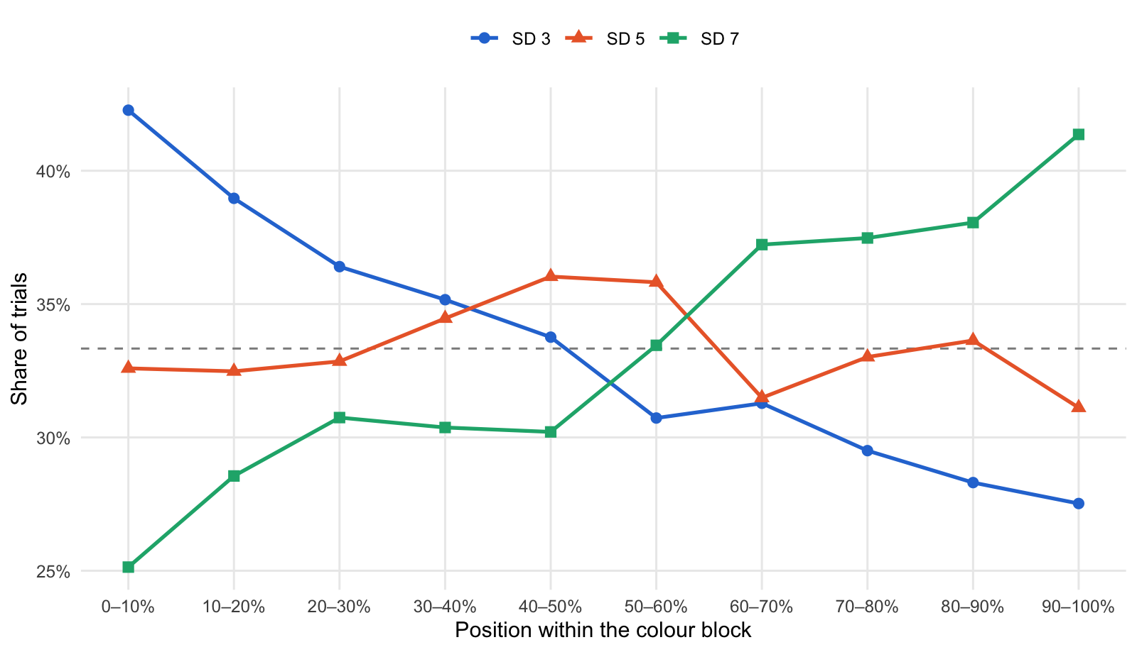
Where in each colour block the levels were shown (dashed = equal share)

3. Tracking: how closely reports follow the stimulus
Mean within-participant correlation between true mean and report
Condition | SD 3 | SD 5 | SD 7
average | 0.83 | 0.79 | 0.71
experience | 0.83 | 0.78 | 0.72
Effect of SD level on the correlation: F(1.88, 186.2) = 136.36, p < .001; condition p = .881; interaction p = .400.
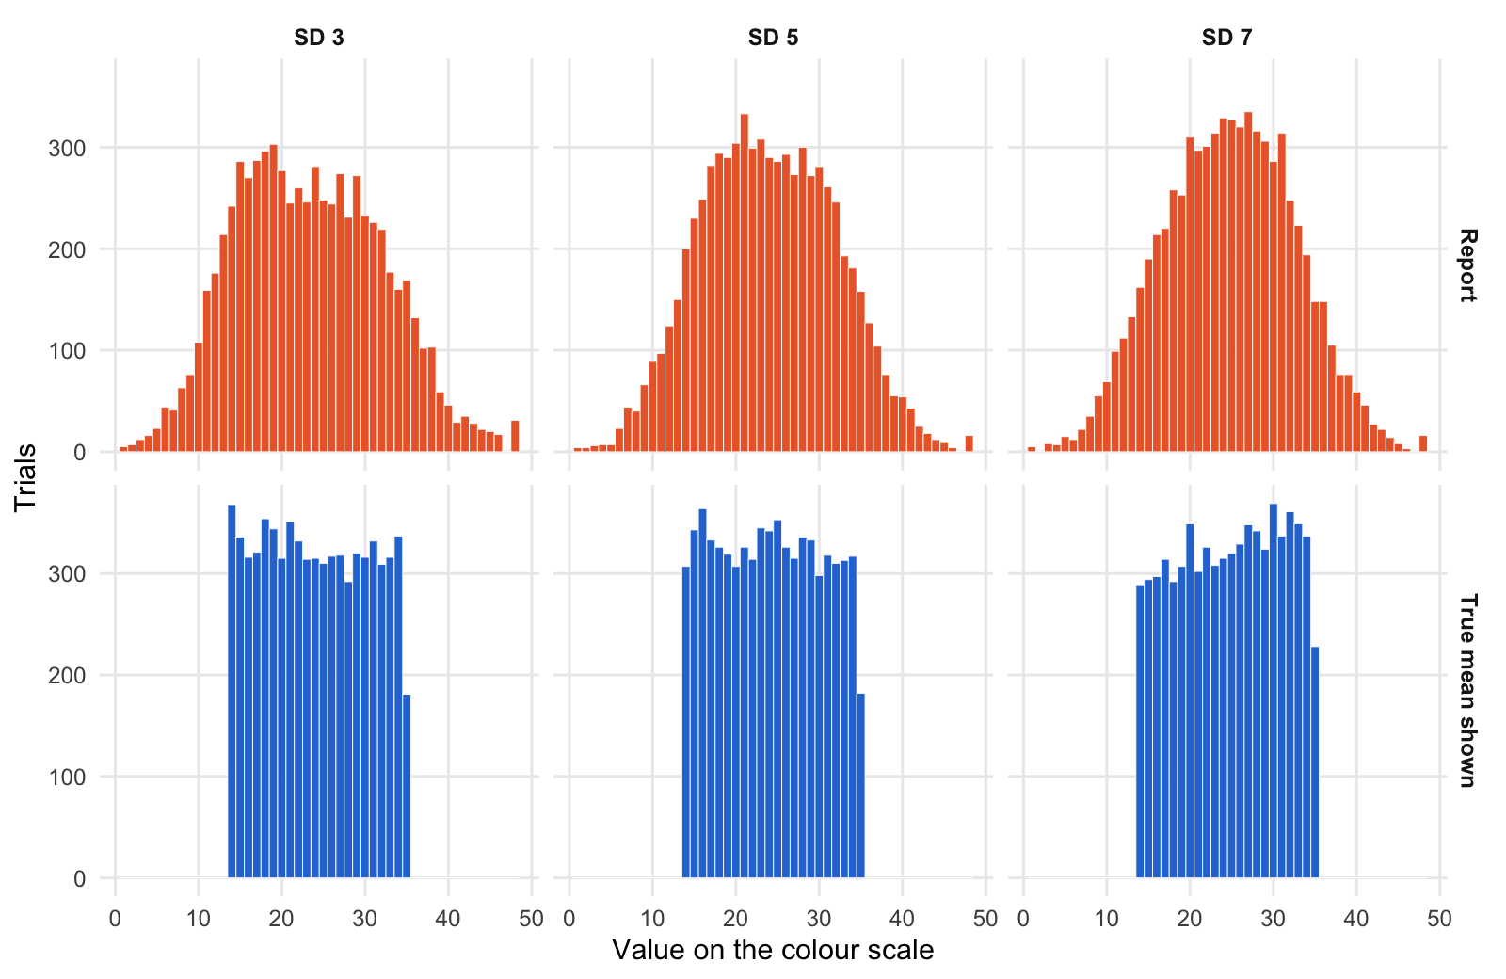
Stimuli shown (blue) vs reports given (orange) at each level
Per-participant accuracy, overall shift and spread (averaged over participants)
Level | Mean absolute error | Shift (report − true) | SD of reports | SD of true values
SD 3 | 4.34 | -0.81 | 8.32 | 6.23
SD 5 | 4.33 | -0.23 | 7.62 | 6.20
SD 7 | 4.75 | 0.02 | 7.28 | 6.15

4. Forward regression
Forward slopes (report on true mean), strict model: each participant has their own slope at each level
Condition | Level | Slope | 95% CI
average | SD 3 | 1.07 | [1.00, 1.14]
average | SD 5 | 0.91 | [0.85, 0.98]
average | SD 7 | 0.78 | [0.71, 0.84]
experience | SD 3 | 1.09 | [1.02, 1.17]
experience | SD 5 | 0.97 | [0.90, 1.03]
experience | SD 7 | 0.85 | [0.79, 0.92]

Does the slope change with SD level? Robustness checks
Check | Result
Strict mixed model | F(2, 191) = 30.21, p < .001
Participant-level ANOVA of each person’s slopes | F(1.78, 176.2) = 128.44, p < .001
Strict model + trial position | F(2, 190) = 32.63, p < .001
Slope × SD level × condition | p = .716

Mean participant slopes within each third of the colour block
Part of block | SD 3 | SD 5 | SD 7
early | 1.03 | 0.90 | 0.78
middle | 1.12 | 0.94 | 0.80
late | 1.14 | 0.98 | 0.84
A slope of 1 keeps the stimulus differences in full; below 1 means extreme stimuli are reported as less extreme.
The same question value by value: the average report for each true value. Each cell shows the mean report (SD of the reports, trials); the SD includes differences between participants.
Average report for each true value (true values rounded)
True value | SD 3 | SD 5 | SD 7
14 | 13.5 (5.1, 368) | 14.9 (5.4, 307) | 15.8 (5.9, 289)
15 | 14.1 (5.0, 336) | 15.1 (5.0, 343) | 16.6 (6.2, 294)
16 | 14.7 (5.0, 316) | 16.4 (5.3, 364) | 17.4 (6.1, 297)
17 | 16.1 (5.5, 321) | 17.4 (5.3, 333) | 18.4 (6.1, 314)
18 | 16.3 (5.1, 354) | 18.6 (5.7, 326) | 18.9 (5.5, 292)
19 | 17.0 (5.4, 344) | 19.0 (5.0, 319) | 20.0 (6.2, 307)
20 | 18.4 (5.1, 315) | 20.1 (5.8, 307) | 21.1 (5.9, 349)
21 | 19.5 (5.3, 351) | 20.2 (5.5, 326) | 21.7 (5.8, 302)
22 | 20.6 (5.6, 332) | 21.5 (5.4, 314) | 22.6 (5.9, 326)
23 | 21.6 (5.5, 314) | 23.1 (5.6, 345) | 24.0 (6.3, 308)
24 | 22.5 (5.6, 315) | 23.3 (5.6, 342) | 23.8 (6.2, 315)
25 | 23.8 (5.4, 310) | 24.7 (5.5, 353) | 24.8 (5.8, 320)
26 | 24.8 (5.3, 317) | 26.1 (6.0, 326) | 26.4 (5.7, 329)
27 | 25.7 (5.9, 318) | 26.9 (5.7, 315) | 26.9 (6.1, 348)
28 | 27.9 (5.5, 292) | 27.3 (5.5, 336) | 27.2 (5.7, 342)
29 | 29.1 (6.1, 320) | 28.6 (5.9, 333) | 28.1 (5.9, 324)
30 | 30.1 (5.4, 316) | 29.6 (5.7, 298) | 28.8 (6.0, 369)
31 | 31.2 (5.9, 332) | 30.7 (5.2, 318) | 29.7 (6.4, 337)
32 | 31.8 (5.7, 309) | 31.7 (5.4, 310) | 31.1 (6.2, 361)
33 | 33.5 (5.9, 316) | 32.3 (5.8, 313) | 31.5 (6.0, 349)
34 | 34.5 (5.8, 337) | 32.8 (6.1, 317) | 31.9 (6.3, 337)
35 | 34.9 (6.4, 181) | 33.1 (6.2, 182) | 33.1 (5.6, 228)

Summary by zone (bias = report − true value)
True values | SD of reports, SD 3 | SD of reports, SD 5 | SD of reports, SD 7 | Bias, SD 3 | Bias, SD 5 | Bias, SD 7
high (>= 32) | 5.89 | 5.84 | 6.05 | 0.22 | -0.93 | -1.56
low (<= 17) | 5.15 | 5.26 | 6.06 | -0.88 | 0.41 | 1.53
middle | 5.50 | 5.59 | 5.96 | -1.06 | -0.25 | 0.06

Same extreme true value: was the report pulled further toward the middle at the higher level? (participant-level, paired)
Extreme true values | Comparison | People | Pulled further toward the middle
low | SD 7 vs SD 3 | 100 | +2.35, p < .001
high | SD 7 vs SD 3 | 100 | +1.80, p < .001
Compression shows up as positive values at both ends (reports move toward the middle from both sides); opposite signs at the two ends mean an overall shift of the reports at one level rather than compression.

5. Why the forward slope changes: noise and narrowing
Slope = correlation × (SD of reports / SD of true values); values centred within participant
Level | Within-array SD | r | SD true | SD reports | SD ratio | Slope | Calibrated slope (r²) | Reverse slope
SD 3 | 2.86 | 0.799 | 6.28 | 8.53 | 1.36 | 1.08 | 0.64 | 0.59
SD 5 | 4.75 | 0.749 | 6.20 | 7.76 | 1.25 | 0.94 | 0.56 | 0.60
SD 7 | 6.65 | 0.678 | 6.23 | 7.50 | 1.21 | 0.82 | 0.46 | 0.56
From SD 3 to SD 7: log change in slope -0.283, of which 58% from the correlation and 42% from the SD ratio (within participants: correlation p < .001, ratio p < .001). Pure noise would raise the ratio as the correlation falls; a falling ratio is a genuine narrowing of the reports. A calibrated observer’s forward slope would equal r²; slopes above that mean people correct less than their noise warrants, which leaves extreme reports exaggerated (reverse slope = r² / forward slope).
SD ratio within each third of the block (trial order held constant)
Part of block | SD 3 | SD 5 | SD 7
early | 1.30 | 1.20 | 1.17
middle | 1.40 | 1.24 | 1.20
late | 1.40 | 1.32 | 1.24
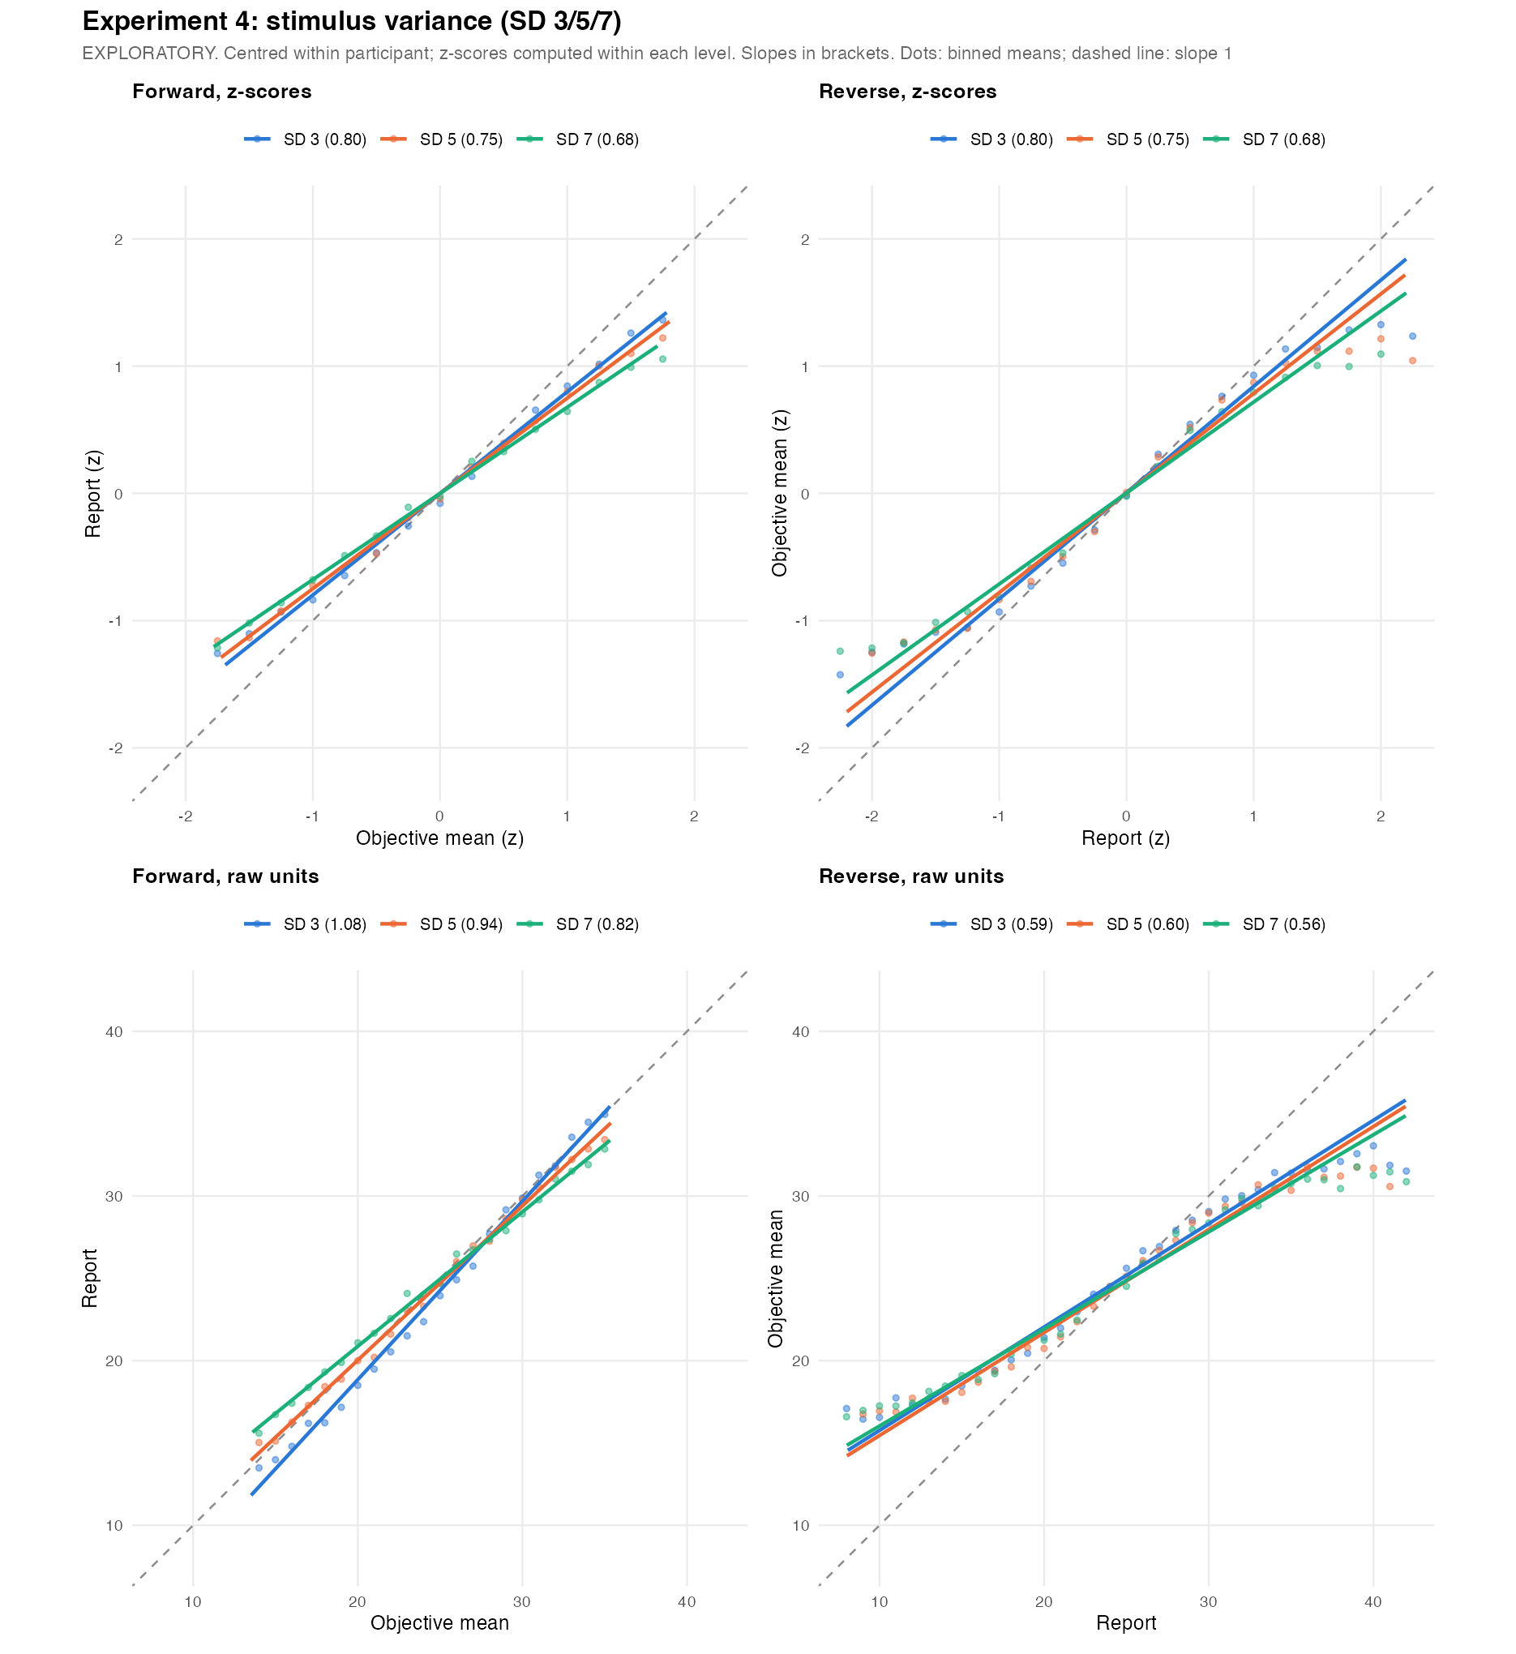
Regression lines per level: forward and reverse, in z-scores (both slopes equal r) and raw units

6. Reverse regression
One straight reverse line (true value on report); each participant’s own slope per level, no participant intercept (zero by design)
Level | Reverse slope | 95% CI
SD 3 | 0.62 | [0.60, 0.65]
SD 5 | 0.64 | [0.61, 0.67]
SD 7 | 0.61 | [0.57, 0.65]
Change in the straight-line reverse slope with SD level: mixed model p = .521, participant level p = .042. A straight line mixes the middle of the range with the nearly flat ends (true means only span about 14–36), so the piecewise model below separates them.
Piecewise reverse slopes (reports as given)
Segment | SD 3 | SD 5 | SD 7
low | 0.330 | 0.322 | 0.334
mid | 0.657 | 0.641 | 0.592
high | 0.089 | 0.135 | 0.154

Do the piecewise slopes differ between levels? (low and high segments use trial-level df; rely on the participant-level column there)
Version | Segment | Level effect | Lowest − highest level | Participant-level
As given | low | F = 0.02, p = .979 | -0.003, p = .951 | +0.268, p = .248
As given | mid | F = 3.71, p = .026 | +0.064, p = .008 | +0.033, p = .051
As given | high | F = 0.65, p = .521 | -0.065, p = .279 | +0.535, p = .099
Shift removed | low | F = 0.12, p = .885 | -0.001, p = .983 | +0.181, p = .504
Shift removed | mid | F = 1.16, p = .314 | +0.032, p = .152 | +0.037, p = .020
Shift removed | high | F = 0.29, p = .750 | +0.044, p = .474 | +0.398, p = .229
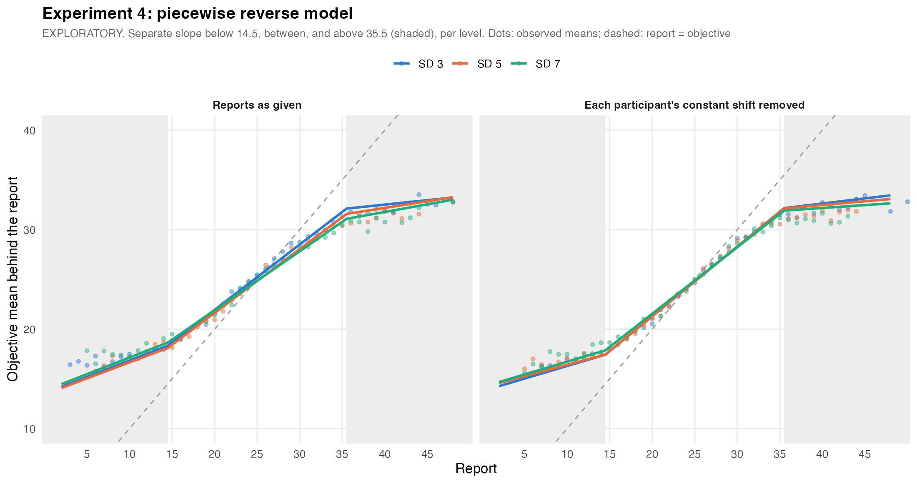
Piecewise reverse model per level (shaded: low and high report segments)

7. Exaggeration at the extremes
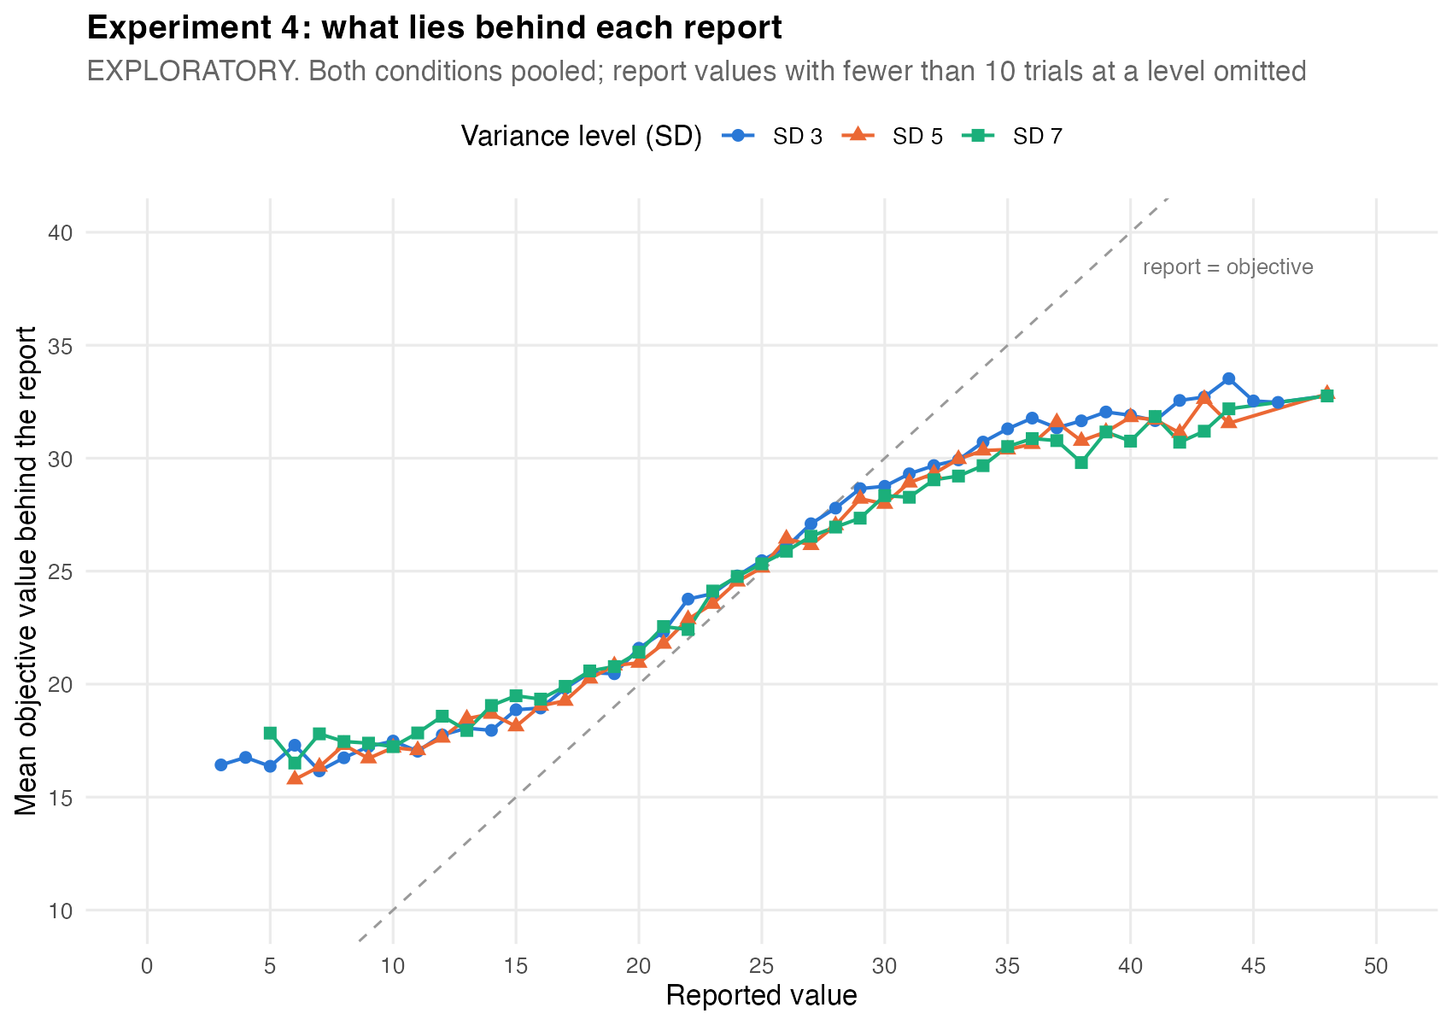
Average true value behind each report value, all levels (reports as given)
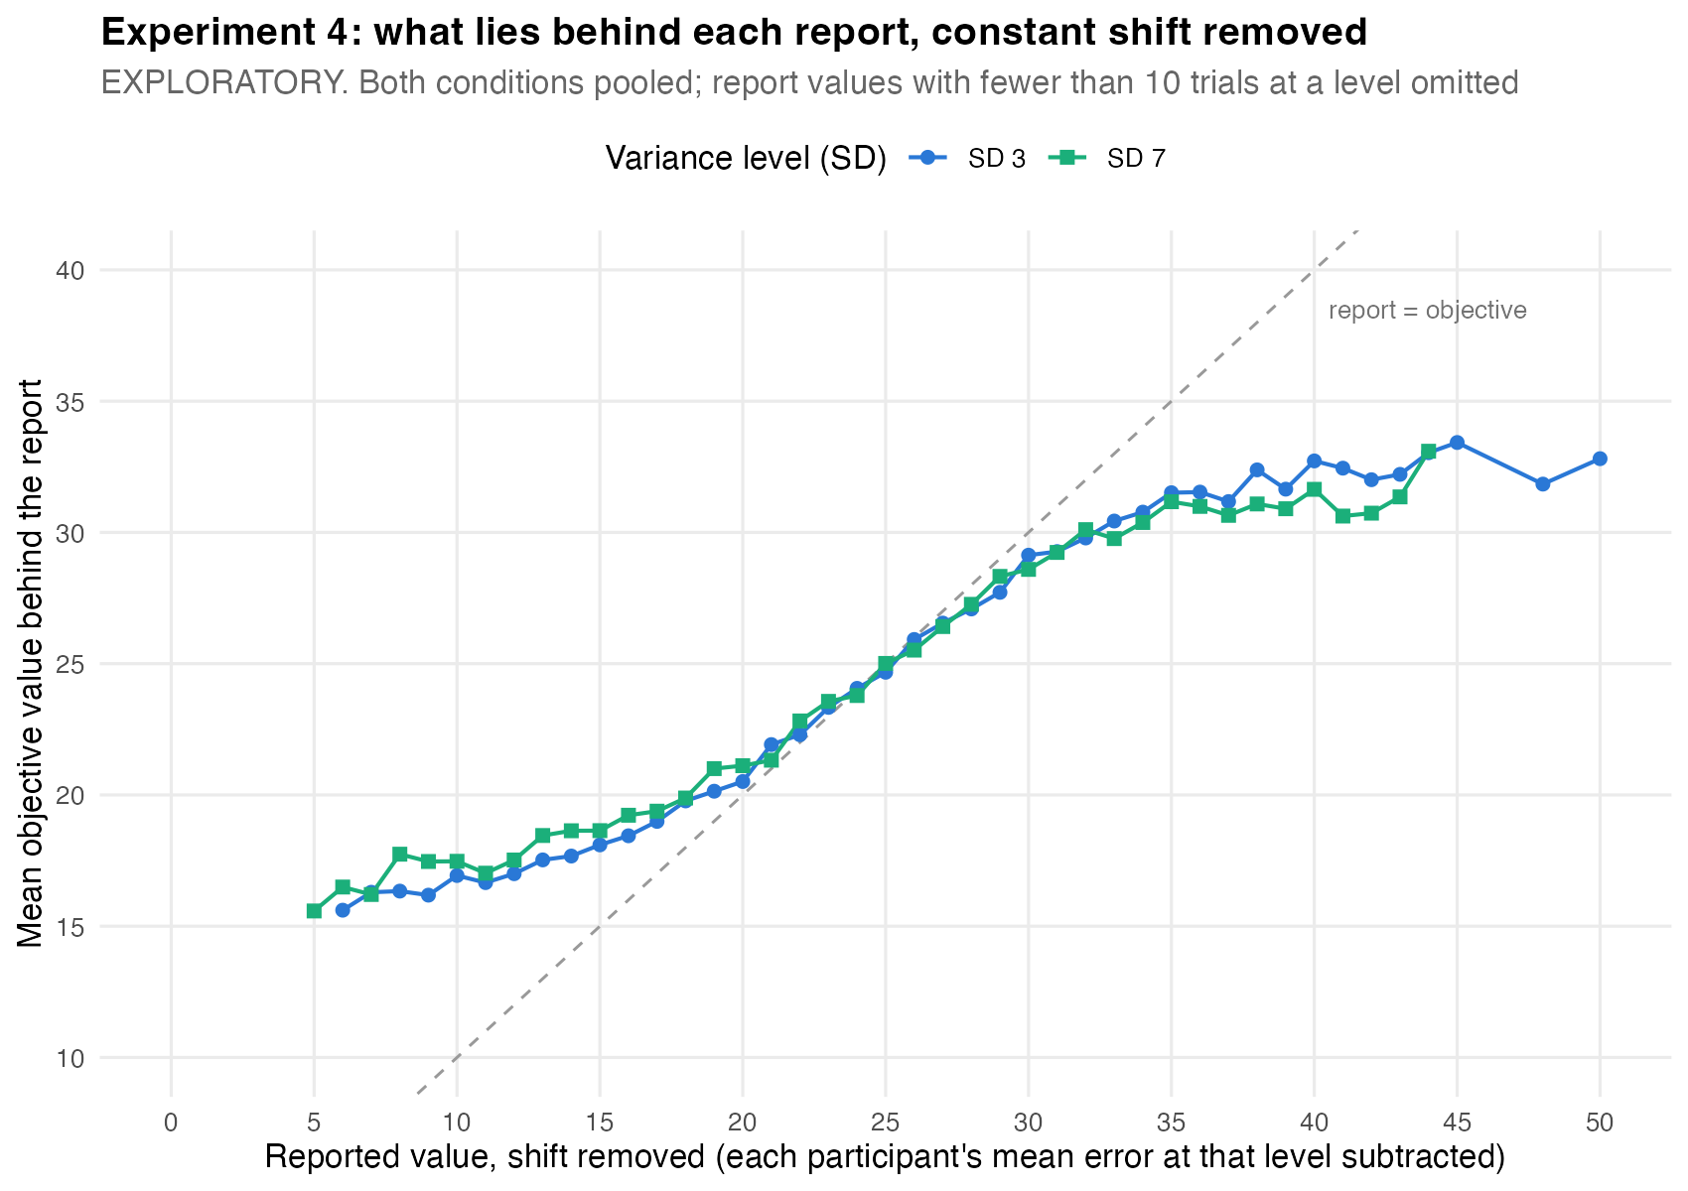
Lowest vs highest level, each participant’s constant shift removed
How much more the same extreme report exaggerated its stimulus at SD 7 than at SD 3 (positive = more exaggeration at the higher level)
Extreme reports | Participant-level | + trial position | + position, reweighted
High (≥ 36) as given | +0.88, p < .001 | +0.92, p < .001 | +1.00, p < .001
Low (≤ 14) as given | +0.33, p = .249 | +0.24, p = .391 | +0.09, p = .759
High (≥ 36) shift removed | +0.58, p = .030 | +0.65, p = .015 | +0.72, p = .008
Low (≤ 14) shift removed | +0.67, p = .003 | +0.59, p = .009 | +0.44, p = .047
Only trials with the same report value are compared. “Shift removed” subtracts each participant’s average reporting error at each level first, so a general tendency to answer high or low at one level cannot look like exaggeration at one end; it removes only a constant, not the regression itself. “Reweighted” gives every level the same distribution of true values.
Extreme reports in four bands (as given); gap = how much less extreme the stimulus was than the report
Band | Level | Trials | People | Report mean (SD) | True mean (SD) | Gap
extreme low (1-9) | SD 3 | 287 | 64 | 6.87 (2.04) | 16.78 (3.11) | 9.90
extreme low (1-9) | SD 5 | 201 | 57 | 7.23 (1.93) | 16.67 (3.00) | 9.45
extreme low (1-9) | SD 7 | 159 | 59 | 7.13 (2.10) | 17.38 (3.86) | 10.25
low (10-14) | SD 3 | 899 | 99 | 12.36 (1.36) | 17.72 (3.37) | 5.36
low (10-14) | SD 5 | 660 | 97 | 12.42 (1.40) | 18.00 (3.73) | 5.58
low (10-14) | SD 7 | 575 | 96 | 12.38 (1.37) | 18.28 (4.13) | 5.90
high (36-40) | SD 3 | 442 | 88 | 37.51 (1.32) | 31.70 (3.17) | 5.82
high (36-40) | SD 5 | 416 | 87 | 37.53 (1.38) | 31.12 (3.49) | 6.41
high (36-40) | SD 7 | 464 | 84 | 37.55 (1.41) | 30.71 (4.04) | 6.85
extreme high (41-50) | SD 3 | 182 | 52 | 43.96 (2.37) | 32.58 (2.15) | 11.38
extreme high (41-50) | SD 5 | 127 | 47 | 43.09 (2.32) | 31.92 (2.98) | 11.17
extreme high (41-50) | SD 7 | 136 | 45 | 43.00 (2.25) | 31.60 (3.57) | 11.40

SD 7 vs SD 3 within each band (participant-level, paired)
Version | Band | People | Gap difference | Same-report difference
As given | extreme low (1-9) | 49 | +0.00, p = .996 | +0.17, p = .614
As given | low (10-14) | 94 | +0.15, p = .635 | +0.21, p = .496
As given | high (36-40) | 77 | +0.87, p = .002 | +0.94, p < .001
As given | extreme high (41-50) | 33 | -0.68, p = .164 | +0.37, p = .353
Shift removed | extreme low (1-9) | 38 | +1.03, p = .029 | +1.03, p = .022
Shift removed | low (10-14) | 97 | +0.73, p = .002 | +0.60, p = .011
Shift removed | high (36-40) | 83 | +0.33, p = .276 | +0.49, p = .087
Shift removed | extreme high (41-50) | 32 | +0.10, p = .876 | +0.27, p = .594

SD of the true values behind a report (averaged over report values, weighted by trials)
zone | SD 3 | SD 5 | SD 7
High (≥ 36) | 2.85 | 3.30 | 3.88
Low (≤ 14) | 3.27 | 3.50 | 4.02
Middle | 4.04 | 4.38 | 4.82
The absolute size of the gap depends on the range of stimuli presented (true values here span about 14–36), so it describes observer and stimulus set together; the differences between levels, which share the same stimulus distribution, carry the claim.

8. Average vs experience condition
The two conditions side by side
Result | Average | Experience
Correlation by level | 0.83 / 0.79 / 0.71 | 0.83 / 0.78 / 0.72
Forward slope by level (strict model) | 1.07 / 0.91 / 0.78 | 1.09 / 0.97 / 0.85
Same-report exaggeration, high reports as given | +0.76, p = .055 | +0.93, p = .005
Same-report exaggeration, low reports shift removed | +0.35, p = .209 | +1.01, p = .006
Condition differences: correlation p = .881; slope change × condition p = .716; participant-level slopes × condition p = .293.

