AIRPORT MANAGEMENT INFORMATION SYSTEM
CMPE343 - Database Management Systems and Programming I
Term Project Report

Prepared by
Zeinab Idris
Student ID: 22306606

Submission Date: 24/05/2026

1. Introduction
The purpose of this project is to design and implement an Airport Management Information System using a relational database management system. The database stores and manages information about airplanes, airplane models, hangars, employees, technicians, traffic controllers, tests, airplane locations, and testing events.
The system was implemented using MySQL and managed through DataGrip. The design uses relational database concepts such as primary keys, foreign keys, entity relationships, constraints, and SQL queries. The implementation contains 11 tables, which is more than the minimum project requirement of 8 tables.

2. Project Assumptions
- Each airplane belongs to one airplane model.
- Each employee is uniquely identified by a social security number (SSN).
- Technicians, traffic controllers, and airport workers are stored as specialized employee types.
- Traffic controllers must have a recorded date for the most recent medical examination.
- Airplanes can move between hangars, so airplane location history is stored using in-date and out-date.
- A technician can be an expert in one or more airplane models.
- Each testing event records the airplane, technician, test type, test date, hours spent, and score.

3. ER Diagram
The ER diagram below shows the main entities and relationships in the Airport Management Information System. It includes airplanes, airplane models, hangars, employees, technicians, traffic controllers, tests, technician expertise, and test events.
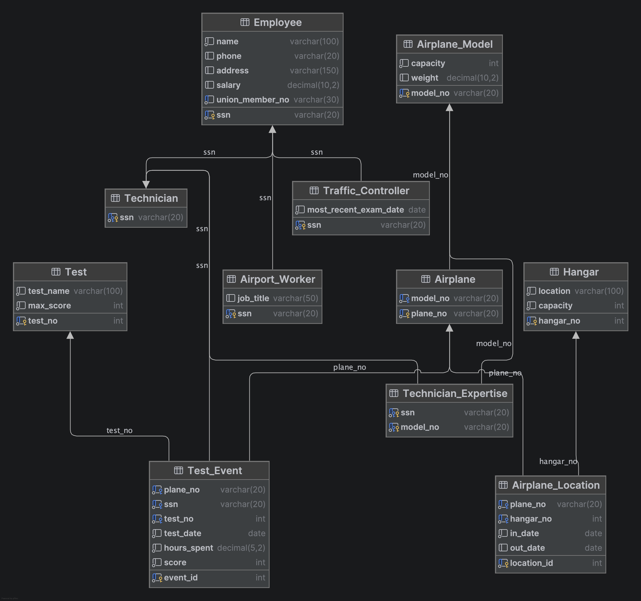

4. Relational Schema
Airplane_Model(model_no PK, capacity, weight)
Airplane(plane_no PK, model_no FK -> Airplane_Model(model_no))
Hangar(hangar_no PK, location, capacity)
Airplane_Location(location_id PK, plane_no FK -> Airplane(plane_no), hangar_no FK -> Hangar(hangar_no), in_date, out_date)
Employee(ssn PK, name, phone, address, salary, union_member_no)
Technician(ssn PK/FK -> Employee(ssn))
Traffic_Controller(ssn PK/FK -> Employee(ssn), most_recent_exam_date)
Airport_Worker(ssn PK/FK -> Employee(ssn), job_title)
Technician_Expertise(ssn PK/FK -> Technician(ssn), model_no PK/FK -> Airplane_Model(model_no))
Test(test_no PK, test_name, max_score)
Test_Event(event_id PK, plane_no FK -> Airplane(plane_no), ssn FK -> Technician(ssn), test_no FK -> Test(test_no), test_date, hours_spent, score)

5. Database Tables and Implementation
The database was created under the name airport_management. The database contains 11 tables: Airplane, Airplane_Location, Airplane_Model, Airport_Worker, Employee, Hangar, Technician, Technician_Expertise, Test, Test_Event, and Traffic_Controller.
The table design uses primary keys to uniquely identify records and foreign keys to connect related tables. For example, Airplane references Airplane_Model, Test_Event references Airplane, Technician, and Test, and Airplane_Location references Airplane and Hangar.
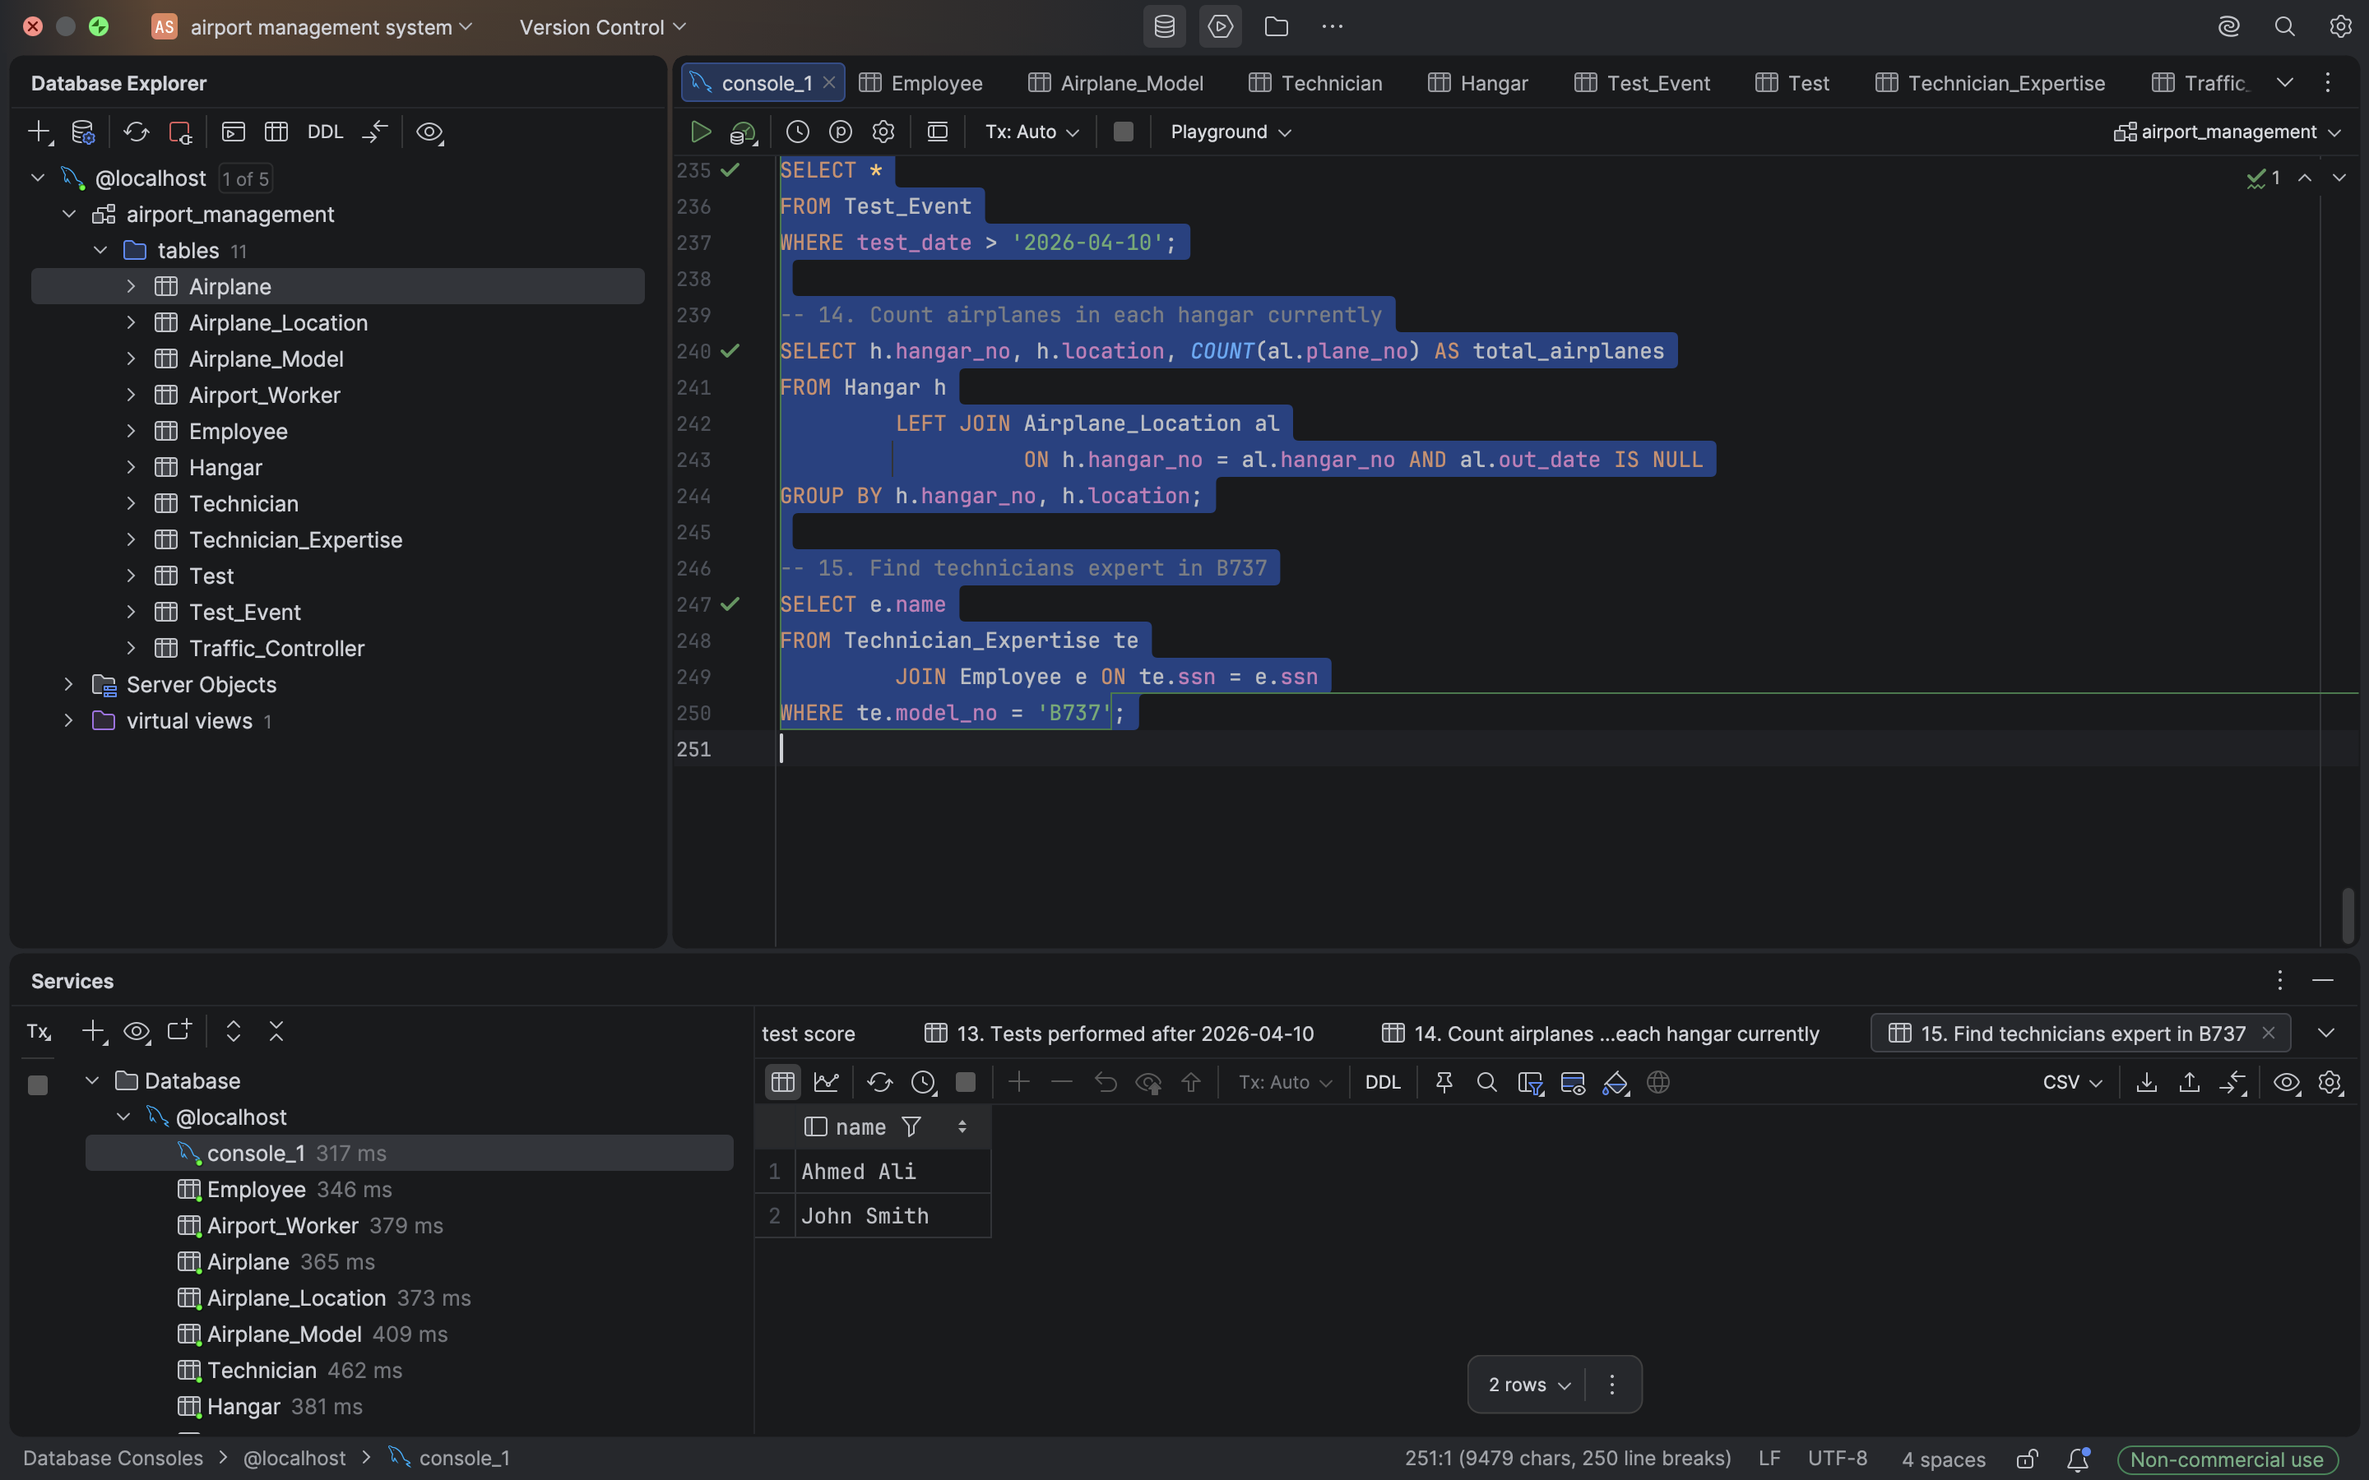

6. DDL and DML Summary
DDL statements were used to create the structure of the database. The CREATE TABLE statements define the attributes, data types, primary keys, foreign keys, and constraints. DML statements were used to insert sample data into the tables, including airplane models, airplanes, employees, technicians, hangars, tests, and test events.
The inserted sample data allows the SQL queries to retrieve meaningful information and demonstrate that the system works correctly.

7. SQL Queries
-- 1. Display all airplanes with their models
SELECT a.plane_no, a.model_no, m.capacity, m.weight
FROM Airplane a
JOIN Airplane_Model m ON a.model_no = m.model_no;
-- 2. Show the current location of airplanes
SELECT al.plane_no, h.hangar_no, h.location
FROM Airplane_Location al
JOIN Hangar h ON al.hangar_no = h.hangar_no
WHERE al.out_date IS NULL;
-- 3. Show all technicians
SELECT e.ssn, e.name, e.phone, e.salary
FROM Employee e
JOIN Technician t ON e.ssn = t.ssn;
-- 4. Show technician expertise
SELECT e.name AS technician_name, am.model_no
FROM Technician_Expertise te
JOIN Technician t ON te.ssn = t.ssn
JOIN Employee e ON t.ssn = e.ssn
JOIN Airplane_Model am ON te.model_no = am.model_no;
-- 5. Show traffic controllers and medical exam dates
SELECT e.ssn, e.name, tc.most_recent_exam_date
FROM Traffic_Controller tc
JOIN Employee e ON tc.ssn = e.ssn;
-- 6. Show all test events
SELECT te.event_id, te.plane_no, e.name AS technician_name,
t.test_name, te.test_date, te.hours_spent, te.score
FROM Test_Event te
JOIN Employee e ON te.ssn = e.ssn
JOIN Test t ON te.test_no = t.test_no;
-- 7. Calculate the average score for each airplane
SELECT plane_no, AVG(score) AS average_score
FROM Test_Event
GROUP BY plane_no;
-- 8. Count the number of tests completed by each technician
SELECT e.name AS technician_name, COUNT(te.event_id) AS total_tests
FROM Test_Event te
JOIN Employee e ON te.ssn = e.ssn
GROUP BY e.name;
-- 9. Find airplanes with test scores greater than 90
SELECT plane_no, score
FROM Test_Event
WHERE score > 90;
-- 10. Calculate total hours spent by each technician
SELECT e.name AS technician_name, SUM(te.hours_spent) AS total_hours
FROM Test_Event te
JOIN Employee e ON te.ssn = e.ssn
GROUP BY e.name;
-- 11. Find the highest test score
SELECT MAX(score) AS highest_test_score
FROM Test_Event;
-- 12. Find the lowest test score
SELECT MIN(score) AS lowest_test_score
FROM Test_Event;
-- 13. Show tests performed after 2026-04-10
SELECT *
FROM Test_Event
WHERE test_date > '2026-04-10';
-- 14. Count airplanes in each hangar currently
SELECT h.hangar_no, h.location,
COUNT(al.plane_no) AS current_airplanes
FROM Hangar h
LEFT JOIN Airplane_Location al
ON h.hangar_no = al.hangar_no
AND al.out_date IS NULL
GROUP BY h.hangar_no, h.location;
-- 15. Find technicians who are experts in the B737 model
SELECT e.name AS technician_name
FROM Technician_Expertise te
JOIN Employee e ON te.ssn = e.ssn
WHERE te.model_no = 'B737';

8. Conclusion
This project successfully designed and implemented an Airport Management Information System using MySQL. The database stores information about airplanes, employees, technicians, traffic controllers, hangars, tests, and testing events. The system also supports useful SQL queries for management and statistical analysis.
The final database contains 11 tables, which exceeds the minimum requirement. The project demonstrates important database concepts such as entity relationships, relational schemas, primary keys, foreign keys, DDL, DML, joins, grouping, and aggregate functions.

