CTR_Prediction

|  |  |
| --- | --- |
| **Summary** | In this codelab, we demonstrate approach for Click-through Rate Prediction |
| **URL** | <https://codelabs-preview.appspot.com/?file_id=1DvTrj0tr7b4ekvTKgbTmAWQnb1oyPjccQ6-ebZR8F-w#0> |
| **Category** | Data Modeling |
| **Environment** | web, kiosk, |
| **Status** | Published |
|  |  |
| **Author** | Dingling Ge, Zefan Feng |
|  |  |
|  |  |

Introduction

Summary of the project and data

Instructions

DataSet

Evaluation

Data Preparation

Subset

Hashing

LR

POLY

FM

FFM

FFM CTR Prediction

Conclusion

Something else

Appendix

# Introduction

**Last Updated:** 2019-11-06

## **Summary of the project and data**

In online advertising, click-through rate (CTR) is a very important metric for evaluating ad performance. As a result, click prediction systems are essential and widely used for sponsored search and real-time bidding.

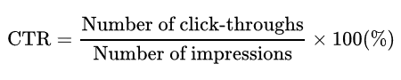

The data we use is from [Kaggle](https://www.kaggle.com/c/avazu-ctr-prediction/data). For the data file:

File descriptions

train - Training set. 10 days of click-through data, ordered chronologically. Non-clicks and clicks are subsampled according to different strategies.

test - Test set. 1 day of ads to for testing your model predictions.

sampleSubmission.csv - Sample submission file in the correct format, corresponds to the All-0.5 Benchmark.

## **Instructions**

* Know about dataset
* Evaluation
* Data Preparation

1. Subset
2. Hashing

* LR Model
* Poly Model
* FM Model
* FFM Model
* FFM CTR Prediction

# DataSet

Duration: 5:00

Our customer data comes from the [Kaggle](https://www.kaggle.com/) ,It’s easy to use, and free for non-commercial projects.

The dataset has the following columns:

Data fields

id: ad identifier

click: 0/1 for non-click/click

hour: format is YYMMDDHH, so 14091123 means 23:00 on Sept. 11, 2014 UTC.

C1 -- anonymized categorical variable

banner_pos

site_id

site_domain

site_category

app_id

app_domain

app_category

device_id

device_ip

device_model

device_type

device_conn_type

C14-C21 -- anonymized categorical variables

# Evaluation

Duration: 5:00

Logarithmic loss is used in the model evaluation:

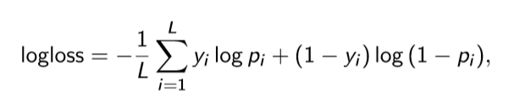

where L is the number of instances, yi ∈{0,1} is the label of the ith instance, and pi is the probability that the ith instance is clicked.

# Data Preparation

Duration: 20:00

## **Subset**

Instead of using the whole dataset, in this project we ﬁnd splitting data into small parts works better than directly using the entire dataset.

The proportion of positive and negative samples in the original data set is about 5:1, so we created a balanced test_CSV which has 20792 records from 98214 ‘click’(which is 0)records and a balanced train_CSV which has 23873 records from 113569 ‘click’(which is 0) to train the model.

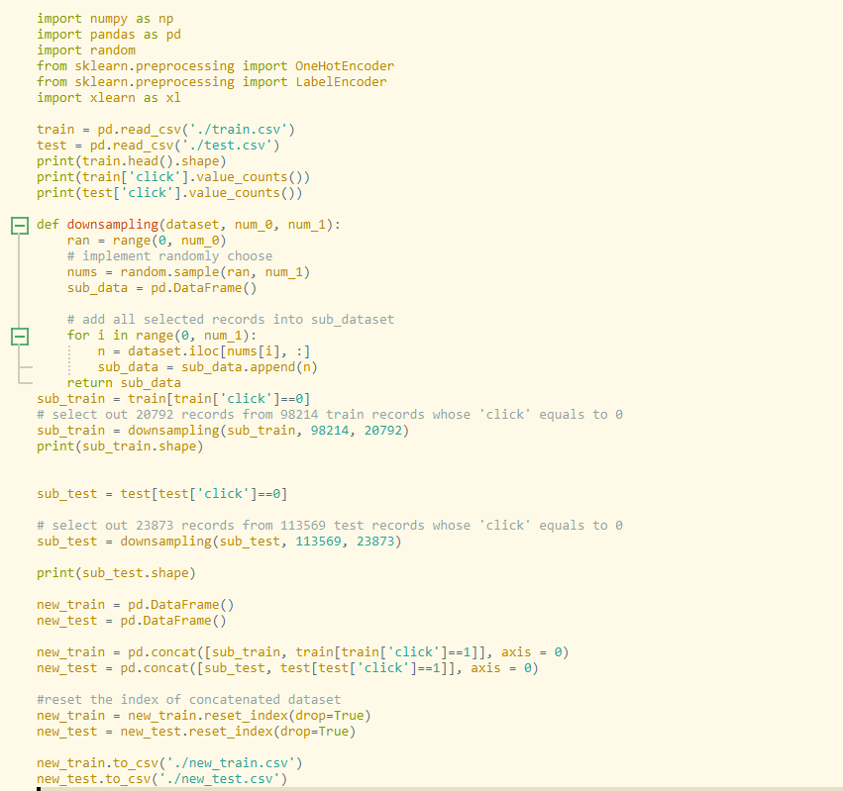

## **Hashing**

We use hashing trick to transform text features.

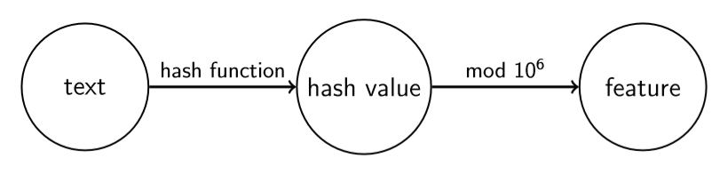

# LR

Duration: 10:00

Code:

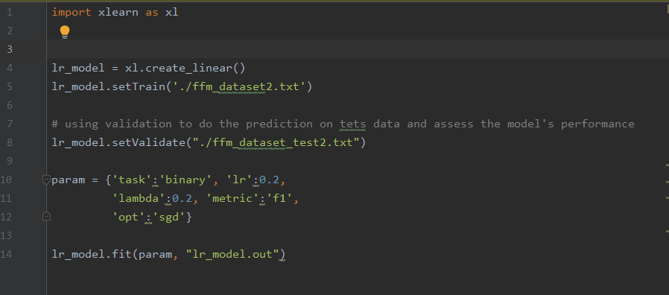

Performance:

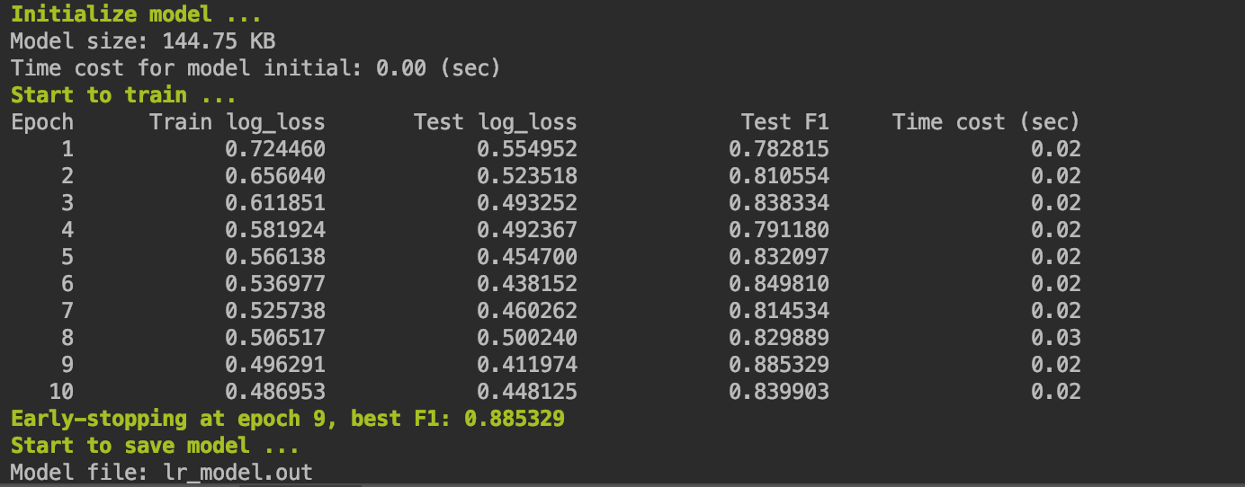

# POLY

Duration: 10:00

Code:

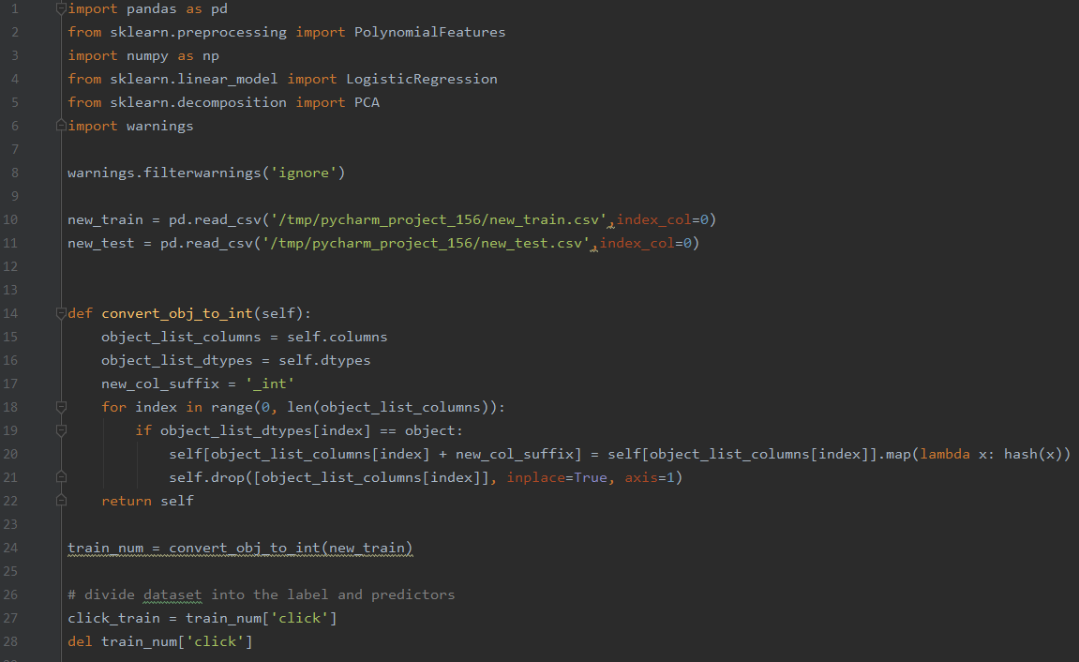

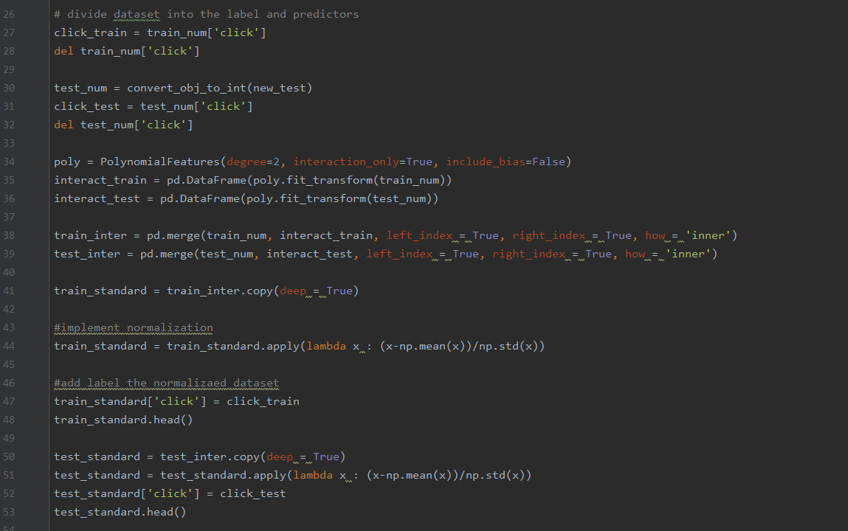

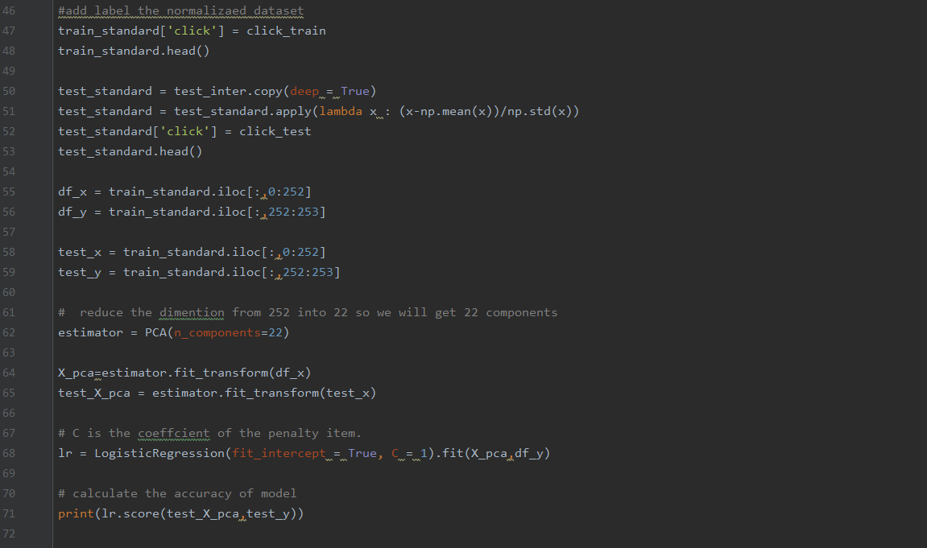

Performance:

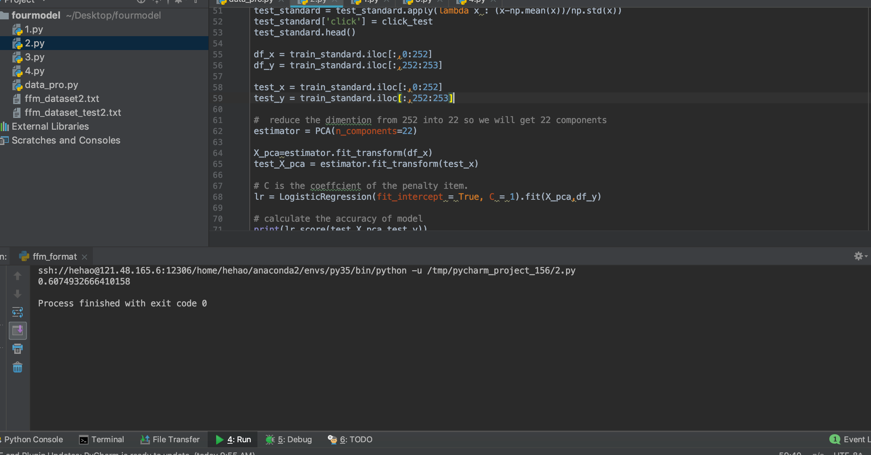

# FM

Duration: 10:00

Code:

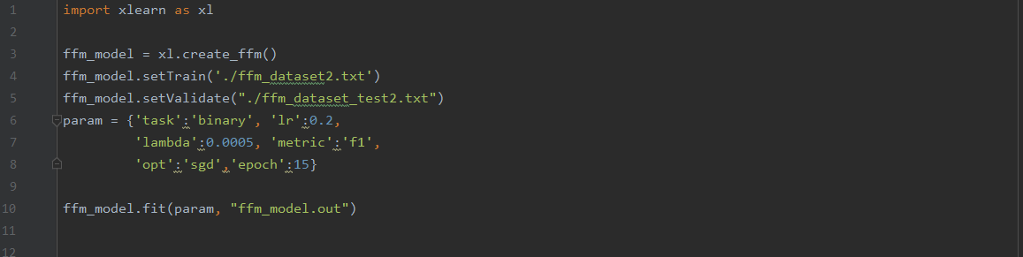

Performance:

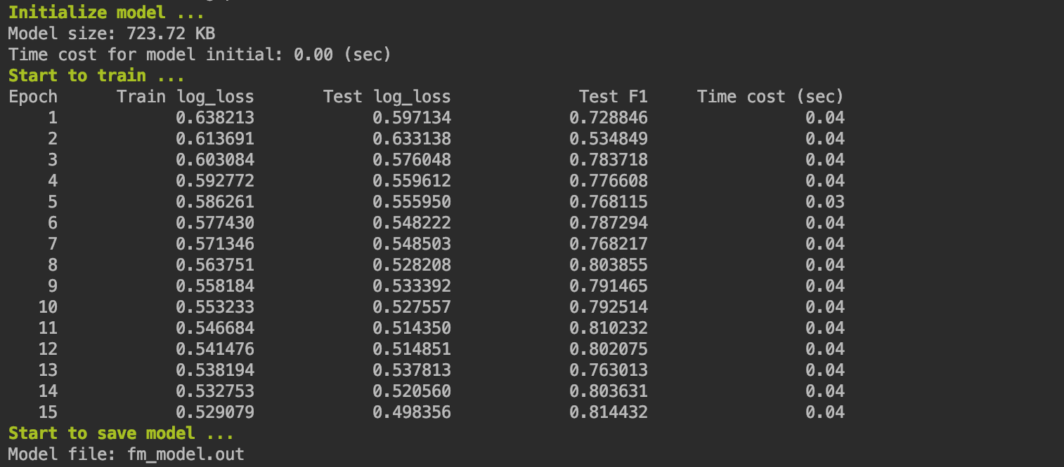

# FFM

Duration: 10:00

Code:

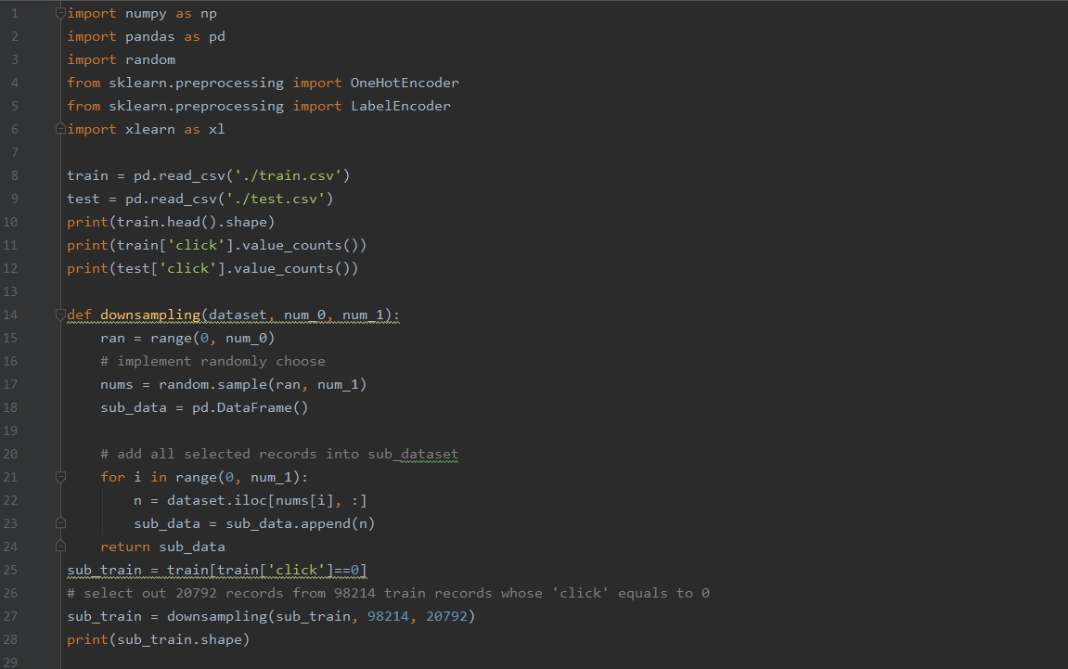

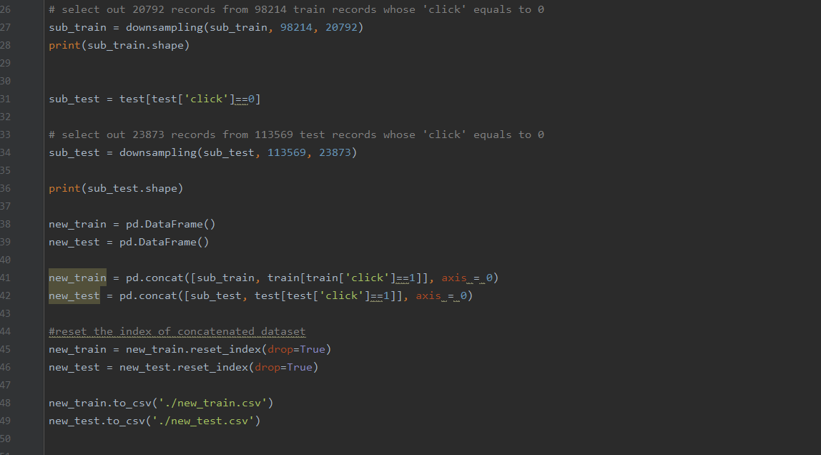

Performance:

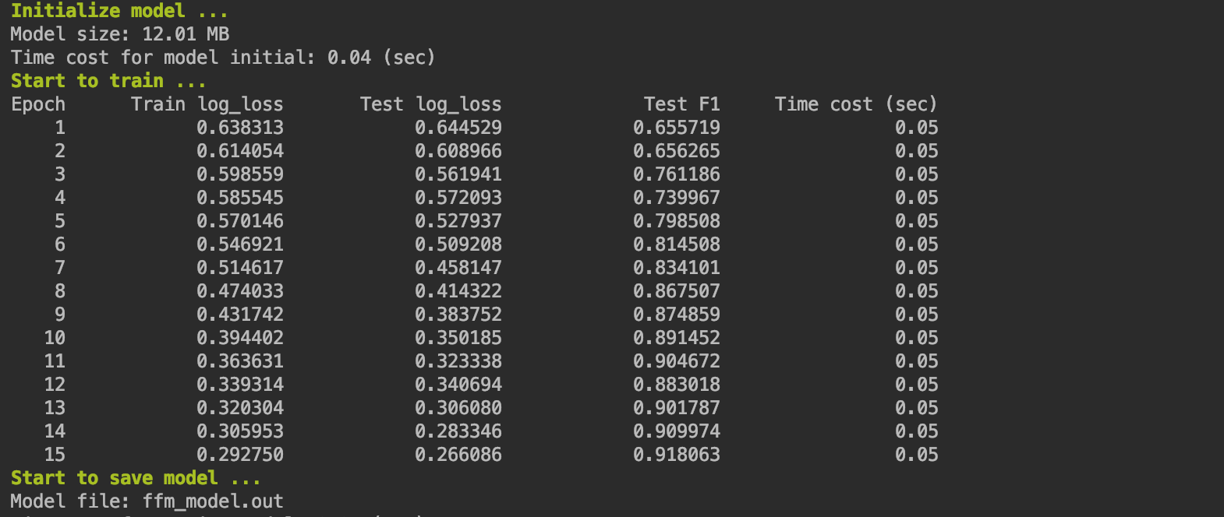

# FFM CTR Prediction

Duration: 10:00

We use ffm_dataset_test2.txt as input, and ffm.out as our model to make CTR predictions.

Code:

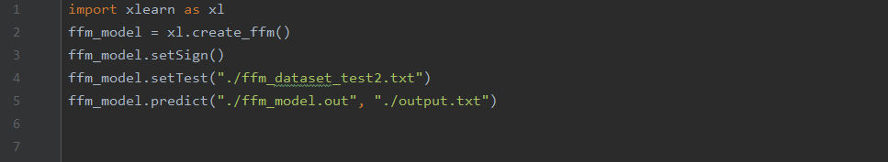

Output:

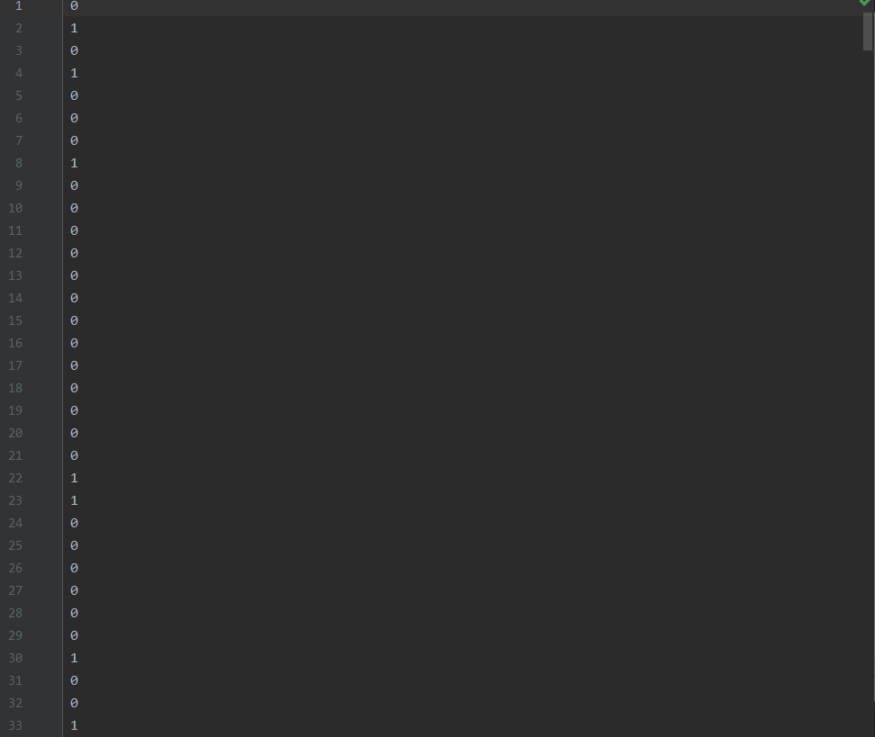

# Conclusion

Duration: 1:30

FFM is a better Model used to predict CTR based on the performance of the 4 models.

## **Something else**

LogLoss is a general method to evaluate models.

# Appendix

Duration: 3:00

You can look up the related analysis in [Kaggle](https://www.kaggle.com/c/avazu-ctr-prediction)

You can look up the detailed code on [Github](https://github.com/DinglingGe/Assignment-2)