

**英语/翻译二学位毕业设计**

|  |
| --- |
| **A report on the translation practice of scientific and technological documents under the variation translation theory and full translation theory** |
| **变译理论和全译理论下的科技文献翻译实践报告** |

|  |  |
| --- | --- |
| 院 系 | 外国语学院翻译系 |
| 专业班级 | 翻译二学位2班 |
| 姓 名 | 徐林蓉 |
| 学 号 | 29 |
| 指导教师 | 王树槐 |

2020年 4 月

**摘要**

科技英语作为一种特殊的英语文体，是一种以承载科技思想为职能，以词汇含义量扩大，句型扩展，句子成分之间关系复杂，用词力求准确，语法结构严密，要表达的思想全部字面化为主要特点的语言。

在此次翻译实践报告中，译者认为应注意以下四点：第一，要理解和表达科技内容，科技概念（特别是科技术语），语言形式，逻辑关系，符号公式，图标数字等。这些要准确无误，忠实于原文。第二，遣词用句等要简洁明了，精炼通顺。第三，语言，文字，术语，简称，符号，公式，语体，文章体例，计量单位等都要规范统一，符合国家和国际标准。第四，进行长难句的翻译过程中，作者应使用拆分句子的方法，将长句变为短句，使句子含义更加简洁明了，符合目的语读者的阅读习惯。

科技术语应当遵循以下原则：一，概念准确，一词一意的单一性原则。二，简明易懂，见词明义的简洁性原则。三，符合科技语言及其术语的规范和符合国家，国际有关标准的规范化原则。

此次汉译英翻译实践报告旨在通过全译理论和变译理论来研究科技文献中专业词汇、句法的处理，译者希望通过这次翻译实践更加了解科技文献翻译，并且为广大科技翻译学习者提供一些经验和参考。

**关键词**：变译理论；全译理论；科技文献翻译；信息类文本；Nature

**Abstract**

As a unique English style, English for science and technology is a kind of thought to be expressed with the function of carrying scientific and technological studies, expanding the meaning of vocabulary, expanding sentence patterns, and complex relations between sentence components, striving for accuracy in wording, and strict grammatical structure. All literalization is the primary characteristic of language.

In this translation practice report, the translator believes that the following four points should be paid attention: First, it is necessary to understand and express scientific and technological content, scientific and technological concepts (primarily scientific and technological terms), language forms, logical relations, symbolic formulas, icon numbers etc., These must be accurate and faithful to the original text. Second, the words and sentences should be concise and clear, concise and smooth. Third, language, text, terminology, abbreviations, symbols, formulas, styles, article styles, measurement units, etc. must be standardized and unified, in line with national and international standards. Fourth, in the process of translating long and complex sentences, the author should use the method of splitting the sentence to turn the long sentence into a short sentence, so that the meaning of the sentence is more concise and precise, in line with the reading habits of the target language readers.

Technological terminology should follow the following principles: First, the concept is accurate, and the principle of unity of the word’s meaning. Second, it is concise and easy to understand, see the direction of conciseness of precise definitions. Third, it conforms to the norms of scientific and technological language and its terminology and conforms to the standardization principles of relevant national and international standards.

The English-to-Chinese translation practice report aims to study the processing of professional vocabulary and syntax in scientific and technological documents through the full translation theory and variation translation theory. The translator hopes to learn more about the translation of scientific and technicaldocuments through this translation practice, and learn for most scientific and technical translations. The author provides some experience and references.

**Key words:** variation translation theory; full translation theory; EST ; information-based texts; Nature

**Contents**

**摘要** Ⅰ

**Abstract** Ⅱ

**1.Description of the Translation task** 1

1.1 Background of the Task 1

1.2 Features of the Task 1

**2.Description of the Translation Process** 3

2.1 Pre-translation Process 3

2.2 Translation Process 3

2.3 Post-translation Process 4

**3. Case Analysis** 6

3.1 Theoretical Basis 6

3.2 Translation Strategies applied at the lexical level 7

3.3 Translation Strategies applied at the syntactic level 8

**4.Summary of the Translation Practice** 12

4.1 Implications 12

**Acknowledgements** 14

**References** 15

**Appendix Ⅰ** 16

**Appendix Ⅱ** 21

1. **Description of the Translation Task**

**1.1 Background of the Task**

As a kind of applied translation, science and technology translation refers to the mutual conversion of science and technology applied styles between two languages. Explain the three processes of analysis, conversion, and reconstruction. As a science and technology translation of used translation, it is produced in a specific communicative environment (including culture, context, interpersonal, professional or subject, etc.). The multiple language factors that constitute the applied science and technology style are all words, sentences, paragraphs, chapters, etc. In the structural unit of graphics. Sci-tech translation is developed along with science and technology. Since the Industrial Revolution, science and technology in Britain and the United States have played a very important role in the world. Many scientific and technological translations are first translated from English as the original text. At the same time, with the development of science and technology of each country, there has been a vocabulary rich in that country's characteristics. In modern times and modern times, countries with earlier industrialization, such as Germany, France, Japan, Italy, and the United Kingdom, have gradually led the world in science and technology. Therefore, advanced scientific and technological vocabulary will also flow into the English and American languages from the languages of these countries, and the latter's borrowing of vocabulary from other languages is also more prominent, resulting in the new characteristics of English-Chinese scientific translation.

**1.2 Features of the Task**

This science report is chosen from NATURE24270 in 2017. And it is organized by editors. The translation volume is about four thousand words.

The author analyzed the original text from two aspects, the first one is the structure and content of the original text, and the second is the language characteristics of the original.

From the structure and content of the original text, the first part is a preface, which briefly introduces the background of supervised learning system in artificial intelligence and asks a series of questions. The second part is the main content of the report which describes reinforcement learning in AlphaGo Zero. The third part is empirical analysis of AlphaGo Zero training.

Then, from the characteristics of the original language, first of all, from the perspective of vocabulary, the style of science requires objectiveness, accuracy, and conciseness. So there are many professional words and nominalizations, such as the tree search(树搜索算法), Deep neural networks(深度神经网络), reinforcement learning(增强学习), supervised learning(有监督算法), a policy network(策略网络), a value network(价值网络). Then, from the analysis of sentence characteristics, there are many passive sentences and long sentences in the report, such as “Much progress towards artificial intelligence has been made using supervised learning systems that are trained to replicate the decisions of human experts”. These analytical methods are designed to ensure the rigor and accuracy of the article.

**2. Description of the Translation Process**

**2.1 Pre-translation Process**

Since the translation content involves formula and scientific symbols which are professional, so after having a general understanding of the terminology and sentence structure of the article before translation, the author decided to use a combination of electronic dictionary and reference books to complete the translation task. The electronic dictionaries are mainly Collins and Lingus, and the reference book is Oxford Advanced English-Chinese Dictionary. The use of reference books, like Artificial intelligence, in the translation process can give accurate and authoritative interpretations of related terms, greatly improving translation progress and reducing missed translations and mistranslations.

The material selected in this translation practice report is to discuss the problems and development directions of deep learning in artificial intelligence. Before translation, the author reviewed a large number of references and related parallel texts, and made sufficient preparations. Firstly, the author proofread the original text to ensure the accuracy and completeness of the content. Secondly, the author read articles throughout the text. In this process, a comprehensive understanding of the style of the text would appear in her mind, so that the main points and difficulties of the translation of the text were generally understood, and the professional vocabulary involved in the translation materials was grasped by the online learning.

There are several difficulties in this translation. Firstly, how to use the combination of sense-for-sense translation and literal translation methods to translate the original text. Secondly, how to find the same words in English to express the Chinese words. Thirdly, how to understand the context to do the translation. Therefore, the author did her work with these problems.

**2.2 Translation Process**

In the first translation, the author adopted the method of literal translation. Although the author had already understood the relevant terms and knowledge before the translation, it is still difficult for her to have a thorough understanding of professional terms and could not clearly tell the target language readers the right meaning due to the tight structure and logical nature of the science report. In terms of syntax, some long and difficult sentences and passive sentences are more complicated in structure, and some words in the translation are unsatisfactory. Therefore, after completing the translation of the first draft, the author recorded the problems encountered in the translation process, and the difficult sentences and translation inconveniences encountered were marked with red font.

In the second translation process, the author no longer used the literal translation method alone, but adopted full translation theory and variation translation theory, combining literal translation with free translation. Also the author deliberated the meaning of words, the context of the original text, the sentences, logical structure and focused on solving the problems left from the first draft.

After two times of tries of translating, the author strove to put the target readers' experience first. So the text is coherent, smooth and easy to understand which is consistent with the style of the news report texts.

**2.3 Post-translation Process**

Post-translation review is extremely important in translation practice. In order to make sure the accuracy and rigor of the translation, the author has adopted several methods: 1. refer to a paper dictionary, like the Oxford Advanced English-Chinese Dictionary; 2. use electronic dictionaries, like Collins and Lingus, and search engines, like Baidu and Google; 3. invite multiple her roommates and classmates to read the translation and get feedback; 4. Discuss the best translation with her classmates.

After the first translation draft was completed, firstly, the author checked the translation by herself to correct the mistranslation or missing translation in time. For the difficult problems encountered in the translation process, the best translation text was finally determined by extensively consulting relevant literature and discussing with classmates. In the process of this translation report, the author has always maintained a cautious and responsible attitude, carefully considered the words, and completed the translation with the help of other people and her own efforts. After the finalization, the author reflected on the translation practice report and summarized her experience, and then wrote this translation practice report.

**3. Case Analysis**

**3.1 Theoretical Basis**

This article is a science report, so the author chose full translation theory and variation translation theory.

Full Translation Theory refers to "preserving" the true meaning of the language as much as possible during the translation process. The more famous ones are Eugene Nida's "functional equivalence" and Christina Nord's "functional translation". Theoretically speaking, the full translation theory is to construct a perfect translation system, which can translate Chinese equivalently, and achieve the consistency of the original text and the target text in terms of syntax, three-dimensionality, and meaning. However, no matter which of these two theories, it ignores the influence of regional cultural differences on translation to a certain extent. Languages are also affected by regional cultures with regional differences, but from this perspective, it is impossible to translate completely in accordance with the original meaning.

Variation Translation Theory is actually a supplement and explanation of full translation theory. The concept of variation translation theory is to translate the original text in a reasonable way under certain special English translation situations. Variation translation and full translation are complementary to each other, and the two are indispensable. The application of variation translation must also be changed appropriately while preserving the overall meaning.

Comparing the full translation theory and the variation translation theory, it can be seen that the full translation theory has general applicability, can ensure the consistency and effectiveness of the translated content, and play an important role in improving the quality of English translation. However, the full translation theory basically does not take into account the influence of regional culture on culture. The similarities and differences of different cultures will directly affect people's understanding of the content of translation, and translators need to translate the language again. This is the root of the theory of translation. Variation translation theory is a supplement on the basis of full translation theory. Translating scientific and technical English through variation translation theory can more effectively improve the accuracy and pertinence of the language.

**3.2 Translation Strategies applied at the lexical level**

For most terms, there are fixed and authoritative expressions before. This requires the author to extensively consult relevant materials or use Internet resources during the translation process to ensure the accuracy and standardization of term translation, rather than fabricating. There are many professional terms used in this article, such as professional names, agricultural words, quantifiers, numbers and so on, which require fixed translation. Some terms need to be translated using full translation theory. And other terms need to be translated using interpretation. Interpretation refers to the interpretation and translation of some special vocabulary or professional terms in the article. This is the key point in the theory of translation, and it is of great significance to the translation of science and technology.

**Example 1**

**Source text:** These **neural networks** were trained by **supervised learning** from human expert moves, and by **reinforcement learning** from self-play.

**Translation:** 这些**神经网络算法**利用高段位棋手的走棋通过**有监督学习**的方式来训练，然后通过自我对弈来完成进行**增强学习**。

**Analysis:** “neural networks”, “supervised learning” and “reinforcement learning” is a professional concept with Chinese characteristics.

**Example 2**

**Source text:** Starting **tabula rasa**, our new program AlphaGo Zero achieved superhuman performance, winning 100–0 against the previously published, champion-defeating AlphaGo.

**Translation:** 从**无知幼儿**开始，我们新的程序—AlphaGo Zero达到了超级专家的水平，在与之前开发的AlphaGo（指代和李世石对弈的AlphaGo）的对弈中，取得了100-0的完胜。

**Analysis:** “tabula rasa” is a term in Locke's philosophy. Locke believes that the mind is like a white board, which is opposed to the doctrine of the existence of the concept of talent.

**Example 3**

**Source text:** we introduce a new reinforcement learning algorithm that incorporates look-ahead search inside the training loop, resulting in rapid improvement and precise and stable learning.

**Translation:** 我们开发了一种能在训练过程中完成前向搜索的增强学习算法，目的是为了快速的提高和精确稳定的学习过程。

**Analysis:** The “reinforcement learning algorithm” and “look-ahead search” are professional words which are uncommon in daily life. So the translation should refer to dictionary to make sure the accuracy.

**Example 4**

**Source text:** Our new method uses a deep neural network with parameters .

**Translation:** 我们的新方法使用具有参数的深层神经网络。

**Analysis:**  and  are formula symbols in scientific report, which is needed to search in some references.

**3.3 Translation Strategies applied at the syntactic level**

**3.3.1 Passive Sentence**

Science report aims to convey effective information by describing the topic viewpoint which is objective and realistic, so the frequency of passive voice is higher. Generally speaking, the passive voice is used less in Chinese, because "being" is considered to be derogatory in Chinese, while English is the opposite. Therefore, when translating this article, pay special attention to the passive voice of translation. And most of these sentences need to be translated using variation translation theory.

**Example 1:**

**Source text:** Much progress towards artificial intelligence has been made using supervised learning systems that are trained to replicate the decisions of human experts.

**Translation:** 利用有监督学习来复制人类专家的决策结果使得人工智能取得了长足发展。

**Analysis:** This is a typical passive sentence, the structure of it is “subject+ be+ done”. In Chinese, it is generally not translated by "be", but it needs to be converted into a positive form in Chinese. We call such a passive voice in Chinese as "invisible passive voice".

**Example 2:**

**Source text:** The policy network was trained initially by supervised learning to accurately predict human expert moves, and was subsequently refined by policy-gradient reinforcement learning.

**Translation:** 策略网络通过有监督的学习来精确的预测高段位棋手的落子，之后再通过价值梯度增强学习来完成系统的增强。

**Analysis：** In order to avoid using “被” in Chinese which will be stiff, “通过” in the original text replace it.

**Example 3:**

**Source text:** The neural network in AlphaGo Zero is trained from games of self-play by a novel reinforcement learning algorithm.

**Translation:** AlphaGo Zero中的神经网络是通过一种新的强化学习算法从自我游戏中进行训练。

**Analysis：**In this sentence, “is trained” is used to indicate passive, which replaced “被” into “通过” in translation in Chinese. In this method, the original meaning will be more accurate and objective.

**3.3.2 Attributive Clause**

The translation of attributive clauses has always been the focus of translation. Because of the differences between Chinese and Western languages, there will often be many problems when translating the attributive clauses. There are three main translation methods for the translation: 1. The pre-translation method, which put the fixed sentence in front of a modified noun; 2. The post-translation method, which put the fixed sentence after the modified noun. When use this method, remember to translate the relationship words; 3. Put the translation at the beginning, and this method should adjust the order of the whole sentence or change the structure. In the translation process, we should choose the appropriate translation method which conforms to the context.

**Example 1:**

**Source text:** The published version, which we refer to as AlphaGo Fan,

defeated the European champion Fan Hui in October 2015.

**Translation:** 我们目前开发的版本—AlphaGo Fan在2015年10月打败了欧洲围棋冠军Fan Hui（樊麾:法国国家围棋队总教练）。

**Analysis:** The method used in this sentence is post-translation method. In this sentence, “这” is translated into “which”, and it connects two clauses.

**Example 2:**

**Source text:** To achieve these results, we introduce a new reinforcement learning algorithm that incorporates look-ahead search inside the training loop, resulting in rapid improvement and precise and stable learning.

**Translation:** 为了实现这些方面，我们开发了一种能在训练过程中完成前向搜索的增强学习算法，目的是为了快速的提高和精确稳定的学习过程。

**Analysis:** The method used in this sentence is pre-translation method.

**Example 3:**

**Source text:** A subsequent version, which we refer to as AlphaGo Lee, used a similar approach (see Methods), and defeated Lee Sedol, the winner of 18 international titles, in March 2016.

**Translation:** 在之后的开发版本中，我们称为AlphaGo Lee，使用和之前相同的方法，在2016年打败了Lee Sedol（18项国际冠军）。

**Analysis：**The method used in this sentence is pre-translation method. In the original text, “version” is the subject and “which” refers to it. Because the sentence is simple, it is appropriate to put the attributive clause completely before the modified noun, and add a "的" to the end of the attributive clause.

**3.3.3 Long and Difficult Sentence**

Long and difficult sentences are usually complex in structure and composed of multiple sentence patterns. Therefore, when dealing with long and difficult sentences, the translator needs to clarify the structure which means to break the sentences first. Then, translating the sentences in the original text directly. Retranslating and rereading the sentences until they can pass accurate information to target language readers. And in this field, abstract translation is important, which refers to the removal and translation of some components in a sentence, but it will not affect the complete meaning of the sentence.

**Example 1:**

**Source text:** Once trained, these networks were combined with a Monte Carlo tree search (MCTS)13–15 to provide a look-ahead search, using the policy network to narrow down the search to high-probability moves, and using the value network (in conjunction with Monte Carlo rollouts using a fast rollout policy) to evaluate positions in the tree.。

**Translation:** 训练结束之后，这两个网络通过蒙特卡洛树搜索的算法相结合来提供对未来局势的前望。使用策略网络来缩小高概率落子的搜索过程，使用价值网络（结合蒙特卡洛快速走子策略）在树上完成对落子位置的评估。

**Analysis:** The original text is long, so the author needs to break the sentence.

**Example 2:**

**Source text:** To achieve these results, we introduce a new reinforcement learning algorithm that incorporates look-ahead search inside the training loop, resulting in rapid improvement and precise and stable learning.

**Translation:** 为了实现这些方面，我们开发了一种能在训练过程中完成前向搜索的增强学习算法，目的是为了快速的提高和精确稳定的学习过程。

**Analysis:** If the author just translates the sentence directly, the real meaning cannot be conveyed. In many cases, sense-for-sense translation can better express the meaning of the original text.

**4. Summary of the Translation Practice**

**4.1 Implications**

Through the translation of Deep Learning and Artificial Intelligence, the author find that the most important thing in the translation of the science report texts are to establish a translation goal, because the translation goal determines what translation theory and translation method to use in the translation process. Taking this translation practice as an example, the author’s goal is to provide more people with the translation of technical terms to refer, which is rare in China. Therefore, from the beginning to the end, the author chose full translation theory and variation translation theory on the principle of placing the target language readers first, hoping to resonate with the text readers. Through this translation practice, the author has a preliminary understanding of science translation and clearly realizes the objectivity of the science text.

The translation process is not smooth for the author, and encounter many difficulties, including the translation of a large number of professional terms and long sentences, as well as how to comprehensively use the translation method combining free translation and literal translation to fully express the original meaning. For professional terminology, the author mainly expand the vocabulary by consulting online dictionaries and reading a large number of parallel texts. For long and difficult sentences, the author adopts strategies such as splitting sentences, adjusting the order of words, and conversing the voice. In terms of text, while ensuring the accuracy of the text, the author use strict expressions in accordance with Chinese expression habits, and retain the style of the source text of the scientific and technological application. Through this translation, the author realize that in the face of a brand new or even unfamiliar text, the practice of direct translation is not appropriate. Before translation, it is essential to reserve a lot of professional knowledge.

There are still many deficiencies in this translation. The accuracy and fineness of the translation may not be qualified, but the author has benefited a lot from this translation process. Not only the author's translation level has been improved, but more importantly, the author understands how to deal with such texts in the future, how to prepare for translation, how to choose theoretical guidance, how to prepare translation strategies and how to solve the translation difficulties encountered in the process.

Finally, through this translation practice, the author clearly realizes that being a qualified translator requires not only a solid language skills, but more importantly, a deep cultural literacy, a serious and responsible attitude, and a humility to others’ translation. In the future study and work, the author must strengthen theoretical study, strengthen translation practice training, take every translation task seriously, and make every effort to contribute to the translation career.

**Acknowledgments**

During this thesis, I have met lots of difficulties and I couldn’t finish it without the help of my teacher, my classmates and my family.

Firstly, I would like to express my deepest gratitude to my supervisor, Professor Wang shuhuai. During the thesis writing, he spent his valuable time helping me revise the paper and giving me many useful suggestions.

Secondly, I would like to thank all the teachers in the foreign language college. They gave me a lot of help during my double degree study.

Finally, sincere gratitude also goes to my parents and classmates who give me the most sincere support and encouragement in completing this thesis.

**References**

[1]方梦之．我国科技翻译研究的回顾与述评[J]．外国语(上海外国语学院学报)，1991(6):41-45.

[2]刘旭. 交际翻译视角下英语定语从句的翻译[D].南京大学,2019.

[3]方梦之．近半世纪我国科技翻译研究的回顾与评述[J]．上海科技翻译，2002(3):1-4．

[4] 单宇，范武邱．国内科技翻译研究现状综述(1997-2014)---基于CNKI557篇硕博论文的考量[J]．中国科技翻译，2016(1):14-17．

[5]林煌天．为繁荣科技翻译事业多做贡献---祝《上海科技翻译》杂志创刊[J]．上海科技翻译，1986(1):2-3．

[6]冯志杰.汉英科技翻译旨要[M].北京:中国对外翻译出版公司,2006.

[7]万世长，陈文东.科技英语中的名词化：功能和特征[J].林区教学，2008(5):86-88.

[8]冯志杰.汉英科技翻译旨要[M].北京:中国对外翻译出版公司,2006.

[9]梁启超．中国近三百年学术史(新校本)[M]．北京:商务印书馆，2013.

[10] Fryer,J. Scientific terminology:Present discrepancies and means of securing uniformity[A]. In Records of the General Conference of the Protestant Missionaries of China,held at Shanghai,May 7-20,1890[C]. Shanghai:American Presbyterian Mission Press,1890:538-546.

[11]李秀云,苏曼.回顾与反思:变译理论视野下的科技英语翻译[J].西北成人教育学院学报,2015(3):57-59.

[12]许润.A Study of C-E Translation of Flower Culture from the Perspective of Peter Newmark's Semantic and Communicative Translation Theory——A Case Study of Xue Baochai's Flower Card in A Dream of Red Mansions[J].海外英语,2019(14):62-63.

[13]黄忠廉.变译理论[M].北京:中国对外翻译有限公司，2001.

**Appendix Ⅰ**

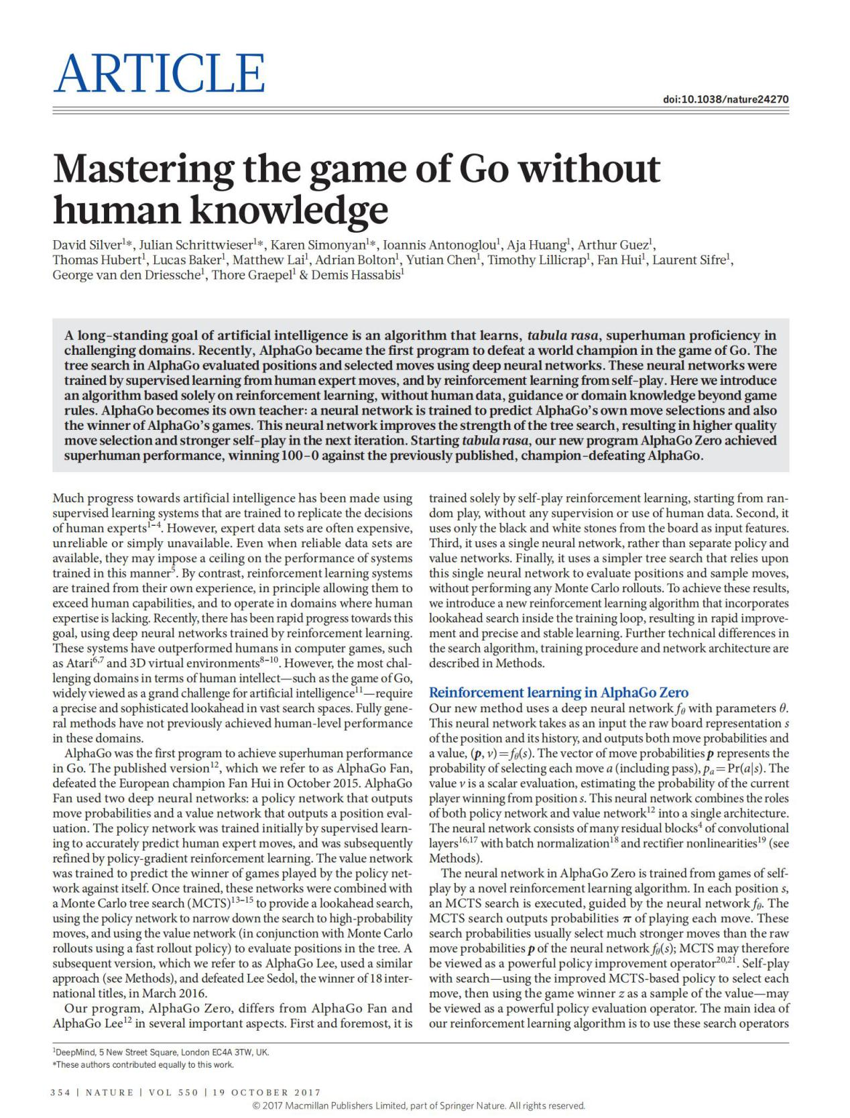

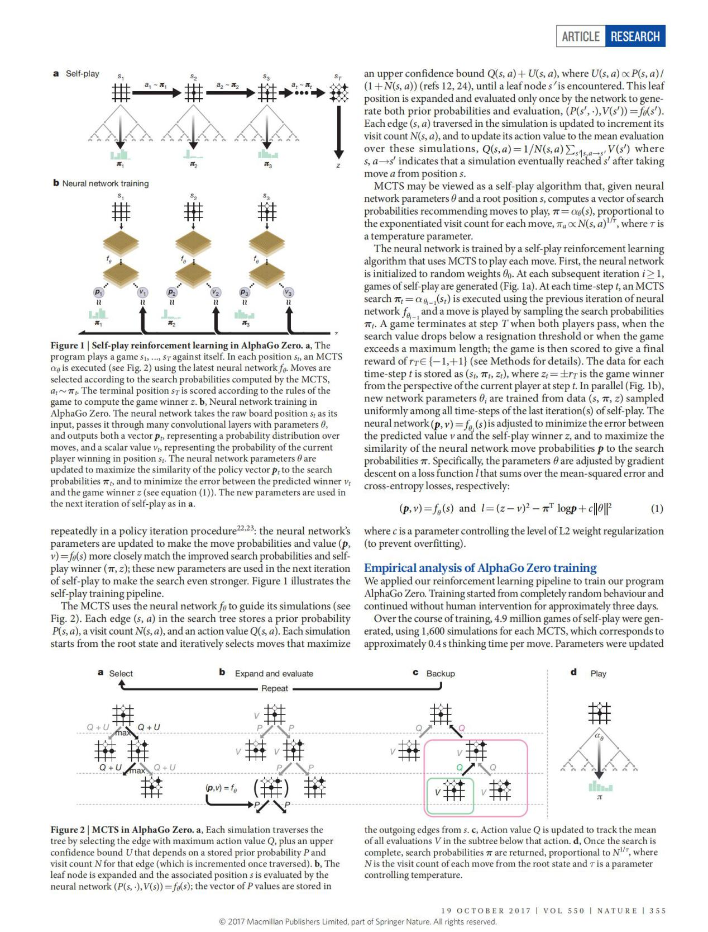

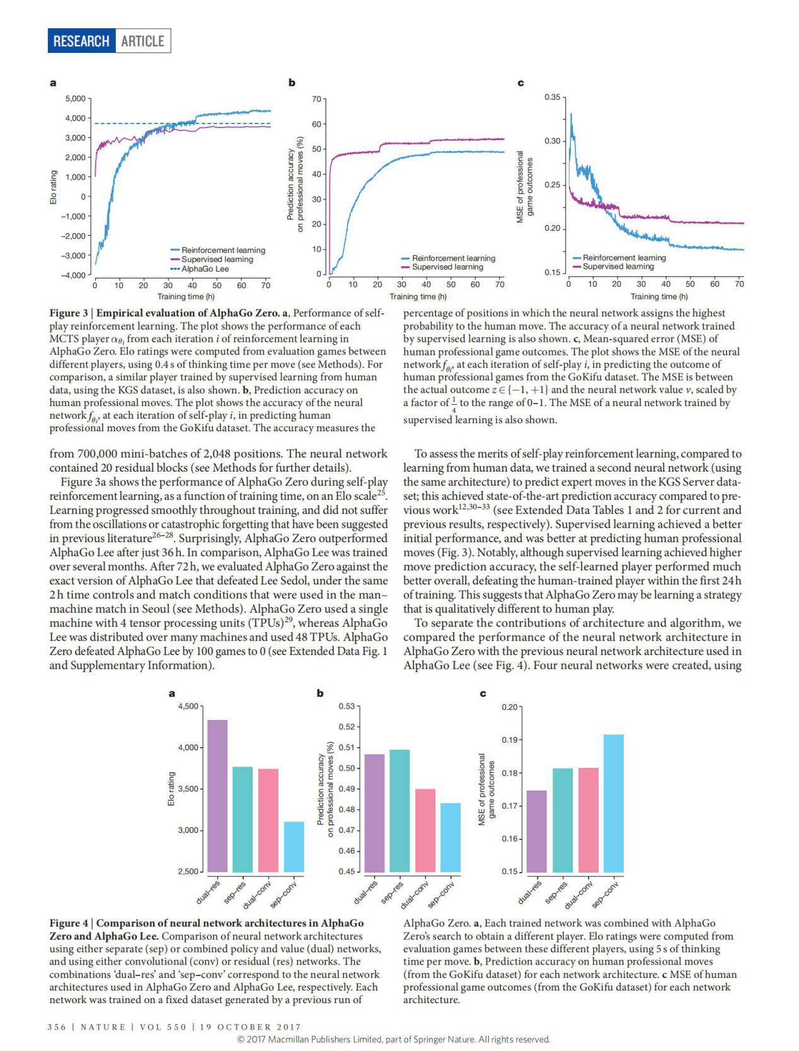

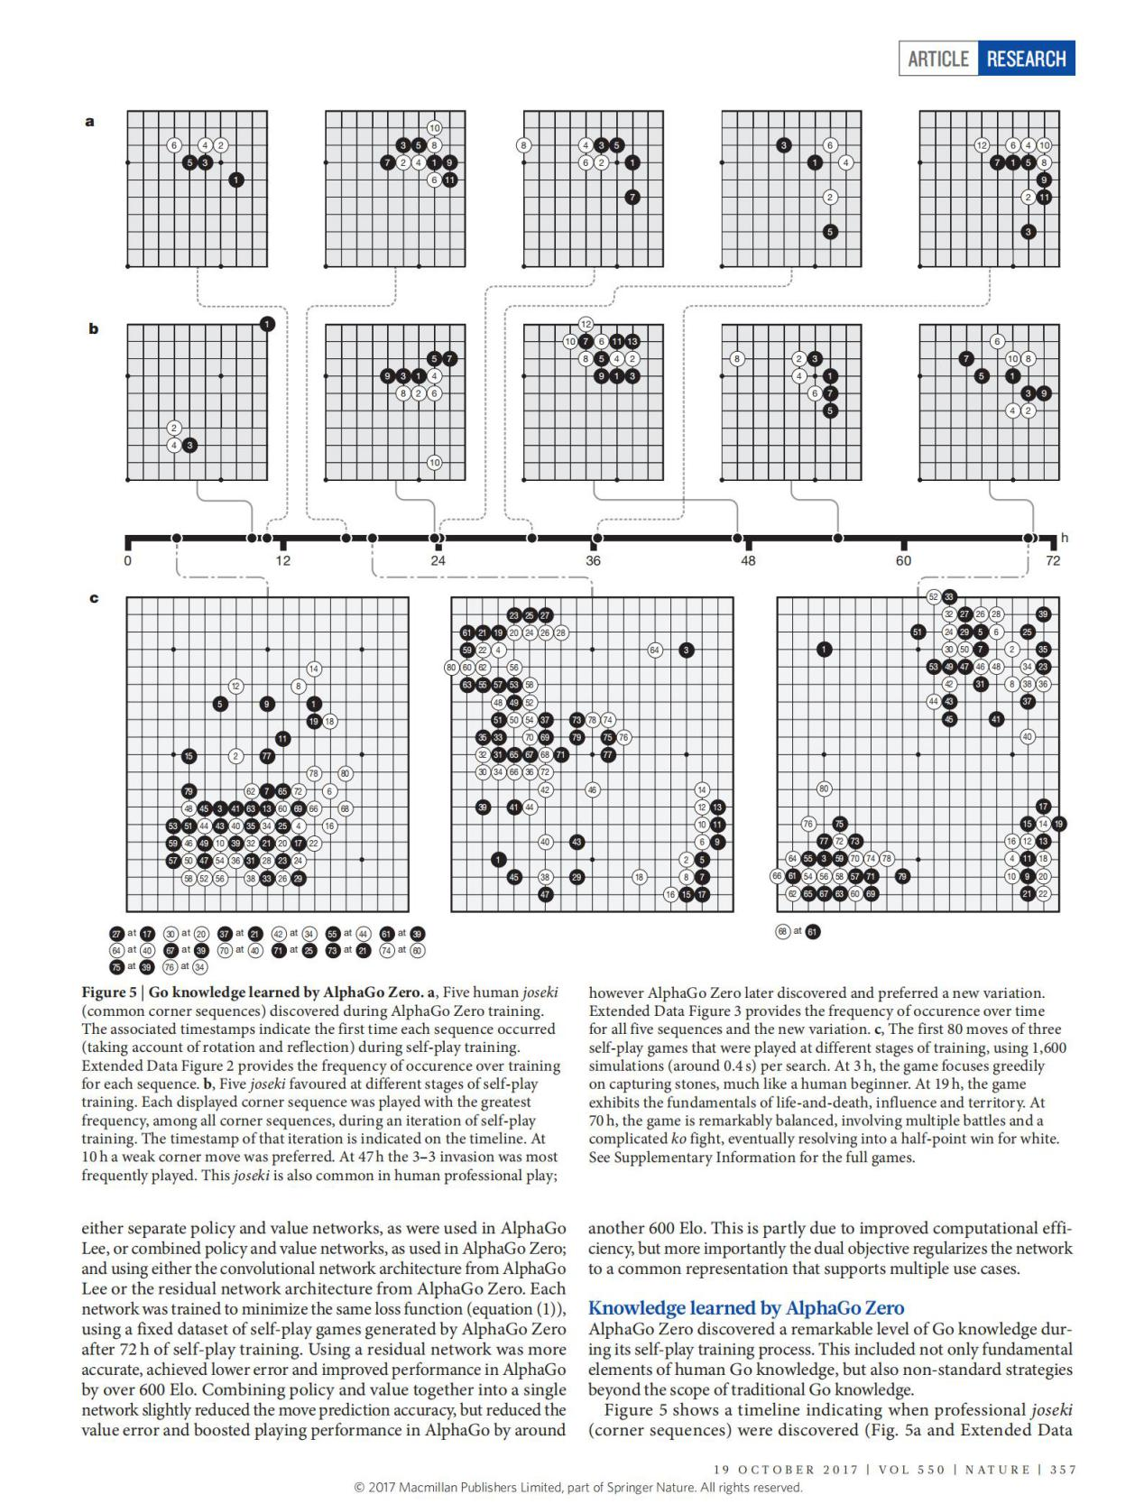

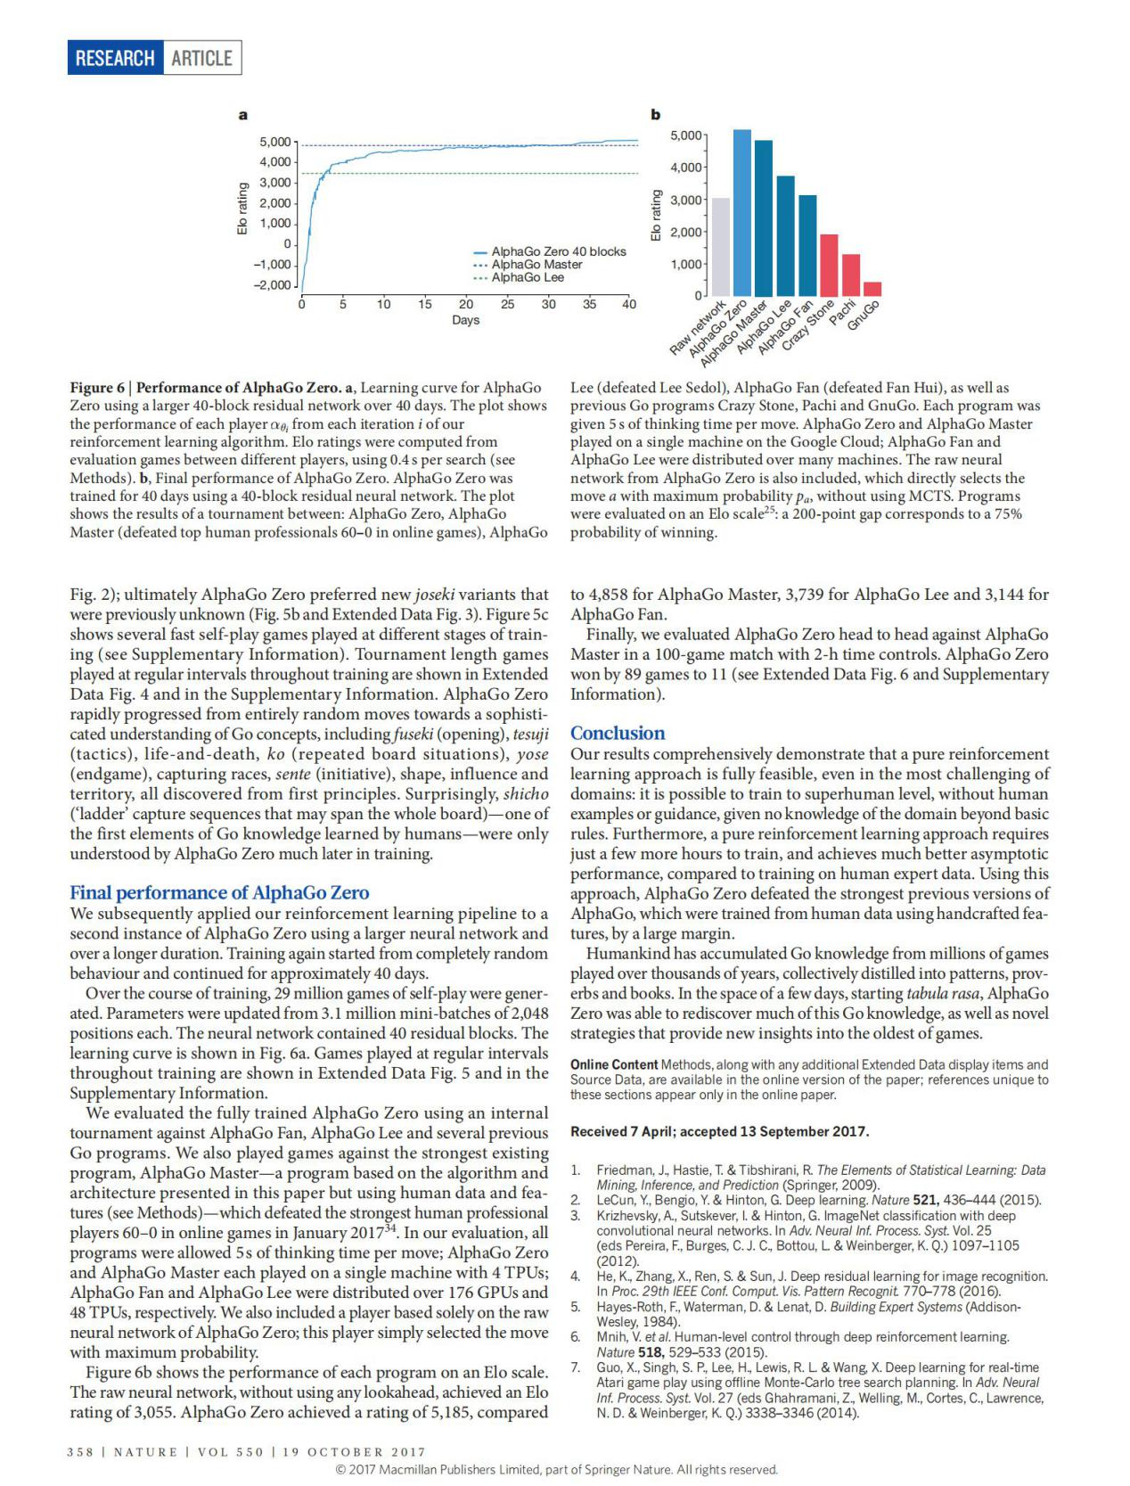

**Appendix Ⅱ**

**不使用人类知识精通围棋！**

**摘要**

长久以来，人工智能的目标是在富有挑战性的领域中学习出一种从无知幼儿到超级专家的算法。最近，AlphaGo成为了在围棋游戏中打败人类世界冠军的第一个程序。其中，AlphaGo对下棋位置的预估和选定下棋位置所使用的树搜索算法使用了神经网络。这些神经网络算法利用高段位棋手的走棋通过有监督学习的方式来训练，然后通过自我对弈来完成进行增强学习。本篇论文中我们提出了一种完全独立的增强学习算法，算法不需要人工数据，或是基于游戏规则的引导或领域知识。AlphaGo变成了自己的老师：训练一个神经网络用来完成AlphaGo的落子预测和对弈的赢家。这个网络同时还提高了树搜索的能力，带来的结果就是能够在下一手中有更高质量的落子选择和更强的自我对弈能力。从无知幼儿开始，我们新的程序—AlphaGo Zero达到了超级专家的水平，在与之前开发的AlphaGo（指代和李世石对弈的AlphaGo）的对弈中，取得了100-0的完胜。

**引言**

利用有监督学习来复制人类专家的决策结果使得人工智能取得了长足发展。然而，专家数据通常需要大量财力，而且也存在不可靠和难以获取的缺点。甚至有的时候获取了可靠的数据之后，也会对通过这种方式训练的系统的性能加以强制限制[5]。于此相反的是，强化学习系统是通过自身的经验来完成训练的，所以在原则上他们是可以超越人类的能力，并在人类经验缺失的领域也能工作。近年来，利用强化学习训练的深部神经网络已经取得了较快的进展。这些系统在电子游戏中已经超越了人类玩家的水平，比如说Atari[6,7]和3D虚拟游戏[8,9,10]。然而，就人类智力而言最富有挑战性的游戏领域—比如说围棋就被广泛的认为是AI领域的重大挑战。这些游戏需要在庞大的搜索空间中完成精确复杂的预判（也就是我们说的看几步棋）。在这个领域中的所有的一般方法都不能达到人类棋手的水平。

AlphaGo是在围棋领域能达到人类超级专家水平的第一个程序，我们目前开发的版本—AlphaGo Fan在2015年10月打败了欧洲围棋冠军Fan Hui（樊麾:法国国家围棋队总教练）。AlphaGo使用了两个深度神经网络：一个是策略网络输出下一步落子位置的概率，一个是价值网络输出对位置的评估（也就是落子胜率）。策略网络通过有监督的学习来精确的预测高段位棋手的落子，之后再通过价值梯度增强学习来完成系统的增强。价值网络通过策略网络的自我博弈来预测游戏的胜方从而完成训练。训练结束之后，这两个网络通过蒙特卡洛树搜索的算法相结合来提供对未来局势的前望。使用策略网络来缩小高概率落子的搜索过程，使用价值网络（结合蒙特卡洛快速走子策略）在树上完成对落子位置的评估。在之后的开发版本中，我们称为AlphaGo Lee，使用和之前相同的方法，在2016年打败了Lee Sedol（18项国际冠军）。

我们现在的程序，AlphaGo Zero，和 Alpha Go、Alpha Lee这些之前的版本相比较，在很多方面都有不同。最重要的是，AlphaGo Zero完全独立的通过自我博弈增强学习来完成训练，从刚开始的随机博弈开始就没有任何的监督或使用人工数据。其次，它只使用棋盘上的黑白子作为输入特征（之前的AlphaGo有人工构建的许多特征）。第三，只使用一个神经网络，而不是分开的策略网络和价值网络。第四，只使用依赖于单一神经网络的简化版树搜索来评估落子概率和落子对局势的影响，不再使用蒙特卡洛的方法。为了实现这些方面，我们开发了一种能在训练过程中完成前向搜索的增强学习算法，目的是为了快速的提高和精确稳定的学习过程。对这些网络结构差异、搜索算法的不同已经训练过程的不同我们将会在Methods部分做进一步的详述。

**AlphaGo Zero强化学习**

我们的新方法使用具有参数θ的深层神经网络fθ。 该神经网络将位置及其历史的原始图表代表作为输入，输出移动概率和值(p，v)=fθ(s)。 移动概率的向量p表示选择每个移动a(包括pass)，pa = Pr(a | s)的概率。 值v是标量评估，估计当前玩家从位置s获胜的概率。 该神经网络将策略网络和价值网络12的角色结合到单一架构中。 神经网络包括许多残差块的卷积层，批量归一化和整流器非线性(参见方法)。

AlphaGo Zero中的神经网络是通过一种新的强化学习算法从自我游戏中进行训练。在每个位置，执行MCTS搜索，由神经网络fθ指导。 MCTS搜索输出每次移动的概率π。这些搜索概率通常选择比神经网络fθ(s)的原始移动概率p更强的移动;因此，MCTS可能被视为强大的策略改提供者。使用改进的基于MCTS的策略来选择每个动作，然后使用游戏赢家z作为价值的样本，可以自我搜索 - 可以被视为强大的策略评估运算符。我们的强化学习算法的主要思想是使用这些搜索算子。

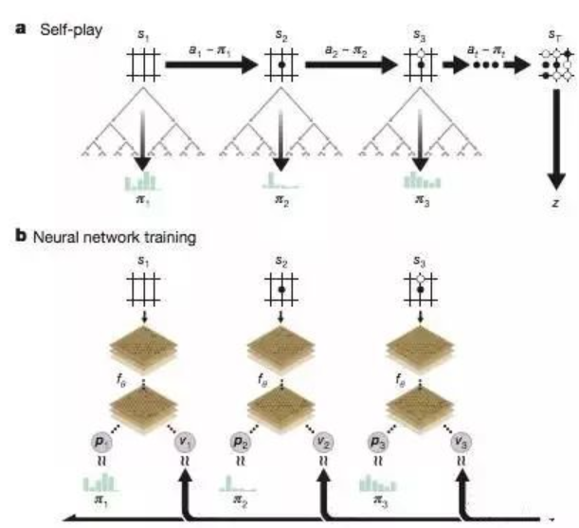

上图a 在AlphaGo Zero中自我强化学习。该程序针对自己的游戏s1，...，sT。在每个位置st中，使用最新的神经网络fθ执行MCTSαθ(参见图2)。根据MCTS计算的搜索概率选择移动，在〜πt。终端位置sT根据游戏规则得分，以计算游戏赢家z。

图b，AlphaGo Zero的神经网络训练。神经网络将原始位置st作为其输入，将其传递给具有参数θ的许多卷积层，并且输出表示移动的概率分布的向量pt和表示当前选手在位置st中获胜的概率的标量值vt。更新神经网络参数θ以最大化策略向量pt与搜索概率πt的相似度，并且使预测的胜者vt和游戏胜者z之间的误差最小化(参见等式(1))。新参数用于下一次自播的迭代。

在策略迭代过程中反复22,23：更新神经网络的参数以使移动概率和值(p，v)=fθ(s)更接近匹配改进的搜索概率和自播赢胜者(π，z);这些新参数用于下一次自我播放，使搜索更加强大。上图说明了自我播放训练流水线。MCTS使用神经网络fθ来引导其模拟

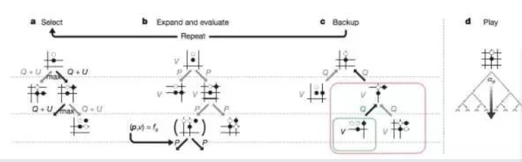

搜索树中的每个边(s，a)存储先验概率P(s，a)，访问次数N(s，a)和动作值Q(s，a)。每个模拟从根状态开始，并迭代地选择最大化上限置信度Q(s，a)+ U(s，a)的移动，其中U(s，a)αP(s，a)/

(1 + N(s，a))(参考12,24)，直到遇到叶节点s'。 (P(s'，·)，V(s'))=fθ(s')，通过网络对该叶位置进行扩展和评估，仅基于两个先验概率和评估。在模拟中遍历的每个边(s，a)被更新以增加其访问次数N(s，a)，并且将其动作值更新为对这些模拟的均值估计，Q(s，a)= 1 / N( s，a)Σs'| s，a→s'V(s')其中s，a→s'表示在从位置s移动a之后，模拟最终达到s'。

MCTS可以被看作是一种自播算法，给定神经网络参数θ和根位置s，计算推荐移动游戏的搜索概率向量，π=αθ(s)，与每次移动的指数访问次数成比例，πaαN(s，a)1 /τ，其中τ是温度参数。

神经网络通过自我强化学习进行训练，使用MCTS计算每个动作的算法。

神经网络被初始化为随机权重θ0。在每次后续迭代i≥1时，产生自己计算的游戏(图1a)。在每个时间步长t，MCTS searchπt=αθi-1(st)使用上述语句执行网络fθi-1，并通过对搜索概率π进行采样来进行移动。当两个玩家通过时，当搜索值下降到阈值以下或当游戏超过最大长度时，游戏终止于步骤T;然后游戏得分，以给予决赛奖励rT∈{-1，+ 1}(详见方法)。每个数据时间步t存储为(st，πt，zt)，其中zt =±rT是游戏赢家。

从步骤t的当前玩家的角度来看。并行地(图1b)，新的网络参数θ是从上一次自播的所有时间步长中均匀采样的数据(s，π，z)进行训练的。神经网络(p，v)=fθi(s)被调整为假设预测值v和自播赢者z之间的差异，并且最大化神经网络移动概率p与搜索概率π的相似性。具体来说，通过对均方误差和交叉熵损耗求和的损失函数l，通过梯度下降来调整参数θ(p，v)=fθ(s)和l =(z-v)2 -πTlogp + cθ2(1)其中c是控制L2权重正则化水平的参数(防止过度配合)。

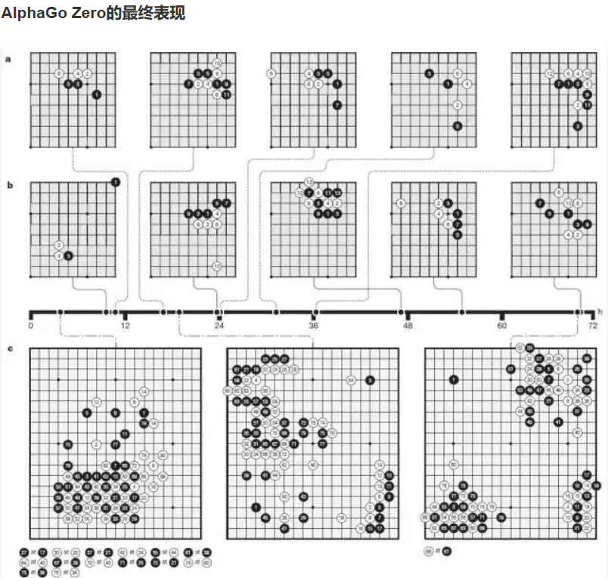

我们随后使用更大的神经网络和更长的持续时间将我们的强化学习流程应用于AlphaGo Zero的第二个实例。训练再次从完全随机的行为开始，持续约40天。

在训练过程中，生成了二千九百万次自娱自乐的游戏。参数从310万个小批量更新，每个2048个职位。神经网络包含40个残差块。学习曲线如图a所示。在扩展数据图5和补充信息中显示了在训练中定期进行的游戏。

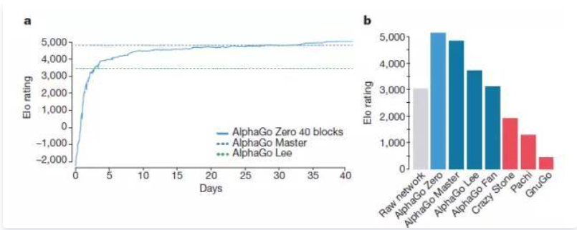

我们通过内部比赛对AlphaGo Fan，AlphaGo Lee和几个以前的Go程序评估了全面训练的AlphaGo Zero。我们还针对最强大的现有程序，AlphaGo Master - 基于本文中提出的算法和架构的程序，(但使用人力资源和功能) - 在线上击败了最强大的人力专业人员60-0(在我们的评估中)，所有的过程都被允许每次移动5次思维时间; AlphaGo Zero和AlphaGo Master都在4台TPU的单机上播放; AlphaGo Fan和AlphaGo Lee分别分布在176个GPU和48个TPU上。我们还包括一个完全基于AlphaGo Zero的原始神经网络的玩家;这个玩家只是以最大的概率选择了移动。

上图b显示了每个程序在Elo量表上的性能。原始神经网络，没有使用任何前瞻，实现了Eo评级为3,055。相比之下，AlphaGo Zero的评级为5,185

李(击败Lee Sedol)，阿尔法·范(击败范慧)以及以前的Go程序疯狂石，Pachi和GnuGo。每个程序每次都有5秒的思考时间。 AlphaGo Zero和AlphaGo Master在Google Cloud上的一台机器上播放; AlphaGo Fan和AlphaGo Lee分布在许多机器上。还包括AlphaGo Zero的原始神经网络，其直接选择最大概率pa的移动a，而不使用MCTS。计划以Elo量表评估25：200分差距对应于75%的获胜概率。

AlphaGo Master为4,858，AlphaGo Lee为3,739，AlphaGo Fan为3,144。

最后，我们评估了AlphaGo Zero的头脑，与AlphaGo Master进行了一场100小时的比赛，并以2小时的时间控制。 AlphaGo Zero赢得89场比赛至11场(见扩展数据图6和补充资料)。

**结论**

我们的研究结果全面表明，即使在最具挑战性的领域，纯粹的强化学习方法也是完全可行的：没有人类的例子或指导，无法超越基本规则领域的知识，有可能训练到超人的层面。 此外，与人类专家培训的数据相比，纯强化学习方法需要训练几个小时，并实现更好的渐近性能。 使用这种方法，AlphaGo Zero击败了AlphaGo的最强大的版本，它们使用手工制作的资源进行了大量的培训。人类已经从数百万年来玩过的数百万场游戏中积累了Go的知识，共同融入了模式，资源和书籍。在几天的的时间里，Alphaura Zero能够重新发现这些Go知识，以及最古老的游戏提供新的见解和新颖策略。