IR Sensor and Module
IR Sensor Module | How IR Sensor Module Works » ElectroDuino
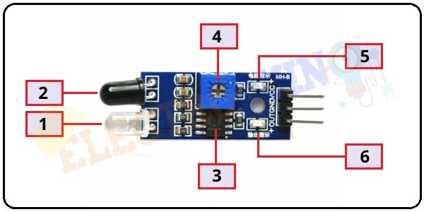
1. Infrared LED or IR Transmitter:
2. Photodiode Receiver or IR Receiver:
4. Variable Resistor (Trim pot)
- This variable resistor is a 10k preset. It is used to set the range of operation. Rotate the preset knob to adjust the detection distance, the effective operation range 2-10 cm. If the preset knob rotated clockwise, the detection range will be increased. If it rotated counterclockwise, the detection range will be decreased.
- Could be used for long/short distance reading
- IE When short distance sensor goes off we know the wall is close
5. Power LED:
- LED that indicates the IR Sensor power supply is on or off

6. Output LED:
- When infrared reflected back to the IR receiver and the sensor detects an obstacle, the green LED lights up. So, the Green LED use to indicate the sensor senses an obstacle.
Circuit 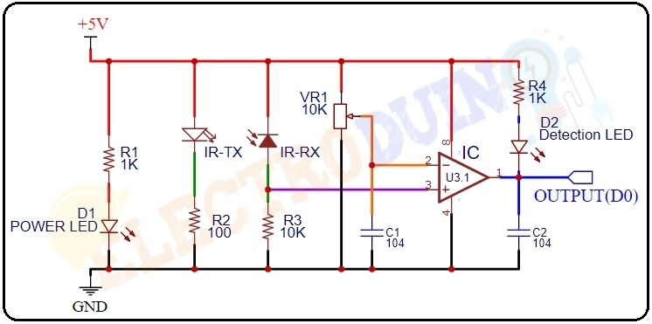

Buy Link

Intensity = 1/d^2
Calibration
Way to protect sensors if crash happens

