UTFPR - Universidade Tecnológica Federal do Paraná

Disciplina – Redes Avançadas

Professor: Kleber Nabas kleber@utfpr.edu.br 99603-1790

**Técnica de Migração – Tunelamento**

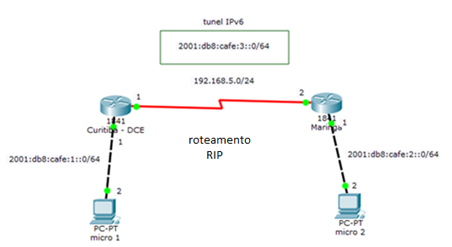

Configuração do Tunel

curitiba# conf term

curitiba(config)#interface tun 0

curitiba(config-if)#ipv6 add 2001:db8:cafe:3::1/64

curitiba(config-if)#tunnel source serial 0/1/0

curitiba(config-if)#tunnel destination 192.168.5.2

curitiba(config-if)#tunnel mode ipv6ip

curitiba(config-if)#ipv6 rip RIPv6 enable

curitiba(config-if)#no shutdown

<CTRL> <Z>

curitiba#wr

maringa#conf term

maringa(config)#interface tun 0

maringa(config-if)#ipv6 add 2001:db8:cafe:3::2/64

maringa(config-if)#tunnel source serial 0/1/0

maringa(config-if)#tunnel destination 192.168.5.1

maringa(config-if)#tunnel mode ipv6ip

maringa(config-if)#ipv6 rip RIPv6 enable

maringa(config-if)#no shutdown

<CTRL> <Z>

maringa#wr

