Monte Carlo Simulation of Coupled Nanocube and Superlattice Tilting
V9.03 samples a 3 x 3 x 3 cluster of 27 Fe3O4 nanocubes at 298.15 K in a 500 G field. Each cube has a center position, a rigid body orientation, and an independent magnetic moment. An MC cycle is a sampling step, not a physical time interval. Metropolis acceptance was used throughout. [1]
Initial structure
The 16 nm model uses the experimental center distance d = 21.0 nm and rhombohedral angle alpha = 74.2 deg. At beta_init = 0, the SL [111] type axis and every cube body [111] axis lie along the laboratory x axis and the field. The magnetic moments are initialized isotropically. Their expected initial value of <|mu_hat dot B_hat|> is 0.5.
Energy model
E_total = E_Z + E_ani + E_dd + E_vdW + E_steric (S1)
E_Z = -m B sum_i (mu_hat_i dot B_hat), m = M_s L^3 (S2)
E_ani = -K V sum_i [(m_x m_y)^2 + (m_x m_z)^2 + (m_y m_z)^2] (S3)
E_dd = (mu_0 m^2 / 4 pi) sum_(i<j) [(mu_hat_i dot mu_hat_j)/r_ij^3 - 3(mu_hat_i dot r_hat_ij)(mu_hat_j dot r_hat_ij)/r_ij^3] (S4)
E_vdW = -(A_H / pi^2) sum_(i<j) sum_(a,b) (Delta V)^2 / |r_ia - r_jb|^6 (S5)
E_steric = (k_stiff / 2) sum_(i<j) max[0, g_0 - g_ij]^2 (S6)
The anisotropy components are evaluated in the cube frame. The van der Waals term uses 4 x 4 x 4 volume elements per cube. A rounded support function gives the surface gap g_ij. The model uses g_0 = 1.8 nm and a rounding radius of 1.5 nm. Ligands are not represented explicitly. The initial minimum surface gap is 1.828 nm.
Monte Carlo sampling
P_accept = min[1, exp(-Delta E / k_B T)] (S7)
Each cycle contains a local mechanical sweep over the 26 noncentral cubes, one global cotilt move, one global body rotation, and 27 dipole moves. Local proposals combine a translation of up to 0.03 nm with a body rotation of up to 2.0 deg. Global cotilt rotates centers and bodies by up to 0.75 deg. Global body rotation is up to 2.0 deg. Dipole rotation is up to 0.30 rad. MOVE_POSITIONS and MOVE_ORIENTATIONS are both True.
The full run uses 2000 cycles, discards the first 500 cycles, and uses seed 1. The initial dipoles are random. The anisotropy model is cubic_first_raw.
Tilt metrics
PCA is applied to all cube centers. The position tensor is
C = sum_i (r_i - r_bar)(r_i - r_bar)^T (S8)
theta_SL = acos(|p_1 dot B_hat|), S_PCA = (lambda_1 - lambda_2)/(lambda_1 + lambda_2 + lambda_3) (S9)
Here p_1 is the eigenvector of the largest eigenvalue. S_PCA measures the shape anisotropy of the finite center cloud. Its initial value is about 0.272 and is not an ordered fraction.
u_bar = N^-1 sum_i u_i, theta_body = acos(|u_bar_hat dot B_hat|), S_body = |u_bar| (S10)
beta_local = N^-1 sum_i acos(u_i dot B_hat) (S11)
Delta_body_to_SL = acos(|u_bar_hat dot p_1|) (S12)
u_i is the cube body [111] axis in laboratory coordinates. Mean local beta is the mean cube body angle relative to the field. It is not a dipole angle. PCA is retained as the SL metric because it gives one global axis without a neighbor cutoff. The nearest neighbor bond metric was removed.
Parameter sources
Experimental inputs are L = 16.0 nm, d = 21.0 nm, alpha = 74.2 deg, B = 0.05 T, T = 298.15 K, and M_s = 2.85 x 10^5 A m^-1. M_s is taken from the present 300 K magnetometry.
The model uses K = 2.0 x 10^4 J m^-3. This is a literature scale value rather than a measurement on the present particles. Bulk magnetite values and their composition dependence are reported in Refs. 2 and 3. The Hamaker constant A_H = 2.0 x 10^-20 J lies within the 9 to 29 zJ range reported for iron oxides in nonpolar media. [4]
The voxel grid, gap threshold, steric stiffness, rounding radius, move sizes, cycle count, equilibration length, and random seed are numerical inputs. The rounding radius should be replaced by a TEM value when available.
Results
The experiment shows coupled cube body and SL tilting, but no independent tilt angle was supplied. The simulated mean body and SL tilts are 4.98 and 4.87 deg for cycles 500 to 1999. The final values are 6.61 and 6.78 deg. The mean body to SL mismatch is 0.72 deg and the final mismatch is 0.81 deg.
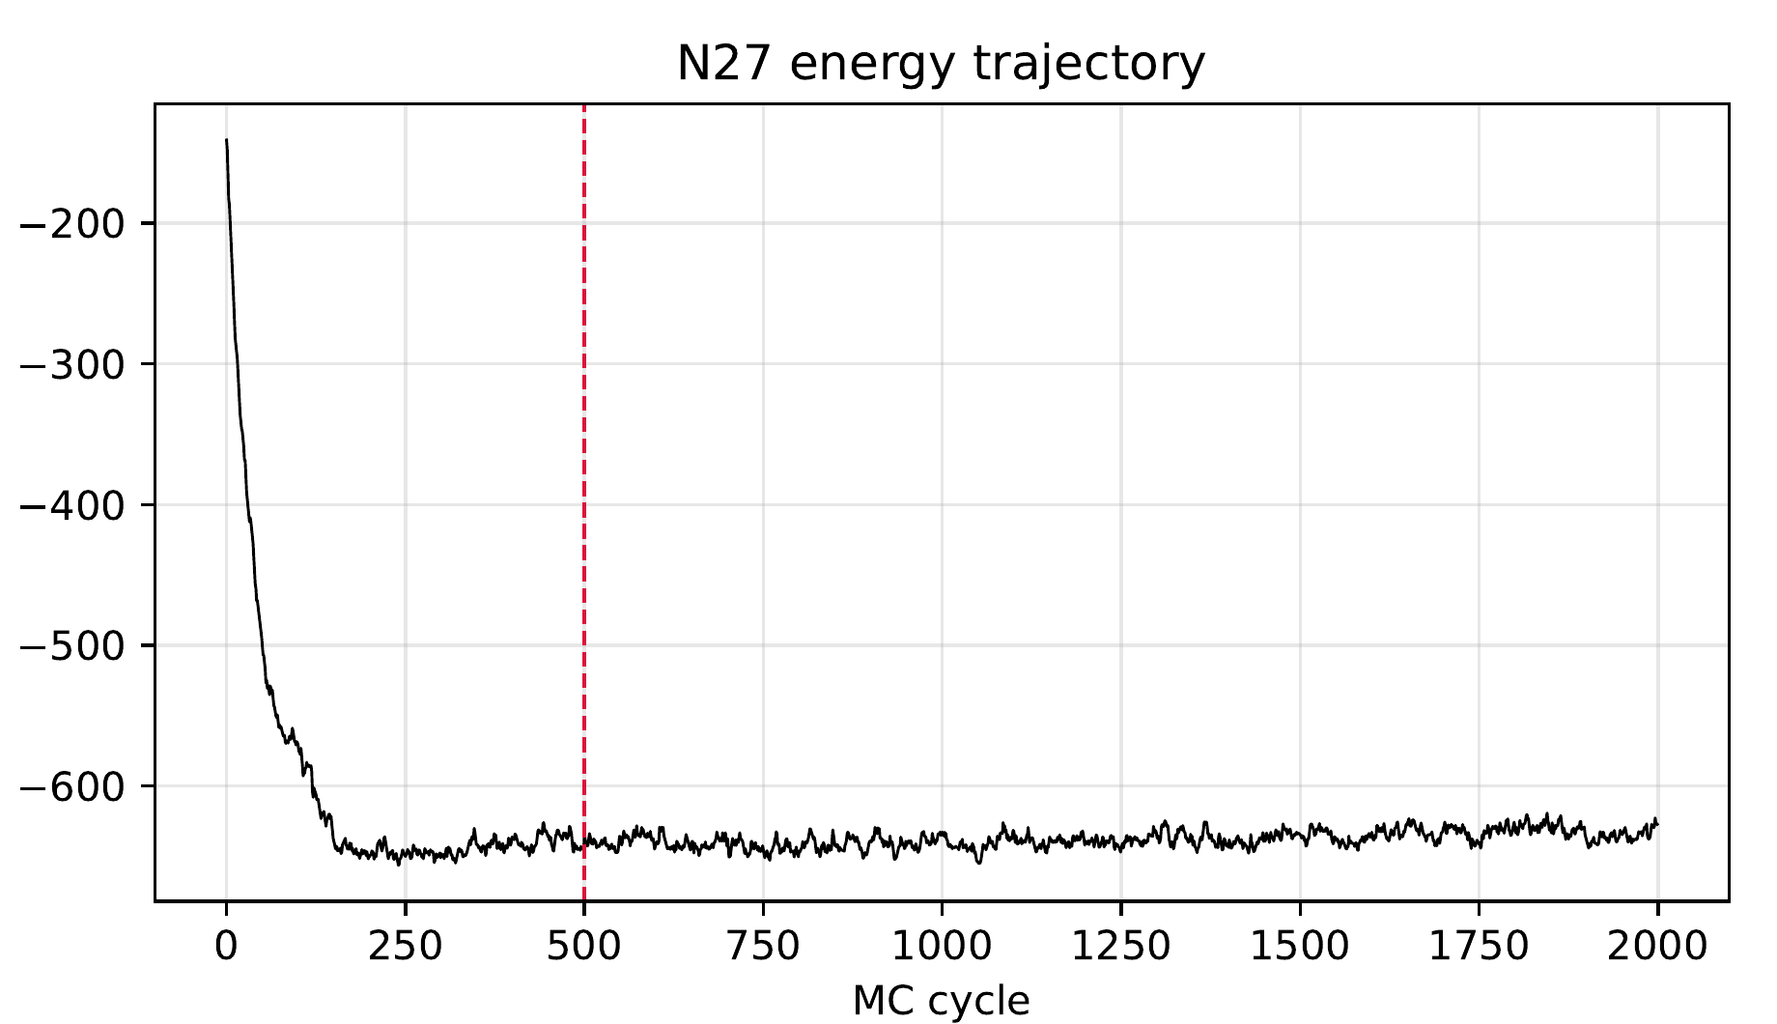
Figure S1. Total cluster energy for the 16 nm run. The red line marks cycle 500.
The energy reaches a plateau before the averaging window. The mean from cycles 500 to 1999 is -637.8 k_B T.
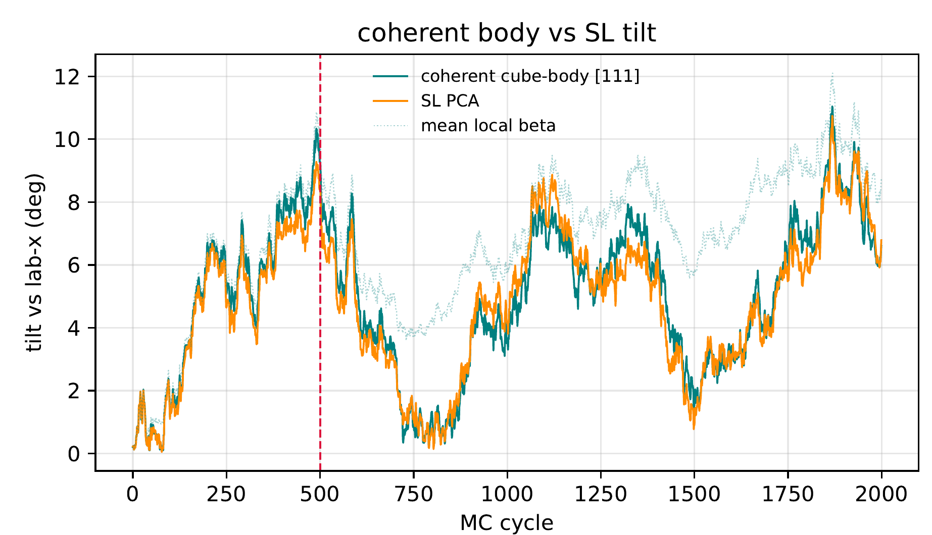
Figure S2. Cube body [111] tilt, SL PCA tilt, and mean local beta. All angles are relative to the field.
The body and SL curves remain close over the full trajectory. Mean local beta is larger because it includes the spread of individual cube axes. Slow tilt fluctuations remain after the energy has stabilized.
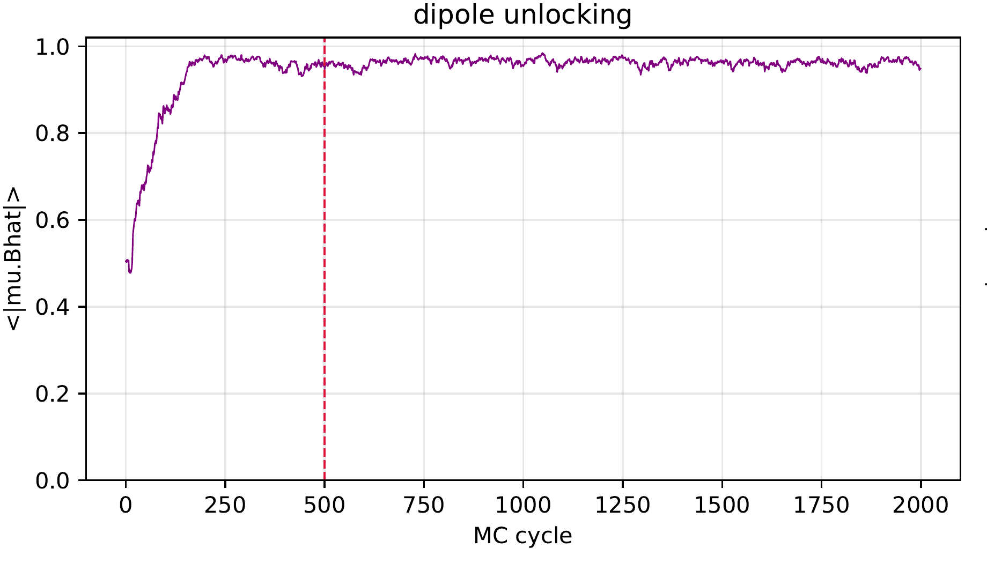
Figure S3. Mean absolute dipole projection on the field.
The projection starts near 0.5 for random moments and rises to an equilibrium mean of 0.963. The moments are strongly field aligned during the averaging window.
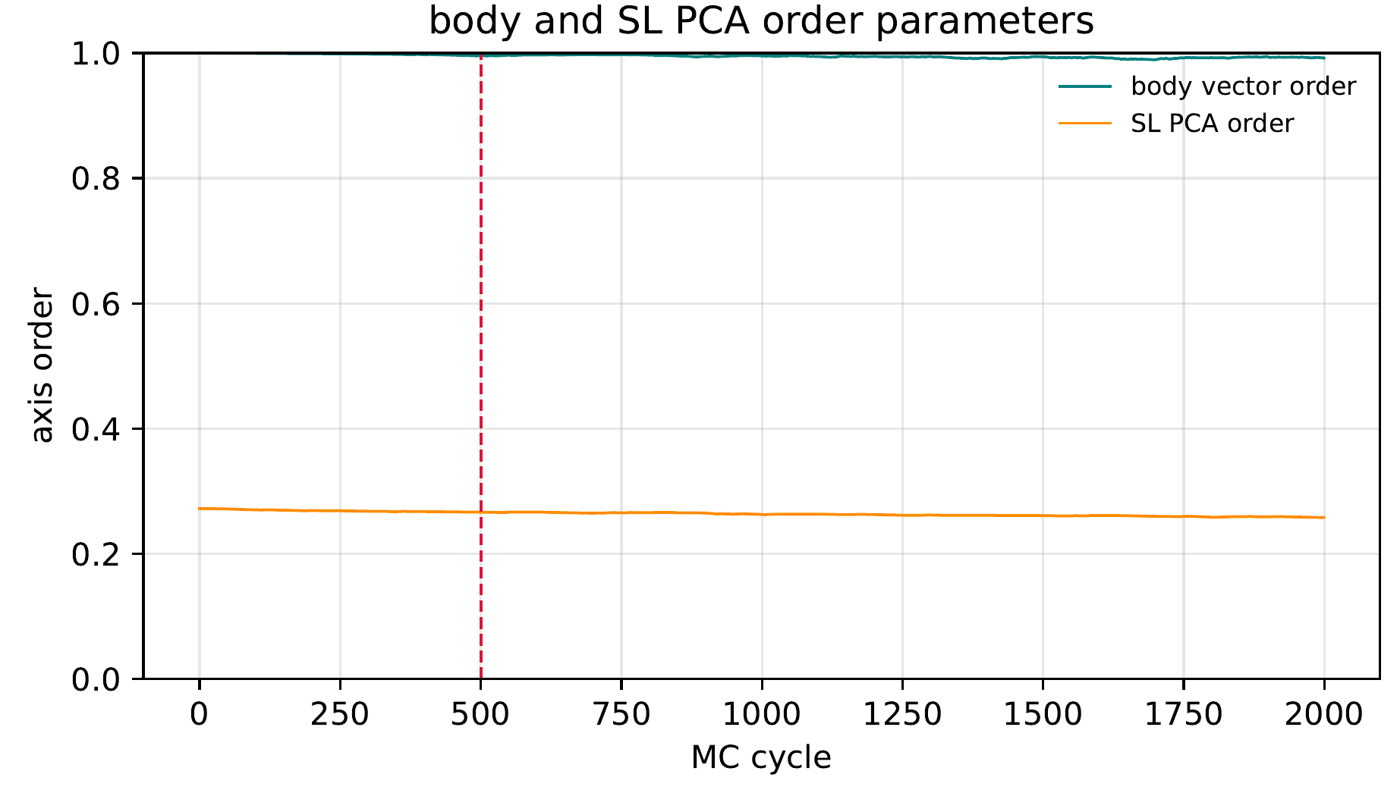
Figure S4. Cube body vector order and SL PCA order.
The body order remains near 1. The SL PCA order remains near 0.27, close to the value of the initial finite rhombohedral cluster. It does not represent 27 percent ordering.
Scope
This single seed run establishes coupled body and SL motion. The tilt has a longer correlation time than the energy. Longer runs and several seeds are required for a statistical uncertainty.
References
1. Metropolis, N., Rosenbluth, A. W., Rosenbluth, M. N., Teller, A. H., Teller, E. Equation of State Calculations by Fast Computing Machines. J. Chem. Phys. 1953, 21, 1087-1092. https://doi.org/10.1063/1.1699114.
2. Bickford, L. R., Jr. Ferromagnetic Resonance Absorption in Magnetite Single Crystals. Phys. Rev. 1950, 78, 449-457. https://doi.org/10.1103/PhysRev.78.449.
3. Aragon, R. Cubic Magnetic Anisotropy of Nonstoichiometric Magnetite. Phys. Rev. B 1992, 46, 5334-5338. https://doi.org/10.1103/PhysRevB.46.5334.
4. Faure, B., Salazar-Alvarez, G., Bergstrom, L. Hamaker Constants of Iron Oxide Nanoparticles. Langmuir 2011, 27, 8659-8664. https://doi.org/10.1021/la201387d.

