**Group Project One**

**Assigned: February 7th, 2023**

**Upload to Assignment Folder (in Week 5); only ONE person needs to submit**

**NOTE: Compress Python program(s), PPT, and all other artifacts created, and upload to folder.**

**Assignment:**

Your group is working on behalf of Forestview to create a proposal / “mock” application. This application deals with data storage. It will allow the user to use Python to add, store, and retrieve data (see project detail). This is part of Forestview’s upcoming SafeZone© proposals to key customers, such as Dell EMC.

The group’s responsibilities are the following:

* Front End
* Application Coding
* Coding Compliance
* Presentation
* Written (including technical documentation)

**Requirements:**

1. **Front End**

* + Markup language: HTML5 (CSS/ bootstrap style tags optional)
  + A “homepage,” with three or four web links at the top; the next line is your team’s name, and any other pertinent information (i.e. team logo, memes)
  + Each page/link represents ONE of your group projects for the semester
  + The first webpage (or first link) is a link to this week’s “product,” as well as pertinent technical information
  + **See “sample webpage” and sample directory hierarchy**

**2. Application Coding**

* The app must store, collect, and search data sets collected from pre-existing .csv files (or equivalent) - example: Northwind’s ‘orders’ and ‘order detail’ files. The external file is to be collected, retrieved, and stored NON-perpetually. New data is able to be added (appended) and deleted.
* A graphical UI must be included (tkinter).
* Storage solutions to include lists, strings, and dictionaries
* Storage solutions must be robust. For example, an employee database, at minimum, should track name, position, SSN, home address, email, phone numbers, skills and have a unique identifier.
* Fields such as SSN, email, orders numbers, product ID numbers, and phone numbers must be in a PROPER format
* Application to be packaged and transmitted as a “.exe” using ‘pyinstaller’
* Coding must utilize “doc strings” / pydoc throughout program
* Comments are appropriate and explanatory; contain necessary information
* Code can’t be executed if imported (see Detail - last page)
* See “proposed coding tasks and task sequence” for *detailed* requirements.

**3. Coding Compliance**

* + Code to be checked with Pylint (or equivalent)
  + User input to be filtered for special characters
  + Use must comply with a user agreement as a condition to the downloading of the application
  + Within the user agreement, the following must be addressed: data privacy, application sharing, and other appropriate language (eg.. “user may not sell or distribute data without the express consent of Forestview….”)
  + Important: you must also provide a unilateral indemnity clause, precluding Forestview from legal ramifications for things such as data breaches, zero-day attacks, and database worms, such as SQL injection.
  + Include language indicating periodic vulnerability assessments against your system, and that you also demand said preventive actions from all your key vendors
  + State that requirements will change over time, as technology and the overall security landscape changes

**4. Presentation**

* + LIVE - Tuesday February 28th, 2023 during class time, either in person or on ZOOM.
  + A demonstration must be provided, showing the adding of at least 50-1000 records
  + This demonstration must include attempts to add so-called “forbidden” characters (“#$%^…..)
  + Technical instructions to be included ON THE application homepage
  + Offer delivery options (eg. “we are working on a CLOUD implementation….”)
  + See “sample webpage” and sample directory hierarchy

**5. Written (including technical documentation)**

* State your case!! Why should YOUR TEAM be chosen?
* Format is Times New Roman, 12 point, double spaced
* Include similar technical documentation from the website
* Include hosting quote in various platforms, such as AWS
* Include future recommendations
* APA references

**End of Requirements – these are MINIMAL requirements; rest of details up to the Group.**

**Appendix A**

**SAMPLE HOME PAGE**

|  | **Note: IP address will be your loopback 127.0.0.1** |
| --- | --- |
|  |
| **<-Your company logo here** |
| **<-Footer should state the date, company address** |

**Note: made with VS Code Snippets 5 from Coder Foundry**

**Appendix B**

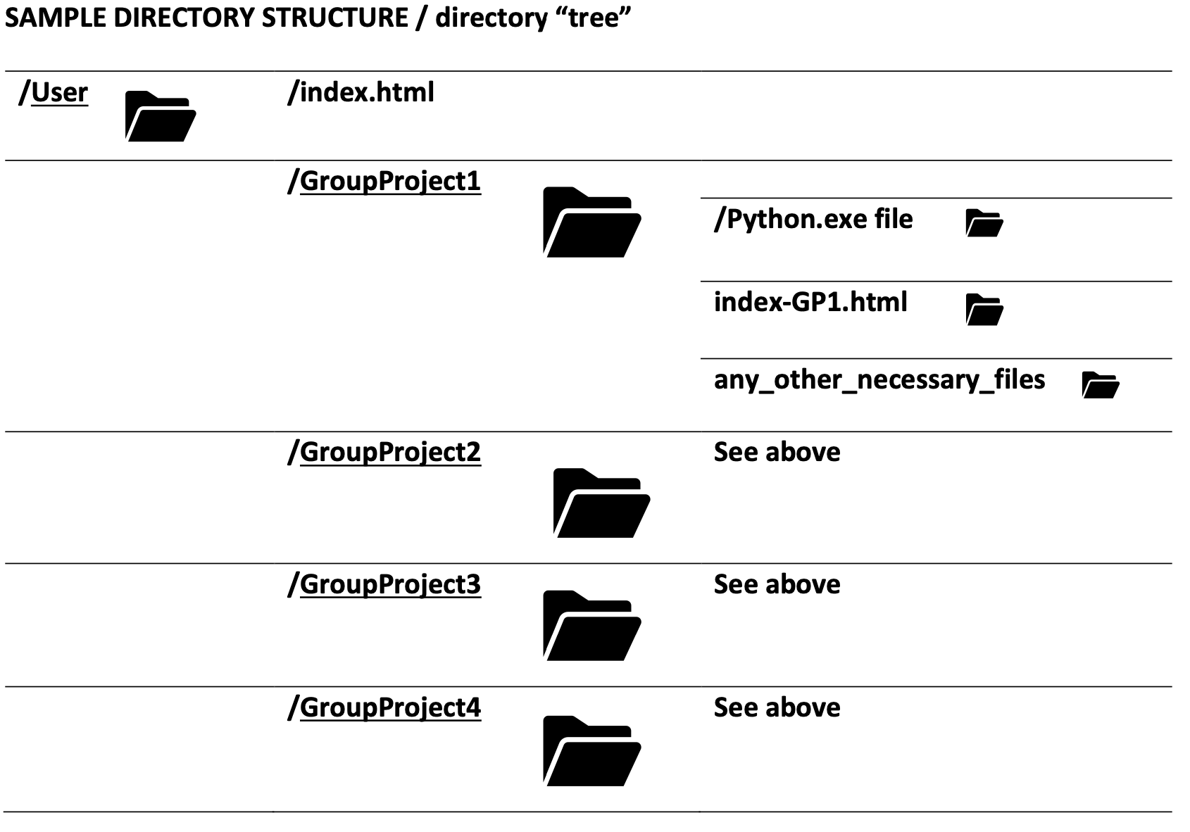

**Appendix C**

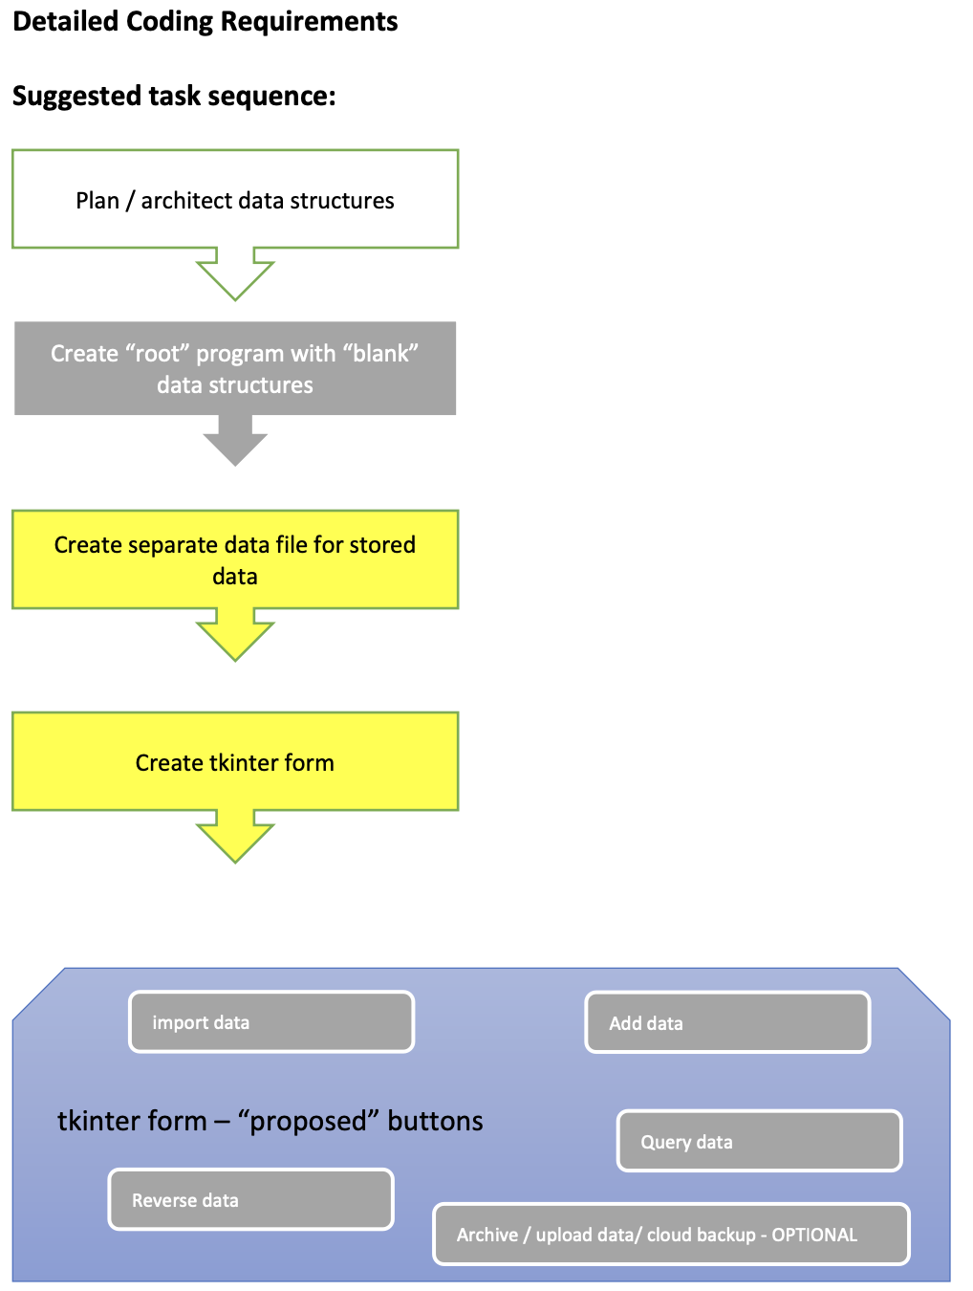

· **Proposed bare minimum**

**Hint: the less images you have the more chance that your program will compile into a “.exe file.”**

Grading Rubric

| 1 | Front End | Meet Requirements | /25 |
| --- | --- | --- | --- |
| 2 | Application Coding | Meet Requirements | /25 |
| 3 | Coding Compliance | Meet Requirements | /25 |
| 4 | Presentation | Meet Requirements | /25 |
| 5 | Written | Meet Requirements | /25 |

Total: 125 points

