**Fragestellung:这是我们提出的问题，怀孕期间母亲体重增长与儿童健康的关系**

Auswirkungen der mütterlichen Gewichtszunahme in der Schwangerschaft auf die Gesundheit des Babys

（Is there a correlation between maternal weight gain during pregnancy and child health status？

Does gaining weight of the mother during pregnancy influence the babys health? ）

**Auswertungsplanung:**

**confounder** is school degree of both parents and income

**这里是我同学提出的分析计划，我表示怀疑。**

Subjektiver Gesundheitszustand共有五个数值1，2，3，4，5，但是不知道分别代表的什么。能先帮我看看这个分析计划可以进行吗？或者说，帮我们根据这个问题改进一下分析方案。我认为应该分析Gewichtszunahme in Schwangerschaft (kg)与Probleme nach Geburt的关系。

1. First Regression: 1-sided Regression with dependence variable Subjektiver Gesundheitszustand （e019）and independence variable: Probleme nach Geburt （e018）

Sklavenniveau berücksichtigen? Because dependence variable is ordinal we need to do an ordinal regression?

1. Second Regression -> After we found a significant correlation with all the specific and detailed variables of problems after birth and maybe more

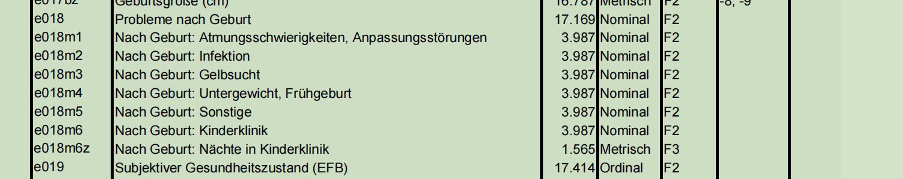

E018后面的这些变量，是她指的，接下来要分析的。

Adjust for: age of child (altkind), sex of child (sex), education of mother, household income and Ost/West geografisch（OW）

Missings: we cannot use any father variables because the father is missing in general, so we need to find another variables or leave it like that and 6.1% as missing percentage of household income is not dramatic as a missing value -> so we do not need to do anything about the missings

Information about regression and power from last meeting:

1-tailed, final n = 340, OR: 2, alpha = 0.001