МИНИСТЕРСТВО НАУКИ И ВЫСШЕГО ОБРАЗОВАНИЯ РОССИЙСКОЙ
ФЕДЕРАЦИИ
ФЕДЕРАЛЬНОЕ ГОСУДАРСТВЕННОЕ БЮДЖЕТНОЕ ОБРАЗОВАТЕЛЬНОЕ
УЧРЕЖДЕНИЕ ВЫСШЕГО ОБРАЗОВАНИЯ
«БЕЛГОРОДСКИЙ ГОСУДАРСТВЕННЫЙ ТЕХНОЛОГИЧЕСКИЙ
УНИВЕРСИТЕТ им. В. Г. ШУХОВА» (БГТУ им. В.Г. Шухова)
Кафедра программного обеспечения
вычислительной техники и автоматизированных
систем

Курсовая работа
по дисциплине: БД
тема: «Разработка веб-приложения для управления и учета оборудования»

Выполнил: студент группы ВТ-231
Ковалев А. В.
Проверили:
Панченко М. В.

Белгород 2025
Цель курсовой работы
Проектирование и разработка информационной системы для автоматизации учета оборудования, включающая создание реляционной базы данных, реализацию интерфейса взаимодействия с БД и обеспечение целостности данных средствами ORM.
Основные задачи:
- Проектирование инфологической и даталогической моделей предметной области.
- Реализация операций манипулирования данными (CRUD) для всех сущностей.Обеспечение ссылочной целостности и нормализация базы данных (3НФ).
- Настройка автоматизированного резервного копирования данных.
Стек технологий и инструменты
- Язык программирования: Python
- СУБД: PostgreSQL.
- Фреймворк для работы с БД: Django
- Управление схемой БД: Django Migrations.
- ORM: Django ORM.
Схема базы данных (ER-диаграмма)
Разработанная база данных находится в третьей нормальной форме (3НФ) и состоит из 15 сущностей. Логическая схема связей представлена на рисунке ниже:
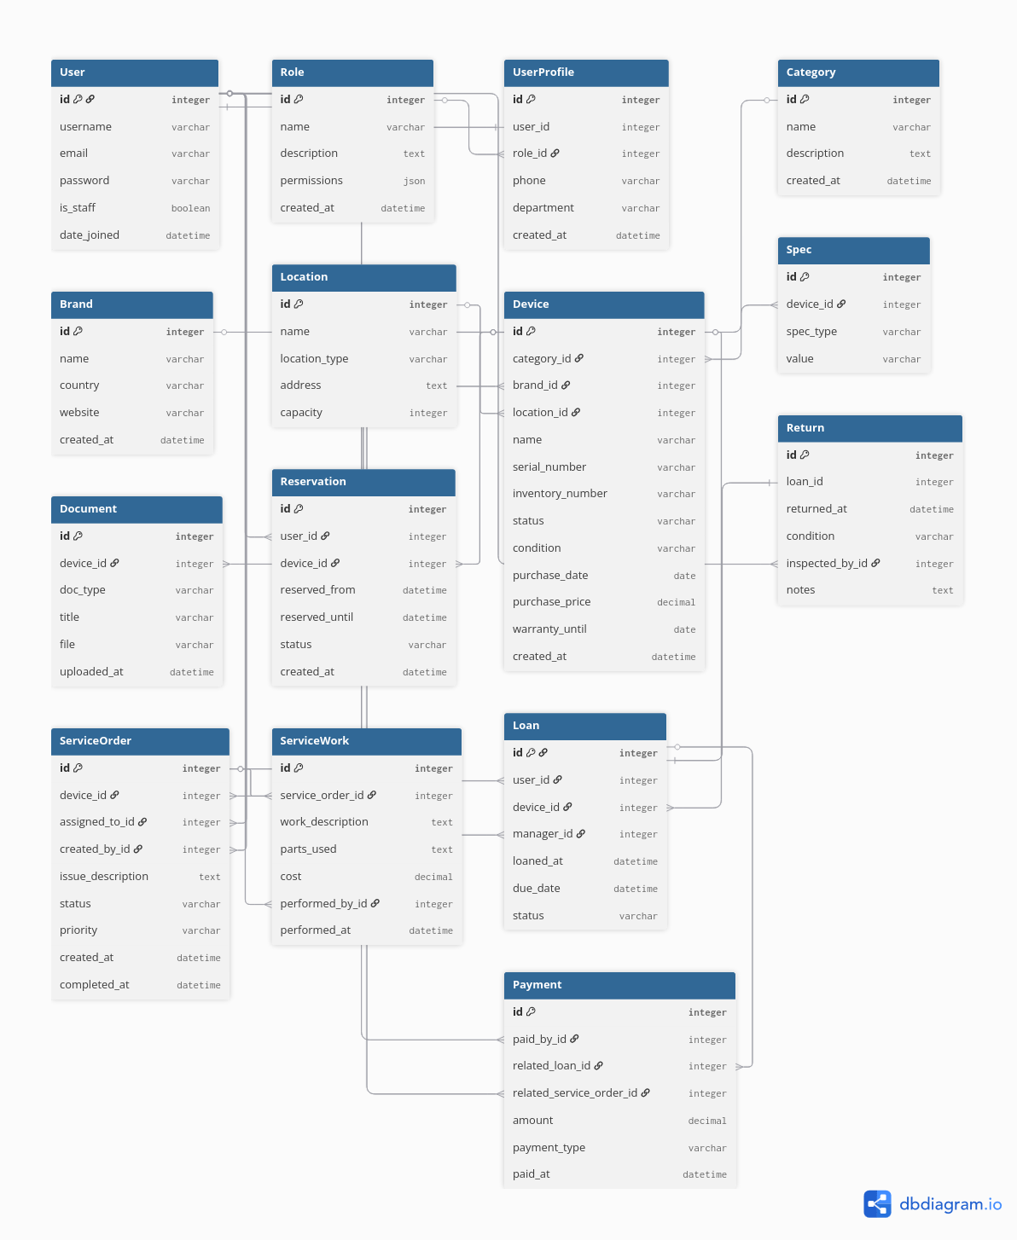
Репозиторий с проектом: https://github.com/ZeiKei9/course_work_device_management
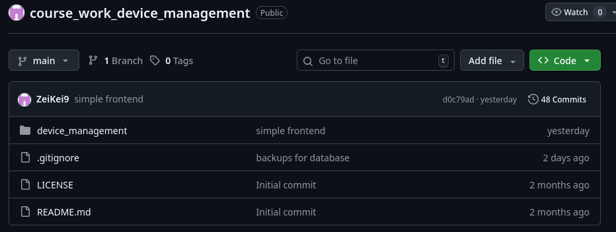
Реализация экспорта данных
В соответствии с заданием реализован механизм выгрузки данных из базы в три формата: CSV, XLSX (Excel), JSON.
1) Для формата CSV используется ввстроенная библиотека csv
2) Для формата XLSX используется библиотека openpyxl
3) Для формата JSON используется одноименная библиотека и встроенные в джанго сериализаторы
Автоматизированное резервное копирование (Backup)
Для обеспечения сохранности данных реализована подсистема автоматического создания резервных копий базы данных PostgreSQL.
Механизм работы:
- Инструмент: Используется утилита pg_dump, запускаемая через системный вызов (subprocess) внутри Django management command. Т. е. мы вызываем из терминала python manage.py backup_db и у нас автоматически делается бекап
- Автоматизация: Скрипт auto_backup.py может быть добавлен в cron (планировщик задач) для ежедневного выполнения.
Хранение:
В соответствии с требованием размещения копии на удаленном компьютере, система настроена на сохранение файлов в директорию /backups.
Документирование
Так же в течении всего цикла разработки моей системы я активно использовал Swagger UI — интерактивную документацию для проверки работоспособности моих эндпоинтов

Листинг программного кода

1. Файлы конфигурации проекта
Файл: manage.py
#!/usr/bin/env python
"""Django's command-line utility for administrative tasks."""
import os
import sys

if __name__ == '__main__':
os.environ.setdefault('DJANGO_SETTINGS_MODULE', 'device_management.settings')
try:
from django.core.management import execute_from_command_line
except ImportError as exc:
raise ImportError(
"Couldn't import Django. Are you sure it's installed and "
"available on your PYTHONPATH environment variable? Did you "
"forget to activate a virtual environment?"
) from exc
execute_from_command_line(sys.argv)

Файл: device_management/settings.py
import os
from datetime import timedelta
from pathlib import Path

from decouple import config

BASE_DIR = Path(__file__).resolve().parent.parent
SECRET_KEY = config("SECRET_KEY")
DEBUG = config("DEBUG", default=False, cast=bool)

ALLOWED_HOSTS = []

INSTALLED_APPS = [
"django.contrib.admin",
"django.contrib.auth",
"django.contrib.contenttypes",
"django.contrib.sessions",
"django.contrib.messages",
"django.contrib.staticfiles",
"django.contrib.sites",
"rest_framework",
"rest_framework.authtoken",
"corsheaders",
"allauth",
"allauth.account",
"allauth.socialaccount",
"django_filters",
"drf_spectacular",
"dbbackup",
"devices",
"users",
"services",
]

SITE_ID = 1

MIDDLEWARE = [
"corsheaders.middleware.CorsMiddleware",
"django.middleware.security.SecurityMiddleware",
"django.contrib.sessions.middleware.SessionMiddleware",
"django.middleware.common.CommonMiddleware",
"django.middleware.csrf.CsrfViewMiddleware",
"django.contrib.auth.middleware.AuthenticationMiddleware",
"allauth.account.middleware.AccountMiddleware",
"django.contrib.messages.middleware.MessageMiddleware",
"django.middleware.clickjacking.XFrameOptionsMiddleware",
]

ROOT_URLCONF = "device_management.urls"

TEMPLATES = [
{
"BACKEND": "django.template.backends.django.DjangoTemplates",
"DIRS": [BASE_DIR / "templates"],
"APP_DIRS": True,
"OPTIONS": {
"context_processors": [
"django.template.context_processors.debug",
"django.template.context_processors.request",
"django.contrib.auth.context_processors.auth",
"django.contrib.messages.context_processors.messages",
],
},
},
]

STATIC_URL = "/static/"
STATICFILES_DIRS = [BASE_DIR / "static"]
STATIC_ROOT = BASE_DIR / "staticfiles"

WSGI_APPLICATION = "device_management.wsgi.application"

DATABASES = {
"default": {
"ENGINE": "django.db.backends.postgresql",
"NAME": config("DB_NAME"),
"USER": config("DB_USER"),
"PASSWORD": config("DB_PASSWORD"),
"HOST": config("DB_HOST", default="localhost"),
"PORT": config("DB_PORT", default="5432"),
}
}

AUTH_PASSWORD_VALIDATORS = [
{
"NAME": "django.contrib.auth.password_validation.UserAttributeSimilarityValidator",
},
{
"NAME": "django.contrib.auth.password_validation.MinimumLengthValidator",
},
{
"NAME": "django.contrib.auth.password_validation.CommonPasswordValidator",
},
{
"NAME": "django.contrib.auth.password_validation.NumericPasswordValidator",
},
]

LANGUAGE_CODE = "en-us"

TIME_ZONE = "UTC"

USE_I18N = True

USE_TZ = True

DEFAULT_AUTO_FIELD = "django.db.models.BigAutoField"

REST_FRAMEWORK = {
"DEFAULT_AUTHENTICATION_CLASSES": [
"rest_framework_simplejwt.authentication.JWTAuthentication",
"rest_framework.authentication.SessionAuthentication",
],
"DEFAULT_PERMISSION_CLASSES": [
"rest_framework.permissions.IsAuthenticatedOrReadOnly",
],
"DEFAULT_PAGINATION_CLASS": "rest_framework.pagination.PageNumberPagination",
"PAGE_SIZE": 20,
"DEFAULT_RENDERER_CLASSES": [
"rest_framework.renderers.JSONRenderer",
"rest_framework.renderers.BrowsableAPIRenderer",
],
"DEFAULT_SCHEMA_CLASS": "drf_spectacular.openapi.AutoSchema",
}

CORS_ALLOWED_ORIGINS = [
"http://localhost:3000",
"http://127.0.0.1:3000",
]

CORS_ALLOW_CREDENTIALS = True

SIMPLE_JWT = {
"ACCESS_TOKEN_LIFETIME": timedelta(hours=5),
"REFRESH_TOKEN_LIFETIME": timedelta(days=1),
"ROTATE_REFRESH_TOKENS": False,
"BLACKLIST_AFTER_ROTATION": True,
"ALGORITHM": "HS256",
"SIGNING_KEY": SECRET_KEY,
"AUTH_HEADER_TYPES": ("Bearer",),
}

AUTHENTICATION_BACKENDS = [
"django.contrib.auth.backends.ModelBackend",
"allauth.account.auth_backends.AuthenticationBackend",
]

ACCOUNT_LOGIN_METHODS = {"username"}
ACCOUNT_SIGNUP_FIELDS = ["email", "username*", "password1*", "password2*"]

MEDIA_URL = "/media/"
MEDIA_ROOT = BASE_DIR / "media"

SPECTACULAR_SETTINGS = {
"TITLE": "Device Management System API",
"DESCRIPTION": "API для системы учёта техники",
"VERSION": "1.0.0",
"SERVE_INCLUDE_SCHEMA": False,
"COMPONENT_SPLIT_REQUEST": True,
}

DBBACKUP_STORAGE = "django.core.files.storage.FileSystemStorage"
DBBACKUP_STORAGE_OPTIONS = {"location": BASE_DIR / "backups"}

DBBACKUP_DATABASES = ["default"]

DBBACKUP_CLEANUP_KEEP = 10
DBBACKUP_CLEANUP_KEEP_MEDIA = 10

DBBACKUP_FILENAME_TEMPLATE = "backup_{databasename}_{datetime}.{extension}"
DBBACKUP_MEDIA_FILENAME_TEMPLATE = "media_{datetime}.{extension}"

Файл: device_management/urls.py
from devices.template_views import device_catalog_view, home_view
from django.conf import settings
from django.conf.urls.static import static
from django.contrib import admin
from django.urls import include, path
from drf_spectacular.views import (
SpectacularAPIView,
SpectacularRedocView,
SpectacularSwaggerView,
)
from rest_framework_simplejwt.views import TokenObtainPairView, TokenRefreshView

urlpatterns = [
path("", home_view, name="home"),
path("catalog/", device_catalog_view, name="device_catalog"),
path("admin/", admin.site.urls),
path("api/token/", TokenObtainPairView.as_view(), name="token_obtain_pair"),
path("api/token/refresh/", TokenRefreshView.as_view(), name="token_refresh"),
path("api/auth/", include("allauth.urls")),
path("api/", include("devices.urls")),
path("api/", include("users.urls")),
path("api/", include("services.urls")),
path("api/schema/", SpectacularAPIView.as_view(), name="schema"),
path(
"api/docs/",
SpectacularSwaggerView.as_view(url_name="schema"),
name="swagger-ui",
),
path("api/redoc/", SpectacularRedocView.as_view(url_name="schema"), name="redoc"),
]

if settings.DEBUG:
urlpatterns += static(settings.MEDIA_URL, document_root=settings.MEDIA_ROOT)

Файл: device_management/asgi.py
import os
from django.core.asgi import get_asgi_application

os.environ.setdefault('DJANGO_SETTINGS_MODULE', 'device_management.settings')
application = get_asgi_application()

Файл: device_management/wsgi.py
import os
from django.core.wsgi import get_wsgi_application

os.environ.setdefault('DJANGO_SETTINGS_MODULE', 'device_management.settings')
application = get_wsgi_application()

2. Приложение Devices (Ядро системы)
Файл: devices/admin.py
from django.contrib import admin
from .models import (
Category,
Brand,
Location,
Device,
Spec,
Document,
Reservation,
Loan,
Return,
)

@admin.register(Category)
class CategoryAdmin(admin.ModelAdmin):
list_display = ["name", "created_at", "updated_at"]
search_fields = ["name", "description"]
list_filter = ["created_at"]

@admin.register(Brand)
class BrandAdmin(admin.ModelAdmin):
list_display = ["name", "country", "website", "created_at"]
search_fields = ["name", "country"]
list_filter = ["country", "created_at"]

@admin.register(Location)
class LocationAdmin(admin.ModelAdmin):
list_display = ["name", "location_type", "capacity", "created_at"]
search_fields = ["name", "address"]
list_filter = ["location_type", "created_at"]

@admin.register(Device)
class DeviceAdmin(admin.ModelAdmin):
list_display = [
"name",
"serial_number",
"category",
"brand",
"status",
"condition",
"location",
"created_at",
]
search_fields = ["name", "serial_number", "inventory_number"]
list_filter = ["status", "condition", "category", "brand", "created_at"]
readonly_fields = ["created_at", "updated_at"]
fieldsets = [
(
"Basic Information",
{
"fields": [
"name",
"serial_number",
"inventory_number",
"category",
"brand",
]
},
),
("Status", {"fields": ["status", "condition", "location"]}),
(
"Purchase Information",
{"fields": ["purchase_date", "purchase_price", "warranty_until"]},
),
("Additional", {"fields": ["notes", "created_at", "updated_at"]}),
]

@admin.register(Spec)
class SpecAdmin(admin.ModelAdmin):
list_display = ["device", "spec_type", "value", "created_at"]
search_fields = ["device__name", "value"]
list_filter = ["spec_type", "created_at"]

@admin.register(Document)
class DocumentAdmin(admin.ModelAdmin):
list_display = ["device", "doc_type", "title", "uploaded_at"]
search_fields = ["device__name", "title"]
list_filter = ["doc_type", "uploaded_at"]

@admin.register(Reservation)
class ReservationAdmin(admin.ModelAdmin):
list_display = [
"user",
"device",
"reserved_from",
"reserved_until",
"status",
"created_at",
]
search_fields = ["user__username", "device__name"]
list_filter = ["status", "created_at"]
readonly_fields = ["created_at", "updated_at"]

@admin.register(Loan)
class LoanAdmin(admin.ModelAdmin):
list_display = ["user", "device", "manager", "loaned_at", "due_date", "status"]
search_fields = ["user__username", "device__name", "manager__username"]
list_filter = ["status", "loaned_at"]
readonly_fields = ["loaned_at", "created_at", "updated_at"]

@admin.register(Return)
class ReturnAdmin(admin.ModelAdmin):
list_display = ["loan", "returned_at", "condition", "inspected_by"]
search_fields = ["loan__user__username", "loan__device__name"]
list_filter = ["condition", "returned_at"]
readonly_fields = ["returned_at", "created_at"]

Файл: devices/apps.py
from django.apps import AppConfig

class DevicesConfig(AppConfig):
default_auto_field = "django.db.models.BigAutoField"
name = "devices"

def ready(self):
import devices.signals

Файл: devices/models.py

from django.db import models
from django.contrib.auth.models import User

class Category(models.Model):
name = models.CharField(max_length=100, unique=True)
description = models.TextField(blank=True, null=True)
created_at = models.DateTimeField(auto_now_add=True)
updated_at = models.DateTimeField(auto_now=True)

class Meta:
verbose_name = "Category"
verbose_name_plural = "Categories"
ordering = ["name"]

def __str__(self):
return self.name

class Brand(models.Model):
name = models.CharField(max_length=100, unique=True)
country = models.CharField(max_length=100, blank=True, null=True)
website = models.URLField(blank=True, null=True)
created_at = models.DateTimeField(auto_now_add=True)
updated_at = models.DateTimeField(auto_now=True)

class Meta:
verbose_name = "Brand"
verbose_name_plural = "Brands"
ordering = ["name"]

def __str__(self):
return self.name

class Location(models.Model):
LOCATION_TYPES = [
("WAREHOUSE", "Warehouse"),
("OFFICE", "Office"),
("STORAGE", "Storage"),
]

name = models.CharField(max_length=100)
location_type = models.CharField(
max_length=20, choices=LOCATION_TYPES, default="WAREHOUSE"
)
address = models.TextField(blank=True, null=True)
capacity = models.IntegerField(default=0)
created_at = models.DateTimeField(auto_now_add=True)
updated_at = models.DateTimeField(auto_now=True)

class Meta:
verbose_name = "Location"
verbose_name_plural = "Locations"
ordering = ["name"]

def __str__(self):
return f"{self.name} ({self.get_location_type_display()})"

class Device(models.Model):
STATUS_CHOICES = [
("AVAILABLE", "Available"),
("RESERVED", "Reserved"),
("LOANED", "Loaned"),
("IN_SERVICE", "In Service"),
("RETIRED", "Retired"),
]

CONDITION_CHOICES = [
("EXCELLENT", "Excellent"),
("GOOD", "Good"),
("FAIR", "Fair"),
("POOR", "Poor"),
]

name = models.CharField(max_length=200)
serial_number = models.CharField(max_length=100, unique=True)
inventory_number = models.CharField(max_length=100, unique=True)
category = models.ForeignKey(
Category, on_delete=models.PROTECT, related_name="devices"
)
brand = models.ForeignKey(Brand, on_delete=models.PROTECT, related_name="devices")
location = models.ForeignKey(
Location,
on_delete=models.SET_NULL,
null=True,
blank=True,
related_name="devices",
)
status = models.CharField(
max_length=20, choices=STATUS_CHOICES, default="AVAILABLE"
)
purchase_date = models.DateField(null=True, blank=True)
purchase_price = models.DecimalField(
max_digits=10, decimal_places=2, null=True, blank=True
)
warranty_until = models.DateField(null=True, blank=True)
condition = models.CharField(
max_length=20, choices=CONDITION_CHOICES, default="GOOD"
)
notes = models.TextField(blank=True, null=True)
created_at = models.DateTimeField(auto_now_add=True)
updated_at = models.DateTimeField(auto_now=True)

class Meta:
verbose_name = "Device"
verbose_name_plural = "Devices"
ordering = ["-created_at"]

def __str__(self):
return f"{self.name} ({self.serial_number})"

def is_available(self):
return self.status == "AVAILABLE"

def get_specifications(self):
return self.specifications.all()

def get_full_name(self):
return f"{self.brand.name} {self.name}"

class Spec(models.Model):
SPEC_TYPE_CHOICES = [
("CPU", "Processor"),
("RAM", "RAM"),
("STORAGE", "Storage"),
("SCREEN", "Screen Size"),
("COLOR", "Color"),
("OS", "Operating System"),
("OTHER", "Other"),
]

device = models.ForeignKey(
Device, on_delete=models.CASCADE, related_name="specifications"
)
spec_type = models.CharField(max_length=20, choices=SPEC_TYPE_CHOICES)
value = models.CharField(max_length=200)
created_at = models.DateTimeField(auto_now_add=True)

class Meta:
verbose_name = "Specification"
verbose_name_plural = "Specifications"
ordering = ["spec_type"]

def __str__(self):
return f"{self.device.name} - {self.get_spec_type_display()}: {self.value}"

class Document(models.Model):
DOC_TYPE_CHOICES = [
("MANUAL", "Manual"),
("WARRANTY", "Warranty"),
("RECEIPT", "Receipt"),
("CONTRACT", "Contract"),
("OTHER", "Other"),
]

device = models.ForeignKey(
Device, on_delete=models.CASCADE, related_name="documents"
)
doc_type = models.CharField(max_length=20, choices=DOC_TYPE_CHOICES)
title = models.CharField(max_length=200)
file = models.FileField(upload_to="documents/%Y/%m/%d/")
description = models.TextField(blank=True, null=True)
uploaded_at = models.DateTimeField(auto_now_add=True)

class Meta:
verbose_name = "Document"
verbose_name_plural = "Documents"
ordering = ["-uploaded_at"]

def __str__(self):
return f"{self.device.name} - {self.get_doc_type_display()}: {self.title}"

class Reservation(models.Model):
STATUS_CHOICES = [
("ACTIVE", "Active"),
("CANCELLED", "Cancelled"),
("COMPLETED", "Completed"),
]

user = models.ForeignKey(
User, on_delete=models.CASCADE, related_name="reservations"
)
device = models.ForeignKey(
Device, on_delete=models.CASCADE, related_name="reservations"
)
reserved_from = models.DateTimeField()
reserved_until = models.DateTimeField()
status = models.CharField(max_length=20, choices=STATUS_CHOICES, default="ACTIVE")
notes = models.TextField(blank=True, null=True)
created_at = models.DateTimeField(auto_now_add=True)
updated_at = models.DateTimeField(auto_now=True)

class Meta:
verbose_name = "Reservation"
verbose_name_plural = "Reservations"
ordering = ["-created_at"]

def __str__(self):
return f"{self.user.username} - {self.device.name} ({self.status})"

class Loan(models.Model):
STATUS_CHOICES = [
("ACTIVE", "Active"),
("OVERDUE", "Overdue"),
("RETURNED", "Returned"),
]

user = models.ForeignKey(User, on_delete=models.CASCADE, related_name="loans")
device = models.ForeignKey(Device, on_delete=models.CASCADE, related_name="loans")
manager = models.ForeignKey(
User, on_delete=models.SET_NULL, null=True, related_name="managed_loans"
)
loaned_at = models.DateTimeField(auto_now_add=True)
due_date = models.DateTimeField()
status = models.CharField(max_length=20, choices=STATUS_CHOICES, default="ACTIVE")
notes = models.TextField(blank=True, null=True)
created_at = models.DateTimeField(auto_now_add=True)
updated_at = models.DateTimeField(auto_now=True)

class Meta:
verbose_name = "Loan"
verbose_name_plural = "Loans"
ordering = ["-loaned_at"]

def __str__(self):
return f"{self.user.username} - {self.device.name} ({self.status})"

class Return(models.Model):
loan = models.OneToOneField(
Loan, on_delete=models.CASCADE, related_name="return_record"
)
returned_at = models.DateTimeField(auto_now_add=True)
condition = models.CharField(max_length=20, choices=Device.CONDITION_CHOICES)
inspected_by = models.ForeignKey(
User, on_delete=models.SET_NULL, null=True, related_name="inspected_returns"
)
notes = models.TextField(blank=True, null=True)
created_at = models.DateTimeField(auto_now_add=True)

class Meta:
verbose_name = "Return"
verbose_name_plural = "Returns"
ordering = ["-returned_at"]

def __str__(self):
return f"Return: {self.loan.device.name} by {self.loan.user.username}"

Файл: devices/permissions.py
from rest_framework import permissions

class IsAdminOrReadOnly(permissions.BasePermission):
def has_permission(self, request, view):
if request.method in permissions.SAFE_METHODS:
return True
return request.user and request.user.is_staff

class IsManagerOrAdmin(permissions.BasePermission):
def has_permission(self, request, view):
if not request.user or not request.user.is_authenticated:
return False

if request.user.is_staff:
return True

try:
profile = request.user.profile
return profile.role and profile.role.name in ["MANAGER", "ADMIN"]
except:
return False

class IsOwnerOrManager(permissions.BasePermission):
def has_object_permission(self, request, view, obj):
if request.user.is_staff:
return True

try:
profile = request.user.profile
if profile.role and profile.role.name in ["MANAGER", "ADMIN"]:
return True
except:
pass

if hasattr(obj, "user"):
return obj.user == request.user

return False

Файл: devices/signals.py
from django.db.models.signals import post_save, pre_save
from django.dispatch import receiver
from django.utils import timezone
from .models import Loan, Return, Device

@receiver(post_save, sender=Loan)
def update_device_status_on_loan(sender, instance, created, **kwargs):
if created:
device = instance.device
device.status = "LOANED"
device.save()

@receiver(post_save, sender=Return)
def update_device_status_on_return(sender, instance, created, **kwargs):
if created:
loan = instance.loan
loan.status = "RETURNED"
loan.save()

device = loan.device
device.status = "AVAILABLE"
device.condition = instance.condition
device.save()

@receiver(pre_save, sender=Loan)
def check_overdue_loan(sender, instance, **kwargs):
if instance.pk:
if instance.status == "ACTIVE" and instance.due_date < timezone.now():
instance.status = "OVERDUE"

Файл: devices/template_views.py
from django.shortcuts import render

def home_view(request):
return render(request, "home.html")

def device_catalog_view(request):
return render(request, "device_catalog.html")

Файл: devices/urls.py
from django.urls import include, path
from rest_framework.routers import DefaultRouter
from .views import BrandViewSet, CategoryViewSet, DeviceViewSet, LoanViewSet, LocationViewSet, ReservationViewSet, ReturnViewSet

router = DefaultRouter()
router.register("categories", CategoryViewSet)
router.register("brands", BrandViewSet)
router.register("locations", LocationViewSet)
router.register("devices", DeviceViewSet)
router.register("reservations", ReservationViewSet)
router.register("loans", LoanViewSet)
router.register("returns", ReturnViewSet)

urlpatterns = [path("", include(router.urls))]

Файл: devices/utils.py
import csv
import json

from django.http import HttpResponse
from openpyxl import Workbook
from openpyxl.styles import Alignment, Font, PatternFill

def export_devices_to_csv(queryset):
response = HttpResponse(content_type="text/csv")
response["Content-Disposition"] = 'attachment; filename="devices.csv"'
response.write("\ufeff".encode("utf8"))

writer = csv.writer(response)
writer.writerow(
[
"ID",
"Name",
"Serial Number",
"Inventory Number",
"Category",
"Brand",
"Status",
"Condition",
"Location",
"Purchase Date",
"Purchase Price",
"Warranty Until",
"Created At",
]
)

for device in queryset:
writer.writerow(
[
device.id,
device.name,
device.serial_number,
device.inventory_number,
device.category.name if device.category else "",
device.brand.name if device.brand else "",
device.get_status_display(),
device.get_condition_display(),
device.location.name if device.location else "",
device.purchase_date,
device.purchase_price,
device.warranty_until,
device.created_at.strftime("%Y-%m-%d %H:%M:%S"),
]
)

return response

def export_loans_to_csv(queryset):
response = HttpResponse(content_type="text/csv")
response["Content-Disposition"] = 'attachment; filename="loans.csv"'
response.write("\ufeff".encode("utf8"))

writer = csv.writer(response)
writer.writerow(
[
"ID",
"User",
"Device",
"Serial Number",
"Manager",
"Loaned At",
"Due Date",
"Status",
]
)

for loan in queryset:
writer.writerow(
[
loan.id,
loan.user.username,
loan.device.name,
loan.device.serial_number,
loan.manager.username if loan.manager else "",
loan.loaned_at.strftime("%Y-%m-%d %H:%M:%S"),
loan.due_date.strftime("%Y-%m-%d %H:%M:%S"),
loan.get_status_display(),
]
)

return response

def export_devices_to_excel(queryset):
response = HttpResponse(
content_type="application/vnd.openxmlformats-officedocument.spreadsheetml.sheet"
)
response["Content-Disposition"] = 'attachment; filename="devices.xlsx"'

wb = Workbook()
ws = wb.active
ws.title = "Devices"

headers = [
"ID",
"Name",
"Serial Number",
"Inventory Number",
"Category",
"Brand",
"Status",
"Condition",
"Location",
"Purchase Date",
"Purchase Price",
"Warranty Until",
"Created At",
]

header_fill = PatternFill(
start_color="366092", end_color="366092", fill_type="solid"
)
header_font = Font(bold=True, color="FFFFFF")

for col_num, header in enumerate(headers, 1):
cell = ws.cell(row=1, column=col_num)
cell.value = header
cell.fill = header_fill
cell.font = header_font
cell.alignment = Alignment(horizontal="center", vertical="center")

for row_num, device in enumerate(queryset, 2):
ws.cell(row=row_num, column=1).value = device.id
ws.cell(row=row_num, column=2).value = device.name
ws.cell(row=row_num, column=3).value = device.serial_number
ws.cell(row=row_num, column=4).value = device.inventory_number
ws.cell(row=row_num, column=5).value = (
device.category.name if device.category else ""
)
ws.cell(row=row_num, column=6).value = device.brand.name if device.brand else ""
ws.cell(row=row_num, column=7).value = device.get_status_display()
ws.cell(row=row_num, column=8).value = device.get_condition_display()
ws.cell(row=row_num, column=9).value = (
device.location.name if device.location else ""
)
ws.cell(row=row_num, column=10).value = device.purchase_date
ws.cell(row=row_num, column=11).value = device.purchase_price
ws.cell(row=row_num, column=12).value = device.warranty_until
ws.cell(row=row_num, column=13).value = device.created_at.strftime(
"%Y-%m-%d %H:%M:%S"
)

for col in ws.columns:
max_length = 0
column = col[0].column_letter
for cell in col:
try:
if len(str(cell.value)) > max_length:
max_length = len(cell.value)
except:
pass
adjusted_width = max_length + 2
ws.column_dimensions[column].width = adjusted_width

wb.save(response)
return response

def export_loans_to_excel(queryset):
response = HttpResponse(
content_type="application/vnd.openxmlformats-officedocument.spreadsheetml.sheet"
)
response["Content-Disposition"] = 'attachment; filename="loans.xlsx"'

wb = Workbook()
ws = wb.active
ws.title = "Loans"

headers = [
"ID",
"User",
"Device",
"Serial Number",
"Manager",
"Loaned At",
"Due Date",
"Status",
]

header_fill = PatternFill(
start_color="366092", end_color="366092", fill_type="solid"
)
header_font = Font(bold=True, color="FFFFFF")

for col_num, header in enumerate(headers, 1):
cell = ws.cell(row=1, column=col_num)
cell.value = header
cell.fill = header_fill
cell.font = header_font
cell.alignment = Alignment(horizontal="center", vertical="center")

for row_num, loan in enumerate(queryset, 2):
ws.cell(row=row_num, column=1).value = loan.id
ws.cell(row=row_num, column=2).value = loan.user.username
ws.cell(row=row_num, column=3).value = loan.device.name
ws.cell(row=row_num, column=4).value = loan.device.serial_number
ws.cell(row=row_num, column=5).value = (
loan.manager.username if loan.manager else ""
)
ws.cell(row=row_num, column=6).value = loan.loaned_at.strftime(
"%Y-%m-%d %H:%M:%S"
)
ws.cell(row=row_num, column=7).value = loan.due_date.strftime(
"%Y-%m-%d %H:%M:%S"
)
ws.cell(row=row_num, column=8).value = loan.get_status_display()

for col in ws.columns:
max_length = 0
column = col[0].column_letter
for cell in col:
try:
if len(str(cell.value)) > max_length:
max_length = len(cell.value)
except:
pass
adjusted_width = max_length + 2
ws.column_dimensions[column].width = adjusted_width

wb.save(response)
return response

def export_devices_to_json(queryset):
response = HttpResponse(content_type="application/json")
response["Content-Disposition"] = 'attachment; filename="devices.json"'

devices_data = []
for device in queryset:
device_dict = {
"id": device.id,
"name": device.name,
"serial_number": device.serial_number,
"inventory_number": device.inventory_number,
"category": {"id": device.category.id, "name": device.category.name}
if device.category
else None,
"brand": {"id": device.brand.id, "name": device.brand.name}
if device.brand
else None,
"status": device.status,
"status_display": device.get_status_display(),
"condition": device.condition,
"condition_display": device.get_condition_display(),
"location": {"id": device.location.id, "name": device.location.name}
if device.location
else None,
"purchase_date": str(device.purchase_date)
if device.purchase_date
else None,
"purchase_price": str(device.purchase_price)
if device.purchase_price
else None,
"warranty_until": str(device.warranty_until)
if device.warranty_until
else None,
"created_at": device.created_at.isoformat(),
}
devices_data.append(device_dict)

response.write(json.dumps(devices_data, indent=2, ensure_ascii=False))
return response

def export_loans_to_json(queryset):
response = HttpResponse(content_type="application/json")
response["Content-Disposition"] = 'attachment; filename="loans.json"'

loans_data = []
for loan in queryset:
loan_dict = {
"id": loan.id,
"user": {
"id": loan.user.id,
"username": loan.user.username,
"email": loan.user.email,
},
"device": {
"id": loan.device.id,
"name": loan.device.name,
"serial_number": loan.device.serial_number,
},
"manager": {"id": loan.manager.id, "username": loan.manager.username}
if loan.manager
else None,
"loaned_at": loan.loaned_at.isoformat(),
"due_date": loan.due_date.isoformat(),
"status": loan.status,
"status_display": loan.get_status_display(),
"notes": loan.notes,
}
loans_data.append(loan_dict)

response.write(json.dumps(loans_data, indent=2, ensure_ascii=False))
return response

Файл: devices/views.py
from django_filters.rest_framework import DjangoFilterBackend
from rest_framework import filters, status, viewsets
from rest_framework.decorators import action
from rest_framework.response import Response

from .models import Brand, Category, Device, Loan, Location, Reservation, Return
from .permissions import IsAdminOrReadOnly, IsManagerOrAdmin, IsOwnerOrManager
from .serializers import (
BrandSerializer,
CategorySerializer,
DeviceListSerializer,
DeviceSerializer,
LoanSerializer,
LocationSerializer,
ReservationSerializer,
ReturnSerializer,
)
from .utils import (
export_devices_to_csv,
export_devices_to_excel,
export_devices_to_json,
export_loans_to_csv,
export_loans_to_excel,
export_loans_to_json,
)

class CategoryViewSet(viewsets.ModelViewSet):
queryset = Category.objects.all()
serializer_class = CategorySerializer
permission_classes = [IsAdminOrReadOnly]
filter_backends = [filters.SearchFilter, filters.OrderingFilter]
search_fields = ["name", "description"]
ordering_fields = ["name", "created_at"]
ordering = ["name"]

class BrandViewSet(viewsets.ModelViewSet):
queryset = Brand.objects.all()
serializer_class = BrandSerializer
permission_classes = [IsAdminOrReadOnly]
filter_backends = [
filters.SearchFilter,
filters.OrderingFilter,
DjangoFilterBackend,
]
search_fields = ["name", "country"]
ordering_fields = ["name", "created_at"]
ordering = ["name"]
filterset_fields = ["country"]

class LocationViewSet(viewsets.ModelViewSet):
queryset = Location.objects.all()
serializer_class = LocationSerializer
permission_classes = [IsAdminOrReadOnly]
filter_backends = [
filters.SearchFilter,
filters.OrderingFilter,
DjangoFilterBackend,
]
search_fields = ["name", "address"]
ordering_fields = ["name", "created_at"]
ordering = ["name"]
filterset_fields = ["location_type"]

class DeviceViewSet(viewsets.ModelViewSet):
queryset = Device.objects.select_related(
"category", "brand", "location"
).prefetch_related("specifications", "documents")
serializer_class = DeviceSerializer
permission_classes = [IsManagerOrAdmin]
filter_backends = [
filters.SearchFilter,
filters.OrderingFilter,
DjangoFilterBackend,
]
search_fields = ["name", "serial_number", "inventory_number"]
ordering_fields = ["name", "created_at", "purchase_date"]
ordering = ["-created_at"]
filterset_fields = ["category", "brand", "status", "condition", "location"]

def get_serializer_class(self):
if self.action == "list":
return DeviceListSerializer
return DeviceSerializer

def get_permissions(self):
if self.action in ["list", "retrieve", "available", "by_serial"]:
return [IsAdminOrReadOnly()]
return [IsManagerOrAdmin()]

@action(detail=False, methods=["get"])
def available(self, request):
available_devices = self.queryset.filter(status="AVAILABLE")
serializer = DeviceListSerializer(available_devices, many=True)
return Response(serializer.data)

@action(detail=False, methods=["get"])
def by_serial(self, request):
serial = request.query_params.get("serial", None)
if not serial:
return Response(
{"error": "Serial number is required"},
status=status.HTTP_400_BAD_REQUEST,
)

try:
device = Device.objects.get(serial_number=serial)
serializer = DeviceSerializer(device)
return Response(serializer.data)
except Device.DoesNotExist:
return Response(
{"error": "Device not found"}, status=status.HTTP_404_NOT_FOUND
)

@action(detail=True, methods=["get"])
def history(self, request, pk=None):
device = self.get_object()
loans = device.loans.all().order_by("-loaned_at")
reservations = device.reservations.all().order_by("-created_at")
service_orders = device.service_orders.all().order_by("-created_at")

return Response(
{
"device": DeviceSerializer(device).data,
"loans_count": loans.count(),
"reservations_count": reservations.count(),
"service_orders_count": service_orders.count(),
}
)

@action(detail=False, methods=["get"])
def export_csv(self, request):
queryset = self.filter_queryset(self.get_queryset())
return export_devices_to_csv(queryset)

@action(detail=False, methods=["get"])
def export_excel(self, request):
queryset = self.filter_queryset(self.get_queryset())
return export_devices_to_excel(queryset)

@action(detail=False, methods=["get"])
def export_json(self, request):
queryset = self.filter_queryset(self.get_queryset())
return export_devices_to_json(queryset)

@action(detail=False, methods=["get"])
def export(self, request):
format_type = request.query_params.get("format", "csv").lower()
queryset = self.filter_queryset(self.get_queryset())

if format_type == "csv":
return export_devices_to_csv(queryset)
elif format_type == "xlsx":
return export_devices_to_excel(queryset)
elif format_type == "json":
return export_devices_to_json(queryset)
else:
return Response(
{"error": "Invalid format. Use csv, xlsx, or json"},
status=status.HTTP_400_BAD_REQUEST,
)

class ReservationViewSet(viewsets.ModelViewSet):
queryset = Reservation.objects.select_related("user", "device").all()
serializer_class = ReservationSerializer
permission_classes = [IsOwnerOrManager]
filter_backends = [
filters.SearchFilter,
filters.OrderingFilter,
DjangoFilterBackend,
]
search_fields = ["user__username", "device__name", "device__serial_number"]
ordering_fields = ["created_at", "reserved_from", "reserved_until"]
ordering = ["-created_at"]
filterset_fields = ["status", "user", "device"]

def perform_create(self, serializer):
serializer.save(user=self.request.user)

def get_queryset(self):
if self.request.user.is_staff:
return self.queryset
try:
profile = self.request.user.profile
if profile.role and profile.role.name in ["MANAGER", "ADMIN"]:
return self.queryset
except:
pass
return self.queryset.filter(user=self.request.user)

@action(detail=False, methods=["get"])
def my_reservations(self, request):
reservations = self.queryset.filter(user=request.user)
serializer = self.get_serializer(reservations, many=True)
return Response(serializer.data)

@action(detail=True, methods=["post"])
def cancel(self, request, pk=None):
reservation = self.get_object()
if reservation.status == "ACTIVE":
reservation.status = "CANCELLED"
reservation.save()
return Response({"status": "Reservation cancelled"})
return Response(
{"error": "Can only cancel active reservations"},
status=status.HTTP_400_BAD_REQUEST,
)

class LoanViewSet(viewsets.ModelViewSet):
queryset = Loan.objects.select_related("user", "device", "manager").all()
serializer_class = LoanSerializer
permission_classes = [IsManagerOrAdmin]
filter_backends = [
filters.SearchFilter,
filters.OrderingFilter,
DjangoFilterBackend,
]
search_fields = ["user__username", "device__name", "device__serial_number"]
ordering_fields = ["loaned_at", "due_date"]
ordering = ["-loaned_at"]
filterset_fields = ["status", "user", "device"]

def get_permissions(self):
if self.action in ["my_loans"]:
from rest_framework.permissions import IsAuthenticated

return [IsAuthenticated()]
return [IsManagerOrAdmin()]

def get_queryset(self):
if self.action == "my_loans":
return self.queryset.filter(user=self.request.user)

if self.request.user.is_staff:
return self.queryset

try:
profile = self.request.user.profile
if profile.role and profile.role.name in ["MANAGER", "ADMIN"]:
return self.queryset
except:
pass

return self.queryset.filter(user=self.request.user)

def perform_create(self, serializer):
serializer.save(manager=self.request.user)

@action(detail=False, methods=["get"])
def active(self, request):
active_loans = self.get_queryset().filter(status="ACTIVE")
serializer = self.get_serializer(active_loans, many=True)
return Response(serializer.data)

@action(detail=False, methods=["get"])
def overdue(self, request):
overdue_loans = self.get_queryset().filter(status="OVERDUE")
serializer = self.get_serializer(overdue_loans, many=True)
return Response(serializer.data)

@action(detail=False, methods=["get"])
def my_loans(self, request):
my_loans = self.queryset.filter(user=request.user)
serializer = self.get_serializer(my_loans, many=True)
return Response(serializer.data)

@action(detail=False, methods=["get"])
def export_csv(self, request):
queryset = self.filter_queryset(self.get_queryset())
return export_loans_to_csv(queryset)

@action(detail=False, methods=["get"])
def export_excel(self, request):
queryset = self.filter_queryset(self.get_queryset())
return export_loans_to_excel(queryset)

@action(detail=False, methods=["get"])
def export_json(self, request):
queryset = self.filter_queryset(self.get_queryset())
return export_loans_to_json(queryset)

@action(detail=False, methods=["get"])
def export(self, request):
format_type = request.query_params.get("format", "csv").lower()
queryset = self.filter_queryset(self.get_queryset())

if format_type == "csv":
return export_loans_to_csv(queryset)
elif format_type == "xlsx":
return export_loans_to_excel(queryset)
elif format_type == "json":
return export_loans_to_json(queryset)
else:
return Response(
{"error": "Invalid format. Use csv, xlsx, or json"},
status=status.HTTP_400_BAD_REQUEST,
)

class ReturnViewSet(viewsets.ModelViewSet):
queryset = Return.objects.select_related(
"loan", "loan__device", "loan__user", "inspected_by"
).all()
serializer_class = ReturnSerializer
permission_classes = [IsManagerOrAdmin]
filter_backends = [
filters.SearchFilter,
filters.OrderingFilter,
DjangoFilterBackend,
]
search_fields = ["loan__user__username", "loan__device__name"]
ordering_fields = ["returned_at"]
ordering = ["-returned_at"]
filterset_fields = ["condition", "inspected_by"]

def perform_create(self, serializer):
serializer.save(inspected_by=self.request.user)

Обьедененные файлы сериализаторов: devices/serializers/*.py
from rest_framework import serializers
from devices.models import Category, Brand, Location, Spec, Document, Device, Reservation, Loan, Return

class CategorySerializer(serializers.ModelSerializer):
class Meta:
model = Category
fields = "__all__"

class BrandSerializer(serializers.ModelSerializer):
class Meta:
model = Brand
fields = "__all__"

class LocationSerializer(serializers.ModelSerializer):
class Meta:
model = Location
fields = "__all__"

class SpecSerializer(serializers.ModelSerializer):
class Meta:
model = Spec
fields = "__all__"

class DocumentSerializer(serializers.ModelSerializer):
class Meta:
model = Document
fields = "__all__"

class DeviceSerializer(serializers.ModelSerializer):
specifications = SpecSerializer(many=True, read_only=True)
documents = DocumentSerializer(many=True, read_only=True)
class Meta:
model = Device
fields = "__all__"

class ReservationSerializer(serializers.ModelSerializer):
class Meta:
model = Reservation
fields = "__all__"

class LoanSerializer(serializers.ModelSerializer):
class Meta:
model = Loan
fields = "__all__"

class ReturnSerializer(serializers.ModelSerializer):
class Meta:
model = Return
fields = "__all__"
Файл: devices/management/commands/auto_backup.py
from datetime import datetime
from django.core.management import call_command
from django.core.management.base import BaseCommand

class Command(BaseCommand):
help = "Automatically backup database and media files"
def handle(self, *args, **options):
try:
call_command("dbbackup", "--clean")
call_command("mediabackup", "--clean")
self.stdout.write(self.style.SUCCESS(f"Backup completed at {datetime.now()}"))
except Exception as e:
self.stdout.write(self.style.ERROR(f"Backup failed: {str(e)}"))

Файл: devices/management/commands/backup_db.py
import os
import subprocess
from datetime import datetime
from django.conf import settings
from django.core.management.base import BaseCommand

class Command(BaseCommand):
help = "Create a backup of the PostgreSQL database"
def add_arguments(self, parser):
parser.add_argument("--output-dir", type=str, default="backups")

def handle(self, *args, **options):
output_dir = options["output_dir"]
os.makedirs(output_dir, exist_ok=True)
db_config = settings.DATABASES["default"]
timestamp = datetime.now().strftime("%Y%m%d_%H%M%S")
backup_path = os.path.join(output_dir, f"backup_{db_config['NAME']}_{timestamp}.sql")

env = os.environ.copy()
env["PGPASSWORD"] = db_config["PASSWORD"]

command = [
"pg_dump", "-h", db_config["HOST"], "-p", str(db_config["PORT"]),
"-U", db_config["USER"], "-F", "c", "-f", backup_path, db_config["NAME"]
]
subprocess.run(command, env=env)
self.stdout.write(self.style.SUCCESS(f"Backup created: {backup_path}"))

3. Приложение Services (Сервис и Платежи)
Файл: services/admin.py
from django.contrib import admin
from .models import ServiceOrder, ServiceWork, Payment

@admin.register(ServiceOrder)
class ServiceOrderAdmin(admin.ModelAdmin):
list_display = ["device", "status", "priority", "created_at"]

@admin.register(ServiceWork)
class ServiceWorkAdmin(admin.ModelAdmin):
list_display = ["service_order", "cost", "performed_by"]

@admin.register(Payment)
class PaymentAdmin(admin.ModelAdmin):
list_display = ["paid_by", "amount", "payment_type", "paid_at"]

Файл: services/apps.py
from django.apps import AppConfig
class ServicesConfig(AppConfig):
default_auto_field = 'django.db.models.BigAutoField'
name = 'services'

Файл: services/models.py
from django.db import models
from django.contrib.auth.models import User
from devices.models import Device, Loan

class ServiceOrder(models.Model):
STATUS_CHOICES = [("PENDING", "Pending"), ("IN_PROGRESS", "In Progress"), ("COMPLETED", "Completed")]
PRIORITY_CHOICES = [("LOW", "Low"), ("MEDIUM", "Medium"), ("HIGH", "High")]
device = models.ForeignKey(Device, on_delete=models.CASCADE, related_name="service_orders")
issue_description = models.TextField()
status = models.CharField(max_length=20, choices=STATUS_CHOICES, default="PENDING")
priority = models.CharField(max_length=20, choices=PRIORITY_CHOICES, default="MEDIUM")
assigned_to = models.ForeignKey(User, on_delete=models.SET_NULL, null=True, related_name="assigned_orders")
created_by = models.ForeignKey(User, on_delete=models.SET_NULL, null=True, related_name="created_orders")
created_at = models.DateTimeField(auto_now_add=True)

class ServiceWork(models.Model):
service_order = models.ForeignKey(ServiceOrder, on_delete=models.CASCADE, related_name="works")
work_description = models.TextField()
cost = models.DecimalField(max_digits=10, decimal_places=2, default=0)
performed_by = models.ForeignKey(User, on_delete=models.SET_NULL, null=True)
performed_at = models.DateTimeField(auto_now_add=True)

class Payment(models.Model):
TYPES = [("DEPOSIT", "Deposit"), ("FINE", "Fine"), ("RENTAL", "Rental Fee")]
amount = models.DecimalField(max_digits=10, decimal_places=2)
payment_type = models.CharField(max_length=20, choices=TYPES)
paid_by = models.ForeignKey(User, on_delete=models.CASCADE, related_name="payments")
related_loan = models.ForeignKey(Loan, on_delete=models.SET_NULL, null=True)
paid_at = models.DateTimeField(auto_now_add=True)

Файл: services/permissions.py
from rest_framework import permissions

class IsManagerOrAdmin(permissions.BasePermission):
def has_permission(self, request, view):
if not request.user.is_authenticated: return False
if request.user.is_staff: return True
try: return request.user.profile.role.name in ["MANAGER", "ADMIN"]
except: return False

class IsOwnerOrReadOnly(permissions.BasePermission):
def has_object_permission(self, request, view, obj):
if request.method in permissions.SAFE_METHODS: return True
return hasattr(obj, "paid_by") and obj.paid_by == request.user

Файл: services/serializers.py
from rest_framework import serializers
from .models import ServiceOrder, ServiceWork, Payment

class ServiceWorkSerializer(serializers.ModelSerializer):
class Meta:
model = ServiceWork
fields = "__all__"

class ServiceOrderSerializer(serializers.ModelSerializer):
works = ServiceWorkSerializer(many=True, read_only=True)
class Meta:
model = ServiceOrder
fields = "__all__"

class PaymentSerializer(serializers.ModelSerializer):
class Meta:
model = Payment
fields = "__all__"

Файл: services/urls.py
from django.urls import include, path
from rest_framework.routers import DefaultRouter
from .views import PaymentViewSet, ServiceOrderViewSet
router = DefaultRouter()

router.register("service-orders", ServiceOrderViewSet)
router.register("payments", PaymentViewSet)
urlpatterns = [path("", include(router.urls))]

Файл: services/views.py
from rest_framework import viewsets
from .models import Payment, ServiceOrder
from .permissions import IsManagerOrAdmin, IsOwnerOrReadOnly
from .serializers import PaymentSerializer, ServiceOrderSerializer

class ServiceOrderViewSet(viewsets.ModelViewSet):
queryset = ServiceOrder.objects.all()
serializer_class = ServiceOrderSerializer
permission_classes = [IsManagerOrAdmin]

class PaymentViewSet(viewsets.ModelViewSet):
queryset = Payment.objects.all()
serializer_class = PaymentSerializer
permission_classes = [IsOwnerOrReadOnly]
def perform_create(self, serializer):
serializer.save(paid_by=self.request.user)

4. Приложение Users (Пользователи)
Файл: users/admin.py
from django.contrib import admin
from .models import Role, UserProfile

@admin.register(Role)
class RoleAdmin(admin.ModelAdmin):
list_display = ["name", "created_at"]

@admin.register(UserProfile)
class UserProfileAdmin(admin.ModelAdmin):
list_display = ["user", "role", "department"]

Файл: users/apps.py
from django.apps import AppConfig
class UsersConfig(AppConfig):
default_auto_field = 'django.db.models.BigAutoField'
name = 'users'

Файл: users/models.py
from django.db import models
from django.contrib.auth.models import User

class Role(models.Model):
ROLE_CHOICES = [("ADMIN", "Administrator"), ("MANAGER", "Manager"), ("USER", "User")]
name = models.CharField(max_length=20, choices=ROLE_CHOICES, unique=True)
permissions = models.JSONField(default=dict, blank=True)
created_at = models.DateTimeField(auto_now_add=True)
def __str__(self): return self.get_name_display()

class UserProfile(models.Model):
user = models.OneToOneField(User, on_delete=models.CASCADE, related_name="profile")
role = models.ForeignKey(Role, on_delete=models.SET_NULL, null=True, blank=True)
phone = models.CharField(max_length=20, blank=True, null=True)
department = models.CharField(max_length=100, blank=True, null=True)
created_at = models.DateTimeField(auto_now_add=True)
def __str__(self): return f"{self.user.username} — {self.role}"

Файл: users/permissions.py
from rest_framework import permissions
class IsAdminOrSelf(permissions.BasePermission):
def has_object_permission(self, request, view, obj):
if request.user.is_staff: return True
return hasattr(obj, "user") and obj.user == request.user
Файл: users/serializers.py
from rest_framework import serializers
from .models import Role, UserProfile
from django.contrib.auth.models import User

class RoleSerializer(serializers.ModelSerializer):
class Meta:
model = Role
fields = "__all__"

class UserProfileSerializer(serializers.ModelSerializer):
class Meta:
model = UserProfile
fields = "__all__"

class UserSerializer(serializers.ModelSerializer):
profile = UserProfileSerializer(read_only=True)
class Meta:
model = User
fields = ["id", "username", "email", "profile"]

Файл: users/urls.py
from django.urls import path, include
from rest_framework.routers import DefaultRouter
from .views import RoleViewSet, UserProfileViewSet, UserViewSet

router = DefaultRouter()
router.register("roles", RoleViewSet)
router.register("profiles", UserProfileViewSet)
router.register("users", UserViewSet)
urlpatterns = [path("", include(router.urls))]

Файл: users/views.py
from rest_framework import viewsets, filters
from .models import Role, UserProfile
from .serializers import RoleSerializer, UserProfileSerializer, UserSerializer
from django.contrib.auth.models import User

class RoleViewSet(viewsets.ModelViewSet):
queryset = Role.objects.all()
serializer_class = RoleSerializer
filter_backends = [filters.SearchFilter, filters.OrderingFilter]
search_fields = ["name", "description"]
ordering_fields = ["name", "created_at"]
ordering = ["name"]

class UserProfileViewSet(viewsets.ModelViewSet):
queryset = UserProfile.objects.all()
serializer_class = UserProfileSerializer
filter_backends = [filters.SearchFilter, filters.OrderingFilter]
search_fields = ["user__username", "phone", "department"]
ordering_fields = ["created_at"]
ordering = ["-created_at"]

class UserViewSet(viewsets.ReadOnlyModelViewSet):
queryset = User.objects.all()
serializer_class = UserSerializer
filter_backends = [filters.SearchFilter, filters.OrderingFilter]
search_fields = ["username", "email", "first_name", "last_name"]
ordering_fields = ["username", "date_joined"]
ordering = ["username"]

Результат работы:
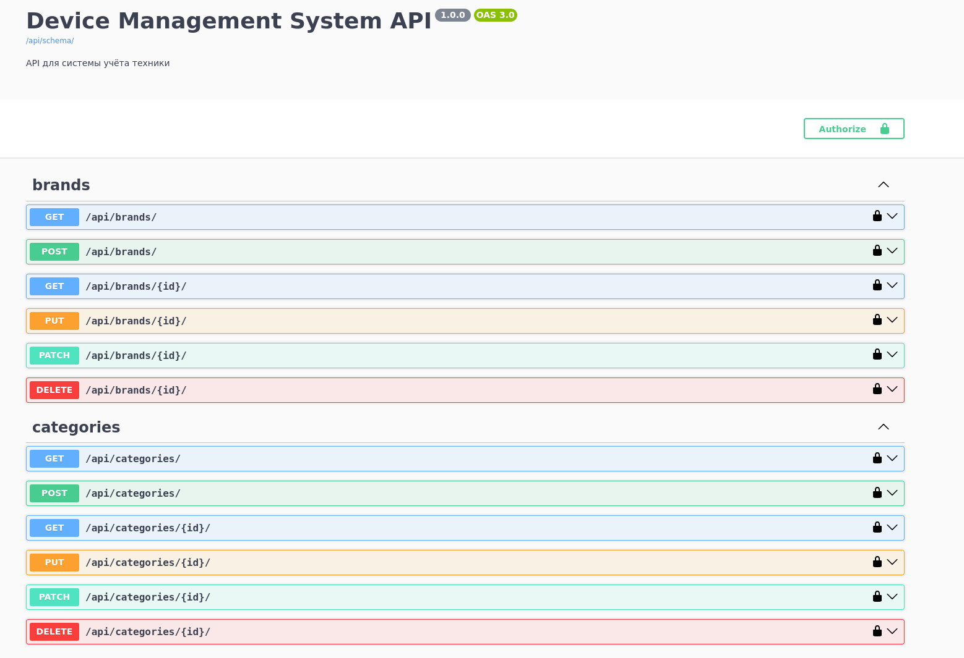
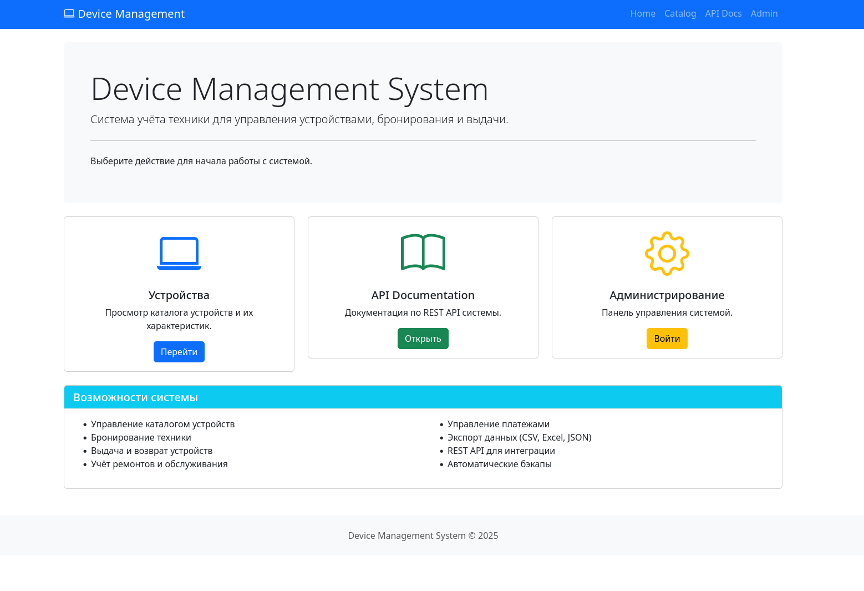

Вывод: В ходе выполнения курсовой работы была спроектирована и реализована информационная система учета оборудования с использованием фреймворка Django и СУБД PostgreSQL. Были изучены и применены на практике механизмы управления версиями схемы данных через Django Migrations, а также принципы построения гибкого программного интерфейса с помощью Django REST Framework. Особое внимание было уделено углубленному изучению технологии ORM, что позволило реализовать сложные выборки и обеспечить ссылочную целостность данных на уровне приложения без написания прямого SQL-кода. Дополнительно были освоены особенности администрирования PostgreSQL и настроена автоматизированная система резервного копирования для обеспечения надежности хранения информации.

