*Emotional state classification via automatic facial expression analysis*

*Mosab Samara, Yazan Abbasi, Mahmoud Zeidat*

1140490, 1140497, 1142306

*Birzeit University, Birzeit, Palestine*

***Abstract*** *–* ***In this project the aim is to o apply a supervised learning technique that generates a reasonable classifier able to recognize the emotional state of Cohn-Kanade dataset which comprises a number of images of eight different facial expressions taken from different subjects via automatic facial expression analysis.***

* INTRODUCTION

Supervised learning is the machine learning task of learning a function that maps an input to an output based on example input-output pairs. It infers a function from labeled training data consisting of a set of training examples. Image classification is a supervised learning problem: define a set of target classes (objects to identify in images), and train a model to recognize them using labeled example photos.

Support vector machines (SVM) are supervised learning models with associated learning algorithms that analyze data used for classification and regression analysis. Logistic regression is a statistical method for analyzing a dataset in which there are one or more independent variables that determine an outcome. The outcome is measured with a dichotomous variable (in which there are only two possible outcomes). Neural Network, is A complex algorithm used for predictive analysis Widely used for data classification and it is biologically inspired by the structure of the human brain.

Orange is an open-source data visualization, machine learning and data mining toolkit. It features a visual programming front-end for explorative data analysis and interactive data visualization, and can also be used as a Python library and it will be used in our project.

* METHODLOGY
* Training

First, using orange we built the model as shown in figure 1, import images was used to import our dataset which is Cohn-Kanade dataset then we extracted data features using image embedding which in turns extract the features by sending the image to the server, where the server would push an image through a pre-trained deep neural network, like Google’s Inception v3 which describe them with 2048 real-valued features. We should note that there are some features in the images that do not interfere with classification like size, width and height so we removed them using select columns as shown in figure 2.

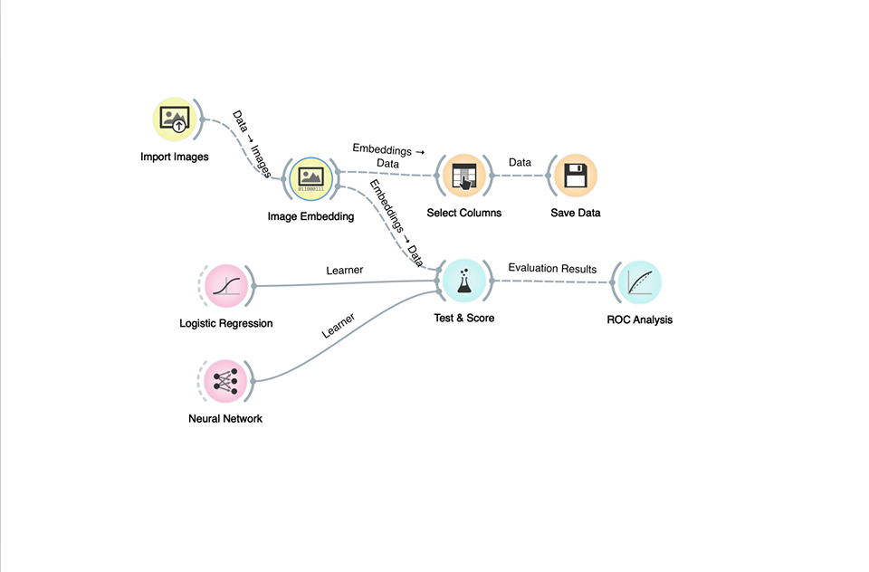

Figure (1): Training data features extraction

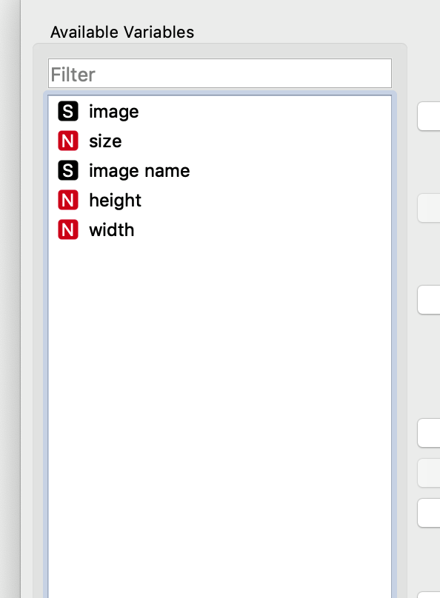

Figure (2): Remove unimportant features

Then the data were classified and saved in an excel file the training was performed using python code. Test and Score used to evaluate the logistic regression and neural network analysis using cross validation with 10-fold and results are shown in the following figure:

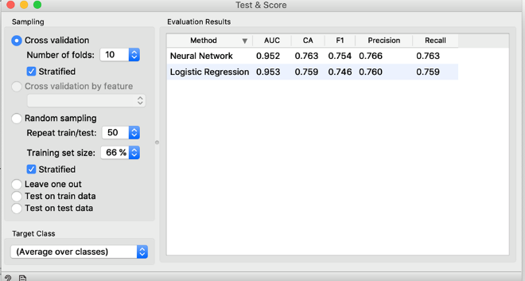

Figure (3) logistic regression and neural network analysis evaluation results

* Testing

For testing the following model were built using orange and some collected data were imported for testing as shown below:

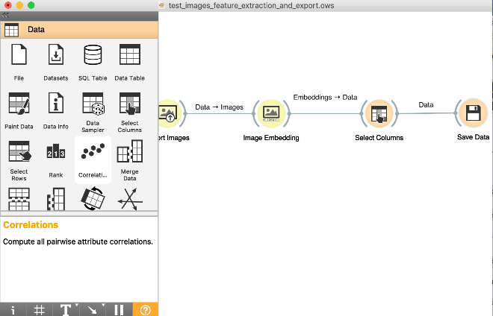.Figure(4): Orange Testing Model

As we can observe that the same operations were made on the testing data for features extraction and classification and were saved in an excel file so it can be processed by the python code and we had the following results: 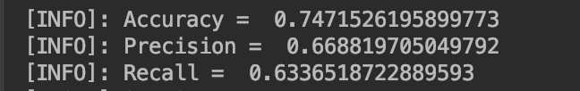

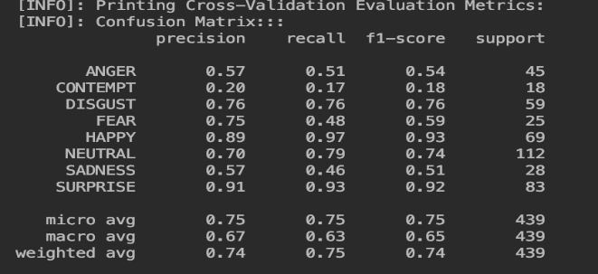

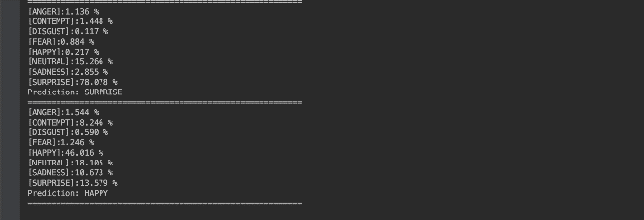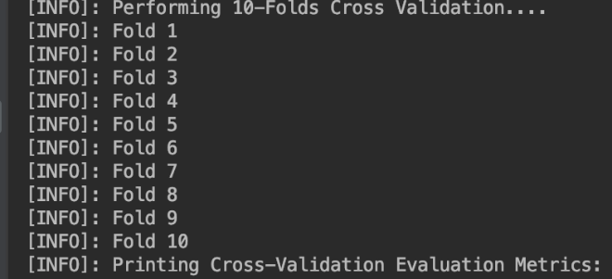

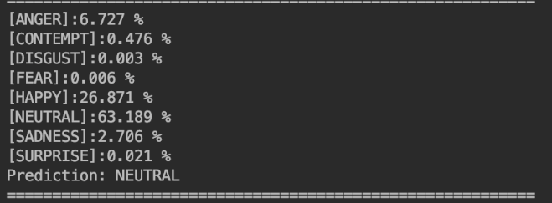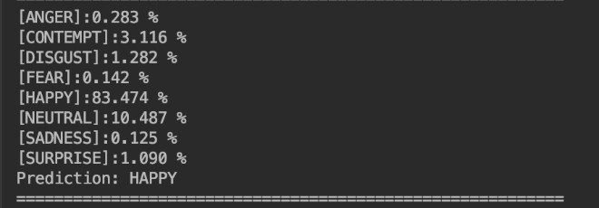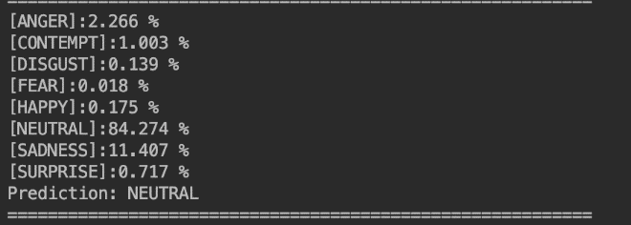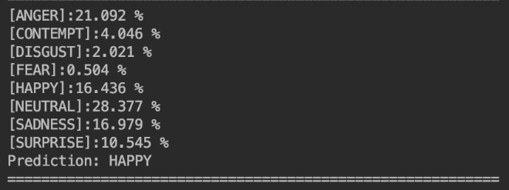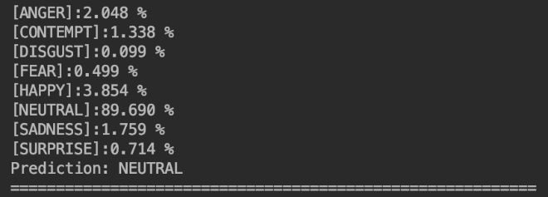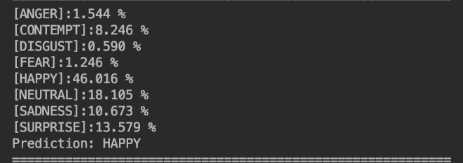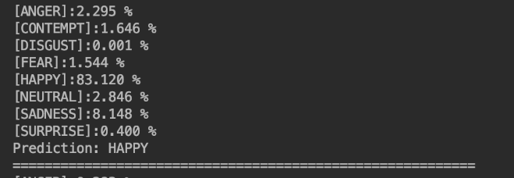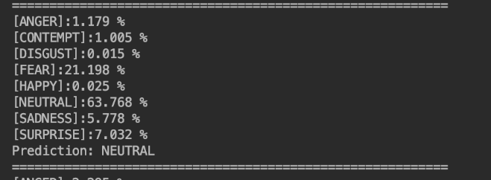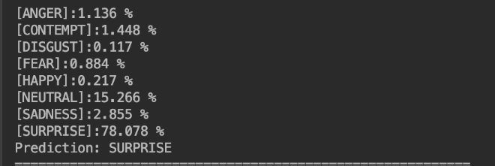

Figure (6): All of our results

* OPTIMIZATION

For optimization a lot of things could be done like extracting more features from the images, providing more data for training or searching for better methods in machine leaning for images classification.

* CONCLUSION

This project gave us the opportunity to better understand machine learning techniques especially that is used for images classification we improve our experience with Orange Data Mining and we better understood the following subjects: Supervised learning, Image classification, Support vector machines (SVM), Logistic regression and Neural Network.

* ACKNOWLEDGMENT

The Authors would like to thank the Instructor Dr. Anas Samara.

* REFERENCES

[1] https://en.wikipedia.org/wiki/Supervised_learning

[2] <https://en.wikipedia.org/wiki/Support-vector_machine>

[3] <https://www.dummies.com/programming/big-data/data-science/how-predictive-analysis-neural-networks-work/>

[4] https://orange.biolab.si/