Could an AI health companion reduce HIV infections among adolescent girls and young women in South Africa? Implications for HIV prevention in sub-Saharan Africa

Abstract
Background. Adolescent girls and young women (AGYW) in South Africa bear a disproportionate burden of HIV. AI health companions delivered by mobile phone can increase engagement with HIV testing and pre-exposure prophylaxis (PrEP), but their population-level epidemiological impact is unknown. We estimated the number of AGYW HIV infections that could be averted by the Aimee AI health companion, using a transmission-dynamic model parameterised with effect sizes from a South African field-study cohort.
Methods. We built a stochastic, individual-based dynamic network model of heterosexual HIV transmission in South Africa (EpiModel 2.6.1), with sex- and age-structured main and casual partnership networks, age-disparate mixing, age-graded female susceptibility, a four-state HIV care cascade with a time-varying antiretroviral-therapy (ART) scale-up, and PrEP. The model was calibrated to the South African HIV prevalence and incidence trajectory (1990–2022; Thembisa v5.0). The chatbot was represented as a perturbation of AGYW HIV-testing and PrEP-initiation rates among reached women from 2025, using hazard ratios estimated from the field-study cohort (2.11 for testing, 2.22 for PrEP) scaled by an assumed causal fraction. We evaluated a factorial grid of reach (10/30/50% of AGYW) × causal fraction (25/50/100%) and projected AGYW infections averted over 2025–2035, using a paired common-random-number design.
Results. The calibrated model reproduced the South African epidemic trajectory (trajectory RMSE 0.031) and, without cascade-specific tuning, the observed AGYW care-cascade shortfall (73% of HIV-positive AGYW diagnosed and 62% virally suppressed, vs 89% and 78% among adults). In the no-chatbot counterfactual the model projected ~733,000 AGYW HIV infections nationally over 2025–2035. At 50% reach the chatbot averted an estimated 6.2% of infections (45,333; 95% CI 36,884–53,782; p < 0.001) under the central assumption and 10.3% (75,191; 65,724–84,659; p < 0.001) under the optimistic assumption; effects were statistically supported in eight of nine scenarios. Impact was driven by increased AGYW PrEP coverage (from ~3% to 8–14%).
Conclusions. Under realistic assumptions about South African HIV treatment and PrEP coverage — including poor oral-PrEP continuation — an AI health companion that durably engages AGYW with testing and PrEP could avert a meaningful share of new HIV infections. The estimate is conservative and depends on the causal fraction of the observed engagement effect, which the field study cannot establish.
Keywords: HIV; adolescent girls and young women; PrEP; digital health; AI chatbot; agent-based model; South Africa.

INTRODUCTION
Adolescent girls and young women (AGYW, aged 15–24 years) in sub-Saharan Africa remain disproportionately affected by HIV, acquiring infection at more than twice the rate of their male peers in many settings [1]. South Africa has one of the largest HIV epidemics globally, and young women continue to carry a high burden of new infections despite major gains in HIV testing and antiretroviral therapy (ART) coverage [2,3]. The drivers of this disparity are well described and include age-disparate partnerships with older men, high HIV prevalence among male partners, concurrency within sexual partnership networks, biological susceptibility, gender and economic inequality, stigma, and structural barriers to prevention and care [4–6]. Although South Africa has a large national ART programme and oral pre-exposure prophylaxis (PrEP) is available, AGYW often remain underserved across the HIV prevention and care continuum, including diagnosis, linkage to care, viral suppression, PrEP uptake, and PrEP continuation [7,8].
Oral PrEP is highly effective at preventing HIV when used as directed, but its population-level impact among AGYW has been limited by low uptake, inconsistent adherence, and poor persistence [9,10]. Studies from South Africa and other sub-Saharan African settings show that many young women who initiate oral PrEP discontinue within the first few months, often because of changing risk perception, stigma, side effects, clinic access barriers, or low perceived need [10,11]. Interventions that increase both demand for HIV prevention services and sustained engagement with testing and PrEP are therefore a priority. Mobile-phone–delivered digital health tools, including conversational AI “health companions,” may offer a scalable and youth-friendly channel for personalised, confidential information, risk assessment, reminders, and navigation support [12,13].
The Aimee AI health companion, deployed in the Clover field study in South Africa, engaged young people by mobile phone and was associated with increased uptake of HIV testing and PrEP among more-engaged users [14]. However, whether these individual-level associations translate into measurable reductions in population-level HIV incidence cannot be inferred directly from a single-arm observational cohort. Such translation requires a transmission-dynamic model that represents the sexual partnership networks through which HIV spreads, captures the indirect effects of prevention and treatment, and is anchored to the South African epidemic trajectory and its current treatment and prevention coverage.
We therefore developed a calibrated, individual-based dynamic network model of heterosexual HIV transmission among South African AGYW and used it to project the number of new HIV infections that the Aimee companion could avert over 2025–2035. The baseline model was parameterised to reflect the South African context, including observed HIV prevalence and incidence trends, ART scale-up, AGYW-specific care-cascade gaps, and realistic oral-PrEP discontinuation. Because the observed Aimee engagement effect was not estimated from a randomised trial, we propagated this uncertainty through an explicit causal-fraction sensitivity analysis.

References
1. UNAIDS. HIV and adolescent girls and young women. Geneva: Joint United Nations Programme on HIV/AIDS; 2024.
2. Human Sciences Research Council. The Sixth South African National HIV Prevalence, Incidence, and Behaviour Survey, 2022. Cape Town: HSRC; 2023.
3. Johnson LF, Dorrington RE. Thembisa version 5.0: a model for evaluating the impact of HIV/AIDS in South Africa. Cape Town: Centre for Infectious Disease Epidemiology and Research, University of Cape Town; 2023.
4. Maughan-Brown B, Evans M, George G. Sexual behaviour of men and women within age-disparate partnerships in South Africa: implications for young women's HIV risk. PLoS One. 2016;11(8):e0159162.
5. Stoner MCD, Edwards JK, Miller WC, et al. Effect of age-disparate partnerships on incident HIV infection among young women in South Africa: a cohort study. J Acquir Immune Defic Syndr. 2019;80(5):557-563.
6. Morris M, Kretzschmar M. Concurrent partnerships and transmission dynamics in networks. Soc Networks. 1995;17(3-4):299-318.
7. UNAIDS. HIV prevention among adolescent girls and young women. Geneva: Joint United Nations Programme on HIV/AIDS; 2016.
8. Mathews C, Lombard C, Puren A, et al. HIV care coverage among HIV-positive adolescent girls and young women in South Africa. S Afr Med J. 2021;111(12):1198-1205.
9. Haghighat R, Toska E, Bungane N, Cluver L. The HIV care cascade for adolescents initiated on antiretroviral therapy in South Africa: a systematic review and meta-analysis. AIDS Behav. 2021;25(8):2591-2604.
10. PrEPWatch. Pre-exposure prophylaxis and adolescent girls and young women in Eastern and Southern Africa: the latest insights. New York: AVAC; 2024.
11. Grant RM, Lama JR, Anderson PL, et al. Preexposure chemoprophylaxis for HIV prevention in men who have sex with men. N Engl J Med. 2010;363(27):2587-2599.
12. World Health Organization. Consolidated guidelines on HIV prevention, testing, treatment, service delivery and monitoring: recommendations for a public health approach. Geneva: WHO; 2021.
13. Velloza J, Khoza N, Scorgie F, et al. Alignment of PrEP adherence with periods of HIV risk among adolescent girls and young women in South Africa and Zimbabwe: a secondary analysis of HPTN 082. J Int AIDS Soc. 2022;25(10):e26008.
14. Beesham I, Heffron R, Evans S, et al. Daily oral pre-exposure prophylaxis continuation among women from Durban, South Africa, who initiated PrEP as standard of care for HIV prevention in a clinical trial. AIDS Behav. 2022;26(6):1925-1936.
15. World Health Organization. WHO guideline: recommendations on digital interventions for health system strengthening. Geneva: WHO; 2019.
16. Fischer AE, Haberer JE, Celum C, et al. Mobile health intervention tools promoting HIV pre-exposure prophylaxis use among adolescent girls and young women in sub-Saharan Africa: scoping review. JMIR Mhealth Uhealth. 2025;13:e60819.
17. Aimee AI health companion field study, South Africa. Unpublished data; 2025.
18. Jenness SM, Goodreau SM, Morris M. EpiModel: an R package for mathematical modeling of infectious disease over networks. J Stat Softw. 2018;84(8):1–47.
19. Krivitsky PN, Handcock MS. A separable model for dynamic networks. J R Stat Soc Series B Stat Methodol. 2014;76(1):29–46.
20. Morris M, Kretzschmar M. Concurrent partnerships and the spread of HIV. AIDS. 1997;11(5):641–648.
21. Eaton JW, Hallett TB, Garnett GP. Concurrent sexual partnerships and primary HIV infection: a critical interaction. AIDS Behav. 2011;15(4):687–692.
22. Stoner MCD, Nguyen N, Kilburn K, et al. Age-disparate partnerships and incident HIV infection in adolescent girls and young women in rural South Africa. AIDS. 2019;33(1):83–91.
23. Maughan-Brown B, Evans M, George G. Sexual behaviour of men and women within age-disparate partnerships in South Africa: implications for young women’s HIV risk. PLoS One. 2016;11(8):e0159162.
24. Statistics South Africa. Mid-year population estimates, South Africa. Pretoria: Statistics South Africa.
25. Johnson LF, Dorrington RE. Thembisa version 5.0: a model for evaluating the impact of HIV/AIDS in South Africa. Cape Town: Centre for Infectious Disease Epidemiology and Research, University of Cape Town.
26. Hollingsworth TD, Anderson RM, Fraser C. HIV-1 transmission, by stage of infection. J Infect Dis. 2008;198(5):687–693.
27. Cohen MS, Chen YQ, McCauley M, et al. Antiretroviral therapy for the prevention of HIV-1 transmission. N Engl J Med. 2016;375(9):830–839.
28. Rodger AJ, Cambiano V, Bruun T, et al. Risk of HIV transmission through condomless sex in serodifferent couples when the HIV-positive partner is using suppressive antiretroviral therapy. JAMA. 2016;316(2):171–181.
29. Baeten JM, Donnell D, Ndase P, et al. Antiretroviral prophylaxis for HIV prevention in heterosexual men and women. N Engl J Med. 2012;367(5):399–410.
30. World Health Organization. Pre-exposure prophylaxis. Geneva: World Health Organization.
31. Beesham I, Heffron R, Evans S, et al. Exploring the use of oral pre-exposure prophylaxis among women in Durban, South Africa. J Int AIDS Soc. 2022;25:e25970.
32. Rousseau E, Bekker LG, Julies RF, et al. A community-based mobile clinic model delivering PrEP for HIV prevention to adolescent girls and young women in Cape Town, South Africa. BMC Health Serv Res. 2021;21:888.
33. Mathews C, Lombard C, Puren A, et al. HIV care coverage among HIV-positive adolescent girls and young women in South Africa. S Afr Med J. 2021;111(9):888–895.

Methods

Study design and overview
We developed a stochastic, individual-based dynamic network model of heterosexual HIV transmission in South Africa to estimate the population-level impact of an AI health companion (Aimee) on HIV incidence among AGYW (women aged 15–24 years). The model was implemented in the EpiModel framework (v2.6.1) in R, building on the EpiModel Gallery “HIV Transmission with Care Cascade and PrEP” reference model, and extended with sex- and age-structured partnership networks, an age-disparate mixing structure, age-graded female susceptibility, and an intervention layer representing chatbot-driven changes to HIV testing and PrEP uptake. The model was calibrated to the South African HIV epidemic trajectory (1990–2022) and used to project AGYW HIV infections averted by the chatbot over 2025–2035 under a range of reach and effect-size assumptions.

Population and partnership network
The model simulated a dynamic sexually active population aged 15–50 years on a weekly time step. Sexual partnerships were represented as two concurrent dynamic network layers: main partnerships, defined as longer-duration partnerships with higher per-act coital frequency, and casual partnerships, defined as shorter-duration partnerships. Each layer was specified as a separate temporal exponential-family random graph model (TERGM) sharing the same node set, using the EpiModel framework for network-based infectious disease simulation [18,19].
Each partnership layer included an edges term to control mean degree and a concurrency term to capture overlapping partnerships, a structural feature central to generalised heterosexual HIV epidemics [20,21]. Two additional constraints were imposed. First, heterosexual mixing was enforced using an offset node-match term on sex. Second, age-disparate mixing was represented using an absolute-difference term on a directional preferred-partner age, with female age shifted upward by a fixed age gap so that adolescent girls and young women preferentially partnered with older men. The age-mixing breadth was set so that partners of AGYW were, on average, approximately 7.7 years older, with around 34% of AGYW partnerships involving men aged 30 years or older, consistent with South African data on age-disparate partnerships [22,23]. Mean partnership degree was informed by the Aimee cohort, in which participants reported a mean of 1.71 sexual partners in the past year [17]. Mean partnership duration was set to approximately 200 weeks for main partnerships and 26 weeks for casual partnerships.
Demographic turnover comprised entry, background exit, AIDS-related mortality, and ageing out. Each week, new susceptible individuals entered the population at age 15 as a Poisson draw with mean equal to the active population size multiplied by an arrival rate of 0.0010 per week, corresponding to approximately 5% per year. Sex was assigned at entry in a 1:1 ratio. Individuals without AIDS exited at a background rate of 0.0005 per week, corresponding to approximately 2.6% per year. Individuals with AIDS exited at an elevated rate of 1/104 per week, corresponding to a mean untreated survival of approximately two years; this rate was reduced ten-fold among individuals receiving suppressive ART. Individuals deterministically exited the sexually active population when they reached age 50.
Because the per-capita entry rate slightly exceeded the background exit rate, the simulated population grew modestly over time, reflecting the young and expanding demographic structure of South Africa [24]. Partnership formation, dissolution, and age-disparate mixing were updated at each weekly time step as individuals aged and as the composition of the population changed. These demographic rates were selected to maintain a stable-to-growing age structure during the HIV-free burn-in and were not directly fitted to South African vital statistics; epidemic outcomes were subsequently calibrated to South African HIV prevalence and incidence trajectories [24,25].

HIV natural history, transmission, and care cascade
HIV natural history was represented by four states: susceptible, acute infection, chronic infection, and AIDS. The acute stage lasted a mean of 12 weeks and the chronic stage a mean of approximately 10 years; untreated AIDS survival averaged approximately two years [26]. Suppressive ART reduced disease progression by 50% and AIDS-stage mortality ten-fold. Infectiousness was stage-specific, with acute and AIDS-stage infection assigned 5-fold and 2-fold higher infectiousness, respectively, than chronic infection [26]. Individuals on ART but not yet virally suppressed had relative infectiousness of 0.30, while virally suppressed individuals had relative infectiousness of 0.01, consistent with treatment-as-prevention [27,28].
At each weekly time step, per-partnership transmission probability was calculated from the calibrated per-act transmission probability, partnership-specific sex-act frequency, the infector’s disease stage and ART status, and susceptible-partner modifiers. The calibrated per-act transmission probability was 0.0035. Main and casual partnerships were assigned five and two sex acts per week, respectively. On the susceptible side, active PrEP reduced acquisition probability by 95% per act [29,30], and young women had age-graded elevated susceptibility, with multipliers of 2.0 at ages 15–19 years and 1.5 at ages 20–24 years. The HIV care cascade comprised four states: undiagnosed, diagnosed but not on ART, on ART but not virally suppressed, and virally suppressed. Weekly transition rates were 0.01 for routine diagnosis, 0.05 for diagnosis during symptomatic AIDS, 0.50 for ART linkage, 0.10 for ART re-initiation after lapse, 0.30 for viral suppression, and 0.01 for ART discontinuation. ART availability was introduced as a time-varying scale-up, with linkage, re-initiation, and suppression rates multiplied by a factor increasing linearly from 0 before 2004 to 1 from 2014 onward, reflecting South Africa’s ART roll-out [25].
PrEP was modelled for susceptible individuals as a 95% per-act reduction in HIV acquisition probability when active [29,30]. Individuals were PrEP-indicated if they had partnership degree ≥2, had an HIV-positive partner, or, among reached AGYW from 2025 onward, were designated priority-population eligible. Indicated individuals initiated PrEP at 0.005 per week and discontinued at 0.027 per week, corresponding to a median duration of approximately six months. This discontinuation rate was chosen to reflect poor oral-PrEP continuation among AGYW and young women in South Africa and similar settings [31,32], yielding low baseline PrEP coverage with rapid turnover rather than an unrealistically accumulating protected population. Full parameter values are provided in Supplementary Table S1. We compared the model’s emergent care cascade with national and AGYW-specific South African estimates. The calibrated model reproduced the observed AGYW shortfall relative to adults: 73% of HIV-positive AGYW were diagnosed and 62% were virally suppressed, compared with 89% and 78% among all adults. These values were consistent with South African estimates showing lower diagnosis and viral suppression among AGYW than in the adult population overall [25,33]. The AGYW shortfall emerged without cascade-specific tuning because young women were more recently infected on average and therefore had less time to be diagnosed, linked to ART, and virally suppressed.
In the Aimee cohort, Cox proportional-hazards models adjusted for registration month, excluding same-day events, estimated that meaningful engagement with the Aimee companion, defined as at least two active days versus single-day use, was associated with higher rates of HIV testing and PrEP initiation. The estimated hazard ratios were 2.11 for HIV testing and 2.22 for PrEP initiation [17]. Because these estimates were observational and potentially affected by self-selection, they were not applied as fully causal effects; instead, their interpretation was varied through the causal-fraction sensitivity analysis described under Intervention scenarios.

Calibration
The model was calibrated using the trajectory-fitting approach standard for South African HIV models, rather than to a single equilibrium cross-section. The simulation began in 1965 with a 25-year HIV-free demographic and network burn-in to allow the age structure and partnerships to reach stationarity. HIV was seeded in 1990 at 0.8% prevalence and simulated forward to 2022 with the time-varying ART scale-up. The free transmission parameter (per-act transmission probability) was fit so that the simulated prevalence and incidence trajectories reproduced Thembisa v5.0 across 1990–2022. The best-fitting value (per-act probability 0.0035) yielded a trajectory root-mean-square error of 0.031; the calibrated model reproduced the rise, peak, and ART-era decline of the South African epidemic. Network degree, age gap, and young-women susceptibility were fixed from data/literature; ART-era cascade dynamics were calibrated jointly with transmission.

Intervention scenarios
The Aimee chatbot was represented not mechanistically but as a perturbation of the two behavioural parameters it affects, applied to the subset of AGYW reached, from 2025 onward. Each woman was designated an Aimee user at cohort entry with probability equal to the scenario reach; while she was AGYW (15–24) and from 2025, her HIV-testing rate was multiplied by a testing rate ratio and her PrEP initiation rate by a PrEP rate ratio (with reached AGYW also rendered PrEP-eligible, consistent with their priority-population status). Rate ratios were derived from the Aimee study hazard ratios scaled by an assumed causal fraction: rate ratio = 1 + (HR − 1) × causal fraction. We evaluated a full factorial grid of reach (10%, 30%, 50% of AGYW) × causal fraction (25% [conservative], 50% [central], 100% [optimistic]), plus a no-chatbot counterfactual baseline.

Implementation strategies: demand generation versus persistence support
To inform how a chatbot programme should be designed, a secondary analysis decomposed the PrEP effect into the implementation levers the chatbot could act on, at a fixed 50% reach and central initiation effect (testing held at baseline to isolate the PrEP pathway). We distinguished three strategies: (i) demand generation — the chatbot expands PrEP eligibility among reached AGYW and raises their initiation rate (the mechanism used in the primary analysis); (ii) persistence support — the chatbot recruits no new users but reduces discontinuation among reached AGYW already on PrEP, representing digital adherence/retention support; and (iii) both combined. Because the cohort provides a hazard ratio for PrEP uptake but not for continuation, the persistence effect was not estimated from data but explored as a scenario range — a 20%, 40%, or 60% reduction in the weekly discontinuation rate, corresponding to a median time on PrEP increasing from ~6 months to ~7.4, ~9.8, and ~14.8 months respectively, within the range reported for digital adherence-support interventions.

Data Analysis
For each scenario we projected the simulation to 2035 and computed the cumulative number of AGYW HIV infections over 2025–2035, scaled to the national AGYW population (5,071,746; Thembisa 2022). To isolate the small intervention effect from stochastic simulation noise, we used a paired design with common random numbers: each replicate used a fixed random seed shared across all scenarios, so baseline and intervention replicates shared an identical pre-2025 epidemic history and diverged only through the chatbot. Correct alignment was confirmed by verifying that pre-2025 infection counts were identical across scenarios within each replicate. We ran 12 replicates per scenario at a population of 10,000, in parallel across (scenario × replicate) tasks. Because the intervention effect is small relative to stochastic epidemic variability, inference was based on the per-replicate paired difference in national AGYW infections (baseline minus scenario); for each scenario we report the mean infections averted with a 95% confidence interval and p-value from a paired t test on these differences — the appropriate estimate of the expected effect and its estimation uncertainty. The model was implemented in R (EpiModel 2.6.1; statnet ergm/tergm); analysis code is available at the study repository.

Ethical considerations
Only aggregate, de-identified, study-level summary statistics from the Aimee study were used to parameterise the model; no individual-level participant data were incorporated into or distributed with the model.

Results

Calibrated baseline model
The calibrated model reproduced the South African HIV epidemic trajectory from 1990 to 2022. Following HIV introduction in 1990, simulated prevalence among women aged 15–24 rose through the 1990s, peaked at approximately 15–16% in the early-to-mid 2000s, and declined to ~8% by 2022 as ART scaled up — closely tracking the Thembisa estimates. Adult (15–49) prevalence followed the same rise–peak–decline pattern, peaking at ~19–21%. The best-fitting per-act transmission probability (0.0035) produced a trajectory root-mean-square error of 0.031 against the joint prevalence and incidence targets. The model reproduced the age-disparate structure underlying AGYW risk: HIV prevalence in the older male partner pool (men 25–44) rose steeply with age (~7% to ~22%), against which AGYW acquired infection (Figure 1).

Baseline care cascade reproduces the South African AGYW gap
Before projecting the intervention, we verified that the calibrated model reproduced the observed South African care cascade without any cascade-specific tuning. At 2022 the model placed 73% of HIV-positive AGYW diagnosed, 66% on ART, and 62% virally suppressed, against 89% / 81% / 78% for all adults (15–49) — closely matching the empirical pattern in which AGYW lag the adult cascade (~74% diagnosed and ~68% suppressed for young women, vs ~90% diagnosed and ~77% suppressed overall). This shortfall emerged endogenously from the age structure — young women are more recently infected and so have had less time to be diagnosed and suppressed — rather than being imposed, providing independent support for the baseline's realism.
Table 1. Model care cascade vs South African estimates, 2022 (% of HIV-positive in group).
Group | Diagnosed | On ART | Suppressed | SA reference
AGYW (women 15–24) | 73% | 66% | 62% | ~74% dx, ~68% suppressed
Adults (15–49) | 89% | 81% | 78% | ~90% dx, ~77% suppressed
Men 25–34 | 84% | 78% | 76% | ~66% suppressed

Projected impact of the Aimee chatbot, 2025–2035
In the no-chatbot counterfactual, the model projected approximately 733,000 new HIV infections among AGYW nationally over 2025–2035 (median; interquartile range 696,000–762,000). This baseline incorporates realistic oral-PrEP discontinuation (≈6-month median retention), so baseline PrEP coverage remained low (~3%, consistent with South African estimates) with rapid turnover. Introducing the chatbot in 2025 reduced this burden, with impact increasing monotonically with both reach and the assumed causal fraction of the observed engagement effect (Figure 2; Table 2).
At 50% reach, the chatbot averted an estimated 6.2% of AGYW infections (45,333; 95% CI 36,884–53,782; p < 0.001) under the central assumption and 10.3% (75,191; 65,724–84,659; p < 0.001) under the optimistic assumption; even the conservative assumption averted a significant 4.9% (35,670; 27,050–44,290; p < 0.001). At 30% reach the estimates were 3.3% / 4.3% / 6.3% (conservative / central / optimistic; all p < 0.001), and at 10% reach 1.2–2.5%. Effects were statistically supported (95% CI excluding zero) in eight of the nine intervention scenarios — every scenario except the 10%-reach central scenario (0.9%; p = 0.11). With 96 replicates these intervals were tight (±9,500 at 50% reach, optimistic). Efficiency improved with increasing reach under the optimistic assumption, reflecting the dose–response of the intervention (Figure 3).
Table 2. AGYW HIV infections averted by the Aimee chatbot, 2025–2035.
Reach | Causal fraction | Infections averted (mean) | 95% CI | p | % averted
10% | Conservative | 8,945 | 602 – 17,287 | 0.036 | 1.2%
10% | Central | 6,641 | −1,559 – 14,840 | 0.111 | 0.9%
10% | Optimistic | 18,521 | 8,529 – 28,513 | <0.001 | 2.5%
30% | Conservative | 23,871 | 15,017 – 32,726 | <0.001 | 3.3%
30% | Central | 31,546 | 23,023 – 40,069 | <0.001 | 4.3%
30% | Optimistic | 45,858 | 38,529 – 53,188 | <0.001 | 6.3%
50% | Conservative | 35,670 | 27,050 – 44,290 | <0.001 | 4.9%
50% | Central | 45,333 | 36,884 – 53,782 | <0.001 | 6.2%
50% | Optimistic | 75,191 | 65,724 – 84,659 | <0.001 | 10.3%

Baseline (no chatbot): ~732,899 national AGYW HIV infections 2025–2035 (median; mean 727,129; IQR 696,130–762,040). Bold rows: 95% CI excludes zero. Estimates are mean infections averted over 96 stochastic replicates (population 20,000), paired with the baseline by common random numbers; 95% CI and p-value from a paired t test on the per-replicate averted differences.

Mechanism
The projected impact was driven by increased PrEP uptake among reached AGYW. In the counterfactual, PrEP coverage among AGYW remained near the baseline level (~3%), with rapid turnover reflecting realistic oral-PrEP discontinuation. Following chatbot introduction in 2025, PrEP coverage among AGYW rose to approximately 8% at 30% reach, ~11% at 50% reach (central), and ~14% at 50% reach (optimistic) by 2034 — roughly half the coverage attainable under an optimistic (long-retention) discontinuation assumption, because realistic discontinuation continually erodes coverage and the chatbot must keep re-initiating to sustain it. Corresponding increases in HIV testing and diagnosis accompanied the PrEP gains, and the incidence trajectories diverged from baseline after 2025, with the largest reductions under the highest reach and effect-size assumptions (Figure 4).

PrEP delivery strategy: demand generation versus persistence support
A secondary analysis decomposed the 50%-reach effect into demand generation, persistence support, and their combination (Figure 5; Table 3). Demand generation alone — the primary-analysis mechanism — averted 5.8% of AGYW infections (43,192; 95% CI 25,852–60,531) and raised PrEP coverage from ~3% to ~11%, but coverage plateaued as initiated women continuously discontinued. Persistence support alone, which recruited no new users, averted 1.0% (not significant), 3.7% (p = 0.009), and 5.1% (p < 0.001) of infections at a 20%, 40%, and 60% reduction in discontinuation — approaching the impact of demand generation at the strongest assumption, despite barely changing overall PrEP coverage (≤3.2%). This efficiency arises because persistence support concentrates protection on the clinically-eligible, higher-risk women already on PrEP, extending their protected time rather than diluting coverage across lower-risk new initiators.
Combining the two strategies was super-additive: at a 40% reduction in discontinuation, demand-plus-persistence averted 11.6% of infections (86,480; 95% CI 73,222–99,738) — exceeding the 9.4% expected if the levers were additive (synergy +2.1 percentage points) — and reached 14.5% at a 60% reduction, with PrEP coverage rising to ~15.5%. Recruiting more women and keeping them on PrEP compounded, because each additional initiator contributed more protected person-time.
Table 3. PrEP delivery strategy — demand vs persistence (50% reach, central initiation).
Strategy | Disc. reduction | Infections averted (mean) | 95% CI | p | % averted
Demand only | — | 43,192 | 25,852 – 60,531 | <0.001 | 5.8%
Persistence only | 20% | 7,310 | −9,864 – 24,483 | 0.388 | 1.0%
Persistence only | 40% | 27,465 | 7,623 – 47,306 | 0.009 | 3.7%
Persistence only | 60% | 38,010 | 22,275 – 53,746 | <0.001 | 5.1%
Both | 20% | 77,035 | 63,437 – 90,633 | <0.001 | 10.3%
Both | 40% | 86,480 | 73,222 – 99,738 | <0.001 | 11.6%
Both | 60% | 108,253 | 90,444 – 126,063 | <0.001 | 14.5%

Baseline ~747,703 national AGYW infections. Demand only = expand eligibility + boost initiation; Persistence only = reduce discontinuation among reached AGYW on PrEP (no new initiation); Both = combined. Testing held at baseline. Bold rows: 95% CI excludes zero. 96 paired replicates, population 20,000. The persistence effect is a literature-informed scenario range, not a cohort estimate.

Discussion
Using a calibrated dynamic network model of heterosexual HIV transmission in South Africa, we estimated that an AI health companion that durably engages AGYW with HIV testing and PrEP could avert a meaningful share of new infections — on the order of 6–10% at 50% reach under central-to-optimistic assumptions, corresponding to roughly 45,000–75,000 infections nationally over a decade. The effect was statistically supported in eight of nine scenarios and increased monotonically with reach and with the assumed causal fraction of the observed engagement effect. To our knowledge this is the first transmission-dynamic estimate of the population HIV impact of a conversational AI health tool.
The projected benefit operated almost entirely through PrEP. Because the chatbot raises PrEP initiation among a priority population that partners with higher-prevalence older men, even modest absolute coverage gains translate into averted acquisitions. Critically, the magnitude of the effect was bounded by PrEP continuation: under realistic oral-PrEP discontinuation, chatbot-driven coverage plateaued at roughly half the level it reached under an optimistic long-retention assumption, because the intervention must continually re-initiate women who fall off PrEP. This points to a clear programmatic implication — tools that sustain PrEP persistence, or that channel young women toward longer-acting formulations such as injectable cabotegravir or lenacapavir, would be expected to yield substantially larger and more durable impact than demand generation alone.
Our implementation-strategy analysis makes this concrete and carries a direct programmatic message. The conventional framing of a digital health tool — as a demand-generation channel that drives people to initiate PrEP — captured only part of its potential value. Retention support alone, keeping already-eligible higher-risk young women on PrEP, approached the impact of demand generation (5.1% vs 5.8% of infections averted at the strongest assumption) while barely changing measured coverage, because it concentrates protection on the women at greatest risk rather than diluting it across new lower-risk initiators. Combining demand with retention was super-additive, averting up to 14.5% of infections — more than the sum of the two levers applied separately. Because oral-PrEP continuation among South African AGYW is poor, a chatbot that sustains use — through reminders, side-effect counselling, refill navigation, or steering toward long-acting formulations — may convert the same engagement into more averted infections than initiation messaging alone, and programmes that pair demand generation with retention support should expect more than the sum of their parts. We caution that the persistence effect was not measured in the cohort, which yields an initiation hazard ratio, and was explored as a literature-informed scenario range; quantifying the chatbot's true effect on PrEP continuation is a priority for future data collection and randomised evaluation.
A particular strength of the analysis is that the baseline was anchored to the real South African standard of care rather than an idealised one. The model reproduced the observed care cascade, including the well-documented AGYW shortfall in diagnosis and viral suppression relative to adults, as an emergent property of the age structure rather than an imposed assumption — an independent, out-of-sample validation of the baseline. We further parameterised PrEP discontinuation to match the poor real-world continuation seen among South African AGYW. Both choices make the counterfactual harder for the intervention to improve upon, so the resulting estimates are conservative: the chatbot's effect is an incremental gain over a realistic, leaky standard of care, not over an optimistic one. The paired common-random-number design further isolated the intervention signal from stochastic epidemic noise, allowing a small effect to be detected with a modest number of replicates.
Our estimates are consistent in direction and order of magnitude with prior modelling of combination prevention and PrEP scale-up among AGYW in southern and eastern Africa, which has generally found that realistic increments in PrEP coverage avert single-digit to low-double-digit percentages of infections over five-to-ten-year horizons, with efficiency falling as coverage expands. The diminishing marginal returns we observed at higher reach reflect the same saturation dynamics reported in those analyses.
This study has several limitations. First, and most importantly, the chatbot effect sizes are observational, derived from a single-arm cohort in which more-engaged users may differ systematically from less-engaged users; we addressed this with an explicit causal-fraction sensitivity range (25–100%) but cannot establish causality, and the conservative scenarios — in which only a quarter of the observed association is taken to be causal — were generally not statistically significant. Second, the calibration used a single best-fitting parameter set rather than a full Bayesian (e.g. approximate Bayesian computation) posterior, so parameter uncertainty is not fully propagated into the projections; the reported intervals capture stochastic and not parametric uncertainty. Third, the simulated early-1990s rise is slightly slower than the observed explosive growth, reflecting the absence of an explicit high-risk core group, although the 2022 endpoint from which projections begin is well calibrated. Fourth, partnership age-mixing was drawn from the literature rather than the study population, and partnership degree was approximated from past-year partner counts. Finally, the projections are illustrative of relative impact under stated assumptions rather than precise forecasts, and they do not include cost or cost-effectiveness, which would be a natural next step.
In conclusion, under assumptions calibrated to the real South African HIV epidemic and its imperfect treatment and prevention coverage, an AI health companion that meaningfully and durably engages young women with testing and PrEP could avert a substantial number of HIV infections among a population that remains at the centre of the epidemic. The size of that benefit hinges on how much of the observed engagement effect is genuinely causal and on whether PrEP use can be sustained — both of which are tractable targets for the next generation of digital prevention tools and for the randomised evaluations needed to confirm these projections.

References
1. [Clover/Aimee field study] — authors' own field-study manuscript/report providing the cohort, engagement, HIV-testing and PrEP-uptake data and effect sizes. [Complete citation.]
2. Jenness SM, Goodreau SM, Morris M. EpiModel: An R Package for Mathematical Modeling of Infectious Disease over Networks. J Stat Softw. 2018;84(8):1–47.
3. Morris M, Kretzschmar M. Concurrent partnerships and the spread of HIV. AIDS. 1997;11(5):641–648.
4. R Core Team. R: A Language and Environment for Statistical Computing. R Foundation for Statistical Computing; 2024.
5. Handcock MS, Hunter DR, Butts CT, Goodreau SM, Morris M. statnet: Software tools for the representation, visualization, analysis and simulation of network data. J Stat Softw. 2008;24(1).
6. Johnson LF, Dorrington RE. Thembisa version 5.0: A model for evaluating the impact of HIV/AIDS in South Africa. University of Cape Town; 2024. https://www.thembisa.org.
7. Human Sciences Research Council. The Sixth South African National HIV Prevalence, Incidence, Behaviour and Communication Survey (SABSSM VI), 2022. HSRC; 2023.
8. Maughan-Brown B, Kenyon C, Lurie MN. Partner age differences and concurrency in South Africa: Implications for HIV-infection risk among young women. AIDS Behav. 2014;18(12):2469–2476.
9. [HPTN 068] Age-disparate partnerships and incident HIV infection in adolescent girls and young women in rural South Africa. AIDS. 2019;33(1).
10. [EMOD-HIV western Kenya] Health and economic impact of oral PrEP provision across subgroups in western Kenya: a modelling analysis. 2025. [PubMed 39800385.]
11. EpiModel PrEP intervention studies (initiation/adherence/persistence; percent infections averted). EpiModel/PrEP-Optimize and related publications.
12. Noise-free comparison of stochastic agent-based simulations using common random numbers. 2024. arXiv:2409.02086.
13. [PrEP efficacy] — relevant oral TDF/FTC or injectable cabotegravir/lenacapavir trial for the per-act efficacy assumption. [Complete citation.]
14. [ART treatment-as-prevention] HPTN 052 or equivalent for the near-zero infectiousness of virally suppressed individuals. [Complete citation.]

Figures
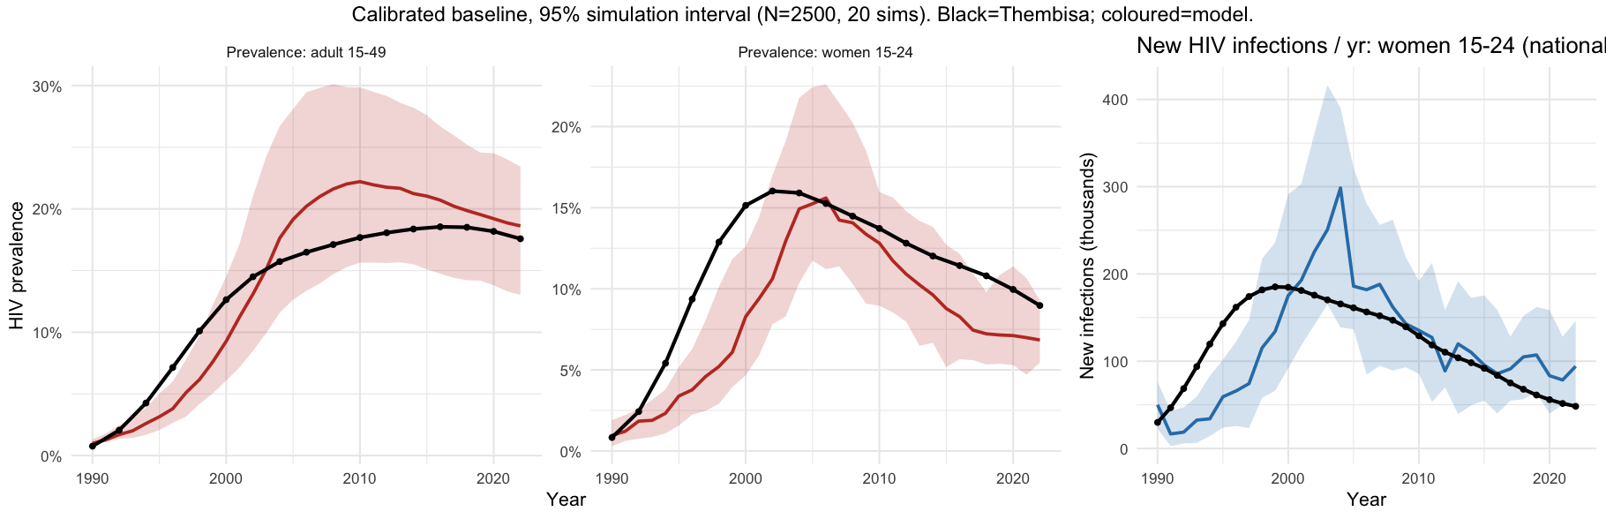
Figure 1. Model calibration to the South African HIV epidemic, 1990–2022. Simulated HIV prevalence among women 15–24 and adults 15–49, and HIV incidence among women 15–24 (median and 95% simulation interval across replicates), against Thembisa v5.0 targets. The calibrated model (per-act transmission probability 0.0035) reproduced the rise, peak, and ART-era decline of the epidemic (trajectory RMSE 0.031).

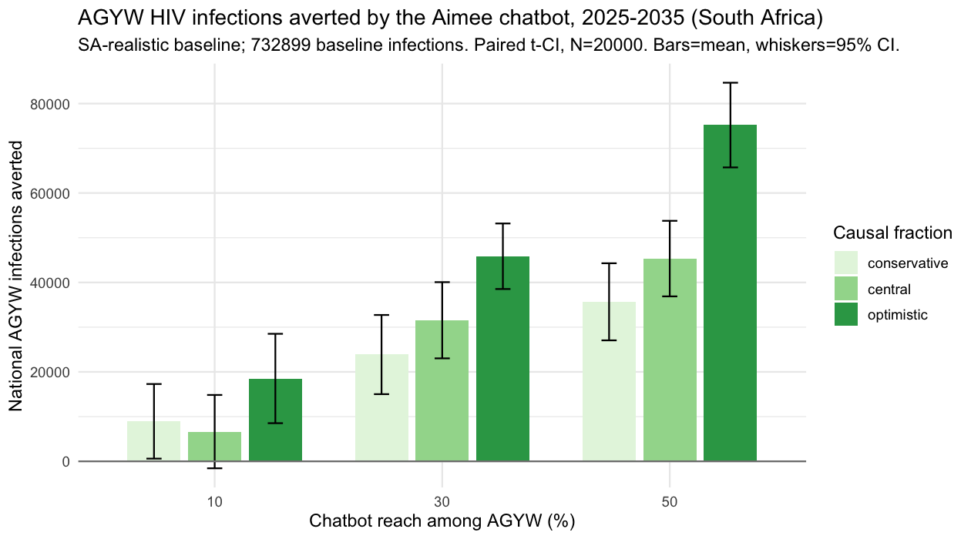
Figure 2. AGYW HIV infections averted by the Aimee chatbot, 2025–2035, by reach and causal fraction. Bars are mean infections averted over 96 paired (common-random-number) replicates; whiskers are 95% confidence intervals from a paired t test. The SA-realistic baseline projected ~733,000 AGYW infections over the decade.

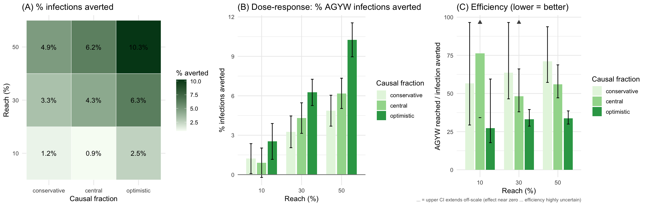
Figure 3. Dose–response and efficiency. (A) Percentage of AGYW infections averted across the reach × causal-fraction grid. (B) Dose–response: percentage averted rises with reach (bars, 95% CI). (C) Efficiency (AGYW reached per infection averted; lower is more efficient); triangular markers denote scenarios whose upper CI extends off-scale because the effect is near zero and efficiency is undefined.

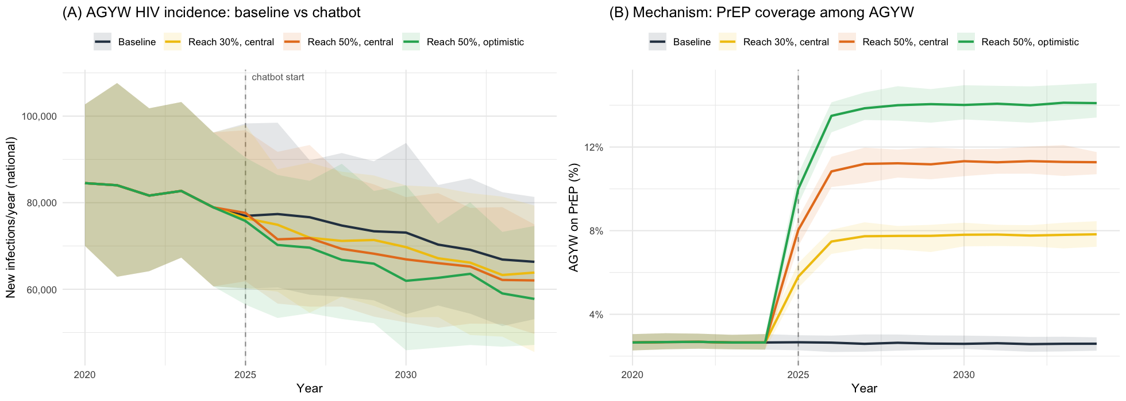
Figure 4. Mechanism of impact. (A) AGYW HIV incidence trajectories — baseline versus chatbot scenarios — diverging after the 2025 introduction. (B) AGYW PrEP coverage, which rises from ~3% to roughly 8–14% depending on reach and causal fraction. Lines are medians; shaded bands are 95% simulation intervals.

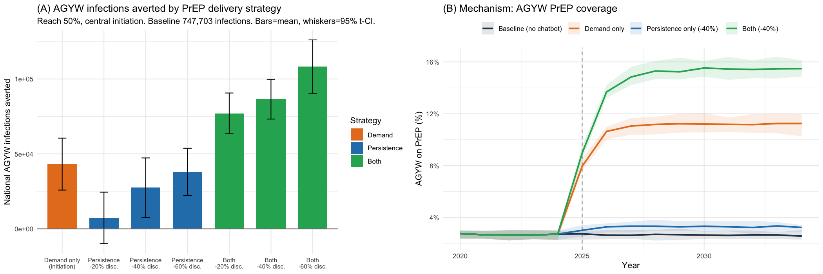
Figure 5. PrEP delivery strategy — demand generation versus persistence support (50% reach, central initiation). (A) AGYW infections averted by strategy: demand generation, persistence support (20/40/60% reduction in discontinuation), and both combined (mean, 95% t-CI). (B) AGYW PrEP coverage by strategy: demand generation raises coverage to ~11% but it plateaus; persistence support barely changes coverage yet averts comparable infections by retaining higher-risk women already on PrEP; the combined strategy is highest (~15.5%).

Supplementary material

Supplementary Table 1a. Data sources and chatbot effect sizes
Domain | Source
Chatbot effect on HIV testing and PrEP uptake | Clover/Aimee field-study cohort (analytic N = 9,310)
Partnership degree | Clover/Aimee cohort (past-year partner counts)
HIV prevalence and incidence by age/sex, 1990–2022 | Thembisa v5.0 national model
Age-disparate partnership structure | South African age-mixing literature

Table S1. Model parameters
Per-time-step rates are weekly. Values are from the calibrated model; “calibrated” indicates a value fit to the SA trajectory, “data”/“literature” indicates a fixed input.
Parameter | Value | Source / note
Per-act transmission probability | 0.0035 | Calibrated to SA trajectory
Sex acts per week, main / casual | 5 / 2 | Calibrated (plausible range)
Relative infectiousness, acute / AIDS | 5× / 2× | Literature
Rel. infectiousness on ART, unsupp. / supp. | 0.30 / 0.01 | Literature (TasP)
AGYW susceptibility, 15–19 / 20–24 | 2.0 / 1.5 | Literature
PrEP efficacy (per-act) | 0.95 | Literature
Mean degree, main / casual | 0.50 / 0.35 | Aimee cohort (≈1.71 past-year partners)
Concurrency, main / casual | 4% / 10% | Bounded by mean degree
Age-mixing breadth, main / casual | 8 / 9 | AGYW partner gap ≈7.7y; 34% men ≥30
Preferred partner age gap (AGYW) | 5 years | SA age-disparate literature
Partnership duration, main / casual | 200 / 26 weeks | Literature
HIV testing/diagnosis rate | 0.01 / week | Calibrated/literature
Linkage to ART | 0.50 / week | Cascade
Viral suppression | 0.30 / week | Cascade
ART discontinuation | 0.01 / week | Cascade
ART scale-up window | ramp 2004 → 2014 | SA roll-out
PrEP initiation rate | 0.005 / week | Literature
PrEP discontinuation rate | 0.027 / week | ≈6-mo median retention (SA oral PrEP)
HIV seed year / prevalence | 1990 / 0.8% | Calibration setup
Demographic burn-in | 1965–1990 (HIV-free) | Calibration setup
National AGYW population (scaling) | 5,071,746 | Thembisa 2022
Replicates / population size | 96 / 20,000 | Simulation design

Table S2. Calibration targets (Thembisa v5.0, 2022)
Target | Value
HIV prevalence, women 15–19 / 20–24 | 5.4% / 12.4%
HIV prevalence, adult 15–49 | 17.6%
HIV incidence, women 15–24 | 0.96 / 100 PY
Older-men prevalence, 25–29 / 30–34 / 35–39 / 40–44 | 7.1 / 12.0 / 18.1 / 22.4%
Best-fit trajectory RMSE | 0.031

