Carleton University

# SYSC 5104 Assignment #2 - Fall 2020

# 

# 

# 

# Modeling CO2 In A Classroom With Barriers

**Name: Zein Hajj-Ali**

**Student ID: 101020677**

**Email:** [**zeinhajjali@cmail.carleton.ca**](mailto:zeinhajjali@cmail.carleton.ca)

**Introduction and Prior Work**

CO2 sensors are being more widely used to detect the presence of occupants in rooms. Although the sensors can accurately predict the presence of occupants, they struggle with predicting the number of occupants due to the high variability in the positioning of the persons. Due to this, models are required to represent the most effective configurations of CO2 sensors in a variety of spaces. The Khalil, Wainer, Dunnigan [1] paper attempts to answer two main questions: What is the optimal sensor location for occupancy detection? What is the latency between when the number of occupants changes, and when the sensors are able to detect that change?

The space is modeled as a 3.5m x 5.75m x 2.5m room, with each cell representing 25cm x 25cm x 25cm (15.625L). Each cell can be one of 6 spaces: 1. Open-air with CO2 constant at 500ppm, 2. Impermeable walls that do not allow CO2 diffusion, 3. CO2 sources (occupants) which add 12.16ppm of CO2 every 5 seconds, 4. Open doors that keep a constant 500ppm CO2 level to allow CO2 to be diffused from the inside out (sinks), 5. Open windows that keep a constant 400ppm CO2 level to allow CO2 to be diffused from the inside out (sinks), and 6. Vents that actively diffuse CO2 with a CO2 background level of <300ppm.

The experiments [1] were done with 10 variations in the layout of the occupants and sources. A sensor was placed on the right and left walls respectively and the results were plotted to show a change in the detected CO2 levels over time. The results show that the flow of CO2 is heavily dependent on the position of the sinks. It also backs up the fact that the CO2 sensors are noticeably sensitive to the configuration of the room as well as the locations of the impermeable walls. The experiments determined that the latency is dependent on the positioning of the sensors and the flow of CO2 in the room. Therefore, each real-life room must be modeled and simulated to accurately determine the ideal location of the sensors.

**Proposed Model**

I propose a model using similar specifications to simulate the effects of glass barriers placed between students as is used in some school districts as precautions against COVID-19. The teacher and students will be modeled as CO2sources, and the glass barriers will be modelled as 3-sided impermeable walls around each student. There will be two open windows modelled as CO2 sinks and some vents distributed around the classroom.

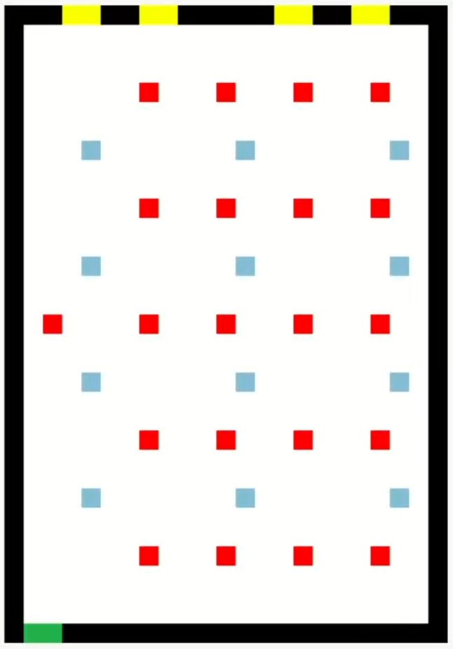 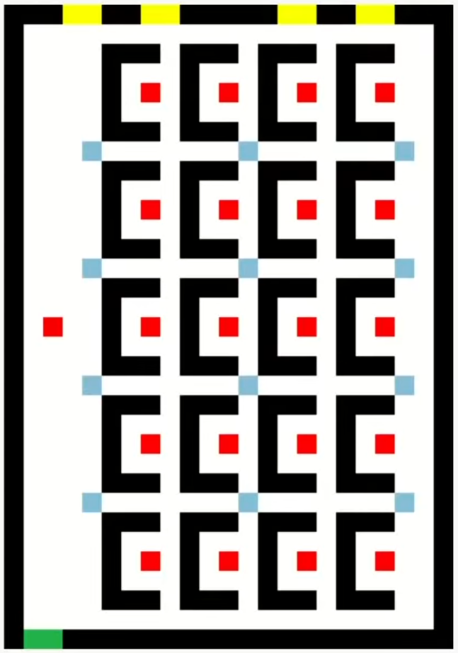

Figure 1: Classroom without barriers Figure 2: Classroom with barriers

The simulation will first be run without the glass barriers, and the results recorded and visualized before rerunning the simulation after the addition of the 3-sided glass barriers. The aim of this is to determine whether the barriers have an effect on the spread of exhaled air in a classroom.

**Formal Specification**

CO2= < Xlist, Ylist, S, X, Y, η, N, {t1, t2}, C, B, Z >,

Where:

Xlist= Ylist = {Ø};

S = type: {0, 1, 2, 3, 4, 5} and conc: {double};

X = Y = Ø;

η = 5;

N = {(0,0), (-1, 0), (0, -1), (0, 1), (1, 0)};

t1= 23;

t2 = 33;

C = {Cij/ i∈[0,20] ˄j∈[0,25]};

B = {∅}

**Experiments and Results**

The first experiment is performed without the addition of the glass barriers between students. The classroom is set up as a 23 cell by 33 cell area, with impermeable walls forming the boundary. One of the walls has an open door (2 cells) near the corner, while the opposite wall has four windows (2 cells each). The teacher is a source that is placed at the middle-front of the classroom. There are 20 students in 4 rows of five spaced equally away from each other. A reasonable amount of vents are placed around the classroom.



Figure 3: Color legend for CO2 levels [1]

We can see that although the room starts out without much CO2, it quickly starts to fill up. The door, windows and vents can’t seem to keep up with the CO2 production from 21 people in a small space.

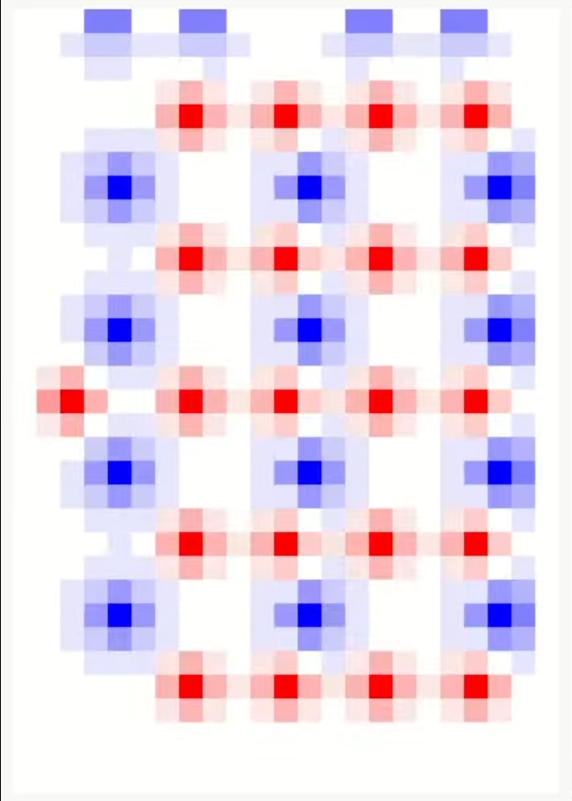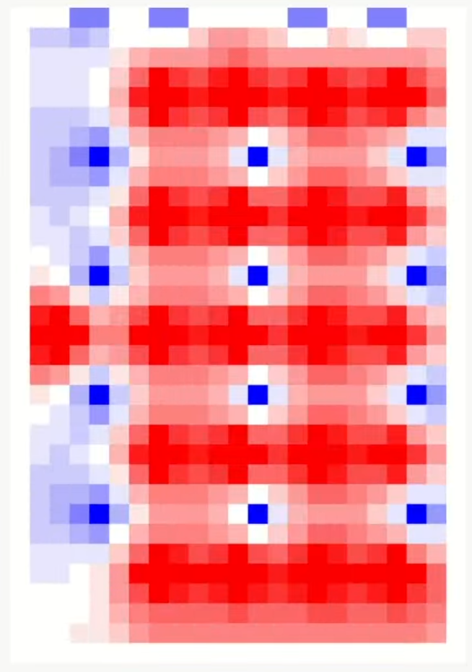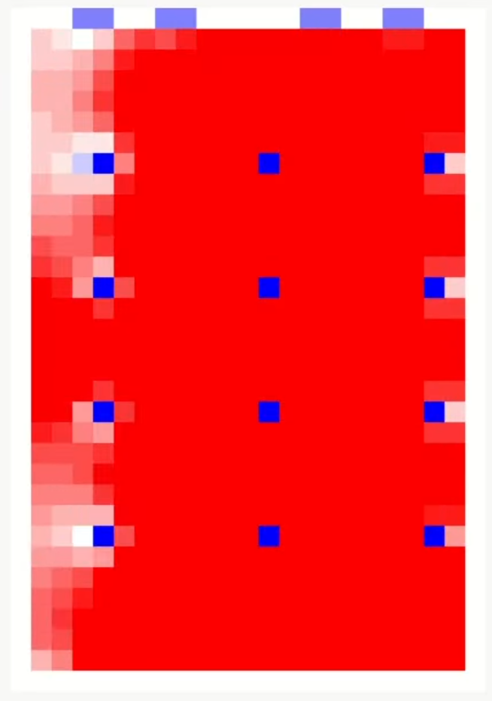

Figure 4: Classroom CO2 levels at the start, middle and end of experiment 1

The second experiment was done after adding a barrier for each student that surrounds them on three sides (one cell thick). The results show that the barriers really stifle the flow of CO2 from student to student, and keeps each student's CO2 output localized near them. On a closer look, it seems that the results are too perfect, perhaps the thickness of the barriers are not allowing the diffusion of CO2 in the model to behave as it would in a real-life scenario.

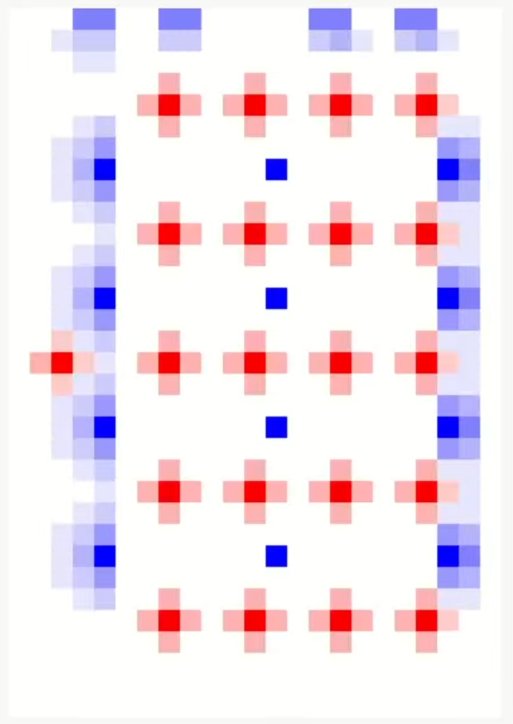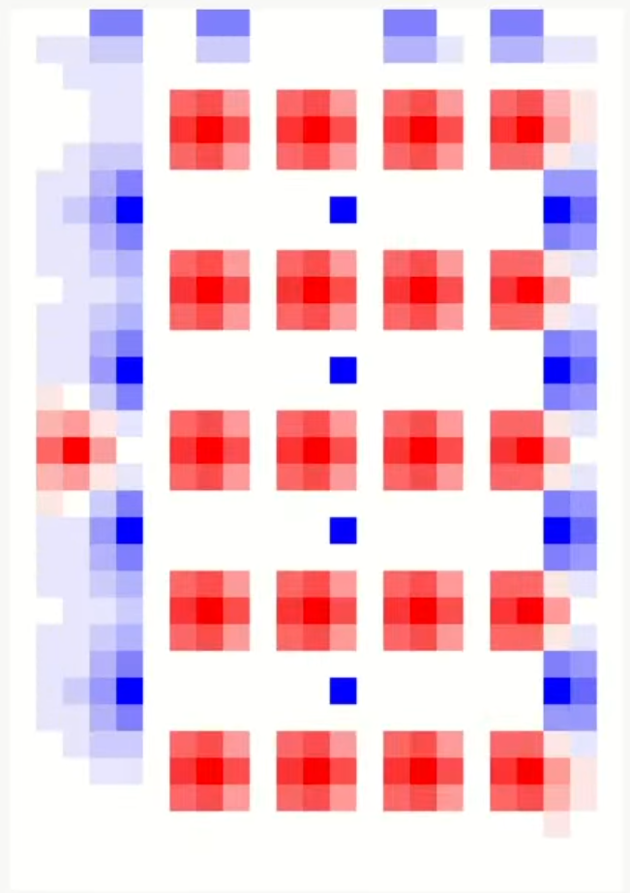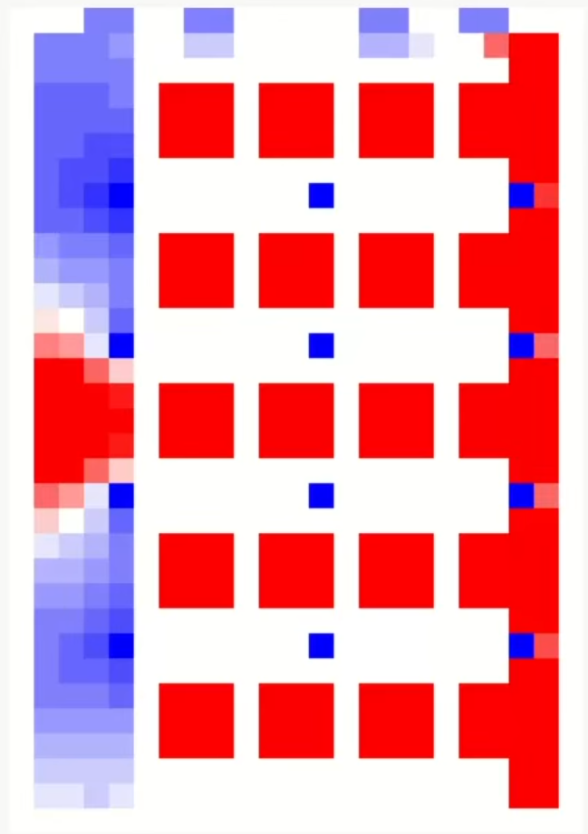

Figure 5: Classroom CO2 levels at the start, middle and end of experiment 2

The third experiment was done after removing the unneeded parts of the barriers. Since the model is using a Von Neumann neighborhood, the corners of the barriers are unused and removing them might give us better insight into how the CO2 levels change with more free space in the model.

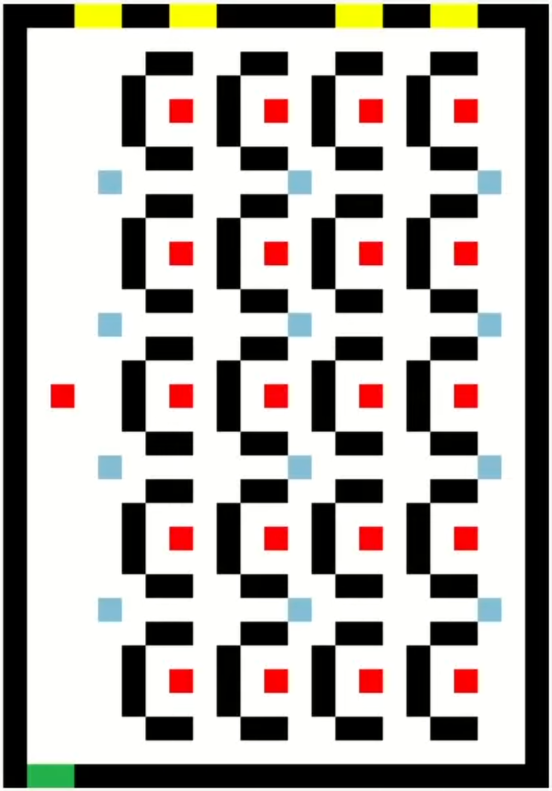

Figure 6: Layout of classroom with adjusted barriers

The results show that CO2 is still spreading all around the classroom, albeit slower than without the barriers. An interesting result is that the teacher at the front of the classroom was much more protected from the student’s CO2 when any barrier was present.

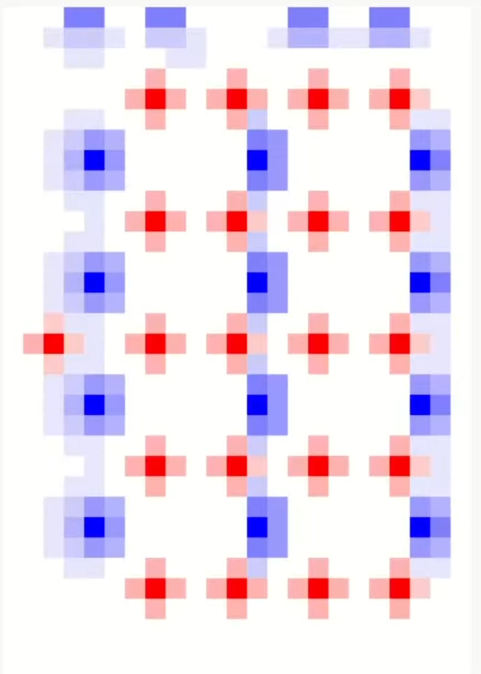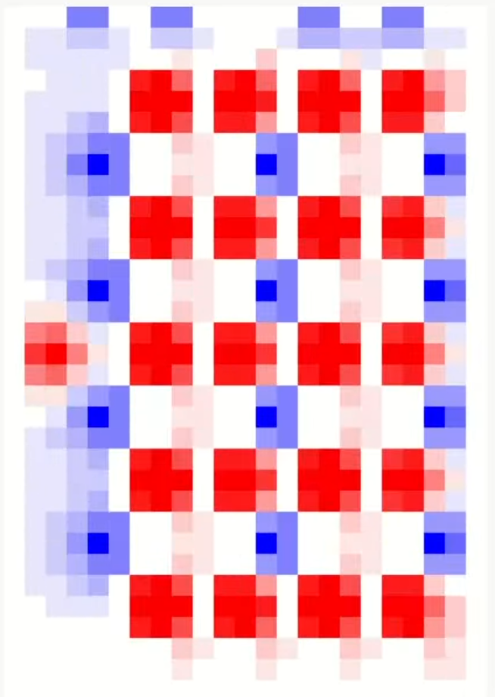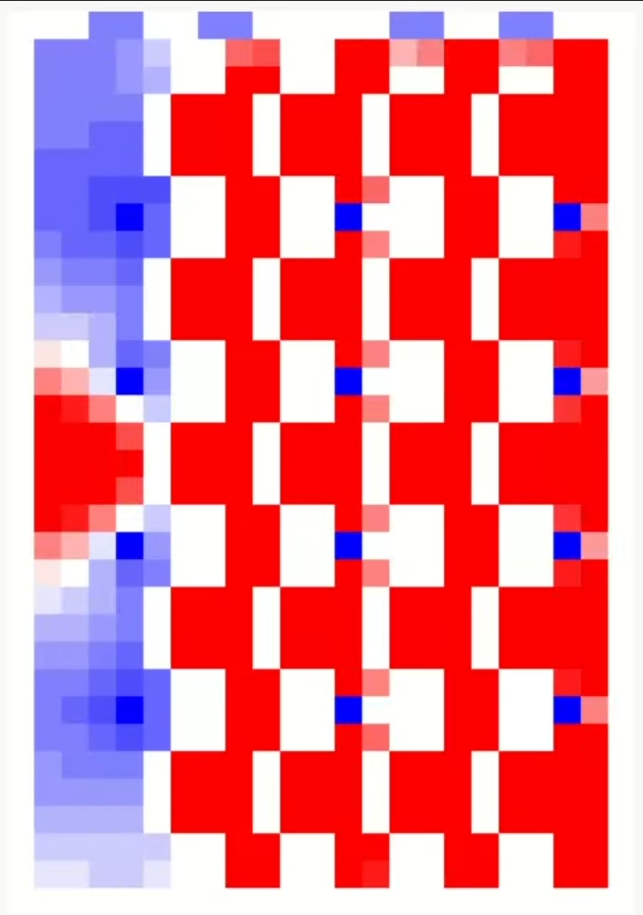

Figure 7: Classroom CO2 levels at the start, middle and end of experiment 3

**Conclusion**

It can be seen from the results that adding barriers around each student in a classroom might not be enough to stop the spread of their CO2/breath around to other students. This does not mean that they do not slow the spread of viruses like COVID-19 since the virus is most commonly passed through water particles or droplets during exhalation. We can see, however, that the teacher who is standing up at the front of the classroom seems to be the most protected. This is due both to the more isolated position they are in, as well as the 3-sided nature of the student’s barriers, which are open only at the side facing away from the teacher. More work can be done on this model, including testing semi-permeable barriers and adjusting the scaling of the model so as to make the barriers significantly thinner (this should make the model more accurate to real-life situations).