
Egypt University of Informatics
Computer and Information Systems
Data Analysis Course

The Analysis of Genes, Geography, and the Clock: Untangling What Really Affects Cancer Patients Worldwide.
Submitted by:
Mira Micheal 23-101038
Mennatallah Amr 23-101022
Maya Shalash 23-101004
Zeina Shaalan 23-101012

Introduction:

This project explores how both biological traits and environmental conditions shape cancer outcomes. Using global patient data from 2015 to 2024, we investigate the influence of gender, diagnosis stage, day of diagnosis, and country-specific factors on survival rates, cancer types, and obesity trends. Through statistical methods including ANOVA, chi-square, and correlation analysis, we aim to understand whether it’s our genetic makeup or the world around us that plays a bigger role in the cancer experience.

Research Question:
Do Genes Predict Cancer's Outcome, or Is Stage at Diagnosis the Real Game Changer?

Hypothesis:
1- : Is there a difference in cancer stage between males and females?
Null Hypothesis (H₀):
  - There is no difference in the distribution of cancer stages between males and females.
Alternative Hypothesis (H₁):
  - There is a difference in the distribution of cancer stage between males and females.
2- Is the stage at which a cancer is diagnosed has a stronger influence on survival and cancer severity than genetic predisposition?"
Null Hypothesis(H₀):
  - There is no difference in the influence of genetic predisposition and cancer stage at diagnosis on survival and cancer severity.
Alternative Hypothesis (H₁):
  - Cancer stage at diagnosis significantly influences survival and cancer severity more than genetic predisposition does.

Population of Interest:
Global cancer patients from 2015 to 2024, spanning multiple countries and regions, who have been characterized by clinical, genetic, lifestyle, and environmental factors.
- Timeframe: 2015–2024
- Geographic Scope: Multiple countries
( United Kingdom,China,Pakistan,Brazil,Germany,Canada,USA,India,Australia,Russia)
- Demographics: Includes patients of various ages and genders.

Sampling Method:
- Simple random sampling was used to ensure unbiased selection from the dataset. From a total of 33,600 cancer patient records (2015–2024), a random sample of 8,400 entries (25%) was selected. A further 6% sample (504 entries) was drawn from this subset for detailed analysis. Random seeds were used to maintain reproducibility and minimize bias.

Bias Identification:

1. Gender Bias
- The dataset contains three gender categories: Male, Female, and Other.
- The "Other" category likely represents a small minority, making statistical testing less reliable for this group.
Risk: Survey designs that generalize findings between "males vs females" may ignore or misrepresent non-binary individuals.
How to Address: Exclude “Other” only when statistically justified due to small N; otherwise, stratify analysis or oversample in future data collection.

2. Geographical Bias
- The dataset covers 10 countries, but the top country has 5,092 patients while the lowest may have far fewer.
- If some regions are underrepresented, results may be biased toward those dominant in the data (e.g., wealthier, more urbanized nations).
Risk: Skewed insights towards more represented regions, potentially wealthier or more urban.
Fix: Use weighting or stratified analysis by country.

3.Cancer Type/Stage Bias
- Cancer Type and Cancer Stage are categorical. Some cancers/stages may be over- or underrepresented.
Risk: Outcomes (like cost or survival) may be driven by which types dominate the data.
Fix: Disaggregate outcomes by cancer type & stage or control for them in models.

4. Environmental Confounder Bias

Environmental variables include air pollution, smoking, alcohol use, obesity.

Risk: Potential residual confounding or unmeasured environmental variables (e.g., diet, occupation).

Fix: Acknowledge and list excluded environmental variables.
Consider sensitivity analyses.
Explore interactions between environmental exposures and other variables.

Additional Considerations

Temporal Bias: The dataset spans 2015–2024. Medical practices, treatment access, and diagnostic standards likely evolved.

Collected Dataset:

https://www.kaggle.com/datasets/zahidmughal2343/global-cancer-patients-2015-2024
Feature Name | Description
Patient_ID | Unique identifier for each cancer patient
Age | Age of patient at time of diagnosis (ranging from 20 to 89)
Gender | Gender identity (Male, Female, Other)
Country_Region | Patient's country or region of residence (10 distinct countries)
Year | Year of diagnosis (from 2015 to 2024)
Genetic_Risk | A score (0–10) estimating hereditary/genetic predisposition to cancer
Air_Pollution | A score (0–10) representing exposure to air pollution in their environment
Alcohol_Use | A score (0–10) measuring alcohol consumption level
Smoking | A score (0–10) reflecting tobacco use
Obesity_Level | A score (0–10) assessing obesity or BMI-related risk
Cancer_Type | Type of cancer diagnosed (e.g., Lung, Breast, Colon, etc.)
Cancer_Stage | Stage of cancer at diagnosis (Stage 0 to Stage IV)
Treatment_Cost_USD | Cost of treatment in US dollars ($5,000–$100,000)
Survival_Years | Number of years patient survived post-diagnosis (0–10 years)
Target_Severity_Score | Composite score (0.9–9.16) reflecting overall cancer severity

Analysis:
Descriptive Statistics Analysis

Period : 2015 - 2024:
The data sampled from the original dataset is a total of 504 observations
- Age :
- Mean : 54.25
- Standard deviation :20.00
- Minimum : 20.00
- Maximum : 89.00
- Genetic Risk :
- Mean :4.99
- Standard deviation :2.85
- Minimum : 0.00
- Maximum : 10.00
- Air Pollution :
- Mean :5.02
- Standard deviation :2.87
- Minimum : 0.00
- Maximum : 10.00
- Alcohol Use :
- Mean : 4.96
- Standard deviation :2.90
- Minimum : 0.00
- Maximum : 10.00
- Smoking :
- Mean :4.67
- Standard deviation :2.96
- Minimum : 0.00
- Maximum : 10.00
- Obesity Level :
- Mean : 4.98
- Standard deviation :2.95
- Minimum : 0.00
- Maximum : 10.00
- Treatment Cost USD :
- Mean : 54126.04
- Standard deviation :27156.92
- Minimum : 5828.69
- Maximum : 99982.37
- Survival Years :
- Mean : 4.94
- Standard deviation :2.90
- Minimum : 0.00
- Maximum : 10.00
- Target Severity Score :
- Mean : 4.84
- Standard deviation :1.14
- Minimum : 0.95
- Maximum : 7.90

Data Visualization
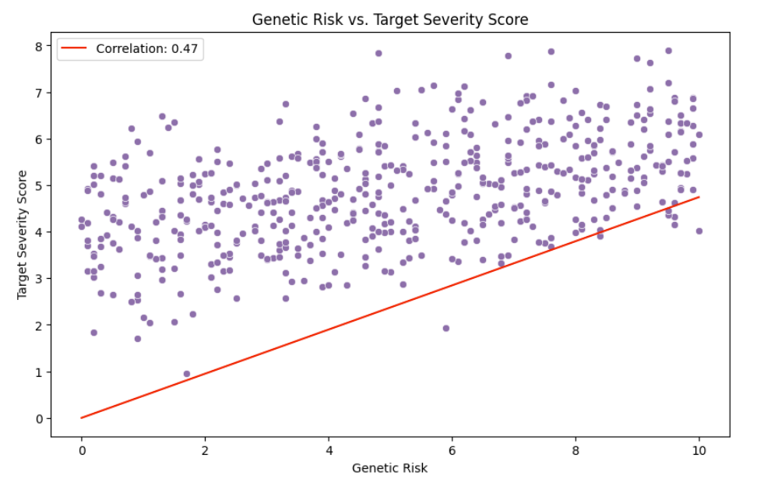

1) Genetic Risk vs Target severity score:
The x-axis represents the Genetic Risk, the Y-axis represents the Target severity score.The scatter plot demonstrates a moderate positive linear relationship between Genetic Risk and Target Severity Score, as the correlation coefficient (r = 0.47), with data points generally following an upward trend from left to right despite noticeable scatter. Visually, the relationship appears roughly linear while a few slightly deviating points do not substantially distort the overall trend. The data points are uniformly distributed across the range of Genetic Risk values, with no strong clustering around any single risk level. The Target Severity Scores exhibit mild vertical clustering between scores of 4 and 6. Statistically, the correlation reflects a moderate effect size (per Cohen’s guidelines), indicating that higher genetic risk tends to be associated with higher severity scores.

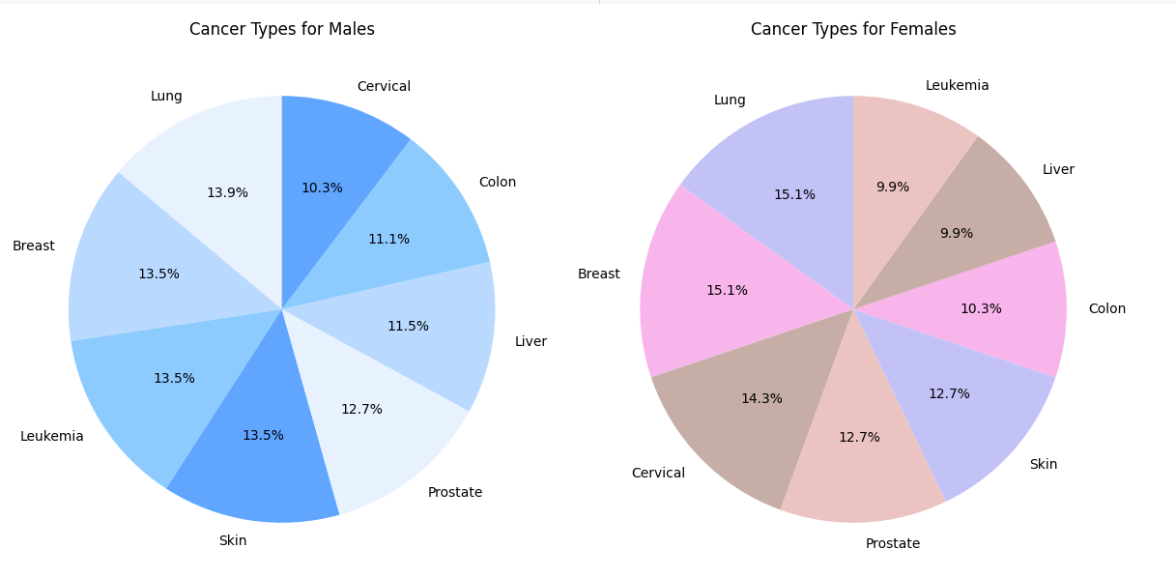

2)Male vs Female and Cancer Types:
The pie charts comparing cancer types in male and female patients reveal some clear patterns—and a few surprises. Breast cancer, though more commonly linked to women, shows up in men as well at 13.5%, which could reflect actual cases or possibly data entry errors. In women, breast cancer and Lung cancer (15.1%) and cervical cancer (14.3%) are the most common types, matching broader health trends. However, cervical cancer is also listed for male patients (10.3%), which isn't biologically plausible and likely points to suggests data entry errors or mislabeling. Lung cancer stands out across both genders—13.9% in men and 15.1% in women—highlighting shared risk factors like smoking or environmental exposure. Overall, these differences and inconsistencies show why it’s crucial to separate data by gender and ensure quality checks, especially when dealing with gender-specific cancers. Doing so helps avoid confusion and supports more accurate, targeted healthcare decisions.

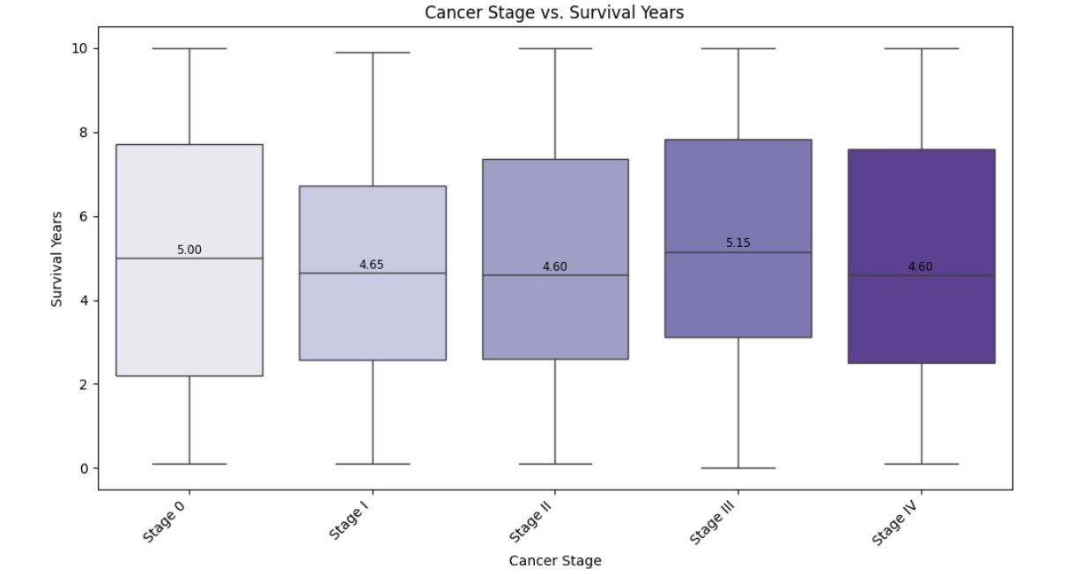3)Cancer stage vs survival years:
The boxplots show that survival times are surprisingly similar across all cancer stages, with median values ranging from 4.60 to 5.15 years. This goes against the usual expectation that survival decreases with more advanced stages. Each stage also has a wide range of outcomes, suggesting that factors beyond stage—like treatment, age, or cancer type—may be driving survival more than stage alone. Notably, Stage III shows the highest median survival, even above Stage 0, which may point to data issues or unexpected treatment effects. Overall, cancer stage doesn’t appear to strongly predict survival on its own, and deeper analysis is needed to explain the variation.

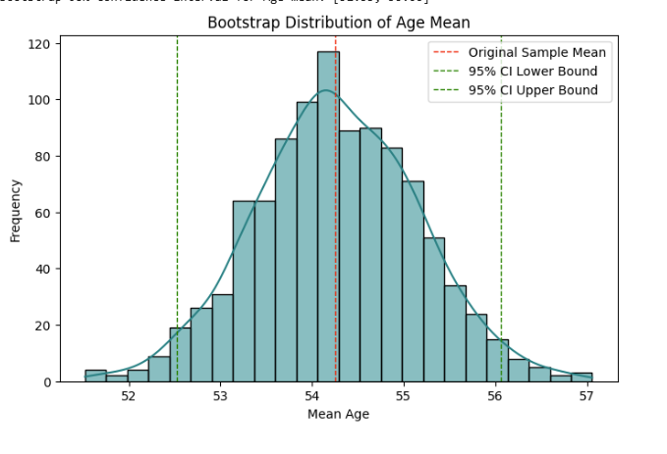5)Bootstrapping observation on mean age:
The histogram displays the distribution of mean ages calculated from 1,000 bootstrap samples. Visually, the curve is smooth and bell-shaped, centred around 54.25 years, indicating that this is the most typical average age in the dataset. This suggests that even if we collected different samples from the same population, the average age would likely remain close to 54. The fact that the distribution looks like a normal curve gives us more confidence that the sample mean is a reliable measure that we can base conclusions on. The 95% confidence interval for the mean age between 52.54 and 56.03, as marked on the chart. This range reflects the expected variability across samples and confirms that the mean is statistically stable, offering strong confidence in its reliability as a representative measure of the population’s average age.
we already contributed other bootstrapping mean graphs on (Genetic Risk,Alcohol use,Air Pollution,Obesity level & Smoking)

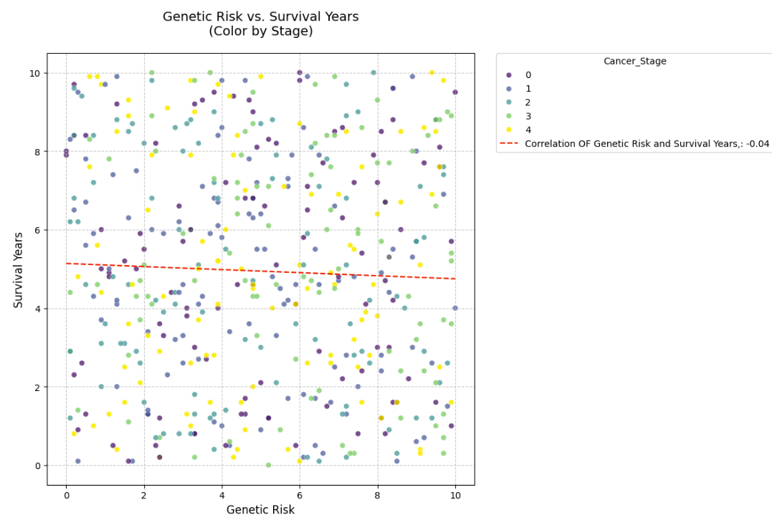
6)Correlation between genetic risk and survival years:
The plot shows no strong visual trend between genetic risk and survival years. The red dashed regression line is nearly flat, and the computed correlation coefficient is -0.04, indicating an extremely weak negative relationship.
Despite coloring by cancer stage, survival years appear evenly spread across all levels of genetic risk, with no clear pattern or slope that suggests higher genetic risk leads to shorter survival.

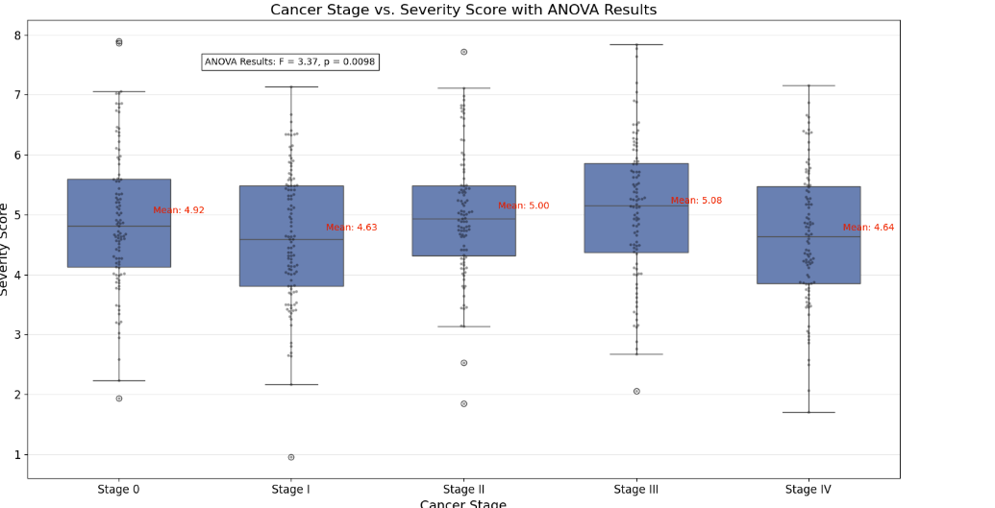
7)Anova test:
The boxplot compares severity scores across cancer stages and includes ANOVA results indicating a statistically significant difference (F = 3.37, p = 0.0098). However, while the p-value suggests some variation, the mean severity scores across stages are quite similar—ranging from 4.63 (Stage I) to 5.08 (Stage III). There is no clear increasing or decreasing trend as stage progresses, which is counter to expectations that higher stages would reflect greater severity. Stage III has the highest average score, but the differences between groups are relatively small. The overlap in interquartile ranges across all stages further emphasizes this similarity. Overall, while stage appears to have a statistically significant relationship with severity score, the practical differences between stages are modest, suggesting that severity may be influenced by additional clinical factors beyond just stage classification.

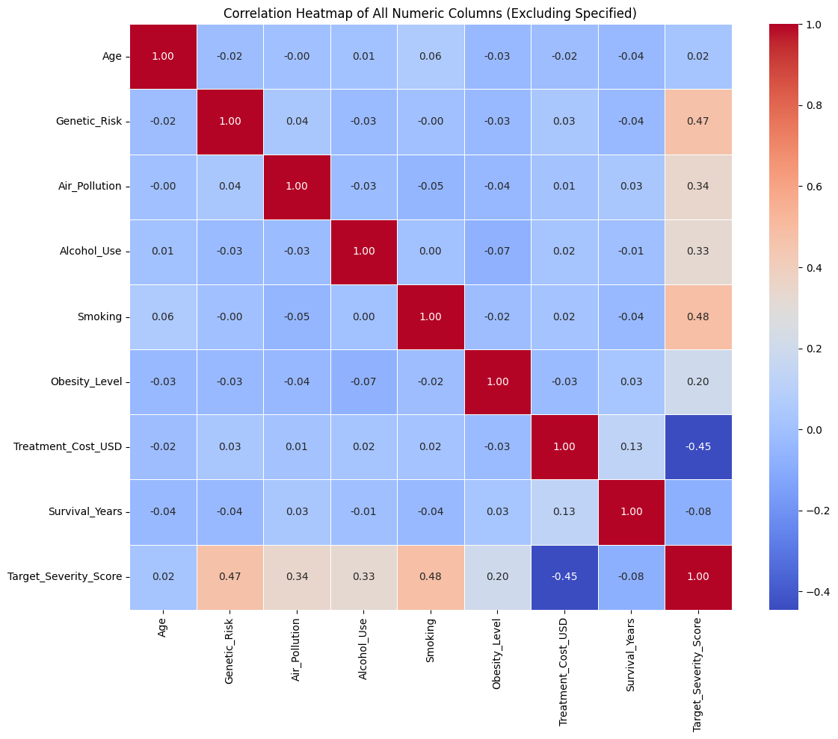
8)
Genetic_Risk (r= 0.47) has the second strongest positive correlation with Target_Severity_Score, meaning that as genetic risk increases, cancer severity tends to increase too.
Among all variables, smoking (r = 0.48) had the strongest positive correlation with severity score, followed by genetic risk (r = 0.47), air pollution (r = 0.34), and alcohol use (r = 0.33). Interestingly, treatment cost showed a negative correlation (r = −0.45), which may reflect the possibility that more severe cases receive limited or palliative care rather than intensive treatment.
Treatment_Cost_USD (-0.45) is negatively correlated with severity — likely because more severe cases require less treatment.
Age and survival-Year have little to no correlation with severity in this dataset.

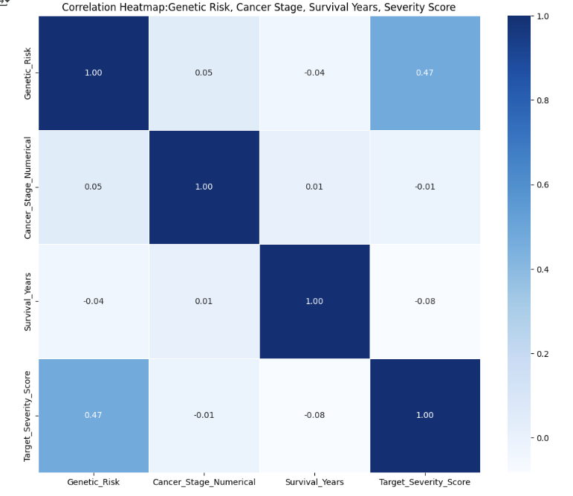
9)Interpretation:
Genetic Risk vs Survival Years
Pattern: Slight downward trend; higher genetic risk is loosely associated with shorter survival.
Correlation: −0.04
Interpretation: There is a very weak negative relationship between genetic risk and survival years.

Cancer Stage vs Survival Years
Pattern: No noticeable relationship; survival years do not appear to be influenced by cancer stage in this dataset.
Correlation: +0.01
Interpretation: Cancer stage has no significant impact on survival years based on the given correlation.

Genetic Risk vs Severity Score
Pattern: Moderate positive trend; patients with higher genetic risk tend to have more severe cancer scores.
Correlation: +0.47
Interpretation: There is a moderate positive relationship between genetic risk and severity score.

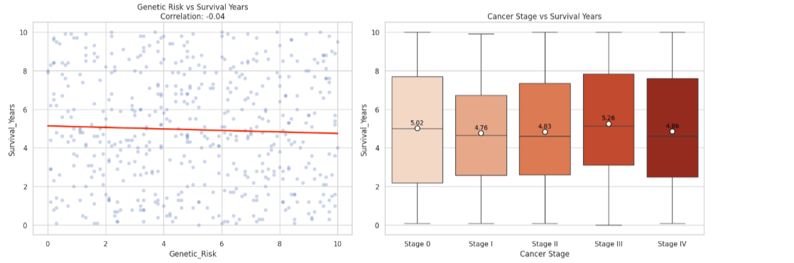

10)
Interpretation:
1. Genetic Risk vs Survival Years
Visual: Scatter Plot with trend line.
Correlation: −0.04

Interpretation:
This plot shows a very slight negative trend, with the regression line sloping gently downward. However, the points are widely dispersed, and the calculated correlation of −0.04 confirms that the relationship is extremely weak. Therefore, we conclude that genetic risks alone are not predictive of survival duration in this dataset..
Conclusion: There is no statistically significant relationship between genetic risk and survival time.
2. Cancer Stage vs Survival Years
Visual: Boxplot by Cancer Stage
Median Survival Years:
Stage 0: Mean survival ~5.02 years
Stage I–IV: Fairly consistent (ranging ~4.6 to 5.3 years)
Interpretation:
Contrary to clinical expectations, there is no clear inverse trend between cancer stage and survival years. In fact, Stage III shows the highest average survival at ~5.26 years. which is counterintuitive. This could point to:
- Effective treatment at later stages
- Small sample sizes or variability in the dataset
- Confounding factors (e.g., treatment intensity, cost)
Conclusion: Cancer stage shows no significant impact on survival years in this sample.

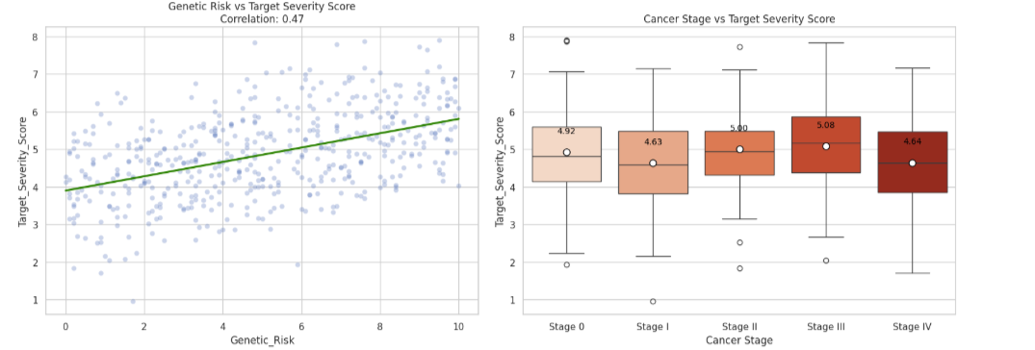
3. Genetic Risk vs Severity Score
Visual: Scatter Plot with trend line.
Correlation: +0.47 (moderate positive)
Interpretation:
This plot presents a clear upward trend. The regression line and the moderate positive correlation indicate that higher Genetic Risk is associated with higher Severity Scores. The trend is visually supported and statistically meaningful.
Conclusion: There is a moderate positive relationship—patients with higher genetic risk tend to experience more severe cancer profiles.
4. Cancer Stage vs Severity Score
Visual: Boxplot by Cancer Stage
Severity score increases slightly from Stage 0 → III
Slight dip in Stage IV (average score drops to 4.64) after peaking at Stage III (5.08)
Interpretation:
Although there is a slight increase in severity scores from Stage I to Stage III, the pattern is inconsistent, and Stage IV shows a drop again. The wide, overlapping ranges confirm the lack of a clear trend.
Conclusion: There is no strong or consistent relationship between cancer stage and severity score.

Hypothesis Testing Steps

· Step 1: Define null and alternative hypothesis
· Step 2: Choose the appropriate test
· Step 3: Calculate the p-value
· Step 4: Determine the statistical significance

Hypothesis One:
Is there a difference in the distribution of cancer stages between males and females?
- Step 1:Define Null and alternative hypothesis
Null Hypothesis (H₀):
H₀: P(Cancer Stage∣Male)=P(Cancer Stage∣Female)

There is no difference in the distribution of cancer stages between males and females.
Alternative Hypothesis (H₁):
(H₁): P(Cancer Stage∣Male)=P(Cancer Stage∣Female)
There is a difference in cancer severity between males and females.

- Step 2:
Chi-squared: evaluates whether two categorical variables (Gender and Cancer_Stage) are independent or dependent .

- Step 3:
χ2=6.271, χ2 =6.271, df = 3,
p- value=0.043
Conclusion:
At the 5% significance level, this p-value is less than α = 0.05. Thus, we reject the null hypothesis and conclude that there is a significant association between gender and cancer stage. This finding suggests that the distribution of cancer stages at diagnosis is not the same for males and females, implying that gender may play a role in how or when cancer is detected or diagnosed across stages.

Hypothesis Two:
- Step 1:Define Null and alternative hypothesis
1. Correlation: Genetic Risk vs. Survival Years
H₀: ρ = 0 (No linear correlation between genetic risk and survival years)
H₁: ρ ≠ 0 (There is a linear correlation between genetic risk and survival years)
2. ANOVA: Cancer Stage and Severity Score
H₀: μ₁ = μ₂ = ... = μₖ (Mean severity scores are equal across all cancer stages)
H₁: ∃ i, j such that μᵢ ≠ μⱼ (At least one group mean is different from the others)

- Step 2:
1:Correlation between Genetic risk and survival years
2:Anova test : Grouped means across different cancer stages with severity score

- Step 3:
p- value Genetic risk and survival years: 0.4408
p value of anova test (F = 3.37, p = 0.0098)

- Step 4:
Conclusion:
Correlation:
With significance level of 0.05, and the correlation analysis between genetic risk and survival years yields a p-value of 0.4408, we conclude that we failed to reject the null hypothesis .Therefore, we do not have sufficient evidence to conclude that a correlation exists between genetic risk and survival time in the population studied.

Anova test:
Based on the ANOVA test results, with a p-value of 0.0098 and significance level of 0.05, we reject the null hypothesis. This provides statistical evidence that mean severity scores are not equal across all cancer stages. In other words, the test reveals that at least one cancer stage differs significantly in terms of severity score.

Taken together, the statistical findings suggest that cancer stage at diagnosis is a more powerful determinant of disease severity than genetic predisposition is of survival. While genetic risk does not show a statistically significant relationship with survival years, cancer stage clearly differentiates severity levels, highlighting the clinical importance of early detection and staging in cancer prognosis and treatment planning.

Conclusion
This study shows that the stage of cancer at the time of diagnosis is very important in determining how severe the disease is (p = 0.0098). Although the differences between stages are not very large in real life, finding cancer early is still key to better treatment results.
On the other hand, genetic risk did not show a clear link with how long people survived (r = -0.04, p = 0.44). This suggests that simply having a genetic risk does not reliably predict how well someone will do. Overall, these results show that cancer outcomes depend on many factors, and knowing the cancer stage is more helpful for treatment than knowing about genetic risks.
The study also found a difference between men and women in how cancer stages were spread (p = 0.043). This may be due to biological differences, social factors, or how cancer is diagnosed. More research is needed to understand these gender differences in diagnosis and treatment.
Environmental and lifestyle factors like smoking, drinking alcohol, and air pollution were somewhat linked to cancer severity. This supports the idea that these factors can make cancer worse. However, other unmeasured factors like diet or access to healthcare might also play a role, so these results should be viewed carefully.
Interestingly, some cancers in more advanced stages (like Stage III) seemed to have better survival than those in earlier stages (like Stage 0). This surprising finding could be because of missing data, differences in treatment, or how the study was done. These problems show why it’s important to have good data and follow patients over time in future studies.

Any potential issues
While the analysis provides valuable insights into the relationship between cancer stage, genetic risk, and survival outcomes, several potential issues could affect the validity and generalizability of the findings:

1. Data Quality & Misclassification Errors
Gender-Specific Cancer Mislabelling: The presence of cervical cancer in male patients and breast cancer in males at a high rate suggests possible data entry errors or misclassification.

Inconsistent Staging Definitions: If cancer staging criteria varied across countries or hospitals, comparisons may be unreliable.

Missing or Incomplete Data: If key variables (e.g., treatment details, comorbidities) were missing, the analysis may suffer from omitted variable bias.

2. Sampling & Representativeness
Geographical Bias: Overrepresentation of certain countries (e.g., the U.S. or U.K.) could skew results if healthcare access, diagnostic practices, or genetic risks differ significantly by region.

Temporal Bias: Changes in diagnostic technology, treatment standards, or data collection methods between 2015 and 2024 may introduce confounding.

Underrepresentation of Minorities: If certain demographics (e.g., non-binary individuals, rural populations) were underrepresented, findings may not generalize.

3. Statistical & Methodological Limitations
Weak Correlation Interpretation: The near-zero correlation between genetic risk and survival years (-0.04) may not indicate a true lack of relationship—nonlinear associations or interactions with other variables (e.g., treatment response) could exist.

ANOVA Assumptions Violation: If severity scores were not normally distributed or variances were unequal across cancer stages, the ANOVA results may be unreliable.

Survival Analysis Limitations: Survival years may be right-censored (patients still alive at the end of the study), leading to underestimated survival times.

4. Confounding Variables
Unmeasured Lifestyle & Environmental Factors: Diet, occupational hazards, and healthcare access were not included but could influence both cancer stage and survival.

Treatment Effects: Differences in treatment protocols (e.g., chemotherapy, immunotherapy) could drive survival outcomes more than stage or genetics alone.

5. Biological & Clinical Plausibility Issues
Counterintuitive Survival Trends: The finding that Stage III patients had higher median survival than Stage 0 contradicts clinical expectations, suggesting:

Data errors (e.g., incorrect staging).

Aggressive early-stage cancers vs. indolent late-stage cases.

Treatment disparities (e.g., Stage III patients receiving better care).

Genetic Risk Measurement: If the genetic risk score was based on limited markers, it may not fully capture hereditary cancer predisposition.

6. Ethical & Reporting Considerations
Gender Exclusion: Omitting the "Other" gender category due to small sample size may marginalize non-binary individuals in cancer research.

Overgeneralization: Conclusions about "genes vs. stage" may oversimplify cancer etiology, which is multifactorial (genes + environment + behavior).

Recommendations for Future Work
Improve Data Validation: Verify cancer type and stage classifications, especially for gender-specific cancers.

Stratified Analysis: Examine effects by country, treatment type, and cancer subtype to reduce confounding.

Expand Variables: Include socioeconomic status, treatment details, and comorbidities for better-adjusted models.

Address Sampling Bias: Ensure proportional representation across regions and demographics in future datasets.

Final Note
While the study highlights important patterns, these limitations suggest cautious interpretation. Further research with refined data and methods is needed to disentangle the complex interplay of genes, stage, and environment in cancer outcomes.

