1. Install docker on VM



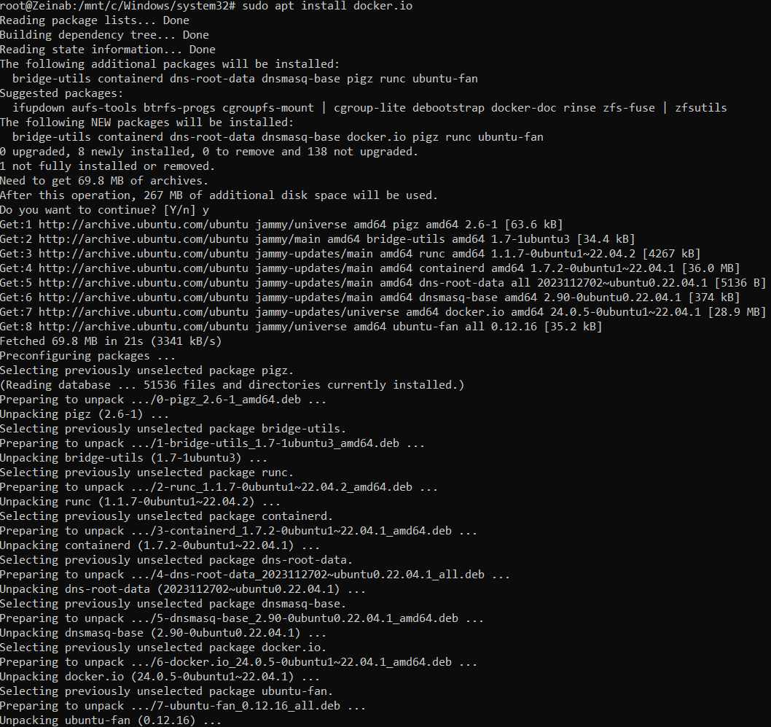



2-Create container for odoo (official image)

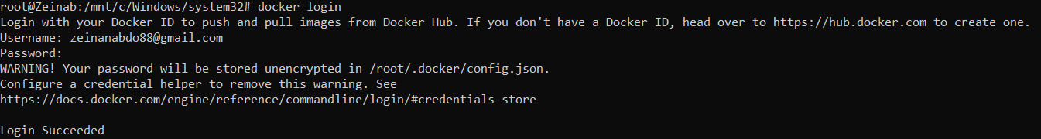

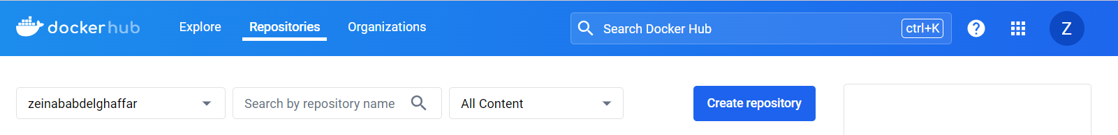

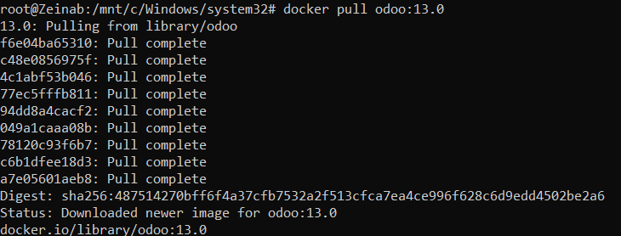

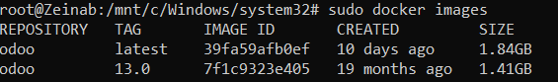

3-How odoo implements its system (odoo app and its database)

