Simple Search for the hyperparameters



Results on the entire dataset



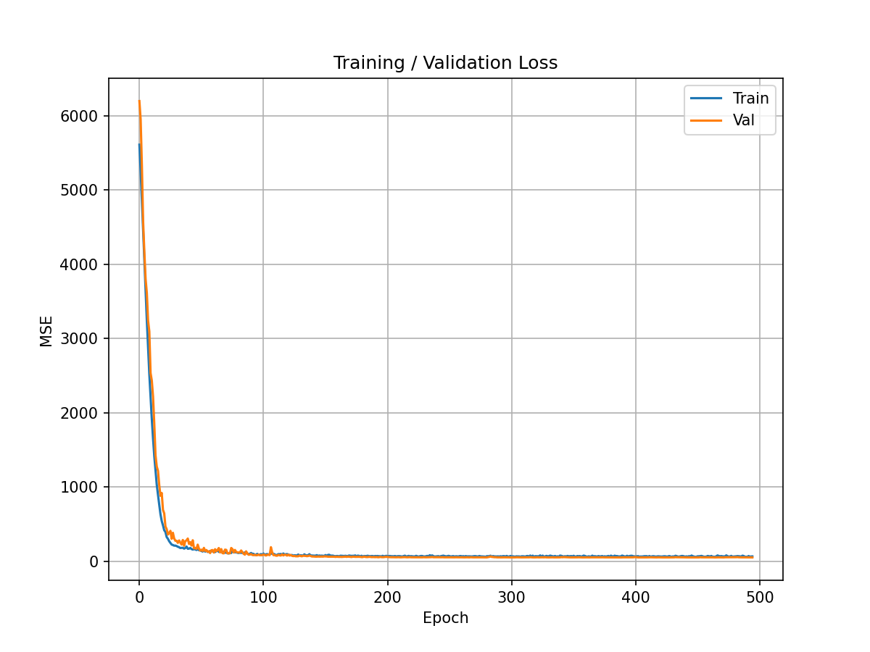

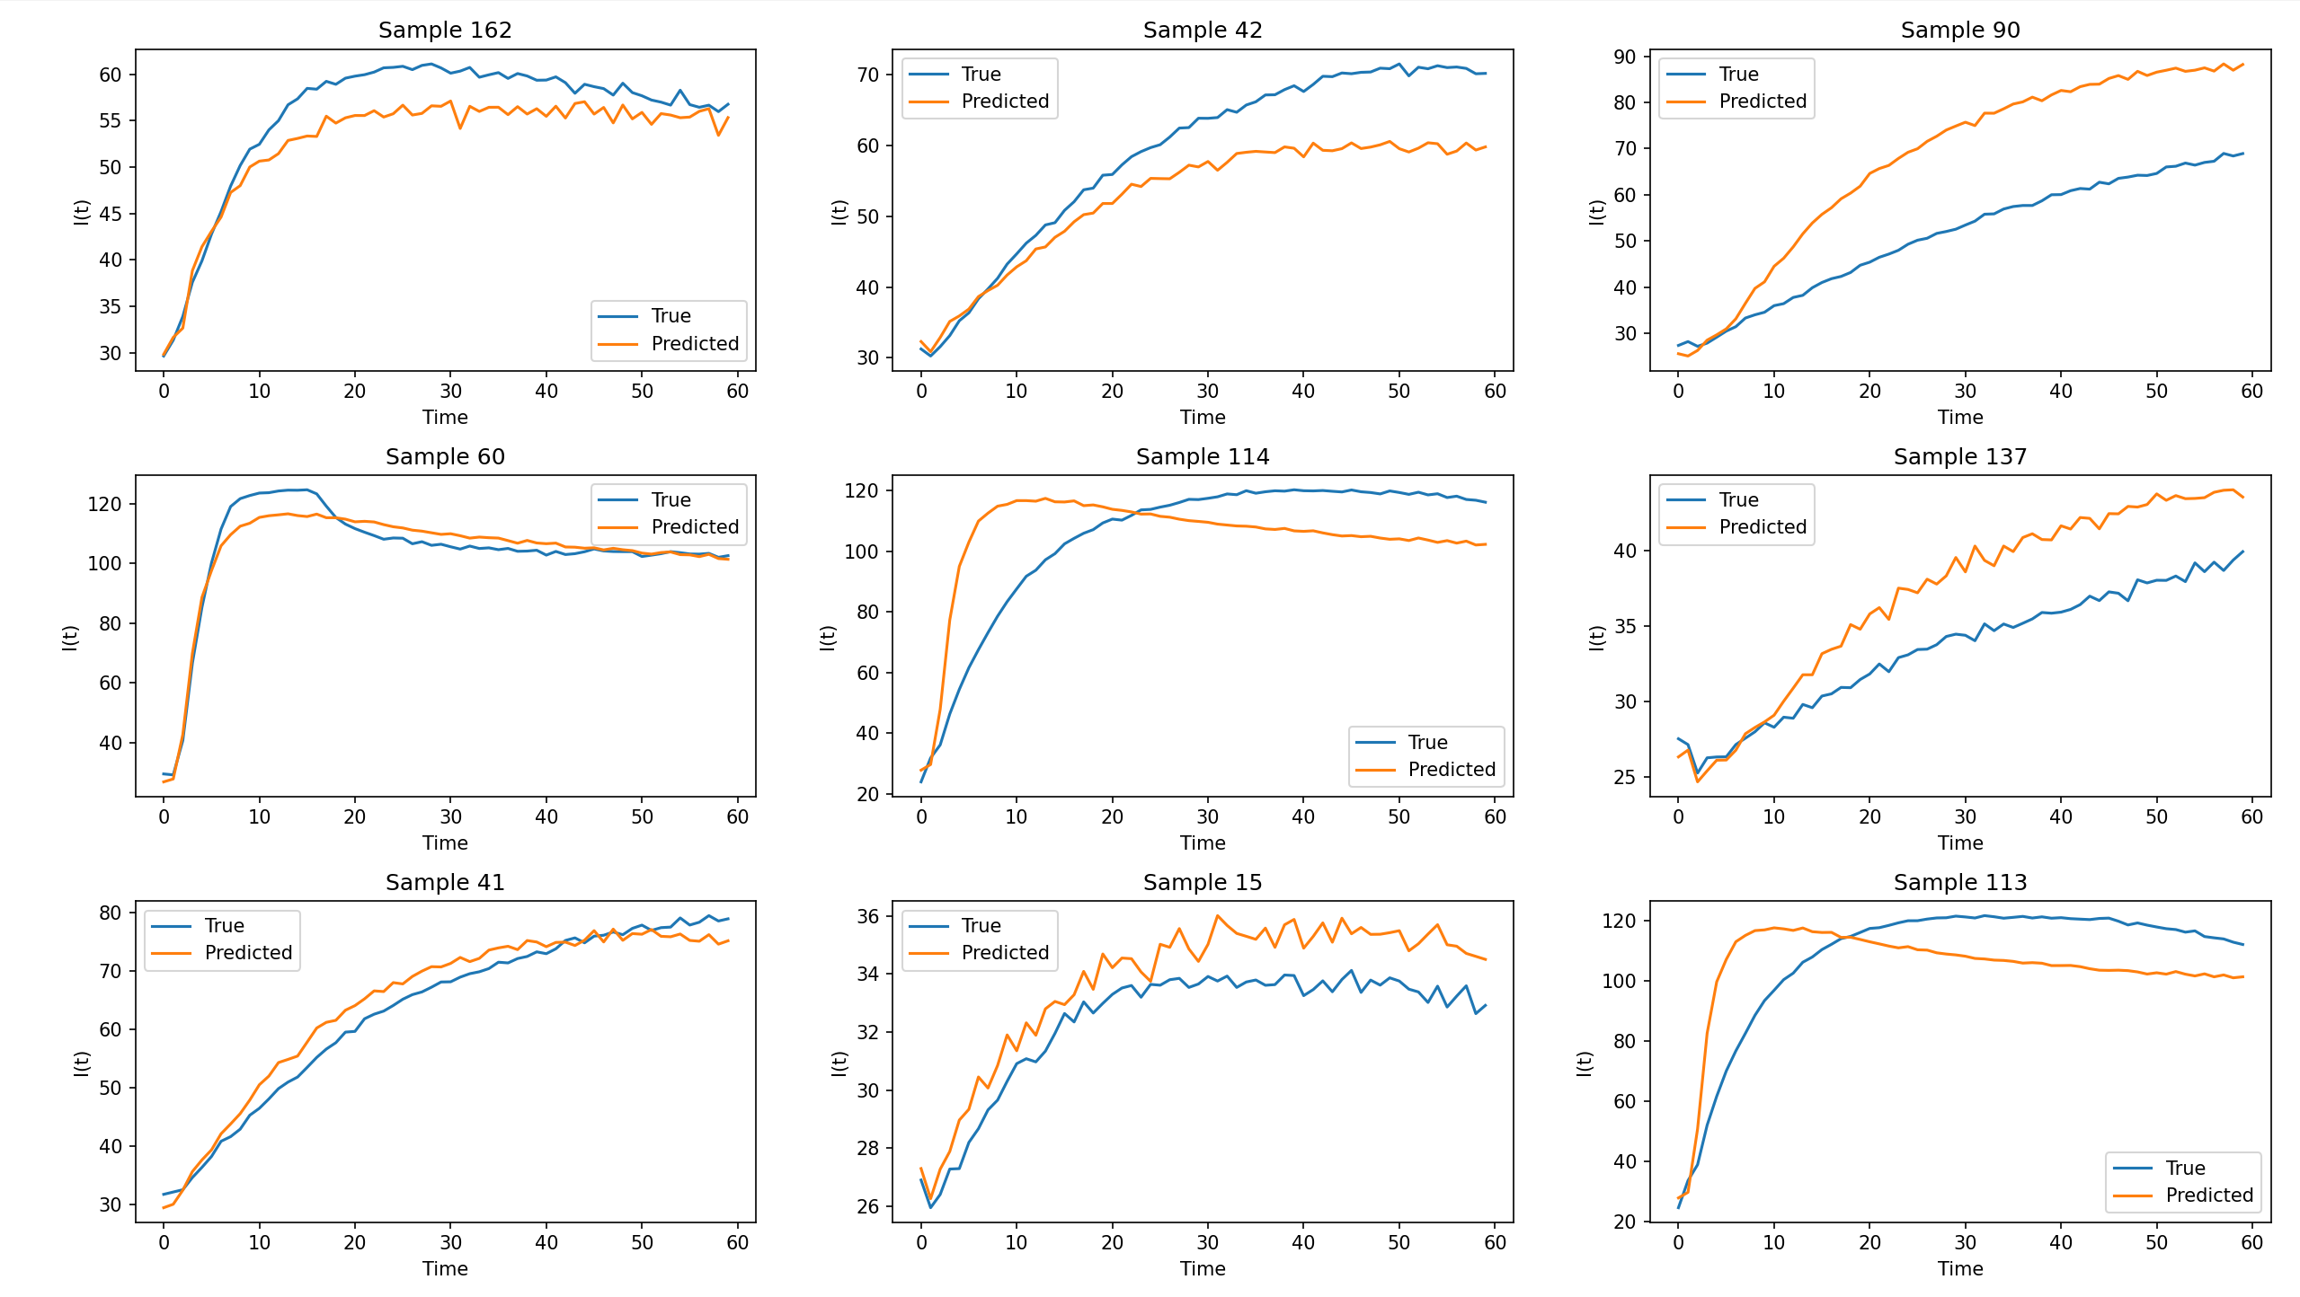

Three Criteria evaluated on the selected test samples:

1. $t_{90\%}$: time to reach the $90\%$ of the maximum of the smoothed curve (window=5)
2. $I_{max}$: the maximum of the smoothed curve
3. $p$: the ratio of the mean value of the last 5 points of the original curve to $I_{max}$

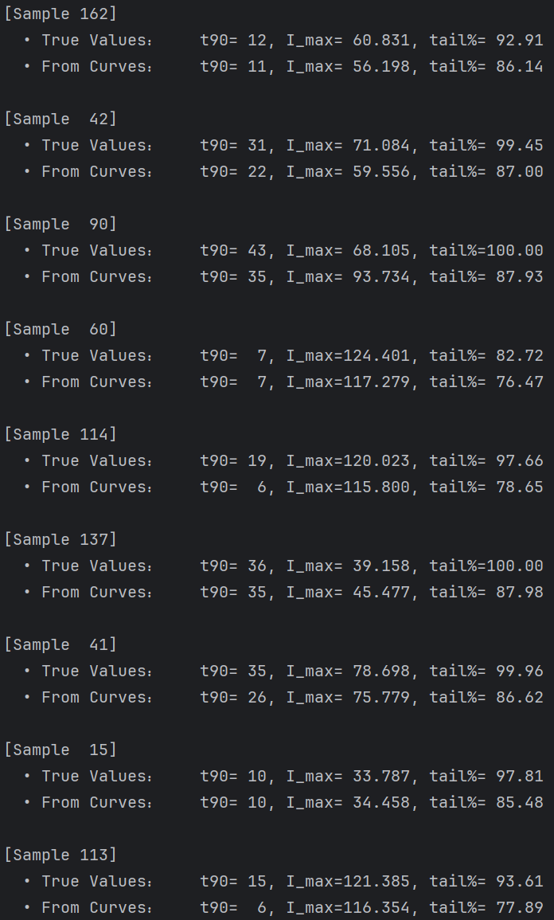

Comments:

Since we are directly optimizing the MSE, which is more sensitive to high-value samples, such as curves with higher maximum intensity, the trained model made better reconstructions of this kind of curve. Potentially, if the acquisition function of Bayesian Optimization is set to attend more to the exploitation, the bias caused by MSE loss seems trivial, but if exploration is considered, this bias should be fixed to avoid incorrect predictions in unknown regions. And it’s still unknown whether directly using an MLP/ML model to reconstruct the three criteria is better than the current framework, but less explainable.

Examples of Criteria

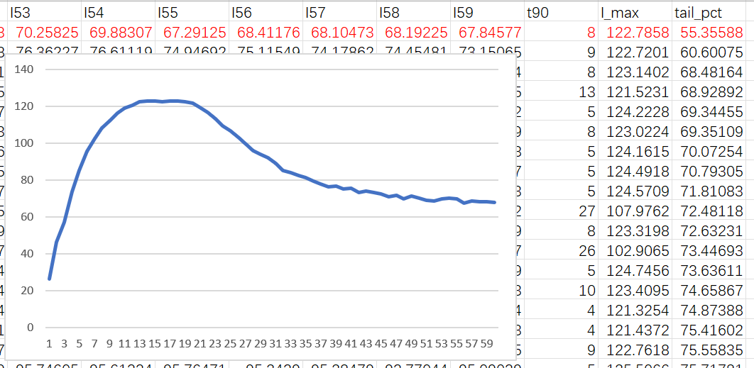

Results of directly regressing criteria



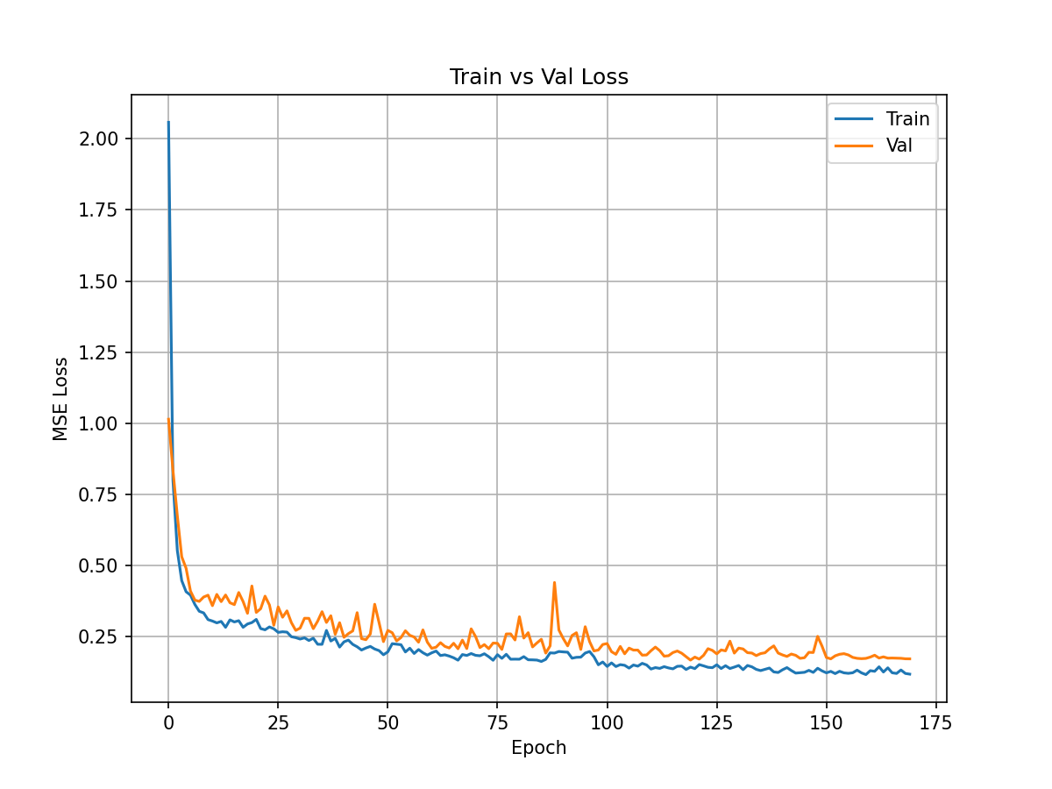

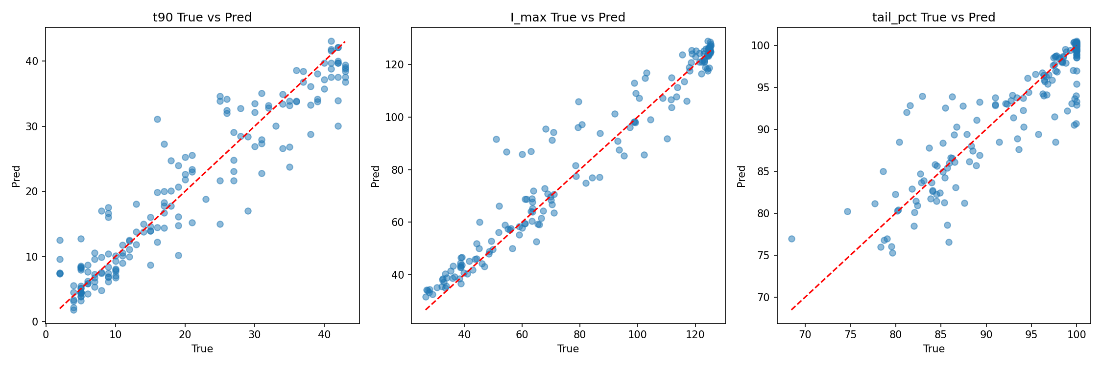

Comparison between Regressing Curves and Regressing Criteria

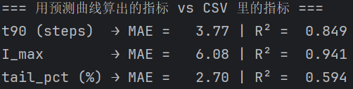

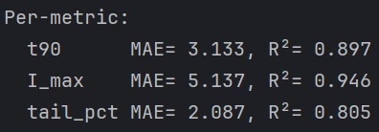

Conclusion:

It’s really clear that directly regressing criteria can give us more accurate results. At this stage, to the best of my knowledge, predicting criteria can give better results, thus we can explore more models to capture the mapping from the concentration vector directly to the criteria. Thus, since the data is quite simple (no need for DNNs /RNNs to reconstruct the entire curve), we can sort algorithms for tabular data.