System Design for Attendance Tracker Application
The NFC Attendance Tracker Application enables Professors to record attendance for their classes with increased speed and accuracy when compared to traditional methods of manually recording attendance. The System enables Professors to create and manage Class Sections as well as to record student attendance through NFC tags on a mobile device; once a tag has been scanned, the attendance information is then automatically recorded in Real Time to the Database, decreasing errors and increasing the amount of time available for the professor to conduct other tasks in the classroom. In addition to tracking attendance, the System also includes an Attendance History feature enabling Professors to view attendance by date and section. Overall, the Design focus is centered around creating a reliable and efficient process for daily Classroom Attendance Management.

Requirements for the Attendance Tracker App
1. Functional Requirements
1.1. User and Credential Management
● User Registration: Allow students and professors to create their own accounts by providing essential profile information.
● Role-Based Access Control (RBAC): The system has different roles for different users. Administrators have full access to everything, instructors can manage their class sessions and view or edit attendance for the students in their sessions, and students can only see their own attendance history.
● NFC Tag Assignment: Every student gets a unique NFC tag linked to their account during registration. To keep things secure, only the professor has the permission to register these cards.
● Credential Lifecycle: If a student loses their NFC tag or it gets stolen, professors can deactivate the old tag and assign a new one to the student’s account, making sure the system stays secure and attendance records stay accurate.

1.2. Session and Schedule Management
● Session Creation: Instructors can create and schedule class sessions, so students know exactly when to attend and the system can track attendance automatically.
● Attendee Definition: For each session, the system keeps a list of expected students so it knows who should be attending. This helps make sure that attendance is tracked accurately for everyone.
● Location/Scanner Association: Students can only check in by tapping their tag on the professor’s application during the session, making sure attendance is recorded correctly.

1.3. Attendance Tracking and Validation
● NFC Tap-to-Record: When a student taps their NFC tag on the teacher’s app, the app reads the tag and immediately sends the attendance info to the system, so it’s recorded right away.
● Real-Time Validation: The backend must perform the following validation in real-time:
o The system checks that the NFC tag being tapped is active and actually belongs to a registered student, so only valid students can mark their attendance.
o The system makes sure that when a student taps their tag, they’re actually supposed to be in that class at that time. If they’re not on the list for the session, their attendance won’t be counted.
o The system makes sure a student can’t check in more than once for the same class.
● Status Recording: The system only checks if you tapped your NFC tag during the session. If you did, it marks you as Present. If not, it marks you as Absent.

1.4. Reporting and Analytics
● Attendance Reports: The system can generate reports for each class that show which students were supposed to attend and whether they were Present or Absent, making it easy for teachers to track attendance quickly.
● Data Export: Teachers can download attendance reports in PDF format, to save, share, or print anytime.

2. Non-Functional Requirements
2.1. Performance
● Check-In Latency: When a student taps their NFC tag, the system should confirm their attendance in less than 1.5 seconds.
● High Throughput: The system should be able to handle at least 30 students checking in at the same time without slowing down.
● Search Response: Looking up student records or session history should be fast, returning results in under half a second.

2.2. Scalability
● Horizontal Scalability: The system uses Firebase, which automatically scales as more students use the app. This means the system can handle 100 users maximum currently without needing to set up or manage multiple servers.
● Data Tier Scaling: The Firebase database can handle a large amount of attendance data and continues to perform well as more students and classes are added.

2.3. Availability and Reliability
● High Availability: The system must maintain 99.9% uptime during operational hours (24 hours, 7 days a week).
● Failover Mechanism: Since Firebase is cloud-based, it has built-in failover and backup mechanisms that help ensure the system remains available even during unexpected service issues.
● Data Integrity: The system should make sure every attendance record is saved correctly and consistently, so no taps are lost or counted twice.

2.4. Security
● Data Encryption: All information sent between the app and the system is encrypted, and sensitive data like passwords and NFC tags are stored safely so no one can steal them.
● Mobile App Tamper Resistance: The teacher’s app should prevent anyone from tampering with attendance data or faking check-ins.

2.5. Maintainability
● Code Quality: The system’s code should be organized, easy to understand, and well-documented so that adding new features or fixing issues is simple..
● Monitoring: The system should keep track of attendance and class schedules so any issues, like missing records or wrong session times, can be spotted and fixed quickly.

Use Case Diagram for NFC Attendance Tracker App

Actors in our System:
● Student - The person whose attendance is being tracked using the NFC tag.
● Instructor/Professor- The teacher who leads the class, can see attendance in real time, and manages records for their own sessions.
● Administrator - A high-level user who sets up the system, manages user accounts, and generates overall reports.
● Mobile Scanner (System) - This is the teacher’s app that reads students’ NFC tags and records their attendance.

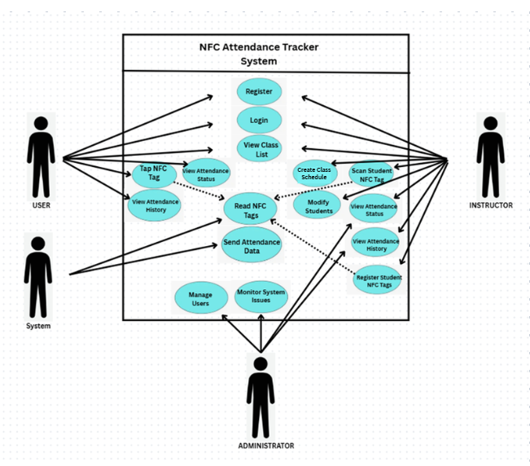

Capacity Estimation for Attendance Tracker Application
Design
focuses on estimating how much system resources are needed to handle daily attendance activities. This includes making sure the database, server, and network can support normal usage and still work smoothly during peak times, such as when many students check in at the start of a class.

● Concurrent Users: This refers to the maximum number of people who can use the system at the same time without any issues.
o Total Registered Users: During peak periods, the system is expected to handle around 60–80 concurrent users, including about 15 professors scanning attendance and 50–60 students accessing the app for schedules or attendance.
o System Capacity: Since this usage is below the 100-connection limit, the system can handle peak activity smoothly with a very low risk of network or performance problems.
● Transactions per Second (TPS): Refers to how many attendance check-ins the system can process every second during peak times.
o Estimated Load: During busy periods, about 15 professors are scanning students, which averages roughly 8–12 transactions per second. Students checking their dashboards add only a small extra load.
o System Capacity: This is very light for Firebase, which can handle around 1,000 writes per second, so the system can easily manage peak check-ins without slowing down.

● Data Storage: Estimate the amount of data storage needed to store users and attendance records
○ User Profiles Data Storage
- Number of Users: 750
- Size per User: 300 bytes
- Total Storage for Users: 750 × 300 bytes = 225,000 bytes ≈ 225 KB
○ Attendance Records Data Storage
- Daily Attendance Records: 1,500
- Size per Record: 150 bytes
- Total Storage per Day: 1,500 × 150 bytes = 225,000 bytes ≈ 225 KB/day
- Semester (4 months ~120 days): 225 KB × 120 days ≈ 27 MB
- Annual Storage: ~50–60 MB
○ Total Data Storage
- Users: 225 KB
- Attendance (1 Year): ~50–60 MB
- Total Estimated Storage: ~50–60 MB + 225 KB ≈ 50–60 MB

● Network Bandwidth: Assess the required bandwidth to support data transfer and user interactions without latency
○ Daily Data Transfer
- Syncing attendance and class text data uses very little bandwidth
- Total Daily Data Transfer: < 20 MB
○ PDF Reports
- Even if all 24 professors download reports later in the day, total ≈ 1.5 MB
○ Monthly Limit vs Usage
- Free Tier Limit: 10,000 MB (10 GB) per month
- Actual Usage: ~400–600 MB per month

High-Level Design for Attendance Tracker App

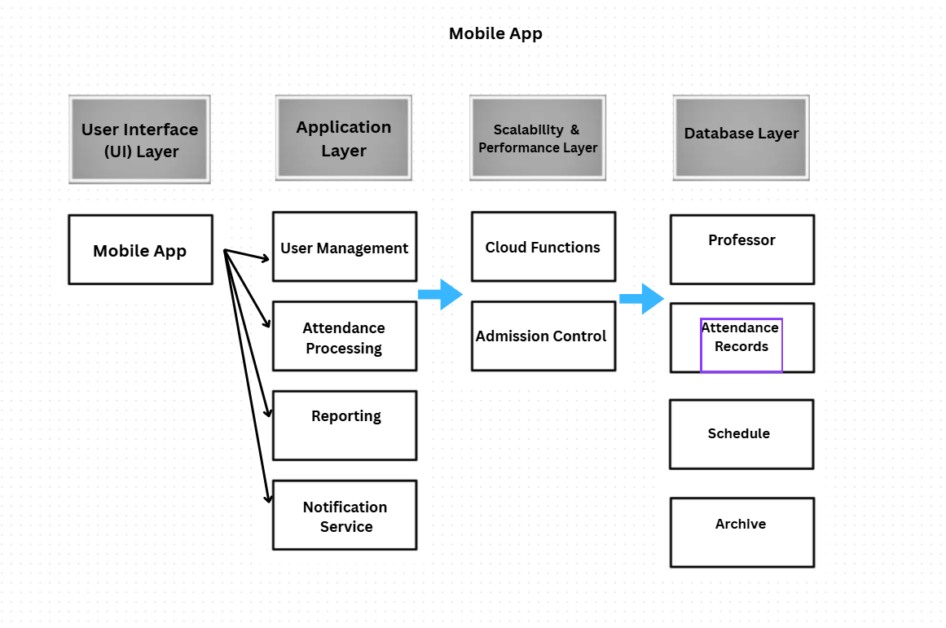

Design
This shows the overall design of the Attendance Tracker, built around a mobile app that teachers, admins, and students can all use.

1. User Interface (UI) Layer
This part is all about what the user sees and interacts with, using a single mobile app built with tools like Flutter or React Native.

Mobile App – Made Simple for Students
- For Professors: Professors can easily record attendance by scanning NFC tags through the app. The system requires an internet connection to save attendance data and uses NFC to confirm that attendance is taken on campus.
- For Students: You can see your attendance anytime and check your history.

2. Application Layer
The Application Layer is the core logic hub of the system. It receives requests from the User Interface (UI), processes them according to school rules, and coordinates with the Data and Integration layers.
As shown in the architecture diagram, this layer is divided into four key functional modules:
- User Management: Handles authentication and authorization. It ensures that students can only view their own data, while professors have the correct permissions to record attendance or modify records.
- Attendance Processing: The "engine" of the app. This module validates the NFC scans from professors, verifies the timestamp and location data, and calculates whether a student is marked as Present, Absent based on the school's grace period policies.
- Reporting: Aggregates raw attendance data into meaningful insights. It generates daily summaries for professors and provides students and professors with a visual breakdown of their attendance history.
- Notification Service: Manages real-time communication. It sends push notifications to students when they are marked absent or alerts professors if an attendance record hasn't been submitted for a scheduled class.

3. Scalability and Performance Layer
This layer is responsible for ensuring the Attendance Tracker remains fast, responsive, and reliable, especially during peak times like the start of morning classes. It uses modern infrastructure tools to handle high volumes of traffic without manual intervention.
As illustrated in the diagram, this layer includes:
- Cloud Functions: It runs automatically in response to specific events (like a student scanning an NFC tag) without the need to manage permanent servers.
- Admission Control: This serves as a gatekeeper for the system, regulating the number of incoming requests to ensure the app doesn't crash if there is a sudden, massive surge in users.

4. Database Layer
The Database Layer acts as the app’s secure storage room, ensuring all information is organized and managed safely. This layer handles the persistence of information through the Database Management System (DBMS) and the Data Access Layer (DAL), which acts as a "librarian" to find, update, or delete records.
Based on the architectural diagram, the data is organized into the following core root nodes:
- Students/Professors: This contains essential info about students and professors.
- Attendance Records: This is the main storage that keeps track of who was present or absent.
- Schedule (Course/Class Schedule): Stores class times and the school policy configurations the app must follow.
- Archive: This specialized storage handles older data to keep the system running quickly while ensuring long-term records are maintained.

Low-Level Design for School Attendance Tracker App
This part explains how the app works behind the scenes, breaking it down into smaller parts and showing what each part does.

Modules
The app is divided into three main modules based on the “brain” of the system we described in the HLD:

1. User & Roster Management Module
Purpose: Keeps track of everyone using the app students, teachers, and admins and organizes the school structure, like classes, courses, and schedules.

2. Attendance Processing Module
Purpose: This is the main part of the app, it handles marking attendance and making sure it’s accurate.

3. Reporting & Notification Module
Purpose: This part of the app creates reports and sends alerts so everyone knows what’s happening.

- Class Diagram
This diagram shows the main entities and their relationships within the Attendance Processing and Roster Management modules.
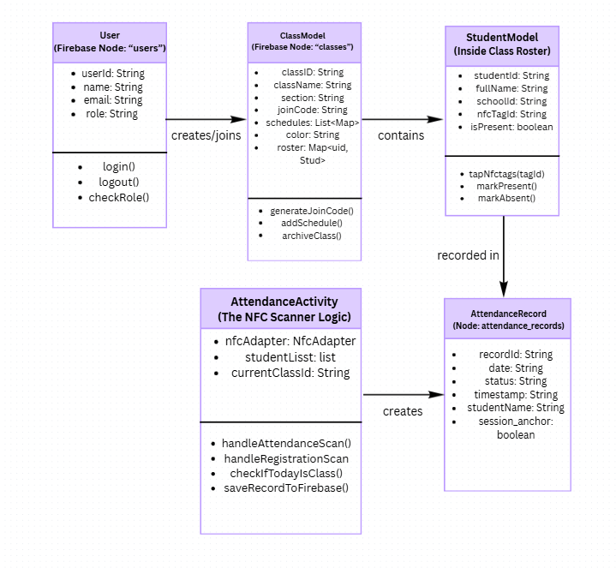

Sequence Diagram: Teacher Submits Attendance
This diagram shows what happens step by step when a teacher uses the mobile app to record attendance, from scanning student NFC tags to checking attendance rules and sending confirmations or notifications.
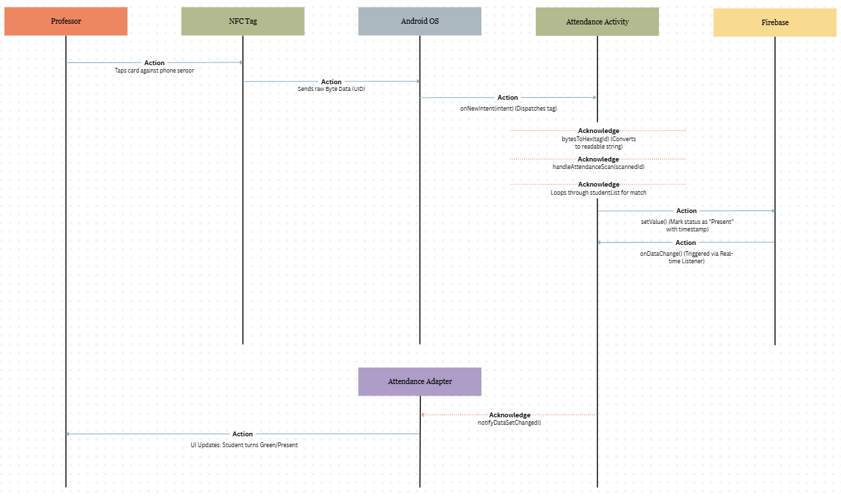

Low-Level Design Diagram
Below is the low-level design diagram for the Attendance Tracker App
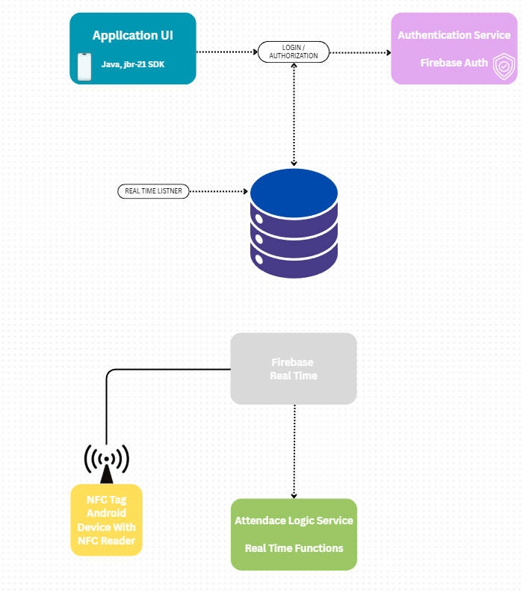

Database Design for Attendance Tracker App
This document outlines the systematic process for designing a robust and scalable attendance tracking system, built using Java for the mobile application and cloud functions, with Firebase Realtime Database and Firebase Authentication as the backend services.
Conceptual Data Model:
It identifies the main entities in the system which are Users (students and professors), NFC tags, Classes, and Attendance Records and how they relate to one another. In the Firebase Realtime Database, these entities are mapped to JSON nodes.
Denormalization & Flattening: Since Firebase Realtime Database is a large JSON tree, efficient design requires denormalization (duplicating some data) and flattening (avoiding deep nesting). This ensures the mobile app can read data quickly without downloading unnecessary information.
Steps include:
Step 1: Flattening Data. Instead of nesting students inside classes, or attendance inside students, we create separate nodes. This keeps the data shallow and prevents performance issues when loading large lists.
Step 2: Using Keys for Relationships. We link data using unique keys (Push IDs). For example, a class node contains a list of student UIDs in its roster, acting effectively as foreign keys.
Step 3: Denormalization for Read Efficiency. To reduce the number of database queries, we duplicate essential display data. For instance, a student's fullName and nfcTagId are stored directly inside the classes/{classId}/roster node. This allows the scanner to validate a tag immediately without needing to fetch the full user profile from the users node.

Realtime Database JSON Structure (Schema):
The database schema is designed as a long JSON tree. This includes the main root nodes and their children. The schema is planned to make the attendance tracking system efficient and scalable.
● Define All Required Root Nodes: Create separate nodes for each entity identified in the conceptual design and the denormalized design.
● Define Data Fields: For each node, we list the specific details that need to be stored, such as a student’s name or ID. We choose the simple data type for each detail (like String, Boolean, or Long) and use unique IDs to link related records together.
● Establish Relationships: Nodes are connected by storing Unique Keys (Strings) as references. So, the system knows which records belong to which students, professors, classes, or the NFC tags.
● Indexing: Firebase Realtime Database requires explicit indexing to maintain performance. We configure .indexOn rules for specific child keys (such as date or email) to ensure that queries like retrieving a student's attendance history remain fast and efficient as the dataset grows.
These are the nodes we create while setting up our Firebase RTDB.
1. Node Users: (Students, Teachers) This root node stores all user accounts and identities.
- Key: userID (String)
- Fields: name, email, role, schoolId, profileColor
- Function: Serves as the master record for user profiles.

2. Node Classes: (Schedules & Roster) This node stores information about each class session and the specific students enrolled in it.
- Key: classID (String)
- Fields: className, section, joinCode, creatorId, schedules
- Sub-Node (roster): A map of students enrolled in this class. Each entry contains the student's nfcTagId and fullName to facilitate offline-capable scanning.
3. Node attendance_records: (The Transaction) This is the main node that keeps track of each attendance entry. It is kept separate from the classes node to ensure that loading a class's details does not accidentally download its entire attendance history.
- Key: classID
- Sub-Key: date (YYYY-MM-DD)
- Fields: studentId, status ("Present"/"Absent"), timestamp, studentName
- Function: Stores the historical log of all check-ins for reporting.
4. Node notifications: This node manages real-time alerts for users.
- Key: userID
- Fields: title, message, type (success/warning/alert), read (boolean), timestamp
- Function: Allows the app to listen to immediate updates, such as when a student is marked absent or a join request is accepted.
5. Node: archived_classes
- Function: Stores data for classes that have ended, keeping the active classes node lightweight and fast.

This design covers all the basic features of the Attendance Tracker, and we can put everything together in a single system by linking the entities according to their relationships.

Microservices used in System Design for Attendance Tracker (Java/Firebase Functions):
Microservices break the system into smaller, independent parts. In Firebase, these are separate cloud functions written in Java that handle specific tasks or requests, which helps keep the mobile app simple, fast, and easy to maintain.
- User Service: This handles everything related to users, like logging in through Firebase Auth, managing roles, and keeping student and teacher profiles in sync with the school’s system.
- NFC & Check-in Service: This important service handles all the NFC check-ins. When the app sends a student’s NFC tag ID, it finds the student’s account, checks that the tap is at the right time and place, and then sends the attendance data to the next service for processing.
- Transaction Processing Service: This part of the system decides if a student is present or absent and then saves that information in the database.
- Notification Service: This service sends alerts to the right people, like notifying someone right after a student is marked absent, so everyone knows quickly.
- Reporting Service: This service creates attendance reports by looking at the data, like how often students attend, and organizes it so teachers and admins can easily see the results.

Scalability for System Design of Attendance Tracker (Firebase)
This means the system can handle more students and extra features without slowing down, even when lots of students check in with their NFC tags at the same time.
- Horizontal Scalability: The system runs on the Firebase Spark Plan, which supports up to 100 simultaneous connections. Based on our capacity estimation of roughly 60–80 peak concurrent users (students and professors), this tier successfully handles our traffic without needing a paid upgrade or complex server management.
- Data Optimization & Archiving: Due to the 1GB storage limit of the free tier, we do not split the database across multiple instances. Instead, we use an Archiving Strategy: finished classes are moved to a separate archived_classes node. This keeps the active classes node small and fast, ensuring we stay within the storage quotas while maintaining performance.
- Monitoring and Logging: We keep track of how the app and cloud functions are working using Firebase Realtime and Google Cloud Logging, so we can quickly spot and fix any problems.
Using microservices and making the system scalable helps the Attendance Tracker run smoothly, stay flexible, and handle lots of students checking in at the same time.

User Manual
Student User Manual
1. Getting Started
- Step 1: Account Setup: Register for a new account or log in using your existing credentials.
- Step 2: Join a Class: Tap the option to join a class. You will need to enter a Class Code, which you can get from your professor or a classmate.
- Step 3: Accessing Classes: Once joined, the class will appear in your "My Classes" window.
2. Managing Your Classes
- Opening a Class: Simply tap on the class name to view its contents.
- Class Options: Press and hold a class card to open a menu where you can:
  - Leave the Class: Remove yourself from the roster.
  - Copy Class Code: Quickly copy the code to share with others.
3. Checking Attendance Records
- Step 1: Inside a specific class, tap the Calendar Icon (top right) to view your attendance record.
- Step 2: Tap the Calendar at the top of the screen again to open the full date picker.
- Step 3: Select a specific date to view records for that day.
- Step 4: Download Records: To save your data, tap the Download Button in the bottom right corner. This will export the records for the date you have selected.
4. Navigating the Sidebar
Tap the three horizontal lines (hamburger menu) in the top left corner to access the following features:
Feature | Description
My Classes | View and access all your active classes.
Calendar | View your overall academic and class schedule.
Notifications | Check updates, alerts, and announcements.
Profile | Update your personal details, such as Name and Student ID.
Settings | Customize the application's appearance and preferences.
Logout | Securely sign out of your account.

Professor User Manual
1. Account & Class Setup
- Step 1: Registration: Log in or create your professor account.
- Step 2: Create/Manage Classes: Access your "My Classes" screen.
- Step 3: Class Options: Press and hold any class card to access administrative tools:
  - Set Schedule: Add, remove, or "Clear All" class meeting times.
  - Edit Details: Customize the Class Name, Section, and Banner Color.
  - Archive Class: Move completed classes to the Archive.
  - Copy Join Code: Copy the code to share with your students.
2. NFC Registration & Attendance
Once you tap to open a specific class, you can manage student entry via the Scanner Button (bottom right) and the Register Toggle (top right).
- Registering Student NFC Cards:
  - Switch the Register Mode toggle (top right) to ON.
  - Tap the Scanner Button (bottom right).
  - The app will now link the student's NFC card to their profile.
- Taking Attendance:
  - Ensure the Register Mode toggle is OFF.
  - Tap the Scanner Button.
  - The app is now in Attendance Mode for students to tap in.
3. Managing Student Rosters
While inside a class, you have direct control over individual student records:
- Manual Override: Manually mark a student as Absent or Present.
- Edit Info: Modify a student’s name.
- NFC Management: Use Unlink NFC Card if a student loses their tag or needs a replacement.
- Drop Student: Use this to "soft delete" a student from the active roster.
4. Setting Attendance Rules
You can automate alerts for student absences via the Settings menu:
- Open the Navigation Sidebar (top left) and select Settings.
- Locate Attendance Rules.
- Adjust the Slider Bar to set the threshold for consecutive absences (Default is 3).
- Tap Save Settings. You will now be alerted when a student misses that many classes in a row.
5. Navigation Sidebar
The sidebar (top left three lines) provides quick access to your global tools:
Feature | Description
My Classes | Your main dashboard for active teaching.
Calendar | View your full teaching schedule.
Notifications | Alerts regarding student status or app updates.
Archived Classes | Access and manage your past classes.
Profile | Edit your professional details and ID.
Settings | Configure app preferences and Attendance Rules.
Logout | Securely exit the application.

