**Enterprise Resource Planning with e-MOR ERP**

04 jANUARY 2025

Zeki Karamuk

sABANcı unıversıty & EMOR

İçindekiler

**Case 1** 2

**Case1.a** 2

**Case 1.b** 3

**Case 1.c** 4

**Case1.d** 6

**Case 2** 7

**Case2.a** 7

**Case2.b** 7

# **Case 1**

## **Case1.a**

The management of the large company is hard process. Becuse all departments must work in harmony with each other. At the same time, all departments must communicate with each other so that the workflow progresses correctly. As stated in the text, Cosmeticsa have growthed rapidly. Becuase of this rapid growth company could not manage all processes and operations concurrently. So even though their revenue has increased, company payed large refunds to its customers for the work they cannot completed on time which lead to decrease customer satisfaction and also profit of the company. These problems may be fully addressed by an ERP system, which can consolidate, optimize, and simplify corporate operations. Without an ERP system, Cosmeticsa lacks real-time insight into operations due to the fragmented data it uses across its divisions. This decentralization leads to miscommunication and inefficiencies, as seen in the conflicts between sales, production, purchasing, and accounting. For example as stated the sales team often commits to unrealistic deadlines, while the production team is unable to meet those timelines due to insufficient ingredient procurement. These issues occur because of the manual processes and a lack of coordination. This manuel process and lack of communication and coordination lead to delayed deliveries, penalties and customer dissatisfaction which decreases the profit and brand value.

With the help of an ERP system, all of the operations will be digital, unified and integrated. Since the company is so big all of the staff cannot communicate with each other. This ERP system will enable seamless communication between staffs and departments. Also with ERP system, all of the processes will be digitalized which will enable to track the processes evertime. By digitilization of the process, the system will prevent the human error. So as a result of the ERP implementation Sales orders would automatically update production schedules and inventory levels, while purchasing teams would receive real-time notifications for procurement needs. This implementation will increase the efficeny of the operations and also improve the collaboration across teams which ensures that changes in customer orders are immediately reflected in production and purchasing workflows so that operational units.

As stated above, An ERP system has many advantages for lots of industries. It would decrease fines and restore customer confidence by increasing order fulfillment and on-time delivery rates. The forecasting capabilities of the system would guarantee that production plans and demand are in sync and optimize inventory levels. Real-time analytics will enhance decision-making and enable the company to respond proactively to market changes by giving management relevant insights.

|  |  |  |
| --- | --- | --- |
| **Aspect** | **Before ERP** | **After ERP** |
| **Data Management** | Decentralized, isolated systems | Centralized, unified and integrated platform |
| **Interdepartmental Communication** | manual coordination | automated updates |
| **Order Management** | Manual, error-prone processes | Automated, real-time tracking |
| **Production Planning** | Reactive, delayed adjustments | Proactive, demand-driven scheduling |
| **Inventory Control** | Overstock/shortages, misalignment | Optimized levels, real-time visibility |
| **Efficiency** | Not efficient | efficient |
| **Customer Satisfaction** | Delays, lost trust | On-time delivery, enhanced trust |
| **Reporting** | Delayed, manual reporting | Real-time, automated analytics |
| **Cost Efficiency** | High penalties, inefficiencies | Reduced costs, streamlined operations |
| **Scalability** | Challenging to expand | Scalable for growth |

*Figure 1 : Comparision with ERP and without ERP system*

## **Case 1.b**

The procure process is one of the most important processes for the workflow because a mistake made here will directly affect the company's profit, and at the same time, the slightest disruption that may occur will cause the work that the company needs to complete not to be completed on time. Many problems may be encountered in this process. For example, the order placed by the purchasing team and the products brought by the manufacturer and procured may be incomplete, faulty or incorrect, which will affect the duration of the project since the company does not have resources directly at its disposal. In addition, since invoices cannot be tracked through a digital platform, the products paid and not received within the company cannot be accurately determined, which causes both loss of profit and prolongation of the work. With Erp integration, the products that come with it can be tracked instantly, so faulty or missing orders can be tracked and paid accordingly, thus minimizing the risk of error and increasing profitability.

Furthermore, an ERP system facilitates improved departmental communication which guarantees synchronization between accounting, inventory, and purchasing. This avoids needless delays and aids in the early detection of possible bottlenecks. As stated above company can track orders and payments with using digital platforms.Order and payment tracking in real time strengthens ties with suppliers because on-time payments build credibility and dependability. Additionally, with the help of the reports generated by ERP system, the organization may find the most trending products that used in the sector and could bargain with suppliers. In addition to increasing operational effectiveness, this guarantees that the business may continue to have a competitive advantage in the marketplace.

## **Case 1.c**

**Steps to implement ERP system:**

1. **Gathering information about system requirement**

First of all conduct a detailed assessment of the company’s requirements. As a senior business management consultant, I would meet with all departments to understand their workflows, challenges, and specific needs. After understanding the business logic and requirements. I have to talk with each department one by one and identify all potential problems that lead to work delay or loss of money.

1. **Market Research**  
   Next, research the ERP market to identify vendors. Especially, I would focus on vendors offering systems with proven success in cosmetics manufacturing. After reviewing vendor offerings, I would write all possible vendors to a shortlist based on their functionality, cost, and reputation.
2. **Creating and Distributing a Request for Proposal (RFP)**  
   Next, I prepare a word document which outlines the COSMETICSA’s specific needs, expected deliverables, budget, and implementation timeline. Share this word with the vendors and request detailed proposals that include system capabilities,post-implementation support plans and possible specializations.
3. **Vendor Demonstrations**  
   Set up demos with the shortlisted vendors. This stage is critical for understanding how the ERP system performs in real-world circumstances. I would ensure that all acquisition committee members attend these meetings to assess the user interface, functionality, and system adaptation to COSMETICSA's criteria.
4. **Evaluation and Vendor Selection**  
   Score and pick the vendor which is best fit for the COSMETICSA’s criterias.
5. **Proof of Concept (PoC)**  
   Conduct a proof-of-concept test to evaluate the ERP system on a modest scale. This trial deployment validates its compliance with COSMETICSA's procedures and ensures that any possible difficulties are recognized and resolved prior to a full rollout.
6. **Contract Negotiation and Final Approval**

Prepare a implementation details and timeline that is agreed with the ERP company and send it to approval.

**Forming the Committee:**

Committee must include representatives from all of the key departments to ensure all needs are addressed and will be satisfied by ERP.

* **Project Sponsor**: A C-level executive
* **IT Manager**: Technical compatibility and system integration.
* **Finance Representative:** Cost implications and budget.
* **Procurement Manager**: To guarantee that the system eliminates inefficiencies in the procurement-to-payment process.
* **Production Manager**: To represent the needs of manufacturing plants for production planning and scheduling.
* **Sales Representative**: To ensure the ERP supports order management and customer relationship workflows.
* **HR Manager**: For training required for ERP adoption.

With the help of this committee the ERP system will meet the operational and strategic needs of COSMETICSA while fostering smooth adoption and implementation.

## **Case1.d**

As a senior consultant, I recommend carefully evaluating the differences between big-bang and phased implementation approaches for COSMETICSA’s ERP system. With the big-bang implementation, the entire system can be put into use quickly with a quick deployment, but the big bang implementation is very prone to errors. Even in the slightest integration error, the entire system will be locked and all units will be affected by this situation. However, with phased implementation, a piecemeal transition can be made. In this case, any errors that may occur will only affect the relevant unit and these errors can be quickly detected and corrected in the flow. Since there will be a fragmented transition when implementing Phased, both old and new systems will need to be used and the cost will increase. But the risk factor will decrease. As a result I will prefer phased implementation because of minimal risk factor.

|  |  |  |
| --- | --- | --- |
| **Feature** | **Big-Bang** | **Phased** |
| **Speed** | Faster organization-wide | Gradual, step-by-step |
| **Risk** | High, widespread impact | Low, controlled impact |
| **Employee Adaptation** | Sudden, challenging | Gradual, easier |
| **Cost** | Lower dual-system costs | Higher dual-system costs |
| **Issue Resolution** | Difficult, large-scale | Easier, smaller-scale |

*Figure 2: Differences between Big Bang and Phased Implementation*

# **Case 2**

# **Case2.a**

The material service request form in Emor is a form that communicates with other departments in the project by filling in information such as the material required for each project and the required delivery time. In this form, the quantities of materials required and delivery times on a project basis are clearly stated. In this way, business units related to the project can view the workflow and plan accordingly, thus preventing delays in the work. In addition, all this information and documents are available as printable and PDF formats on the e-mor platform. In this way, information about the project can be conveyed directly to the senior management. In addition, reports can be kept digitally as pdf, thus eliminating tools such as files that take up unnecessary space and making the information accessible more quickly. At the same time, as the information becomes easily accessible, reports can be displayed whether any errors occurred during the purchasing phase, for example whether the seller brought too few products. Furthermore, these forms promote transparency and accountability by establishing a visible audit trail, allowing businesses to successfully manage expenses while maintaining operational efficiency.

## **Case2.b**

*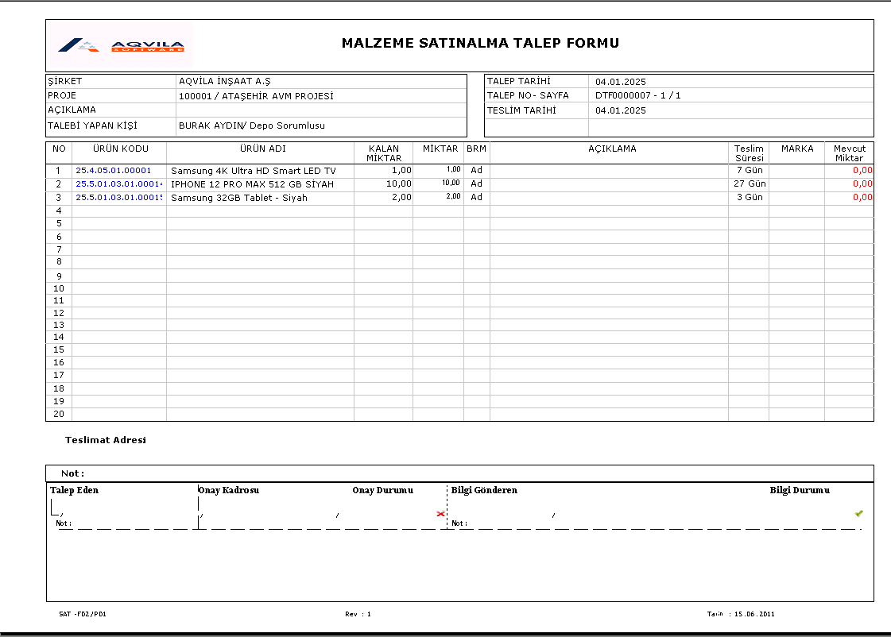Figure 3: Report Generated Sample*