CPSC 2720 - 2020

Escape the Hotel



Team Infinity

User Manual

By: Jackson Druhan, Jacob Lachowski, Muhammad Saleh, & James Smith

Dec 2 , 2020

Table of Contents

* Introduction-----------------------------------------------------3
* Game Over View-------------------------------------------3
* Guide ---------------------------------------------------------4
* Trouble shooting Guide-------------------------------------5

Introduction

This document is the user manual inside will include a game Overview which is a short description of what the game works, what is inside and what the purpose of the game is. Then a guide to tell the user how to start the game, commands that can be entered, and a sample walk through of the game. Then at the end the document there will be a trouble shooting guide so that the user will know if there are any errors within the game and what to do if the user need in game help.

Game Overview

Game will be split up into three environments, the hotel room, the hallway, and the lobby each with three separate spaces within them. The room will include the player’s hotel room, the adjoined bathroom, and the balcony. The hallway will include the main hallway, the staircase, and the elevator. The lobby will include the main lobby area, the reception desk, and the lobby restaurant. Each environment is separated by a puzzle that requires the use of objects that can be found in each room and interactions with NPCs that can be found throughout. Progressing and winning will rely on where the player goes, what items they have collected and used, and what NPCs have been interacted with.

Guide

**How to start the game? (What does the grader need to enter on the command line?)**

The player will start in the hotel room and will be able to enter in com

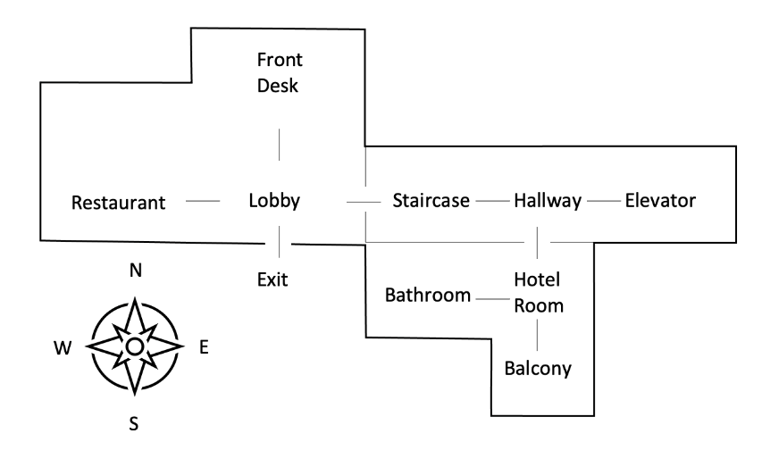

**What are command that can be entered?**

The commands that make a player move around the hotel are m ove east, move north, move west, and move south. Key: HotelBathroom (Take/Use), Door: HotelRoom (Interact/Move), Railing: HotelBalcony (Interact/Move), 4 - Painting: Hallway (Interact), 5 - Door: Hallway (Interact), 6 - Button: HallwayElevator (Interact), 7 - Wallet: LobbyRestaurant (Interact/Use).

**Sample walk through**

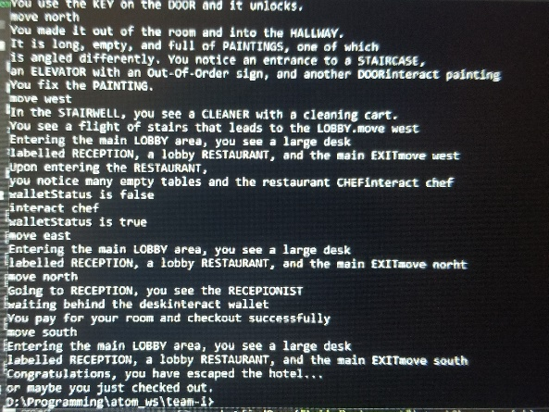

Here you can see some the of actions the user can take in order to play the game.

Troubleshooting Guide

**How can the user get in-game help?**

For the user to get help within the game the user can:

1. Input help into the game to find what options they have.
2. Find out where they are within the game. They can look at the map in the user manual, input all four directions to see where they can go and what they can do.(move north or move east or move south or move west)
3. They can interact with NPCs and different things like keys, paintings, doors, elevator and a wallet.
4. After process of elimination and playing the game a couple of time they should understand how to win.

**What are possible errors and how can the user fix them or deal with them?**

As far as the group is concerned there should not be any errors with in the game. And the user will not have to deal with anything as long as they understand what the moves, actions are within the game. Only problem that the group came across is game may exit sometimes all you need to do is restart it.