1. This program is coded in Visual studio with winform by C#, and the solver is GUROBI. Thus, to start with this program please first install those software;
2. The test cases are in the files as follows, Timetable14.csv, Timetable20.csv..are the cases with different number of trips in vehicle scheduling. If you want to test the case with 14 trips, you just change the name “Timetable14.csv” to “Timetable.csv”, since the problem always read the file “Timetable.csv”;

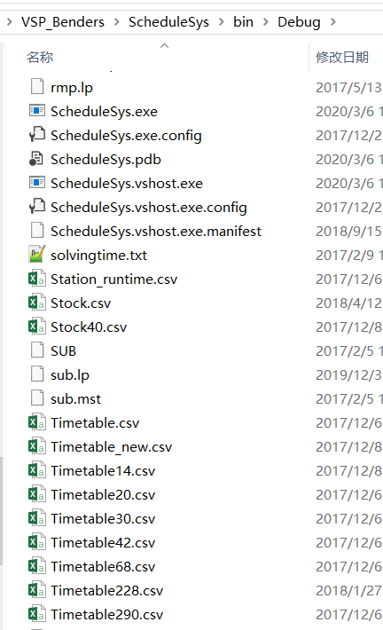

1. In visual studo, you start the program. The Form as the follows you can see. Click the button the red arrow points to.

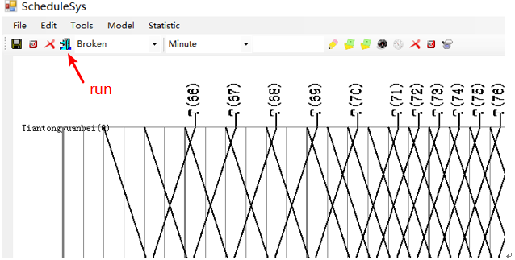

1. Then you should select the solution method. The “model_solve” is refer to the arc-based model solved by GUROBI, and “Branch_price_cut” is refer to the path-based model solved by the algorithm that combines Benders decomposition and Column generation.

