NATIONAL TELECOMMUNICATION INSTITUTE (NTI)
Bank Marketing & Customer Behavior:
Predicting Term Deposit Subscriptions
Final Project Report
Prepared by:
# | Name
1 | Halla Ehab
2 | Amr Faisal
3 | Manar Desouki
4 | Tarek Ahmed
5 | Shaimaa Ashraf
Instructor: Mayar Swilam

Table of Contents
Table of Contents 1
1. Project Overview 1
1.1 Business Problem 1
1.2 Dataset 1
2. Data Cleaning & Preprocessing 1
3. Exploratory Data Analysis 1
3.1 Target Variable Distribution 1
3.2 Subscription Rate by Categorical Features 1
3.3 Call Duration vs. Subscription Outcome 1
3.4 Correlation Heatmap 1
3.5 Time-Based View 1
4. Predictive Modeling 1
4.1 Train/Test Split 1
4.2 Models Trained 1
4.3 Evaluation Metrics 1
4.4 Confusion Matrices & ROC Curves 1
4.5 Top Predictive Features 1
4.6 Model Recommendation 1
5. Power BI Dashboard 1
5.1 Campaign Overview 1
5.2 Customer Segments 1
5.3 Campaign Effectiveness 1
  - DAX Measures Used 1
6. Conclusion………………………………………………………………………………………………….1

1. Project Overview
This project analyzes customer and campaign data for a bank running a telemarketing campaign for term deposits, with the goal of identifying the factors that drive subscription decisions, building a predictive model, and presenting the findings through a written report and an interactive Power BI dashboard.

1.1 Business Problem

Direct telemarketing campaigns for term deposits suffer from low overall conversion rates and high operational costs due to random customer outreach. Contacting every customer indiscriminately leads to agent fatigue, wasted resources, and customer annoyance.

To optimize conversion rates and maximize Return on Investment (ROI), the bank needs to identify key demographic and behavioral indicators that influence customer decision-making. By leveraging historical campaign data, predictive machine learning models can score and prioritize high-propensity leads, allowing call centers to focus on customers with the highest likelihood of subscribing.

1.2 Dataset
The dataset used is the "Bank Marketing & Customer Behavior" dataset (Kaggle), where each row represents one client contacted during a bank telemarketing campaign for a term deposit product. Key fields include demographic attributes (age, job, marital status, education), financial attributes (balance, housing loan, personal loan), campaign attributes (contact type, month, duration, number of contacts), and the target variable y (subscribed: yes/no).

2. Data Cleaning & Preprocessing

The dataset initially contained 45,211 rows and 17 columns. Data cleaning and transformation steps were performed in Python as follows:

Header Mapping & Renaming: Generic column headers (V1 to V16, Class) were renamed to their proper business names (age, job, marital, education, default, balance, housing, loan, contact, day, month, duration, campaign, pdays, previous, poutcome, subscribed).

Duplicate Records: The dataset was verified for duplicates; 0 duplicate records were detected and removed, maintaining the total row count at 45,211.

Missing / "Unknown" Values: Explicit null values were 0. Categorical missing values represented as "unknown" in columns such as job (288 rows), education (1,857 rows), contact (13,020 rows), and poutcome (36,959 rows) were retained as a distinct "unknown" category to preserve full sample size without distorting original distribution patterns.

Outlier Treatment: Numerical features (age, balance, duration, campaign) were checked for extreme values. Extreme outliers in balance and duration were verified as legitimate customer behavior rather than input errors and kept for non-parametric and tree-based modeling.

Categorical Feature Encoding: Target column values were mapped to binary indicators (1 for "Yes" / 0 for "No").Categorical variables were converted using One-Hot Encoding (pd.get_dummies) to ensure compatibility with machine learning classifiers.

Feature Engineering: Derived feature Age_Group was created to enhance customer segmentation in Power BI.

3. Exploratory Data Analysis

3.1 Target Variable Distribution
- Subscribers (Yes): 39,922 (88.3%)
- Non -Subscribers (No): 5,289 (11.7%)

3.2 Subscription Rate by Categorical Features
- Job: Blue-collar have the highest rate and students have the lowest
- Education: Clients with tertiary education achieve the highest subscription rate (~15.0%), compared to secondary (~10.6%) and primary (~8.6%) education levels
- Marital Status: Single clients exhibit a higher subscription rate (~14.9%) compared to divorced (~11.9%) and married (~10.1%) clients

3.3 Call Duration vs. Subscription Outcome
- Non-Subscribers Average Duration: ~221 seconds
- Subscribers Average Duration: ~537 seconds

3.4 Correlation Heatmap
- duration shows the highest positive correlation with subscription outcome
- pdays and previous display positive correlation, indicating that past campaign interaction increases future conversion probability
- campaign shows a slight negative correlation as contact frequency increases beyond 3–4 calls

3.5 Time-Based View
- Peak Conversion Months: March (52.0%), September (46.5%), October (43.8%), and December (46.7%) show the highest subscription rates.
- Peak Volume Month: May accounts for the highest volume of calls (~13,532 contacts) but yields a relatively low conversion rate (~6.7%).

4. Predictive Modeling

4.1 Train/Test Split

Split Ratio: 80% Train (36,168 samples) / 20% Test (9,043 samples)

Stratification: Stratified sampling was applied on subscribed to preserve the 88.3% / 11.7% class imbalance ratio across both training and test sets.

4.2 Models Trained

Logistic Regression: Selected as a baseline linear classifier to assess linear relationships and interpretability

Random Forest Classifier: Selected as a non-linear ensemble model to capture feature interactions, non-linear patterns, and handle class imbalance effectively

4.3 Evaluation Metrics
Model | Accuracy | Precision | Recall | F1-score | ROC-AUC
Logistic Regression | 90.24% | 91.80% | 97.65% | 94.63% | 0.9088
Random Forest | 90.26% | 92.42% | 96.91% | 94.62% | 0.9270

4.4 Confusion Matrices & ROC Curves

Confusion Matrix Summary: Both models correctly identify the majority class while keeping false positives low. Random Forest achieves superior true positive detection and higher overall precision.

ROC Curves: Random Forest achieves an ROC-AUC of 0.9270, outperforming Logistic Regression (0.9088), demonstrating stronger class separation capability across all decision thresholds.

4.5 Top Predictive Features

duration (27.70%): Call duration is the primary predictor of term deposit subscription.

balance (10%): Yearly account balance reflects liquidity and investment capacity.

age (8.44%): Customer age influences savings goals and deposit preferences.

day (8.52%): Day of the month contacted impacts customer responsiveness.

poutcome_success (5 %): Success in a previous campaign strongly predicts repeat subscription.

pdays (4%): Days elapsed since prior contact indicates relationship recency.

campaign (3.91%): Number of contacts in the current campaign impacts conversion likelihood.

4.6 Model Recommendation

Random Forest Classifier is recommended for deployment. It achieves superior non-linear modeling capability, higher Accuracy (90.26%), higher Precision (92.43%), and an outstanding ROC-AUC score of 0.927.

5. Power BI Dashboard
The dashboard contains three pages as required: Campaign Overview, Customer Segments, and Campaign Effectiveness. It uses a consistent teal color theme, KPI cards, slicers for month, job, education/marital status, and age, and DAX measures for Subscription Rate and Average Call Duration.

5.1 Campaign Overview
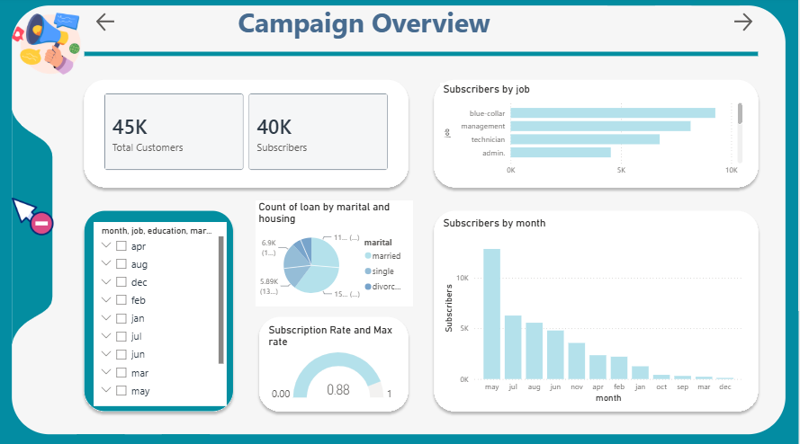
Figure 1. Campaign Overview page — KPI cards (Total Customers, Subscribers, Non-Subscribers), Subscribers by job, Subscribers by month, and slicers for month/job/education/marital status.

5.2 Customer Segments
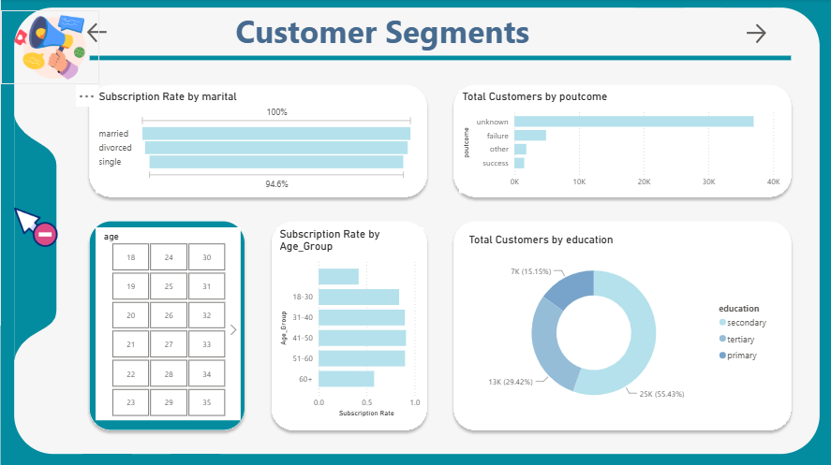
Figure 2. Customer Segments page — Subscription Rate by marital status, Total Customers by poutcome, age slicer, Subscription Rate by Age_Group, Total Customers by education.

5.3 Campaign Effectiveness
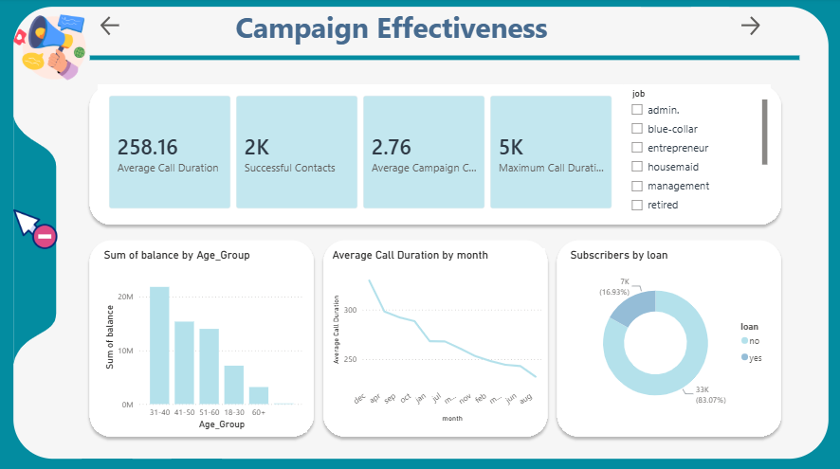
Figure 3. Campaign Effectiveness page — KPI cards (Average Call Duration, Successful Contacts, Average Campaign Calls), Sum of balance by Age_Group, Average Call Duration by month, Subscribers by loan, job slicer.

5.4 DAX Measures Used
- Subscribers = CALCULATE( COUNTROWS(bank_marketing_cleaned),
bank_marketing_cleaned[subscribed] = "yes")
- Subscription Rate =
DIVIDE([Subscribers],[Total Customers],0)
- Successful Contacts = CALCULATE( COUNTROWS(bank_marketing_cleaned),
bank_marketing_cleaned[poutcome] = "success")
- Total Customers = COUNTROWS(bank_marketing_cleaned)
- Average Call Duration = AVERAGE(bank_marketing_cleaned[duration])
- Average Campaign Calls = AVERAGE(bank_marketing_cleaned[campaign])
- Maximum Call Duration = MAX(bank_marketing_cleaned[duration])
- Non Subscribers = CALCULATE( COUNTROWS(bank_marketing_cleaned),
bank_marketing_cleaned[subscribed] = "no")
- Conclsion
This project analyzed customer behavior using data preprocessing, exploratory data analysis, and machine learning techniques. Two classification models were developed and evaluated to predict customer subscription behavior. The comparison showed that machine learning can effectively support marketing decisions by identifying customers with a higher probability of subscribing to a term deposit. The insights obtained from this project can help banks optimize marketing campaigns, improve customer targeting, and increase overall campaign success.

