31 Ocak 2021

Zekihan aZMAN

250201007

CENG422 Final Project

First, I designed network with visual paradigm online. I go with every smallest unit has a router and every router is connected with a switch that handles units’ network and routers are connected by a few switches placed mostly for easy management. More sensible approach would be to use less router and more switch and that will be better if this structure never changes. I assigned routers to the smallest unit because if there is a need to separate that unit from the network it will be easier. If a unit needs its own firewall it can just put it there. every unit can have its own Nat, etc. Because of these kinds of things, I used a router in every smallest unit. For every unit there is an ethernet switch so that every device in that unit can connect to the router without wasting ports or requiring separate routings. For every unit there is one pc unit to demonstrate it is working. Every unit's routers are connected by a switch that is connected to the other building. For modem simulation I go with two modems connected by serial and output by switches. Normal modems connect to ethernet, so it needs to output ethernet that is why I did not just connect branches by serial directly.

Every router has two legs (except branch connection) one of them in 10.1.1.0/24 sub domain other is its respective subdomain that starts 10.1.2.0/24 and goes like that. The reason I give 10.1.0.0 as IP, since it is a company it can have a lot of devices that need to connect. even if there is not now it can have these needs in the future. since it is private IP it does not hurt to have more so I kind of give a lit bit more than needed. Now for the configurations. Every router has two fast ethernet and some of them have serial ports too. One of the fast Ethernet ports is in the 10.1.1.0/24 subdomain and other is in 10.1.0.0/24 (can be 10.1.2.0/24 or 10.1.3.0/24 goes on like that.). The reason I go with it is the faster the better :). And every pc is in the same subdomain as its router that it connects to. One of the problems that I got is sometimes pc s subdomains are different if not set directly so give IP 10.1.2.2 255.255.255.0 at first.

Second problem configuring all routers with IP route. Since there are a lot of routers, I seek out some automated things to configure it for me. I find Open Shortest Path First (OSPF) is a routing protocol for Internet Protocol (IP) networks. With these routers start to see each other without any work needed. They broadcast signals to see who is there. But it quickly became apparent to me that it got complicated very quickly and could not connect the branch side. So, I seek out an easier solution which is Enhanced Interior Gateway Routing Protocol (EIGRP) is an advanced distance-vector routing protocol that is used on a computer network for automating routing decisions and configuration. The protocol was designed by Cisco Systems as a proprietary protocol, available only on Cisco routers. Its only configuration is setting routing type to EIGRP 100 and network as 10.0.0.0 with this it will establish a connection with all routers that have EIGRP and subdomain 10.0.0.0. Like that every pc can ping everywhere. But it is one drawback is after first start up it is sometimes taking minutes of time to establish a neighborship relations, so it takes some time to ping.

Now for the modem side. For the most part modems use the same configurations with added serial connection. For the internal IP address of two modems, I used 50.0.0.0/30. Since it acts like the internet it does not need to be private and I mostly did not care about its subdomain. For the office building sides IP I go with 20.1.1.0/30 subdomain and its connected router has the same IP with extra fast Ethernet port. And as extra it has network 20.0.0.0 in its routing discovery network. Discovery network addresses are its connected domains for every router.

For the remote branch side, it is connected to modem by 30.1.1.0/30 subdomain. For being able to differentiable I used 11.1.1.0/24 subdomain for inside of remote branch. More sensible approach would be using 192.168.1.0/24 subdomain. But using 11.1.1.1 seemed much easier.

And lastly every switch has enough port open for specified amount to accommodate what is asked.

After configuring all sides one time I scaled and change only IP a little bit and whole network has been created.

You can find all configurations in config folder in the same directory as well as diagrams from designer and gns3.

Here is router neighbor adjacency example from office building floor 2 office 2 router.

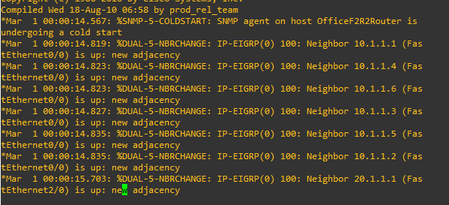

Here is ping example from factory floor pc to remote branch and office building.

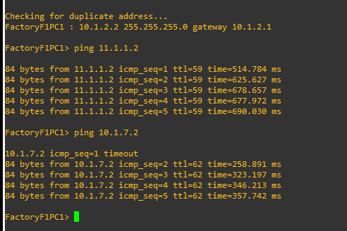

Here is ping from remote branch to factory building floor 1. First two misses due to EIGRP establishing neighbor adjacency.

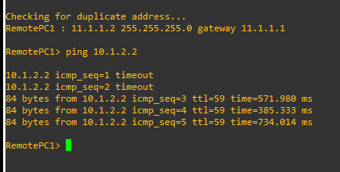

Factory Floor 1 PC configuration.



Remote branch router.

