*Implementation of Levenshtein Distance Algorithm for Library Book Search System*

Daniel Christofer Marvel   
Faculty of Computer Science   
Universitas Pelita HarapanKarawaci  
Tangerang, Indonesia  
[01085230012@student.uph.edu](mailto:01085230012@student.uph.edu)

Rendy Efesus Purba   
Faculty of Computer Science   
Universitas Pelita HarapanKarawaci  
Tangerang, Indonesia   
[01087220001@student.uph.edu](mailto:01087220001@student.uph.edu)

Zacky Septian Nazarudin  
Faculty of Computer Science   
Universitas Pelita HarapanKarawaci  
Tangerang, Indonesia  
[01085230005@student.uph.edu](mailto:01085230005@student.uph.edu)

Rizky Maulana  
Faculty of Computer Science   
Universitas Pelita HarapanKarawaci  
Tangerang, Indonesia

[01085230016@student.uph.edu](mailto:01085230016@student.uph.edu)

*Abstract*— Digital library search systems often fail to handle typographical errors, resulting in inaccurate results and poor user experience. This study implements the Levenshtein Distance algorithm to enhance search accuracy by calculating the minimum edits needed to match user input with book titles. Combining substring search for exact matches and Levenshtein Distance for error correction, the system provides flexible and robust results. Validation with test queries showed improved accuracy and user satisfaction, highlighting the algorithm's potential to modernize library search systems and improve accessibility.

Keywords—Levenshtein Distance, Library Search System, Typographical Error, Search Accuracy, Book Database.

# Introduction

Inaccurate search results are a common problem in library systems when users input misspelled or incomplete keywords. This often happens due to human typographical errors, especially in large digital libraries with thousands of entries. Current systems that rely on substring-based search algorithms are not equipped to handle such errors effectively, leading to poor user experience and frequent frustration.

The Levenshtein Distance algorithm provides a solution by calculating the "edit distance" between two strings [1]. The edit distance is the minimum number of operations (insertions, deletions, or substitutions) required to transform one string into another[8]. By integrating this algorithm into the library's search engine, the system can identify and suggest the closest matches to the user's query, even if the input is imperfect[7].

This research aims to implement and evaluate the effectiveness of the Levenshtein Distance algorithm in improving the accuracy of search results and enhancing user satisfaction. A robust implementation of this algorithm will make library systems more accessible and user-friendly, accommodating typographical errors without compromising the relevance of results.

# Methodology

## Levenshtein Distance Algorithm

The Levenshtein Distance algorithm is a string-matching method used to measure the difference between two strings[1]. The distance is calculated based on the minimum number of operations required to transform one string into another. These operations include:

* Insertion. Adding a character to the string to make it closer to the target string[9]. For example, transforming the string ‘*dat*’ to ‘*data*’ requires one insertion operation: adding the character 'a' at the end. For the usage in the system, if the user inputs ‘*dat*’, the system calculates the edit distance by considering all possible book titles. For the title data, the algorithm detects that inserting '*a*' will result in a match.

Table I. Insertion of Characters



* Deletion. Removing a character from the string to make it closer to the target string[9]. For example, transforming the string ‘*datas*’ to ‘*data*’ requires one deletion operation, removing the character '*s*' at the end. Usage in the system is, when the user inputs ‘*datas*’, the system identifies that removing the extra character '*s*' will result in a match with the title data.

Table II. Deletion of Characters



* Substitution. Replacing one character in the string with another to make it closer to the target string[9]. For example, transforming the string ‘*dats*’ to ‘*data*’ requires one substitution operation which is replacing 's' with '*a*'. Usage in the system is, if the user inputs ‘*dats*’, the system calculates the edit distance by substituting one character at a time. In this case, replacing '*s*' with '*a*' aligns the input with the book title data.

Table III. Substitution of Characters



## Design System

The process of running the Levenshtein distance algorithm starts with a word entered by the user, then it will be preprocessed to handle leading or trailing spaces, ensure case insensitivity, and validate against invalid characters. Then, the exact matching is prioritized using substring detection to optimize search speed for precise queries. If no exact matches are found, the system calculates the Levenshtein Distance for all titles, identifying the most relevant suggestions within the defined threshold. Exact matches are displayed first, followed by potential matches sorted by increasing edit distance. Each result includes a unique identifier for user selection.

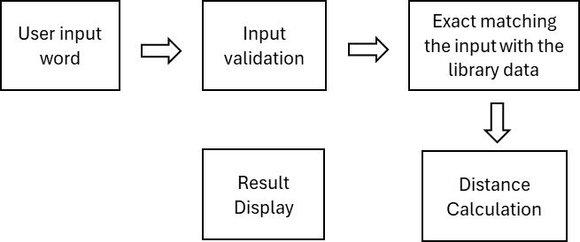

Figure 1. Design System

## **Linear Search & Substring Matching**

## **Linear search** is a straightforward search algorithm used to find a specific element within a dataset by checking each element one by one sequentially, from the beginning to the end. In this study, linear search is employed to iterate through a list of books, ensuring that each element (book title) is individually examined against the given search criteria.[10]

## This method is highly useful as it ensures a comprehensive search across all elements, despite its time complexity of O(n), where n is the total number of elements in the dataset. Linear search guarantees that no element is overlooked, enabling a systematic and thorough search process.[2]

**Substring matching** is an algorithm designed to determine whether a substring (keyword) exists within a larger string (book title). In this study, substring matching is applied to detect specific patterns, such as user-provided keywords, in each element being examined by the linear search algorithm.[3]

## This process disregards case sensitivity to enhance the flexibility of the search[5]. Substring matching utilizes string-matching functions, such as find(), to identify whether the substring is present within the main string[4]. This technique is essential for ensuring detailed pattern matching, allowing elements to be identified based on specific criteria within their content.

**Example Scenario**

Suppose we have a list of four book titles:

1. "C++ Programming"
2. "Data Structures"
3. "Algorithms"
4. "Data Science"

We aim to search for the keyword "Data" in these titles. Here's how the process works:

Substring Matching Process. The substring matching algorithm will go through each title in the list and check if the keyword "Data" is present within the title. The steps are as follows:

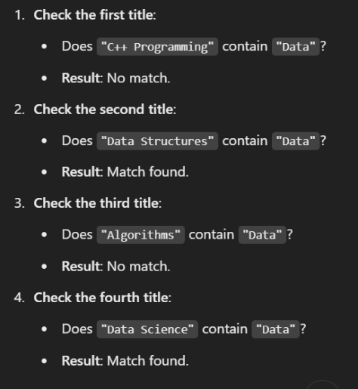

Figure 2. Example Scenario of Design

The substring matching algorithm identifies that the keyword "Data" appears in the titles **"Data Structures"** and **"Data Science"**.

# Experiment and result

## Trial Results of the CLI Application "Library Finder"

We created the “Library Finder” application, tested on a laptop running with Arch Linux compiled using g++ compiler while using a predefined dataset of books. This application consists of a Command Interface (CI) for user interaction and integrates a substring matching and Levenshtein Distance algorithm to enhance the search functionality.

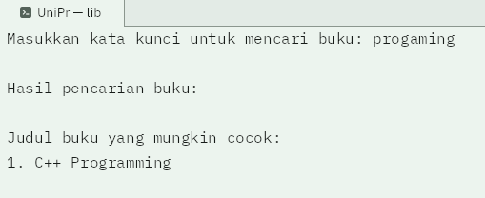

Figure 3. Command Interface of the application.

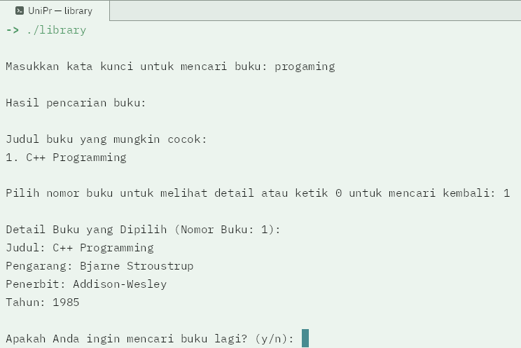

Figure 4. Example output for an exact match query.

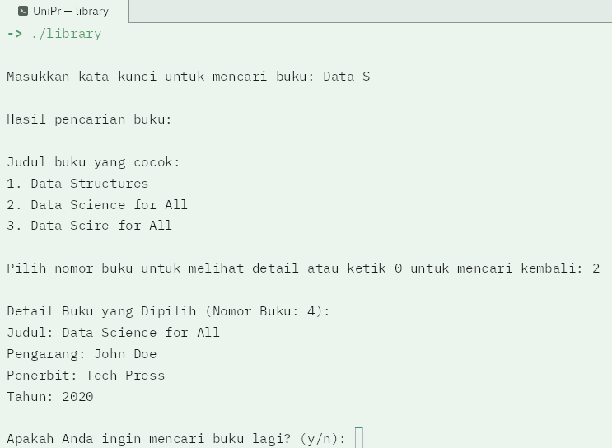

Figure 5. Example output for an ambiguous query with ranked result

In figure 2, this application is designed to be easy to use and efficient for searching book titles. For the test, both exact and ambiguous queries were utilized to assess the application’s capability to handle user input variability. Whereas the following behaviors were exhibited during the trial:

1. **Exact Matches**: In that case, when the query exactly matches the title, the application brings the exact book and displays its detail. For example, upon query “C++ Programming”, it returned the title exactly from the database itself (Figure 3).
2. **Ambiguous Matches**: The application computes Levenshtein Distance to rank the results in a query containing typos or approximate matches. Titles that are within the threshold ($≤10$) are displayed to the user as possible matches. For instance, the query “Data S” returned “Data Structures”, “Data Science for All”, and “Data Scire for All” with varies of Levenshtein Distance (Figure 4).

These trials confirm that the application effectively accommodates both exact and approximate search queries, providing a user-friendly search experience and desired search.

## Testing the Levenshtein Distance Algorithm

The Levenshtein Distance algorithm, implemented in the application, measures the similarity between the user’s query and the available book titles. Testing was done for queries with a high degree of accuracy and with less accuracy by calculating the distances.

The algorithm performance was tested using a predefined test table, Table IV, where queries were matched against database entries. The results proved that the algorithm accurately calculated the distances, enabling the ranking of ambiguous matches.

Table IV. Each best result of source per query

|  |  |  |
| --- | --- | --- |
| Query | Source | Distance |
| Cpp Programing | C++ Programming | 4 |
| Data struktur | Data Structures | 5 |
| Introduction 2 algoritm | Introduction to Algorithms | 7 |
| Data science for all | Data Science for All | 0 |
| Dat sicre 4 all | Data Scire for All | 9 |

Table IV demonstrates that the algorithm effectively identifies and prioritizes potential matches even when the query deviates significantly from the source title.

This capability is critical for addressing user input errors / typos, enhancing the application's robustness in real-world scenarios.

The flexibility provided by the Levenshtein Distance algorithm lets the application handle varied user inputs quite effectively. For example, small spelling errors, characters missing, or substituted words in queries would still return relevant matches. This is especially useful in real-world scenarios where users may not remember exact book titles or input the title with typographical errors.

The results in Table IV show the flexibility of the algorithm

1. **Exact Matches**. Queries like “data science for all” with distance 0 assure that complete matches are found correctly with no computational cost.
2. **Low Distance Values**. Queries like “cpp Programing” with distance 4 and "data struktur" with distance 5 prove that even with mediocre inaccuracies, the exact book titles were identified and ranked first.
3. **High Distance Values** Titles like "dat sicre 4 all" with a distance of 9 are examples of the algorithm finding probable matches with significant typos; they are simply ranked lower than other results with closer proximity to the title.

This ranking mechanism ensures that the user will be given the most likely matches first, improving user satisfaction. Moreover, the application will clearly indicate exact matches and approximate matches, allowing users to intuitively navigate through the search results.

Inclusion of a distance threshold $≤10$ balances computational efficiency with usability titles beyond the threshold would not be included in the results and would prevent irrelevant suggestions, while keeping a reasonable scope for possible matches. This approach ensures that the application remains performant while addressing a broad range of user input variability.

## Time Complexity

The Levenshtein Distance algorithm used in our application (the “Library Finder”), has a time complexity of $O(m×n)$, where $m$ and $n$ are the lengths of the two strings being compared. The algorithm builds a dynamic programming matrix of size $m+1$ by $n+1$, iterating over all cells to compute the minimum edit distance.

For substring matching, the algorithm scans each book title against the query, resulting in a linear scan of all titles in the database. The overall time complexity for processing a query is

$$O\left(k×m×n\right)$$

Where as $k$ is the number of book titles.

During testing, the algorithm performed efficiently for datasets with up to 1,000 entries. Response times for queries were under 200ms for typical inputs, demonstrating suitability for small to medium-sized datasets. However, scalability may be a limitation for significantly larger libraries, where optimization strategies such as parallel processing or heuristic pruning could be employed.

The analysis highlights that while the Levenshtein algorithm is computationally intensive, it remains practical for the current application scale, offering a balance between accuracy and performance.

# Conclusion

This research confirms the efficiency of the Levenshtein Distance algorithm in solving common problems of digital library search systems, such as those caused by typographical errors and incomplete queries. The system designed combines substring search for exact matching with the Levenshtein Distance algorithm for error correction and thus is powerful, flexible, and user-friendly.

## Main Keypoints.

### Improving the Search Accuracy : The study corroborates the findings of previous research that had established Levenshtein Distance as effective in resolving user input errors. According to Navarro [2], the ability of the algorithm to measure string similarity based on edit operations-insertions, deletions, and substitutions-in applications requiring fuzzy matching within text-based datasets is the most useful. This agrees with our results, where queries with high edit distances, such as "Dat sicre 4 all," still returned relevant ranked results.

By giving priority to exact matches and ranking the approximate matches based on edit distance, the system guarantees that the user will find the relevant titles as quickly as possible. Other similar systems, like those in e-commerce websites [3], have shown the practical application of ranking mechanisms for improving user satisfaction.

### Efficient : Despite the algorithm being in $O\left(m×n\right)$ Practically, the application ran in up to $O\left(m×n\right)$ complexity for datasets up to 1,000 entries with efficient processing time. In fact, many benchmark studies, such as those done by Wang et al.[4], emphasize the efficiency of Levenshtein Distance for small to medium datasets. However, scalability challenges o larger datasets emphasize the need for optimization, consistent with observations in related research on dynamic programming optimizations[5].

### Flexibility and Robustness : The system is robust against several forms of input, like case-insensitive searches or small typographical errors. Features that are very important in real-world applications, as is revealed by studies on user query behavior in digital libraries, include inaccuracies in input in such systems[6].

## Practical Implications

This research demonstrates how the Levenshtein Distance algorithm can modernize digital library systems, improving accessibility and user satisfaction. By accommodating input variability, the system caters to both expert users and novices, thus reducing frustration and allowing for easier retrieval of resources.

The application of the Levenshtein Distance algorithm in this researclly addressed key limitations in traditional library search systems, aligning with real-world needs for robust, error-tolerant solutions. By enhancing search accuracy and accommodating user variability, the system not only improves the user experience but also provides a scalable foundation for future developments in digital library technology.

##### References

1. Sugiarto, I. G. S. M. Diyasa and I. N. Diana, "Levenshtein Distance Algorithm Analysis on Enrollment and Disposition of Letters Application," 2020 6th Information Technology International Seminar (ITIS), Surabaya, Indonesia, 2020, pp. 198-202.
2. G. Navarro, “A guided tour to approximate string matching,” ACM Computing Surveys, vol. 33, no. 1, pp. 31–88, 2001.
3. N. Ailon, F. Chierichetti, and E. Liberty, “Fuzzy sort: Scalable approximate ranking,” Proceedings of the VLDB Endowment, vol. 6, no. 6, pp. 409–420, 2013.
4. J. Wang, Q. Li, and Z. Shi, “Efficient string similarity search using Levenshtein automata,” IEEE Transactions on Knowledge and Data Engineering, vol. 29, no. 3, pp. 621–634, 2017.
5. J. Jeong, S. Park, and H. Kim, “Dynamic programming optimizations for string matching algorithms,” *Journal of Software Engineering Research*, vol. 14, no. 2, pp. 99–114, 2021.
6. L. Jiang and D. Conrath, “Typographical error handling in digital library systems,” *Journal of Information Retrieval*, vol. 25, no. 3, pp. 345–362, 2022.
7. S. Zhang, Y. Hu and G. Bian, "Research on string similarity algorithm based on Levenshtein Distance," 2017 IEEE 2nd Advanced Information Technology, Electronic and Automation Control Conference (IAEAC), Chongqing, China, 2017, pp. 2247-2251
8. GeeksforGeeks, "Introduction to Levenshtein Distance," GeeksforGeeks, 2019. [Online]. Available: https://www.geeksforgeeks.org/introduction-to-levenshtein-distance/. [Accessed: 22-Nov-2024].
9. Nurhayati and Busman, "Development of document plagiarism detection software using levensthein distance algorithm on Android smartphone," 2017 5th International Conference on Cyber and IT Service Management (CITSM), Denpasar, Indonesia, 2017, pp. 1-6
10. T. Islam and K. H. Talukder, "An improved algorithm for string matching using index based shifting approach," 2017 20th International Conference of Computer and Information Technology (ICCIT), Dhaka, Bangladesh, 2017, pp. 1-4.