Course Title | ITEP 207 NETWORKING 1
Sem/AY | 2nd Semester 2024-2025
Lesson Title | DATA LINK LAYER
Date
Description of the Lesson | The lesson on the data link layer provides students with a comprehensive understanding of its role within the OSI model, covering key concepts such as framing, error detection, and correction techniques, while emphasizing practical skills in designing, implementing, and troubleshooting data link layer protocols and mechanisms to facilitate efficient and reliable data transmission in networking environments.

Learning Outcomes

Intended Learning Outcomes | Students should be able to meet the following intended learning outcomes:  - Explain the role and importance of the data link layer in the OSI (Open Systems Interconnection) model and its interaction with adjacent layers.  - Understand the principles of framing, error detection, and error correction techniques used in data link layer protocols.
Targets/ Objectives | At the end of the lesson, students should be able to:  - Understanding the Data Link Layer: Mastery of the data link layer's role within the OSI model and its interactions with adjacent layers is foundational for subsequent comprehension.  - Design and Implementation: Proficiency in designing and implementing data link layer protocols and mechanisms ensures practical application and reinforces understanding through hands-on experience.

Student Learning Strategies
Offline Activities | Lecture Guide  What is a Data Link?  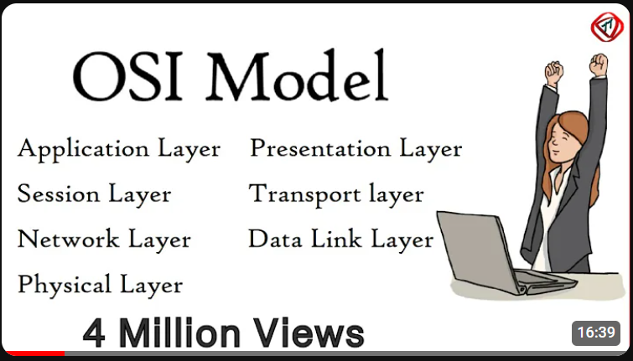  Youtube Link: https://youtu.be/vv4y_uOneC0?si=ICY_8n2NgcHx0zhv  Data Link Layer is the second layer of OSI Layered Model. This layer is one of the most complicated layers and has complex functionalities and liabilities. Data link layer hides the details of underlying hardware and represents itself to upper layer as the medium to communicate.  Data link layer works between two hosts which are directly connected in some sense. This direct connection could be pointed to point or broadcast. Systems on broadcast networks are said to be on the same link. The work of a data link layer tends to get more complex when it is dealing with multiple hosts on a single collision domain.  The data link layer is responsible for converting data streams to signals bit by bit and to send that over the underlying hardware. At the receiving end, Data link layer picks up data from hardware which are in the form of electrical signals, assembles them in a recognizable frame format, and hands over to the upper layer.  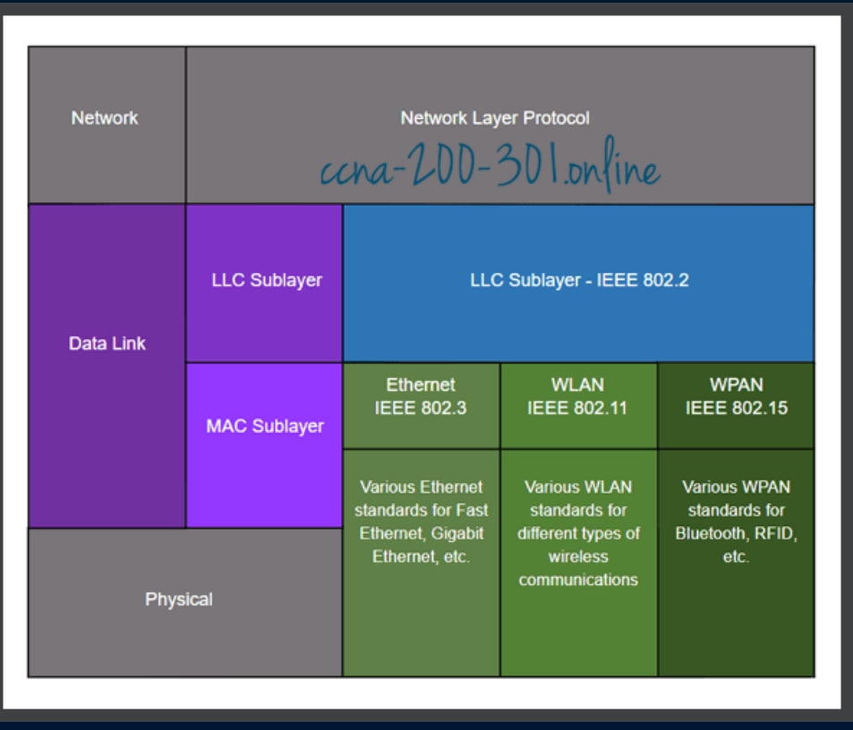  Data link layer has two sub-layers  Logical Link Control:  It deals with protocols, flow control, and error control  Media Access Control:  It deals with actual control of the media.  FUNCTIONALITY OF DATA LINK LAYER  The data link layer does many tasks on behalf of the upper layer.  Framing  Data-link layer takes packets from Network Layer and encapsulates them into Frames.Then, it sends each frame bit-by-bit on the hardware. At receiver’ end, the data link layer picks up signals from hardware and assembles them into frames.  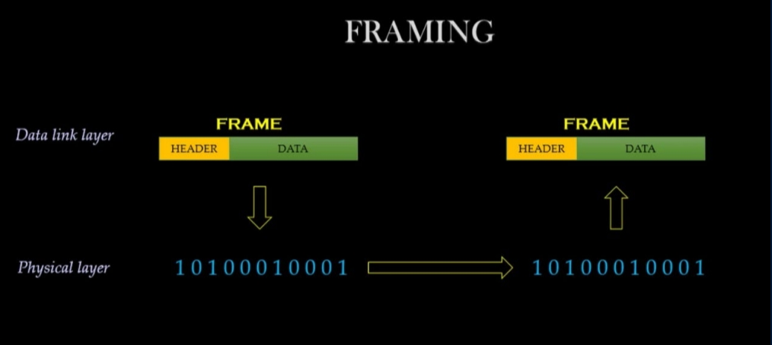  Addressing  Data-link layer provides layer-2 hardware addressing mechanism. Hardware address is assumed to be unique on the link. It is encoded into hardware at the time of manufacturing.  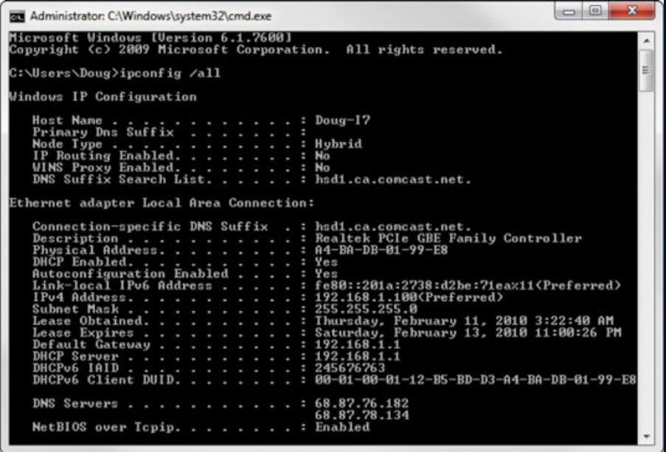  Synchronization  When data frames are sent on the link, both machines must be synchronized in order to transfer to take place.  Error Control  Sometimes signals may have encountered problems in transition and the bits are flipped.These errors are detected and attempted to recover actual data bits. It also provides an error reporting mechanism to the sender.  Flow Control  Stations on the same link may have different speeds or capacity. Data-link layer ensures flow control that enables both machines to exchange data at the same speed.  Multi-Access  When the host on the shared link tries to transfer the data, it has a high probability of collision. Data-link layer provides mechanisms such as CSMA/CD to equip capability of accessing a shared media among multiple Systems.  ERROR DETECTION AND CORRECTION  Types of Errors  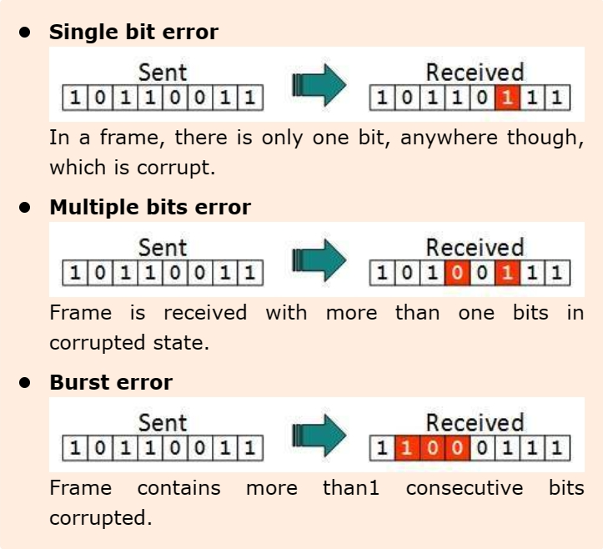  There may be three types of errors:  Error control mechanism may involve two possible ways:  - Error detection  - Error correction  Error Detection  Errors in the received frames are detected by means of Parity Check and Cyclic Redundancy Check (CRC). In both cases, a few extra bits are sent along with actual data to confirm that bits received at the other end are the same as they were sent. If the counter-check at receiver’ end fails, the bits are considered corrupted.  Parity Check  One extra bit is sent along with the original bits to make a number of 1s either even in case of even parity, or odd in case of odd parity. The sender while creating a frame counts the number of 1s in it. For example, if parity is used and number of 1s is even then one bit with value 0 is added. This way number of 1s remains even.If the number of 1s is odd, to make it even a bit with value 1 is added.  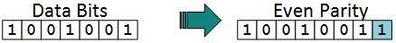  Cyclic Redundancy Check (CRC)  CRC is a different approach to detect if the received frame contains valid data. This technique involves binary division of the data bits being sent. The divisor is generated using polynomials. The sender performs a division operation on the bits being sent and calculates the remainder. Before sending the actual bits, the sender adds the remainder at the end of the actual bits. Actual data bits plus the remainder is called a codeword. The sender transmits data bits as codewords.  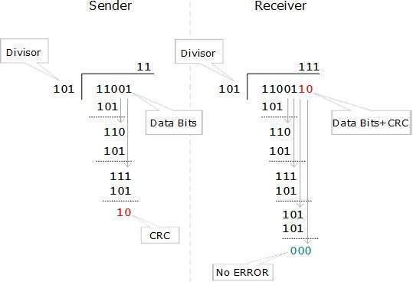  Error Correction  In the digital world, error correction can be done in two ways:  - Backward Error Correction: When the receiver detects an error in the data received, it requests back the sender to retransmit the data unit.  - Forward Error Correction: When the receiver detects some error in the data received, it executes error-correcting code, which helps it to auto-recover and to correct some kinds of errors.  Error Control:  Requirements for error control mechanism:  Error detection - The sender and receiver, either both or any, must ascertain that there is some error in the transit.  Positive ACK - When the receiver receives a correct frame, it should acknowledge it.  Negative ACK - When the receiver receives a damaged frame or a duplicate frame, it sends a NACK back to the sender and the sender must retransmit the correct frame.  Retransmission: The sender maintains a clock and sets a timeout period. If an acknowledgement of a data-frame previously transmitted does not arrive before the timeout the sender retransmits the frame, thinking that the frame or its acknowledgement is lost in transit.  There are three types of techniques available which Data-link layer may deploy to control the errors by Automatic Repeat Requests (ARQ):  - Stop-and-wait ARQ  - Go-Back-N ARQ  - Selective Repeat ARQ

