Course Title | ITEP 207 NETWORKING 1
Sem/AY | 2nd Semester 2024-2025
Lesson Title | MEDIUM ACCESS CONTROL SUBLAYER
Date
Description of the Lesson | The lesson on the Medium Access Control (MAC) Sublayer covers essential topics related to how data is regulated and communicated over shared network mediums. This chapter is crucial for understanding the principles of network data access and the technologies that enable efficient and fair use of networking channels.
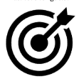
Learning Outcomes

Intended Learning Outcomes | Students should be able to meet the following intended learning outcomes:  - Addresses challenges in distributing channel access among multiple users or devices in a network.  - Explores protocols allowing simultaneous network access for multiple devices.  - Covers LAN technology, including frame formats, collision detection, and Ethernet switches.
Targets/ Objectives | At the end of the lesson, students should be able to:  Understand the role and importance of the MAC sublayer in managing access to shared communication channels.  Identify and describe various MAC protocols like CSMA/CD, CSMA/CA, and Token Passing, including their principles of operation and differences.  Develop proficiency in configuring and optimizing MAC parameters to enhance network performance and troubleshoot common issues.
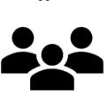
Student Learning Strategies
Offline Activities | Lecture Guide  Medium Access Control Sublayer (MAC sublayer)  The medium access control (MAC) is a sublayer of the data link layer of the open system interconnections (OSI) reference model for data transmission. It is responsible for flow control and multiplexing for transmission medium. It controls the transmission of data packets via remotely shared channels. It sends data over the network interface card.  MAC Layer in the OSI Model  The Open System Interconnections (OSI) model is a layered networking framework that conceptualizes how communications should be done between heterogeneous systems. The data link layer is the second lowest layer. It is divided into two sublayers−  - The logical link control (LLC) sublayer  - The medium access control (MAC) sublayer  Functions of MAC Layer  - It provides an abstraction of the physical layer to the LLC and upper layers of the OSI network.  - It is responsible for encapsulating frames so that they are suitable for transmission via the physical medium.  - It resolves the addressing of source station as well as the destination station, or groups of destination stations.  - It performs multiple access resolutions when more than one data frame is to be transmitted. It determines the channel access methods for transmission.  - It also performs collision resolution and initiating retransmission in case of collisions.  - It generates the frame check sequences and thus contributes to protection against transmission errors.  MAC Addresses  MAC address or media access control address is a unique identifier allotted to a network interface controller (NIC) of a device. It is used as a network address for data transmission within a network segment like Ethernet, Wi-Fi, and Bluetooth.  MAC address is assigned to a network adapter at the time of manufacturing. It is hardwired or hard-coded in the network interface card (NIC). A MAC address comprises six groups of two hexadecimal digits, separated by hyphens, colons, or no separators. An example of a MAC address is 00:0A:89:5B:F0:11.  Channel Allocation Problem in Computer Network  Channel allocation is a process in which a single channel is divided and allotted to multiple users in order to carry user specific tasks. There are user’s quantity may vary every time the process takes place. If there are N number of users and channel is divided into N equal-sized sub channels, Each user is assigned one portion. If the number of users are small and don’t vary at times, then Frequency Division Multiplexing can be used as it is a simple and efficient channel bandwidth allocating technique.  Channel allocation problem can be solved by two schemes: Static Channel Allocation in LANs and MANs, and Dynamic Channel Allocation.  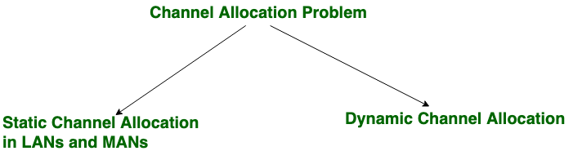  1. Static Channel Allocation in LANs and MANs:  It is the classical or traditional approach of allocating a single channel among multiple competing users using Frequency Division Multiplexing (FDM). if there are N users, the frequency channel is divided into N equal sized portions (bandwidth), each user being assigned one portion. Since each user has a private frequency band, there is no interference between users.  However, it is not suitable in case of a large number of users with variable bandwidth requirements.  It is not efficient to divide into a fixed number of chunks.  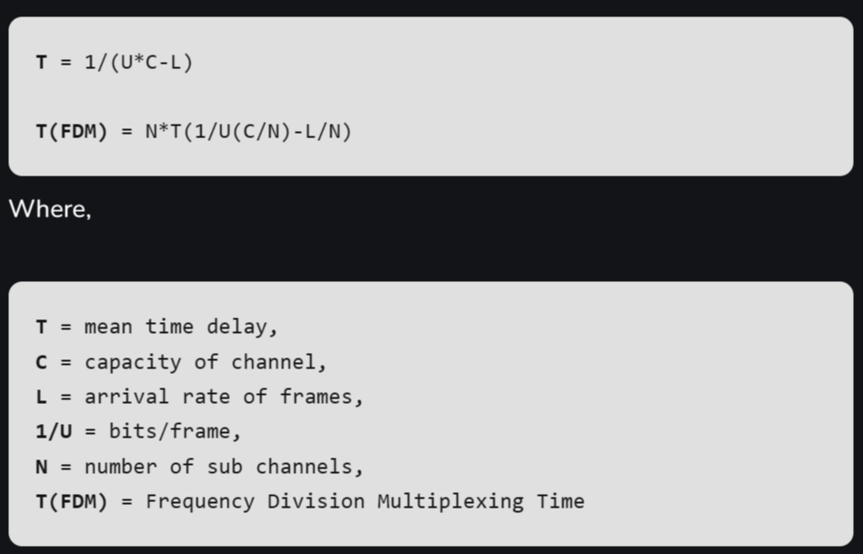  2. Dynamic Channel Allocation:  In the dynamic channel allocation scheme, frequency bands are not permanently assigned to the users. Instead channels are allotted to users dynamically as needed, from a central pool. The allocation is done considering a number of parameters so that transmission interference is minimized.  This allocation scheme optimises bandwidth usage and results in faster transmissions.  Dynamic channel allocation is further divided into:  - Centralised Allocation  - Distributed Allocation  Multiple Access Control  If there is a dedicated link between the sender and the receiver then a data link control layer is sufficient, however if there is no dedicated link present then multiple stations can access the channel simultaneously. Hence multiple access protocols are required to decrease collision and avoid crosstalk. For example, in a classroom full of students, when a teacher asks a question and all the students (or stations) start answering simultaneously (send data at same time) then a lot of chaos is created( data overlap or data lost) then it is the job of the teacher (multiple access protocols) to manage the students and make them answer one at a time.  Thus, protocols are required for sharing data on non dedicated channels. Multiple access protocols can be subdivided further as –  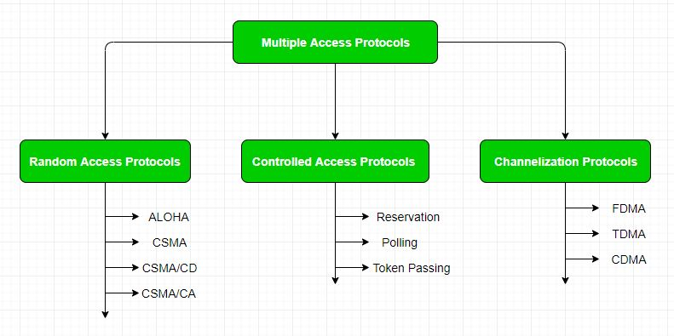  1. Random Access Protocol:  In this, all stations have the same superiority that no station has more priority than another station. Any station can send data depending on the medium's state( idle or busy). It has two features:  - There is no fixed time for sending data  - There is no fixed sequence of stations sending data  The Random access protocols are further subdivided as:  (a) ALOHA – It was designed for wireless LAN but is also applicable for shared medium. In this, multiple stations can transmit data at the same time and can hence lead to collision and data being garbled.  (b) CSMA – Carrier Sense Multiple Access ensures fewer collisions as the station is required to first sense the medium (for idle or busy) before transmitting data. If it is idle then it sends data, otherwise it waits till the channel becomes idle. However there is still a chance of collision in CSMA due to propagation delay. For example, if station A wants to send data, it will first sense the medium.If it finds the channel idle, it will start sending data. However, by the time the first bit of data is transmitted (delayed due to propagation delay) from station A, if station B requests to send data and senses the medium it will also find it idle and will also send data. This will result in collision of data from station A and B.  (c) CSMA/CD – Carrier sense multiple access with collision detection. Stations can terminate transmission of data if collision is detected. For more details refer – Efficiency of CSMA/CD  (d) CSMA/CA – Carrier sense multiple access with collision avoidance. The process of collision detection involves the sender receiving acknowledgement signals. If there is just one signal(its own) then the data is successfully sent but if there are two signals(its own and the one with which it has collided) then it means a collision has occurred. To distinguish between these two cases, collision must have a lot of impact on received signal. However it is not so in wired networks, so CSMA/CA is used in this case.  2. Controlled Access:  In this, the data is sent by that station which is approved by all other stations. For further details refer – Controlled Access Protocols  3. Channelization:  In this, the available bandwidth of the link is shared in time, frequency and code to multiple stations to access the channel simultaneously.  What is Ethernet?  Ethernet is the most widely used LAN technology and is defined under IEEE standards 802.3. The reason behind its wide usability is that Ethernet is easy to understand, implement, and maintain, and allows low-cost network implementation. Also, Ethernet offers flexibility in terms of the topologies that are allowed. Ethernet generally uses a bus topology. Ethernet operates in two layers of the OSI model, the physical layer and the data link layer. For Ethernet, the protocol data unit is a frame since we mainly deal with DLLs. In order to handle collisions, the Access control mechanism used in Ethernet is CSMA/CD.  History of Ethernet  Robert Metcalfe’s invention of Ethernet in 1973 completely changed computer networking. With Ethernet Version 2’s support for 10 Mbps and an initial data rate of 2.94 Mbps, it first gained popularity in 1982. Ethernet’s adoption was accelerated by the IEEE 802.3 standardization in 1983. Local area networks (LANs) and the internet were able to expand quickly thanks to the rapid evolution and advancement of Ethernet, which over time reached speeds of 100 Mbps, 1 Gbps, 10 Gbps, and higher. It evolved into the standard technology for wired network connections, enabling dependable and quick data transmission for private residences, commercial buildings, and data centers all over the world.  Key Features of Ethernet  - Speed: Ethernet is capable of transmitting data at high speeds, with current Ethernet standards supporting speeds of up to 100 Gbps.  - Flexibility: Ethernet is a flexible technology that can be used with a wide range of devices and operating systems. It can also be easily scaled to accommodate a growing number of users and devices.  - Reliability: Ethernet is a reliable technology that uses error-correction techniques to ensure that data is transmitted accurately and efficiently.  - Cost-effectiveness: Ethernet is a cost-effective technology that is widely available and easy to implement. It is also relatively low-maintenance, requiring minimal ongoing support.  - Interoperability: Ethernet is an interoperable technology that allows devices from different manufacturers to communicate with each other seamlessly.  - Security: Ethernet includes built-in security features, including encryption and authentication, to protect data from unauthorized access.  - Manageability: Ethernet networks are easily managed, with various tools available to help network administrators monitor and control network traffic.  - Compatibility: Ethernet is compatible with a wide range of other networking technologies, making it easy to integrate with other systems and devices.  - Availability: Ethernet is a widely available technology that can be used in almost any setting, from homes and small offices to large data centers and enterprise-level networks.  - Simplicity: Ethernet is a simple technology that is easy to understand and use. It does not require specialized knowledge or expertise to set up and configure, making it accessible to a wide range of users.  - Standardization: Ethernet is a standardized technology, which means that all Ethernet devices and systems are designed to work together seamlessly. This makes it easier for network administrators to manage and troubleshoot Ethernet networks.  - Scalability: Ethernet is highly scalable, which means it can easily accommodate the addition of new devices, users, and applications without sacrificing performance or reliability.  - Broad compatibility: Ethernet is compatible with a wide range of protocols and technologies, including TCP/IP, HTTP, FTP, and others. This makes it a versatile technology that can be used in a variety of settings and applications.  - Ease of integration: Ethernet can be easily integrated with other networking technologies, such as Wi-Fi and Bluetooth, to create a seamless and integrated network environment.  - Ease of troubleshooting: Ethernet networks are easy to troubleshoot and diagnose, thanks to a range of built-in diagnostic and monitoring tools. This makes it easier for network administrators to identify and resolve issues quickly and efficiently.  - Support for multimedia: Ethernet supports multimedia applications, such as video and audio streaming, making it ideal for use in settings where multimedia content is a key part of the user experience.Ethernet is a reliable, cost-effective, and widely used LAN technology that offers high-speed connectivity and easy manageability for local networks.  What is Wireless LAN?  WLAN stands for Wireless Local Area Network. WLAN is a local area network that uses radio communication to provide mobility to the network users while maintaining the connectivity to the wired network. A WLAN basically, extends a wired local area network. WLAN’s are built by attaching a device called the access point(AP) to the edge of the wired network. Clients communicate with the AP using a wireless network adapter which is similar in function to an ethernet adapter. It is also called a LAWN is a Local area wireless network.  The performance of WLAN is high compared to other wireless networks. The coverage of WLAN is within a campus or building or that tech park. It is used in the mobile propagation of wired networks. The standards of WLAN are HiperLAN, Wi-Fi, and IEEE 802.11. It offers service to the desktop laptop, mobile application, and all the devices that work on the Internet. WLAN is an affordable method and can be set up in 24 hours. WLAN gives users the mobility to move around within a local coverage area and still be connected to the network. Most latest brands are based on IEE 802.11 standards, which are the WI-FI brand name.  History  A professor at the University of Hawaii who’s name was Norman Abramson, developed the world’s first wireless computer communication network. In 1979, Gfeller and u. Bapst published a paper in the IEE proceedings reporting an experimental wireless local area network using diffused infrared communications. The first of the IEEE workshops on Wireless LAN was held in 1991.  WLAN Architecture  Components in Wireless LAN architecture as per IEEE standards are as follows:  Stations: Stations consist of all the equipment that is used to connect all wireless LANs. Each station has a wireless network controller.  Base Service Set(BSS): It is a group of stations communicating at the physical layer.  Extended Service Set(ESS): It is a group of connected Base Service Set(BSS).  Distribution Service (DS): It connects all Extended Service Set(ESS).  Characteristics of WLAN  - Seamless operation.  - Low power for battery use.  - Simple management, easy to use for everyone.  - Protection of investment in wired networks.  - Robust transmission technology.  Advantages of WLAN  - Installation speed and simplicity.  - Installation flexibility.  - Reduced cost of ownership.  - Reliability.  - Mobility.  - Robustness.  Disadvantages of WLAN  - Slower bandwidth.  - Security for wireless LANs is the prime concern.  - Less capacity.  - Wireless networks cost four times more than wired network cards.  - Wireless devices emit low levels of RF which can be harmful to our health.  Broadband Wireless  It is just like a dial-up connection, in this the DSL uses a particular wire i.e. copper phone wires and the coaxial cable are used for cable internet, some fiber-optic cables are used for fiber internet. Some wireless broadband connections are also available such as satellite, 4G, or 5G LTE. Every connection uses different frequencies that provide different ranges and internet speeds.  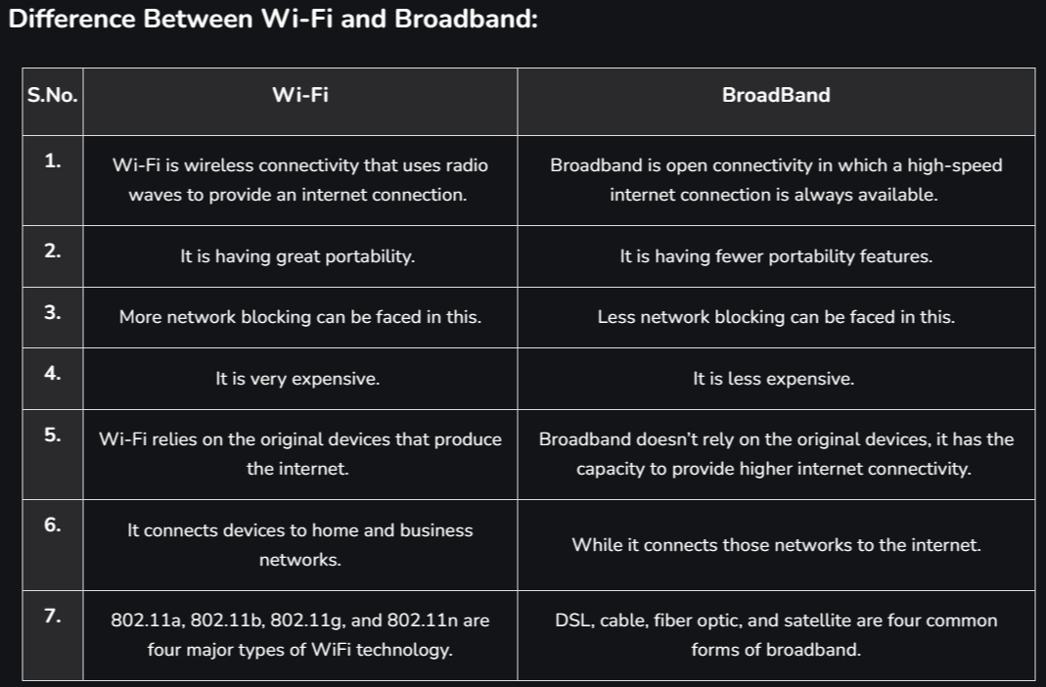  What is Bluetooth?  Bluetooth is used for short-range wireless voice and data communication. It is a Wireless Personal Area Network (WPAN) technology and is used for data communications over smaller distances. This generation changed into being invented via Ericson in 1994. It operates within the unlicensed, business, scientific, and clinical (ISM) bands from 2.4 GHz to 2.485 GHz. Bluetooth stages up to 10 meters. Depending upon the version, it presents information up to at least 1 Mbps or 3 Mbps. The spreading method that it uses is FHSS (Frequency-hopping unfold spectrum). A Bluetooth network is called a piconet and a group of interconnected piconets is called a scatternet.  What is Bluetooth?  Bluetooth simply follows the principle of transmitting and receiving data using radio waves. It can be paired with the other device which has also Bluetooth but it should be within the estimated communication range to connect. When two devices start to share data, they form a network called piconet which can further accommodate more than five devices.  Key Features of Bluetooth  - The transmission capacity of Bluetooth is 720 kbps.  - Bluetooth is a wireless device.  - Bluetooth is a Low-cost and short-distance radio communications standard.  - Bluetooth is robust and flexible.  - The basic architecture unit of Bluetooth is a piconet.  Types of Bluetooth  - In-Car Headset: One can make calls from the car speaker system without the use of mobile phones.  - Stereo Headset: To listen to music in the car or in music players at home.  - Webcam: One can link the camera with the help of Bluetooth with their laptop or phone.  - Bluetooth-equipped Printer: The printer can be used when connected via Bluetooth with mobile phone or laptop.  - Bluetooth Global Positioning System (GPS): To use Global Positioning System (GPS) in cars, one can connect their phone with the car system via Bluetooth to fetch the directions of the address.  Advantages of Bluetooth  - It is a low-cost and easy-to-use device.  - It can also penetrate through walls.  - It creates an Ad-hoc connection immediately without any wires.  - It is used for voice and data transfer.  Disadvantages of Bluetooth  - It can be hacked and hence, less secure.  - It has a slow data transfer rate of 3 Mbps.  - Bluetooth communication does not support routing.  Applications of Bluetooth  - It can be used in wireless headsets, wireless PANs, and LANs.  - It can connect a digital camera wireless to a mobile phone.  - It can transfer data in terms of videos, songs, photographs, or files from one cell phone to another cell phone or computer.  - It is used in the sectors of Medical healthcare, sports and fitness, Military.  Radio Frequency Identification (RFID)  Radio Frequency Identification (RFID) is a form of wireless communication that incorporates the use of electromagnetic or electrostatic coupling in the radio frequency portion of the electromagnetic spectrum to uniquely identify an object, animal or person. It uses radio frequency to search ,identify, track and communicate with items and people. It is a method that is used to track or identify an object by radio transmission used over the web. Data digitally encoded in an RFID tag which might be read by the reader. This device works as a tag or label during which data is read from tags that are stored in the database through the reader as compared to traditional barcodes and QR codes. It is often read outside the road of sight either passive or active RFID.  Kinds of RFID  There are many kinds of RFID, each with different properties, but perhaps the most fascinating aspect of RFID technology is that most RFID tags have neither an electric plug nor a battery. Instead, all of the energy needed to operate them is supplied in the form of radio waves by RFID readers. This technology is called passive RFID to distinguish it from the(less common) active RFID in which there is a power source on the tag.  UHF RHID ( Ultra-High Frequency RFID ). It is used on shipping pallets and some driver’s licenses. Readers send signals in the 902-928 MHz band. Tags communicate at distances of several meters by changing the way they reflect the reader signals; the reader is able to pick up these reflections. This way of operating is called backscatter.  HF RFID (High-Frequency RFID ). It operates at 13.56 MHz and is likely to be in your passport, credit cards, books, and noncontact payment systems. HF RFID has a short-range, typically a meter or less because the physical mechanism is based on induction rather than backscatter.  There are also other forms of RFID using other frequencies, such as LF RFID(Low-Frequency RFID), which was developed before HF RFID and used for tracking.  Types of RFID  - Passive RFID: Passive RFID tags do not have their own power source. It uses power from the reader. In this device, RF tags are not attached by a power supply and passive RF tags stored their power. When it is emitted from active antennas, the RF tags are used for specific frequencies like 125-134KHZ as low frequency, 13.56MHZ as a high frequency and 856MHZ to 960MHZ as ultra-high frequency.  - No need embedded power  - Tracking inventory  - Has unique identification number  - Sensitive for interference  - Semi-passive RFID  - Active RFID: In this device, RF tags are attached by a power supply that emits a signal and there is an antenna which receives the data. means, an active tag uses a power source like a battery. It has its own power source, and does not require power from the source/reader.  - Embedded power: communication over large distance  - Has unique identifier /identification number  - Use other devices like sensors  - Better than passive tags in the presence of metal  Advantages of RFID  - It provides data access and real-time information without taking too much time.  - RFID tags follow the instruction and store a large amount of information.  - The RFID system is non-line of sight nature of the technology.  - It improves the Efficiency, traceability of production.  - In RFID hundreds of tags read in a short time.  Disadvantages of RFID  - It takes longer to program RFID Devices.  - RFID is intercepted easily even if it is Encrypted.  - In an RFID system, there are two or three layers of ordinary household foil to dam the radio wave.  - There is privacy concern about RFID devices; anybody can access information about anything.  - Active RFID can be costlier due to the battery.  What is Data Link Layer Switching?  Data Link Switching (DLSw) is a protocol used to facilitate communication between disparate networks by tunneling data link layer (Layer 2) information over a packet-switched network (like IP or IPX). It is primarily used to connect IBM SNA networks over an IP-based infrastructure.  How does Data Link Switching work?  DLSw operates by encapsulating data link layer (Layer 2) frames within a DLSw header. This header is then encapsulated within an IP or IPX packet, allowing for the transportation of layer 2 frames across the packet-switched network. DLSw peers are used to establish a connection between devices and forward encapsulated frames between them.  Advantages of using Data Link Switching  Some advantages of using Data Link Switching include the ability to connect geographically distant networks, simplifying network configuration and management, and providing reliable and efficient transport of legacy protocols over modern IP-based networks.  Disadvantages of using Data Link Switching  Disadvantages of using Data Link Switching include potential performance issues due to the additional overhead of encapsulation, limited support from modern network devices, and the necessity for a specialized skill set to troubleshoot and manage the DLSw environment.  References:  https://www.geeksforgeeks.org/channel-allocation-problem-in-computer-network/  https://www.geeksforgeeks.org/multiple-access-protocols-in-computer-network/  https://www.geeksforgeeks.org/what-is-ethernet/  https://www.geeksforgeeks.org/wlan-full-form/  https://www.geeksforgeeks.org/difference-between-wi-fi-and-broadband/  https://www.geeksforgeeks.org/bluetooth/  https://l.messenger.com/l.php?u=https%3A%2F%2Fwww.devx.com%2Fterms%2Fdata-link-switching%2F%23%3A~%3Atext%3DData%2520Link%2520Switching%2520(DLSw)%2520is%2520a%2520protocol%2520used%2520to%2520facilitate%2Cover%2520an%2520IP%252Dbased%2520infrastructure&h=AT0fdLC9PzTcbe5u8fthUyoUMuSAbzrns2xwpGZLQkhfkuiangLa9GWTmly_tvkBBeYMrOXiKcNoUZv02XvM3Uc4O6rSCL5hxzDIsBFh7IBWENhSYpEDGh-LT8_lzfxhCviLxw

