Course Title | ITEP 207 NETWORKING 1
Sem/AY | 2nd Semester 2024-2025
Lesson Title | The Transport Layer
Date
Description of the Lesson | The Transport Layer, often referred to as Layer 4 in the OSI model, is crucial for managing network traffic between hosts and ensuring complete data flows. It’s responsible for the end-to-end communication services for applications, providing features such as connection-oriented communication, reliability, flow control, and multiplexing. This layer ensures that data packets are delivered in order and without errors, by using protocols like TCP for connection-oriented transmissions and UDP for simpler messaging transmissions. The Transport Layer also handles the segmentation of data from the application layer into smaller units, known as segments, for easier transmission and reassembles them at the destination. It’s a key player in enabling applications on different hosts to communicate over the network
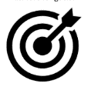
Learning Outcomes

Intended Learning Outcomes | Students should be able to meet the following intended learning outcomes:
Targets/ Objectives | At the end of the lesson, students should be able to:
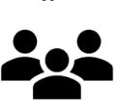
Student Learning Strategies
Offline Activities | Lecture Guide  The transport Layer is the second layer in the TCP/IP model and the fourth layer in the OSI model. It is an end-to-end layer used to deliver messages to a host. It is termed an end-to-end layer because it provides a point-to-point connection rather than hop-to-hop, between the source host and destination host to deliver the services reliably. The unit of data encapsulation in the Transport Layer is a segment.  Working of Transport Layer  The transport layer takes services from the Application layer and provides services to the Network layer.  At the sender’s side: The transport layer receives data (message) from the Application layer and then performs Segmentation, divides the actual message into segments, adds the source and destination’s port numbers into the header of the segment, and transfers the message to the Network layer.  At the receiver’s side: The transport layer receives data from the Network layer, reassembles the segmented data, reads its header, identifies the port number, and forwards the message to the appropriate port in the Application layer.  Responsibilities of a Transport Layer  The Process-to-Process Delivery  End-to-End Connection between Hosts  Multiplexing and Demultiplexing  Congestion Control  Data integrity and Error correction  Flow control  1. The Process-to-Process Delivery  While Data Link Layer requires the MAC address (48 bits address contained inside the Network Interface Card of every host machine) of source-destination hosts to correctly deliver a frame and the Network layer requires the IP address for appropriate routing of packets, in a similar way Transport Layer requires a Port number to correctly deliver the segments of data to the correct process amongst the multiple processes running on a particular host. A port number is a 16-bit address used to identify any client-server program uniquely.  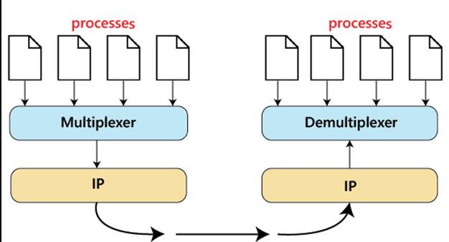  Process to process delivery  2. End-to-end Connection between Hosts  The transport layer is also responsible for creating the end-to-end Connection between hosts for which it mainly uses TCP and UDP. TCP is a secure, connection-orientated protocol that uses a handshake protocol to establish a robust connection between two end hosts. TCP ensures the reliable delivery of messages and is used in various applications. UDP, on the other hand, is a stateless and unreliable protocol that ensures best-effort delivery. It is suitable for applications that have little concern with flow or error control and requires sending the bulk of data like video conferencing. It is often used in multicasting protocols.  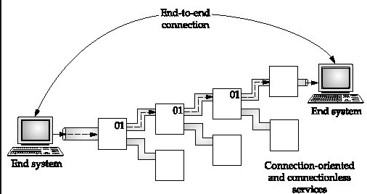  End to End Connection.  3. Multiplexing and Demultiplexing  Multiplexing (many to one) is when data is acquired from several processes from the sender and merged into one packet along with headers and sent as a single packet. Multiplexing allows the simultaneous use of different processes over a network that is running on a host. The processes are differentiated by their port numbers. Similarly, Demultiplexing (one to many) is required at the receiver side when the message is distributed into different processes. Transport receives the segments of data from the network layer distributes and delivers it to the appropriate process running on the receiver’s machine.  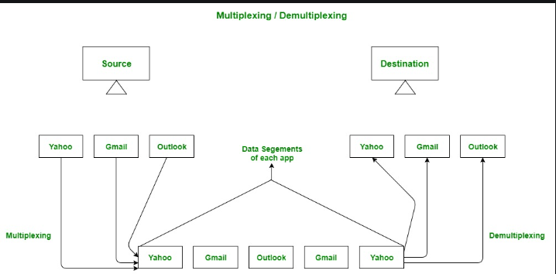  Multiplexing and Demultiplexing  4. Congestion Control  Congestion is a situation in which too many sources over a network attempt to send data and the router buffers start overflowing due to which loss of packets occurs. As a result, the retransmission of packets from the sources increases the congestion further. In this situation, the Transport layer provides Congestion Control in different ways. It uses open-loop congestion control to prevent congestion and closed-loop congestion control to remove the congestion in a network once it occurred. TCP provides AIMD – additive increases multiplicative decrease and leaky bucket technique for congestion control.  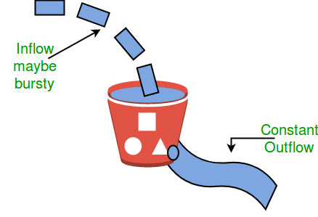  Leaky Bucket Congestion Control Technique  5. Data integrity and Error Correction  The transport layer checks for errors in the messages coming from the application layer by using error detection codes, and computing checksums, it checks whether the received data is not corrupted and uses the ACK and NACK services to inform the sender if the data has arrived or not and checks for the integrity of data.  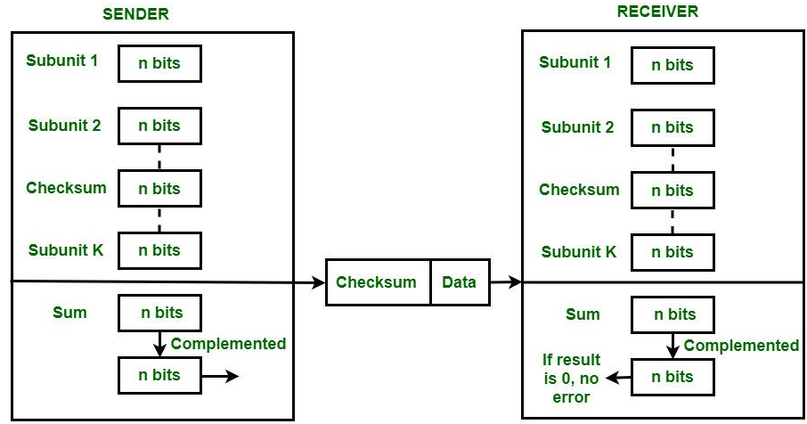  Error Correction using Checksum  6. Flow Control  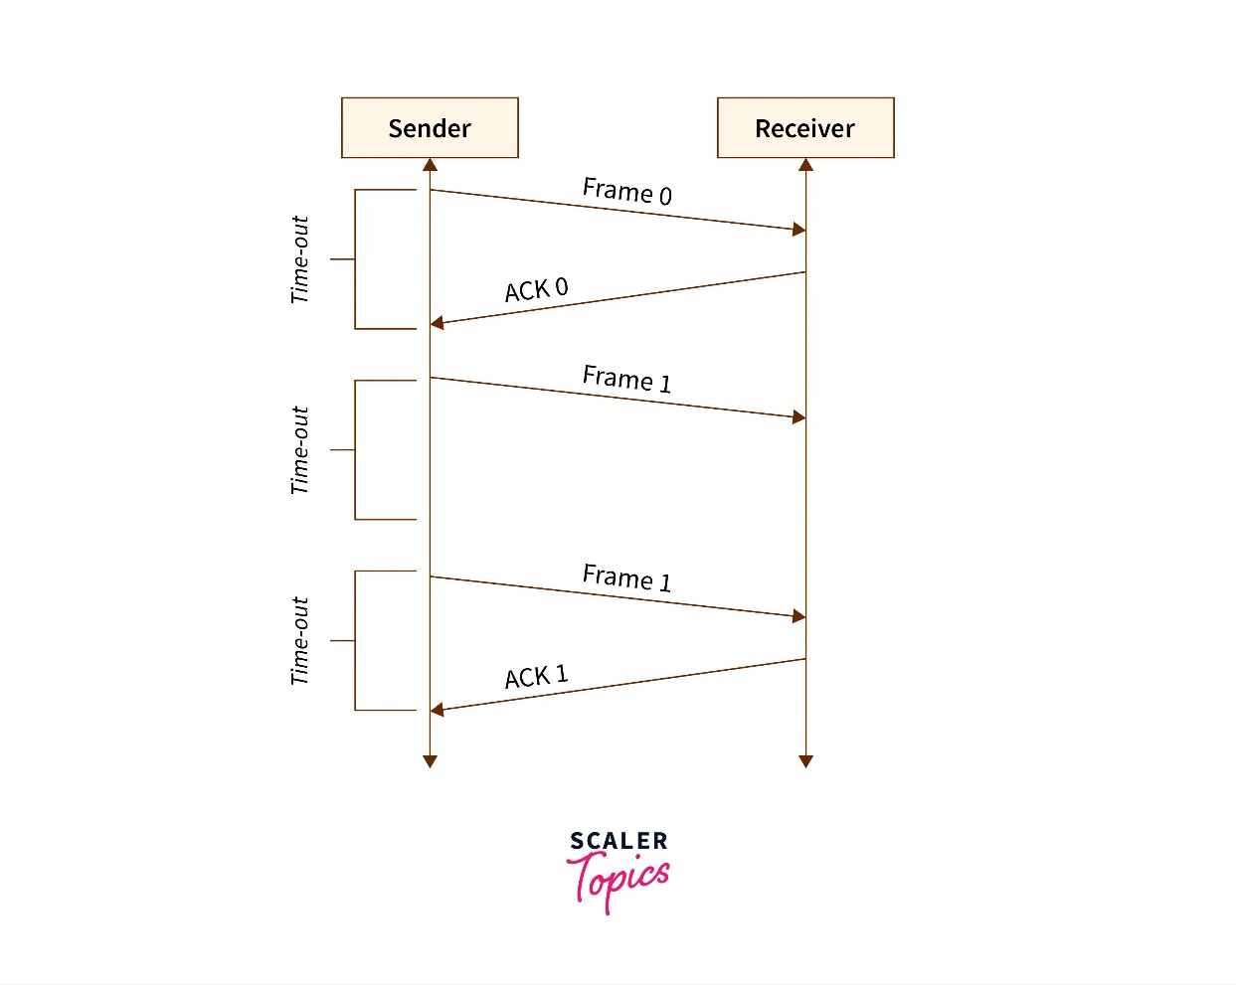  The transport layer provides a flow control mechanism between the adjacent layers of the TCP/IP model. TCP also prevents data loss due to a fast sender and slow receiver by imposing some flow control techniques. It uses the method of sliding window protocol which is accomplished by the receiver by sending a window back to the sender informing the size of data it can receive.  Protocols of Transport Layer  - Transmission Control Protocol (TCP)  What is Transmission Control Protocol (TCP)?  TCP (Transmission Control Protocol) is one of the main protocols of the Internet protocol suite. It lies between the Application and Network Layers which are used in providing reliable delivery services.  What is Transmission Control Protocol (TCP)?  Transmission Control Protocol is a connection-oriented protocol for communications that helps in the exchange of messages between different devices over a network. The Internet Protocol (IP), which establishes the technique for sending data packets between computers, works with TCP.  The position of TCP is at the transport layer of the OSI model. TCP also helps in ensuring that information is transmitted accurately by establishing a virtual connection between the sender and receiver.  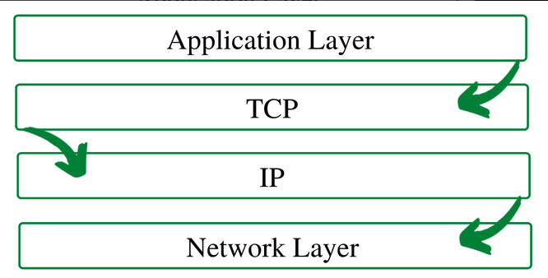  What is Internet Protocol (IP)?  Internet Protocol is a method that is useful for sending data from one device to another from all over the internet. Every device contains a unique IP Address that helps it communicate and exchange data across other devices present on the internet.  For more, you can refer to the TCP/IP Model.  Working of Transmission Control Protocol (TCP)  To make sure that each message reaches its target location intact, the TCP/IP model breaks down the data into small bundles and afterward reassembles the bundles into the original message on the opposite end. Sending the information in little bundles of information makes it simpler to maintain efficiency as opposed to sending everything in one go.  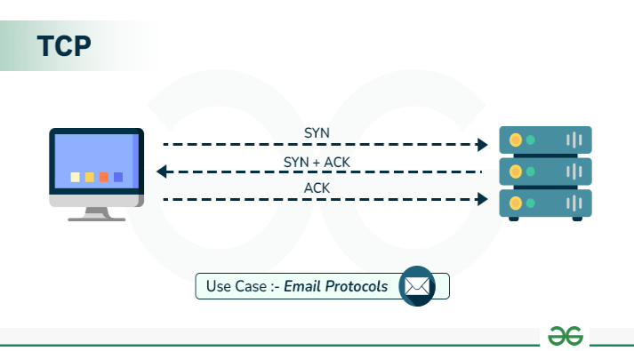  After a particular message is broken down into bundles, these bundles may travel along multiple routes if one route is jammed but the destination remains the same.  For Example: When a user requests a web page on the internet, somewhere in the world, the server processes that request and sends back an HTML Page to that user. The server makes use of a protocol called the HTTP Protocol. The HTTP then requests the TCP layer to set the required connection and send the HTML file.  Now, the TCP breaks the data into small packets and forwards it toward the Internet Protocol (IP) layer. The packets are then sent to the destination through different routes.  The TCP layer in the user’s system waits for the transmission to get finished and acknowledges once all packets have been received.  Features of TCP/IP  Some of the most prominent features of Transmission control protocol are mentioned below.  - Segment Numbering System: TCP keeps track of the segments being transmitted or received by assigning numbers to each and every single one of them. A specific Byte Number is assigned to data bytes that are to be transferred while segments are assigned sequence numbers. Acknowledgment Numbers are assigned to received segments.  - Connection Oriented: It means sender and receiver are connected to each other till the completion of the process. The order of the data is maintained i.e. order remains same before and after transmission.  - Full Duplex: In TCP data can be transmitted from receiver to the sender or vice – versa at the same time. It increases efficiency of data flow between sender and receiver.  - Flow Control: Flow control limits the rate at which a sender transfers data. This is done to ensure reliable delivery. The receiver continually hints to the sender on how much data can be received (using a sliding window).  - Error Control: TCP implements an error control mechanism for reliable data transfer. Error control is byte-oriented. Segments are checked for error detection. Error Control includes – Corrupted Segment & Lost Segment Management, Out-of-order segments, Duplicate segments, etc.  - Congestion Control: TCP takes into account the level of congestion in the network. Congestion level is determined by the amount of data sent by a sender.  Advantages of TCP  - It is a reliable protocol.  - It provides an error-checking mechanism as well as one for recovery.  - It gives flow control.  - It makes sure that the data reaches the proper destination in the exact order that it was sent.  - Open Protocol, not owned by any organization or individual.  - It assigns an IP address to each computer on the network and a domain name to each site thus making each device site to be distinguishable over the network.  Disadvantages of TCP  - TCP is made for Wide Area Networks; thus its size can become an issue for small networks with low resources.  - TCP runs several layers so it can slow down the speed of the network.  - It is not generic in nature. Meaning, it cannot represent any protocol stack other than the TCP/IP suite. E.g., it cannot work with a Bluetooth connection.  - No modifications since their development around 30 years ago.  User Datagram Protocol (UDP)  User Datagram Protocol (UDP) is a Transport Layer protocol. UDP is a part of the Internet Protocol suite, referred to as UDP/IP suite. Unlike TCP, it is an unreliable and connectionless protocol. So, there is no need to establish a connection before data transfer. The UDP helps to establish low-latency and loss-tolerating connections over the network. The UDP enables process-to-process communication.  What is User Datagram Protocol?  Though Transmission Control Protocol (TCP) is the dominant transport layer protocol used with most of the Internet services; provides assured delivery, reliability, and much more but all these services cost us additional overhead and latency. Here, UDP comes into the picture. For real-time services like computer gaming, voice or video communication, and live conferences; we need UDP. Since high performance is needed, UDP permits packets to be dropped instead of processing delayed packets. There is no error checking in UDP, so it also saves bandwidth.  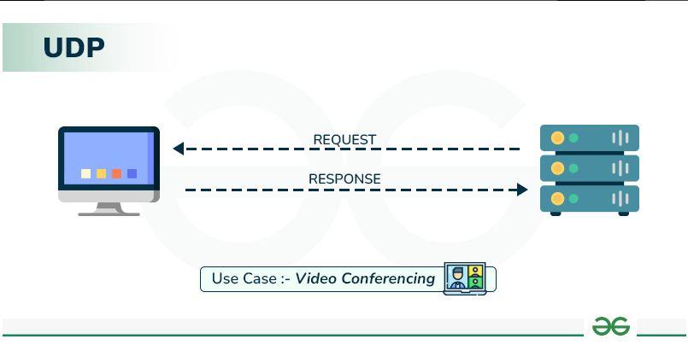  UDP Header  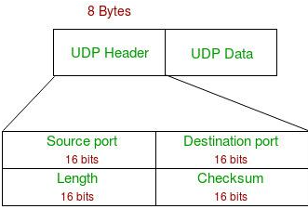  UDP header is an 8-byte fixed and simple header, while for TCP it may vary from 20 bytes to 60 bytes. The first 8 Bytes contain all necessary header information and the remaining part consists of data. UDP port number fields are each 16 bits long, therefore the range for port numbers is defined from 0 to 65535; port number 0 is reserved. Port numbers help to distinguish different user requests or processes.  UDP Header  - Source Port: Source Port is a 2 Byte long field used to identify the port number of the source.  - Destination Port: It is a 2 Byte long field, used to identify the port of the destined packet.  - Length: Length is the length of UDP including the header and the data. It is a 16-bits field.  - Checksum: Checksum is 2 Bytes long field. It is the 16-bit one’s complement of the one’s complemented sum of the UDP header, the pseudo-header of information from the IP header, and the data, padded with zero octets at the end (if necessary) to make a multiple of two octets.  Notes – Unlike TCP, the Checksum calculation is not mandatory in UDP. No Error control or flow control is provided by UDP. Hence UDP depends on IP and ICMP for error reporting. Also, UDP provides port numbers so that is can differentiate between user’s requests.  Applications of UDP  - Used for simple request-response communication when the size of data is less and hence there is lesser concern about flow and error control.  - It is a suitable protocol for multicasting as UDP supports packet switching.  - UDP is used for some routing update protocols like RIP(Routing Information Protocol).  - Normally used for real-time applications which can not tolerate uneven delays between sections of a received message.  - UDP is widely used in online gaming, where low latency and high-speed communication is essential for a good gaming experience. Game servers often send small, frequent packets of data to clients, and UDP is well suited for this type of communication as it is fast and lightweight.  - Streaming media applications, such as IPTV, online radio, and video conferencing, use UDP to transmit real-time audio and video data. The loss of some packets can be tolerated in these applications, as the data is continuously flowing and does not require retransmission.  - VoIP (Voice over Internet Protocol) services, such as Skype and WhatsApp, use UDP for real-time voice communication. The delay in voice communication can be noticeable if packets are delayed due to congestion control, so UDP is used to ensure fast and efficient data transmission.  - DNS (Domain Name System) also uses UDP for its query/response messages. DNS queries are typically small and require a quick response time, making UDP a suitable protocol for this application.  - DHCP (Dynamic Host Configuration Protocol) uses UDP to dynamically assign IP addresses to devices on a network. DHCP messages are typically small, and the delay caused by packet loss or retransmission is generally not critical for this application.  - Following implementations uses UDP as a transport layer protocol:  - NTP (Network Time Protocol)  - DNS (Domain Name Service)  - BOOTP, DHCP.  - NNP (Network News Protocol)  - Quote of the day protocol  - TFTP, RTSP, RIP.  - The application layer can do some of the tasks through UDP-  - Trace Route  - Record Route  - Timestamp  - UDP takes a datagram from Network Layer, attaches its header, and sends it to the user. So, it works fast.  - Actually, UDP is a null protocol if you remove the checksum field.  - Reduce the requirement of computer resources.  - When using the Multicast or Broadcast to transfer.  - The transmission of Real-time packets, mainly in multimedia applications.  Advantages of UDP  - Speed: UDP is faster than TCP because it does not have the overhead of establishing a connection and ensuring reliable data delivery.  - Lower latency: Since there is no connection establishment, there is lower latency and faster response time.  - Simplicity: UDP has a simpler protocol design than TCP, making it easier to implement and manage.  - Broadcast support: UDP supports broadcasting to multiple recipients, making it useful for applications such as video streaming and online gaming.  - Smaller packet size: UDP uses smaller packet sizes than TCP, which can reduce network congestion and improve overall network performance.  - User Datagram Protocol (UDP) is more efficient in terms of both latency and bandwidth.  Disadvantages of UDP  - No reliability: UDP does not guarantee delivery of packets or order of delivery, which can lead to missing or duplicate data.  - No congestion control: UDP does not have congestion control, which means that it can send packets at a rate that can cause network congestion.  - No flow control: UDP does not have flow control, which means that it can overwhelm the receiver with packets that it cannot handle.  - Vulnerable to attacks: UDP is vulnerable to denial-of-service attacks, where an attacker can flood a network with UDP packets, overwhelming the network and causing it to crash.  - Limited use cases: UDP is not suitable for applications that require reliable data delivery, such as email or file transfers, and is better suited for applications that can tolerate some data loss, such as video streaming or online gaming.  UDP Pseudo Header  - The purpose of using a pseudo-header is to verify that the UDP packet has reached its correct destination  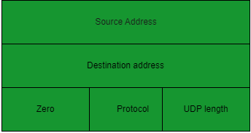  - The correct destination consists of a specific machine and a specific protocol port number within that machine  UDP pseudo header  UDP Pseudo Header Details  - The UDP header itself specify only protocol port number.thus , to verify the destination UDP on the sending machine computes a checksum that covers the destination IP address as well as the UDP packet.  - At the ultimate destination, UDP software verifies the checksum using the destination IP address obtained from the header of the IP packet that carried the UDP message.  - If the checksum agrees, then it must be true that the packet has reached the intended destination host as well as the correct protocol port within that host.  User Interface  A user interface should allow the creation of new receive ports, receive operations on the receive ports that returns the data octets and an indication of source port and source address, and an operation that allows a datagram to be sent, specifying the data, source and destination ports and address to be sent.  IP Interface  - The UDP module must be able to determine the source and destination internet address and the protocol field from internet header  - One possible UDP/IP interface would return the whole internet datagram including the entire internet header in response to a receive operation  - Such an interface would also allow the UDP to pass a full internet datagram complete with header to the IP to send. the IP would verify certain fields for consistency and compute the internet header checksum.  - The IP interface allows the UDP module to interact with the network layer of the protocol stack, which is responsible for routing and delivering data across the network.  - The IP interface provides a mechanism for the UDP module to communicate with other hosts on the network by providing access to the underlying IP protocol.  - The IP interface can be used by the UDP module to send and receive data packets over the network, with the help of IP routing and addressing mechanisms.  - The IP interface provides a level of abstraction that allows the UDP module to interact with the network layer without having to deal with the complexities of IP routing and addressing directly.  - The IP interface also handles fragmentation and reassembly of IP packets, which is important for large data transmissions that may exceed the maximum packet size allowed by the network.  - The IP interface may also provide additional services, such as support for Quality of Service (QoS) parameters and security mechanisms such as IPsec.  - The IP interface is a critical component of the Internet Protocol Suite, as it enables communication between hosts on the internet and allows for the seamless transmission of data packets across the network.  SCTP Full Form  SCTP stands for Stream Control Transmission Protocol.  It is a connection- oriented protocol in computer networks which provides a full-duplex association i.e., transmitting multiple streams of data between two end points at the same time that have established a connection in network. It is sometimes referred to as next generation TCP or TCPng, SCTP makes it easier to support telephonic conversation on Internet. A telephonic conversation requires transmitting of voice along with other data at the same time on both ends, SCTP protocol makes it easier to establish reliable connection.  SCTP is also intended to make it easier to establish connection over wireless network and managing transmission of multimedia data. SCTP is a standard protocol (RFC 2960) and is developed by Internet Engineering Task Force (IETF).  - Unicast with Multiple properties –  It is a point-to-point protocol which can use different paths to reach end host.  - Reliable Transmission –  It uses SACK and checksums to detect damaged, corrupted, discarded, duplicate and reordered data. It is similar to TCP but SCTP is more efficient when it comes to reordering of data.  - Message oriented –  Each message can be framed and we can keep order of datastream and tabs on structure. For this, In TCP, we need a different layer for abstraction.  - Multi-homing –  It can establish multiple connection paths between two end points and does not need to rely on IP layer for resilience.  - Security –  Another characteristic of SCTP that is security. In SCTP, resource allocation for association establishment only takes place following cookie exchange identification verification for the client (INIT ACK). Man-in-the-middle and denial-of-service attacks are less likely as a result. Furthermore, SCTP doesn’t allow for half-open connections, making it more resistant to network floods and masquerade attacks.  Advantages of SCTP:  - It is a full- duplex connection i.e. users can send and receive data simultaneously.  - It allows half- closed connections.  - The message’s boundaries are maintained and application doesn’t have to split messages.  - It has properties of both TCP and UDP protocol.  - It doesn’t rely on IP layer for resilience of paths.  Disadvantages of SCTP:  - One of key challenges is that it requires changes in transport stack on node.  - Applications need to be modified to use SCTP instead of TCP/UDP.  - Applications need to be modified to handle multiple simultaneous streams.  What is DCCP (Datagram Congestion Control Protocol)?  Congestion in a network means deterioration of network or services which are caused due to overloading of network nodes, basically, this problem is primarily associated with large networks, in which a large amount of data and information is being transmitted. Congestion can be caused by several reasons: either the routers which are being used are not fast enough, the CPUs which are being used are not fast enough and they do not manage to quit queues in OS in a timely manner, buffers are not large enough as our requirements or they are lost from the packets. Also, in the case of very high traffic, the situation can be worse enough that no packages are delivered at all.  DCCP is basically a message-based transport-level protocol. The setting of a secure connection is easily maintained using it, its closure i.e. ECN (Explicit Congestion Notification), congestion control, and negotiation of features. DCCP is a great technique to access congestion control mechanisms, also we don’t need to implement them at the application level also.  DCCP basically allows similar Transfer Control Protocol feeds also, but delivery in the order of transmission cannot be done. Sequential delivery of multiple streams (as in SCTP- Stream Control Transmission Protocol) is not available in DCCP.  DCCP is widely used in applications package delivery is composed of time constraints. The examples that come under this category include multiplayer online games, internet telephony, streaming media (video, audio), etc. The most important feature of these applications is that old messages quickly become expired automatically, lose their usefulness by default.  DCCP connection setup can be explained through the below image, it is basically similar to TCP connection setup:  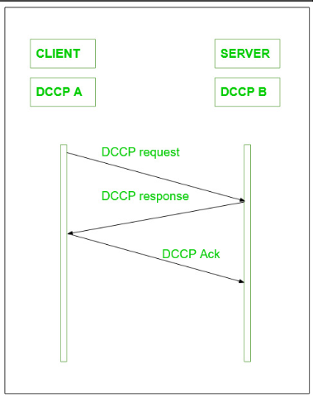  DCCP Connection setup  On the other hand, the higher priority is given to new messages, so to resend the packets is not very much useful here, it would eventually consume time and unnecessary network resources as well. Datagram Congestion Control Protocol can also be used as a general congestion control technique for those types of applications that are based on the UDP protocol as well. A safety mechanism can also be added and possibly one for packet delivery in the order of transmission. In other cases, DCCP helps to use various congestion control mechanisms, generally Transmission Control Protocol-friendly. Confirmation traffic and data traffic are both contained in a DCCP connection.  The transmitter gets to know with the help of confirmations that his packages have arrived at the destination or have been marked by ECN. Confirmations are used with the purpose of safety demanded by the congestion control mechanism. Its primary aim is to reach 100% safely.  DCCP Packet structure:  The DCCP generic header has various forms according to the value given to X i.e. the Extended Sequence Numbers bit.  Let X = 1,  the Sequence Number field is 48 bits long, and the generic header takes 16 bytes, which is clearly explained in the below image.  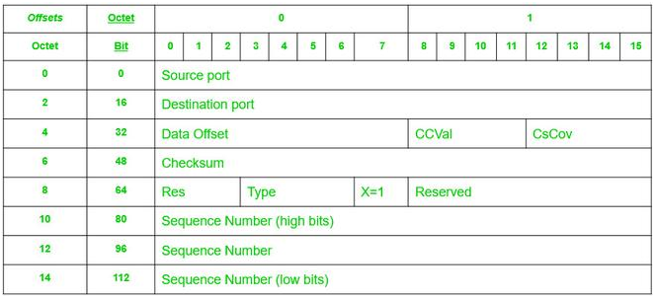  DCCP generic header when X=1  If we change the value of X = 0, only the low 24 bits of the Sequence Number are transmitted, and the generic header is 12 bytes long which is shown in the below image:  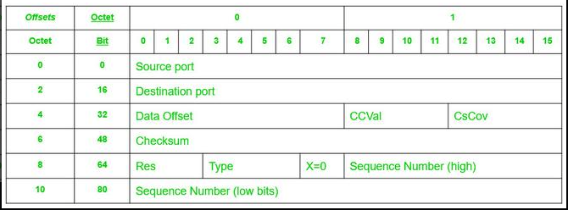  DCCP generic header when X=0  Features of DCCP:  - DCCP is a non-reliable datagram stream, with a good feature of confirmation.  - DCCP helps to secure negotiation of options, including negotiation of the most suitable mechanism for congestion control.  - It provides a secure handshake protocol with the purpose of initializing and closing the connection of DCCP.  - It plays a vital role in the discovery of the maximum transmitting unit on the chosen path by the user.  - It provides techniques that allow servers to avoid storing states for attempted unconnected, unconfirmed disconnections, or for already closed connections as well.  - Confirmation mechanisms are a very good feature of DCCP which helps to communicate packet loss and ECN information.  - Optional mechanisms are also some good techniques that communicate to the emitting application with high security, which packets have reached the receiver and which are not, also whether they have been marked by ECN or not, or they are corrupted or removed in the receiver buffer.  - DCCP can support multiple concurrent streams within a single connection, which enables applications to transmit multiple data flows over the same connection.  - It provides a mechanism for applications to prioritize their data flows, which helps in achieving better Quality of Service (QoS).  - DCCP supports both connection-oriented and connectionless communication modes.  - It offers a congestion control mechanism that is more flexible than the TCP congestion control mechanism.  - DCCP can be used over both IP version 4 and IP version 6 networks.  Advantages  - Congestion control: Unlike UDP, which has no built-in mechanism for controlling congestion, DCCP includes congestion control algorithms that help to prevent network overload and ensure reliable delivery of data.  - Quality of Service (QoS) support: DCCP provides support for QoS, which allows network administrators to prioritize different types of traffic based on their importance. This can be useful for applications such as video streaming or voice over IP, where low latency and high reliability are essential.  - Flexibility: DCCP is designed to be a flexible protocol, allowing network administrators to choose from a variety of congestion control algorithms based on the specific requirements of their network and applications.  - Compatibility: DCCP is designed to work with existing IP networks and is compatible with traditional IP protocols like TCP and UDP.  Real-World Applications  - Streaming media: DCCP is often used in streaming media applications, such as video conferencing, where low latency and high reliability are important. The congestion control algorithms built into DCCP help to ensure that these applications can run smoothly and effectively, even in networks with high levels of congestion.  - Gaming: Some online gaming applications also make use of DCCP, as its congestion control algorithms can help to prevent network slowdowns and ensure that game data is delivered quickly and reliably.  - Telemetry: DCCP is also used in telemetry applications, where large amounts of data need to be transmitted from remote devices back to a central control center. The congestion control algorithms built into DCCP  - help to ensure that this data is delivered reliably and efficiently, even in congested networks.  - Remote Access: DCCP can be used for remote access applications, as it provides a reliable and secure connection for remote access to servers and other resources.  AppleTalk Transaction Protocol (ATP)  What is ATP (AppleTalk Transaction Protocol)?  ATP stands for AppleTalk Transaction Protocol. It is a part of a series of networking protocols called the ‘AppleTalk’ developed by Apple Inc. It is a transport layer protocol that lets you transfer small amounts of data across a network. It provides an error-free and reliable means of communication in a client-server setup. It performs most of the transport layer functions like segmentation, packet sequencing, etc.  ATP works on top of an architecture that is similar to a client-server architecture. There is a requester that makes a request to another endpoint which is called a responder. The responder performs the needful and reverts back with a response.  Transactions in ATP:  The following diagram describes how a transaction occurs:  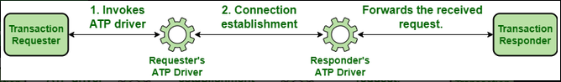  Transactions in ATP  - The requester invokes the ATP interface. The interface then uses the ATP driver to establish a dedicated connection with the responder’s ATP driver.  - The driver at the responder side invokes the responder application which processes the incoming request and returns a response to be sent back to the requester.  - In order to send the response, the responder invokes its ATP interface which uses the pre-established connection to send the response back to the requester.  As mentioned before, ATP can be used to send small amounts of data. There is a restriction on the amount of data that can be transmitted by both the requester and the responder. For the requester, the data that can be transmitted is 578 bytes and for the responder, the limit is 4624 bytes.  Types of ATP Transactions:  There are two types of ATP transactions:  - At-Least-Once Transactions: In an ALO transaction, it is guaranteed that the responder will receive all the requests sent to it at least once. It offers no guarantee that the same request won’t be sent again to the responder.  - eXactly-Once Transactions: In an XO transaction, it is guaranteed that the responder will receive all the requests sent to it exactly once. It guarantees that a request that has been received once by the responder won’t be sent again.  The nature of the transaction to be used is determined by the kind of processing required by the request. If multiple executions of the same request are likely to cause some kind of inconsistency in the results obtained, then XO transactions are used. If multiple executions of the request are not likely to cause problems, then ALO transactions are used.  ATP Packet Format:  An ATP packet consists of an ATP header followed by the data. The size of the ATP header is 8 bytes. The entire packet is stored inside a DDP (Datagram Delivery Protocol) datagram and is transported as a data link layer frame.  Following is the structure of an ATP packet:  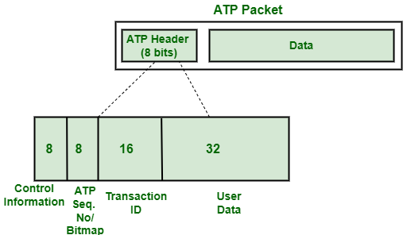  Structure of an ATP Packet  The data part follows the ATP header which can be up to 578 bytes or up to 4624 bytes depending on whether the packet is being sent by the requester side or the responder side.  Following is a detailed description of the fields of the ATP header:  Control Information Byte:  It is used to store control-related information about a request/response like the type of transaction, whether this packet is the last packet to be received or not etc. The control information byte stores the following information –  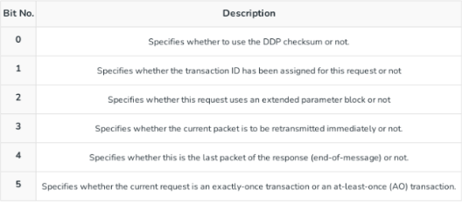  Bitmap/Sequence Number:  The Bitmap/Sequence Number is 8 bits in size. ATP is well-known for the reliability it offers during data transmission. It guarantees that the requester will receive all the packets sent to it in response to its request. In order to do so, it needs to track which packets have been received by the requester and which are yet to be received. The approach used by ATP for the same is to assign sequence numbers to all the packets which are sent in response and to mark the last packet of response as “end-of-message” (indicated by bit 4 of the control information byte in ATP header). The requester assembles all the packets on receiving them, checks the sequence number and the control information byte of the ATP header, and determines whether it has received all the packets or not. If not, then the ATP driver on the receiver’s end initiates retransmission of the lost packets.  Transaction ID:  The transaction ID is used to associate each request with its corresponding response. It is 16 bits in size. The requester can make multiple requests at any given time. Transaction ID helps ATP to keep track of all the requests made and to ensure that the response delivered for every request is correct. It is carried by the 3rd and the 4th byte of the ATP header.  User Data:  The last 4 bytes of the ATP header are not used by ATP. They are reserved for use by the requester and responder applications. The ATP driver supports pre-defined functions that let you set the values of these headers to what you want.  The following table summarizes the fields that are part of the ATP header:  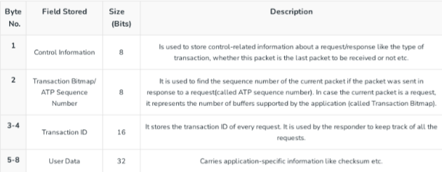  FCP (Fibre Channel Protocol)  Protocol means a set of instructions or rules and regulations. So, instead of first learning about fiber channel protocol, let’s get into what a fiber channel is:  Fibre Channel is a high-speed networking technology primarily used for transmitting data among data centers, computer servers, switches, and storage at data rates of up to 128 Gbps with distances up to 10Km.  Fibre Channel Protocol (FCP) is the SCSI (Small Computer System Interface) interface protocol operating on an established Fibre Channel connection. As Fibre Channel provides us with a high-speed data transfer service it can be used to connect workstations, mainframes, displays, storage devices, and supercomputers. The FCP provides one standardized way for storage, data transfer, and networking as the main task of the FCP is to ensure the successful transfer of large and bulky information/ data so that the manufacturers can easily support a variety of channels and networks.  The Fibre Channel protocol, also known as FC, is a method for transferring data serially over copper or optical fiber in order to achieve lower latency and faster speeds. It is a SCSI interface protocol that utilizes Fibre Channel connections. This protocol is used to connect high-performance computers, storage devices, mainframes, big data workstations, and displays as virtual big data structured screens.  So, Fibre Channel is primarily used to connect computer data storage to servers in storage area networks (SAN) in commercial data centers. Though fiber channel mainly runs on optical fiber cables it is also capable of transmitting over copper cables. As mentioned earlier, fiber channels can transmit data up to 128 Gbps (Gigabits per second) hence the alternate name Gigabit Fibre Channel (GFC).  FCP Topologies:  - DAS (Direct Attached Storage)  - NAS (Network Attached Storage)  - SAN (Storage Area Network)  FCP Ports:  - N Port (The Node Port)  - F Port (The Fabric Port)  - L Port (The Loop Port)  - FL Port (The Fabric Loop Port)  - E Port (The Extension Port)  - G Port (The Generic Port)  - GL Port (The Generic Loop Port)  - SL Port (The Segmented Loop Port)  - TL Port (The Translated Loop Port)  - T Port (The Trunk Port)  There are two main protocols for fiber channels with regard to block storage:  - Fibre channel protocol (FCP): covered in the article  - FICon (Fibre Connection) is a protocol that transports ESCon (Enterprise Systems Connection) commands, used by IBM mainframe computers, over Fibre Channel.  FCP Features Fibre Channel:  - Data transfer speed of up to 128Gbps over a distance of 10Km.  - Both Fiber optic cable and copper cables can be used.  - FCP is used to transmit SCSI (Small Computer System Interface) commands over a Fibre Channel Network (FCN)  - The Fibre Channel Protocol (FCP) is an original protocol used in Storage Area Network (SAN).  - SFP (Small Form-factor Pluggable) connectors are used to facilitate a reliable, wired, high-speed connection.  - The Fibre Channel Protocol (FCP) offers a bandwidth range of 100 MB/s to 1.6 GB/s and can support distances of up to 500 meters to 10 kilometers.  - FCP operates similarly to both TCP and UDP protocols.  - The Fibre Channel Protocol (FCP) is both reliable and stable, with a balanced design.  - In Fibre Channel Protocol (FCP), World Wide Names (WWN) are used for addressing.  - These 8-byte addresses consist of 16 hexadecimal characters.  - The Fibre Channel Protocol (FCP) uses a format such as 15:00:00:f0:8c:95:de.  - Ability to carry multiple existing interface command sets, including Internet Protocol (IP), SCSI, IPI, HIPPI-FP, and audio/video.  - Support for multiple cost/performance levels, from small systems to supercomputers.  - In Fibre Channel Protocol (FCP), a dedicated host bus adapter, specialized cables, and switches are used. It is distinct from Ethernet at all layers of the OSI model, including the physical layer  World Wide Name (WWN):  A World Wide Name (WWN) or World Wide Identifier (WWID) is a unique identifier used in storage technologies like Fibre Channel. It is a unique identifier that is hard-coded into each Fibre similar to how devices have MAC Addresses. It is a 64-bit or 128-bit name and is assigned by the Institute of Electrical and Electronics Engineers IEEE. Each network storage device that a manufacturer produces must include the manufacturer’s WWN, in order to help system administrators (SA) uniquely categorize and identify storage segments.  The WWN looks for example:  15:00:00:f0:8c:08:95:de  Types of World Wide Name (WWN):  There are majorly two types of WWNs implemented in an FC Storage Area Network (SAN):  - World Wide Node Name (WWNN): A World Wide Node Name, WWNN, or WWnN, is a World Wide Name assigned to a node (an endpoint, a device) in a Fibre Channel fabric.  - World Wide Port Name (WWPN): a World Wide Port Name, WWPN, or WWpN, is a World Wide Name assigned to a port in a Fibre Channel fabric. In order to behave as a unique identifier in the network, it works similarly to the MAC address in Ethernet protocol.  Fibre Channel Protocol (FCP) uses World Wide Node Names (WWNN) to identify nodes in data storage networks. These names can identify multiple network interfaces on a single node. The WWPN (World Wide Port Name) can also be derived from the WWNN.  - In Fibre Channel Protocol (FCP), a unique World Wide Port Name (WWPN) is assigned to every individual port on a node.  - In Fibre Channel Protocol (FCP), a multiport Host Bus Adapter (HBA) will have a different number of World Wide Port Names (WWPNs) for each port. WWPNs are similar to the MAC address in Ethernet networks.  - In Fibre Channel Protocol (FCP), World Wide Port Names (WWPN) are burn-in by the manufacturer. They are validated to be globally unique.  - In Fibre Channel Protocol (FCP), World Wide Port Names (WWPNs) are assigned to Host Bus Adapters (HBAs) on both client and storage systems.  - In Fibre Channel Protocol (FCP), World Wide Port Names (WWPNs) are given more importance when configuring Fibre Channel Networks, compared to World Wide Node Names (WWNNs).  - In Fibre Channel Protocol (FCP), World Wide Port Names (WWPNs) cannot be changed once assigned.  Advantages of Fibre Channel:  - FCP has high performance  - provides good backup and restoration and simplified consolidation  - also offers congestion-free data flow, Gigabit bandwidth, compatibility with multiple topologies and protocols, flow control, and self-management  - It is providing high-speed data transfer  - It is cost-efficient  - High-speed data can be transferred over a distance of 10km  - supports several fault-tolerant features  - FCP having good bandwidth and speed  - The FCP protocol utilizes data frames for transmitting information over a network, which can be used for both link-level and device-level communications  - FCP having good Flow Control  - The Fibre Channel protocol (FCP) is known for its balanced and reliable nature, providing stable communication between devices  - FCP is a balanced and reliable protocol that is used to transmit SCSI (Small Computer System Interface) commands over Fibre Channel Networks (FCN)  Disadvantage of Fibre Channel:  - FCP can be more expensive in cost compared to iSCSI  - FCP can be more costly and complex to implement  - FCP requires updating the cards within servers  - also purchasing FC cables and switches  - More expensive than SCSI (Small Computer System Interface)  - More complex than SCSI (Small Computer System Interface)  - More equipment/ overhead (like FC cables, switches, etc.,) is required  Principle Of Reliable Data Transfer Protocol  Transport Layer Protocols are central piece of layered architectures, these provides the logical communication between application processes. These processes use the logical communication to transfer data from transport layer to network layer and this transfer of data should be reliable and secure. The data is transferred in the form of packets but the problem occurs in reliable transfer of data.  The problem of transferring the data occurs not only at the transport layer, but also at the application layer as well as in the link layer. This problem occur when a reliable service runs on an unreliable service, For example, TCP (Transmission Control Protocol) is a reliable data transfer protocol that is implemented on top of an unreliable layer, i.e., Internet Protocol (IP) is an end to end network layer protocol.  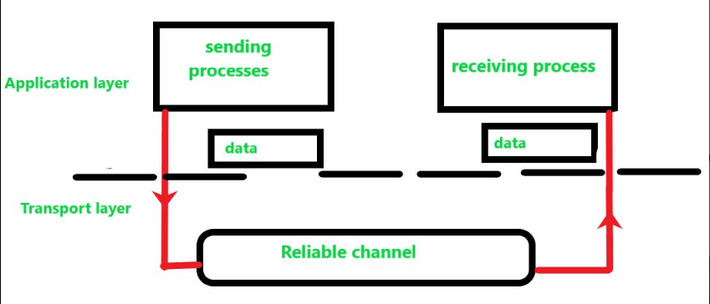  Figure: Study of Reliable Data Transfer  In this model, we have designed the sender and receiver sides of a protocol over a reliable channel. In the reliable transfer of data, the layer receives the data from the above layer breaks the message in the form of segment and put the header on each segment and transfer. Below layer receives the segments and remove the header from each segment and make it a packet by adding to header.  The data which is transferred from the above has no transferred data bits corrupted or lost, and all are delivered in the same sequence in which they were sent to the below layer this is reliable data transfer protocol. This service model is offered by TCP to the Internet applications that invoke this transfer of data.  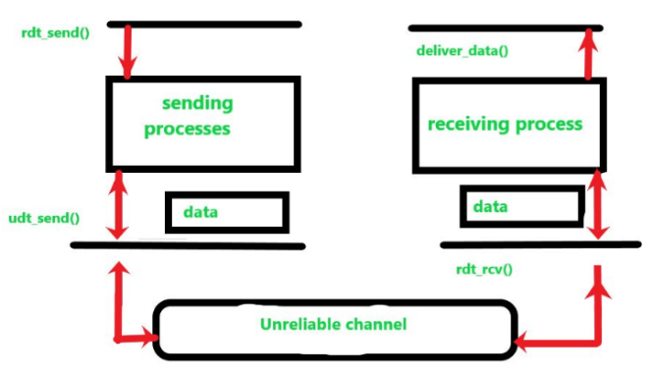  Figure: Study of Unreliable Data Transfer  Similarly in an unreliable channel we have design the sending and receiving side. The sending side of the protocol is called from the above layer to rdt_send() then it will pass the data that is to be delivered to the application layer at the receiving side (here rdt-send() is a function for sending data where rdt stands for reliable data transfer protocol and _send() is used for the sending side).  On the receiving side, rdt_rcv() (rdt_rcv() is a function for receiving data where -rcv() is used for receiving side), will be called when a packet arrives from the receiving side of the unreliable channel. When the rdt protocol wants to deliver data to the application layer, it will do so by calling deliver_data() (where deliver_data() is a function for delivering data to upper layer).  In reliable data transfer protocol, we only consider the case of unidirectional data transfer, that is transfer of data from the sending side to receiving side(i.e. only in one direction). In case of bidirectional (full duplex or transfer of data on both the sides) data transfer is conceptually more difficult. Although we only consider unidirectional data transfer but it is important to note that the sending and receiving sides of our protocol will needs to transmit packets in both directions, as shown in above figure.  In order to exchange packets containing the data that is needed to be transferred the both (sending and receiving) sides of rdt also need to exchange control packets in both direction (i.e., back and forth), both the sides of rdt send packets to the other side by a call to udt_send() (udt_send() is a function used for sending data to other side where udt stands for unreliable data transfer protocol).  Reliable User Datagram Protocol (RUDP)  RUDP stands for Reliable user datagram protocol, whereas UDP is one of the core members of IP i.e internet protocol suite. UDP is used as a highly time-sensitive communicative protocol. R in RUDP stands for Reliable, it is a UDP-based data transfer but with higher Reliability. It provides reliability by using the sliding window protocol. RUDP is basically the solution to the UDP where data reliability along with confirmation is needed.  As UDP provides unreliable data transfer protocol which is unreliable services of things and the worst it sometimes goes missing without notice. Reliable UDP uses both positive and negative feedback to provide data reliability which provides reliable data transfer.  In UDP sender’s simply send a message without a piece of prior information about the receiver’s availability which results in a faster rate but it can result in the loss of some packages, also the receiver can receive duplicate packets and UDP also does not provide information that the package has been received or not. RUDP used a sliding window protocol that delivers or transfers the datagram with reliability.  RUDP Architecture  The sending process and receiving process of the architecture both stand in the application layer. The sender server sends the data packets to the receiving channel using RUDP protocol; a window size is maintained by both the sender and the receiver; the window consists of some predefined value tending to maximum avoiding the communication errors taking all the edge cases where the packets can be dropped.  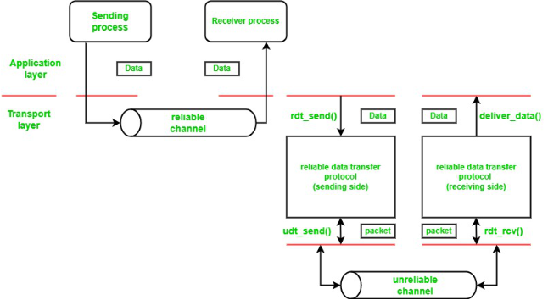  RUDP Protocol Architecture  Implementation of RUDP protocol:  Use synchronized shared buffers using counting semaphores so that only one thread accesses the buffer at a time to prevent the deadlock situation from occurring.  Let’s keep two-variable called as the base and next to keep the track of the window functioning. If the sender sent’s the packet, the variable next is incremented to 1, this is the way of calculating the number of packets in the buffer.  The timeouts are handled using the timers which are scheduled immediately after sending the packet over the channel, simulate the packet loss rate and random network delay in the protocol.  packets are kept in a queue and assigned a value that values the system’s current time plus the network delay. When the current time of the system is associated with the assigned value the packet is freed from the queue and sent over the network. While the packet is sent over the network it gives an (ACK) acknowledgment. When the ack matches with the sequence number senders send another packet assigning it with the consecutive number.  Classes in RUDP Protocol:  Following are the classes that are used to implement the RUDP protocol:  - RUDP: This contains the send () and receives () functions called by the client and server.  - Buffer_RUDP: contains the implementation shared buffer using counting semaphores.  - Receiver_Thread: Implements a threaded architecture that simultaneously waits for the packets in the sockets while sending and receiving the data and waits to process the incoming data.  - Segment_RUDP: defines the structure of RUDP packets.  - Timeout_Handler: to handle the timeouts  - Support_RUDP: provides functions like send_UDP();  - Client: It sends the data.  - Server: It receives the data.  Sliding Window Protocol:  Sliding window protocol also known as RUDP’s SWP on which RUDP is based, is used where the reliability comes into play and it is very much essential or for security reasons where the knowledge of data transferred along with confirmation is required. It works in segments which means it divides the provided data into segments then packets or data packets are prepared and sent over the network, resulting in when the receiver receives the package it checks the order of the packets and discards duplicates and after that, is sent it sends the acknowledgment to the sender for the correctly received packets.  There are 3 Sliding window Protocols:  - One Bit Sliding Window Protocol  - Go back to N protocol  - Selective Repeat Protocol  Piggy-backing Technique:  Sliding window Protocol uses the piggy-backing technique, the technique is based on the acknowledgment that is received but, how is received? So, the answer is it provides the sliding window protocol to attach the acknowledgment in the next frame so that when a receiver receives the data it maintains a set of sequence numbers which is corresponding to the frames that are also can be called acknowledgment frames within a window portion of same or different sizes.  The mathematics of frame calculation:  When a new packet is sent by the sender to the receiver it is given the highest packet sequence mark and the window’s upper edge is incremented with one for the acknowledged frames and vice versa for the unacknowledged frames. That calculates the mark of unacknowledged frames as well as acknowledged frames and when this number comes to zero that means all the packets have been delivered successfully and it provides feedback to the sender. It is used in data-intensive applications that require a lot of work in a very less amount of time over high-speed networks, where reliability plays a very important role.  Server-Side Code Architecture:  - Client Class sets the rate of loss and sends the data to the RUDP class, where window sizes of both the sender and receiver are set in the class.  - The RUDP class as per the working divides the data into segments of equal sizes and hence assigns the frames i.e. sequence number and checksum to each segment separately then put it in the sender’s window if it has any available slot.  - Support_RUDP comes into play now, when the data packets in segments are sent by the sender this class collects and prepares the packets from the segments and sends them over the unreliable channel. Once it is sent the timer goes on immediately.  - Thread_receiver class is the important class for the RUDP structure it provides a thread along with the thread of the data it parallelly sends a thread with the data and waits on the socket for the incoming data, when  - it receives the packet from the socket it makes a segment and verifies the checksum, if the checksum clarifies it is the sent data, then it checks for the acknowledgment if the acknowledgment received then it removes the packet from sender’s window and sent it over the socket; if a timeout happens and a packet is lost it resends the packet and restart the timer immediately, If the RUDP class receives the packet before the timeout then it cancels the timer.  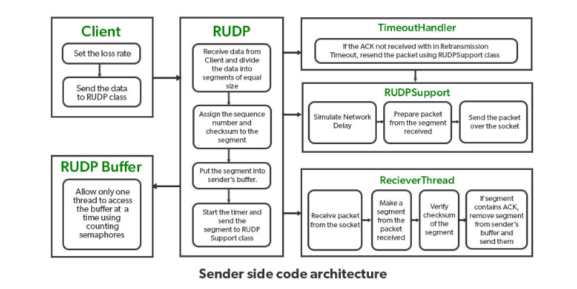  Server-Side Code Architecture:  Receiver Side Code Architecture:  - Thread_receiver Class that implemented a thread parallel run with the thread of the sent data and one of the instances waits at the socket to continue to process the data that is coming. Once the class receives the packet is verified with the segment and made a segment from it and matches with the checksum. If the segment contains the required data, then it sends an acknowledgment and puts it in the Buffer_receiver class and if the packet is not there then it stores all following the lost into the Buffer_receiver.  - Once the lost packet is received it processes all and then the RUDP class delivers all the packets reordering correctly once it was buffered to the server.  - Once the confirmation is provided that all the data have been received then the connection is closed.  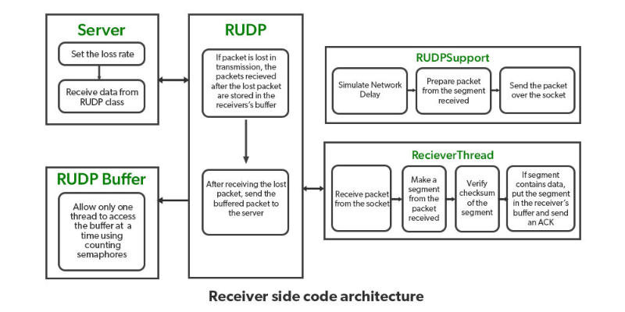  Receiver Side Code Architecture:  PseudoCode for RUDP Class:  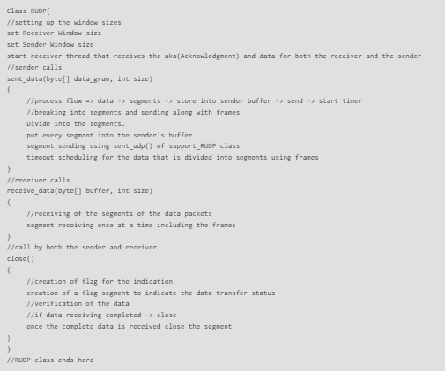  Pseudo Code of Thread_receiver class:  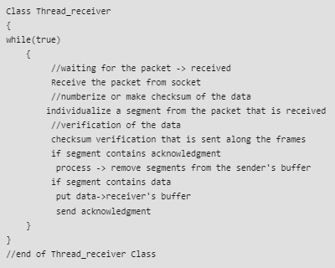  Pseudo Code for Support_RUDP class:  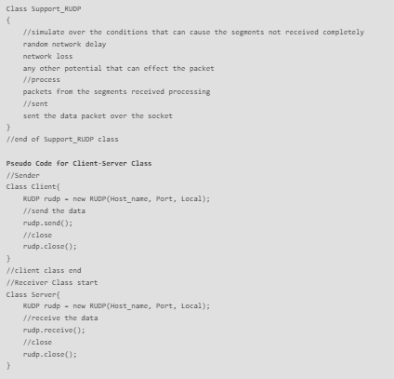  Structured Steam Transport (SST)  What is SST (Structured Steam Transport)?  Structured stream transport is an experimental transport protocol that is similar to TCP (Transmission control protocol) that provides an organized, reliable byte-stream abstraction. SST enhances the traditional stream abstraction hierarchical hereditary structure, which allows applications to create lightweight child streams from any existing stream. Datagrams that support small transactions and streams are best suited for long-running conversations but neither of two support applications like HTTP(HyperText Transfer Protocol) which is a mixture of transaction sizes and applications or multiple transport instances(like FTP). TCP streams support 3-way hand-shaking delays on startup whereas Time-Wait streams in SST offer independent data transfer and flow control. All streams share one congestion control context.  SST Protocol Architecture:  - The channel protocol provides sequencing, connection security, and congestion control.  - The negotiation protocol provides mechanical of establishing channels between hosts, including symmetric key agreement for channel security and negotiating optional protocol extension.  - The registration protocol provides support for a simple, optional host registration and lookup service. Secure host identification and NAT(Network Access Transaction) traversal.  - The stream protocol is a convenient, high stream abstraction based on the above three protocols to implement the SST application.  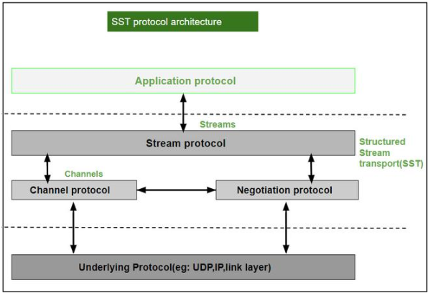  SST Protocol Architecture  Features of SST:  - Over a single SST session, multiple independent streams can run in parallel.  - Relative priority between streams to apply application-specific policies.  - It provides wire efficiency, including header overhead of SST, UDP encapsulation is only 4 bytes larger than TCP.  - It provides built-in communication security.  - It provides efficient support for the short use of reliable steams.  - Streams can be arbitrarily long-running and may preserve internal application-specific record marks.  - Hole punching support for transparent communication across most NATs and Firewalls.  Sequenced Packet Exchange (SPX)  What is SPX (Sequenced Packet Exchange)?  NetWare, developed by Novell is a NOS that expands to Network Operating systems. NOS is a special kind of operating system which helps the personal computers in a network (eg: computers connected in LAN) to share files and resources like printers. They make PCs connected over a network to act in a client-server architecture. The IPX/SPX is the protocol used in the NetWare OS.  The IPX protocol corresponds to the network layer and the SPX protocol on top of it corresponds to the transport layer in the OSI model. The IPX/SPX are similar to TCP/IP where IPX takes up the role of IP and SPX takes up the role of TCP.  SPX Protocol  The SPX protocol was developed by Novell for Local Area Networks. It expands to Sequenced Packet Exchange and it is connection-oriented. It enables the exchange of information between the clients and the server in a network with the help of IPX protocol. The IPX/SPX protocol is derived from the SPP (Sequenced Packet Protocol) which was defined in Xerox Network Systems. The SPP is a connectionless protocol while the SPX is connection-oriented.  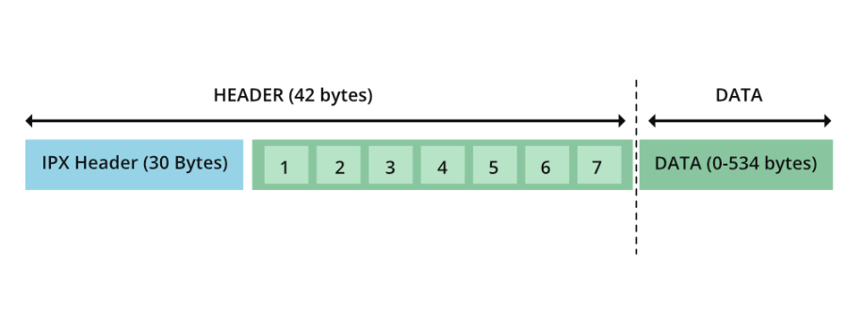  Format of SPX data packet  The SPX data packet contains a 42-byte header and data may vary from 0 to 534 bytes. The minimum length is 42 bytes, ie., without any data. The first 30 bytes are taken from the IPX header and the rest of the 12 bytes are new seven fields (mentioned as 1…7 in the above diagram) belonging to SPX.  The fields considered from the IPX header are as follows:  Checksum  The checksums are required to maintain the integrity of the data exchanged. The source and destinations derive the checksums in some methods. The source appends it to the header and sends it to the destination. On the other hand, the destination compares the checksum calculated by itself against the one in the packet’s header. If there is a mismatch then data is said to be corrupt. Usually, 16-bit checksums are used in networking protocols. IPX also uses 2 bytes for checksum in the header. If the hex value of FFFF is set, then the checksum is not used.  Length  This denotes the total length (header + data) of the packet exchanged. It consumes 2 bytes.  Transport Control  This is a 1-byte field that is used to count the number of routers the packet has passed through. Starting from the value 0, each router that gets the packet adds ‘1’ to this field. When the packet has gone through 15 routers, the 16th router will discard the packet.  Packet type  This is used to know what service does the packet render. It also takes only 1 byte. Depending on this byte’s value, either one of the following can be the packet type :  - 0 – Unknown  - 1 – Routing Information protocol  - 2 – Echo packet  - 3 – Error packet  - 4 – Packet Exchange Protocol  - 5 – Sequenced Packet Protocol  - 17- NetWare Core Protocol  Source address  The address of the source of the packet is mentioned in the IPX addressing structure. It takes 12 bytes.  Destination address  The address of the destination application to which the packet has to be delivered. It should follow the IPX addressing structure. For sending data to all the computers in the network FF:FF:FF:FF:FF: FF should be specified in the destination. It takes 12 bytes.  IPX Addressing Structure  The IPX addressing structure contains three fields:  - Network  - Node  - Socket  The network is used to specify a network’s number in the internetwork communication. Internetwork communication allows data exchange between the nodes present in different cable connections. If the network number is mentioned as 00:00:00:00, then communication is happening within the same network. It takes 32-bits to specify the number of a network.  The node is used to uniquely identify the personal computer in that network.  The socket is used to identify the appropriate application in the destination side to which the packet has to be delivered.  Thus, 2(checksum) + 2(Length) + 1(Transport control) + 1(Packet type) + 12(Source addr) + 12(Destination Addr) = 30 bytes of IPX header. The IPX header along with seven following fields make up the header of a SPX packet.  The seven new fields are:  - Connection control  - Datastream type  - Source connection ID  - Destination connection ID  - Sequence number  - Acknowledge number  - Allocation number  1. Connection control  It is a 1-byte field, which controls the bidirectional data exchange. There are four flags that will be set depending on whether the packet is for a system or an individual application. The flags are as follows:  - END_OF_MESSAGE  - ATTENTION  - ACKNOWLEDGEMENT_REQUIRED  - SYSTEM PACKET  2. Datastream type  It is a 1-byte field that denotes the type of data in the packet. The hex values 0xFE and 0xFF are reserved for specific purposes. The value 0xFE is used by the client to indicate that this is the last message and the packet delivered is known as the end-of-connection packet. If the value is set to 0xFF, then it is a system packet that acknowledges the termination of connection and this is referred to as an end-of-connection-acknowledgment packet.  3 & 4. Source connection ID & Destination connection ID  These refer to the identification number associated with the local source and remote destination. Each takes 2 bytes; thus, both together consume 4 bytes.  5. Sequence number  This is a count managed by the SPX protocol to indicate the number of packets sent in a single direction. This takes 2 bytes and the maximum value it can reach is 0xFFFF(65,535). After the maximum value, it resets to ‘0’.  6. Acknowledge number  This takes 2 bytes and indicates the sequence number expected. Here also the maximum value is 0xFFFF(65,535). The duplicate packets can be determined using acknowledge number. If the new packet’s sequence number < acknowledge number, then it is a duplicate packet and has to be discarded.  7. Allocation number  The packets will be sent till the sequence number of the local source is equal to the allocation number of the remote destination. To control the flow of data and to know the remaining buffers that are listening to SPX packets, the (allocation number of destination – acknowledge number) formula can be used. It consumes 2 bytes.  Difference Between TCP/IP and IPX/SPX  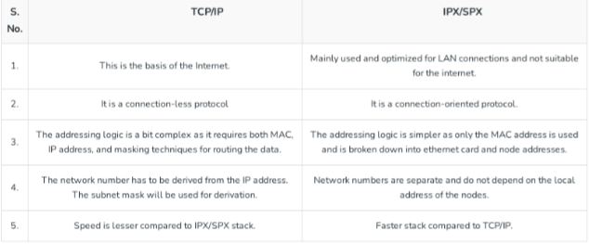

Course Title | ITEP 207 NETWORKING 1
Sem/AY | 2nd Semester 2023-2024
Lesson Title | Network Layer
Date
Description of the Lesson | This lesson introduces the Network layer services-packetizing, routing, forwarding, Difference between routing and forwarding, Other Services Expected from Network Layer- Error Control, Flow Control and Congestion Control. Also, the Advantages and Disadvantages of Network layer.

Learning Outcomes

Intended Learning Outcomes | Students should be able to meet the following intended learning outcomes:  - Understand the concept of Network Layer
Targets/ Objectives | At the end of the lesson, students should be able to:

Student Learning Strategies
Offline Activities | Lecture Guide  Network Layer  The network Layer is the third layer in the OSI model of computer networks. Its main function is to transfer network packets from the source to the destination. It is involved both the source host and the destination host. At the source, it accepts a packet from the transport layer, encapsulates it in a datagram, and then delivers the packet to the data link layer so that it can further be sent to the receiver. At the destination, the datagram is decapsulated, and the packet is extracted and delivered to the corresponding transport layer.  Features of Network Layer  - The main responsibility of the Network layer is to carry the data packets from the source to the destination without changing or using them.  - If the packets are too large for delivery, they are fragmented i.e., broken down into smaller packets.  - It decides the route to be taken by the packets to travel from the source to the destination among the multiple routes available in a network (also called routing).  - The source and destination addresses are added to the data packets inside the network layer.  Services Offered by Network Layer  The services which are offered by the network layer protocol are as follows:  - Packetizing  - Routing  - Forwarding  1. Packetizing  The process of encapsulating the data received from the upper layers of the network (also called payload) in a network layer packet at the source and decapsulating the payload from the network layer packet at the destination is known as packetizing.  The source host adds a header that contains the source and destination address and some other relevant information required by the network layer protocol to the payload received from the upper layer protocol and delivers the packet to the data link layer.  The destination host receives the network layer packet from its data link layer, decapsulates the packet, and delivers the payload to the corresponding upper layer protocol. The routers in the path are not allowed to change either the source or the destination address. The routers in the path are not allowed to decapsulate the packets they receive unless they need to be fragmented.  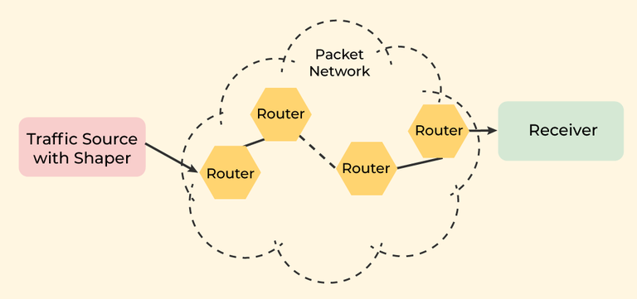  Packetizing  2. Routing  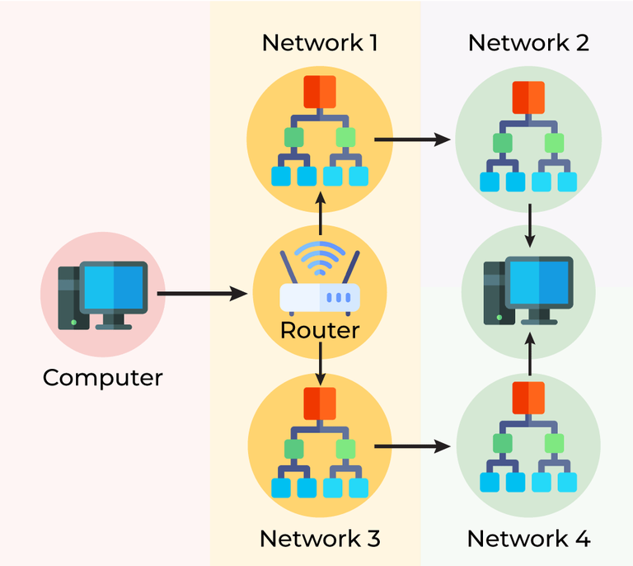  Routing is the process of moving data from one device to another device. These are two other services offered by the network layer. In a network, there are a number of routes available from the source to the destination. The network layer specifies some strategies which find out the best possible route. This process is referred to as routing. There are a number of routing protocols that are used in this process and they should be run to help the routers coordinate with each other and help in establishing communication throughout the network.  Routing  3. Forwarding  Forwarding is simply defined as the action applied by each router when a packet arrives at one of its interfaces. When a router receives a packet from one of its attached networks, it needs to forward the packet to another attached network (unicast routing) or to some attached networks (in the case of multicast routing). Routers are used on the network for forwarding a packet from the local network to the remote network. So, the process of routing involves packet forwarding from an entry interface out to an exit interface.  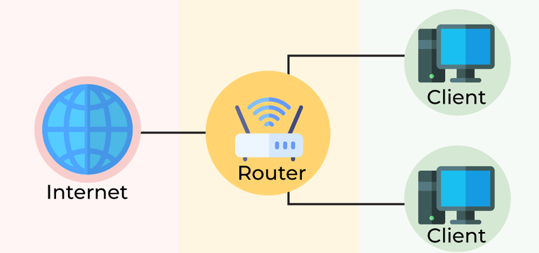  Forwarding  Difference between Routing and Forwarding  Routing Forwarding  Routing is the process of moving data from one device to another device. Forwarding is simply defined as the action applied by each router when a packet arrives at one of its interfaces.  Operates on the Network Layer. Operates on the Network Layer.  Work is based on Forwarding Table. Checks the forwarding table and work according to that.  Works on protocols like Routing Information Protocol (RIP) for Routing. Works on protocols like UDP Encapsulating Security Payloads.  Other Services Expected from Network Layer  - Error Control  Although it can be implemented in the network layer, it is usually not preferred because the data packet in a network layer may be fragmented at each router, which makes error-checking inefficient in the network layer.  Error control in TCP is mainly done through the use of three simple techniques :  - Checksum – Every segment contains a checksum field which is used to find corrupted segments. If the segment is corrupted, then that segment is discarded by the destination TCP and is considered lost.  - Acknowledgement – TCP has another mechanism called acknowledgement to affirm that the data segments have been delivered. Control segments that contain no data but have sequence numbers will be acknowledged as well but ACK segments are not acknowledged.  - Retransmission – When a segment is missing, delayed to deliver to a receiver, corrupted when it is checked by the receiver then that segment is retransmitted again. Segments are retransmitted only during two events: when the sender receives three duplicate acknowledgements (ACK) or when a retransmission timer expires.  - Retransmission after RTO: TCP always preserves one retransmission time-out (RTO) timer for all sent but not acknowledged segments. When the timer runs out of time, the earliest segment is retransmitted. Here no timer is set for acknowledgement. In TCP, the RTO value is dynamic in nature and it is updated using the round trip time (RTT) of segments. RTT is the time duration needed for a segment to reach the receiver and an acknowledgement to be received by the sender.  - Retransmission after Three duplicate ACK segments: RTO method works well when the value of RTO is small. If it is large, more time is needed to get confirmation about whether a segment has been delivered or not. Sometimes one segment is lost and the receiver receives so many out-of-order segments that they cannot be saved. In order to solve this situation, three duplicate acknowledgement method is used and missing segment is retransmitted immediately instead of retransmitting already delivered segment. This is a fast retransmission because it makes it possible to quickly retransmit lost segments instead of waiting for timer to end.  2. Flow Control  It regulates the amount of data a source can send without overloading the receiver. If the source produces data at a very faster rate than the receiver can consume it, the receiver will be overloaded with data. To control the flow of data, the receiver should send feedback to the sender to inform the latter that it is overloaded with data.  There is a lack of flow control in the design of the network layer. It does not directly provide any flow control. The datagrams are sent by the sender when they are ready, without any attention to the readiness of the receiver.  Difference between Flow Control and Congestion Control  Flow Control and Congestion Control are traffic controlling methods for different situations. The main difference between flow control and congestion control is that, In flow control, rate of traffic received from a sender can be controlled by a receiver. On the other hand, In congestion control, rate of traffic from sender to the network is controlled.  Flow Control:  Flow control is a technique used to regulate the flow of data between different nodes in a network. It ensures that a sender does not overwhelm a receiver with too much data too quickly. The goal of flow control is to prevent buffer overflow, which can lead to dropped packets and poor network performance  Advantages of Flow Control:  - Prevents buffer overflow: Flow control prevents buffer overflow by regulating the rate at which data is sent from the sender to the receiver.  - Helps in handling different data rates: Flow control helps in handling different data rates by regulating the flow of data to match the capacity of the receiving device.  - Efficient use of network resources: Flow control helps in efficient use of network resources by avoiding packet loss and reducing the need for retransmissions.  Disadvantages of Flow Control:  - May cause delays: Flow control may cause delays in data transmission as it regulates the rate of data flow.  - May not be effective in congested networks: Flow control may not be effective in congested networks where the congestion is caused by multiple sources.  - May require additional hardware or software: Flow control may require additional hardware or software to implement the flow control mechanism.  Congestion Control:  Congestion control is a technique used to prevent congestion in a network. Congestion occurs when too much data is being sent over a network, and the network becomes overloaded, leading to dropped packets and poor network performance.  Advantages of Congestion Control:  - Prevents network congestion: Congestion control prevents network congestion by regulating the rate at which data is sent from the sender to the receiver.  - Efficient use of network resources: Congestion control helps in efficient use of network resources by reducing the number of lost packets and retransmissions.  - Fair allocation of network resources: Congestion control ensures a fair allocation of network resources by regulating the rate of data flow for all sources.  Disadvantages of Congestion Control:  - May cause delays: Congestion control may cause delays in data transmission as it regulates the rate of data flow.  - May require additional hardware or software: Congestion control may require additional hardware or software to implement the congestion control mechanism.  - May lead to underutilization of network resources: Congestion control may lead to underutilization of network resources if the congestion is not severe.  Similarities between Flow Control and Congestion Control:  - Both regulate the flow of data: Both flow control and congestion control regulate the flow of data in a network.  - Both prevent packet loss: Both flow control and congestion control prevent packet loss by regulating the rate of data flow.  - Congestion Control  Congestion occurs when the number of datagrams sent by the source is beyond the capacity of the network or routers. This is another issue in the network layer protocol. If congestion continues, sometimes a situation may arrive where the system collapses and no datagrams are delivered. Although congestion control is indirectly implemented in the network layer, still there is a lack of congestion control in the network layer.  Congestion Control techniques in Computer Networks:  Congestion control refers to the techniques used to control or prevent congestion. Congestion control techniques can be broadly classified into two categories.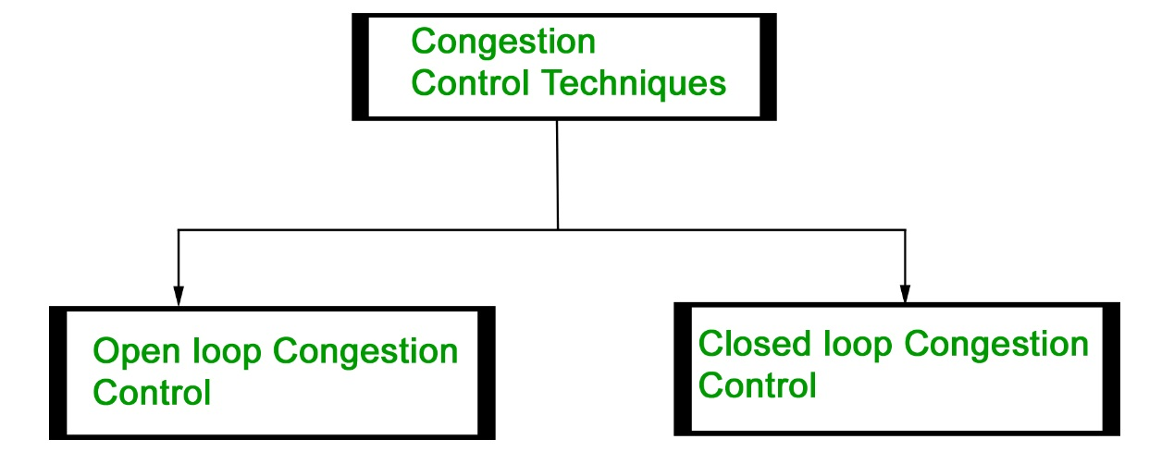  Open Loop Congestion Control  Open loop congestion control policies are applied to prevent congestion before it happens. The congestion control is handled either by the source or the destination.  Policies adopted by open loop congestion control –  - Retransmission Policy :  It is the policy in which retransmission of the packets are taken care of. If the sender feels that a sent packet is lost or corrupted, the packet needs to be retransmitted. This transmission may increase the congestion in the network.  To prevent congestion, retransmission timers must be designed to prevent congestion and also able to optimize efficiency.  - Window Policy :  The type of window at the sender’s side may also affect the congestion. Several packets in the Go-back-n window are re-sent, although some packets may be received successfully at the receiver side. This duplication may increase the congestion in the network and make it worse.  Therefore, Selective repeat window should be adopted as it sends the specific packet that may have been lost.  - Discarding Policy :  A good discarding policy adopted by the routers is that the routers may prevent congestion and at the same time partially discard the corrupted or less sensitive packages and also be able to maintain the quality of a message.  In case of audio file transmission, routers can discard less sensitive packets to prevent congestion and also maintain the quality of the audio file.  - Acknowledgment Policy :  Since acknowledgements are also the part of the load in the network, the acknowledgment policy imposed by the receiver may also affect congestion. Several approaches can be used to prevent congestion related to acknowledgment.  The receiver should send acknowledgement for N packets rather than sending acknowledgement for a single packet. The receiver should send an acknowledgment only if it has to send a packet or a timer expires.  - Admission Policy :  In admission policy a mechanism should be used to prevent congestion. Switches in a flow should first check the resource requirement of a network flow before transmitting it further. If there is a chance of a congestion or there is a congestion in the network, router should deny establishing a virtual network connection to prevent further congestion.  Closed Loop Congestion Control  Closed loop congestion control techniques are used to treat or alleviate congestion after it happens. Several techniques are used by different protocols; some of them are:  1. Backpressure :  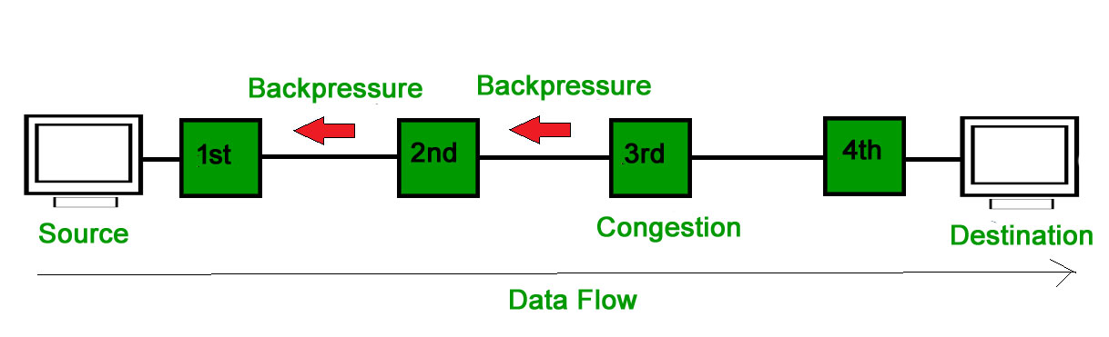  Backpressure is a technique in which a congested node stops receiving packets from upstream node. This may cause the upstream node or nodes to become congested and reject receiving data from above nodes. Backpressure is a node-to-node congestion control technique that propagate in the opposite direction of data flow. The backpressure technique can be applied only to virtual circuit where each node has information of its above upstream node.  In above diagram the 3rd node is congested and stops receiving packets as a result 2nd node may be get congested due to slowing down of the output data flow. Similarly 1st node may get congested and inform the source to slow down.  2. Choke Packet Technique :  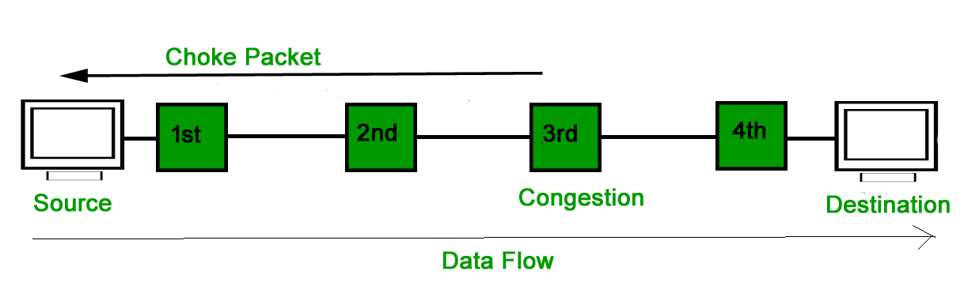  Choke packet technique is applicable to both virtual networks as well as datagram subnets. A choke packet is a packet sent by a node to the source to inform it of congestion. Each router monitors its resources and the utilization at each of its output lines. Whenever the resource utilization exceeds the threshold value which is set by the administrator, the router directly sends a choke packet to the source giving it a feedback to reduce the traffic. The intermediate nodes through which the packets has traveled are not warned about congestion.  3. Implicit Signaling :  In implicit signaling, there is no communication between the congested nodes and the source. The source guesses that there is congestion in a network. For example when sender sends several packets and there is no acknowledgment for a while, one assumption is that there is a congestion.  4. Explicit Signaling :  In explicit signaling, if a node experiences congestion it can explicitly sends a packet to the source or destination to inform about congestion. The difference between choke packet and explicit signaling is that the signal is included in the packets that carry data rather than creating a different packet as in case of choke packet technique.  Explicit signaling can occur in either forward or backward direction.  Forward Signaling : In forward signaling, a signal is sent in the direction of the congestion. The destination is warned about congestion. The receiver in this case adopt policies to prevent further congestion.  Backward Signaling : In backward signaling, a signal is sent in the opposite direction of the congestion. The source is warned about congestion and it needs to slow down.  Advantages of Network Layer Services  - Packetization service in the network layer provides ease of transportation of the data packets.  - Packetization also eliminates single points of failure in data communication systems.  - Routers present in the network layer reduce network traffic by creating collision and broadcast domains.  - With the help of Forwarding, data packets are transferred from one place to another in the network.  Disadvantages of Network Layer Services  - There is a lack of flow control in the design of the network layer.  - Congestion occurs sometimes due to the presence of too many datagrams in a network that is beyond the capacity of the network or the routers. Due to this, some routers may drop some of the datagrams, and some important pieces of information may be lost.  - Although indirect error control is present in the network layer, there is a lack of proper error control mechanisms as due to the presence of fragmented data packets, error control becomes difficult to implement.

