Course Title | ITEP 207 NETWORKING 1
Sem/AY | 2nd Semester 2024-2025
Lesson Title | Application Layer
Date
Description of the Lesson | The lesson provides a comprehensive understanding of various protocols and concepts essential for networking applications at the application layer.

Learning Outcomes

Intended Learning Outcomes | Students should be able to meet the following intended learning outcomes:
Targets/ Objectives | At the end of the lesson, students should be able to:

Student Learning Strategies
Offline Activities | Lecture Guide: Understanding Application Layer Protocols  I. Introduction to Application Layer: A. Overview of OSI Model B. Significance of Application Layer  II. Functions of Application Layer: A. Identifying Communication Partners B. Determining Resource Availability C. Synchronizing Communication  III. Services Provided by the Application Layer: A. Network Virtual Terminal B. File Transfer, Access, and Management (FTAM) C. Addressing D. Mail Services E. Directory Services F. Authentication  IV. Network Application Architecture: A. Client-Server Architecture 1. Characteristics 2. Advantages and Disadvantages B. P2P (Peer-to-Peer) Architecture 1. Features  V. Client and Server Processes: A. Definition and Roles B. P2P File-Sharing System  VI. Client-Server Model: A. Definition and Characteristics  VII. Advantages and Disadvantages of Client-Server Networks: A. Centralized B. Security C. Performance D. Scalability E. Traffic Congestion F. Robustness G. Specific Hardware Requirements  VIII. Domain Name System (DNS): A. Overview B. Components C. Working  IX. File Transfer Protocol (FTP): A. Overview B. Objectives C. Mechanism D. FTP Clients E. Advantages and Disadvantages  X. Telnet: A. Introduction B. Types of Login (Local and Remote) C. Working Principle D. Network Virtual Terminal (NVT)  XI. Simple Mail Transfer Protocol (SMTP): A. Overview B. Components C. Working Principle  XII. Simple Network Management Protocol (SNMP): A. Overview B. Components C. Management Components  XIII. HyperText Transfer Protocol (HTTP): A. Overview B. Features C. HTTP Transactions D. Uniform Resource Locator (URL)  Application Layer  The application layer in the OSI model is the closest layer to the end user which means that the application layer and end user can interact directly with the software application. The application layer programs are based on client and servers.  The Application layer includes the following functions:  - Identifying communication partners: The application layer identifies the availability of communication partners for an application with data to transmit.  - Determining resource availability: The application layer determines whether sufficient network resources are available for the requested communication.  - Synchronizing communication: All the communications occur between the applications requires cooperation which is managed by an application layer.  Services of Application Layers  - Network Virtual terminal:  An application layer allows a user to log on to a remote host. To do so, the application creates a software emulation of a terminal at the remote host. The user's computer talks to the software terminal, which in turn, talks to the host. The remote host thinks that it is communicating with one of its own terminals, so it allows the user to log on.  - File Transfer, Access, and Management (FTAM):  An application allows a user to access files in a remote computer, to retrieve files from a computer and to manage files in a remote computer. FTAM defines a hierarchical virtual file in terms of file structure, file attributes and the kind of operations performed on the files and their attributes.  - Addressing:  To obtain communication between client and server, there is a need for addressing. When a client made a request to the server, the request contains the server address and its own address. The server response to the client request, the request contains the destination address, i.e., client address. To achieve this kind of addressing, DNS is used.  - Mail Services:  An application layer provides Email forwarding and storage.  - Directory Services:  An application contains a distributed database that provides access for global information about various objects and services.  Authentication:  It authenticates the sender or receiver's message or both.  Network Application Architecture  Application architecture is different from the network architecture. The network architecture is fixed and provides a set of services to applications. The application architecture, on the other hand, is designed by the application developer and defines how the application should be structured over the various end systems.  Application architecture is of two types:  - Client-server architecture:  An application program running on the local machine sends a request to another application program is known as a client, and a program that serves a request is known as a server. For example, when a web server receives a request from the client host, it responds to the request to the client host.  Characteristics Of Client-server architecture:  - In Client-server architecture, clients do not directly communicate with each other. For example, in a web application, two browsers do not directly communicate with each other.  - A server is fixed, well-known address known as IP address because the server is always on while the client can always contact the server by sending a packet to the sender's IP address.  Disadvantage Of Client-server architecture:  It is a single-server based architecture which is incapable of holding all the requests from the clients. For example, a social networking site can become overwhelmed when there is only one server exists.  - P2P (peer-to-peer) architecture:  It has no dedicated server in a data center. The peers are the computers which are not owned by the service provider. Most of the peers reside in the homes, offices, schools, and universities. The peers communicate with each other without passing the information through a dedicated server, this architecture is known as peer-to-peer architecture. The applications based on P2P architecture includes file sharing and internet telephony.  Features of P2P architecture  - Self scalability:  In a file sharing system, although each peer generates a workload by requesting the files, each peer also adds a service capacity by distributing the files to the peer.  - Cost-effective:  It is cost-effective as it does not require significant server infrastructure and server bandwidth.  Client and Server processes  - A network application consists of a pair of processes that send the messages to each other over a network.  - In P2P file-sharing system, a file is transferred from a process in one peer to a process in another peer. We label one of the two processes as the client and another process as the server.  - With P2P file sharing, the peer which is downloading the file is known as a client, and the peer which is uploading the file is known as a server. However, we have observed in some applications such as P2P file sharing; a process can be both as a client and server. Therefore, we can say that a process can both download and upload the files.  Client and Server model  - A client and server networking model is a model in which computers such as servers provide the network services to the other computers such as clients to perform a user based tasks. This model is known as client-server networking model.  The application programs using the client-server model should follow the given below strategies:  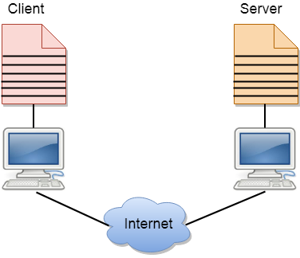  - An application program is known as a client program, running on the local machine that requests for a service from an application program known as a server program, running on the remote machine.  - A client program runs only when it requests for a service from the server while the server program runs all time as it does not know when its service is required.  - A server provides a service for many clients not just for a single client. Therefore, we can say that client-server follows the many-to-one relationship. Many clients can use the service of one server.  - Services are required frequently, and many users have a specific client-server application program. For example, the client-server application program allows the user to access the files, send e-mail, and so on. If the services are more customized, then we should have one generic application program that allows the user to access the services available on the remote computer.  Client  A client is a program that runs on the local machine requesting service from the server. A client program is a finite program means that the service started by the user and terminates when the service is completed.  Server  A server is a program that runs on the remote machine providing services to the clients. When the client requests for a service, then the server opens the door for the incoming requests, but it never initiates the service.  A server program is an infinite program means that when it starts, it runs infinitely unless the problem arises. The server waits for the incoming requests from the clients. When the request arrives at the server, then it responds to the request.  Advantages of Client-server networks:  - Centralized:  Centralized back-up is possible in client-server networks, i.e., all the data is stored in a server.  - Security:  These networks are more secure as all the shared resources are centrally administered.  - Performance:  The use of the dedicated server increases the speed of sharing resources. This increases the performance of the overall system.  - Scalability:  We can increase the number of clients and servers separately, i.e., the new element can be added, or we can add a new node in a network at any time.  Disadvantages of Client-Server network:  - Traffic Congestion is a big problem in Client/Server networks. When a large number of clients send requests to the same server may cause the problem of Traffic congestion.  - It does not have a robustness of a network, i.e., when the server is down, then the client requests cannot be met.  - A client/server network is very decisive. Sometimes, regular computer hardware does not serve a certain number of clients. In such situations, specific hardware is required at the server side to complete the work.  - Sometimes the resources exist in the server but may not exist in the client. For example, If the application is web, then we cannot take the print out directly on printers without taking out the print view window on the web.  DNS  An application layer protocol defines how the application processes running on different systems, pass the messages to each other.  - DNS stands for Domain Name System.  - DNS is a directory service that provides a mapping between the name of a host on the network and its numerical address.  - DNS is required for the functioning of the internet.  - Each node in a tree has a domain name, and a full domain name is a sequence of symbols specified by dots.  - DNS is a service that translates the domain name into IP addresses. This allows the users of networks to utilize user-friendly names when looking for other hosts instead of remembering the IP addresses.  - For example, suppose the FTP site at EduSoft had an IP address of 132.147.165.50, most people would reach this site by specifying ftp.EduSoft.com. Therefore, the domain name is more reliable than IP address.  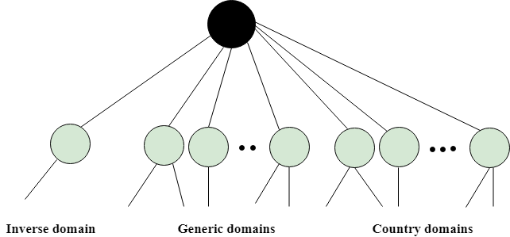  DNS is a TCP/IP protocol used on different platforms. The domain name space is divided into three different sections: generic domains, country domains, and inverse domain.  Generic Domains  - It defines the registered hosts according to their generic behavior.  - Each node in a tree defines the domain name, which is an index to the DNS database.  - It uses three-character labels, and these labels describe the organization type.  Label Description  aero Airlines and aerospace companies  biz Businesses or firms  com Commercial Organizations  coop Cooperative business Organizations  edu Educational institutions  gov Government institutions  info Information service providers  int International Organizations  mil Military groups  museum Museum & other nonprofit organizations  name Personal names  net Network Support centers  org Nonprofit Organizations  pro Professional individual Organizations  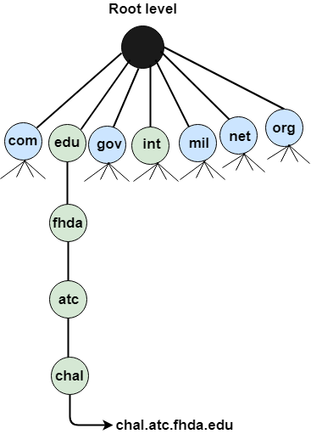  Country Domain  The format of country domain is same as a generic domain, but it uses two-character country abbreviations (e.g., us for the United States) in place of three-character organizational abbreviations.  Inverse Domain  The inverse domain is used for mapping an address to a name. When the server has received a request from the client, and the server contains the files of only authorized clients. To determine whether the client is on the authorized list or not, it sends a query to the DNS server and ask for mapping an address to the name.  Working of DNS  - DNS is a client/server network communication protocol. DNS clients send requests to the. server while DNS servers send responses to the client.  - Client requests contain a name which is converted into an IP address known as a forward DNS lookup while requests containing an IP address which is converted into a name known as reverse DNS lookups.  - DNS implements a distributed database to store the name of all the hosts available on the internet.  - If a client like a web browser sends a request containing a hostname, then a piece of software such as DNS resolver sends a request to the DNS server to obtain the IP address of a hostname. If DNS server does not contain the IP address associated with a hostname, then it forwards the request to another DNS server. If IP address has arrived at the resolver, which in turn completes the request over the internet protocol.  FTP  - FTP stands for File transfer protocol.  - FTP is a standard internet protocol provided by TCP/IP used for transmitting the files from one host to another.  - It is mainly used for transferring the web page files from their creator to the computer that acts as a server for other computers on the internet.  - It is also used for downloading the files to computer from other servers.  Objectives of FTP  - It provides the sharing of files.  - It is used to encourage the use of remote computers.  - It transfers the data more reliably and efficiently.  Why FTP?  Although transferring files from one system to another is very simple and straightforward, but sometimes it can cause problems. For example, two systems may have different file conventions. Two systems may have different ways to represent text and data. Two systems may have different directory structures. FTP protocol overcomes these problems by establishing two connections between hosts. One connection is used for data transfer, and another connection is used for the control connection.  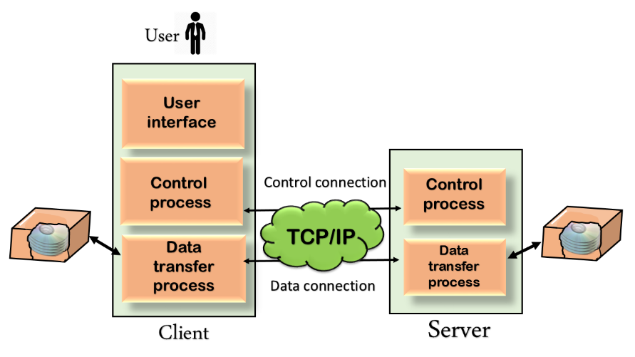  Mechanism of FTP  The above figure shows the basic model of the FTP. The FTP client has three components: the user interface, control process, and data transfer process. The server has two components: the server control process and the server data transfer process.  There are two types of connections in FTP:  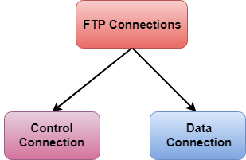  - Control Connection:  The control connection uses very simple rules for communication. Through control connection, we can transfer a line of command or line of response at a time. The control connection is made between the control processes. The control connection remains connected during the entire interactive FTP session.  - Data Connection:  The Data Connection uses very complex rules as data types may vary. The data connection is made between data transfer processes. The data connection opens when a command comes for transferring the files and closes when the file is transferred.  FTP Clients  - FTP client is a program that implements a file transfer protocol which allows you to transfer files between two hosts on the internet.  - It allows a user to connect to a remote host and upload or download the files.  - It has a set of commands that we can use to connect to a host, transfer the files between you and your host and close the connection.  - The FTP program is also available as a built-in component in a Web browser. This GUI based FTP client makes the file transfer very easy and also does not require to remember the FTP commands.  Advantages of FTP:  - Speed: One of the biggest advantages of FTP is speed. The FTP is one of the fastest ways to transfer the files from one computer to another computer.  - Efficient: It is more efficient as we do not need to complete all the operations to get the entire file.  - Security: To access the FTP server, we need to login with the username and password. Therefore, we can say that FTP is more secure.  - Back & forth movement: FTP allows us to transfer the files back and forth. Suppose you are a manager of the company, you send some information to all the employees, and they all send information back on the same server.  Disadvantages of FTP:  - The standard requirement of the industry is that all the FTP transmissions should be encrypted. However, not all the FTP providers are equal and not all the providers offer encryption. So, we will have to look out for the FTP providers that provides encryption.  - FTP serves two operations, i.e., to send and receive large files on a network. However, the size limit of the file is 2GB that can be sent. It also doesn't allow you to run simultaneous transfers to multiple receivers.  - Passwords and file contents are sent in clear text that allows unwanted eavesdropping. So, it is quite possible that attackers can carry out the brute force attack by trying to guess the FTP password.  - It is not compatible with every system.  Telnet  - The main task of the internet is to provide services to users. For example, users want to run different application programs at the remote site and transfers a result to the local site. This requires a client-server program such as FTP, SMTP. But this would not allow us to create a specific program for each demand.  - The better solution is to provide a general client-server program that lets the user access any application program on a remote computer. Therefore, a program that allows a user to log on to a remote computer. A popular client-server program Telnet is used to meet such demands. Telnet is an abbreviation for Terminal Network.  - Telnet provides a connection to the remote computer in such a way that a local terminal appears to be at the remote side.  There are two types of logins:  Local Login  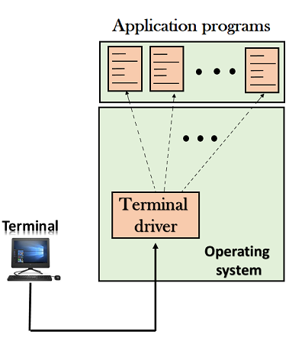  - When a user logs into a local computer, then it is known as local login.  - When the workstation running terminal emulator, the keystrokes entered by the user are accepted by the terminal driver. The terminal driver then passes these characters to the operating system which in turn, invokes the desired application program.  - However, the operating system has special meaning to special characters. For example, in UNIX some combination of characters has special meanings such as control character with "z" means suspend. Such situations do not create any problem as the terminal driver knows the meaning of such characters. But it can cause the problems in remote login.  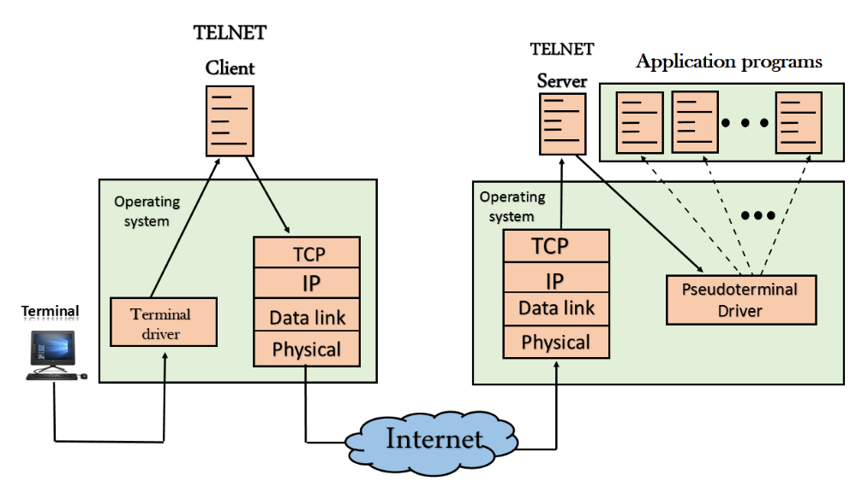  Remote login  - When the user wants to access an application program on a remote computer, then the user must perform remote login.  How remote login occurs  - At the local site  The user sends the keystrokes to the terminal driver, the characters are then sent to the TELNET client. The TELNET client which in turn, transforms the characters to a universal character set known as network virtual terminal characters and delivers them to the local TCP/IP stack  - At the remote site  The commands in NVT forms are transmitted to the TCP/IP at the remote machine. Here, the characters are delivered to the operating system and then pass to the TELNET server. The TELNET server transforms the characters which can be understandable by a remote computer. However, the characters cannot be directly passed to the operating system as a remote operating system does not receive the characters from the TELNET server. Therefore, it requires some piece of software that can accept the characters from the TELNET server. The operating system then passes these characters to the appropriate application program.  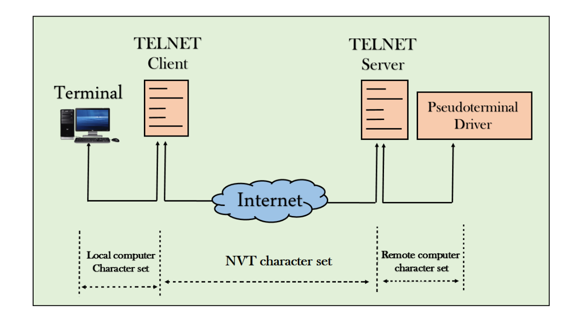  Network Virtual Terminal (NVT)  - The network virtual terminal is an interface that defines how data and commands are sent across the network.  - In today's world, systems are heterogeneous. For example, the operating system accepts a special combination of characters such as end-of-file token running a DOS operating system ctrl+z while the token running a UNIX operating system is ctrl+d.  - TELNET solves this issue by defining a universal interface known as network virtual interface.  - The TELNET client translates the characters that come from the local terminal into NVT form and then delivers them to the network. The Telnet server then translates the data from NVT form into a form which can be understandable by a remote computer.  SMTP  - SMTP stands for Simple Mail Transfer Protocol.  - SMTP is a set of communication guidelines that allow software to transmit an electronic mail over the internet is called Simple Mail Transfer Protocol.  - It is a program used for sending messages to other computer users based on e-mail addresses.  - It provides a mail exchange between users on the same or different computers, and it also supports:  - It can send a single message to one or more recipients.  - Sending message can include text, voice, video or graphics.  - It can also send the messages on networks outside the internet.  - The main purpose of SMTP is used to set up communication rules between servers. The servers have a way of identifying themselves and announcing what kind of communication they are trying to perform. They also have a way of handling the errors such as incorrect email address. For example, if the recipient address is wrong, then receiving server reply with an error message of some kind.  Components of SMTP  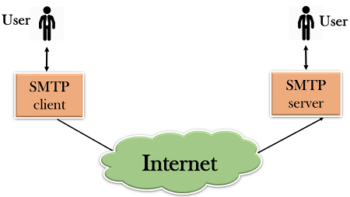  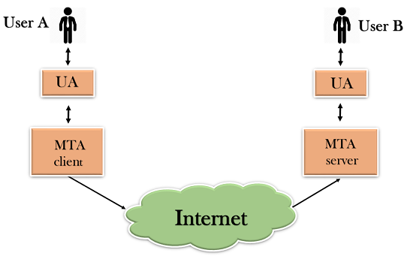  - First, we will break the SMTP client and SMTP server into two components such as user agent (UA) and mail transfer agent (MTA). The user agent (UA) prepares the message, creates the envelope and then puts the message in the envelope. The mail transfer agent (MTA) transfers this mail across the internet.  - SMTP allows a more complex system by adding a relaying system. Instead of just having one MTA at sending side and one at receiving side, more MTAs can be added, acting either as a client or server to relay the email.  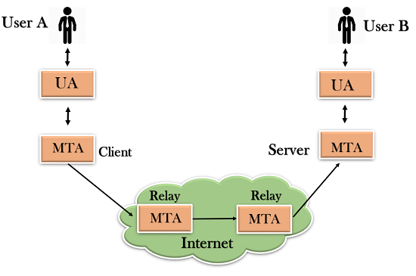  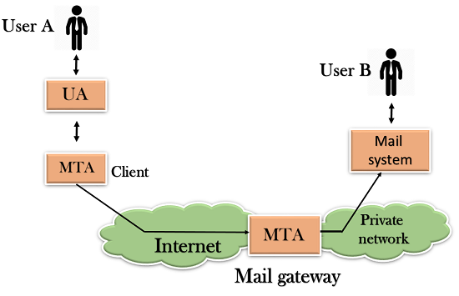  - The relaying system without TCP/IP protocol can also be used to send the emails to users, and this is achieved by the use of the mail gateway. The mail gateway is a relay MTA that can be used to receive an email.  Working of SMTP  - Composition of Mail: A user sends an e-mail by composing an electronic mail message using a Mail User Agent (MUA). Mail User Agent is a program which is used to send and receive mail. The message contains two parts: body and header. The body is the main part of the message while the header includes information such as the sender and recipient address. The header also includes descriptive information such as the subject of the message. In this case, the message body is like a letter and header is like an envelope that contains the recipient's address.  - Submission of Mail: After composing an email, the mail client then submits the completed e-mail to the SMTP server by using SMTP on TCP port 25.  - Delivery of Mail: E-mail addresses contain two parts: username of the recipient and domain name. For example, vivek@gmail.com, where "vivek" is the username of the recipient and "gmail.com" is the domain name.  If the domain name of the recipient's email address is different from the sender's domain name, then MSA will send the mail to the Mail Transfer Agent (MTA). To relay the email, the MTA will find the target domain. It checks the MX record from Domain Name System to obtain the target domain. The MX record contains the domain name and IP address of the recipient's domain. Once the record is located, MTA connects to the exchange server to relay the message.  - Receipt and Processing of Mail: Once the incoming message is received, the exchange server delivers it to the incoming server (Mail Delivery Agent) which stores the e-mail where it waits for the user to retrieve it.  - Access and Retrieval of Mail: The stored email in MDA can be retrieved by using MUA (Mail User Agent). MUA can be accessed by using login and password.  SNMP  - SNMP stands for Simple Network Management Protocol.  - SNMP is a framework used for managing devices on the internet.  - It provides a set of operations for monitoring and managing the internet.  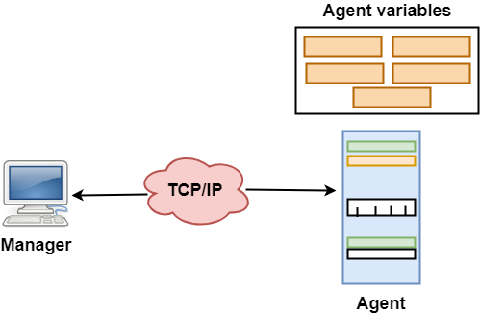  SNMP Concept  - SNMP has two components Manager and agent.  - The manager is a host that controls and monitors a set of agents such as routers.  - It is an application layer protocol in which a few manager stations can handle a set of agents.  - The protocol designed at the application level can monitor the devices made by different manufacturers and installed on different physical networks.  - It is used in a heterogeneous network made of different LANs and WANs connected by routers or gateways.  Managers & Agents  - A manager is a host that runs the SNMP client program while the agent is a router that runs the SNMP server program.  - Management of the internet is achieved through simple interaction between a manager and agent.  - The agent is used to keep the information in a database while the manager is used to access the values in the database. For example, a router can store the appropriate variables such as a number of packets received and forwarded while the manager can compare these variables to determine whether the router is congested or not.  - Agents can also contribute to the management process. A server program on the agent checks the environment, if something goes wrong, the agent sends a warning message to the manager.  Management with SNMP has three basic ideas:  - A manager checks the agent by requesting the information that reflects the behavior of the agent.  - A manager also forces the agent to perform a certain function by resetting values in the agent database.  - An agent also contributes to the management process by warning the manager regarding an unusual condition.  Management Components  - Management is not achieved only through the SNMP protocol but also the use of other protocols that can cooperate with the SNMP protocol. Management is achieved through the use of the other two protocols: SMI (Structure of management information) and MIB(management information base).  - Management is a combination of SMI, MIB, and SNMP. All these three protocols such as abstract syntax notation 1 (ASN.1) and basic encoding rules (BER).  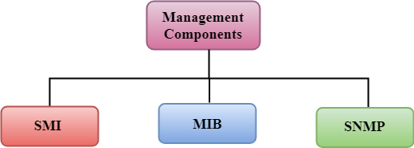  SMI  The SMI (Structure of management information) is a component used in network management. Its main function is to define the type of data that can be stored in an object and to show how to encode the data for the transmission over a network.  MIB  - The MIB (Management information base) is a second component for the network management.  - Each agent has its own MIB, which is a collection of all the objects that the manager can manage. MIB is categorized into eight groups: system, interface, address translation, ip, icmp, tcp, udp, and egp. These groups are under the mib object.  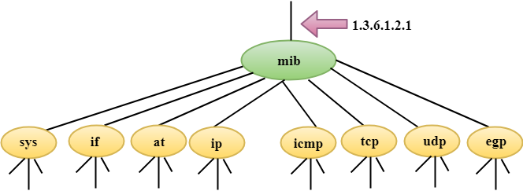  SNMP  SNMP defines five types of messages: GetRequest, GetNextRequest, SetRequest, GetResponse, and Trap.  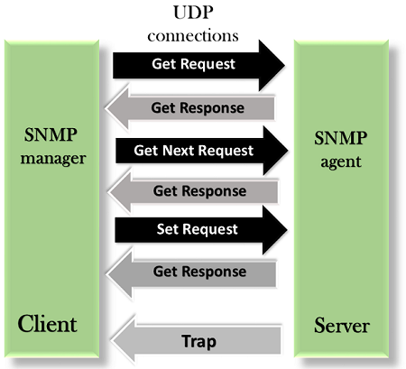  GetRequest: The GetRequest message is sent from a manager (client) to the agent (server) to retrieve the value of a variable.  GetNextRequest: The GetNextRequest message is sent from the manager to agent to retrieve the value of a variable. This type of message is used to retrieve the values of the entries in a table. If the manager does not know the indexes of the entries, then it will not be able to retrieve the values. In such situations, GetNextRequest message is used to define an object.  GetResponse: The GetResponse message is sent from an agent to the manager in response to the GetRequest and GetNextRequest message. This message contains the value of a variable requested by the manager.  SetRequest: The SetRequest message is sent from a manager to the agent to set a value in a variable.  Trap: The Trap message is sent from an agent to the manager to report an event. For example, if the agent is rebooted, then it informs the manager as well as sends the time of rebooting.  HTTP  - HTTP stands for HyperText Transfer Protocol.  - It is a protocol used to access the data on the World Wide Web (www).  - The HTTP protocol can be used to transfer the data in the form of plain text, hypertext, audio, video, and so on.  - This protocol is known as HyperText Transfer Protocol because of its efficiency that allows us to use in a hypertext environment where there are rapid jumps from one document to another document.  - HTTP is similar to the FTP as it also transfers the files from one host to another host. But, HTTP is simpler than FTP as HTTP uses only one connection, i.e., no control connection to transfer the files.  - HTTP is used to carry the data in the form of MIME-like format.  - HTTP is similar to SMTP as the data is transferred between client and server. The HTTP differs from the SMTP in the way the messages are sent from the client to the server and from server to the client. SMTP messages are stored and forwarded while HTTP messages are delivered immediately.  Features of HTTP:  - Connectionless protocol: HTTP is a connectionless protocol. HTTP client initiates a request and waits for a response from the server. When the server receives the request, the server processes the request and sends back the response to the HTTP client after which the client disconnects the connection. The connection between client and server exist only during the current request and response time only.  - Media independent: HTTP protocol is a media independent as data can be sent as long as both the client and server know how to handle the data content. It is required for both the client and server to specify the content type in MIME-type header.  - Stateless: HTTP is a stateless protocol as both the client and server know each other only during the current request. Due to this nature of the protocol, both the client and server do not retain the information between various requests of the web pages.  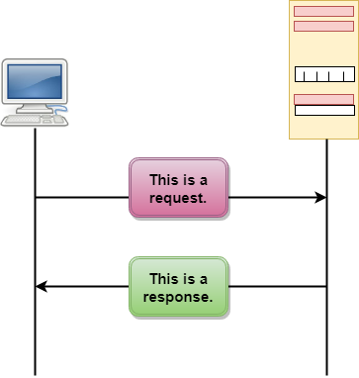  HTTP Transactions  The above figure shows the HTTP transaction between client and server. The client initiates a transaction by sending a request message to the server. The server replies to the request message by sending a response message.  Messages  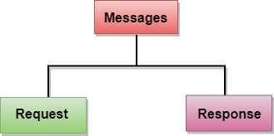  HTTP messages are of two types: request and response. Both the message types follow the same message format.  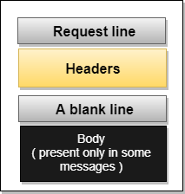  Request Message: The request message is sent by the client that consists of a request line, headers, and sometimes a body.  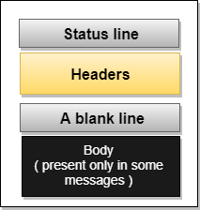  Response Message: The response message is sent by the server to the client that consists of a status line, headers, and sometimes a body.  Uniform Resource Locator (URL)  - A client that wants to access the document in an internet needs an address and to facilitate the access of documents, the HTTP uses the concept of Uniform Resource Locator (URL).  - The Uniform Resource Locator (URL) is a standard way of specifying any kind of information on the internet.  - The URL defines four parts: method, host computer, port, and path.  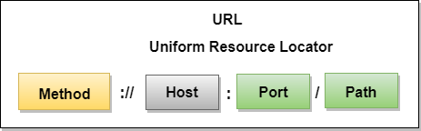  - Method: The method is the protocol used to retrieve the document from a server. For example, HTTP.  - Host: The host is the computer where the information is stored, and the computer is given an alias name. Web pages are mainly stored in the computers and the computers are given an alias name that begins with the characters "www". This field is not mandatory.  - Port: The URL can also contain the port number of the server, but it's an optional field. If the port number is included, then it must come between the host and path and it should be separated from the host by a colon.  - Path: Path is the pathname of the file where the information is stored. The path itself contain slashes that separate the directories from the subdirectories and files.

