LSPU Self-Paced Learning Module (SLM)
Course | ITEP 309 Networking 2
Sem/AY | First Semester/2020-2021
Module No. | 1
Lesson Title | Routing Fundamentals
Week Duration | 1
Date | Oct 5 to 9, 2020
Description of the Lesson | This lesson will discuss Routing fundamentals terminologies, principles, concept, application, advantages, and importance of routing in networking. Also, discuss the unfamiliar terms in networking and it functions and uses.

Learning Outcomes

Intended Learning Outcomes | Students should be able to meet the following intended learning outcomes:  - To define what is routing  - To understand the importance of implementing routing on a corporate network  - Demonstrate simple Static routing  - To identify default routes  - To understand the importance of Load Balancing
Targets/ Objectives | At the end of the lesson, students should be able to:  - Explain what is what is routing  - Understand the importance of implementing routing on a corporate network  - Configure simple static routing  - Identify default routes  - Understand the importance of Load Balancing

Student Learning Strategies

Online Activities (Synchronous/  Asynchronous) | - Lecture presentation uploaded in Google Classroom  Students will be instructed to download lecture presentations with narrations / pre-recorded lecture presentation uploaded in Google Classroom.  For further instructions, refer to your Google Classroom and see the schedule of activities for this module.  - Learning Guide Questions:  - What is Routing?  - Why it is important to implement routing on a corporate network?  - How to configure simple static routing?  - How identify default routes?  - Importance of Load Balancing in Networking?  Note: The insight that you will post on online discussion forum using Learning Management System (LMS) will receive additional scores in class participation.
Offline Activities  (e-Learning/Self-Paced) | Lecture Guide  Routing Fundamentals  Router Functions  A router has two main functions:  - Determining the best path to available networks  - Forwarding traffic to those networks  The Routing Table  - The best available path or paths to a destination network are listed in a router’s routing table and will be used for forwarding traffic  - A routing table consists of directly connected networks and routes configured statically by the administrator or dynamically learned through a routing protocol.  Connected and Local Routes  - The administrator configures IP addresses on the router’s interfaces  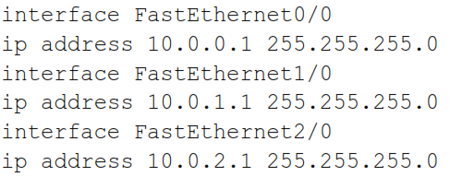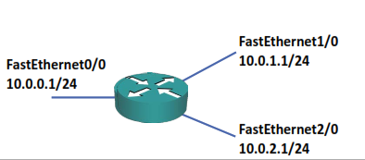  CLI Command (Local Routes)  show ip route  - From IOS 15, local routes will also be added to the routing table  - Local routes always have a /32 mask and show the IP address configured on the interface  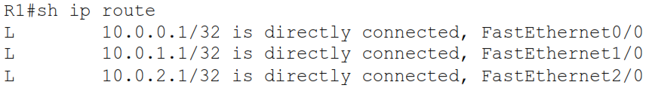  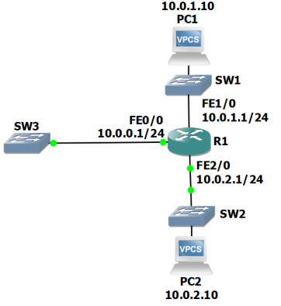    Static Routes  - If a router receives traffic for a network which it is not directly attached to, it needs to know how to get there in order to forward the traffic  - An administrator can manually add a static route to the destination, or the router can learn it via a routing protocol  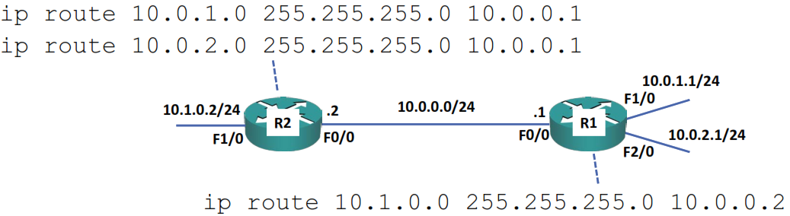  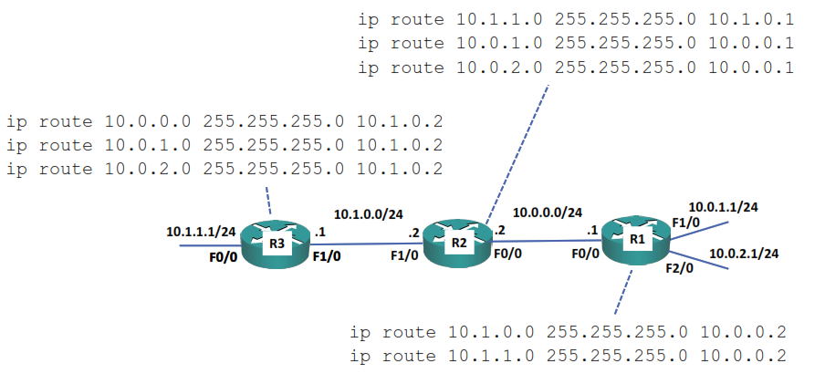  Example Infrastructure  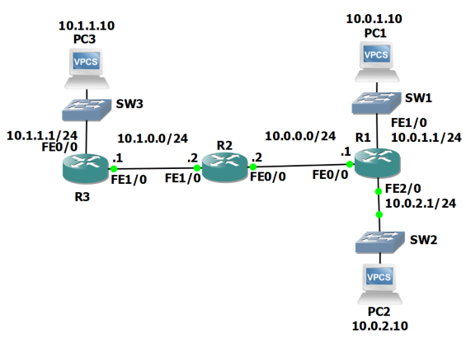  Static Routes  - Routes on router 1  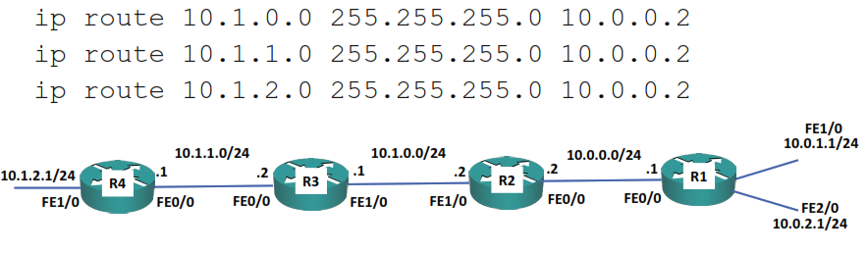  Summary Routes  - For static routing, summary routes lessen administrative overhead and memory usage on the routers  - Routes on R1:  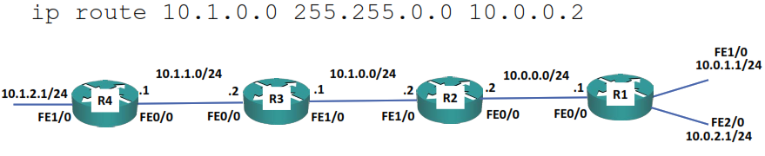  Summary Routes  - Summarization doesn’t have to be on classful boundaries    - To summarize the range 10.1.0.0 to 10.1.3.0:  Longest Prefix Match  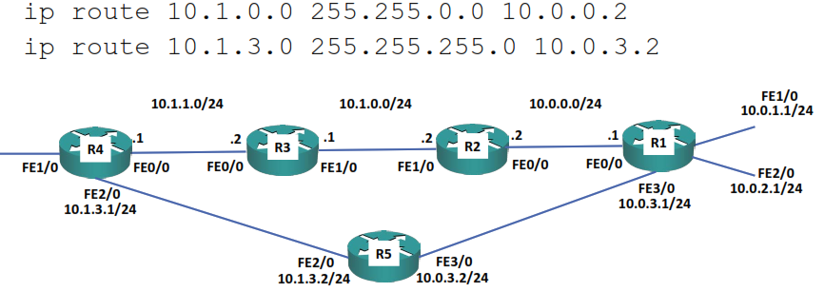  - When there are overlapping routes, the longest prefix will be selected  Load Balancing  - When multiple equal length routes are added for the same destination, the router will add them all to the routing table and load balance between them  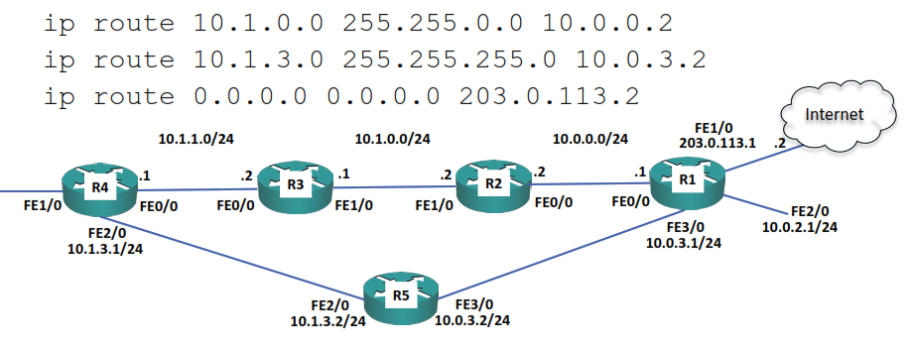  Default Route (Gateway of Last Resort)  Laboratory Topology  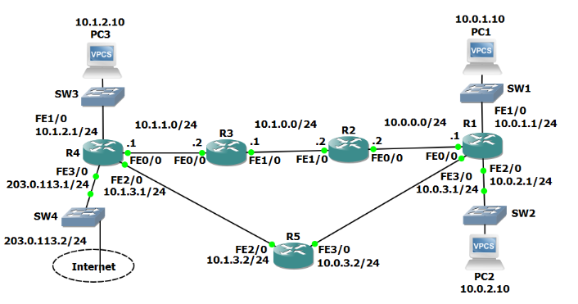
Engaging Activities

- What is your understanding about Routing?
__________________________________________________________________________________
__________________________________________________________________________________
__________________________________________________________________________________
__________________________________________________________________________________
__________________________________________________________________________________
__________________________________________________________________________________
__________________________________________________________________________________
- Why it is very important to configure and implement routing on a large-scale or corporate network?
__________________________________________________________________________________
__________________________________________________________________________________
__________________________________________________________________________________
__________________________________________________________________________________
__________________________________________________________________________________
__________________________________________________________________________________
__________________________________________________________________________________

- How do you define load balancing?
__________________________________________________________________________________
__________________________________________________________________________________
__________________________________________________________________________________
__________________________________________________________________________________
__________________________________________________________________________________
__________________________________________________________________________________
__________________________________________________________________________________
__________________________________________________________________________________
__________________________________________________________________________________
__________________________________________________________________________________
__________________________________________________________________________________
- How do you identify default route?
__________________________________________________________________________________
__________________________________________________________________________________
__________________________________________________________________________________
__________________________________________________________________________________
__________________________________________________________________________________
__________________________________________________________________________________
__________________________________________________________________________________
__________________________________________________________________________________
__________________________________________________________________________________

- What is the primary role of a load balancer in a network?
__________________________________________________________________________________
__________________________________________________________________________________
__________________________________________________________________________________
__________________________________________________________________________________
__________________________________________________________________________________
__________________________________________________________________________________
__________________________________________________________________________________
__________________________________________________________________________________
__________________________________________________________________________________
__________________________________________________________________________________


Performance Tasks

Performance Task 2
Direction: list down terminologies in networking infrastructure and its uses in your own idea or explanation.

Devices / tools | Terminologies / sources | Idea or personal explanation


Understanding Directed Assess

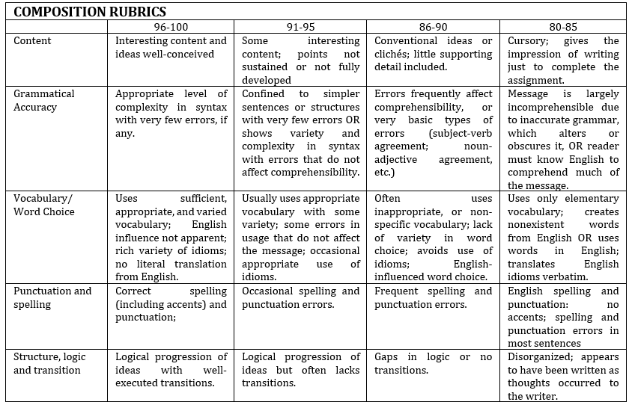


Learning Resources

- https://www.flackbox.com/cisco-ccna-lab-options
- https://www.flackbox.com/#elementor-action%3Aaction%3Dpopup%3Aopen%26settings%3DeyJpZCI6IjEwMzk4IiwidG9nZ2xlIjpmYWxzZX0%3D
- https://www.youtube.com/channel/UCK4ji45I-zxeWXAFKmu3p6Q
- https://study-ccna.com/
- https://www.cybrary.it/course/cisco-ccna/
- https://www.udemy.com/course/ccna-complete/
- https://www.udemy.com/course/networkplus/

