LSPU Self-Paced Learning Module (SLM)
Course | ITEP 309 Networking 2
Sem/AY | First Semester/2020-2021
Module No. | 2
Lesson Title | Routing Fundamentals
Week Duration | 2-3
Date | Oct 12 to 23, 2020
Description of the Lesson | This lesson will discuss Dynamic Routing Protocol terminologies, principles, concept, application, advantages, and importance of routing in networking. Also, discuss the unfamiliar terms in networking and it functions and uses.

Learning Outcomes

Intended Learning Outcomes | Students should be able to meet the following intended learning outcomes:  - To understand the difference between dynamic and static routing  - To identify different types of Routing protocols  - To understand routing protocol metrics  - To understand the networks administrative distance  - To identify loopback interfaces  - To demonstrate adjacencies and passive interfaces
Targets/ Objectives | At the end of the lesson, students should be able to:  - Explain the difference between dynamic and static routing  - Explain different types of Routing protocols  - Identify routing protocol metrics  - Identify networks administrative distance  - Determine loopback interfaces  - Explain adjacencies and passive interfaces

Student Learning Strategies

Online Activities (Synchronous/  Asynchronous) | - Lecture presentation uploaded in Google Classroom  Students will be instructed to download lecture presentations with narrations / pre-recorded lecture presentation uploaded in Google Classroom.  For further instructions, refer to your Google Classroom and see the schedule of activities for this module.  - Learning Guide Questions:  - What is Dynamic Routing?  - What is Static Routing?  - What are the different routing protocols?  - How do you explain routing protocol metrics?  - How to determine network administrative distance?  - What is Loopback Interfaces?  - How to you explain adjacencies and passive interfaces  Note: The insight that you will post on online discussion forum using Learning Management System (LMS) will receive additional scores in class participation.
Offline Activities  (e-Learning/Self-Paced) | Lecture Guide  Dynamic Routing Protocols  - When a routing protocol is used, routers automatically advertise their best paths to known networks to each other.  - Routers use this information to determine their own best path to the known destinations.  - When the state of the network changes, such as a link going down or a new subnet being added, the routers update each other.  - Routers will automatically calculate a new best path and update the routing table if the network changes.  You can get to these networks via me:  10.0.1.0/24  10.0.2.0/24    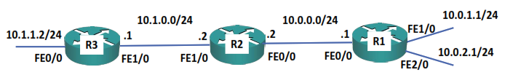  Routing Table:  10.0.0.0/24 Connected FE0/0  10.1.0.0/24 Connected FE1/0  10.0.1.0/24 10.0.0.1 FE0/0  10.0.2.0/24 10.0.0.1 FE0/0  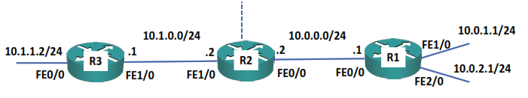    You can get to these  networks via me:  10.0.0.0/24  10.0.1.0/24  10.0.2.0/24  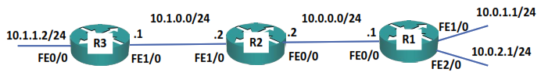  Routing Table:  10.1.1.0/24 Connected FE0/0  10.1.0.0/24 Connected FE1/0  10.0.0.0/24 10.1.0.2 FE1/0  10.0.1.0/24 10.1.0.2 FE1/0  10.0.2.0/24 10.1.0.2 FE1/0  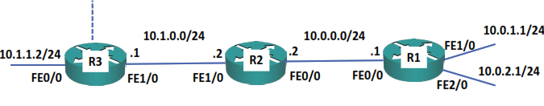  Summary Routes    You can get to these networks via me:  10.0.0.0/16  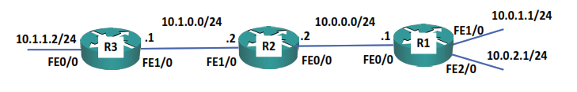  - Summary routes lead to less memory usage in routers as their routing tables contain less routes  - They also lead to less CPU usage as changes in the network only affect other routers in the same area  - For example, if the link on R1 to the 10.0.1.1/24 network goes down, R2 will lose its route there and try to compute a new path  - R3 will not be affected as its summary route to 10.0.0.0/16 is unchanged  Dynamic Routing Protocols vs Static Routes  - Routing protocols are more scalable than administrator defined static routes.  - Using purely static routes is only feasible in very small environments.  Dynamic Routing Protocol Advantages  - The routers automatically advertise available subnets to each other without the administrator having to manually enter every route on every router.  - If a subnet is added or removed the routers will automatically discover that and update their routing tables.  - If the best path to a subnet goes down routers automatically discover that and will calculate a new best path if one is available.  Dynamic Routing Protocols vs Static Routes  - Using a combination of a dynamic routing protocol and static routes is very common in real world environments.  - In this case the routing protocol will be used to carry the bulk of the network information.  - Static routes can also be used on an as needed basis. For example for backup purposes or for a static route to the Internet (which will typically be injected into the dynamic routing protocol and advertised to the rest of the routers.)  Laboratory Infrastructure  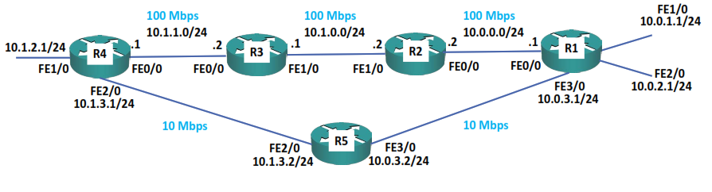  Routing Protocol Types  Routing protocols can be split into two main types:  - Interior gateway protocols (IGPs)  - Exterior gateway protocols (EGPs)  - Interior gateway protocols are used for routing within an organization  - Exterior gateway protocols are used for routing between organizations over the Internet  - The only EGP in use today is BGP (Border Gateway Protocol)  Interior Gateway Protocols  Interior gateway protocols can be split into two main types:  - Distance Vector routing protocols  - Link State routing protocols  Distance Vector Routing Protocols  - In Distance Vector protocols, each router sends its directly connected neighbors a list of all its known networks along with its own distance to each of those networks  - Distance vector routing protocols do not advertise the entire network topology  - A router only knows its directly connected neighbors and the lists of networks those neighbors have advertised. It doesn’t have detailed topology information beyond its directly connected neighbors  - Distance Vector routing protocols are often called ‘Routing by rumor’  Link State Routing Protocols  - In Link State routing protocols, each router describes itself and its interfaces to its directly connected neighbors  - This information is passed unchanged from one router to another  - Every router learns the full picture of the network including every router, its interfaces and what they connect to  RIP: Routing Information Protocol  EIGRP: Enhanced Interior Gateway Routing Protocol  OSPF: Open Shortest Path First  IS-IS: Intermediate System – Intermediate System  BGP: Border Gateway Protocol  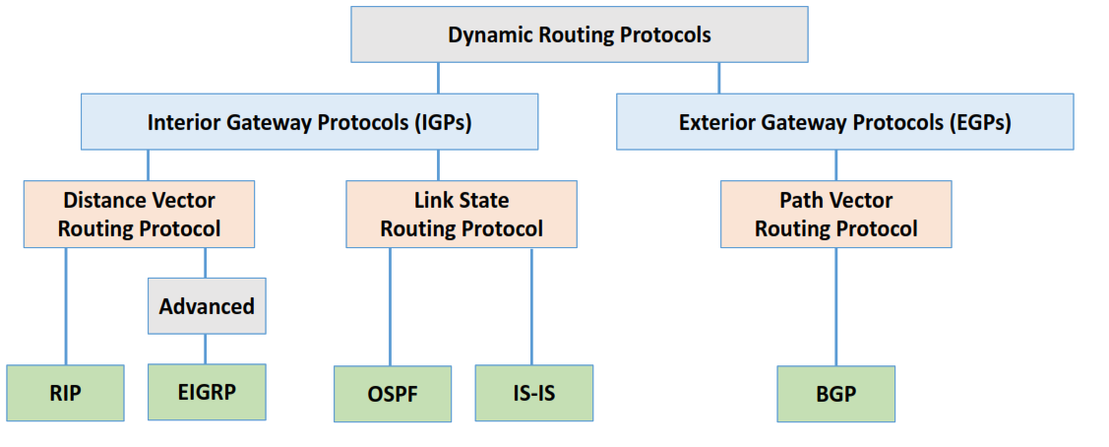  Interior Gateway Protocols  - All of the IGPs do the same job, which is to advertise routes within an organization and determine the best path or paths  - An organization will typically pick one of the IGPs  - If an organization has multiple IGPs in effect (for example because of a merger), information can be redistributed between them. This should generally be avoided if possible
Engaging Activities

- What are your understanding about Static and Dynamic Routing?
__________________________________________________________________________________
__________________________________________________________________________________
__________________________________________________________________________________
__________________________________________________________________________________
__________________________________________________________________________________
__________________________________________________________________________________
__________________________________________________________________________________
- What is the most common type of routing protocol?
__________________________________________________________________________________
__________________________________________________________________________________
__________________________________________________________________________________
__________________________________________________________________________________
__________________________________________________________________________________
__________________________________________________________________________________
__________________________________________________________________________________

- How do you define administrative distance?
__________________________________________________________________________________
__________________________________________________________________________________
__________________________________________________________________________________
__________________________________________________________________________________
__________________________________________________________________________________
__________________________________________________________________________________
__________________________________________________________________________________
__________________________________________________________________________________
__________________________________________________________________________________
__________________________________________________________________________________
__________________________________________________________________________________
- How do you identify default route?
__________________________________________________________________________________
__________________________________________________________________________________
__________________________________________________________________________________
__________________________________________________________________________________
__________________________________________________________________________________
__________________________________________________________________________________
__________________________________________________________________________________
__________________________________________________________________________________
__________________________________________________________________________________

- How do you define loopback interfaces?
__________________________________________________________________________________
__________________________________________________________________________________
__________________________________________________________________________________
__________________________________________________________________________________
__________________________________________________________________________________
__________________________________________________________________________________
__________________________________________________________________________________
__________________________________________________________________________________
__________________________________________________________________________________


Performance Tasks

Performance Task 2
Direction: list down terminologies in todays lesson that you find difficult to understand.

Terminologies / sources | Idea or personal explanation


Understanding Directed Assess

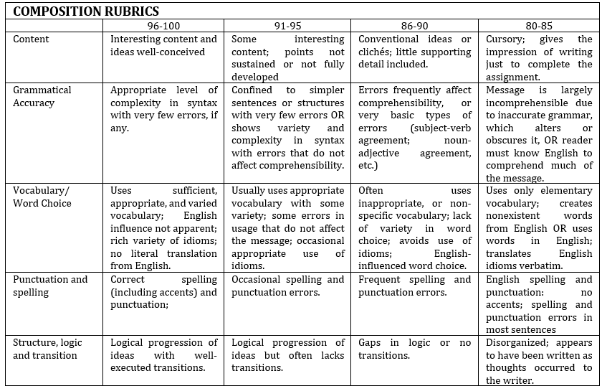


Learning Resources
- https://www.flackbox.com/cisco-ccna-lab-options
- https://www.flackbox.com/#elementor-action%3Aaction%3Dpopup%3Aopen%26settings%3DeyJpZCI6IjEwMzk4IiwidG9nZ2xlIjpmYWxzZX0%3D
- https://www.youtube.com/channel/UCK4ji45I-zxeWXAFKmu3p6Q
- https://study-ccna.com/
- https://www.cybrary.it/course/cisco-ccna/
- https://www.udemy.com/course/ccna-complete/
- https://www.udemy.com/course/networkplus/

