LSPU Self-Paced Learning Module (SLM)
Course | ITEP 309 Networking 2
Sem/AY | First Semester/2020-2021
Module No. | 3
Lesson Title | Routing Information Protocol
Week Duration | 4-5
Date | Oct 26 to November 06, 2020
Description of the Lesson | This lesson will discuss on Routing Information Protocol that focuses on tracing network hops in tracing where the network traffic proceeds from source to its destination.

Learning Outcomes

Intended Learning Outcomes | Students should be able to meet the following intended learning outcomes:  - Learn and understand the routing information protocol  - To demonstrate the configuration of routing information protocol  - To identify the usage and importance of routing information protocol on a corporate network  - To simulate different scenarios in implementing routing information protocol
Targets/ Objectives | At the end of the lesson, students should be able to:  - Explain the routing information protocol  - Explain the configuration of routing information protocol  - Understand the usage and importance of routing information protocol on a corporate network  - To understand the simulation of different scenarios in implementing routing information protocol

Student Learning Strategies

Online Activities (Synchronous/  Asynchronous) | - Lecture presentation uploaded in Google Classroom  Students will be instructed to download lecture presentations with narrations / pre-recorded lecture presentation uploaded in Google Classroom.  For further instructions, refer to your Google Classroom and see the schedule of activities for this module.  - Learning Guide Questions:  - What is Routing Information Protocol?  - What is Network Self-Discovery?  - What is the commands used in tracing the hops of a specific network traffic?  Note: The insight that you will post on online discussion forum using Learning Management System (LMS) will receive additional scores in class participation.
Offline Activities  (e-Learning/Self-Paced) | Lecture Guide  Routing Information Protocol (RIP)  ▪ Interior Gateway Protocol  ▪ Distance-vector protocol using hop count  ▪ Maximum hops of 15, 16 is infinite  ▪ Oldest dynamic routing protocol, provides updates every 30 seconds  ▪ Easy to configure and runs over UDP  RIP Characteristics  - The Routing Information Protocol (RIP) is a Distance Vector routing protocol  - It uses hop count as its metric  - The maximum hop count is 15  - It will perform Equal Cost Multi Path, for up to 4 paths by default  RIPv2 vs RIPv1  - RIPv1 is a legacy protocol which is not typically used anymore (although it is still supported on Cisco routers)  - RIPv1 does not send subnet mask information with routing updates so Variable  - Length Subnet Masking (VLSM) is not supported. RIPv2 does support VLSM  - RIPv1 updates are sent every 30 seconds as broadcast traffic  - RIPv2 uses multicast address 224.0.0.9 RIPv2 supports authentication, RIPv1 does not  RIPng  RIPng (RIP next generation) supports IPv6 networks  RIPv2 Configuration  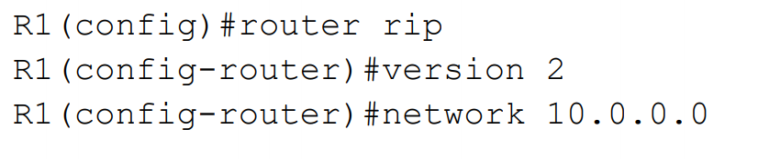  The ‘network’ command should reference a classful network. No subnet mask is specified.  Auto-Summary  - RIP will automatically summarise routes to the classful boundary by default  - For example, 192.168.10.1/30 will be advertised as 192.168.10.0/24  - 172.16.10.1/30 will be advertised as 172.16.0.0/16  - This is almost never desirable  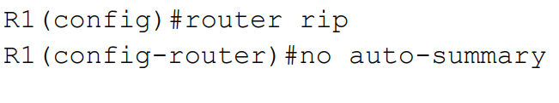  Manual Summarization  Manual summarisation gives you control of exactly how you summarise  The individual summarised routes are not advertised - only their summary route  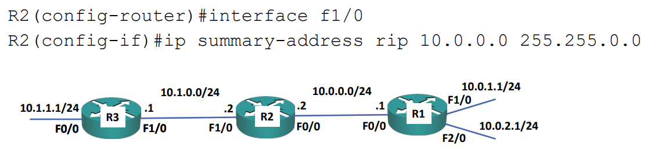  RIPv2 Verification – show ip protocols  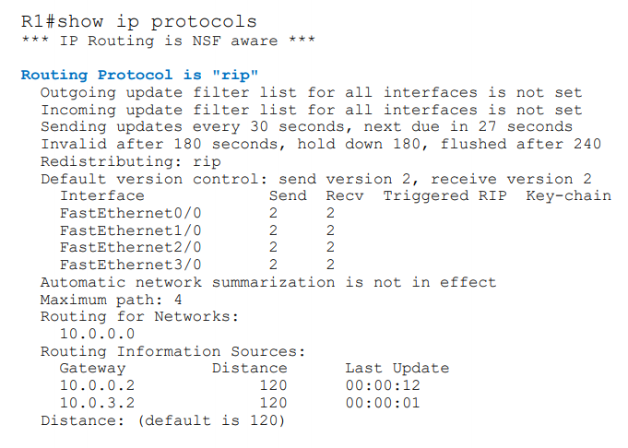  RIPv2 Verification – show run | section rip  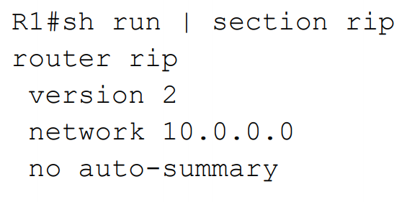  RIPv2 Verification – show ip route  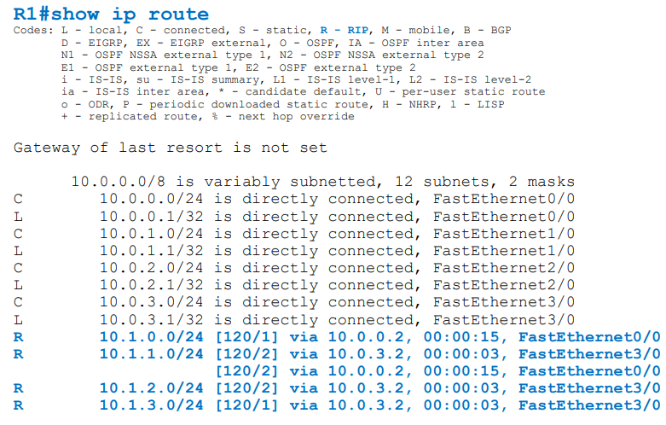  RIPv2 Verification – show ip rip database  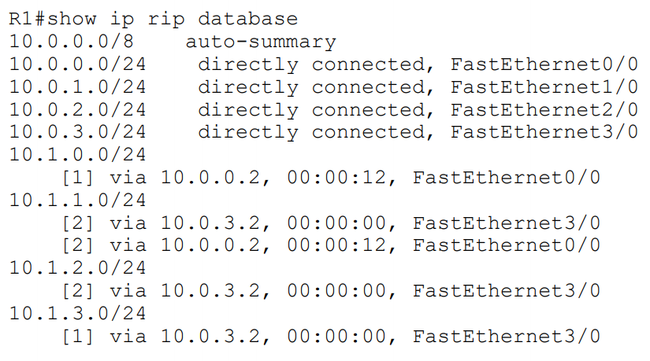  Passive Interfaces  - Passive interfaces work differently in RIP than other routing protocols  - With other routing protocols, a passive interface will not send out or listen for routing updates  - The network configured on the interface will be advertised to other peer routers running the routing protocol  - In RIP, a passive interface does not send out updates but it does listen to incoming updates from other RIP speaking neighbors  - The router can receive updates on the passive interface and use them in the routing table.  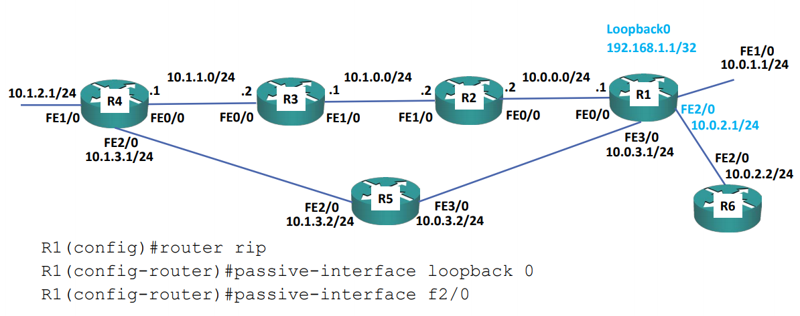  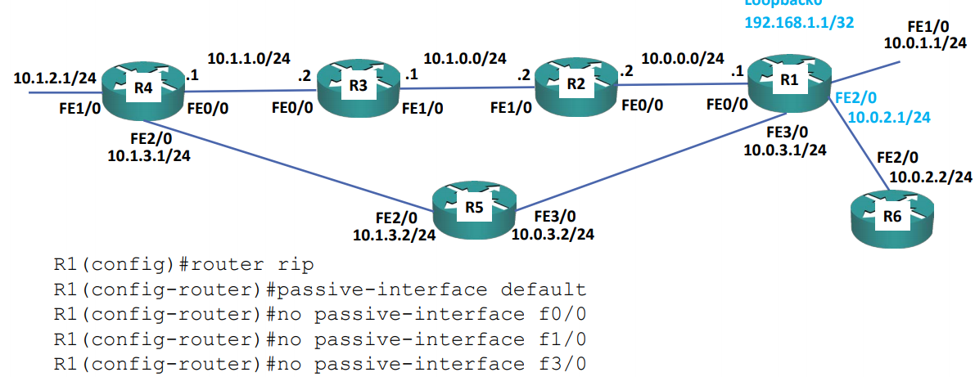  Default Route Injection  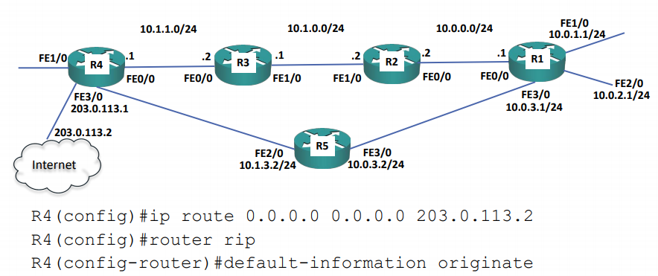  Default Route Injection Verification  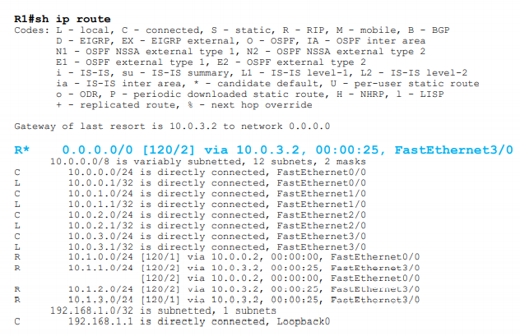  RIP Default Timers  - Update: The router sends updates every 30 seconds.  - Invalid: After no updates for 180 seconds the route becomes invalid.  - Hold Down: The hold down timer is used to stabilize the network, it starts when the invalid timer completes. When a route enters hold down, it can't be installed even if there is a new route with a better metric. 180 seconds by default.  - Flush: 240 seconds from the last update the route is flushed.  - The timers can be changed to achieve faster convergence times  - Be careful with this as it can introduce instability if the timers are set too low  - All routers in the network should have the same timer settings  - The update timer must be lower than the other timers.  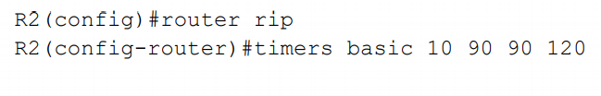  Sample Laboratory Infrastructure  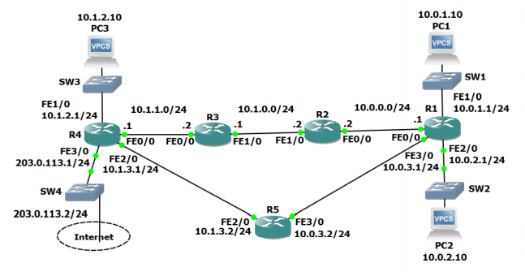
Engaging Activities

- How do you define Routing Information Protocol?
__________________________________________________________________________________
__________________________________________________________________________________
__________________________________________________________________________________
__________________________________________________________________________________
__________________________________________________________________________________
__________________________________________________________________________________
__________________________________________________________________________________
- How do you explain network hops?
__________________________________________________________________________________
__________________________________________________________________________________
__________________________________________________________________________________
__________________________________________________________________________________
__________________________________________________________________________________
__________________________________________________________________________________
__________________________________________________________________________________

- How do you check for directly connected interfaces?
__________________________________________________________________________________
__________________________________________________________________________________
__________________________________________________________________________________
__________________________________________________________________________________
__________________________________________________________________________________
__________________________________________________________________________________
__________________________________________________________________________________
__________________________________________________________________________________
__________________________________________________________________________________
__________________________________________________________________________________
__________________________________________________________________________________
- How do you trigger the Routing Information Protocol auto summary?
__________________________________________________________________________________
__________________________________________________________________________________
__________________________________________________________________________________
__________________________________________________________________________________
__________________________________________________________________________________
__________________________________________________________________________________
__________________________________________________________________________________
__________________________________________________________________________________
__________________________________________________________________________________

- How do you check how many hops it will take for the source to reach the destination?
__________________________________________________________________________________
__________________________________________________________________________________
__________________________________________________________________________________
__________________________________________________________________________________
__________________________________________________________________________________
__________________________________________________________________________________
__________________________________________________________________________________
__________________________________________________________________________________
__________________________________________________________________________________


Performance Tasks

Performance Task 2
Direction: Provide a one-liner explanation for the terminologies listed below.

Terminologies / sources | Idea or personal explanation
Tracert
Rip database
RIPng
Auto-summary
Network <network-address>


Understanding Directed Assess

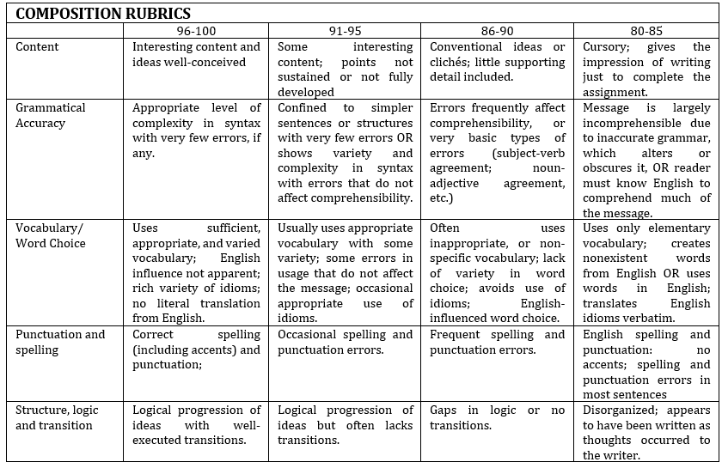


Learning Resources
- https://www.flackbox.com/cisco-ccna-lab-options
- https://www.flackbox.com/#elementor-action%3Aaction%3Dpopup%3Aopen%26settings%3DeyJpZCI6IjEwMzk4IiwidG9nZ2xlIjpmYWxzZX0%3D
- https://www.youtube.com/channel/UCK4ji45I-zxeWXAFKmu3p6Q
- https://study-ccna.com/
- https://www.cybrary.it/course/cisco-ccna/
- https://www.udemy.com/course/ccna-complete/
- https://www.udemy.com/course/networkplus/

