LSPU Self-Paced Learning Module (SLM)
Course | ITEP 309 Networking 2
Sem/AY | First Semester/2020-2021
Module No. | 4
Lesson Title | OSPF
Week Duration | 8-9
Date | November 23 – December 04, 2020
Description of the Lesson | This lesson will discuss on OSPF (Open Shortest Path First) focusing on how routing can be fully utilized using one of the most used protocols on a wide-scale of network topologies.

Learning Outcomes

Intended Learning Outcomes | Students should be able to meet the following intended learning outcomes:  - Understand the fundamental usage of OSPF  - Elaborate how OSPF should be implemented on top of the other protocols
Targets/ Objectives | At the end of the lesson, students should be able to:  - Learn and understand the open shortest path first  - To demonstrate the configuration of open shortest path first  - To identify the usage and importance of open shortest path first on a corporate network  - To simulate different scenarios in implementing open shortest path first

Student Learning Strategies

Online Activities (Synchronous/  Asynchronous) | - Lecture presentation uploaded in Google Classroom  Students will be instructed to download lecture presentations with narrations / pre-recorded lecture presentation uploaded in Google Classroom.  For further instructions, refer to your Google Classroom and see the schedule of activities for this module.  - Learning Guide Questions:  - What is Open Shortest Path First?  - What is Dijskstra’s algorithm>?  - Is OSPF one of the open standard protocol?  Note: The insight that you will post on online discussion forum using Learning Management System (LMS) will receive additional scores in class participation.
Offline Activities  (e-Learning/Self-Paced) | Lecture Guide  - OSPF is a Link State routing protocol  - It supports large networks  - It has very fast convergence time  - Messages are sent using multicast  - OSPF is an open standard protocol  - It uses Dijkstra’s Shortest Path First algorithm to determine the best path  to learned networks  OSPF vs EIGRP vs RIP  - RIP has scalability limitations so it is not typically used in production networks  - It is suitable for small networks or lab/test environments  - The choice for most companies for their IGP comes down to EIGRP or OSPF  - OSPF is the most commonly used  - It supports large networks and has always been an open standard.  - It is supported on all vendors equipment EIGRP can be simpler to implement and troubleshoot It was historically a Cisco proprietary protocol  - It is now an open standard but there is still limited support on other vendor’s equipment  Link State Routing Protocols  - In Link State routing protocols, each router describes itself and its interfaces to its directly connected neighbours  - This information is passed unchanged from one router to another  - Every router learns the full picture of the network including every router, its interfaces and what they connect to  - OSPF routers use LSA Link State Advertisements to pass on routing updates  OSPF Operations  1. Discover neighbours  2. Form adjacencies  3. Flood Link State Database (LSDB)  4. Compute Shortest Path  5. Install best routes in routing table  6. Respond to network changes  OSPF Packet Types  - Hello: A router will send out and listen for Hello packets when OSPF is enabled on an interface, and form adjacencies with other OSPF routers on the link  - DBD DataBase Description: Adjacent routers will tell each other the networks they know about with the DBD packet  - LSR Link State Request: If a router is missing information about any of the networks in the received DBD, it will send the neighbour an LSR  - LSA Link State Advertisement: A routing update  - LSU Link State Update: Contains a list of LSA’s which should be updated, used during flooding  - LSAck: Receiving routers acknowledge LSAs  OSPF Configuration – Process ID  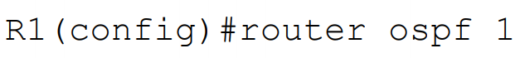  - Different interfaces on a router can run in different instances of OSPF.  - Different instances have different Link State Databases  - Only one instance is typically configured on OSPF routers – multiple Process IDs are very rarely used  - The Process ID is locally significant. It does not have to match on the neighbour router to form an adjacency  - In the example below, R2 will form adjacencies with both R1 and R3 (even though the Router ID does not match on both sides)  - R1 and R3 will not learn each others routes because they are in different Process IDs on R2  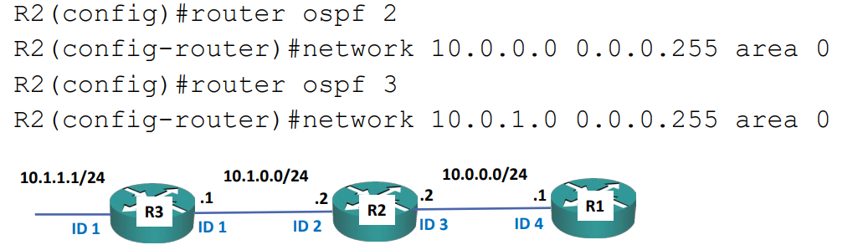  - This is a normal configuration. All routers will learn all routes  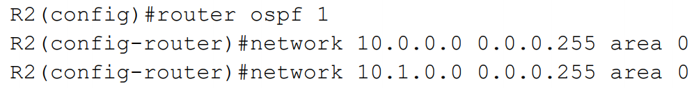  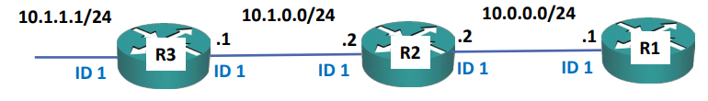  OSPF Configuration – network  - The network command uses a wildcard mask which is the inverse of a subnet mask.  - Subtract each octet in the subnet mask from 255 to calculate the wildcard mask  - A subnet mask of 255.255.0.0 equals a wildcard mask of 0.0.255.255  - A subnet mask of 255.255.255.252 equals a wildcard mask of 0.0.0.3  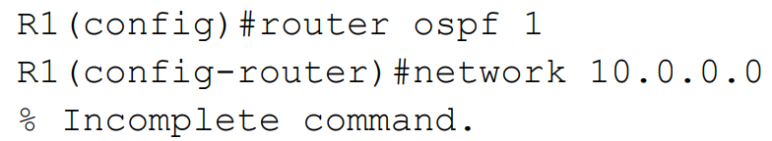  - The command does not default to using the classful boundary  - You must enter a wildcard mask  The network command means:  - Look for interfaces with an IP address which falls within this range.  - Enable OSPF on those interfaces – send out and listen for OSPF hello messages, and peer with adjacent OSPF routers.  - Advertise the network and mask which is configured on those interfaces.  OSPF Configuration Example – network  - Interface FE1/0 and FE2/0 fall within this range, FE0/0 does not  - OSPF will be enabled on FE1/0 and FE2/0 and the router will peer with adjacent OSPF routers  - Networks advertised: 10.0.1.0/24 10.0.2.0/24 10.1.0.0/24 is NOT advertised 10.0.0.0/16 is NOT advertised  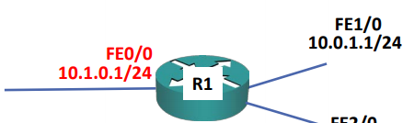  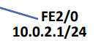  OSPF Verification – show run | section ospf  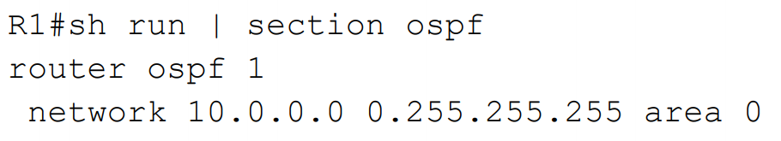  OSPF Verification – show ip ospf interface brief  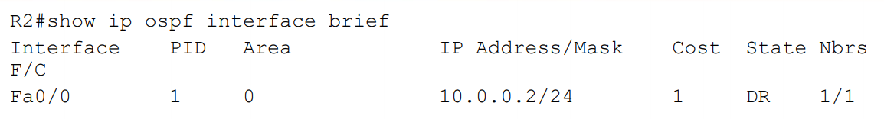  OSPF Operations  1. Discover neighbours  2. Form adjacencies  3. Flood Link State Database (LSDB)  4. Compute Shortest Path  5. Install best routes in routing table  6. Respond to network changes  OSPF Verification -show ip ospf neighbor  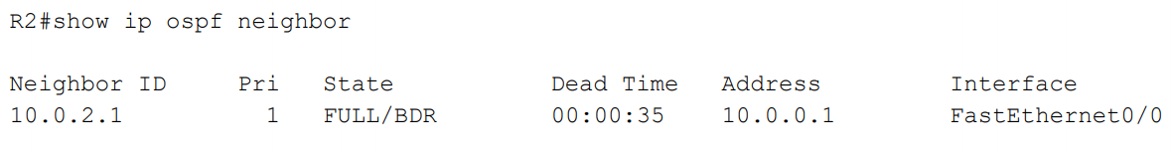  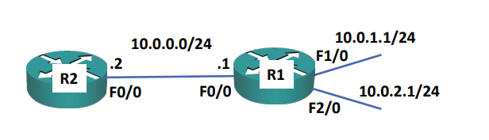  OSPF Verification -show ip ospf database  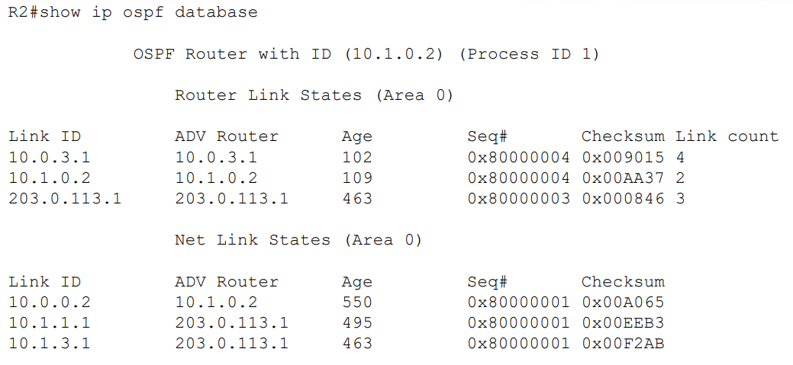  OSPF Verification -show ip route  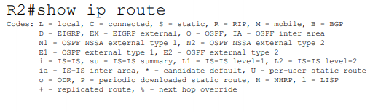  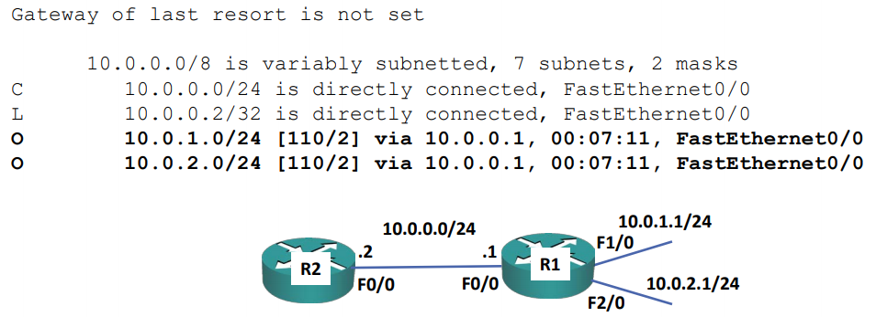
Engaging Activities

- How do you define Open Shortest Path First?
__________________________________________________________________________________
__________________________________________________________________________________
__________________________________________________________________________________
__________________________________________________________________________________
__________________________________________________________________________________
__________________________________________________________________________________
__________________________________________________________________________________
- Why OSPF is suitable for small network lab/test environments?
__________________________________________________________________________________
__________________________________________________________________________________
__________________________________________________________________________________
__________________________________________________________________________________
__________________________________________________________________________________
__________________________________________________________________________________
__________________________________________________________________________________

- Which among the following protocols are most commonly used (RIP, EIGRP and OSPF) and why ?
__________________________________________________________________________________
__________________________________________________________________________________
__________________________________________________________________________________
__________________________________________________________________________________
__________________________________________________________________________________
__________________________________________________________________________________
__________________________________________________________________________________
__________________________________________________________________________________
__________________________________________________________________________________
__________________________________________________________________________________
__________________________________________________________________________________
- How do you explain link state routing protocol?
__________________________________________________________________________________
__________________________________________________________________________________
__________________________________________________________________________________
__________________________________________________________________________________
__________________________________________________________________________________
__________________________________________________________________________________
__________________________________________________________________________________
__________________________________________________________________________________
__________________________________________________________________________________

- What Flood Link State Database can provide for its operation?
__________________________________________________________________________________
__________________________________________________________________________________
__________________________________________________________________________________
__________________________________________________________________________________
__________________________________________________________________________________
__________________________________________________________________________________
__________________________________________________________________________________
__________________________________________________________________________________
__________________________________________________________________________________


Performance Tasks

Performance Task 2
Direction: Provide a one-liner explanation for the terminologies listed below.

Terminologies / sources | Idea or personal explanation
Router ospf 1
Area 0
Sh run | section ospf
Show ip ospf interface brief
Show ip ospf neighbor


Understanding Directed Assess

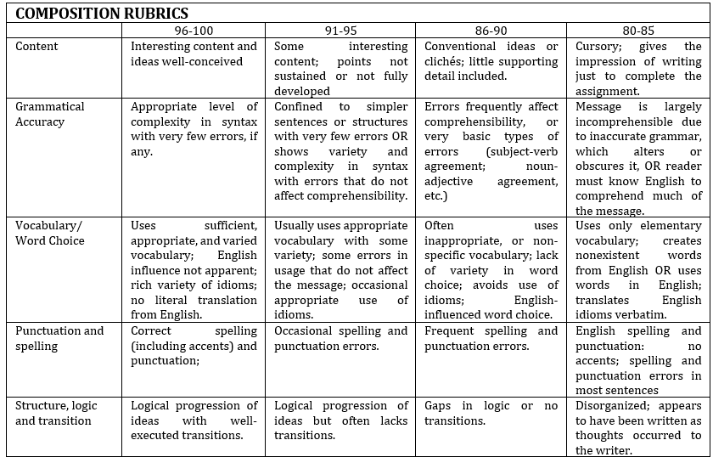


Learning Resources
- https://www.flackbox.com/cisco-ccna-lab-options
- https://www.flackbox.com/#elementor-action%3Aaction%3Dpopup%3Aopen%26settings%3DeyJpZCI6IjEwMzk4IiwidG9nZ2xlIjpmYWxzZX0%3D
- https://www.youtube.com/channel/UCK4ji45I-zxeWXAFKmu3p6Q
- https://study-ccna.com/
- https://www.cybrary.it/course/cisco-ccna/
- https://www.udemy.com/course/ccna-complete/
- https://www.udemy.com/course/networkplus/

