LSPU Self-Paced Learning Module (SLM)
Course | ITEP 309 Networking 2
Sem/AY | First Semester/2020-2021
Module No. | 7
Lesson Title | VLAN Trunking Protocol
Week Duration | 12-13
Date | December 21 – December 31, 2020
Description of the Lesson | To save cost on network infrastructure and to have an optimal performance VLAN is widely used to utilize the maximum efficiency of the network devices. On this lesson, we will be discussing one of the most useful protocols available in networking that helps a lot of collisions, traffics and network problems solved.

Learning Outcomes

Intended Learning Outcomes | Students should be able to meet the following intended learning outcomes:  - Learn VLAN as one of the most useful protocol in networking  - Understand how it works and how it can provide a solution on complex network infrastructures  - Understand how to configure and how it can be implemented
Targets/ Objectives | At the end of the lesson, students should be able to:  - Learn VLAN as one of the most useful protocol in networking  - Understand how it works and how it can provide a solution on complex network infrastructures  - Understand how to configure and how it can be implemented

Student Learning Strategies

Online Activities (Synchronous/  Asynchronous) | - Lecture presentation uploaded in Google Classroom  Students will be instructed to download lecture presentations with narrations / pre-recorded lecture presentation uploaded in Google Classroom.  For further instructions, refer to your Google Classroom and see the schedule of activities for this module.  - Learning Guide Questions:  - How to configure VLAN?  - What are the problems that can be solved with this protocol?  - Why VLAN is essential in managing a wide scale network infrastructure?  Note: The insight that you will post on online discussion forum using Learning Management System (LMS) will receive additional scores in class participation.
Offline Activities  (e-Learning/Self-Paced) | Lecture Guide  Explain the Role of VLANs in a Converged Network  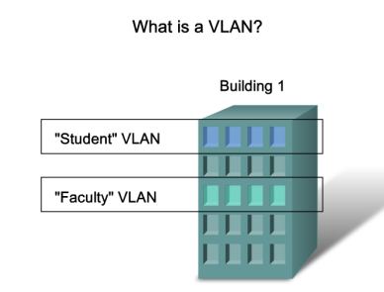  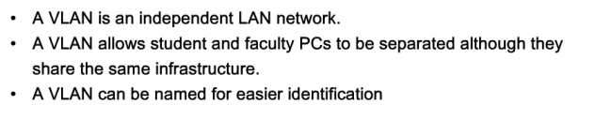  Describe the different types VLANs  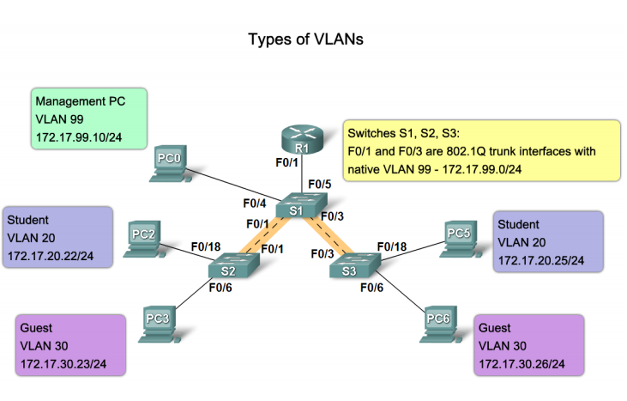  Describe the VLAN port membership modes  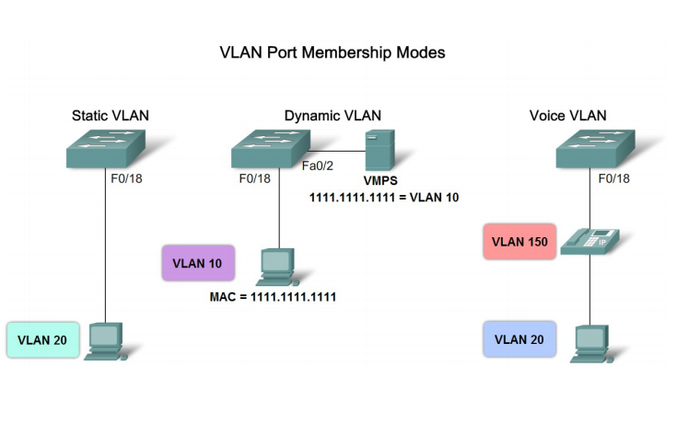  Describe how to manage broadcast domains with VLANs  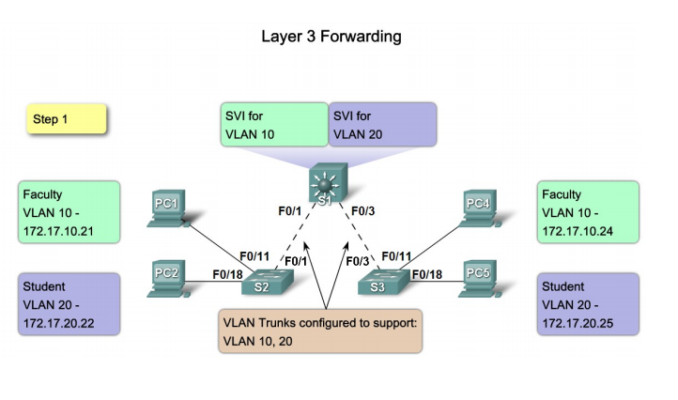  Explain the role of a trunk when using multiple VLANs in a converged network  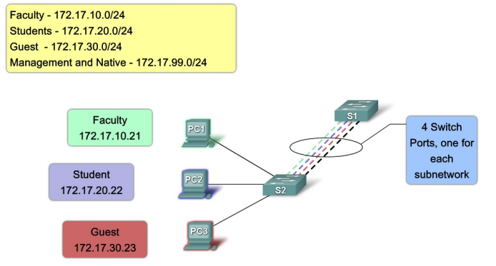  Describe how a trunk works  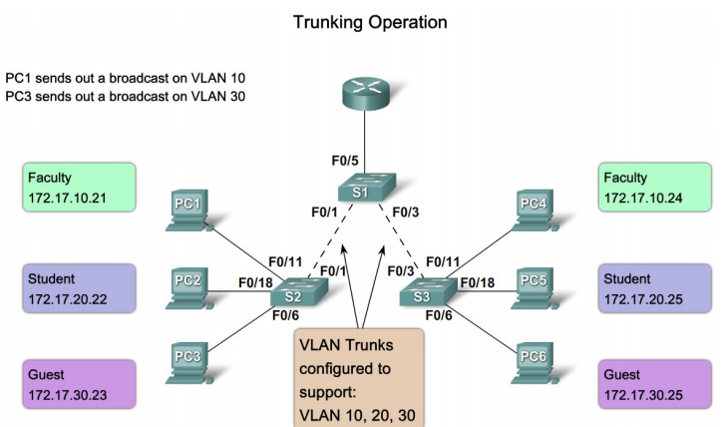  Describe the switch port trunking modes  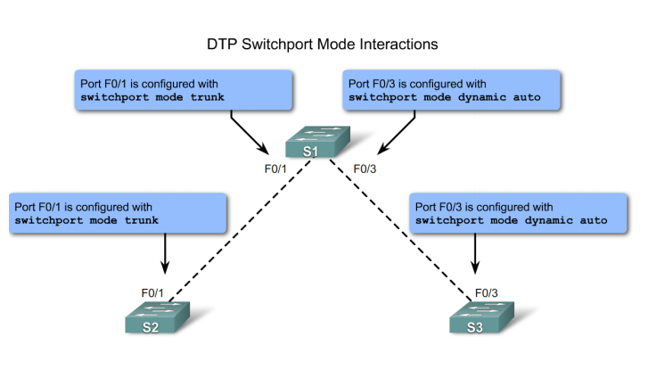  Describe the steps to configure trunks and VLANs  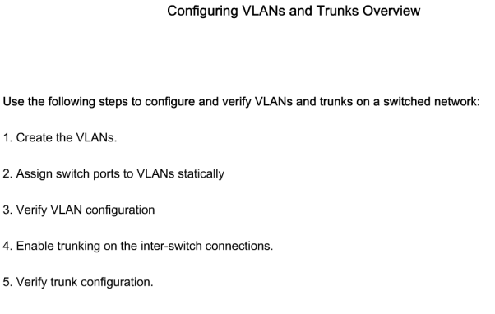  Configure VLANs on the Switches in a Converged Network Topology  Describe the Cisco IOS commands used to create a VLAN on a Cisco Catalyst switch  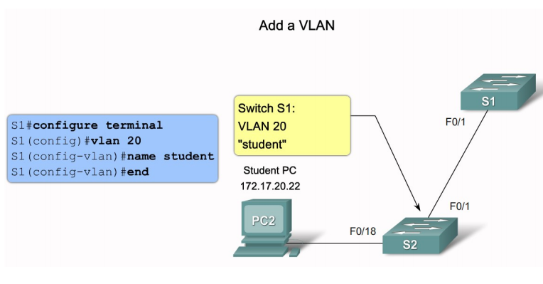  Describe the Cisco IOS commands used to manage VLANs on a Cisco Catalyst switch  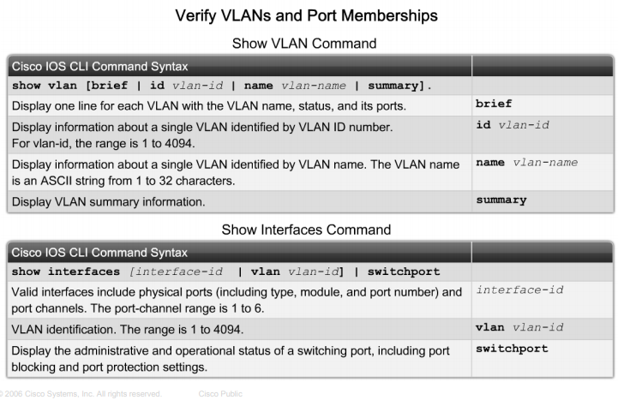  Describe the Cisco IOS commands used to create a trunk on a Cisco Catalyst switch  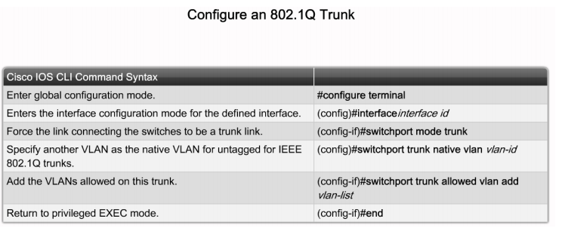  Describe the common problems with VLANs and trunks  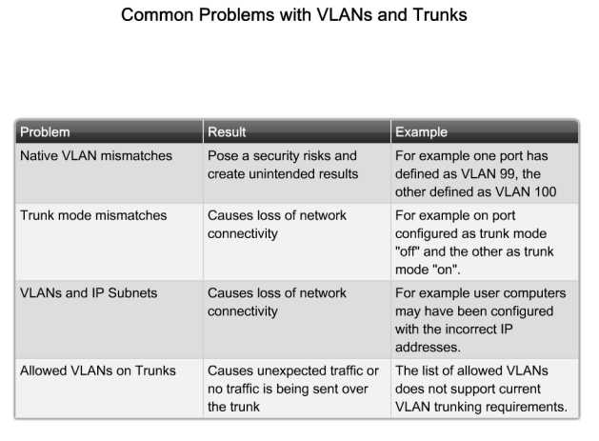  Troubleshoot Common Software or Hardware Misconfigurations Associated with VLANs  Describe the common problems with VLANs and trunks  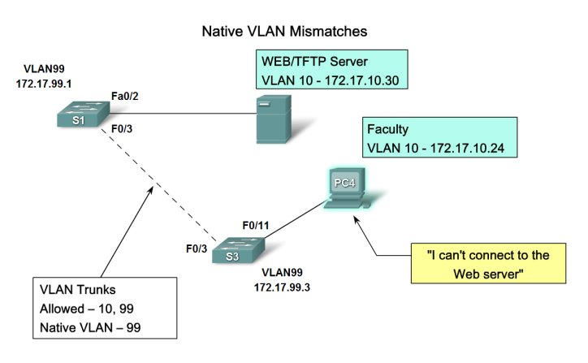  Describe how to use the troubleshooting procedure to fix a common problem with VLAN configurations  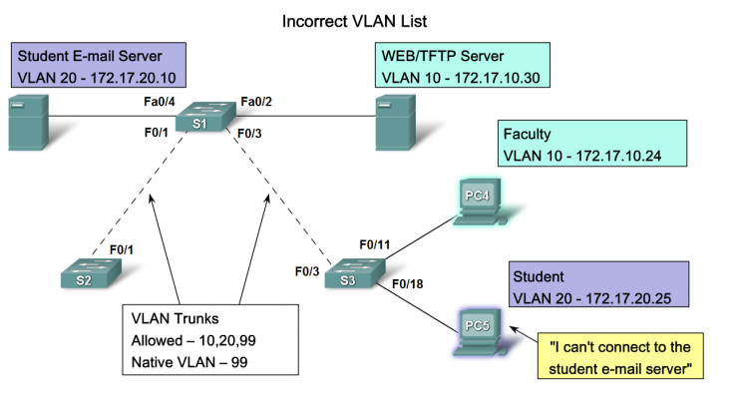  Summary  VLANS Allows an administrator to logically group devices that act as their own network Are used to segment broadcast domains Some benefits of VLANs include Cost reduction, security, higher performance, better management  Types of Traffic on a VLAN include Data, Voice Network protocol and Network management Communication between different VLANs requires the use of Routers  Trunks A common conduit used by multiple VLANS for intra-VLAN communication  EEE 802.1Q The standard trunking protocol Uses frame tagging to identify the VLAN to which a frame belongs Does not tag native VLAN traffic
Engaging Activities

- How do you describe VLAN in terms of its usability?
__________________________________________________________________________________
__________________________________________________________________________________
__________________________________________________________________________________
__________________________________________________________________________________
__________________________________________________________________________________
__________________________________________________________________________________
__________________________________________________________________________________
- Is it a great idea to use VLAN on a single network with only 5 computers? Why?
__________________________________________________________________________________
__________________________________________________________________________________
__________________________________________________________________________________
__________________________________________________________________________________
__________________________________________________________________________________
__________________________________________________________________________________
__________________________________________________________________________________

- Suppose you are managing 50 computers for 10 departments, how are you going to utilize VLAN for the entire network?
__________________________________________________________________________________
__________________________________________________________________________________
__________________________________________________________________________________
__________________________________________________________________________________
__________________________________________________________________________________
__________________________________________________________________________________
__________________________________________________________________________________
__________________________________________________________________________________
__________________________________________________________________________________
__________________________________________________________________________________
__________________________________________________________________________________
- As VLAN is commonly used to create a separate virtual network on a physical infrastructure, how are you going to implement this on a multi-layered network platform?
__________________________________________________________________________________
__________________________________________________________________________________
__________________________________________________________________________________
__________________________________________________________________________________
__________________________________________________________________________________
__________________________________________________________________________________
__________________________________________________________________________________
__________________________________________________________________________________
__________________________________________________________________________________

- If a company requested a vlan configuration for their office, how are you going to address their request once the network devices and peripherals has been provided to you?
__________________________________________________________________________________
__________________________________________________________________________________
__________________________________________________________________________________
__________________________________________________________________________________
__________________________________________________________________________________
__________________________________________________________________________________
__________________________________________________________________________________
__________________________________________________________________________________
__________________________________________________________________________________


Performance Tasks

Performance Task 2
Direction: Provide a one-liner explanation for the terminologies listed below.

Terminologies / sources | Idea or personal explanation
VLAN
Trunking
Virtual isolation
Vlan <id>
Vlan <Name>


Understanding Directed Assess

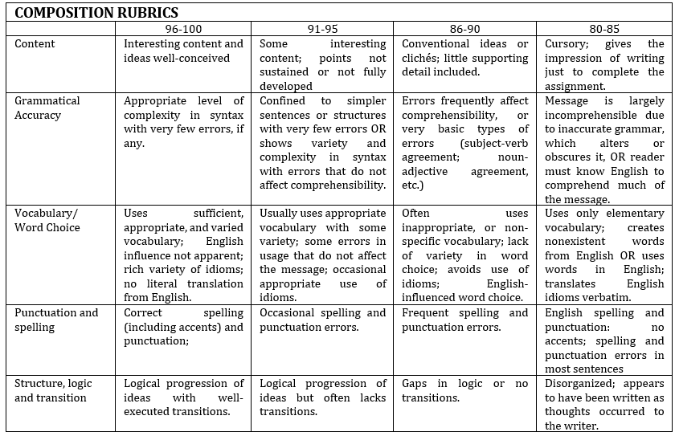


Learning Resources
- https://www.flackbox.com/cisco-ccna-lab-options
- https://www.flackbox.com/#elementor-action%3Aaction%3Dpopup%3Aopen%26settings%3DeyJpZCI6IjEwMzk4IiwidG9nZ2xlIjpmYWxzZX0%3D
- https://www.youtube.com/channel/UCK4ji45I-zxeWXAFKmu3p6Q
- https://study-ccna.com/
- https://www.cybrary.it/course/cisco-ccna/
- https://www.udemy.com/course/ccna-complete/
- https://www.udemy.com/course/networkplus/

