Landing Page

  - Edit of sliders in landing page, picture, price, loc, etc. (In Zoo Admin)
  - The Design in the visitor and Admin button.
  - Explore our zoo in view details edit of the data inside
  - registration of establishments error to create
  - Upcoming event& promotions the data is not sync
  - Wildlife Funfacts(did you know) Must be editable in “Animals” in Zoo Admin – Note: animals and Funfacts separate add/edit in “Animals menu”

Super Admin Page
  - Notification not Functional
  - Profile setting not Functional
  - Sign out/Log out button Move It to navigation
  - Cancel/Renew Membership in Subscription not Functional
  - Add/edit/delete feature in subscription plan not Functional
  - Add/edit button in subscription redundant
  - (Report) Export pdf and DL CSV Not Functional
  - User management Edit Not Functional
  - (Establishment Types) Delete Button not Functional
  - Redundant of admin profile/Security shortcut
  - Profile Not Responsive

Zoo Admin
  - Profile of zoo admin and settings.
  - Notifications bell not working.
  - Bundle? – nakalito kung pano siya gamitin like my all services? Para san yung may mga no.?
  - Services edit button (Service List) Not Functional
  - graph builder design and functions
  - Trivia or quizzes not working
  - Remove the task list for staff

Visitor Page
  - Visitor map and Zone in dash board
  - + Book an Adventure (Bookings) - redundant
  - Package Standard Pricing (Bookings) ? – i mean san siya sa booking bundle part sa zoo admin di naming siya gets
  - Add Ons (Selection ) – paayos yung design and di siya mai unselect pagnapindot
  - Events once the date is done it will automatic remove or closed
  - Profile (Edit Profile) – the mobile no. is missing when we want to edit the profile

Staff Page
  - Remove Rending Duties
  - Quick Scan Ticket ?
  - Ticket Scanner? – like pano siya nagana
  - Remove the task board
  - Profile of staff at the top side the picture and name is not changing
Data
  - Sync the data For example in Bookings event etc. – need na real data siya and need na namin tanggalin mga mock data eh
  - need to Use a Real gmail for Registration for visitor, zoo admin staff etc.
  - Notification in Visitor, Zoo admin, staff if possible nagsesend nag notif sa gmail kapag may nag booking or kahit kahit functional or responsive sa website

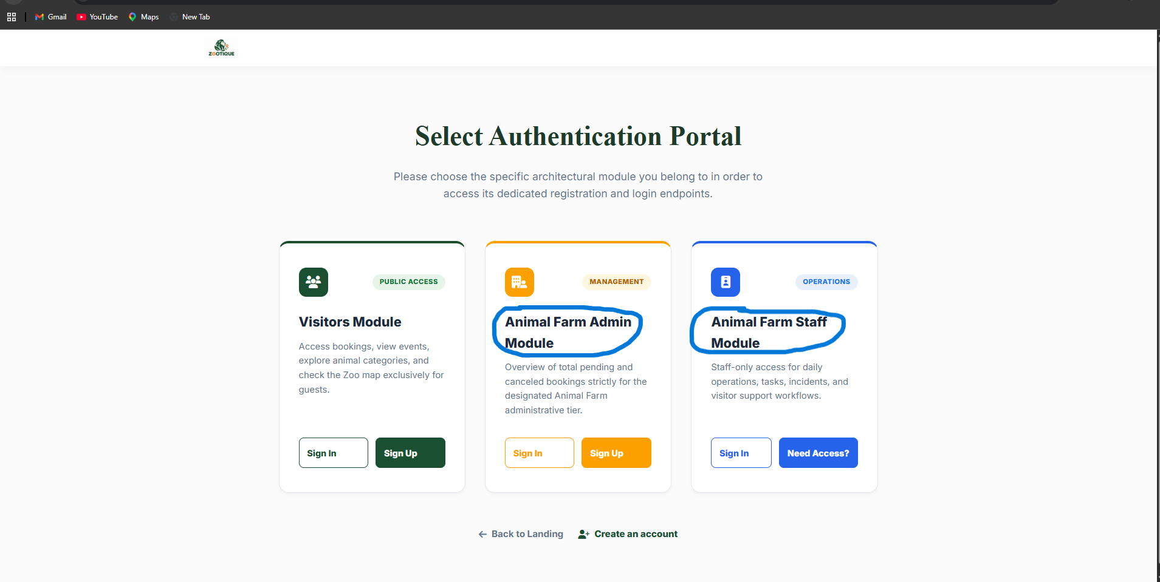
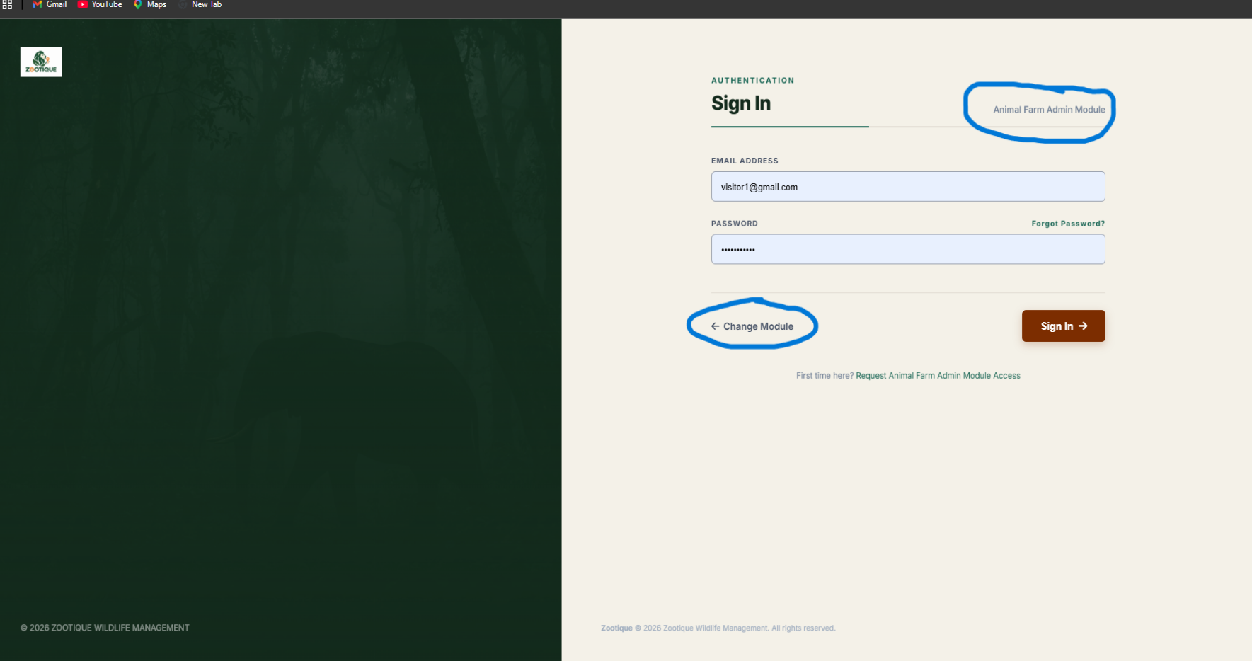
Paayus nalang na yung Animal farm is maging Zoo: For example Zoo admin Module or Zoo staff module – and pag naman clinic mo yung change module
Yung nakahighlight is pa change nalang din ng Zoo admin module etc.
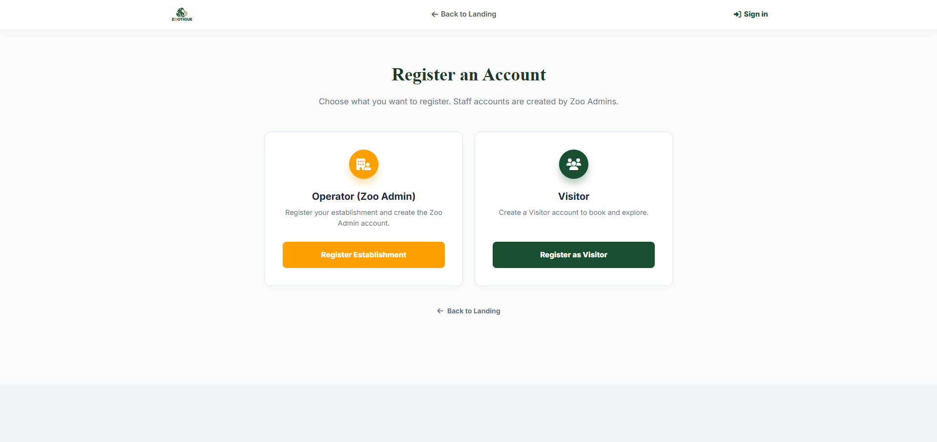
Paremove nalang nung “Back to landing page” sa taas (Sa Create Account part)

Landing page – Slider – Explore & Book – Back to Zoos :
pa tanggal nalang nung “account” and palipat nung laman sa bookings and if we click “book now’ tsaka siya pupunta dun sa login page nang visitor and direct siya pupunta dun sa chinoose niyang bookings nung Zoo.
Note: “Book Now” Is not functional yet – kaya pinapalipat ko nalang sa “bookings” and has combined functions.
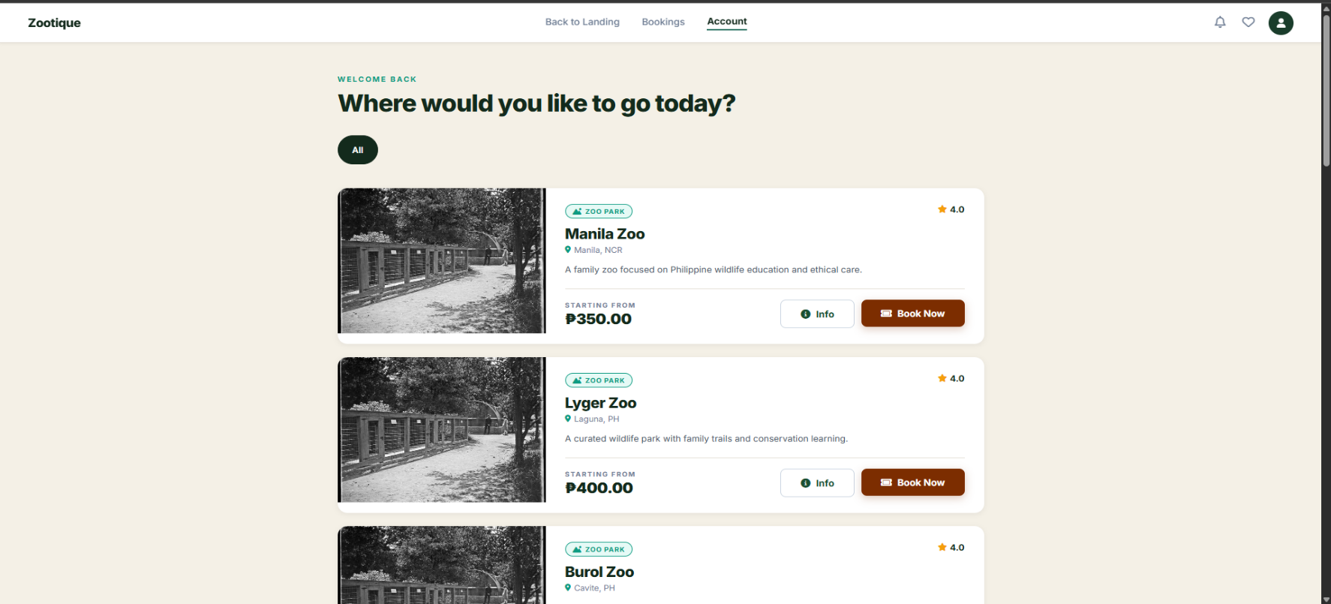

TO BE CONTINUE..

