Steps:_

1. Create new folder in desktop, named runoff_calculation and name folders like this

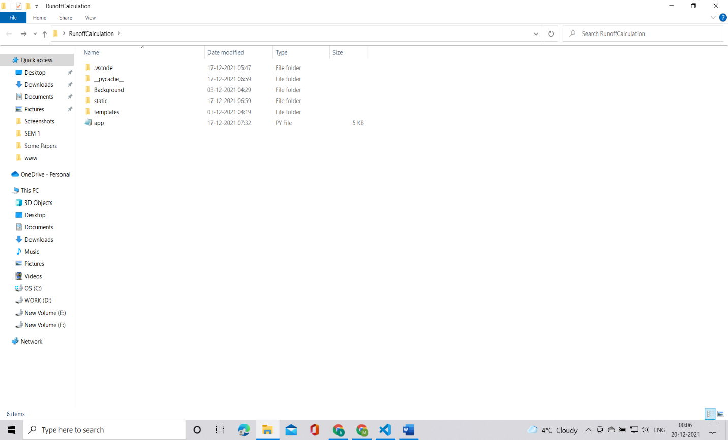

Now in vscode, drag the file to open this

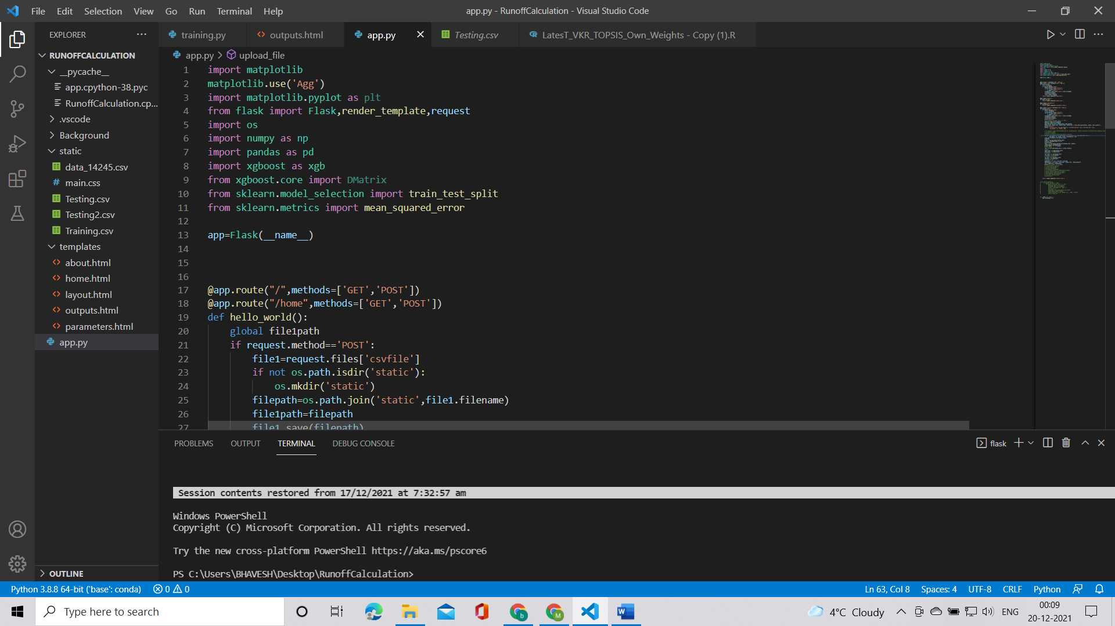

Now, just type flask run in the terminal(next to The file path)