Binnr cheat sheet

## Installation

install.packages(“path/to/binnr.zip”, repos=NULL, type=”source”)

> require(binnr)

> data(titanic) # data set used for all examples

## Binning Data

> mod <- bin(data=titanic, y=titanic$Survived)

## Optional Bin Function Arguments

|  |  |
| --- | --- |
| Argument | Definition |
| data | data.frame of independent predictors |
| y | Performance variable (binary only for now) |
| w | Numeric vector of weights |
| min.iv | Minimum information gain for a split |
| min.cnt | Minimum number of records per bin |
| min.res | Minimum number of responses per bin |
| max.bin | Maximum number of bins |
| mono | Monotonicity:   * -1 Decreasing * 0 No monotoncity * 1 Increasing * 2 Either increasing or decreasing |
| exceptions | Values to withhold from discretization |

## Handling Multi-collinearity

> cc <- mod$cluster()

> to_drop <- mod$prune_clusters(cc, corr=0.90, 1)

> mod$drop(to_drop)

## Viewing Data

This is typically handled through the adjust function.

> mod$drop(to_drop)

> mod$variables$Age$show()



Observed WoE

Red bar is value that will be substituted

% of records

Bin index

## Fitting Models

> mod$fit(“model 1”, “Initial model with all variables”)

> mod

2 models

|-- scratch | 00.0 ks |

|-- * model 1 | 58.2 ks | Initial model with all variables

## Reviewing Models

> mod$select(“model 1”) # select any model that has been fitted

> mod$sort() # sort by inmodel, not dropped, then IV

> mod$summary() # print summary statistics

> mod$compare(“model 1”, “model 2”) # compare coefs & contrib

## Groups of Variables

> mod$get_dropped(invert = ) # optionally invert selection

[1] "Survived"

> mod$get_inmodel(invert = ) # optionally invert selection

[1] "Pclass" "Sex" "Age" "Fare" "Embarked"

> mod$drop(c("Pclass", "Fare"))

> mod$get_dropped()

[1] "Survived" "Pclass" "Fare"

## Adjusting Bins

mod$adjust()

## Bin Manipulation Commands

|  |  |
| --- | --- |
| Command | Definition |
| (Q)uit | Quit adjust function |
| (n)ext | Move to next variable |
| (p)revious | Move to previous variable |
| (g)oto | Goto variable; prompted to enter variable name |
| (m)ono | Change monotonicity when prompted |
| (e)xceptions | Change variable exceptions when prompted |
| (s)et equal | Set one WoE level equal to another when prompted |
| (u)ndo | Undo the last manipulation command |
| (r)eset | Reset the bin to its initial state |
| (d)rop/undrop | Flag the variable as dropped or un-dropped |
| != <#> | Neutralize requested variable levels (WoE -> 0) |
| + <#> | Expand requested level (one at a time) |
| - <#> | Collapse requested level(s):   * Adjacent for Continuous bins (ex: - 1:2) * Can be separate for Discrete bins (ex: - c(1,3)) |

All of the bin manipulation functions modify the Scorecard object in place. This is very different from how previous versions of binnr worked. This means you no longer have to assign the return value.

## Pseudo P-Values

When the model is mostly finished run several bootstrap fits to determine which variables are entering by chance and which enter repeatedly.

> pvals <- mod$pseudo_pvalues(times = 50, bag.fraction = 1,

replace = TRUE)

|  |  |
| --- | --- |
| Argument | Definition |
| times | Number of repeated samples to draw |
| bag.fraction | Percent of records to sample |
| replace | Whether to sample with replacement |

> boxplot(t(pvals$coefs))

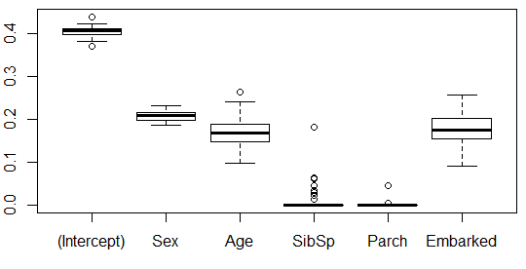

> pvals$pvalues

(Intercept) Sex Age SibSp Parch Embarked

0.00 0.00 0.00 0.84 0.96 0.00

> mod$drop(names(which(pvals$pvalues > 0.10)))

The pseudo p-values represent the percentage of model runs that the coefficient was zero. Dropping all variables that exceed a pseudo p-value threshold and refitting removes spurious variables and results in a parsimonious model.

> mod$fit(“final model”)

> mod

3 models

|-- scratch | 00.0 ks |

|-- model 1 | 58.3 ks | initial model

|-- * final model | 57.1 ks |

The out-of-fold KS drops a little, but the tradeoff is likely worth it for a model with fewer variables.

## Generating SAS Code

Binnr provides functions for generating SAS model code