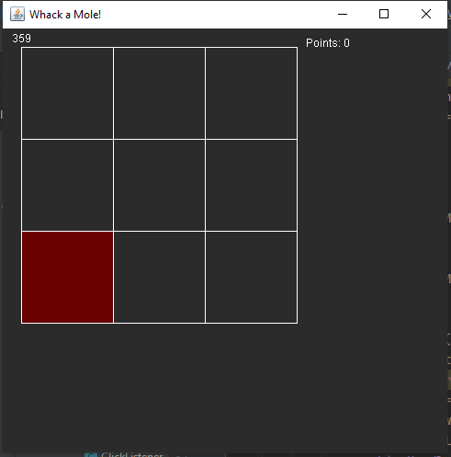
Whack a Mole!
A guide by Zelaboy111

Welcome 3
Terms of Service (TOS) 4
Distribution 4
Setting up the frame 5
Constructor 7
Graphics Handler 8
Add GraphicsHandler to the JFrame 9
Grid 10
Frames Per Second 12
Mole 14
Adding Graphics to 16
the Mole 16
Random Mole 18
Listener 20
Point System 22
The End 23

Welcome
Welcome to this guide of ‘Whack a Mole’. This guide is for beginning Java developers on making a variant of the game ‘Whack-a-Mole’. It is a step-by-step guide from which you hopefully learn the basics from Java. The further you are in this guide the more you will have to translate things yourself into the Java language. This is done so you challenge yourself. If you do not understand what is asked from you, there is no need to worry. After each section an image from the code will be put so you can type it over if you didn’t catch all of it.
You can use the text editor you like to use for Java, one I personally advise to use is Intellij Community Edition -which is totally free. Note that this guide will not teach you how to use the text editor itself as you can use the editor you like.
There are some things you should know before you start reading this guide further. First, when ‘{ … }’ is used, the dots are placed to indicate there is code in between. In this case there can also be empty lines.
Second, you use a ‘;’ after almost each line of code. When you use an if-/else- statement the curly brackets are used. Functions also use the curly brackets. Curly brackets indicate code over multiple lines (multi-line code).
At last you have to know that you can set variables using the ‘=’ sign (int number = 0). You also use mathematical symbols in if-/else- statements. Take as example you want an if-statement whether a variable is more than or equal to 10, you use ‘>=’.

Terms of Service (TOS)
Please read the Terms of Service (TOS) before you continue reading this document. If you continue reading, you are agreeing to the TOS.

Distribution
Do not distribute this document whilst claiming it has been made by you. The distribution from this document is allowed as long as you do not change the text in the document. This includes, of course, changing credits or editing the TOS.

Setting up the frame
Every project has a main function. This function is called ‘public static void main(String[] args) { }’. But what does this function mean? Below is a short summary from the words that are used in this function.
• public means other classes are able to use this function as long as there is a static access to the class. When using ‘public’ in a constructor, the constructor will be available for every other class to use (there is no such thing as a static constructor).
• static means the function has static access itself. When used with a public function, the function can be used using [Class name].[Function-name]. When using ‘private static’-class-variables you can ensure the variable does not get set again when you make a new class instance. Static class-variables are variables which are the same in every instance from a class.
• void means the function does not return anything.
• main is the name of the function. You can call a function by its’ name, after the name of the function you place two brackets: ‘()’. Inside these brackets are your variables used when you call a function, more about that later.
• String[] args are the arguments in the function. In this case it is a String-array called ‘args’. A String is a text and is typed using “” (“Hello World”). A String-array (String[]) is a String, only with more values. For example, the variable does not only contain “Hello World” but also “Test”.
• {} after each function/class/if-/else- statement you create, you have to put curly brackets. Inside these brackets we write our code.

We now know the function to start the program so let’s start with making our class. The class name does not matter that much as long as you know what the class does. This class I will be calling ‘Frame’ with as reason this class will extend the class JFrame and it is the frame/window from the game.
Once your class has been created, it should look like the image below. In my case I created a package called ‘wam.zeldaboy111’ and put my class called ‘Frame’ in this package.
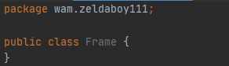

As we do have a class now, we can start typing our code. We will start by typing “ extends JFrame” (from javax.swing.*) right behind the class name (in this case the class name is ‘Frame’). By doing this we will inherit/take over all existing functions from inside the class JFrame (basically, we will be able to use them).
Then we make the main-method. Inside the curly brackets we type our code, which in this case is making a new instance from the class Frame. This can be done by typing “new Frame();”.
Your class should now look like the image below.
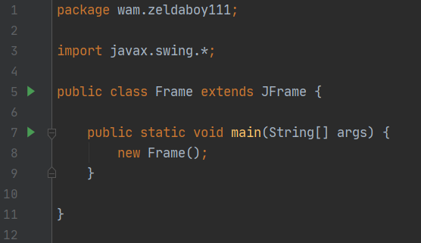

Constructor
We now are going to set up the constructor from the class. This constructor will be “private Frame() {}” (if you named your class something else, replace ‘Frame’ with your class name). The word ‘private’ means this function is only available to the class it has been typed in, in this case Frame. This way we can prevent other classes from getting static access inside the class Frame as we do not want this to happen.
Now we will be creating a new instance from the class JFrame. You should be able to create a new instance from this class as you have already used the code to create an instance from the class Frame.
After you have made a new instance from the class JFrame we will be making the frame visible. This is done by typing “setVisible(true);”.
Once we run our program -in Intellij you either click the green arrow -> run or use the shortcut crtl+shift+F10- we can see our frame pop up. However, once we close the frame, we see the program still running (else the console should put out an exit code). To resolve this issue, you type “setDefaultCloseOperation(WindowConstants.EXIT_ON_CLOSE);”. We can also set our size using “setSize(width, height);” where you replace ‘width’ with the width and ‘height’ with the height.

If you do have an automatic completion, you can test out what else you can do with your frame to change things up. Just type “set” and scroll down the list that pops up. The picture below is what my final frame setup looks like.
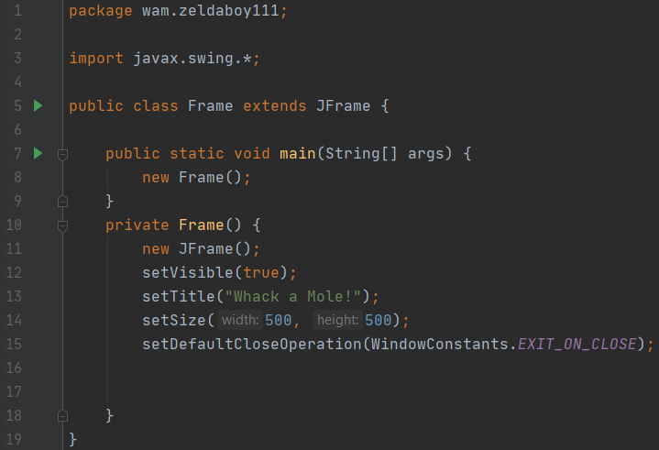

Graphics Handler
Next up we will be setting up the graphics handler. The class I am using for this is called ‘GraphicsHandler’. The class will be used to handle the graphics.
We start with extending the class ‘JPanel’ from javax.swing.*. This will allow us to add the class as component to the frame. More about this when we are done typing the basics of this class.
Next up we will be creating a variable which can be used in the whole class but not outside of the class. You know what access it should have yet? The variable will be called “private Frame frame;”. This is a variable from the class Frame which will let us use functions from here. As Frame (our class containing the main-method) extends JFrame, we will be able to use those functions as well.
After we have extended the class JPanel we will be creating a new constructor. This constructor will have the argument ‘Frame’. This constructor looks something like this: “public GraphicsHandler(Frame frame) { }”. You should know what public means -the definition can be found on page 3. “Frame frame” inside the brackets means that we are expecting the input of a Frame (our class containing the main-method) and we use “frame” to use this variable.
Inside the curly brackets from the constructor we will be setting the variable from the class called ‘frame’ to the variable from the function which is also called ‘frame’. We can access the variable from the class using “this.frame”. To set this variable to the variable frame from our method, we will be using “this.frame = frame;”. This will set the variable inside of the class to the value of the variable inside of the function. This allows us to use the functions from the class Frame everywhere in the class GraphicsHandler.

Painting
Next we will set up the method “public void paintComponent(Graphics g) { }”. Once again, you should know what “public void” means. “Graphics g” means we want a graphics variable as input. To use the graphics-argument in the function, we call ‘g’, this means you can replace the ‘g’ with however you like to name it in your function (i.e. ‘graphics’).
Next up we need to set the color to a different color. You can change the color to black by using “g.setColor(Color.BLACK);”. You can also create your own color using “g.setColor(new Color(rgb-value));”.
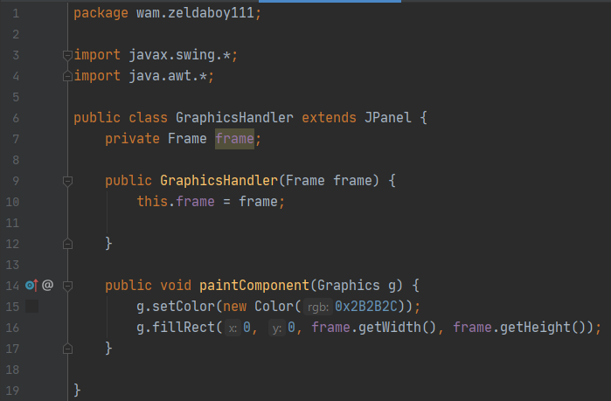
The last thing we have to do in this class is fill the frame with our color. To do this, we will be using “g.fillRect(0, 0, frame.getWidth(), frame.getHeight());”. “fillRect” means fill a rectangle. The first two numbers are the starting x and z, the second two numbers are the width and height from the rectangle we will be filling. “frame.getWidth()” will get the variable called frame from our class and will get the width-value from there. This value is equal to the value we set earlier in our class Frame.

The picture left from is what my class GraphicsHandler looks like. The only difference you can have is the color you set the graphics color to and the x, z, width and height from the function .fillRect().

Add GraphicsHandler to the JFrame
Before we can test if our frame gets set to the color we want, we have to add the GraphicsHandler as a component to the frame. Else the function “paintComponent(Graphics g) {…}” will not be called (this function is automatically called once added to the JFrame).
We add the GraphicsHandler to the frame by creating a new instance from the class GraphicsHandler inside the method “add(Component);”. No worries if you do not understand this, I got you with the picture from the class ‘Frame’ before we can test whether our frame gets painted the correct color.

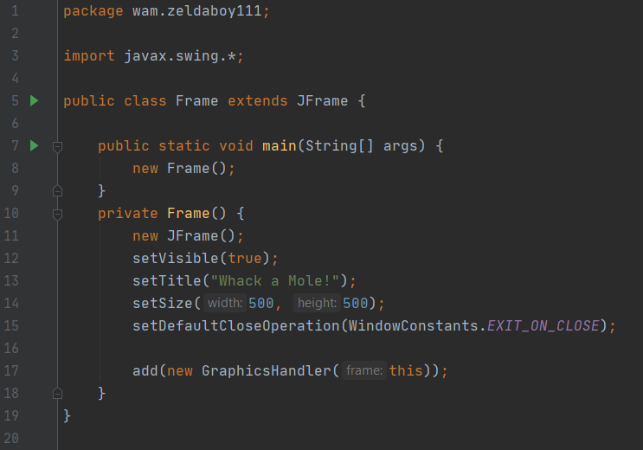

Grid
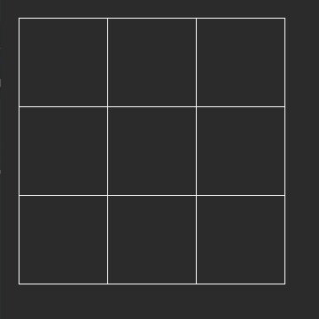
As we now have a background -in the color you prefer- we can start with making the grid. It will be a simple grid that looks like the image on the right side. Making this grid will involve the usage of variables and a for-loop to make you a bit more familiar with these things.

To create this grid, we will first define the size of our grid with two variables: rowSize and columnSize. These variables are Integers (int in short). We can set them to the size we want every row and column to be. These variables will be private static final variables. This means they are not available for other classes; they will not redefine when we make a new instance from the class GraphicsHandler and the variable cannot be changed anywhere else in the code.
The steps to make this code are as follows:
- Make a private static final integer variable named “rowSize” and one named “columnSize”. Set these variables to a number (i.e. 100) by typing “= 100;” behind the variable name. Do the same thing with the two integers “startLocationX” and “startLocationY” (i.e. 20).
- Make another function named drawGrid that takes the Graphics as input.
- Call the function you have made after the line in which you fill the rectangle.

The picture below is what your class should look like after you have done the things from the three dots. Did you find it hard to make this code? Do not worry, just keep practicing with it and you will learn over time.
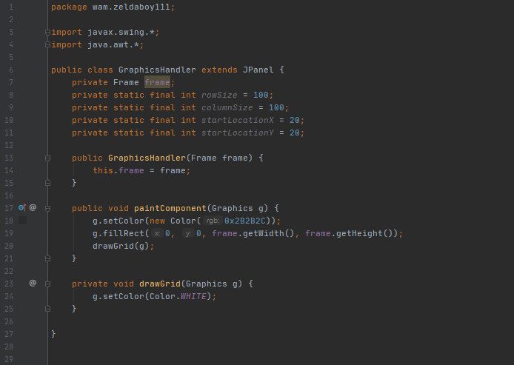

Once we have made this function, we will be setting up this function. First, we will set the color to a different color to enable us to see the lines, you should be able to do this yourself. Next, we will be using a for-loop. The for-loop looks like this:
for(int pointOnGrid = 0; pointOnGrid < 4; pointOnGrid++) { … }
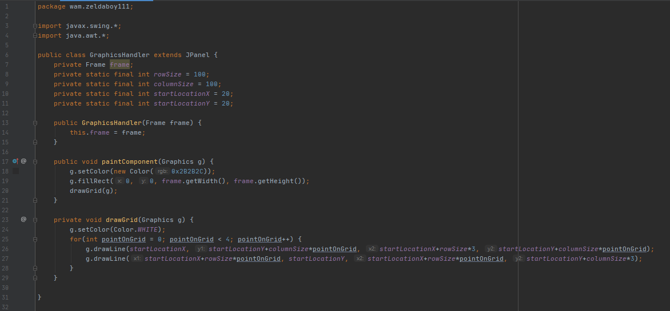
What does this mean? This will take every number from 0 to 4 (this excludes 4) as value for ‘pointOnGrid’. This way we can tell our program where to start and end with drawing the line without having to type the line for drawing 8 times. On the image below you can see what the class should look like when you are finished with this code.

The function ‘g.drawLine(..);’ takes four numbers. These numbers are the starting x, starting y, ending x and ending y.
startLocationX and startLocationZ are the locations we want to start from drawing the grid. If we do not add these two integers, we will see the grid start on the very edge from our frame.
In both functions we either multiply the rowSize or columnSize with pointOnGrid or 3. By multiplying with pointOnGrid we can make sure the lines do not appear on the same x-and-z values every time. By multiplying with 3, we define the length of every line. We want to have three squares in each direction thus we multiply by three.

Now it is your turn. I am challenging you to make the function draw a grid from 4x4 instead of 3x3, after you have done this you can change it back to 3x3 as this is the final grid size we will be using.

Frames Per Second
Congratulations, you have finished making your grid! Before we can move on to making the actual mole, we need to create a method that updates the screen. For this, we will be implementing ‘Runnable’. You implement after you extend a class.
After we have implemented the Runnable, we will create a new variable in the class called ‘thread’. This variable will be private. The type from the variable thread is ‘Thread’. In the constructor we will be initializing and starting the thread. We will be doing this by typing -at the bottom of the constructor- ‘this.thread = new Thread(this);’ and a line lower ‘thread.start();’
When we have created this variable, we will be making two more integer variables inside the class. These are called ‘fps’ and ‘frames’. The variables will be private.
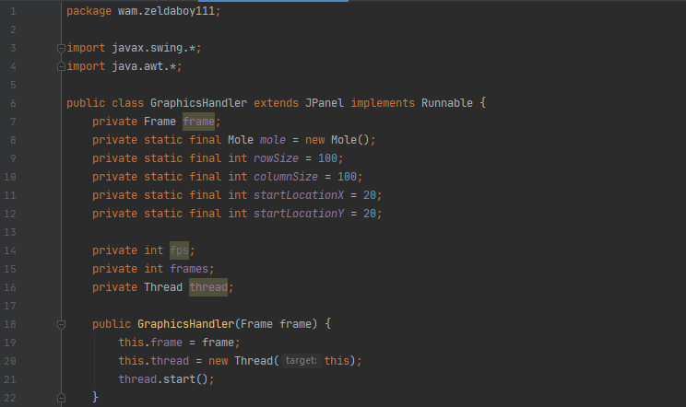
After we have done these four things, the first couple of lines from the class should look like the image below.
Now we will get rid of the red error line. To resolve this error we will be creating the function ‘public void run() { … }’. I will be writing this function below the function ‘drawGrid(Graphics g) { … }’. This function will have the @Override-annotation. We can simply add this by adding a line above the function name containing “@Override”. This annotation means the function from an interface is being overridden.
In the run-function we will start with setting the class-variables ‘fps’ and ‘frames’ to zero. After that we will be setting a variable with as type long and as name ‘lastFpsUpdate’. The variable is set to the current time in milliseconds, this is done by typing “long lastFpsUpdate = System.currentTimeMillis();”. In one second are one thousand milliseconds.
Next up we will be creating a while-loop. The loop will be as follows: ‘while(true) { … }’. Inside the brackets we will be creating the system for calculating the frames a user has per second. We will start off by repainting the frame, this ensures the function ‘paintComponent(Graphics g) { … }’ is being called thus the screen updates its graphics. We can do this by using ‘frame.repaint();’.
Next up we add one to the variable ‘frames’. This can be done in multiple ways: frames = frames+1; frames += 1 and frames++. I prefer to use “frames++;” in this case. After this, we will be doing some math. We will check whether the current time in milliseconds minus the last time we updated the fps-variable is more than or equal to one thousand. If this is the case, we want to set the variable fps to the variable frames, set frames to zero and set lastFpsUpdate to the current time in milliseconds.
At last we will be preventing the screen from updating as many times as it possible can update. This is achieved by typing “Thread.sleep(2);”. This will make the program sleep (do nothing, wait) for two milliseconds and continue running after the sleep has finished. There will show up an error, we need to make a try-catch. This can be done by typing ‘try { … } catch(InterruptedException e) { e.printStackTrace(); }’. At the place of the dots our sleep will be placed.
If you did not everything what you are having to write, you can type over the code from the image below. However, I do advise to really try and code it yourself. A lot of the times you are using things you have already learned, else there will be explained how to do it.
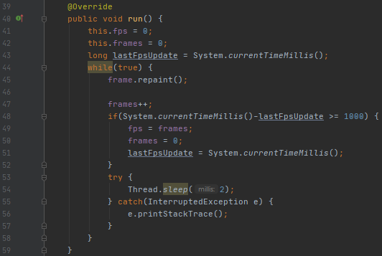

Currently we do have one issue. We do not know what the FPS is the user is getting. To check the FPS, we can print it out in the console, but it can be a bit messy when you print out other things. For that reason, we will be writing the FPS as String on the screen. To do this we head into the function ‘paintComponent(Graphics g) { …}’ and write (after you draw the grid) ‘g.drawString(fps+””, 10, 15);’. To convert the fps-variable (which is an integer) into a String, we use ‘””’. The first number is the x-coordinate we want the FPS to be at, the second is the y-coordinate.
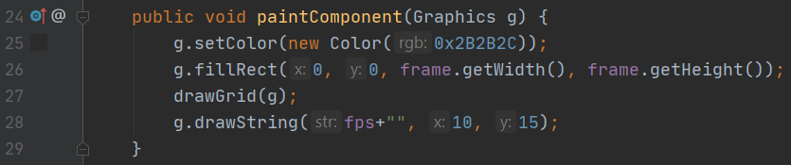
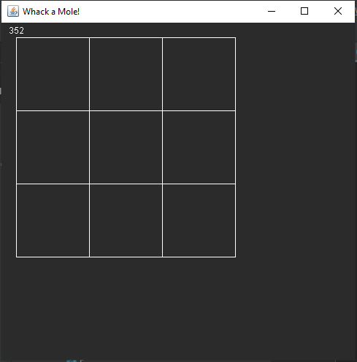
Below is an image from my current function paintComponent. On the right you can see what my game currently looks like when running.

Mole
After our grid has been made, we can start making the mole itself. The mole will be represented by a colored rectangle. We will start off by making the mole show up then we will implement a click detection and at last we will be setting up a point counter.

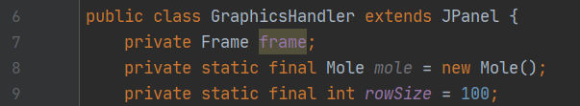
We will start off by creating a class called ‘Mole’. After the class has been created, we will be creating a variable in the class GraphicsHandler. This is a private static final class-variable from the class Mole with as name ‘mole’. We will immediately set the variable to a new instance from the class Mole. Below is the code used to create this instance if you do not remember the correct code.

Next up we will be creating the actual mole. We will be using a randomizer which is timed for this. The method we will be creating to show the mole is called ‘public void tryShowMole(Graphics g) { … }’. The reason I chose to use ‘try’ in the name of the function is as it will try to show the mole. When the delay is not big enough, it will not show up.
The next thing we have to do is make a private variable called ‘moleDelay’ and a private static final variable called ‘maxMoleDelay’ (both of these variables are integers). The second variable we will be initializing to an integer, I will be setting it to one thousand as it represents the delay for when the mole will show up.
Inside the function ‘tryShowMole(Graphics g) { … }’ we are going to write some code to make the delay functioning. First, we are going to check if moleDelay is less than (<) zero, if it is we will be setting it to zero.
Second, we will be checking if the moleDelay is more than or equal (>=) to the maxMoleDelay. If it is we will be calling a function called ‘private void showMole(Graphics g) { … }’. When the delay is less than (<) maxMoleDelay, we will be adding one to the moleDelay variable.
For now, the function ‘showMole’ will be setting the moleDelay-variable to zero and we will print out a line in the console using “System.out.println(“The Mole has shown up!”);”.
Below is an image if you cannot figure out what the code should look like in the end.
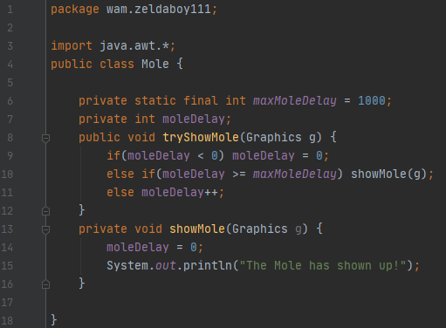

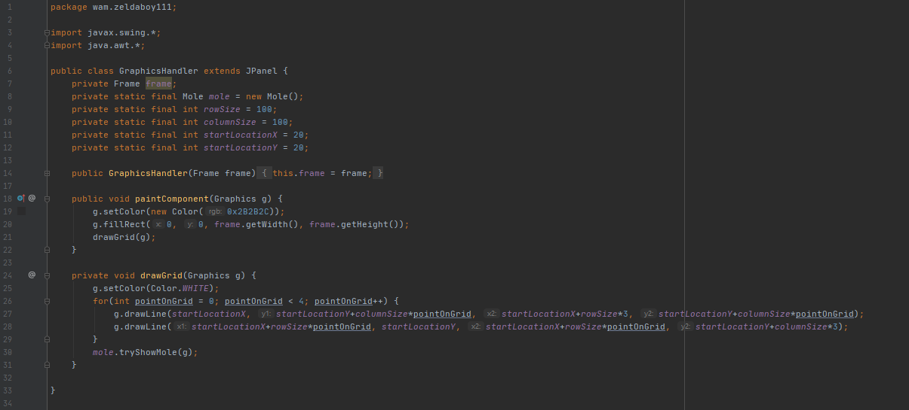
Behold, if we do test the game right now, we will not be seeing any messages in the console. The reason for this is that we are not calling the method ‘tryShowMole(Graphics g) { … }’. We will go over to the class GraphicsHandler and call the method after we have drawn the grid in the function ‘drawGrid(Graphics g) { … }’. The class GraphicsHandler should look something like the image below now.
When we run the program, we will once in a while see the message in the console that the mole has shown up.

Adding Graphics to

the Mole
To represent the mole on the screen, we will be filling the rectangle from the grid the mole is currently at. We will start off by making four functions in the class GraphicsHandler, these are ‘getRowSize() { … }’, ‘getColumnSize() { … }’, ‘getStartLocationX() { … }’ and ‘getStartLocationY() { … }’. These functions will all be public static and will return the corresponding variable to the name of the function. This means that ‘getRowSize() { … }’ will return the variable rowSize.
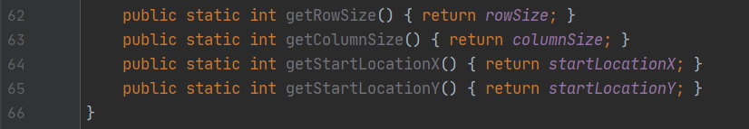
Once you have made these four functions, they should look like the image below.

The functions we have just made do also have a name. These functions are called getters. When we make a function to set the variable rowSize, we call the function a setter.

Next up: the appearance from the mole. To do this we will make use of the fillRect-function. In the class Mole we will replace the line “System.out.println(“The Mole has shown up!”);” with “g.fillRect(x, y, width, height);’. We will replace x with GraphicsHandler.getStartLocationX(), the y with the start location on the y-coordinate, the width with the size from the rows and the height with the size of the columns. After this has been done, we will be changing the color from the graphics before we fill the rectangle, else we will not be able to see where the mole currently is. You should be able to change the color from the graphics.
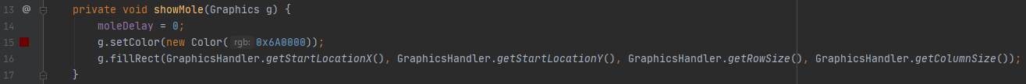
Once the graphics color has been set and the rectangle has been filled, your code should look like the image below.
Once we start the program, we will not see the red rectangle very long. It will just show up for a split second. The reason for this is that we are immediately redrawing the frame thus resetting where the mole is. For this issue is a very easy solution, we will just set a counter to the time the mole will show up.
We will start off by setting a private static final integer called maxMoleShowingTime, I will set it to two hundred. We will also set a variable called moleShowingTime, this is a private integer. The first variable is the time the mole will be visible, the second variable is the time the mole is currently visible.
Next up, we will be deleting the line where we set the variable moleDelay to zero inside the function ‘showMole(…) { … }’. Instead of this line, we will be adding one to moleShowingTime. To do this we will be making the same system as used in the function ‘tryShowMole(…) { … }’. This time it will look a bit different. We start off by checking if the time the mole is visible for is more than or equal to the max time it is visible. When this is true, we want to set the variables moleShowingTime and moleDelay both to zero.
We will now just type ‘else { … }’. This means the code in the else-code-block will be running if the if-statement is not true. We will start this code-block with checking if the time the mole has been visible for is less than zero. If it is less than zero, we will set it to zero. Else, we will add one to the variable moleShowingTime. A handy little tip for curly brackets if that when the code from an if-statement is a single line, you do not have to put curly brackets behind the if-statement.
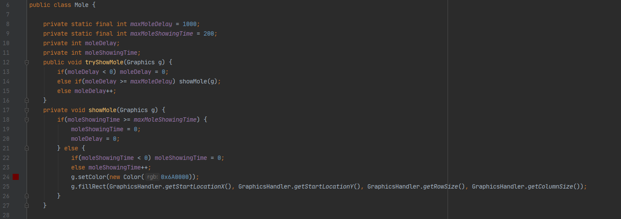
We will then set the color and fill the rectangle here. When you have finished the timer for showing the mole, your code should look something like the image below.
We can now run our program and see the mole a bit better. You can play around with the time the mole shows up by changing the variable maxMoleShowingTime.

Random Mole
This game would not be any fun if the mole does not change the rectangle it displays. To make the mole show up in a randomized slot we will be setting two integers for the x- and y-coordinate the mole is. We will have to set these variables inside the constructor from the class Mole.
Instead of just filling the rectangle, we will now make the selection from the display slot right above the place you set your color. We will start off by checking of either of them is minus one, to do this we use ‘||’ inside of the if-statement. When this is true, we will be setting the variables to a new Random integer value between zero and two. Below are the instructions for this piece of code summed up.
- Make two private integers for the x and z from the display slot.
- Set the two created integers to minus one inside the constructor.
- Set the x- and z-coordinate of the display slot to minus one when the mole disappears.
- If either of the two display slots is equal to minus one, set both to ‘new Random().nextInt(3);’. You can detect if either of them is minus one by having “if(x == -1 || y == -1) { … }” (although I recommend taking other names).
- Change the position of the rectangle (not the size) to the starting location plus the display slot from the axis multiplied by the size of the rows/columns (x is row, y is column).

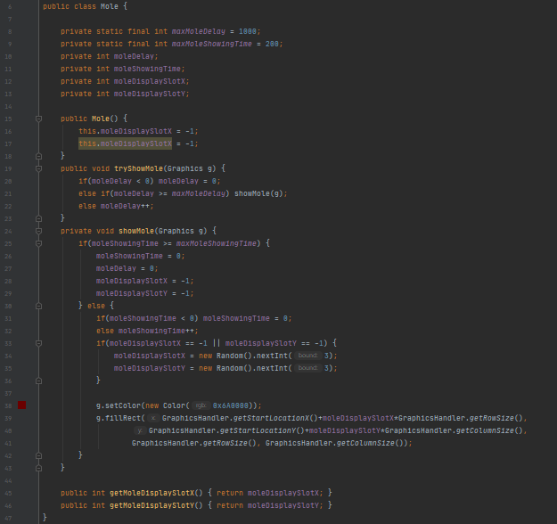
I hope these instructions were clear enough for you to make this piece of code work. I also hope that you can read the code below and figure out what code is equal to what code.

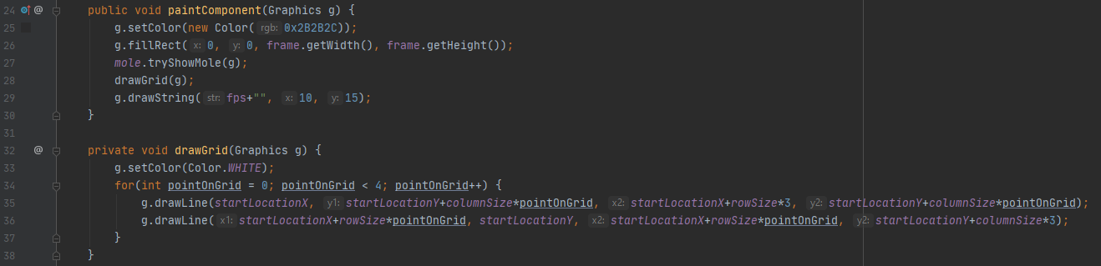
Upon running the program, we will see that the mole is drawn over the grid and that the FPS is colored in the color as the mole is. To resolve this, we have to shift around the position from the line ‘mole.tryShowMole(g);’. We will move it out of the current function and place it on the line between drawing the background and drawing the grid.

Before we are moving on to handling the user input from the mouse, we will be making two more getters for getting the variables moleDisplaySlotX and moleDisplaySlotZ. These methods will be public integers and will be called ‘getMoleDisplaySlotX’ and ‘getMoleDisplaySlotZ’. It is very likely you did not name these variables as I did. If this is the case, you just have to replace my variable name with yours.

Listener
To detect where the user clicks, we will be creating a listener. For this we will be making a new class named ‘ClickListener’. We will be implementing ‘MouseListener’ in this class. Next, we will be overriding the five methods we have to override. These functions are: mouseClicked(MouseEvent e) { …}; mousePressed(MouseEvent e) { … }; mouseReleased(MouseEvent e) { … }; mouseEntered(MouseEvent e) { … }; and mouseExited(MouseEvent e) { … }. All of these functions will be empty besides the function ‘mouseReleased(MouseEvent e) { … }’. We will be using this function to check whether you click inside the rectangle the mole is or not.
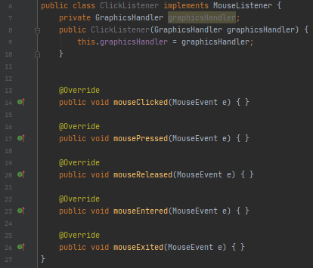
Before we can start handling the user input from the mouse, we will be having to add the class we just made to the frame and we have to get the same instance from the Mole-class as used in the class GraphicsHandler. Thus, we will be making a constructor which sets the private variable ‘graphicsHandler’ from the type ‘GraphicsHandler’ to the give class as parameter. The class now looks like the image on the right.

Next up we will be adding some things to the class GraphicsHandler. First, we will be making a getter for the variable mole. This getter will not be static and can be accessed by any class with static access.
At last we will be adding the class ClickListener as a MouseListener to the frame. We will do this by writing “frame.addMouseListener(new ClickListener(this));” inside of the constructor-method.
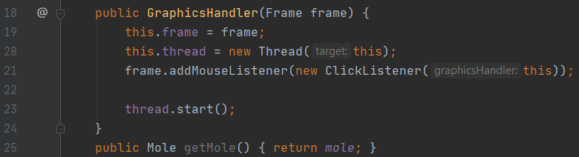
If I put the getter and constructor below each other they look like the image below. You can change the order of methods however you prefer them to be in.

Now that we have the getter for the mole and registered the listener we are working on, we can move on inside the listener. Below are the instructions for the method mouseReleased which we are overriding.
- If either the x- or y-coordinate from the mole is minus one, return the method (tip: graphicsHandler.getMole()).
- Set two integers (inside the method) to the starting location from the rectangle from the grid the mole is. Name these integers in a way it represents what it is set to. (tip: look at the method you are filling the rectangle).
- Check if the x-coordinate from the click (e.getX()) is more than or equal to the variable you set to represent the row from the mole on the screen. Do the same for the y-coordinate (thus the column). To do this with one if-/else-statement, you can use ‘&&’.
- When this is true, check if the x-coordinate is less than or equal to the variable you set to represent the row from the mole plus one time the size from the row. Do the same for the column.
- Whenever all created checks are true, print to the system that you whacked the mole (tip: System.out.println();).
- Make a method that can be accessed by any class that has static access which sets the time mole is showing to the max time the mole may show up. The function will have as name ‘hideMole’.
- Call the function you just made when the user whacks a mole.

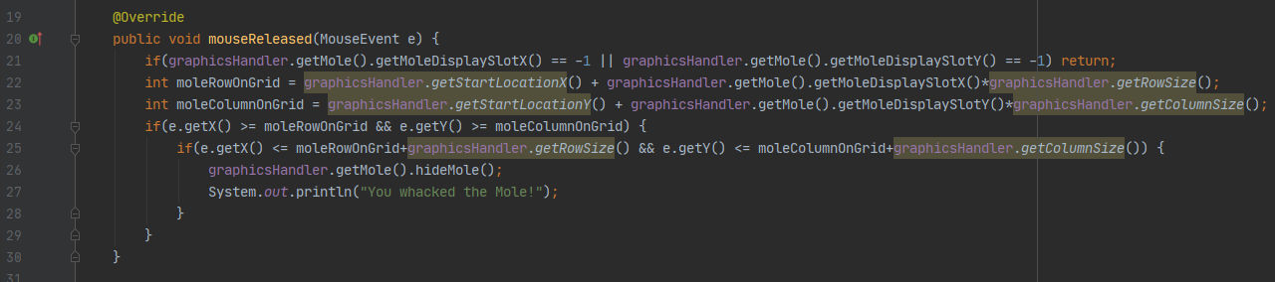
Once you have done this, you can run the program and test yourself it your code is correct. If you did not understand what was asked or you are having problems, below is an image from the code.

Point System
There is one more thing left to do, that is telling the player the amount of points they have. For this final step I will be setting the things you have to do below each other and -of course- provide a screenshot from the final functions.
- Create a variable called points inside GraphicsHandler and set this variable to zero inside the constructor. The variable will be private.
- Create a function called moleWhacked inside of the class GraphicsHandler. This function is public and does not return anything.
- Add one to the points the player currently has inside the function moleWhacked.
- Replace the line where you print out the user has whacked a mole with the method-call from the method you just created.
- Draw a String with as text “Points:” and the amount of points the player currently has. Make this String appear 10 pixels right of the last grid (tip: rowSize*3 is the size of the grid). The y-coordinate will be startLocationY.
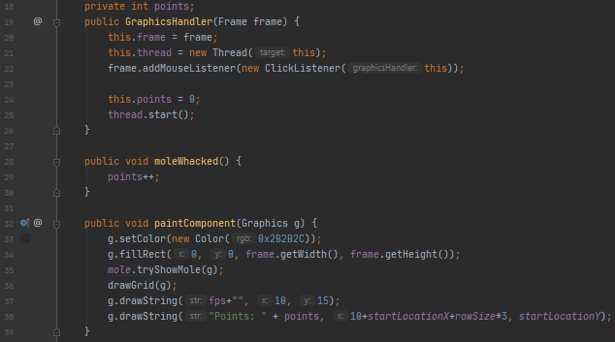
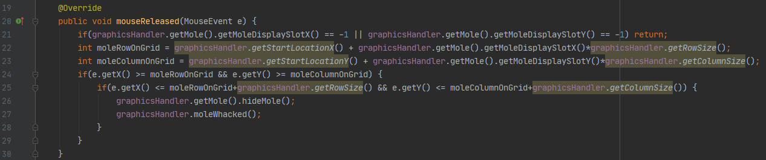

The End
Congratulations! You have just finished the guide on Whack a Mole. I hope you have learned something from this guide thus have a better understanding from Java.
Remember: to learn Java well, you have to keep practicing and play around with things you learn.

